C++ Programming
( by Vishal Tyagi)

Definition:
C++ is a general-purpose programming language that was developed by Bjarne Stroustrup as an enhancement of the C language to add object-oriented paradigm.

Feature :
• Object-Oriented → Uses classes and objects (OOP concepts)
• Fast & Efficient → Close to hardware, high performance
• Multi-paradigm → Supports procedural + OOP + generic programming
• Memory Control → Direct access and management of memory
• Portable → Runs on different platforms

Use Case of C++:
• Game development 🎮
• Operating systems (Windows, Linux parts)
• Embedded systems (IoT devices)
• Software applications (browsers, tools)
• High-performance systems (banking, simulations)

Structure of the C++ program :
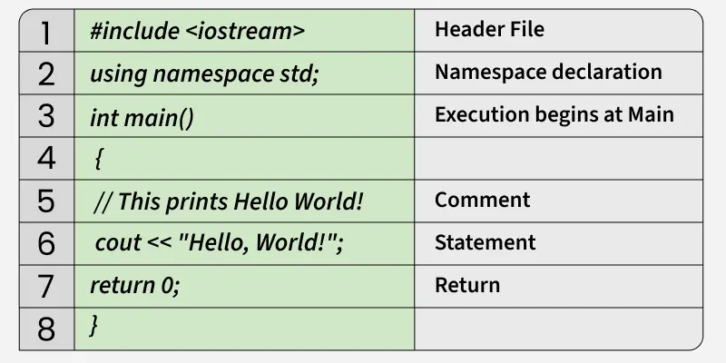
- Header Files: A header file is a file that contains declarations (names of functions, variables, or classes) that you want to use in your program.
- namespace std: a namespace is used to organize code and prevent naming conflicts, especially in large projects or when using libraries.
- main () : program execution starts from main function.

📊 Difference Between C and C++

Feature | C | C++
Programming Type | Procedural programming | Multi-paradigm (procedural + object-oriented + generic)
Approach | Top-down approach | Bottom-up approach
Data Security | Less secure (no data hiding) | More secure (supports encapsulation & abstraction)
Object-Oriented Programming (OOP) | Not supported | Fully supported (classes, inheritance, polymorphism)
Memory Management | Uses malloc () and free () | Uses new and delete
Exception Handling | Not supported | Supported (try, catch)

📘 Data Types in C++:

Data types define the kind of data a variable can store. There are three type of data types :

✅ 1. Basic (Primitive) Data Types : These are built-in data types provided by C++. Ex: int, char, double, float etc.
✅ 2. Derived Data Types : Data types that are derived from basic data types. Ex. Array, pointer, reference , function etc.
✅ 3. User-Defined Data Types: These are created by the programmer to define custom data structures. Ex: class , struct , enum etc.

📊 C++ Data Types Size & Range :
Data Type | Size (Bytes) | Range (Approx)
char | 1 | -128 to 127
unsigned char | 1 | 0 to 255
int | 4 | -2,147,483,648 to 2,147,483,647
unsigned int | 4 | 0 to 4,294,967,295
short int | 2 | -32,768 to 32,767
long int | 4 or 8 | Very large (system dependent)
long long int | 8 | ±9 × 10¹⁸ (approx)
float | 4 | ~ ±3.4 × 10³⁸
double | 8 | ~ ±1.7 × 10³⁰⁸
long double | 10, 12 or 16 | Very high precision

Variables in C++:

In C++, variable is a name given to a memory location. The value stored in a variable can be accessed or changed during program execution. Ex:
int num = 3;
Explanation: num is variable. 3 is stored in num. type of num is int.

Rules for Naming Variable:

The names given to a variable are called identifiers. There are some rules for creating these identifiers (names):
- A name can only contain letters (A-Z or a-z), digits (0-9), and underscores (_).
- It should start with a letter or an underscore only.
- It is case sensitive.
- The name of the variable should not contain any whitespace and special characters (i.e. #, $, %, *, etc).

📌 Memory Layout of C++:

A C++ program is divided into 4 main memory parts: Code → Data → Heap → Stack
- 🧠 Code Segment (Text Segment) :
• Stores the compiled program instructions
• This is the actual code of your program
• Usually read-only (can’t be modified)

- 📦 Data Segment:
- Stores global and static variables
- It has two parts :
- Initialized Data :
Global/static variables with values
Ex : int x = 10; // stored here

- Uninitialized Data (BSS) :
Variables without initialization (default = 0)
Ex : int y; // stored here

- 🏗 Heap:
• Used for dynamic memory allocation
• Memory allocated during runtime using:
- new (C++)
- malloc() (C)
• Managed by the programmer

4. 📚 Stack
- Stores function calls and local variables
- Works in LIFO (Last In, First Out) manner

⭐ Key Points :
- Stack is fast but limited
- Heap is large but slower
- Data segment = global/static variables
- Code segment = program instructions
- Stack grows downward, heap grows upward

Storage Classes in C++:
storage class defines the scope (visibility), lifetime, and linkage of variable

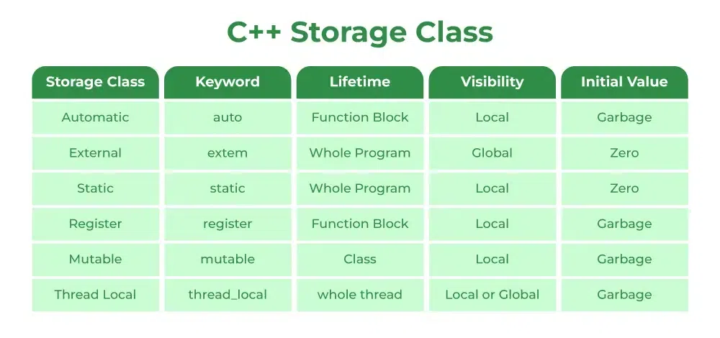

Operators in C++:

Operator is a symbol that tells the compiler to perform a specific operation on one or more operands (values or variables).
🔹Types of Operators in C++ :
  - ➕ Arithmetic Operators : +,-,*./,%
  - 🔍 Relational (Comparison) Operators : ==, !=, >, <, <=
  - 🔗 Logical Operators: ||, &&, !
  - 📝 Assignment Operators : =, +=, /=
  - 🔄 Increment & Decrement Operators : ++, --
  - ❓ Conditional (Ternary) Operator : (a>b)?yes:no
  - 🔧 Bitwise Operators : |,&, ^

First C++ Program :
#include <iostream>
using namespace std;
#define PI 3.14
double Area(double radius){
return PI*radius*radius;
}
int main() {
double radius;
cout<<"enter the radius : ";
cin>>radius;
cout<<"area is :"<<Area(radius); // total area
return 0;
}

How C++ program runs :

[ Hello.cpp ] Source Code
▼
┌───────────────┐
│ Preprocessor │ ──► Cleans code, expands macros & headers
└───────────────┘
▼
┌───────────────┐
│ Compiler │ ──► Checks syntax, creates Object Code (.obj)
└───────────────┘
▼
┌───────────────┐
│ Linker │ ──► Merges Object Code with Libraries
└───────────────┘
▼
[ Executable ] (.exe file stored on Hard Drive)
▼
┌───────────────┐
│ Loader │ ──► Copies .exe from Hard Drive into RAM
└───────────────┘
▼
┌───────────────┐
│ CPU │ ──► Reads instructions from RAM & executes
└───────────────┘

- We have Hello.cpp file.
- Preprocessor removes comment, replaces macro & replace header file name from header file code.
- Compiler will check syntax error, if there is no syntax error then convert into obj code.
- Linker will combine obj code with standard library code and then generate one .exe file .
- Loader will load .exe file into ram from memory storage , so the cpu can execute it.

Basic C++ Object for input & output:
cout: used for display output
cin: used for user input
getline(cin, str): used for long string

Arrays in C++ :

An array is a collection of elements of the same data type stored in contiguous memory locations. It allows multiple values to be stored under a single name and accessed using an index.
Int arr[]={1,2,3,4,5};
Int size=sizeof(arr)/sizeof(arr[0]);

Pointers and References in C++:

Feature | Pointer | Reference
Definition | A pointer stores the memory address of another variable | A reference is an alias (another name) for an existing variable
Declaration | Uses * symbol | Uses & symbol
Initialization | Can be declared without initialization | Must be initialized at the time of declaration
Null Value | Can be NULL or nullptr | Cannot be null
Reassignment | Can point to another variable | Cannot be reassigned to refer to another variable
Memory Address | Has its own memory address | Shares the same memory address as the referenced variable
Dereferencing | Requires dereferencing using * | No dereferencing needed
Usage | Useful for dynamic memory, arrays, and data structures | Useful for function parameters and operator overloading
Safety | Less safe (can cause dangling pointers) | Safer compared to pointers

new and delete Operators in C++ For Dynamic Memory :
the new and delete operators are used for Dynamic Memory Allocation. They allow you to allocate .and free memory from the Heap during runtime.
Syntax :
1. Dynamic Allocation for Single Variables :
int *num=new int(value); // memory allocation
delete num; // memory deallocation
num=nullptr;// avoid from dangling pointer

2. Dynamic Allocation for Arrays :
Int *arr=new int[size]; // memory allocation
delete[] arr; // deallocation memory
arr=nullptr; // avoid from dangling pointer

Templates :

A template in C++ is a blueprint which allows you to write a single function or class that can work with any data type (integers, floats, doubles, or custom text types) without rewriting the exact same code over and over again.
Ex:
Function Template:

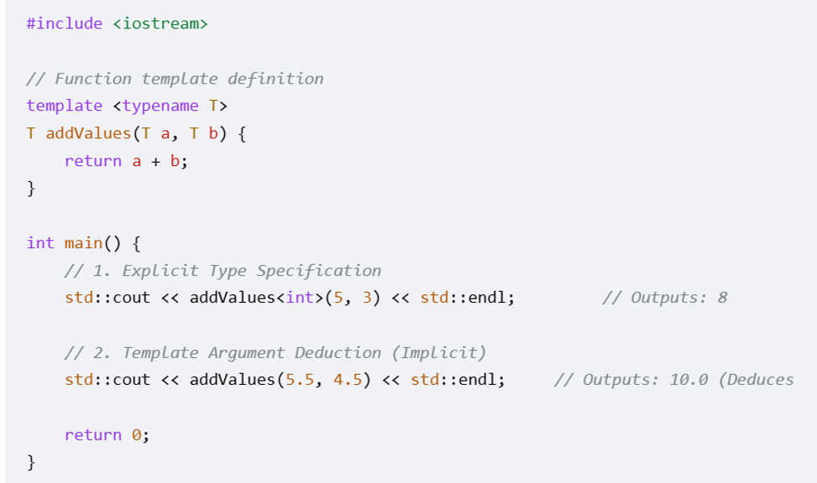

Class Template:

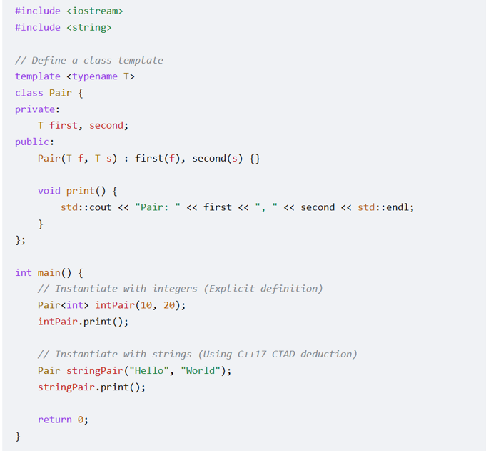

OOPS:

Object: object is a real world entity which has some properties and some behavior. When an object is created, memory is allocated in ram.

Class : A Class is a user-defined data type that acts as a blueprint for creating objects. It contains data members (variables) and member functions (methods) into a single unit. The size of empty class is 1. All data members and function inside the class is private by default. Ex :
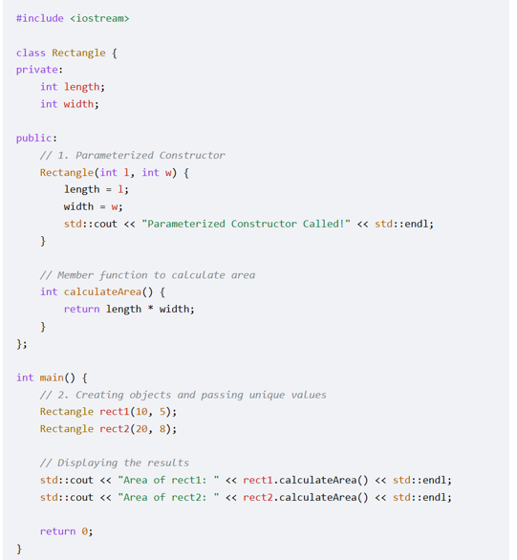

Constructor: It is a member function of a class which is used to initialized data members of the class. It calls automatically when an object created of a class. It has same name as class name, but it does not have return value. There are some types of constructor :
1. Default Constructor: Takes no arguments. If you do not write any constructor, the compiler automatically creates an empty default constructor. Eg.
class Wall {
public:
int length;
Wall() { // Default Constructor
length = 10;
}
};

2. Parameterized Constructor: Takes arguments to initialize data members with custom values at the time of object creation.Eg:
class Wall {
public:
int length;
Wall( int len): length(len) { }
};

3.Copy Constructor: Initializes a new object using an existing object of the same class. There are two types of Constructor:
(i):Shallow Copy: Copies pointer addresses. Both objects share the same memory. If your class allocates dynamic memory using new, the default copy constructor copies the pointer address, not the data. This means both objects will point to the exact same memory location, leading to crashes or data corruption when destructors are called. Ex:
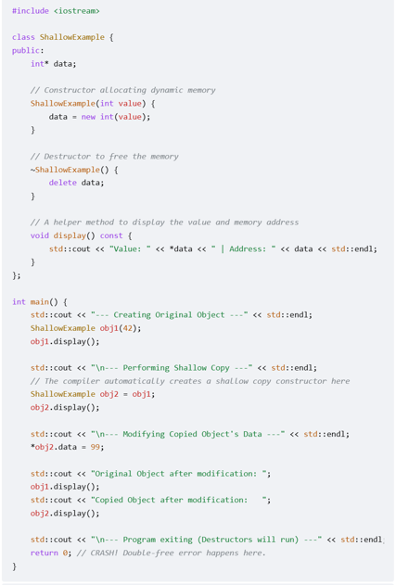

(ii). Deep Copy: Copies the actual data. Each object gets its own separate memory.

#include <iostream>
using namespace std;

class Student {
public:
string name;
int *age;

// Parameterized Constructor: Performs a Deep Copy
Student(string p_name, int *p_age) : name(p_name) {
age = new int(*p_age);
}

// Copy Constructor: Performs a Deep Copy
Student(const Student &obj) {
name = obj.name;
age = new int(*obj.age);
}

void getdata() {
cout << "name is :" << name << " | age is " << *age << " (Address: " << age << ")" << endl;
}

// Destructor: Safely deletes its own independent pointer
~Student() {
delete age;
age = nullptr;
}
};

int main() {
int *age_ptr = new int(10); // Main owns this memory block

Student obj1("vishal", age_ptr);
Student obj2 = obj1; // Deep copy occurs here (completely independent)

*obj2.age = 20; // This ONLY changes obj2's age to 20

cout << "--- obj1 State ---" << endl;
obj1.getdata(); // Correct: Prints 10 (Not affected by obj2!)

cout << "--- obj2 State ---" << endl;
obj2.getdata(); // Correct: Prints 20

delete age_ptr; // Cleans up main's pointer safely
return 0;
}
Copy Assignment Operator : when two or more object initialize , after that we want to copy object from one object to another then we use copy assignment operator: Ex :
#include <iostream>
using namespace std;

class Student {
public:
string name;
int *age;

// Parameterized Constructor: Performs a Deep Copy
Student(string p_name, int *p_age) : name(p_name) {
age = new int(*p_age);
}

// Copy Constructor: Performs a Deep Copy
Student(const Student &obj) {
name = obj.name;
age = new int(*obj.age);
}

Student &operator=(const Student &obj)
{
if(this==&obj)
{
return *this;
}

delete age;
name=obj.name;
age=new int(*obj.age);
return *this;
}
void getdata() {
cout << "name is :" << name << " | age is " << *age << " (Address: " << age << ")" << endl;
}

// Destructor: Safely deletes its own independent pointer
~Student() {
delete age;
age = nullptr;
}
};

int main() {
int *age_ptr = new int(10); // Main owns this memory block

Student obj1("vishal", age_ptr);
*age_ptr=30;
obj1.getdata();
Student obj2("rohit",age_ptr);
obj2.getdata();
obj1=obj2;
obj1.getdata();
delete age_ptr;
return 0;
}

Encapsulation: it is defined as wrapping up of data & information in a single unit. It is used for data hiding and data protection. We can achieve encapsulation by Access modifier, getter & setter function.
Access modifier: private & protected access modifier protect our data from global access.
Getter & Setter function: we can read data with the help of getter & setter function without modifying the data.

Ex:
#include <iostream>
#include <string>
class BankAccount {
private:
// 1. Data members are hidden from direct external modification
double balance;
public:
// Constructor
BankAccount(double initialBalance) {
balance = (initialBalance > 0) ? initialBalance : 0;
}
// 2. Getter (Read-only access)
double getBalance() const {
return balance;
}
// 3. Setter with integrated validation rules
void deposit(double amount) {
if (amount > 0) { // Prevents accidental or malicious corruption
balance += amount;
}
}
};

int main() {
BankAccount account(100.0);
// account.balance = -500; // COMPILER ERROR: Protected by encapsulation
account.deposit(50.0); // Validated access via public interface
std::cout << "Balance: $" << account.getBalance() << std::endl;
return 0;
}

Inheritance: Inheritance is a process in which one class can inherits the properties and behaviour of another class. It improves code reusability. There are five types of inheritance:
• Single Inheritance: One derived class inherits from exactly one base class.
• Multiple Inheritance: One derived class inherits directly from two or more base classes (e.g., class Smartphone : public Camera, public Phone).
• Multilevel Inheritance: A derived class acts as a base class for another class (e.g., Grandchild : Child : Parent).
• Hierarchical Inheritance: Multiple derived classes inherit from a single common base class.
• Hybrid Inheritance: A combination of multiple and multilevel patterns, often forming a diamond shape. EX: Diamond Problem :
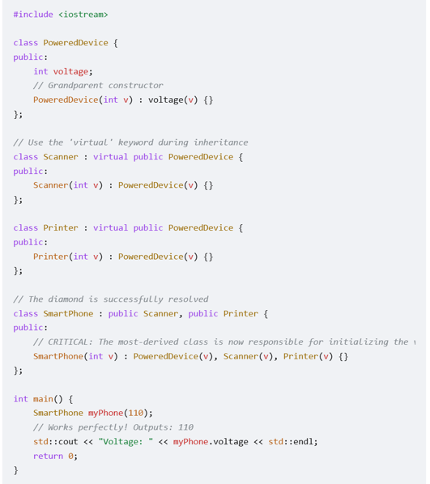

Polymorphism: It is a process in which different objects responds to a message in different ways. There are two type of polymorphism:
1.Compile-time polymorphism(Static Binding): The C++ compiler selects the appropriate function or operator to execute during compilation. We can achieve it by function overloading and operator overloading.
A. Function Overloading: We can define multiple functions with the same name but different parameter types or counts. Example
#include <iostream>
class PrintData {
public:
void display(int i) { std::cout << "Integer: " << i << "\n"; }
void display(double f) { std::cout << "Float: " << f << "\n"; }
};
B. Operator Overloading: we overload the built-in operator to provide a special meaning for user defined data type.ex;
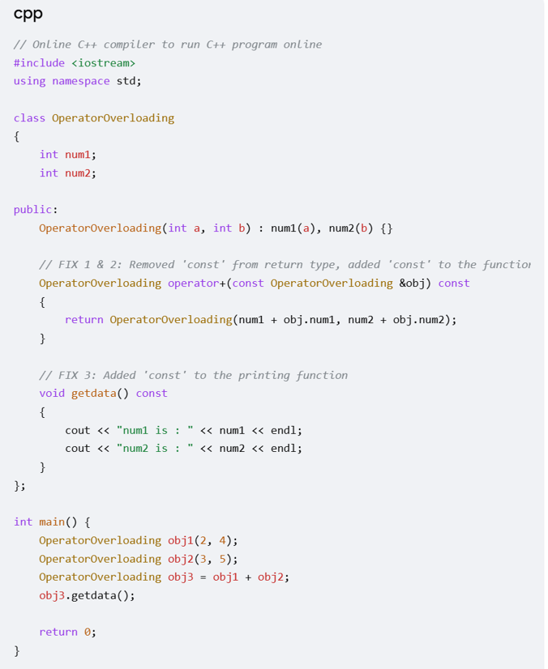

For practice:
- Overload pre increment operator
- Overload post increment operator

- Run-Time Polymorphism (Dynamic Binding): Runtime Polymorphism in C++, also known as late binding or dynamic Polymorphism, is achieved through function overriding. The function call resolves at runtime int run time Polymorphism . Any class which contains virtual function , it have one vtable which contains reference of each virtual function. The same vtable will be inherits in derived class.
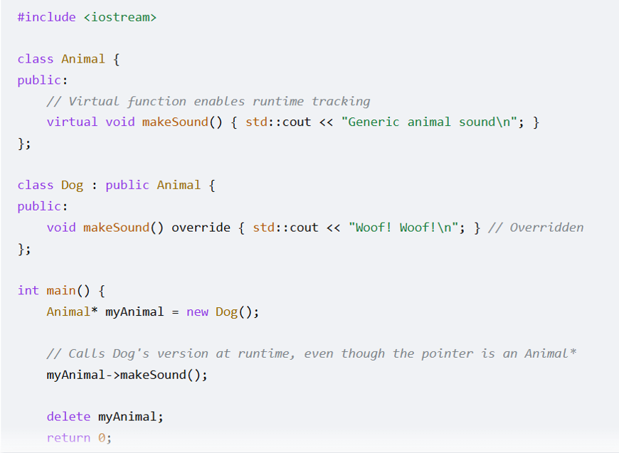

What is pure virtual function ?
A pure virtual function in C++ is a virtual function that has no implementation in the base class and is assigned = 0. If a derived class fails to implement the pure virtual function, that derived class also becomes an abstract class
• Any class containing at least one pure virtual function automatically becomes an Abstract Class.
• Rule: You cannot instantiate (create an object of) an abstract class.
• Purpose: It serves purely as a blueprint or interface for other classes
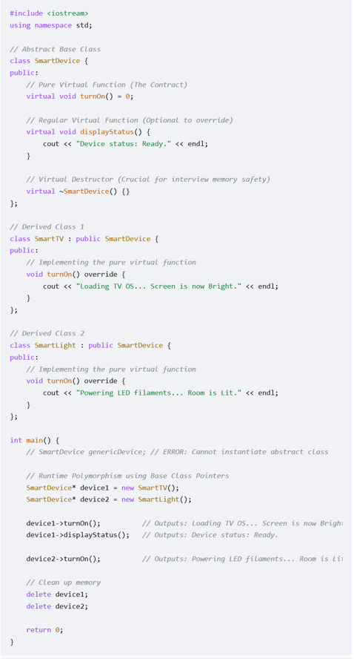
What is Destructor: A destructor is a special member function that is automatically called when an object goes out of scope or is explicitly deleted. Its primary job is to release resources (like heap memory, file handles, or database connections) acquired by the object during its lifetime.
Syntax: Same name as the class, preceded by a tilde (~). It takes no arguments and has no return type (e.g., ~MyClass();).
Virtual Destructor: A virtual destructor is a destructor in a base class that is declared with the virtual keyword. It ensures that when you delete a derived (child) class object through a base class pointer, the derived class's destructor is called first, followed by the base class's destructor.
- Syntax: virtual ~BaseClass();
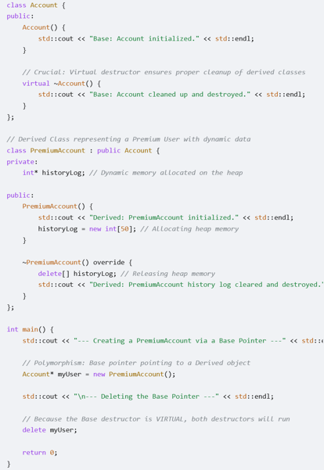

Friend Function: It is a function which is not a member of a class, but it can access all data members of a class. The class object cannot access the friend function. It contains class object as argument always. It can be public, private & protected.
Use: we use when left hand side object(outsider object) is different from right hand side. Ex: cout<<obj;
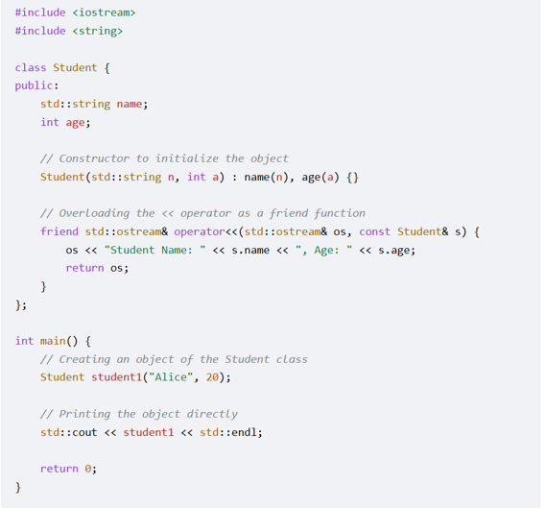

Friend Class: Friend class in C++ is a class that is granted special permission to access the private and protected members of another class.
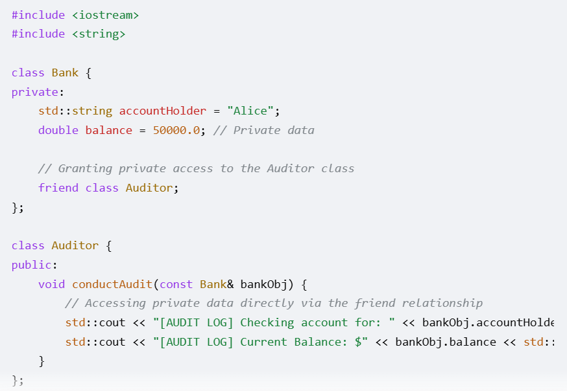
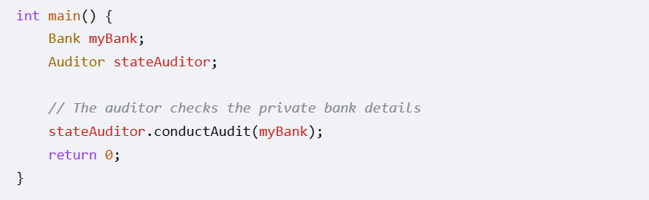

Call by value VS Call By Reference: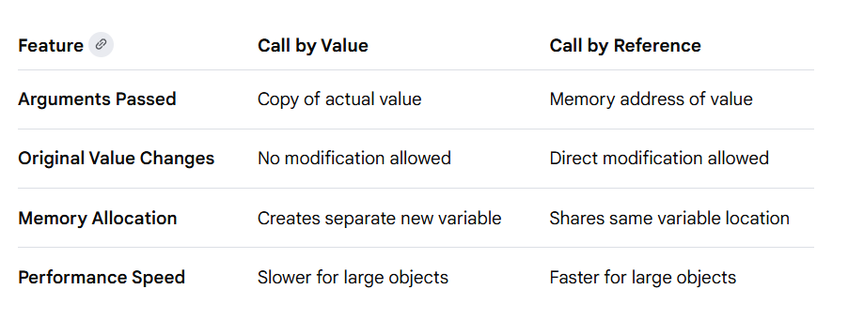
Pointer vs Reference:
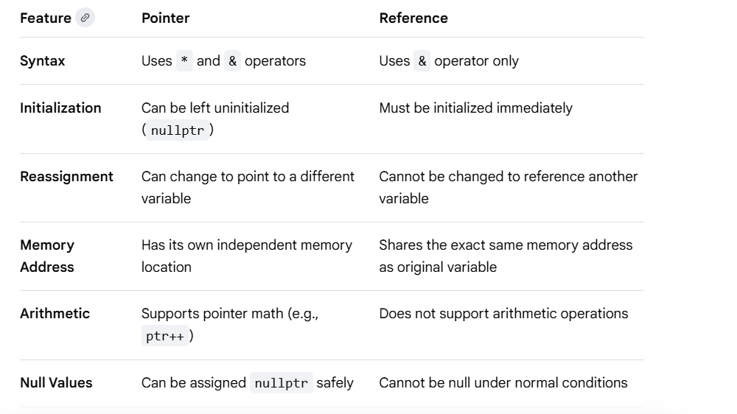
Top Interview Question:
- Differences between C and C++: Key contrasts regarding object-oriented programming, namespaces, and reference variables.
- The 4 major pillars of OOP: Define encapsulation, abstraction, inheritance, and polymorphism.
- Keywords struct vs class: The default access specifiers and visibility inheritances for both.
- Reference vs Pointer: How they differ in syntax, memory allocation, and re-assignability.
- Compilation process: Step-by-step pipeline across preprocessing, compiling, assembling, and linking.
- Namespace functionality: Purpose of namespaces and how they eliminate naming conflicts.
- Inline functions: How inline reduces overhead and the scenario where the compiler ignores it.
- const keyword positions: Differences between const int*, int* const, and const int* const.
- const member functions: Definition and how they guarantee no mutations of class member variables.
- constexpr vs const: Compile-time constant evaluation versus run-time read-only guarantees.
- Scope Resolution Operator (::): Accessing global variables, nested namespaces, and static members.
- static keyword: Its varying behaviors inside functions, files, and classes.
- Storage classes: Differences between auto, register, static, extern, and mutable.
- mutable keyword: Modifying a class data member inside a const member function.
- volatile keyword: Informing the compiler that a variable can change outside program execution.
- Function Overloading: How the compiler matches functions via name mangling.
- Operator Overloading: Rules, syntax, and operators that cannot be overloaded (e.g., . or ?:).
- Explicit type casting constructors: Using explicit to prevent implicit type conversions.
- The four C++ typecasts: Applications of static_cast, dynamic_cast, const_cast, and reinterpret_cast.
- Lvalue vs Rvalue: Definitions and expression identification.
- Pre-increment vs Post-increment: Memory and performance differences between ++i and i++.
- std::cout and printf(): Mechanism, type safety, and buffering variations between streams and C functions.
- Macros vs Inline Functions: Type safety and debugging contrasts.
- Friend functions and classes: Granting private member access without breaks in inheritance.
- Undefined Behavior (UB): Examples including uninitialized reads and signed integer overflows.

- Stack vs Heap memory: Lifespan, allocation speeds, and spatial limits.
- new/delete vs malloc()/free(): Constructors/destructors calling execution differences.
- delete vs delete[]: The exact danger of executing mismatching array deallocations.
- Memory Leaks: Detection strategies and prevention techniques.
- Dangling Pointers: Identification and techniques to safely neutralize them.
- Wild and Void Pointers: Definition and typecasting requirements for generic tracking.
- Function Pointers: Declaring, binding, and executing runtime lookups.
- Smart Pointers introduction: Concept, overhead, and historical evolution.
- std::unique_ptr implementation: Ownership modeling and preventing deep copy allocations.
- std::shared_ptr internals: Reference counting, control block locations, and tracking copies.
- std::weak_ptr utility: Break cyclic dependencies created by shared references.
- RAII paradigm: Resource Acquisition Is Initialization definition and use cases.
- Segmentation Fault: Common causes such as null pointer dereferences and stack overflows.
- Memory alignment & Padding: How the CPU reads bytes and impacts structural layouts.
- Pointer arithmetic: Rules for incrementing indices across homogeneous blocks.
- Smart pointer conversion: Constructing a shared interface from a unique reference.
- Custom allocators: Overriding standard heap configurations for performance optimization.
- Shallow vs Deep copy: Impact on pointers within class instances.
- Cache locality: Array versus linked list spatial cache performance behavior.
- Object slicing: Passing a derived class instance by value into a base layout block.
- std::addressof utility: Retrieving addresses when an overloaded address-of operator exists.
- Garbage Collection: Why C++ uses RAII over automated runtime garbage sweeps.
- Double-free vulnerabilities: Triggers and avoidance methods using smart reference controls.
- Memory-mapped I/O: Accessing system hardware configurations through explicit reference maps.
- Null pointer safety: Why nullptr is preferred over the macro NULL.

- Constructors types: Default, parameterized, and copy constructor behavior.
- Initializer lists: Situations where member initialization lists are strictly mandatory.
- Destructors rules: Cleanup orders and constraints on throwing exceptions.
- Virtual Destructors: Why base classes require a virtual destructor.
- Virtual functions & Dynamic Dispatch: Runtime polymorphism and late binding mechanisms.
- VTABLE and VPTR internals: Structural lookups used by the compiler during dynamic calls.
- Pure Virtual Function: Declaring abstractions and rules for abstract classes.
- Inheritance types: Public, protected, and private visibility access patterns.
- Multiple Inheritance: Diamond Problem description and structural conflicts.
- Virtual Inheritance: Resolution for redundant base allocations.
- Method Overriding vs Overloading: Static compile-time polymorphism vs dynamic runtime checks.
- override and final specifiers: Preventing compile-time mismatches and inheritance.
- Abstract Class vs Interface: Differences in data members and functional behaviors.
- Static Polymorphism: Achieving compile-time dispatch using templates.
- Rule of Three / Five / Zero: Managing explicit object destruction, copies, and moves.
- Copy-and-Swap idiom: Exception-safe assignment operator implementation.
- Deep copy allocation: Duplicating heap-bound resources during object copies.
- Nested and Inner Classes: Scope limits, access levels, and parent relationships.
- Composition vs Inheritance: "Has-a" design logic vs "Is-a" coupling models.
- Base class slicing protection: Design choices to prevent truncation during copy actions.
- Virtual function defaults: Default argument binding variations between base and derived implementations.
- Constructor chaining: Sequence of execution across inheritance structures.
- Private constructors: Use cases including the Singleton Design Pattern.
- Anonymous classes: Local layout rules and implementation usage.
- Polymorphic collections: Storing base pointers to manipulate varied subclass instances safely.

- STL architecture: Containers, Iterators, Algorithms, and Functors overview.
- std::vector vs std::list: Array block layouts vs linked list implementations.
- Vector growth mechanics: Dynamic reallocation strategy, size() vs capacity(), and reserve().
- std::map vs std::unordered_map: Red-Black trees (Ordered) vs Hash Tables (Unordered).
- Time Complexities: Lookup, insertion, and deletion speeds across standard STL structures.
- Iterator Invalidations: Container mutations that break valid iterator offsets.
- std::deque structural layout: Segmented block arrays vs contiguous vector allocations.
- push_back() vs emplace_back(): Direct temporary copy evaluation vs in-place allocations.
- std::set properties: Sorting limits, duplicates prevention, and underlying trees.
- Class and Function Templates: Syntax and template deduction configurations.
- Template Specialization: Custom overrides for specific types.
- Functors: Classes overloading the function call operator () and their state maintenance capabilities.
- std::sort internals: IntroSort mechanics combining QuickSort, HeapSort, and InsertionSort.
- std::priority_queue mapping: Internal heap structuring, sorting orders, and modifications.
- Remove-Erase Idiom: Cleaning target items out of sequence vectors.
- Custom hashing: Injecting user structures into std::unordered_map storage keys.
- std::pair and std::tuple: Bundling multiple heterogeneous values.
- Iterator Categories: Input, Output, Forward, Bidirectional, and Random-Access features.
- std::array: Benefits over standard C-style arrays.
- std::string_view: Zero-allocation string reading capabilities.
- Metaprogramming basics: Type evaluation and calculations performed during compilation.
- std::find vs member find: Computational differences when looking up values in structured trees.
- Smart iterators: Using std::back_inserter to grow target sequences automatically during copies.
- std::span: Contiguous memory access references.
- Thread-safe containers: STL concurrency limits and race condition mitigations.

- Move Semantics: Asset tracking optimizations using rvalue reference models (&&).
- std::move and std::forward: Casting expressions to rvalues vs conditional forwarding.
- Lambda Expressions: Inline closure syntax, scope captures, and anonymous declarations.
- Lambda vs std::function: Concrete functional code footprints vs generic object wrappers.
- std::thread management: Forking background processing paths and handling terminations.
- Race Conditions & Data Races: Multi-threaded write collisions and prevention.
- std::mutex and locks: Synchronization guards via std::lock_guard and std::unique_lock.
- std::atomic variables: Lock-free operations for primitive operations.
- Deadlocks: Triggers, dependencies, and mitigation using std::lock.
- Condition Variables: Managing thread notifications via std::condition_variable.
- Asynchronous Tasks: Spawning background jobs using std::async, std::future, and std::promise.
- Perfect Forwarding: Transporting argument types without losing reference qualifications.
- Exception Safety Guarantees: Basic, strong, and no-throw (noexcept) models.
- noexcept specifier: Optimization flags for move operations during reallocations.
- Smart pointer ownership transfer: Passing ownership across distinct boundaries.
- C++20 Concepts: Constraints on template parameters for clear compilation checks.
- C++20 Modules: Replacing header files to speed up compilation pipelines.
- C++20 Coroutines: Stackless asynchronous functions utilizing co_await and co_return.
- C++20 Ranges: Composing data transformations using views and piping operators.
- Memory Models & Orders: memory_order_seq_cst and multi-threaded synchronization behaviors.
- Structured Bindings: Direct decomposition tuple syntax.
- Inline Variables: Defining shared static class resources without standalone cpp files.
- Type Traits: Querying data specifications at compile time using <type_traits>.
- Thread Pools: Reusing persistent worker tasks to avoid instantiation overhead.
- std::variant and std::any: Type-safe alternatives to unions and void references.

- String Reversal: In-place reversals and multi-byte checks.
- String Palindrome: Checking symmetrical character sequences.
- Anagram Detection: Validating character distributions across separate string pairs.
- First Unique Character: Finding individual characters inside complex streams.
- Two Sum Problem: Indexing item pairs that meet static summation targets.
- Array Reverse: Swapping items in contiguous collections.
- Find Duplicates: Isolating redundant listings in sequential records.
- Merge Sorted Arrays: Combining pre-sorted collections without losing order.
- Maximum Subarray (Kadane’s): Evaluating optimal continuous summation blocks.
- Move Zeroes: Shifting empty components to terminations while keeping sequence alignments.
- Linked List Reversal: Unlinking node pointer tracks in reverse.
- Detect Cycle (Floyd’s): Fast and slow index approaches across lists.
- Merge Two Sorted Lists: Weaving ordered chains into individual sequences.
- Find Middle of List: Isolating central components in single pass searches.
- Valid Parentheses: Balanced character checks using stack containers.
- Queue using Stacks: Replicating FIFO behaviors with LIFO systems.
- Binary Tree Inorder Traversal: Iterative or recursive implementations.
- Invert a Binary Tree: Swapping left and right child assignments.
- Maximum Depth of Tree: Measuring max path levels recursively.
- Binary Search: Fast structural search matching across sorted indexes.
- FizzBuzz: Traditional loop output validation.
- Fibonacci Sequence: Comparing recursive, memoized, and iterative options.
- Climbing Stairs: Dynamic programming patterns for total permutation variations.
- LRU Cache Design: Implementing eviction strategies via hash maps and doubly linked lists.
- Custom Vector Class: Basic storage reallocations, item tracking, and indexing.

- Remove N-th Node From End: Delete the target node in a single traversal using the two-pointer technique.
- Intersection of Two Lists: Find the exact node where two singly linked lists merge into a shared track.
- Palindrome Linked List: Verify if a list reads the same forward and backward with O(1) extra space.
- Add Two Numbers: Sum two numbers represented by linked lists where each node contains a single digit.
- Flatten a Multilevel List: Flatten a linked list where nodes can point to next, previous, or a child list.
- Container With Most Water: Find two lines that together with the x-axis form a container holding the most water.
- 3Sum Problem: Find all unique triplets in an array that sum up to exactly zero.
- Longest Substring Without Repeating Characters: Use a sliding window to track the maximum distinct character sequence.
- Minimum Size Subarray Sum: Find the minimal length of a contiguous subarray for which the sum is ≥ a target value.
- Trapping Rain Water: Compute how much water an elevation map can trap after raining.
- Min Stack Design: Build a stack supporting push, pop, top, and retrieving the minimum element in O(1) time.
- Next Greater Element: Use a monotonic stack to find the first greater element to the right for each array item.
- Daily Temperatures: Calculate the number of days you must wait until a warmer temperature occurs.
- Sliding Window Maximum: Return the maximum element inside a moving window of size k.
- Evaluate Reverse Polish Notation: Compute the value of an arithmetic expression in postfix notation.
- Binary Tree Level Order Traversal: Output tree values level-by-level using a queue-based Breadth-First Search (BFS).
- Lowest Common Ancestor (LCA): Find the lowest shared ancestor node for two specified target nodes in a tree.
- Validate Binary Search Tree: Check if a tree satisfies standard BST ordering rules across all subtrees.
- Number of Islands: Count isolated clusters of land cells in a 2D grid using Depth-First Search (DFS) or BFS.
- Course Schedule (Topological Sort): Detect cycles in dependency graphs to determine if all tasks can be finished.

- Search in Rotated Sorted Array: Find a target item inside a shifted sorted array in
runtime.
- Find Peak Element: Locate a local maximum item that is strictly greater than its immediate neighbors.
- Merge Intervals: Combine overlapping intervals into a single sorted sequence of distinct ranges.
- Product of Array Except Self: Build an output array without using the division operator in O(n) time.
- K-th Largest Element: Find the k-th largest item in an unsorted array using std::nth_element or a min-heap.
- Thread-Safe Queue: Implement a concurrent queue using std::mutex and std::condition_variable.
- String Tokenizer: Write a custom version of strtok or a string splitter using std::string_view.
- Shared Pointer Clone: Implement a basic version of std::shared_ptr with reference counting logic.
- Custom Matrix Class: Design a multi-dimensional array class handling rule-of-five memory configurations.
- Object Pool Pattern: Build a resource pooling class that recycles expensive object allocations.

