21/10/2016

Kaizen Software Consultants

Andrew Moore - 11000585

Gurparteek Singh - 12027013

Michelle Quaglia - 11245089

Robert Mitchell - 11035159

Vishal Uniyal - 12103584

Major Assignment

48433: Software Architecture

Case Study: Wearable health device Monitoring

< blank page >

Contents

Glossary 4

Table of abbreviations 4

List of Figures 4

List of Tables 4

References 4

1. Introduction 6

1.1. System purpose 6

1.2. Document purpose 6

2. Project Context 7

2.1. Problem statement 7

2.2. Objectives 8

2.3. Stakeholders and their interests 9

2.4. User narratives 11

2.5. User Scenarios 14

2.6. Quality Requirements 16

2.7. Project Risks and Constraints 16

2.7.1. Table of Risks 16

2.7.2. Table of Constraints 17

3. Conceptual Architecture 18

4. Execution Architecture 20

4.1. Execution Architecture Diagram 20

4.2. Main Communication Paths and Data Types 21

5. Implementation Architecture 23

5.1. Initial Implementation Architecture 23

5.2. Final Implementation Architecture 25

6. Rationale 27

7. Evaluation 29

< blank page >

# Glossary

## Table of abbreviations

|  |  |
| --- | --- |
| Abbreviation | Meaning |
| WHD | Wearable health device |
| ADC | Analogue to digital conversion |
| DAC | Digital to analogue conversion |
| TCP | Transmission control protocol |
| IP | Internet protocol |
| SMS | Short message service |
| GSM | Global system for mobile |
| UI | User interface |
| COTS | Customised off-the-shelf |
| WPA2 | Wi-Fi protected access II |

## List of Figures

Figure 1: Overall conceptual architecture 18

Figure 2: Conceptual architecture as layers 19

Figure 3: Execution architecture 20

Figure 4: Initial implementation architecture 24

Figure 5: Final implementation architecture 26

## List of Tables

Table 1: Regular system cases 8

Table 2: System objectives 8

Table 3: Stakeholder analysis 10

Table 4: User narratives 13

Table 5: Quality attributes of stakeholder needs 16

Table 6: Table of project risks 17

Table 7: Table of project constraints 17

Table 8: Architecture of data communication in the execution of the system 22

Table 9: Rationale for the components of the system 28

Table 10: Evaluating our architecture against the system objectives 31

# References

* McBride, T., 2016, *UTS Online Subject (48433): Software Architecture*, Autumn 2016, University of Technology, Sydney.

< blank page >

# Introduction

# System purpose

The system is to be designed to solve the problem of being able to monitor the health conditions of patients remotely. The system is then able to alert carers and doctors to the health condition and location of the patient, so that they can get the fastest response possible to the patient if they have problems.

# Document purpose

The purpose of this document is to present the case study problem and the suggested software architectural solution as determined by Kaizen Software Consultants. The document is split into sections that are designed to lead from the project context through to architecture phases and finally, a fully developed architecture that can be used for designing and implementing the working software.

The solution in this document must provide a workable software architecture that can be used by a team of developers to design and implement the system. Therefore it needs to meet the following objectives:

* Identify the stakeholders and their requirements
* Identify and describe the scenarios under which the system will be used
* Identify and provide detail of the required quality attributes of the system
* Build a set of documented architecture documentation from conceptual, to execution and, finally, the implementation solution
* Provide explanation and reasoning for architectural design choices
* Provide and explain alternative architectures considered

# Project Context

# Problem statement

A system architecture is to be designed in order to control a wearable health device network that can cope with a range of regular cases. The Wearable Health Device (WHD) will be deployed in hospitals and aged care facilities where patients will have a wearable band monitoring personal health metrics. It is up to the architecture further detailed to handle all events and be capable to catch exception cases to minimise any foreseeable consequences. The regular cases that the system will be designed around are listed in the table below.

|  |  |
| --- | --- |
| Case | Description |
| Normal Monitoring | • Patient walks away from carer  • Patient becomes lost or disorientated  • WHD monitor continues to transmit data  • Base station relays the patient’s location and health information to carer |
| Patient Problems | • Patient walks away from carer  • Patient suffers a decline in health  • WHD recognises the symptoms, transmits data and request help  • Base Station sends message and data to carer  • If no response base station will raise alarm |
| Abnormal Symptoms | • Base station polls WHD  • Base station compares results with historical data from the patient  • Base station ascertains abnormalities  • Base station messages carer and doctor via SMS  • Carer attends to check on patient  • Doctor signs on and reviews data  • If necessary: Doctor calls carer  ELSE: Doctors ignores |
| Abnormal Symptoms 2 | • Base station polls WHD  • Base station compares results with population data for the demographic of the patient  • Base station ascertains abnormalities  • Base Station alerts doctor  • Doctor signs on and reviews data  • If necessary: Doctor calls carer to inform issue  ELSE: Doctors ignore |
| Data Mining | • Base Station polls data  • WHD transmits data  • Data is deemed normal and stored into Database for future reference |

Table 1: Regular system cases

# Objectives

|  |  |
| --- | --- |
| ID | The system must… |
| OBJ01 | Collect sensor data (for health metrics) from a wearable health device |
| OBJ02 | Collect location information from a wearable health device |
| OBJ03 | Be deployed in a hospital or aged care facility |
| OBJ04 | Support a minimum of ten wearable health devices simultaneously |
| OBJ05 | Alert carer or doctor when patient has abnormal symptoms |
| OBJ06 | Trigger alarms when critical scenarios occur |
| OBJ07 | Alarm if patient has a decline in health and carer has not responded to request |
| OBJ08 | Be secure |
| OBJ09 | Collect data for trend analysis |
| OBJ10 | Achieve SLA level of 99.99% (equating to daily downtime of 8.6s, yearly 52m 35.7s) |
| OBJ11 | Be modular and scalable |

Table 2: System objectives

# Stakeholders and their interests

The system has various stakeholders that will interact with it. Each stakeholder has different requirements and functionality from the system. Below, the primary and secondary stakeholders are outlined, along with their requirements that will most affect the design of a suitable architecture.

|  |  |  |  |
| --- | --- | --- | --- |
| Stakeholder | Stakeholder Level | Characteristics of the stakeholder | Requirements |
| Patient | Primary | May be elderly or physically unwell. May have health issues and unfit to make decisions. | * Monitoring of their health conditions accurately * Alerting carers when required * Being assisted when physically unwell * Making their location known at all times |
| Doctor | Primary | Busy, stressed and overworked. | * Quick response time to alerts * Clear and simple user interface * Security and integrity for the stored data * Structured patient data that is always available. * Be able to send/receive alerts via SMS * View connected devices at a glance |
| Carer | Primary | Busy; overworked; likely many patients on their watch. | * Be able to locate patient at any time * Send/receive SMS alerts * Simple interface * Structured patient data that is always available * View connected devices at a glance |
| Developer | Secondary | Not from medical industry. Busy | * Ability to maintain and update modules as required * Ability to remotely push software updates |
| Researchers | Secondary | Academic. Interested in trends | * Real world patient data to assist in better understanding and modelling trends * Accurate and consistent data |
| Family and Friends | Secondary | Concerned. Wanting the best for their friend/family member | * Reliable data * Patient to be looked after *always* * Be able to trust the system |
| Product Buyer | Primary | Budget based. Wanting best for the facility operations | * The system needs to be scalable, maintainable, modifiable, testable, reliable and secure so I can provide the best possible service to the staff members and patients. |
| Product Seller | Primary | Profit based. Focused on making the best system for potential buyers. | * The system needs to be scalable, modifiable, reliable and secure so that more buyers are interested to purchase the system. |

Table 3: Stakeholder analysis

# User narratives

|  |  |  |  |  |
| --- | --- | --- | --- | --- |
| As a… | I want… | So that… | Story Points (Fibonacci sequence) | Importance |
| Patient | To move freely around my room or normal places | The carer does not have to physically see me all the time | 5 | L |
| Patient | My carer to be automatically alerted in an emergency situation | I can get help immediately | 21 | H |
| Patient | My health to be monitored remotely and accurately | I can enjoy life and have less things to worry about | 13 | H |
| Patient | My carer to know my location at all times | My carer can find me when I am lost | 5 | M |
| Patient | My personal health information to be stored accurately and securely | My privacy is not invaded | 8 | H |
| Carer | To get alerts on my phone about abnormal behaviour of patients | I can alert the doctor and wait for further action. | 13 | H |
| Carer | To track the location of my patient(s) | I can find them if they are lost | 5 | M |
| Carer | Know the health information of my patient(s) | I can monitor their health information for any abnormality | 8 | M |
| Carer | The system to raise an alarm when I am unable to respond in time | The doctor can take further action to analyse the patient’s situation. | 5 | H |
| Carer | A simple and easy to use system | I don’t get confused with too many options | 8 | M |
| Carer | An option to enable advanced/detailed data | I can analyse the patient’s health information in greater detail | 13 | L |
| Carer | To see an overview of all the connected devices | I can easily identify a patient, health and device information in one place | 8 | M |
| Carer | I want to easily track down the location and information of multiple patients at a time | I can easily manage multiple patients. | 8 | H |
| Duty Doctor | A simple and easy to use system | I don’t get confused with too many options | 8 | M |
| Duty Doctor | An option to enable advanced/detailed data | I can analyse the patient’s health information in greater detail | 13 | L |
| Duty Doctor | To call the carer | So I can give advice about patients’ health information if required. | 3 | H |
| Duty Doctor | To easily alert the emergency services | They can try to save patients that are in critical situation | 3 | H |
| Duty Doctor | To securely login into the system | No unauthorized person can steal or manipulate data | 5 | H |
| Duty Doctor | To see an overview of all the connected devices | I can easily identify whether particular devices are connected to the system or not | 8 | M |
| Developers | To maintain and update small modules at a time | There is no overall negative affect on the whole system and to minimise down-time | 13 | H |
| Developers | Remotely push any software updates | The system is updated as soon as possible and I save time as I don’t have to travel to physically update | 13 | M |
| Family  /Friends | To be alerted in a case of emergency | We know about patient’s situation and which hospital we should go to. | 3 | H |
| Emergency Personnel | System to send alerts in real time | We can take action as fast as possible and try to save lives | 3 | H |
| Emergency Personnel | To receive accurate alerts for genuine emergency | We spend our valuable time wisely and not waste time | 8 | H |
| Researcher | Access to consistent data from the system's database | I can compare the data to statistics for research purposes | 8 | H |
| Researcher | Access to accurate data | I can analyse real world patient data to better understand the modelling trend | 8 | H |
| Product Buyer | An scalable system | I can add in more devices and implement new features | 21 | H |
| Product Buyer | A reliable system | I can trust that the system will not fail | 8 | H |
| Product Buyer | An affordable system | I can spend within my budget | 8 | M |
| Product Seller | A secure system | The potential buyers can trust that the system will prevent unauthorised access breaches. | 13 | H |
| Product Seller | A scalable system | It is easy to replicate and build upon | 13 | H |

Table 4: User narratives

# User Scenarios

**Patient**

I need the system to monitor my health information accurately and wirelessly. I should be able to freely move around my room and still have a device which actively monitors my health. My carer should be able to locate me if I get lost around the hospital or nursing home. If I am going through an emergency situation, the system should automatically alert my carer that I need help. I want my personal data to be stored securely and accurately due to privacy concerns.

**Carer**

I need to log into the system securely so I can have a look at the overview of all assigned patients and devices. The overview of the system should be easy to navigate so I can find most useful information related to each patient's health. I should also get pop-up alerts on the system and SMS alerts on my phones in an emergency situation such as abnormal data, increased heartrate etc. If I am unable to respond to the alert on time, the system should automatically alert the duty doctor. I should also be able to see the location of all patients so that I can easily find any patient that is lost or requires assistance.

**Duty Doctor**

I need the system to be secure and simple to use. I am busy and so I want to easily access patient data without delay. I expect that different levels of authentication will allow access to different patient data. When I log onto the system, I want to know how many patients are wearing devices. I need to be able to choose filter data by time period or see a full report of the patient’s history. If necessary, I want to be able to alert the patient’s carer of required health information via the system. When I am needed, I want to be contacted by the carer. I want to be able to locate the patient from the software, and if needed, sync a new wearable health device to a patient. In the case of an emergency, I need to be able to alert emergency personnel.

**Developer**

I need the different system requirements to be set clear and firm so that I can create the solution based on business needs. I need to have access to the system once deployed so that I can check system vitals and if needed, fix bugs. The system needs to be maintainable and modifiable so any changes can be implemented easily. The system also needs to be testable so the test criteria of the systems and components can be easily created and determine if criteria is met or not. If new features are required after the system is deployed, I need to minimise the chance of disruption to the system when I am updating certain parts. I would like perform updates remotely. I would like to monitor the system.

**Family and Friends**

I want to be sure that my loved one or friend is being looked after adequately. I want to be able to trust that if their health deteriorates, the correct people are made aware and my loved one is seen to ASAP. I want to know that they are safe and if they get lost, someone will be able to find them.

**Emergency Personnel**

If and only if a patient is in duress, I need to be contacted ASAP so as to come to the patient’s assistance.

**Researchers**

I want to review real patient data and be able to learn more about health trends by analysing this data. I need the data to be as fluid as possible to ensure the trends are as true as possible. I need to be aware of any outliers in data and the reasons for them, so that I can consider this when analysing the data.

**Product Buyer**

The system needs to be scalable so more devices can be added and new features can be implemented without impacting the overall performance. The system needs to be reliable and should not fail as many patients, careers and doctors will rely on the product. Lastly, the system needs to have security to avoid privacy breaches through unauthorised access. The system must allow my facility to monitor patients' health consistently, reliably and securely.

**Product Seller**

I need the system to be scalable because the potential buyers can enlarge the product by adding in more components and features. A scalable system can generate more revenue as more devices are added into the system which are required by the patients. The product must be reliable in order to attract potential buyers. I must be able to ensure security to protect privacy of patient’s data.

|  |  |  |  |  |  |  |  |  |  |  |
| --- | --- | --- | --- | --- | --- | --- | --- | --- | --- | --- |
|  | Primary Stakeholders | | | | | | Secondary Stakeholders | | |  |
| **Quality attributes** | **System Buyer** | **System Seller** | **Patient** | **Duty Doctor** | **Carer** | **Developer** | **Family and Friend** | **Emergency personnel** | **Researchers** | **Total** |
| **Availability** |  |  | 2 | 1 | 5 |  | 1 | 5 | 2 | 16 |
| **Maintainability** | 1 | 2 |  |  |  | 2 |  |  |  | 5 |
| **Modifiability** | 1 |  |  |  |  | 3 |  |  |  | 4 |
| **Performance** |  |  |  | 5 |  |  |  | 3 | 3 | 11 |
| **Scalability** | 4 | 4 |  |  |  |  |  |  |  | 8 |
| **Usability** |  |  |  | 3 | 3 |  |  |  |  | 6 |
| **Testability** | 1 |  |  |  |  | 5 |  |  |  | 6 |
| **Security** | 2 | 2 | 3 |  |  |  | 4 |  |  | 11 |
| **Reliability** | 1 | 2 | 5 | 1 | 2 |  | 5 | 2 | 5 | 23 |
| **Total** | 10 | 10 | 10 | 10 | 10 | 10 | 10 | 10 | 10 | 90 |

# Quality Requirements

Table 5: Quality attributes of stakeholder needs

# Project Risks and Constraints

# Table of Risks

| Risk | Detail |
| --- | --- |
| False Negative – Issue undetected | The risk that the system will overlook issues and not report potential life threatening situations. |
| False Positives – detected non-issues | The risk that the system will be "too sensitive" and trigger alarms when not required, taking carers and doctors effectively offline to investigate when no issue is present. |
| Over Dependency | The risk that staff and patients will become complacent in the system and will not recognise signs of adverse health conditions that may not be detected by device. Also if device goes offline for whatever reason and staff are unaware that system is not operating correctly and assume patent's health is in check when not. |
| Over load of Data | The risk that the amount of data being transferred will create a queue in data processing and thus make results non real-time. |
| Non Adoption | The risk that existing staff and patients see the system as too complex or a waste of resources and don’t utilise to full potential |
| Expense | The risk that the developed system will become too expensive for facilities to implement the required hardware systems to allow the overall product to operate. | |

Table 6: Table of project risks

# Table of Constraints

|  |  |
| --- | --- |
| Constraint | Detail |
| Budget | The system must be able to be purchased and implemented at an affordable cost to facilities similar to those of an aged care facility or hospital. This means a trade-off between the quality and quantity (redundancy) of components versus the cost will be required |
| Ease of use | The system must have a UI that is simple enough to be used by the facility staff, carers and doctors; of which some may not be greatly computer literate. Improving the ease of use improves likelihood of adoption into the industry. |
| Reliable & availability | The system must run at a high level of reliability of data accuracy but also a high rate of up-time reliability. The ability to be available on a regular 24/7 basis with minimal exception cases or times where system will be offline. |
| Secure | The system must remain secure as it is holding private and personal data. Reasonable attempts to keep malicious entities out of system must be taken. | |

Table 7: Table of project constraints

# Conceptual Architecture

The conceptual architecture as shown in the figure below demonstrates the communication levels that will occur across the system with the actors (users), devices, and subsystems.

The actors on the system are represented as oval and their interaction on the system can be seen through the arrows. The components of the main system are as shown as orange rectangles, they are where the main architecture will sit and the design requirements will be filled. The external hardware systems can be seen as red rectangles, these components externally working from of the designed system and will most likely be bought off the shelf.

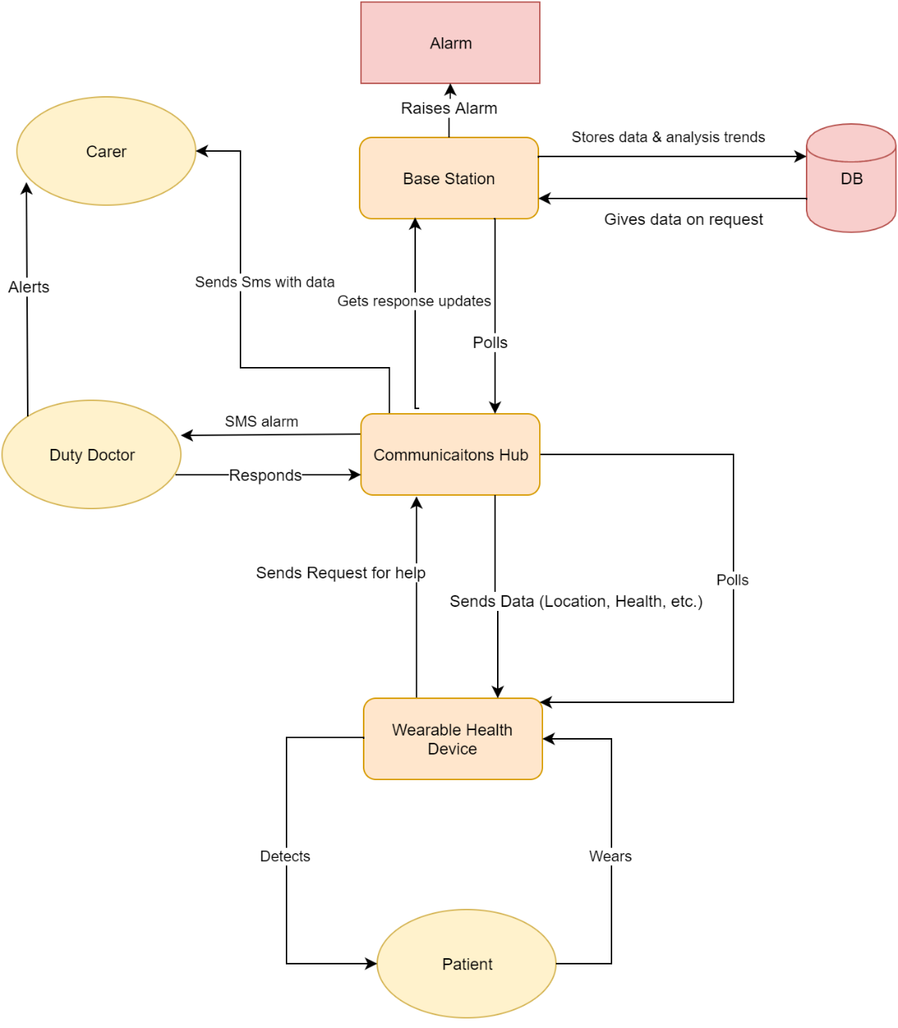

Figure 1: Overall conceptual architecture

The following diagram demonstrates the levels that exist in the architecture and where it sits. Working from outside inwards we see that the architecture sits in a location for example a hospital or health care facility. This affects how the architecture is formed to perform in the environment required. Users exist within the environment as well as other actors such as carers and doctors. The users interact with the hardware in the form of the Wearable health device, communication hub and base station (through User Interface) which acts upon the software architecture and its components. Communication is happening across all levels of the environment in terms of input/outputs and cause and effects. This communication could be for example the users interacting with the environment around them, or the Logic component signalling the doctors in an event. It is vital to understand the many level which exist and how they interact with each other.

This is our overall layered conceptual architecture.



Figure 2: Conceptual architecture as layers

# Execution Architecture

# Execution Architecture Diagram

The following architecture diagram shows our original design for our execution architecture. This execution architecture is represented as a set of components that each have communication paths built over message buses on a client-queue-server style architecture.



Figure 3: Execution architecture

The database interface is an example of a bus. Also the patient data would sit in a queue on the communication hub which feeds into the data analytics system. The wearable health devices and alarm device are examples of the clients; as are the user interfaces.

For the WHD, our initial execution architecture is to have many of these clients that can register to the communication hub queue via the WHD list and to update the status.

# Main Communication Paths and Data Types

| Component 1 | Component 2 | Direction | Data type | Communication path type |
| --- | --- | --- | --- | --- |
| Patient | WHD | From (component) 1 to (component) 2 | Analogue sensors | ADC |
| WHD | Communication hub | Bi-directional | Data packets over TCP/IP | Message consumer-producer queue |
| Alarm | Communication hub | From 2 to 1 | Analogue output | DAC |
| Carer | SMS | Bi-directional | Text | GSM |
| Doctor | SMS | Bi-directional | Text | GSM |
| Carer | Doctor | Bi-directional | Text, voice | GSM |
| User interface | Communications hub | Bi-directional | Objects |  |
| Communication hub | Data analytics | Bi-directional | Various objects | Bus (alternative is message queue) |
| Data analytics | DBMS (write module) | From 1 to 2 | Data packets over TCP/IP | Packet routing |
| Database management system (read module) | Database interface | From 2 to 1 | Data packets over TCP/IP | Packet routing |
| DBMS (read module) | User interface | From 1 to 2 | Data packets over TCP/IP | Packet routing |
| User interface | Data analytics | From 2 to 1 | Boolean |  |

Table 8: Architecture of data communication in the execution of the system

Our final execution architecture became our initial implementation architecture as shown in the following section.

# Implementation Architecture

# Initial Implementation Architecture

Figure 4 is our very first implementation architecture divided into physical components and within it are other software or hardware components. The diagram shows what a wearable device can do and how it maintains session in the server base station.

The SMS server (COTS) is responsible for sending real time data and alerts to carer and doctor. The base station operates data processing from the WHD and trend analytics. The base station software has algorithms (that includes COTS analytical libraries) set to analyse data, send logs to the database and sends alert to the officials if critical abnormal data is detected. This diagram has only one base station and one database. These are operating on a single server which is a risk for failure.

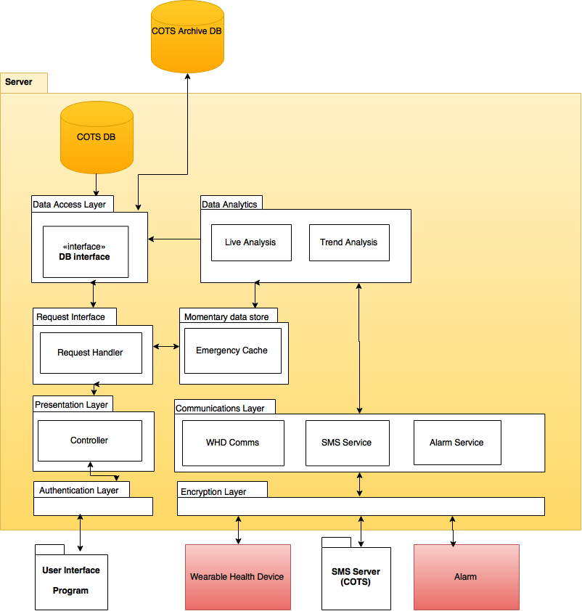

Figure 4: Initial implementation architecture

For security, authentication layer and encryption layer is added. For backup, an archival database outside the server (COTS) is created so that when the base station server fails and the server data is lost, we will still have data stored in an external backup database. User interface is pushed out of the server because every server shouldn’t be limited to one workstation (accessible by one computer). Any client computer within the campus should be able to access the server but the maintain security by having WPA2 password encryption. The data sent between external physical devices (WHD, SMS service, Alarm) and the server is continuous, and it can be manipulated by a third party if not encrypted, so the is a new layer called encryption layer uses hexadecimal encoding. Another new layer is added for faster alert system i.e. momentary data store, which stores critical data as cache and send the log to the official to take further actions. Data access layer sends and stores data in both internal and archive databases, also sends data when data request is made from the UI. This system still faces availability, security issues.

# Final Implementation Architecture

In the previous Implementation Architecture, if the server fails, then the session between WHD, SMS, Alarm, UI will fail and it won’t be able to store further logs, emergency alert, until the server is fixed and up and running again. Also one server handling all the work and storing all the logs are easily accessible and easily manipulated by third party, so it is a huge blow to the security and quality.

Now the system has local base systems as mini servers. There are multiple of them, this is because they become scalable; which means they will have the ability to accommodate more and more devices, and also become available when one base station fails. Now all the physical devices have to go through encryption and authentication, the WHD, SMS services will have a unique ID so that no other similar devices connect and manipulate the data or RSVPs. This ID automatically authenticates the WHD, and SMS users. All the services go through controller, which can forward back the SMS logs, WHD session to UI so that users can keep track of the data.

Self-diagnosing system is a new component added to the system, it keeps pinging, each system components and check if they are working properly in a synchronous way. We added a backup analytics system, it one analytics system overloads the other keep on giving the correct data.

Distributed file system is operating on external servers. It is keeping concurrently synchronised databases so that the alternative copies can act as redundant failovers. Local base station has its own local database. The base station maintains error logs.

/Users/vishaluniyal/Downloads/Implementation V2.png

Figure 5: Final implementation architecture

# Rationale

Kaizen Software Consultants have outlined below, the rationale behind our major architectural decisions.

|  |  |
| --- | --- |
| *Component/Subsystems* | *Rationale* |
| SMS Server | An external server that specializes in releasing SMS's that can be utilised as a COTS as this will reduce the working scope of development and reduce production cost, improving delivery time and budget. |
| Authentication+ Encryption | Authentication is implemented at the points of the system that has interaction with components or users outside of the base station to avoid the threat of hacking or unauthorized access of private data. These components work in the system to ensure that private data is safe and untampered with allowing improved data integrity for data mining and research. |
| UI | Having a UI associated with accessing the patient data for review, mainly used by the duty doctor to make assessments on patients health. Having a UI improves the Usability and improves interpretation time. A well designed UI will also improve the adoption rate by staff and industry if it can be seen to fill their requirements better. |
| Alarm | A COTS system that involves interfacing signals from the architecture to physical cues of an issue that has happened, predominately when no electronic response is received from the SMS alerts to doctors. |
| Self-Diagnosing Unit | A component implemented to check the running health of the system that will periodically check communication channels between layers and when a component goes offline or external server can't be reached it will trigger SMS alert or physical alarm to warn users to be alert. |
| Communication System | Communication components identified in the executional architecture have been coupled into a package that enable a coherent stream of data flowing in and out. Acting as a translator for incoming WHD info to be sent to analytics this improves performance as systems can have specific roles and operate them faster. |
| Data Analytics + Backup | A redundancy component is put in place to improve reliability and also availability in case there was ever updates to be done to the analytics components. Having this running in parallel means that if a component fails the system won’t be crippled and can continue to run while repairs are made. |
| Momentary Data Store | A small cache for data that has been flagged for doctor review as patient has exhibited abnormal symptoms. Having this store point closer to the UI improves performance for the doctors also enables a redundancy in case the local DB has a failure important data that signals possible health conditions has a second store point. |
| Request + Presentation | Components involved in the fetching and displaying of data to the User Interface. |
| Local DB | Having a short range of data (30 - 60 days based on patient requirements) held onsite that enable quicker querying of comparison data for the doctor and carers to make better decisions on. |
| Trend Analytics | Trend analytics exists off site on a server side opposed to live data analytics that happens at a local level. This reduces bandwidth of data sent, increased performance as it is located closure to the main data store where trends will be developed from. Can be accessed by researchers at a high centralized level. |
| Data Access + Store | Components that create cohesion in the system allowing single channel data flow between the data distribution centre and the requiring systems needing for the data. |
| DB Array | Having redundancy in the distributed database for improved reliability, availability and catching failure cases where each database will be able to replicate/backup from the other mirroring databases. |
| DB Archive | Archive exists to hold a backup of the databases as a further redundancy and backup of all historical data that can be distributed across multiple locations that can be expanded and scaled to the required size. |

Table 9: Rationale for the components of the system

# Evaluation

Kaizen have evaluated the proposed architecture by comparing the system to the objectives outlined in section 2.2

| Objective Evaluated | Description | Will it work? | Can it fail? |
| --- | --- | --- | --- |
| OBJ01 | Collect sensor data | Yes. WHD directly communicates with the base station which after moving through various layers, reaches the database where it is collected. | Possibly. WHD out of battery, damaged or faulty. |
| OBJ02 | Location | Yes. WHD sends location at pre-determined intervals. Base station receives and acts according to the data decipher component’s output. | Possibly. WHD out of battery, damaged or faulty. Packets lost in transmit. |
| OBJ03 | Deployment | Yes. System functionality is independent of deployment environment. | Possibly. Bandwidth interference in hospital or crowded frequency range. |
| OBJ04 | 10 Devices | Yes. WHD component in Communications Hub manages connected devices, polls and forwards their data with device ID appended so only data associated to that device ID will be associated to the wearer. | Shouldn’t. |
| OBJ05 | Carer/doctor communications | Yes. The SMS system is COTS and will be managed by SMS component in communication hub. If system is malfunctioning, self-diagnosing unit alerts all carers/doctors with SMS and put all staff on alert. | Yes. Network downtime, service provider fault, user phone battery is dead. |
| OBJ06 | Alarming (critical condition) | Yes. Within the communication layer, the alarm is directly triggered when critical data is received from WHD.  The momentary data store ensures if downtime occurs, alarm in cue until actioned.  Self-diagnosing unit will ping the alarm system to ensure it is online and ready to receive alarm requests. | Shouldn’t as there is built in redundancy with momentary data store and self-diagnosing unit. |
| OBJ07 | Alarm (health decline, unanswered SMS request) | Yes. SMS service has a dedicated timer checking for response. If timeout occurs, alarm is raised. | Possibly, if timer routine is somehow corrupted. |
| OBJ08 | Security | Yes. Authentication and encryption layers add security when input is received via various hardware and software interfaces | Yes, as we have not designed with security auditing in mind. |
| OBJ09 | Data Collection | Yes. Data store layer with 2 master DB interfaces and 3 slave instances ensuring data is not compromised.  Backup DB is COTS and will perform scheduled data dumps. | Possibly, if remote data centre is compromised. |
| OBJ10 | SLA 99.99% | Yes. Final architecture incorporates N+1 redundancy in distributed file system reducing load on base station and boosting system performance.  System components are cohesive and have minimal coupling paths reducing opportunity of failure or data corruption. | Yes. Unforeseen external factors (natural). Longer than usual maintenance takes place. |
| OBJ11 | Modular and scalable | Yes. Final architecture has grouped components into cohesive layers that interact with other layers only when required.  Scalability is achieved by adding extra base stations as needed (with up to 10 devices) which will talk to the remote redundant backend.  Modular approach reduces processing and improves maintainability and modifiability. | Possibly, if data centre becomes compromised. |

Table 10: Evaluating our architecture against the system objectives