**1. Display name of the patient who has requested A+ve Blood group.**

select p_fname,p_lname from patient p join request r on p.p_id=r.p_id where r_blood_group='A Positive';

**Output :**

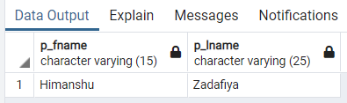

**2.Display blood stock of every available blood type.**

select blood_group,sum(blood_stock) from inventory group by blood_group;

**Output :**

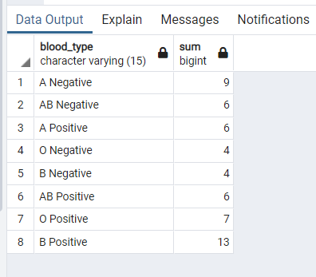

**3.Display the total no.of units requested for B-ve bldtype on date='2021-11-18'.**

select r_blood_amount from request where r_blood_group='B Negative' and r_date='2021-11-18'

**Output :**

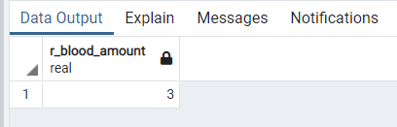

**4.Display the details of patient those who has requested for B-ve blood type.**

select p.p_id,p_fname,p_lname,p_age,p_gender,p_blood_group from patient p join request r on p.p_id=r.p_id where r_blood_group='B Negative'

**Output :**

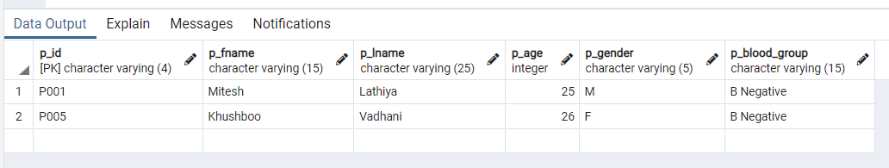

**5.Display the Name of the hospital who has requested highest unit of the blood.**

select h.h_name,sum(r_blood_amount) from hospital h join request r on h.h_id=r.h_id group by h.h_id order by h.h_name desc limit 1;

**Output :**

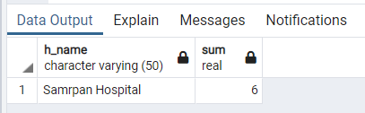

**6.Display Patient name who trasnactio id='tr02'.**

select p_fname,p_lname from patient p natural join payment p1 where p1.t_id='tr02'

**Output :**

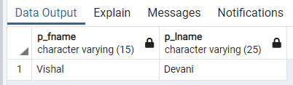

**7.Display the patient transaction details whose pay more then one time.**

select p_id,count(p_id) from payment group by p_id having count(p_id)>1;

**Output :**

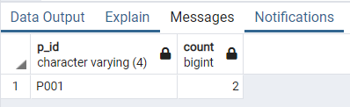

**8.Display the patient details and amount who pay more than one time.**

select p_fname,p_lname,p1.t_amount from patient p join payment p1 on p.p_id=p1.p_id where p.p_id in (select p_id from payment group by p_id having count(p_id)>1);

**Output :**

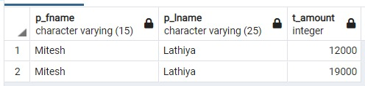

**9.Display the number of patient having disease='Diabetes'.**

select p_fname,p_lname from patient natural join patient_disease where p_disease='Diabetes'

**Output :**

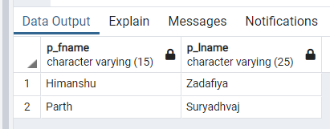

**10.Display the patient name who have more than one disease.**

select p_fname,p_lname from patient where p_id in (select p_id from patient_disease group by p_id having count(p_id)>1)

**Output :**

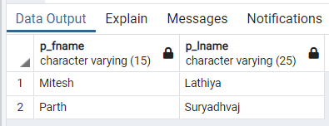

**11.Display the number of blood request in a given month(Octomber'2021).**

select sum(r_blood_amount) as blood_amount from request where EXTRACT(MONTH FROM r_date)=10;

**Output :**

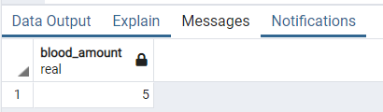

**12.Display all the camp organize in year=2021.**

select c_id,c_contact_no,c_location from camp where EXTRACT(YEAR FROM c_date)=2021;

**Output :**

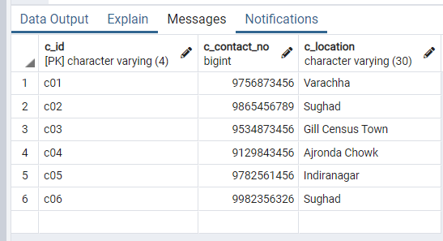

**13.Calculate Blood stock for each blood group.**

select blood_group,sum(blood_stock)as Total_blood_Stock from inventory group by blood_group;

**Output :**

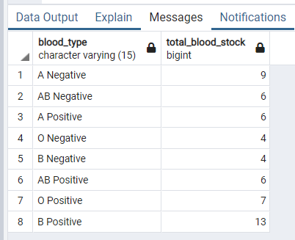

**14.Display the Details of Employee who work in camp on date=2021-11-18.**

select e_id,e_fname,e_lname from employee e join department d on e.dept_id=d.dept_id join camp c on d.dept_id=c.dept_id where c_date='2021-11-18';

**Output :**

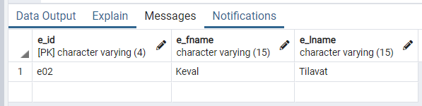

**15.Display number of units of O+ve blood group for every branch.**

select bb.bb_name,sum(i.blood_stock) as Total,'O Positive' as Blood_Group from inventory i join department d on i.dept_id=d.dept_id join blood_bank bb on d.bb_id=bb.bb_id where i.blood_group='O Positive' group by bb.bb_name

**Output :**

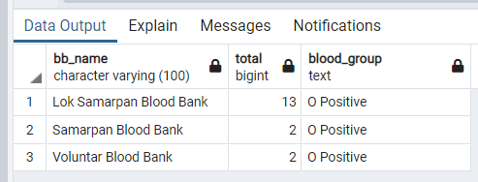

**16.Display the Employee Id working in Camp='c03'.**

select distinct e_id,e_fname,e_lname from employee e join department d on e.dept_id=d.dept_id join camp c on d.dept_id=c.dept_id where c.c_id='c03';

**Output :**

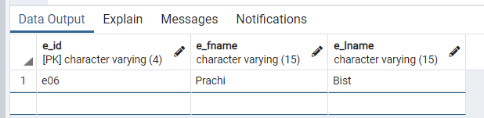

**17.Check the blood which is requested by patient is available or not in the inventory of the blood bank ='Voluntar Blood Bank'.**

select i.blood_group as InventoryBlood,i.blood_stock as InventoryStock,r.r_blood_group as PatientRequested,r.r_blood_amount as RequestBloodAmount,bb.bb_name as BloodBankName from inventory i join department d on i.dept_id=d.dept_id join blood_bank bb on d.bb_id=bb.bb_id join request r on bb.bb_id=r.bb_id join patient p on r.p_id=p.p_id where i.blood_group=r.r_blood_group and bb.bb_name='Voluntar Blood Bank';

**Output :**

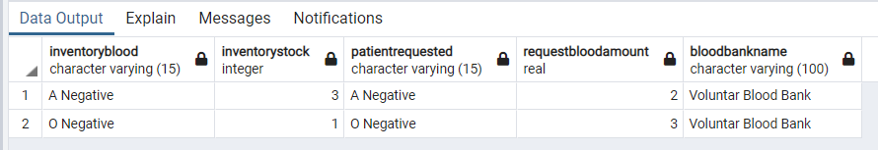

**18.Display the contact of the dononr whose blood type is A+ve.**

select d.d_id,d_contact_no from donor_contact d natural join donor d1 where d_blood_group='A Positive';

**Output :**

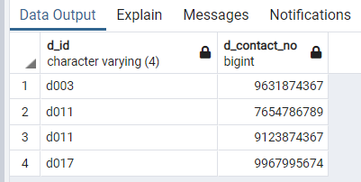

**19.Display the name and contact of the donor whose blood group match with patient requested blood group.**

select d.d_id , d_fname , d_lname , d1.d_contact_no , d.d_blood_group , p.p_id , p.p_fname , p.p_lname , p.p_blood_group from donor_contact d1 join donor d on d1.d_id=d.d_id join camp c on d.c_id=c.c_id join department dep on c.dept_id = dep.dept_id join blood_bank bb on dep.bb_id=bb.bb_id join request r on bb.bb_id=r.bb_id join patient p on r.p_id=p.p_id where d.d_blood_group=p.p_blood_group;

**Output :**

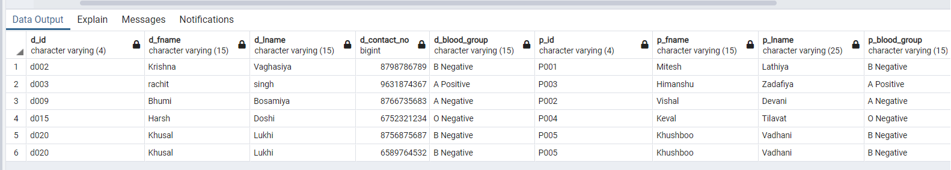

**20.List all the patients and donors associated with the any particular blood bank.**

(select p.p_id,p_fname,p_lname,bb_name from patient p join request r on p.p_id=r.p_id join blood_bank bb on r.bb_id=bb.bb_id where bb_name='Lok Samarpan Blood Bank')

union

(select d.d_id,d_fname,d_lname,bb_name from donor d join camp c on d.c_id=c.c_id join department d1 on c.dept_id=d1.dept_id join blood_bank bb on d1.bb_id=bb.bb_id where bb_name='Lok Samarpan Blood Bank')

**Output :**

