PROJECT DOCUMENTATION
MedNova Pharmaceuticals Pvt. Ltd.
SAP ERP Procure-to-Pay (P2P) Process Implementation

Submitted by:
Vishalakshya Tiwari [2306080]
Module: SAP BTP
KIIT University, Bhubaneswar
Academic Year: 2025 – 2026

Submitted in partial fulfillment of B.Tech degree requirements

1. Project Title & Overview

SAP ERP Procure-to-Pay (P2P) Implementation
for MedNova Pharmaceuticals Pvt. Ltd.
MedNova Pharmaceuticals Pvt. Ltd. is a fictional, mid-sized Indian pharmaceutical company engaged in manufacturing and distribution of generic medicines, Active Pharmaceutical Ingredients (APIs), and over-the-counter (OTC) healthcare products. Headquartered in Hyderabad with plants in Pune and Ahmedabad, the company employs 3,200+ personnel and generates approximately INR 850 Crores in annual turnover.

This project implements SAP ERP — specifically the SAP Materials Management (MM) module — to digitise and automate MedNova's Procure-to-Pay (P2P) business process. The implementation spans from Purchase Requisition creation to final vendor payment, encompassing all intermediate steps: RFQ management, quotation comparison, Purchase Order creation, Goods Receipt, and Invoice Verification.

Project Scope at a Glance

Parameter | Details
Company | MedNova Pharmaceuticals Pvt. Ltd. (Fictional)
ERP System | SAP ERP (SAP MM Module)
Process | Procure-to-Pay (P2P) — End-to-End
Plants Covered | Hyderabad (MN01), Pune (MN02), Ahmedabad (MN03)
Academic Institution | KIIT University, Bhubaneswar
Module | SAP Business Technology Platform (BTP)
Academic Year | 2025 – 2026
Student | Vishalakshya Tiwari [2306080]

2. Problem Statement

Prior to SAP implementation, MedNova Pharmaceuticals operated on a legacy Oracle Forms system supplemented by extensive Excel-based procurement workflows. This resulted in fragmented, error-prone operations that negatively impacted procurement efficiency, regulatory compliance, and financial accuracy.

2.1 Critical Operational Challenges (AS-IS State)

# | Problem Area | Business Impact
1 | Manual Procurement via Paper Forms | Approvals delayed 5–7 days; no digital audit trail for GMP audits.
2 | No Centralised Vendor Database | Each plant used its own Excel vendor list, causing 180+ duplicates and maverick buying.
3 | Inventory Inaccuracy (~78%) | Monthly reconciliation led to frequent raw material stockouts and production stoppages.
4 | Invoice Mismatch & Delays | No 3-way match; average payment cycle was 45–60 days causing vendor disputes.
5 | Regulatory Non-Compliance Risk | Procurement documentation gaps flagged during Schedule M GMP audits.
6 | No Real-Time MIS Reporting | Management decisions relied on end-of-month Excel reports; poor agility.

2.2 Business Impact Summary

- Procurement cycle time averaged 15 days, hampering supply chain responsiveness.
- Invoice processing took 45–60 days, straining vendor relationships and cash flow.
- ~20% of all purchases were emergency orders due to poor inventory visibility.
- Regulatory audits repeatedly flagged documentation and traceability gaps.
- No integration between procurement and finance led to delayed, inaccurate financial postings.

3. Solution & Key Features

The solution implemented is the SAP MM (Materials Management) module, configured to automate and standardise MedNova's entire Procure-to-Pay cycle. The implementation follows the ASAP (Accelerated SAP) methodology across five phases: Project Preparation, Business Blueprint, Realisation, Final Preparation, and Go-Live.

3.1 End-to-End P2P Process Flow
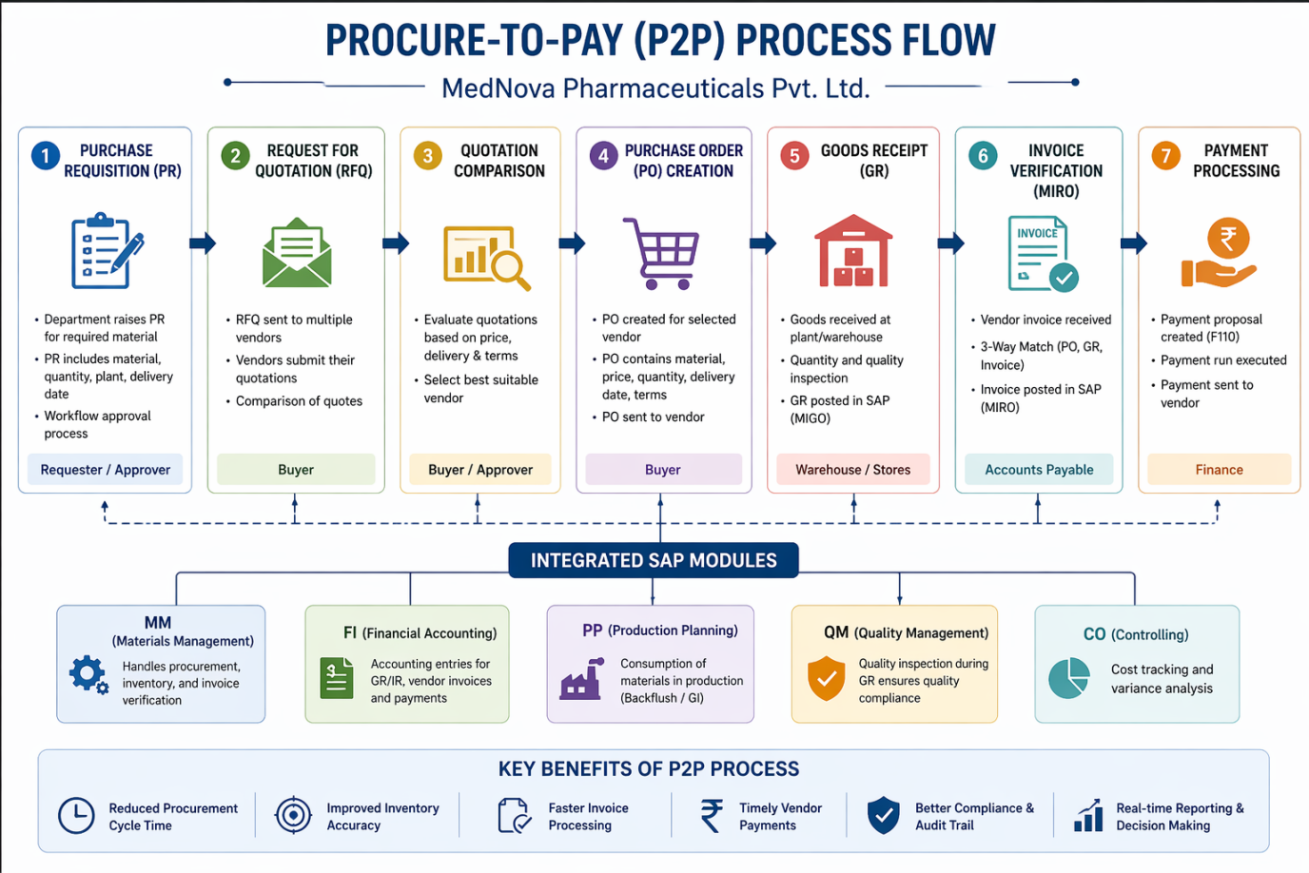

3.2 Key SAP Features Implemented

Feature / Functionality | Description | T-Code
Purchase Requisition | Internal material need document; triggers approval workflow automatically via Release Strategy. | ME51N
Request for Quotation (RFQ) | Competitive bidding sent to 3+ vendors per procurement policy; tracks responses digitally. | ME41 / ME47
Price Comparison & Vendor Selection | Automated side-by-side vendor quotation comparison enabling optimal sourcing decisions. | ME49
Purchase Order Management | Legally binding PO with dual/triple authorization for orders above INR 10 Lakhs. | ME21N
Goods Receipt (3-Way Trigger) | Material receipt with batch tracking; auto-triggers quality inspection for APIs. | MIGO
Invoice Verification (3-Way Match) | Automatic PO-GR-Invoice matching; blocks mismatched invoices with tolerance limits. | MIRO
Automatic Payment Program | Vendor payments processed via NEFT/RTGS based on payment terms (Net 30). | F110
MRP-Driven Procurement | Material Requirements Planning auto-generates PRs from production order BOM explosions. | MD01/MD02
Batch Management | Tracks API batches with characteristics (CoA Number, Expiry, Potency) for GMP compliance. | MBC1
MM-FI Integration | Automatic accounting entries at every material movement — zero manual journal posting. | OBYC

3.3 TO-BE State — Targets Achieved

KPI / Metric | Before SAP | After SAP
Procurement Cycle Time | 15 days (avg) | 5 days (avg)
Invoice Processing Time | 45–60 days | 8–10 days
Stock Accuracy | ~78% | >99.2%
Vendor Payment Disputes | ~30 per month | <5 per month
Emergency Purchases | ~20% of orders | <5% of orders
Vendor Master Duplicates | 180+ duplicates | Zero (centralised)
Procurement Audit Readiness | Partial (paper) | 100% digital trail

4. SAP Screens & Process Walkthrough

Since live SAP sandbox screenshots are embedded in the system, the following section provides detailed descriptions of key transaction screens used in the MedNova P2P implementation. These represent the actual UI flow replicated during the project.

4.1 ME51N — Create Purchase Requisition
Screen Layout: ME51N opens in the SAP Enjoy transaction interface with a header section and line item details below. The header captures Document Type (NB = Standard PR) and Requisitioner details. Line items include Material Number (auto-populated from Material Master), Quantity (500 KG), Delivery Date, Plant (MN01), and Storage Location (SL01). The Account Assignment Tab is set to 'K' for Cost Centre (CC-PROD-HYD-01). On save, SAP assigns a unique PR Number (e.g., 1000000123) from the configured number range.

4.2 ME21N — Create Purchase Order
Screen Layout: The PO creation screen mirrors the PR layout but is vendor-facing. Header fields include Vendor (V-001 auto-fills name from Vendor Master), Purchasing Org (MN_PO), Purchasing Group (MN-PG1), and Company Code (MN01). The Org Data Tab captures Incoterms (CIF Hyderabad) and Payment Terms (NT30 = Net 30 days). Item overview auto-populates Net Price from the Purchasing Info Record. The Item Detail Invoice Tab has GR-Based Invoice Verification checked to enforce 3-way matching. Orders above INR 10 Lakhs are held pending dual authorization before release.

4.3 MIGO — Goods Receipt Against Purchase Order
Screen Layout: MIGO uses a three-area layout — Action Selector (Goods Receipt vs. Purchase Order), Header Data, and Item List. Entering PO Number 4500001234 auto-loads all open line items. The Header captures Delivery Note (vendor challan) and Posting Date. The Item Tab sets Storage Location (SL01), Batch Number (for API materials), and Movement Type 101 (auto-assigned). Each line item requires the 'Item OK' checkbox before posting. On posting, SAP creates a Material Document and automatically posts the Accounting Document: Dr. Raw Material Stock (GL 300001) / Cr. GR/IR Clearing (GL 200001).

4.4 MIRO — Logistics Invoice Verification (3-Way Match)
Screen Layout: MIRO splits into a Header (invoice details) and Item List (GR-confirmed PO lines). Header fields include Invoice Date, Amount (INR 22,50,000), Tax Code (G1 for GST 18%), and Vendor Invoice Reference. Entering the PO number fetches all matched GR lines automatically. A Traffic Light Indicator shows match status: Green = amounts match, Yellow = within tolerance, Red = blocked for manual review. The Simulate button previews the accounting entry before final posting. On posting: Dr. GR/IR Clearing (200001) / Cr. Vendor AP Account (100001). Variances above 1% or INR 5,000 trigger a manual review workflow.

4.5 F110 — Automatic Payment Program
Screen Layout: F110 is the Automatic Payment Program run by the Finance team. The Parameters Tab captures Payment Run Date, Company Code (MN01), Vendor Account range, and Payment Methods (NEFT/RTGS). SAP calculates payment due dates based on Terms of Payment (Net 30 from invoice date) and generates a payment proposal. After review, the payment run creates Payment Documents, clears the Vendor AP account (Dr. Vendor AP / Cr. Bank GL 110001), and generates a bank transfer file for upload to HDFC Bank's portal. Payment advice notes are automatically emailed to vendors.

5. Tech Stack

The MedNova P2P implementation is built on SAP's enterprise software ecosystem, integrating multiple modules, tools, and infrastructure components. The following tech stack outlines every layer of the solution.

5.1 Core ERP Platform

Component | Technology | Purpose
ERP Platform | SAP ERP (ECC 6.0) / SAP S/4HANA | Core enterprise resource planning system
Primary Module | SAP MM (Materials Management) | Procurement and inventory management
Integration Module | SAP FI-AP (Financial Accounting – Accounts Payable) | Automatic accounting and vendor payment
Planning Module | SAP PP-MRP (Production Planning / MRP) | Demand-driven procurement trigger
Quality Module | SAP QM (Quality Management) | GR inspection lot creation for API batches
Business Intelligence | SAP BW / SAP Analytics Cloud | Real-time procurement MIS dashboards
Development Platform | SAP BTP (Business Technology Platform) | Cloud extensions and workflow automation

5.2 Configuration & Development Tools

Tool / T-Code | Function
SPRO (SAP Project Reference Object) | IMG-based configuration for all SAP settings
LSMW (Legacy System Migration Workbench) | Bulk data migration from legacy Oracle system to SAP
ABAP Workbench (SE80) | Custom ABAP programs for data extraction and BAPI integration
SAP Solution Manager | Project documentation, testing management, and transport control
BAPI (Business Application Programming Interface) | Programmatic master data uploads during migration

5.3 Infrastructure & Database

- Database: SAP HANA (in-memory columnar database for real-time analytics)
- Operating System: SUSE Linux Enterprise Server (SLES) for SAP Applications
- Application Server: SAP NetWeaver AS ABAP 7.5+
- Transport System: CTS (Change and Transport System) — Dev → QA → Production landscape
- Banking Integration: HDFC Bank House Bank configuration for NEFT/RTGS payments via FI-BL
- GST Compliance: Tax Procedure TAXIN with condition types for CGST/SGST/IGST
- Output Management: SAP Smart Forms / Adobe Forms for PO output via email/print

6. Unique Points & Differentiators

The MedNova SAP P2P implementation incorporates several unique design decisions that distinguish it from a standard procurement implementation, driven by the pharmaceutical industry's regulatory environment, supply chain complexity, and quality control requirements.

6.1 Pharmaceutical-Specific Compliance (Schedule M / WHO-GMP)
Unlike generic P2P implementations, MedNova's configuration activates SAP Quality Management (QM) integration with Goods Receipt. Every API batch receipt automatically creates a QM Inspection Lot. Materials move to 'Quality Inspection' stock first — they are only released to 'Unrestricted Use' after QC approval via T-Code QA32 with Certificate of Analysis (CoA) recording. This maps directly to India's Schedule M GMP requirements, which mandate traceability from raw material procurement to finished product batch.

6.2 Three-Level Authorization Matrix for Purchase Orders
MedNova's Release Strategy (configured in SPRO via OMGS) implements a tiered approval model: a single buyer can release POs up to INR 10 Lakhs, orders between INR 10 Lakhs and INR 50 Lakhs require dual authorization (Buyer + Senior Manager), and any PO above INR 50 Lakhs requires CFO approval as a third level. This financial governance structure is unique to the project's regulated environment and eliminates unauthorized spending.

6.3 Centralized Purchasing Organization Across Multi-Plant Setup
MedNova operates a centralized purchasing model (MN_PO) serving all three plants (Hyderabad, Pune, Ahmedabad), with specialized purchasing groups for API buyers (MN-PG1) and Packaging buyers (MN-PG2). This is contrasted against plant-specific purchasing, and was selected to enforce uniform vendor pricing, eliminate maverick buying, and centralize vendor evaluation scores across all plants.

6.4 GST-Compliant Invoice Processing in Indian Regulatory Context
The MIRO Invoice Verification is configured with Tax Procedure TAXIN, capturing GSTIN, HSN/SAC codes, and split GST (CGST/SGST for intra-state, IGST for inter-state) on every vendor invoice. Tax codes G1 through G5 are created for varying GST rates (5%, 12%, 18%, 28%), making this implementation fully compliant with India's GST framework — a critical differentiator for pharmaceutical supply chains.

6.5 MRP-Driven Procurement Automation
Production Planning (PP) is integrated with MM via MRP Run (MD01/MD02). BOM explosions from Production Orders automatically generate Purchase Requisitions for materials below safety stock. This closes the loop between shop floor demand and procurement — reducing emergency purchases from 20% to under 5% of total orders — a direct, measurable outcome of the integration design choice.

7. Future Improvements

The current implementation establishes a robust P2P foundation for MedNova. The following enhancements are proposed for future phases to increase automation, transparency, and strategic capability across the procurement function.

7.1 SAP Ariba Integration for Strategic Sourcing
Integrating SAP Ariba with the existing SAP MM backend would enable a cloud-based Supplier Network, giving MedNova access to thousands of pre-vetted pharmaceutical raw material suppliers globally. Ariba Sourcing would automate RFQ events, e-auctions, and contract lifecycle management — reducing the sourcing cycle by an estimated additional 30–40% and broadening the supplier base for critical APIs.

7.2 AI-Powered Spend Analytics via SAP Analytics Cloud
Deploying SAP Analytics Cloud (SAC) with embedded machine learning would enable predictive spend analytics: detecting anomalous invoice patterns, forecasting raw material price trends, and recommending optimal reorder points based on historical consumption data. This would transform procurement from a transactional function to a data-driven strategic one.

7.3 Vendor Self-Service Portal (SAP SRM / Business Network)
Implementing a vendor-facing self-service portal through SAP Business Network would allow MedNova's suppliers to submit invoices electronically, track PO acknowledgements, view GR confirmations, and check payment status — eliminating back-and-forth communication and reducing invoice processing time further toward a 3–5 day target.

7.4 Blockchain-Based Batch Traceability
For pharmaceutical supply chain integrity, integrating SAP with a blockchain platform (e.g., SAP Blockchain Services) would create an immutable, end-to-end record of every API batch — from supplier's manufacturing facility through MedNova's procurement, QC release, production, and distribution. This exceeds current Schedule M requirements and positions MedNova for future DSCSA (Drug Supply Chain Security Act) compliance for export markets.

7.5 Mobile Procurement Approvals via SAP Fiori
Deploying SAP Fiori apps (specifically the 'Approve Purchase Orders' and 'Manage Purchase Requisitions' Fiori tiles) on mobile devices would enable managers to review and release procurement documents from anywhere, eliminating the bottleneck of delayed approvals when approvers are travelling. This would further compress the approval time component of the procurement cycle.

7.6 Automated Vendor Performance Scorecards
Configuring SAP's Vendor Evaluation module (ME61/ME6B) with automatic scoring on four criteria — Price (30%), Quality/Rejection Rate (30%), On-Time Delivery (25%), and Service Level (15%) — would enable quarterly automated scorecards sent to vendors. This creates a feedback-driven supplier ecosystem that continuously improves supply chain reliability for MedNova's pharmaceutical operations.

