TASK 1
BASIC NETWORK SNIFFER
CodeAlpha Cyber Security Internship
Submitted By
Pyla Vishalatha

Objective
The objective of this project is to develop a Basic Network Sniffer using Python. The program captures and analyzes network packets traveling through a network and displays important information such as source IP address, destination IP address, and protocol type. This project helps in understanding network communication and packet analysis.

Tools and Technologies Used
- Python 3.14.2
- Scapy Library
- Windows Operating System
- Visual Studio Code / Notepad

Methodology
- Installed Python and the Scapy library.
- Developed a Python script to capture network packets.
- Used the Scapy sniff() function to monitor network traffic.
- Extracted packet details including:
  - Source IP Address
  - Destination IP Address
  - Protocol Information
- Displayed the captured information on the console.
- Tested the program by generating network traffic through web browsing.

Python Code
from scapy.all import sniff
from scapy.layers.inet import IP

def packet_callback(packet):
if packet.haslayer(IP):
print("=" * 50)
print(f"Source IP : {packet[IP].src}")
print(f"Destination IP : {packet[IP].dst}")
print(f"Protocol : {packet[IP].proto}")

sniff(prn=packet_callback, count=10)

Results
The network sniffer successfully captured live network packets and displayed:
- Source IP Address
- Destination IP Address
- Protocol Type (TCP/UDP)
- Network communication details
The program was able to monitor and analyze packet information generated by the system and internet traffic.
CODE: 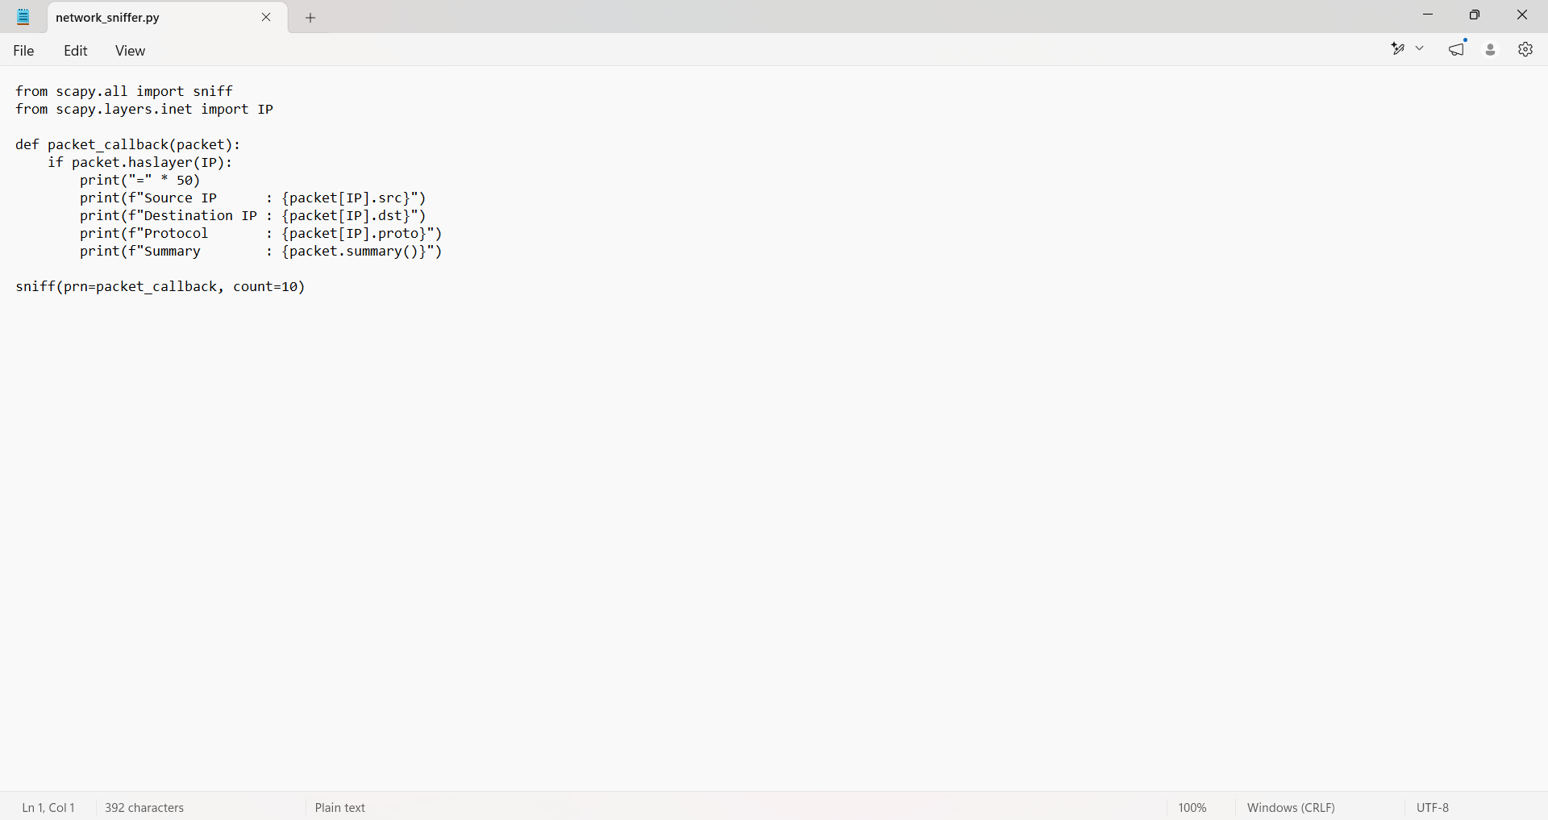

OUTPUT:
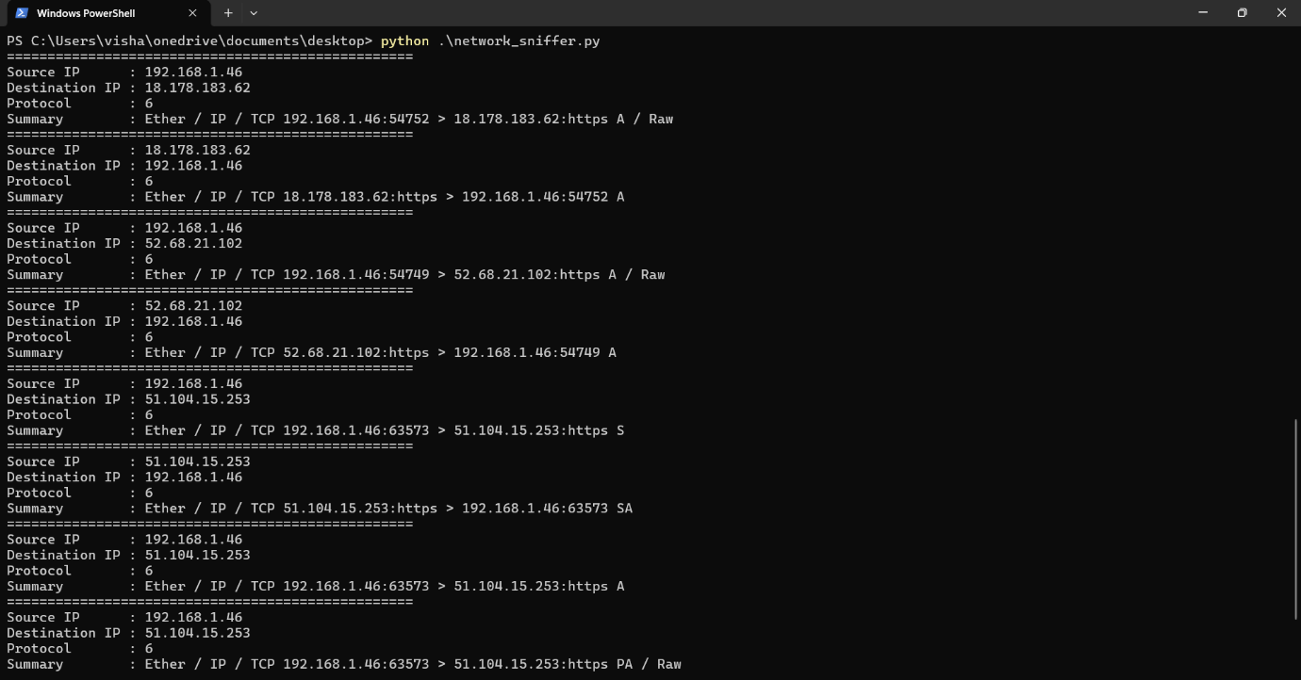

Conclusion
The Basic Network Sniffer was successfully implemented using Python and the Scapy library. The project provided practical experience in packet capturing, network monitoring, and protocol analysis. This project enhanced understanding of how data travels across networks and how packet analysis can be used in cybersecurity.

Outcome
The project successfully met the objectives of capturing and analyzing network packets and displaying key packet information. The implementation demonstrated the basic concepts of network traffic monitoring and packet inspection.

