**SMART GARBAGE MONITORING SYSTEM**

**Project Report**

**Submitted for the course: INTERNET OF THINGS (CSE3009)**

**By**

**(Name of students with reg. number)**

|  |  |
| --- | --- |
| **VISHAL BHASKAR** | **15BCE0048** |

**Name of faculty: Prof. ANAND M.**

**(SCOPE)**



**Contents**

1 Abstract 3

2 Literature survey 4

3 Proposed architecture/Methodology 6

4 Innovative idea in your project 7

5 Circuit diagram/Arudino Layout 9

6 Sample code of the project 10

7 Snapshots of the project 15

8 Conclusion and future work 17

9 References 17

**1 Abstract**

This project, IOT Garbage Monitoring system is a very innovative system which will help to keep the cities clean. This system monitors the garbage bins and informs about the level of garbage collected in the garbage bins and sends a notification if the garbage level is higher than a particular set value. For this, the system uses ultrasonic sensors which are placed over the garbage bins to detect the garbage level and compare it with the garbage bins depth. The system makes use of microcontroller, ultrasonic sensor, GSM module for sending data and LEDs. The system is powered by a 12V transformer. If the garbage level exceeds a certain amount, the device notifies the garbage collector to clean up the garbage bin. Thus, helping us to keep the city clean.

**2 Literature Survey**

Some of the following garbage type Packaging waste, Agricultural waste, Inorganic waste, Liquid waste etc. In solid waste bin monitoring system garbage bin set the public place then Camera set for garbage bin location. The camera captured image for garbage bin. Radio Frequency Identification (RFID), GPS and GIS send image for work station. The RFID reader and camera are mounted in the truck, when truck comes closer to the bin RFID reader communicated RFID tag. & send all information.

The waste management is built around several elements. Waste item, domestic bin, trash bags, collective containers and collecting vehicles. The waste flow starts from the waste item and the domestic bin to end in the collecting vehicles. Use the waste identification for sorting process.

The several models available for the garbage monitoring systems. Generally, they just show the amount of garbage which is filled in the bin and they give the percentage of the garbage content in the bin. The previous models lack any innovation and just simply showed up a warning when the garbage bin about to be filled completely.

**2.1 Details about the parts used**

**2.1.1 Ultrasonic sensors**

Ultrasonic sensors “are based on the measurement of the properties of acoustic waves with frequencies above the human audible range,” often at roughly 40 kHz. They typically operate by generating a high-frequency pulse of sound, and then receiving and evaluating the properties of the echo pulse.

The main advantage of ultrasonic sensors is that measurements may be made without touching or otherwise impeding the target. In addition, depending on the distance measured, measurement is relatively quick (it takes roughly 6ms for sound to travel 1m). However, many factors such as temperature, angle, and material may affect measurements.

**2.1.2 GSM module**

GSM/GPRS module is used to establish communication between a computer and a GSM-GPRS system. Global System for Mobile communication (GSM) is an architecture used for mobile communication in most of the countries. Global Packet Radio Service (GPRS) is an extension of GSM that enables higher data transmission rate. GSM/GPRS module consists of a GSM/GPRS modem assembled together with power supply circuit and communication interfaces (like RS-232, USB, etc) for computer.

**2.1.3 Arduino**

Arduino is an open-source platform used for building electronics projects. Arduino consists of both a physical programmable circuit board (often referred to as a microcontroller) and a piece of software, or IDE (Integrated Development Environment) that runs on your computer, used to write and upload computer code to the physical board. The Arduino hardware and software was designed for artists, designers, hobbyists, hackers, newbies, and anyone interested in creating interactive objects or environments. Arduino can interact with buttons, LEDs, motors, speakers, GPS units, cameras, the internet, and even your smart-phone or your TV! This flexibility combined with the fact that the Arduino software is free, the hardware boards are pretty cheap, and both the software and hardware are easy to learn has led to a large community of users who have contributed code and released instructions for a huge variety of Arduino-based projects.

**2.1.4 LED**

A light-emitting diode (LED) is a two-lead semiconductor light source. It is a p–n junction diode that emits light when activated. When a suitable voltage is applied to the leads, electrons are able to recombine with electron holes within the device, releasing energy in the form of photons. The color of the light (corresponding to the energy of the photon) is determined by the energy band gap of the semiconductor. LEDs are typically small (less than 1 mm2 ) and integrated optical components may be used to shape the radiation pattern.

**3 Methodology**

Our product consists of an Arduino board, two ultrasonic sensors, 6 LEDs consisting of 2 red, 2 yellow, 2 green LEDs, a GSM module. We place the ultrasonic sensor in the lid of the garbage bin to measure the distance. Then we program our Arduino board to act according to the height detected by the ultrasonic sensor. We are placing 3 LEDs consisting of red, yellow and green color at our garbage bins. It will show the amount of garbage in the bin from outside. If the amount of garbage is low, the green LED will glow, if the garbage bin has a moderate amount of garbage that is around half filled, the yellow LED will glow and if the garbage bin is full, the red LED will glow showing that the garbage bin is completely filled and we need to empty the garbage bin. And if the red LED glows that is the garbage bin is full, our system sends a message to the garbage collector that the following garbage bin is completely filled and he needs to empty it soon. We are now placing 2 Ultrasonic sensors at two different garbage bins to show the working of the product. Each of them will have separate LEDs to show the amount of garbage from outside.

**4 Innovative idea in the project:**

In this project, not only like all other garbage monitoring systems, it will warn the garbage collector when the bin is full but also it will give the shortest path to the location where the garbage bin is located. So that the garbage collector can easily find where the garbage bin is located. He will be given a shortest route consisting of different points in the locality to the destination that is where the garbage bin is full now.

For calculating the shortest path, we are using Dijkstra’s algorithm. It is an algorithm to find the shortest path between the various vertices of the graph, it not only gives the total cost to reach that vertex but also gives the path which will be followed to get the minimum cost possible. First of all the distance between two vertices are set as infinite. Then the distance is calculated between the two nodes and it replaces the existing value of distance if it is shorter than the existing distance. The same process is repeated for each and every node and hence the shortest path is calculated between the source and destination.

In our project first of all the weight between all the nodes are set as 99. Then we are changing the weight between the two nodes which are connected to each other as the weight of them. Then the source is set as the starting place of the garbage collector, here we have set it as “Main Gate”. As no garbage bin is full in the start, the destination is set the same as the source. When in some garbage bin, the height of garbage exceeds a certain limit, the red LED glows and the destination is set as the location of the garbage bin which is full now. Then the Dijkstra’s algorithm is run between the source and the destination and the shortest path is calculated. This shortest path is now sent to the garbage collector via SMS on his mobile. So now even if he is new in the city, he can rush to the place in no time as he has the shortest path.

This project doesn’t needs any internet connection, so it is very beneficial as all the garbage collectors don’t have a internet connection. They will get the path to the garbage bin as a text message on their phone directly. So the issue of internet connectivity is also solved by this project.

Diagram of path taken as input:

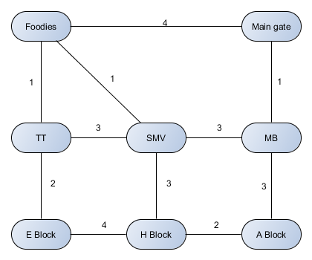

**5 Circuit Diagram/ Arduino layout**

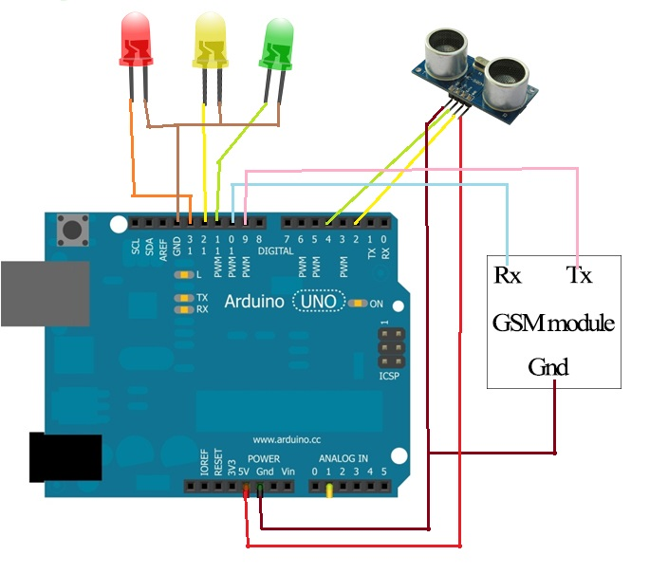

**6 Sample code of project**

#include <SoftwareSerial.h>

#include <string.h>

SoftwareSerial mySerial(9, 10);

const int trigPin1 = 2;

const int echoPin1 = 4;

const int trigPin2 = 3;

const int echoPin2 = 5;

int ledr1=13,ledy1=12,ledg1=11,ledr2=7,ledy2=6,ledg2=8;

int IN=99,N=9;

void setup() {

mySerial.begin(9600);

Serial.begin(9600);

pinMode(ledr1,OUTPUT);

pinMode(ledy1,OUTPUT);

pinMode(ledg1,OUTPUT);

pinMode(ledr2,OUTPUT);

pinMode(ledy2,OUTPUT);

pinMode(ledg2,OUTPUT);

delay(100);

}

void dijsktra(int cost[9][9],int source,int target)

{

int dist[N],prev[N],selected[N]={0},i,m,min1,start,d,j,a,target1,x=0;

char path[N],path1[50],path2[50];

target1=target;

for(i=1;i< N;i++)

{

dist[i] = IN;

prev[i] = -1;

}

start = source;

selected[start]=1;

dist[start] = 0;

while(selected[target] ==0)

{

min1 = IN;

m = 0;

for(i=1;i< N;i++)

{

d = dist[start] +cost[start][i];

if(d< dist[i]&&selected[i]==0)

{

dist[i] = d;

prev[i] = start;

}

if(min1>dist[i] && selected[i]==0)

{

min1 = dist[i];

m = i;

}

}

start = m;

selected[start] = 1;

}

start = target;

j = 0;

while(start != -1)

{

path[j++] = start+64;

start = prev[start];

}

path[j]='\0';

strrev(path);

printf("\n");

strcpy(path1,"main-gate");

for(i=1;i<strlen(path);i++)

{

/*if (path[i]=='A')

Serial.print(" main gate");*/

if(path[i]=='B')

strcat(path1,"--->MB");

else if(path[i]=='C')

strcat(path1,"--->SMV");

else if(path[i]=='D')

strcat(path1,"--->TT");

else if(path[i]=='E')

strcat(path1,"--->FOODIES");

else if(path[i]=='F')

strcat(path1,"--->E-BLOCK");

else if(path[i]=='G')

strcat(path1,"--->H-BLOCK");

else if(path[i]=='H')

strcat(path1,"--->A-BLOCK");

}

Serial.print(path1);

if(target1>1 && x<2)

{

SendMessage(path1);

x=x+1;

}

}

void loop()

{

int target=1,x1=0;

long duration1, cm1;

pinMode(trigPin1, OUTPUT);

digitalWrite(trigPin1, LOW);

delayMicroseconds(2);

digitalWrite(trigPin1, HIGH);

delayMicroseconds(10);

digitalWrite(trigPin1, LOW);

pinMode(echoPin1, INPUT);

duration1 = pulseIn(echoPin1, HIGH);

cm1 = microsecondsToCentimeters(duration1);

long duration2, cm2;

pinMode(trigPin2, OUTPUT);

digitalWrite(trigPin2, LOW);

delayMicroseconds(2);

digitalWrite(trigPin2, HIGH);

delayMicroseconds(10);

digitalWrite(trigPin2, LOW);

pinMode(echoPin2, INPUT);

duration2 = pulseIn(echoPin2, HIGH);

cm2 = microsecondsToCentimeters(duration2);

delay(100);

Serial.println("");

if(cm1>50)

{

digitalWrite(ledr1,LOW);

digitalWrite(ledy1,LOW);

digitalWrite(ledg1,HIGH);

}

else if(cm1>10 && cm1<50)

{

digitalWrite(ledr1,LOW);

digitalWrite(ledg1,LOW);

digitalWrite(ledy1,HIGH);

}

else

{

digitalWrite(ledy1,LOW);

digitalWrite(ledg1,LOW);

digitalWrite(ledr1,HIGH);

target=8;

}

if(cm2>50)

{

digitalWrite(ledr2,LOW);

digitalWrite(ledy2,LOW);

digitalWrite(ledg2,HIGH);

}

else if(cm2>10 && cm2<50)

{

digitalWrite(ledr2,LOW);

digitalWrite(ledg2,LOW);

digitalWrite(ledy2,HIGH);

}

else

{

digitalWrite(ledy2,LOW);

digitalWrite(ledg2,LOW);

digitalWrite(ledr2,HIGH);

target=6;

}

int cost[9][9],i,j,w,ch,co;

int source=1,x,y;

for(i=1;i< N;i++)

{for(j=1;j< N;j++)

{cost[i][j] = IN;}}

cost[1][2]=cost[2][1]=1;

cost[1][5]=cost[5][1]=4;

cost[2][3]=cost[3][2]=3;

cost[2][8]=cost[8][2]=3;

cost[3][4]=cost[4][3]=3;

cost[3][5]=cost[5][3]=1;

cost[3][7]=cost[7][3]=3;

cost[4][5]=cost[5][4]=1;

cost[4][6]=cost[6][4]=2;

cost[6][7]=cost[7][6]=4;

cost[7][8]=cost[8][7]=2;

dijsktra(cost,source,target);}

long microsecondsToCentimeters(long microseconds)

{return microseconds/29/2;}

void SendMessage(char path[50])

{ mySerial.println("AT+CMGF=1");

delay(1000);

mySerial.println("AT+CMGS=\"+919939581716\"\r");

delay(1000);

mySerial.println(path);

delay(100);

mySerial.println((char)26);

delay(1000);

}

**7 Snapshots of project**

When both the garbage bins are empty. Both showing green light.

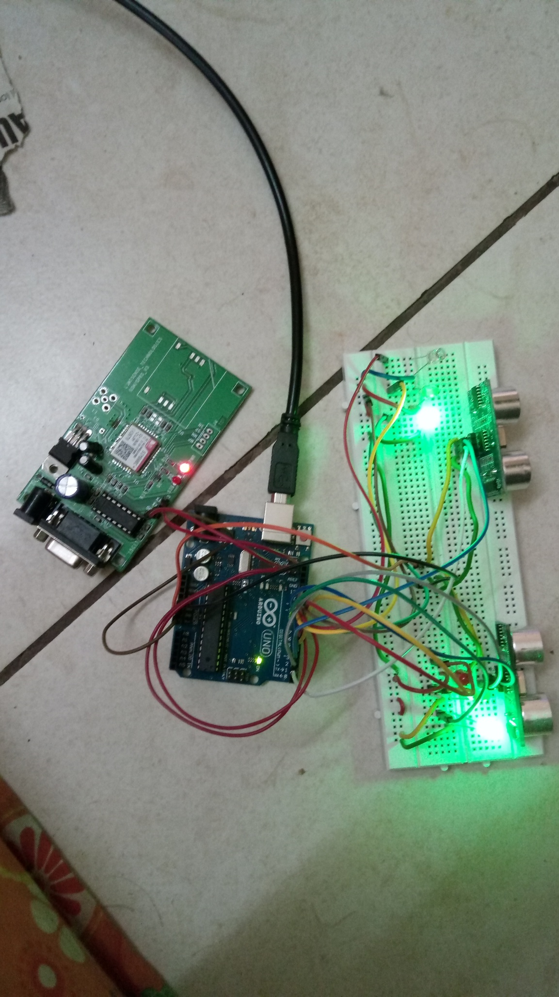

When one of the garbage bins gets full:

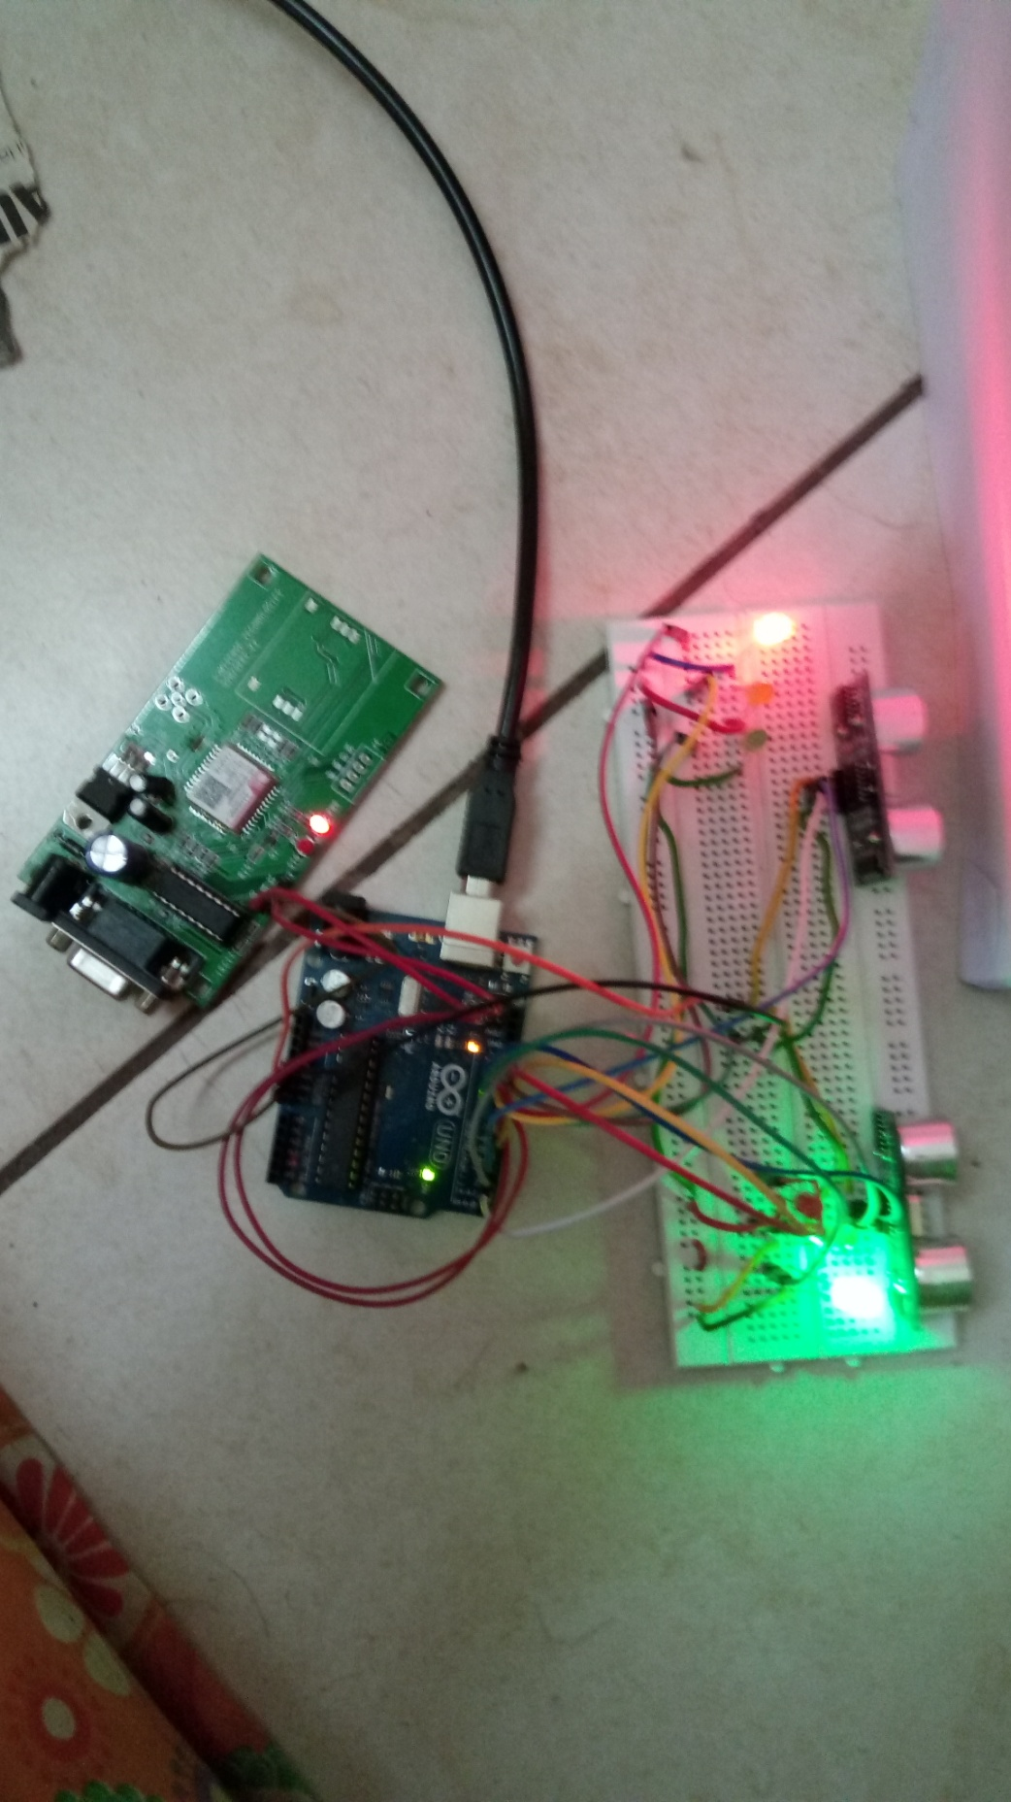

Text message received by the garbage collector:

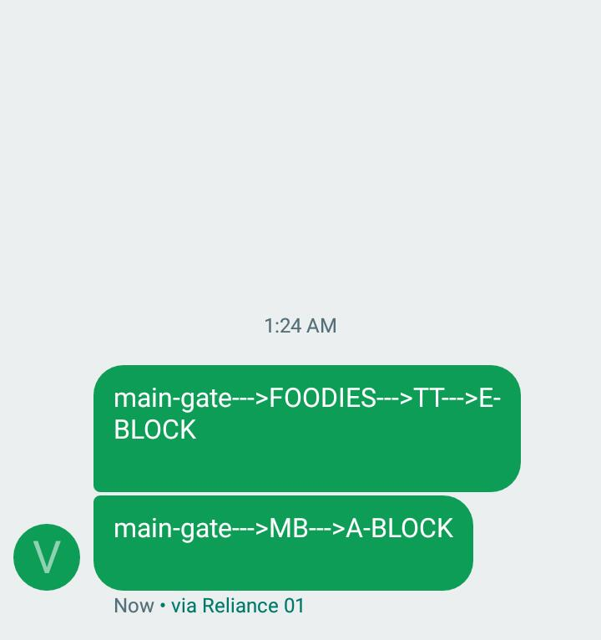

**8 Conclusions and future work**

Thus in this project, we not only successfully monitored the level of the garbage in the garbage bin but also sent a SMS alerting the garbage collector to inform him that the garbage bin at the given location is filled up completely and also gave him the shortest path to reach that place so that he can work more efficiently now. This project will increase the productivity of city cleanliness maintaining corporations. And thus help the city to be clean and green.

**9 References**   
[1] [www.wenglor.com](http://www.wenglor.com)

[2] <https://www.arduino.cc/>

[3] <http://ijireeice.com>

[4] en.wikipedia.org