Name: Vishal R.

Super set ID: 6413500

**Scenario – 1:**

BEGIN

    EXECUTE IMMEDIATE 'DROP TABLE CUSTOMERS';

EXCEPTION

    WHEN OTHERS THEN NULL;

END;

/

CREATE TABLE CUSTOMERS (

    CUSTOMER_ID     NUMBER PRIMARY KEY,

    NAME            VARCHAR2(100),

    DOB             DATE,

    LOAN_INTEREST   NUMBER(5,2)

);

INSERT INTO CUSTOMERS VALUES (1, 'John Smith', TO_DATE('1950-03-10', 'YYYY-MM-DD'), 8.50);

INSERT INTO CUSTOMERS VALUES (2, 'Alice Johnson', TO_DATE('1980-07-15', 'YYYY-MM-DD'), 7.75);

INSERT INTO CUSTOMERS VALUES (3, 'Robert Lee', TO_DATE('1945-12-01', 'YYYY-MM-DD'), 9.00);

COMMIT;

SET SERVEROUTPUT ON;

BEGIN

    FOR cust_rec IN (

        SELECT CUSTOMER_ID, DOB, LOAN_INTEREST

        FROM CUSTOMERS

    )

    LOOP

        DECLARE

            v_age NUMBER;

        BEGIN

            v_age := TRUNC(MONTHS_BETWEEN(SYSDATE, cust_rec.DOB) / 12);

            IF v_age > 60 THEN

                UPDATE CUSTOMERS

                SET LOAN_INTEREST = cust_rec.LOAN_INTEREST - 1

                WHERE CUSTOMER_ID = cust_rec.CUSTOMER_ID;

                DBMS_OUTPUT.PUT_LINE('Discount applied to Customer ID: ' || cust_rec.CUSTOMER_ID);

            END IF;

        END;

    END LOOP;

    COMMIT;

END;

/

OUTPUT:

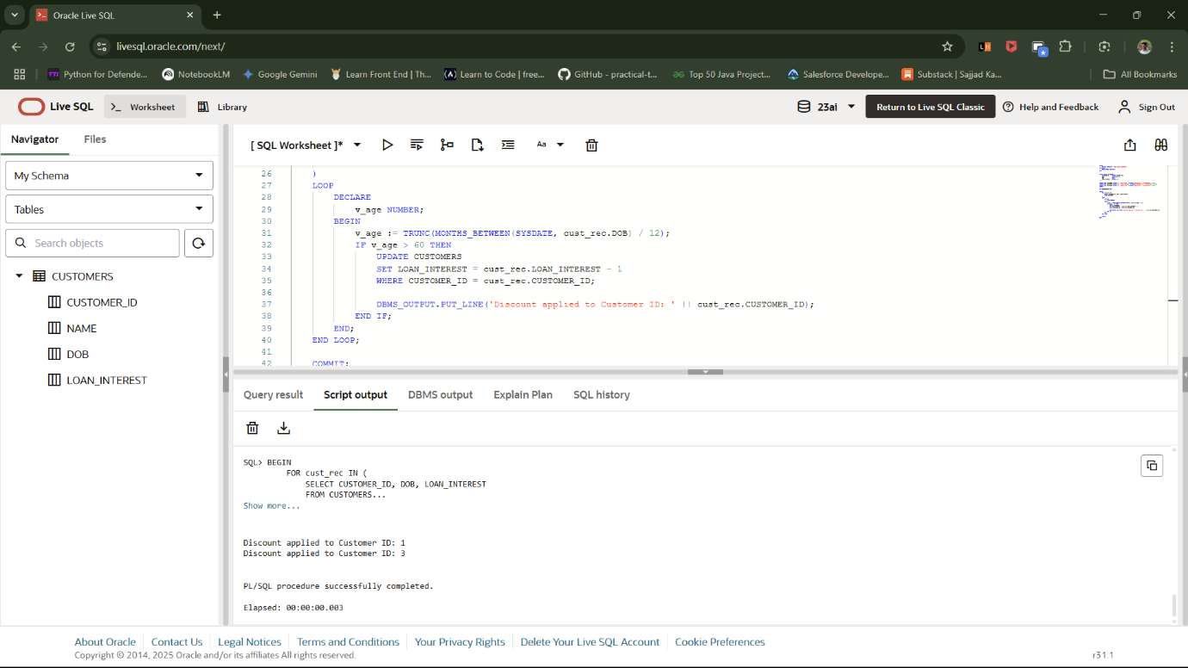

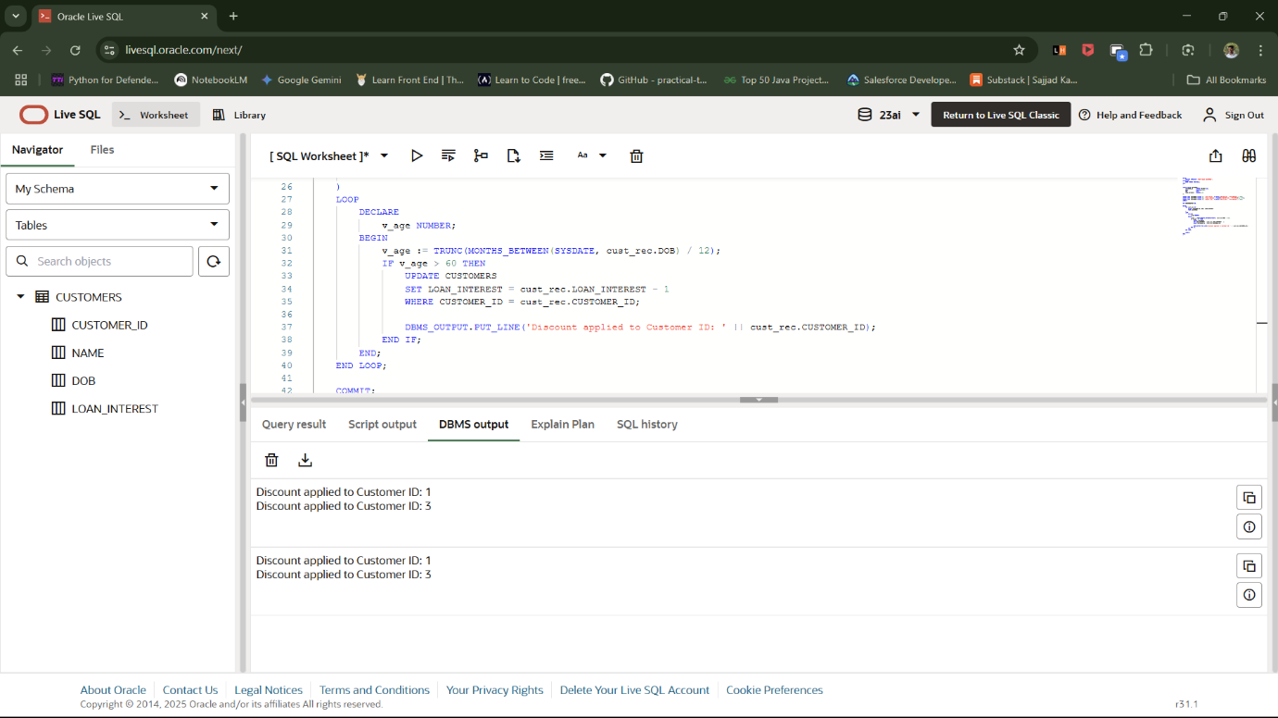

**Scenario – 2:**

SET SERVEROUTPUT ON;

CREATE TABLE CUSTOMERS (

    CUSTOMER_ID   NUMBER PRIMARY KEY,

    NAME          VARCHAR2(100),

    BALANCE       NUMBER(12,2),

    ISVIP         CHAR(1) DEFAULT 'N'

);

BEGIN

    EXECUTE IMMEDIATE 'DROP TABLE CUSTOMERS';

EXCEPTION

    WHEN OTHERS THEN

        IF SQLCODE != -942 THEN

            RAISE;

        END IF;

END;

/

BEGIN

    INSERT INTO CUSTOMERS VALUES (1, 'John Smith', 8500.00, 'N');

    INSERT INTO CUSTOMERS VALUES (2, 'Alice Johnson', 12500.00, 'N');

    INSERT INTO CUSTOMERS VALUES (3, 'Robert Lee', 20000.00, 'N');

    INSERT INTO CUSTOMERS VALUES (4, 'Emily Clark', 9900.00, 'N');

    COMMIT;

END;

/

BEGIN

    FOR cust_rec IN (

        SELECT CUSTOMER_ID, BALANCE

        FROM CUSTOMERS

    )

    LOOP

        IF cust_rec.BALANCE > 10000 THEN

            UPDATE CUSTOMERS

            SET ISVIP = 'Y'

            WHERE CUSTOMER_ID = cust_rec.CUSTOMER_ID;

            DBMS_OUTPUT.PUT_LINE('Promoted to VIP: Customer ID = ' || cust_rec.CUSTOMER_ID);

        END IF;

    END LOOP;

    COMMIT;

END;

/

BEGIN

    FOR rec IN (SELECT * FROM CUSTOMERS) LOOP

        DBMS_OUTPUT.PUT_LINE('ID: ' || rec.CUSTOMER_ID || ', Name: ' || rec.NAME || ', Balance: ' || rec.BALANCE || ', VIP: ' || rec.ISVIP);

    END LOOP;

END;

/

OUTPUT:

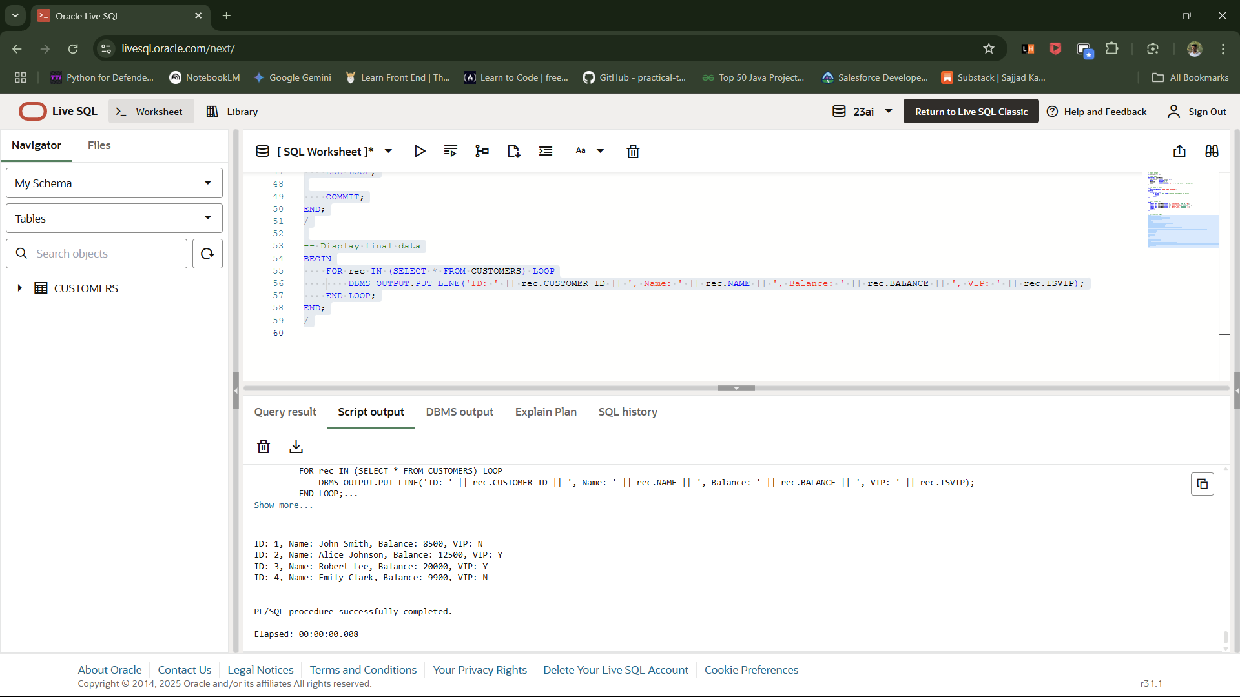

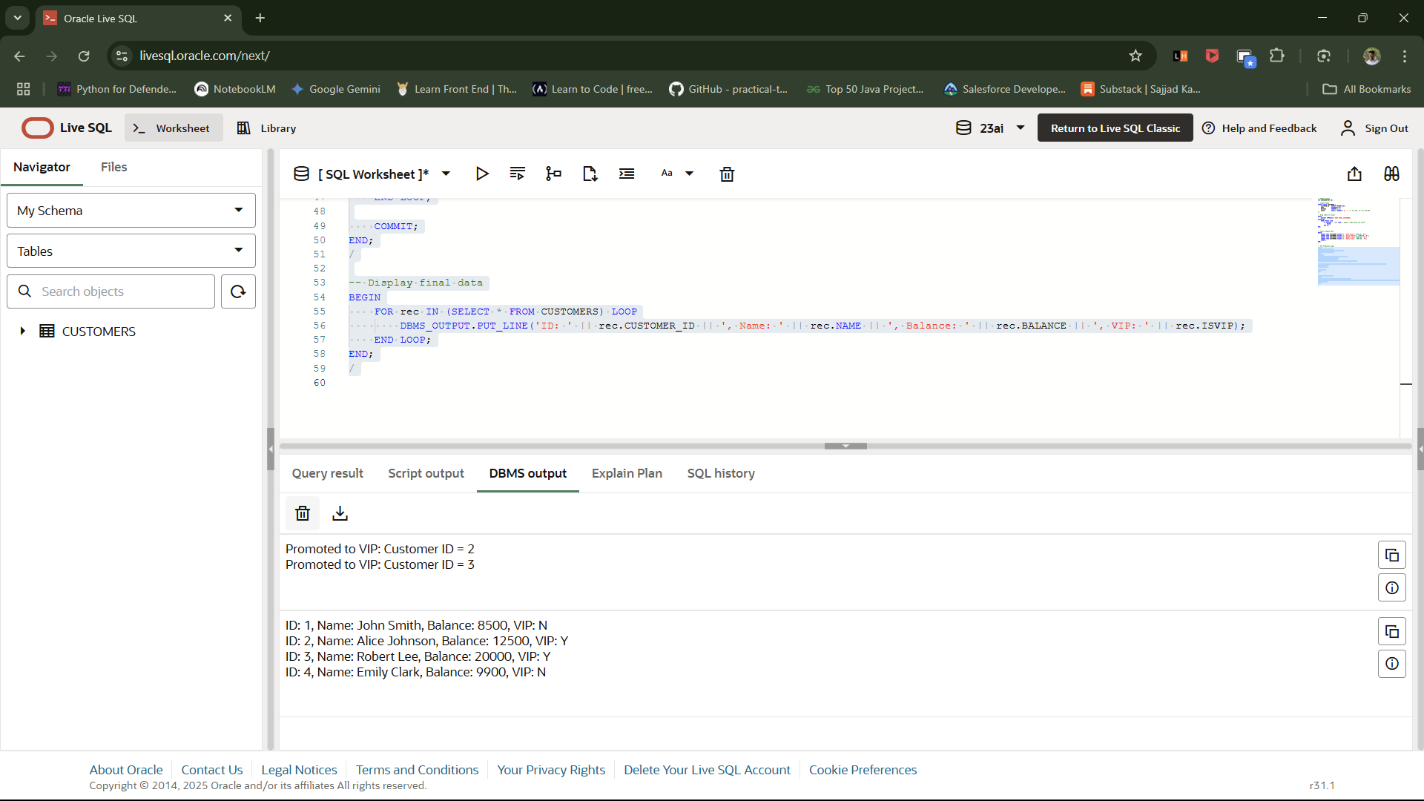

**Scenario – 3:**

SET SERVEROUTPUT ON;

BEGIN

    EXECUTE IMMEDIATE 'DROP TABLE LOANS';

EXCEPTION

    WHEN OTHERS THEN

        IF SQLCODE != -942 THEN RAISE; END IF;

END;

/

BEGIN

    EXECUTE IMMEDIATE 'DROP TABLE CUSTOMERS';

EXCEPTION

    WHEN OTHERS THEN

        IF SQLCODE != -942 THEN RAISE; END IF;

END;

/

CREATE TABLE CUSTOMERS (

    CUSTOMER_ID   NUMBER PRIMARY KEY,

    NAME          VARCHAR2(100)

);

CREATE TABLE LOANS (

    LOAN_ID        NUMBER PRIMARY KEY,

    CUSTOMER_ID    NUMBER,

    DUE_DATE       DATE,

    AMOUNT         NUMBER(12,2),

    CONSTRAINT fk_customer FOREIGN KEY (CUSTOMER_ID) REFERENCES CUSTOMERS(CUSTOMER_ID)

);

BEGIN

    INSERT INTO CUSTOMERS VALUES (1, 'John Smith');

    INSERT INTO CUSTOMERS VALUES (2, 'Alice Johnson');

    INSERT INTO CUSTOMERS VALUES (3, 'Robert Lee');

    INSERT INTO CUSTOMERS VALUES (4, 'Emily Clark');

    COMMIT;

END;

/

BEGIN

    INSERT INTO LOANS VALUES (101, 1, SYSDATE + 5, 5000.00);   -- due soon

    INSERT INTO LOANS VALUES (102, 2, SYSDATE + 15, 10000.00); -- due soon

    INSERT INTO LOANS VALUES (103, 3, SYSDATE + 40, 15000.00); -- not due

    INSERT INTO LOANS VALUES (104, 4, SYSDATE + 29, 7500.00);  -- due soon

    COMMIT;

END;

/

BEGIN

    FOR loan_rec IN (

        SELECT L.LOAN_ID, L.CUSTOMER_ID, L.DUE_DATE, L.AMOUNT, C.NAME

        FROM LOANS L

        JOIN CUSTOMERS C ON L.CUSTOMER_ID = C.CUSTOMER_ID

        WHERE L.DUE_DATE BETWEEN SYSDATE AND SYSDATE + 30

    )

    LOOP

        DBMS_OUTPUT.PUT_LINE(

            'Reminder: Loan ID ' || loan_rec.LOAN_ID ||

            ', Amount: $' || loan_rec.AMOUNT ||

            ', Due Date: ' || TO_CHAR(loan_rec.DUE_DATE, 'DD-Mon-YYYY') ||

            ', Customer: ' || loan_rec.NAME

        );

    END LOOP;

END;

/

OUTPUT:

