Name: Vishal R

Super set: 6413500

**Scenario – 1:**

SET SERVEROUTPUT ON;

BEGIN

    EXECUTE IMMEDIATE 'DROP PROCEDURE ProcessMonthlyInterest';

EXCEPTION

    WHEN OTHERS THEN

        IF SQLCODE != -4043 THEN RAISE; END IF;

END;

/

BEGIN

    EXECUTE IMMEDIATE 'DROP TABLE ACCOUNTS';

EXCEPTION

    WHEN OTHERS THEN

        IF SQLCODE != -942 THEN RAISE; END IF;

END;

/

CREATE TABLE ACCOUNTS (

    ACCOUNT_ID     NUMBER PRIMARY KEY,

    CUSTOMER_NAME  VARCHAR2(100),

    ACCOUNT_TYPE   VARCHAR2(20),

    BALANCE        NUMBER(12,2)

);

/

BEGIN

    INSERT INTO ACCOUNTS VALUES (1, 'John Smith', 'SAVINGS', 10000.00);

    INSERT INTO ACCOUNTS VALUES (2, 'Alice Johnson', 'CURRENT', 20000.00);

    INSERT INTO ACCOUNTS VALUES (3, 'Robert Lee', 'SAVINGS', 5000.00);

    INSERT INTO ACCOUNTS VALUES (4, 'Emily Clark', 'SAVINGS', 15000.00);

    COMMIT;

END;

/

CREATE OR REPLACE PROCEDURE ProcessMonthlyInterest IS

BEGIN

    UPDATE ACCOUNTS

    SET BALANCE = BALANCE + (BALANCE * 0.01)

    WHERE ACCOUNT_TYPE = 'SAVINGS';

    DBMS_OUTPUT.PUT_LINE('Monthly interest applied to all savings accounts.');

END;

/

BEGIN

    ProcessMonthlyInterest;

END;

/

BEGIN

    FOR acc IN (SELECT * FROM ACCOUNTS) LOOP

        DBMS_OUTPUT.PUT_LINE('ID: ' || acc.ACCOUNT_ID ||

                             ', Name: ' || acc.CUSTOMER_NAME ||

                             ', Type: ' || acc.ACCOUNT_TYPE ||

                             ', Balance: ' || acc.BALANCE);

    END LOOP;

END;

/

Output:  
  
**Scenario – 1:**

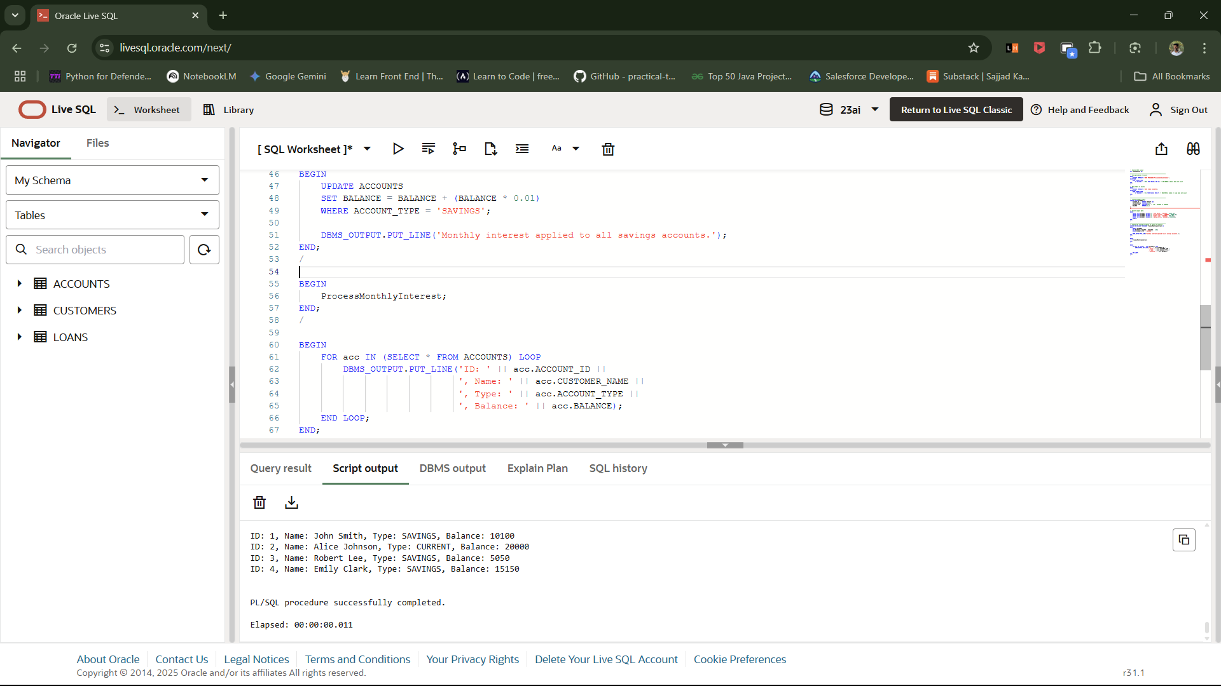

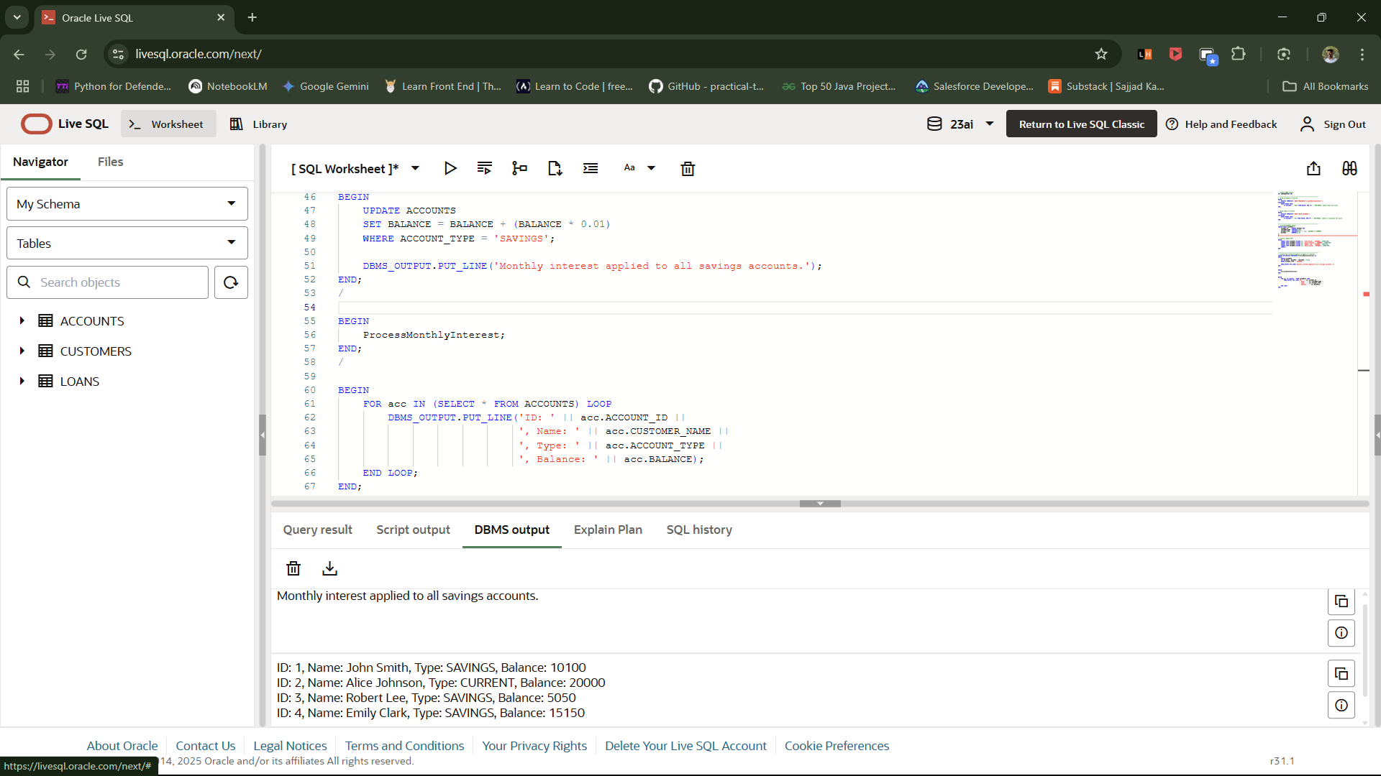

Scenario – 2:

SET SERVEROUTPUT ON;

BEGIN

    EXECUTE IMMEDIATE 'DROP PROCEDURE UpdateEmployeeBonus';

EXCEPTION

    WHEN OTHERS THEN

        IF SQLCODE != -4043 THEN RAISE; END IF;

END;

/

BEGIN

    EXECUTE IMMEDIATE 'DROP TABLE EMPLOYEES';

EXCEPTION

    WHEN OTHERS THEN

        IF SQLCODE != -942 THEN RAISE; END IF;

END;

/

CREATE TABLE EMPLOYEES (

    EMP_ID        NUMBER PRIMARY KEY,

    NAME          VARCHAR2(100),

    DEPARTMENT    VARCHAR2(50),

    SALARY        NUMBER(10,2)

);

BEGIN

    INSERT INTO EMPLOYEES VALUES (1, 'Alice', 'SALES', 50000);

    INSERT INTO EMPLOYEES VALUES (2, 'Bob', 'HR', 45000);

    INSERT INTO EMPLOYEES VALUES (3, 'Charlie', 'SALES', 55000);

    INSERT INTO EMPLOYEES VALUES (4, 'Diana', 'IT', 60000);

    INSERT INTO EMPLOYEES VALUES (5, 'Ethan', 'SALES', 52000);

    COMMIT;

END;

/

CREATE OR REPLACE PROCEDURE UpdateEmployeeBonus (

    dept_name IN VARCHAR2,

    bonus_pct IN NUMBER

) IS

BEGIN

    UPDATE EMPLOYEES

    SET SALARY = SALARY + (SALARY * bonus_pct / 100)

    WHERE UPPER(DEPARTMENT) = UPPER(dept_name);

    DBMS_OUTPUT.PUT_LINE('Bonus of ' || bonus_pct || '% applied to department: ' || dept_name);

END;

/

BEGIN

    UpdateEmployeeBonus('SALES', 10);

END;

/

BEGIN

    FOR emp IN (SELECT * FROM EMPLOYEES) LOOP

        DBMS_OUTPUT.PUT_LINE('ID: ' || emp.EMP_ID ||

                             ', Name: ' || emp.NAME ||

                             ', Dept: ' || emp.DEPARTMENT ||

                             ', Salary: ' || emp.SALARY);

    END LOOP;

END;

/

OUTPUT:

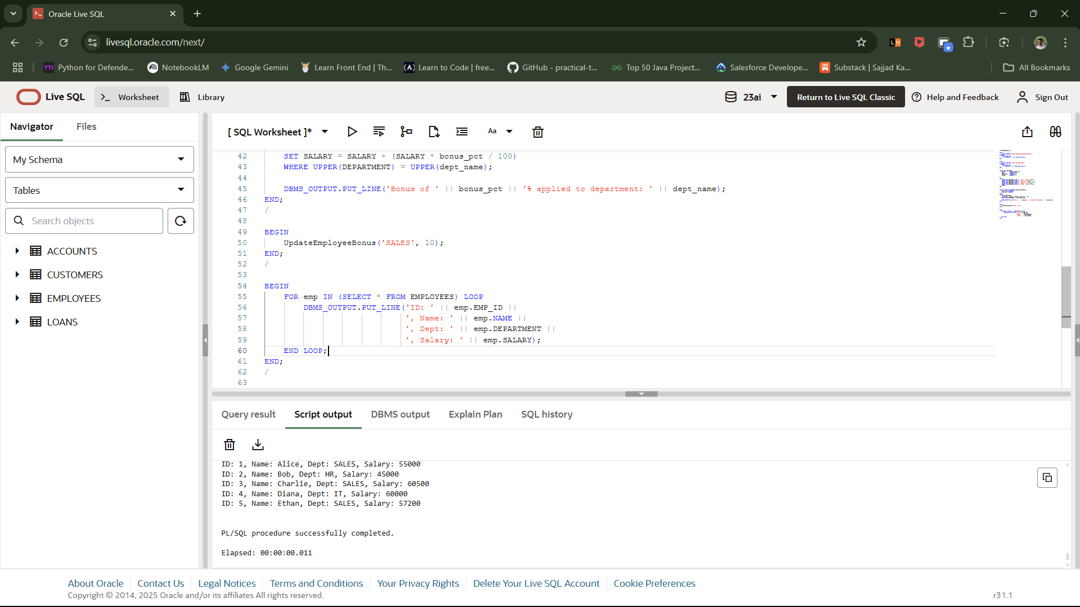

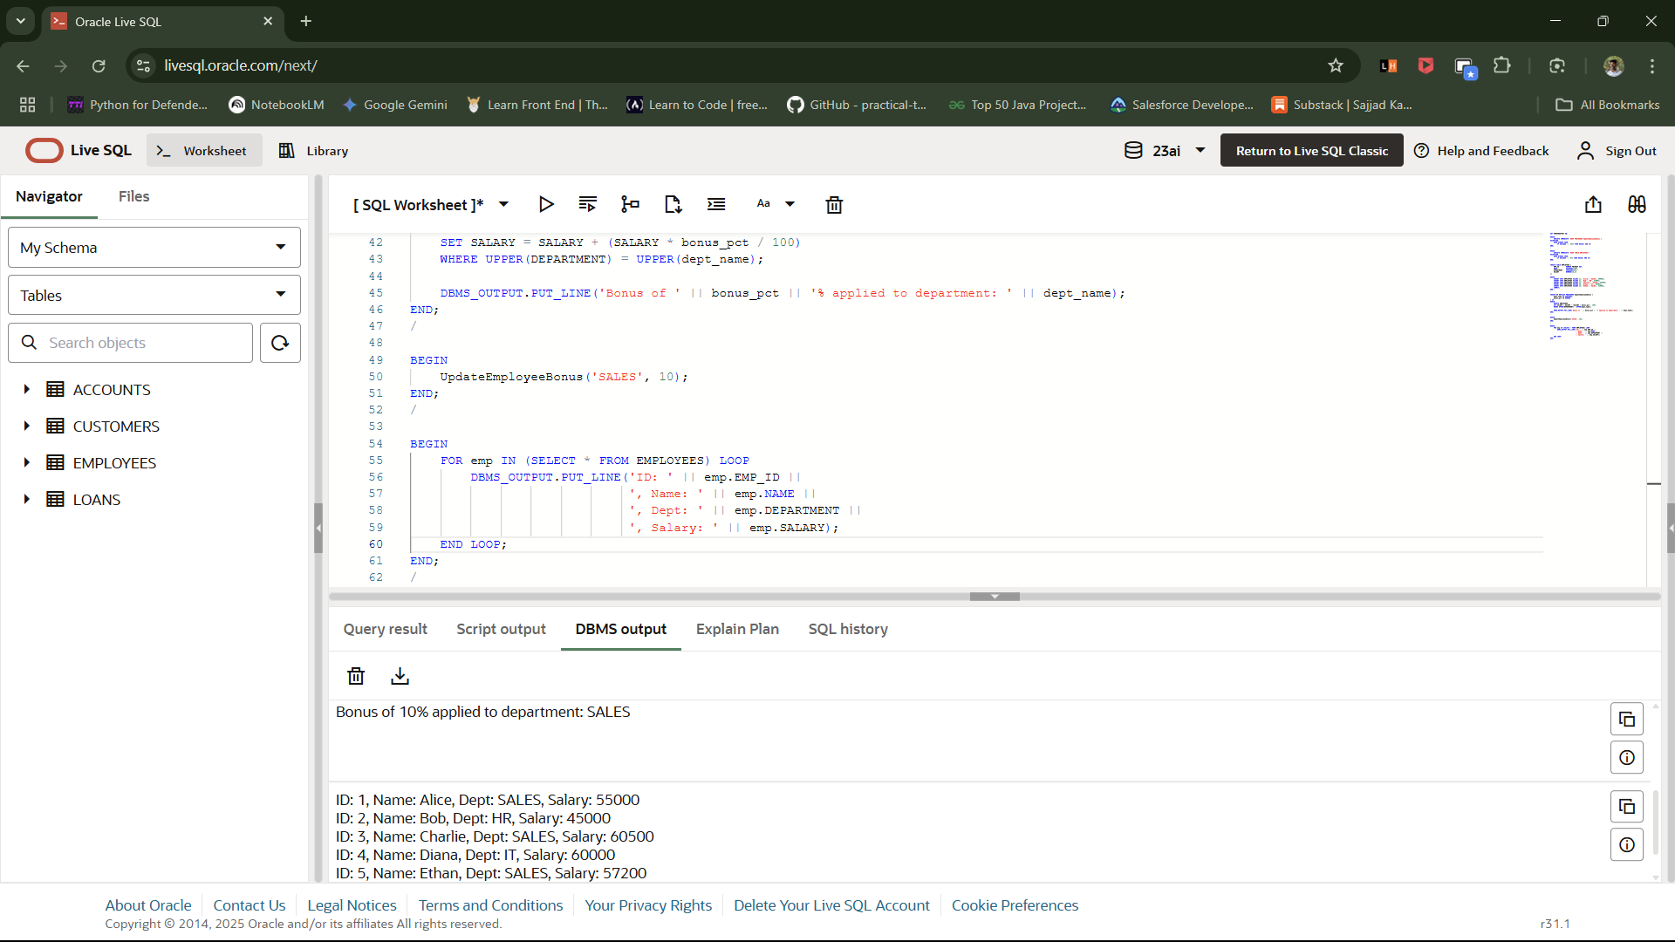

Scenario – 3:

SET SERVEROUTPUT ON;

BEGIN

    EXECUTE IMMEDIATE 'DROP PROCEDURE TransferFunds';

EXCEPTION

    WHEN OTHERS THEN

        IF SQLCODE != -4043 THEN RAISE; END IF;

END;

/

BEGIN

    EXECUTE IMMEDIATE 'DROP TABLE ACCOUNTS';

EXCEPTION

    WHEN OTHERS THEN

        IF SQLCODE != -942 THEN RAISE; END IF;

END;

/

CREATE TABLE ACCOUNTS (

    ACCOUNT_ID     NUMBER PRIMARY KEY,

    CUSTOMER_NAME  VARCHAR2(100),

    BALANCE        NUMBER(12,2)

);

BEGIN

    INSERT INTO ACCOUNTS VALUES (1, 'John Smith', 10000.00);

    INSERT INTO ACCOUNTS VALUES (2, 'Alice Johnson', 5000.00);

    COMMIT;

END;

/

CREATE OR REPLACE PROCEDURE TransferFunds (

    p_from_account   IN NUMBER,

    p_to_account     IN NUMBER,

    p_amount         IN NUMBER

) IS

    v_from_balance NUMBER;

BEGIN

    SELECT BALANCE INTO v_from_balance

    FROM ACCOUNTS

    WHERE ACCOUNT_ID = p_from_account;

    IF v_from_balance < p_amount THEN

        RAISE_APPLICATION_ERROR(-20001, 'Insufficient funds in source account.');

    END IF;

    UPDATE ACCOUNTS

    SET BALANCE = BALANCE - p_amount

    WHERE ACCOUNT_ID = p_from_account;

    UPDATE ACCOUNTS

    SET BALANCE = BALANCE + p_amount

    WHERE ACCOUNT_ID = p_to_account;

    DBMS_OUTPUT.PUT_LINE('Transfer of $' || p_amount || ' from Account ' || p_from_account || ' to Account ' || p_to_account || ' successful.');

    COMMIT;

EXCEPTION

    WHEN NO_DATA_FOUND THEN

        DBMS_OUTPUT.PUT_LINE('Error: One of the accounts does not exist.');

    WHEN OTHERS THEN

        DBMS_OUTPUT.PUT_LINE('Transfer failed: ' || SQLERRM);

        ROLLBACK;

END;

/

BEGIN

    TransferFunds(1, 2, 2000);

END;

/

BEGIN

    FOR acc IN (SELECT * FROM ACCOUNTS ORDER BY ACCOUNT_ID) LOOP

        DBMS_OUTPUT.PUT_LINE('Account ID: ' || acc.ACCOUNT_ID ||

                             ', Name: ' || acc.CUSTOMER_NAME ||

                             ', Balance: ' || acc.BALANCE);

    END LOOP;

END;

/

OUTPUT:

