**MOVIE DB _Readme**

**Prerequisite:-**

1. Make changes to the config.properties file by entering your device or emulator details.
2. Change network speed in capabilities (i.e. gsm,gprs,evod,full)
3. Open Charles proxy & configure your real device or emulator to get the logs.

**Charles Proxy network traffic trace and network speed**

Example:-

1. Change network speed in capabilities with gsm (low network)
2. Turn on the Charles proxy
3. Run the automation script
4. Observe the speed & duration of the data for GSM on runtime.

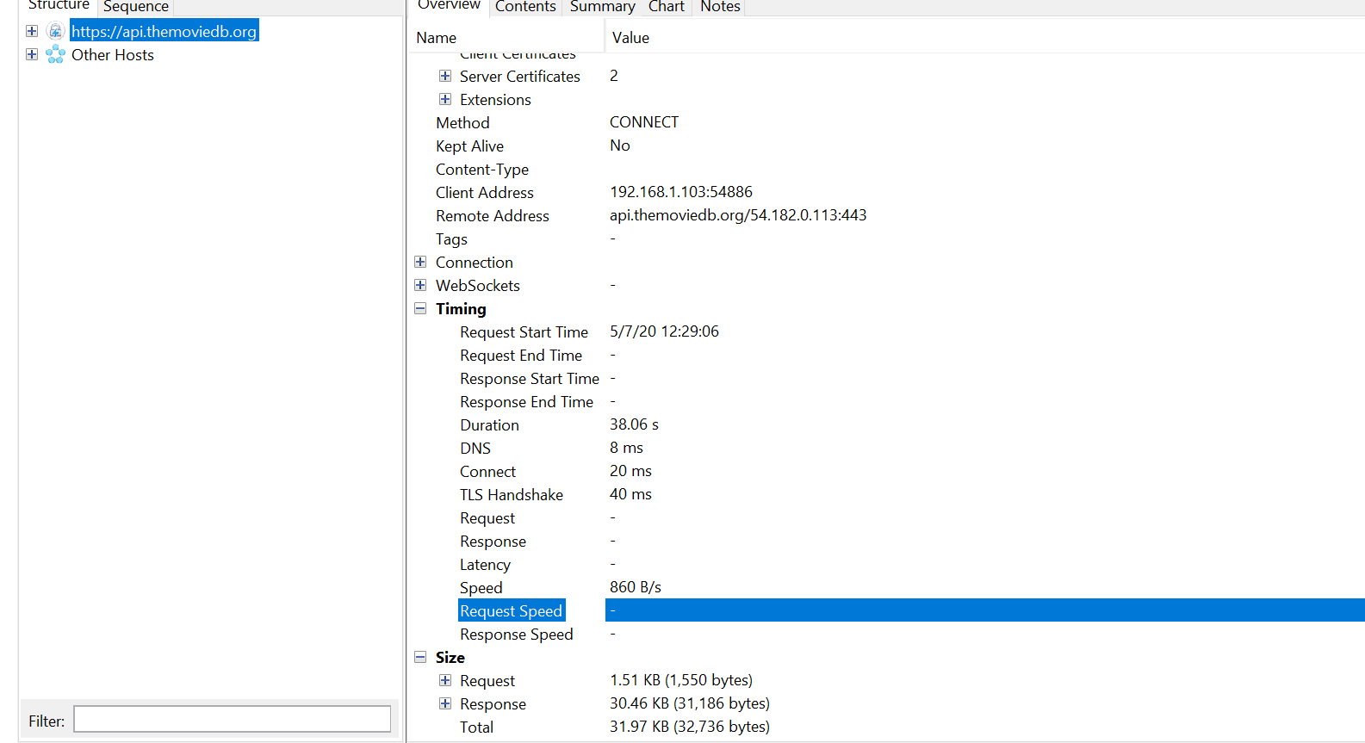

Follow the above step with some higher network and observe the speed and duration.

Refer below screenshot for evod network.

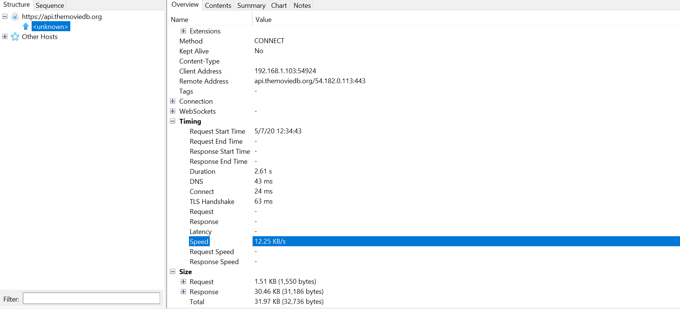

* Using Charles proxy we can trace network traffic & network speed
* Also we can change the network speed by using Throttling option.

**Junit Result with scenario:-**

