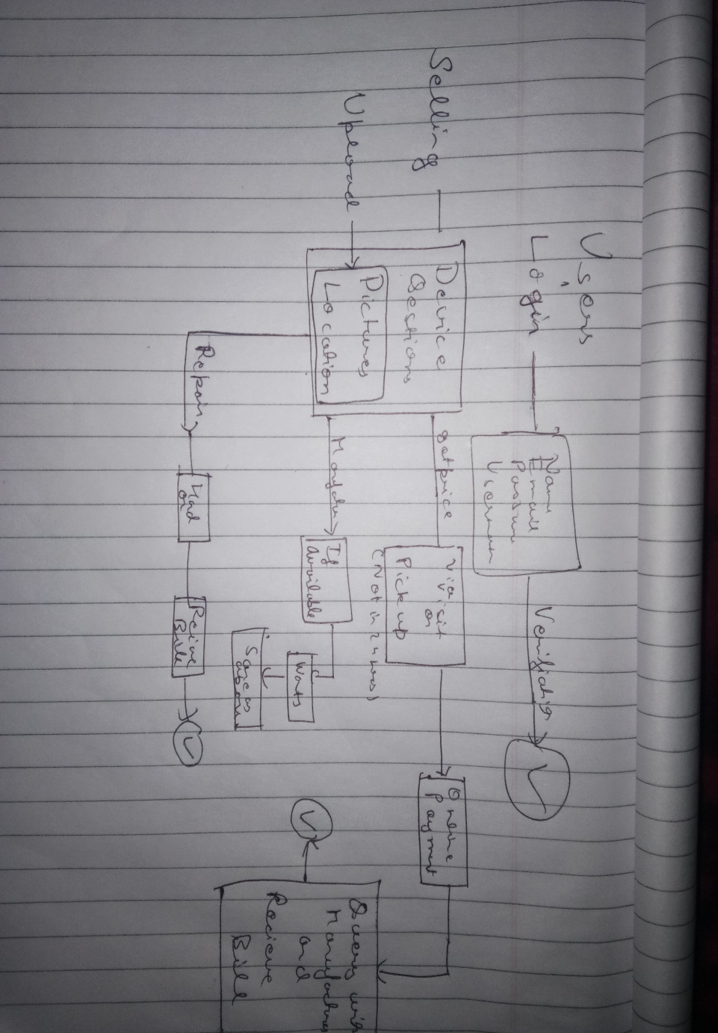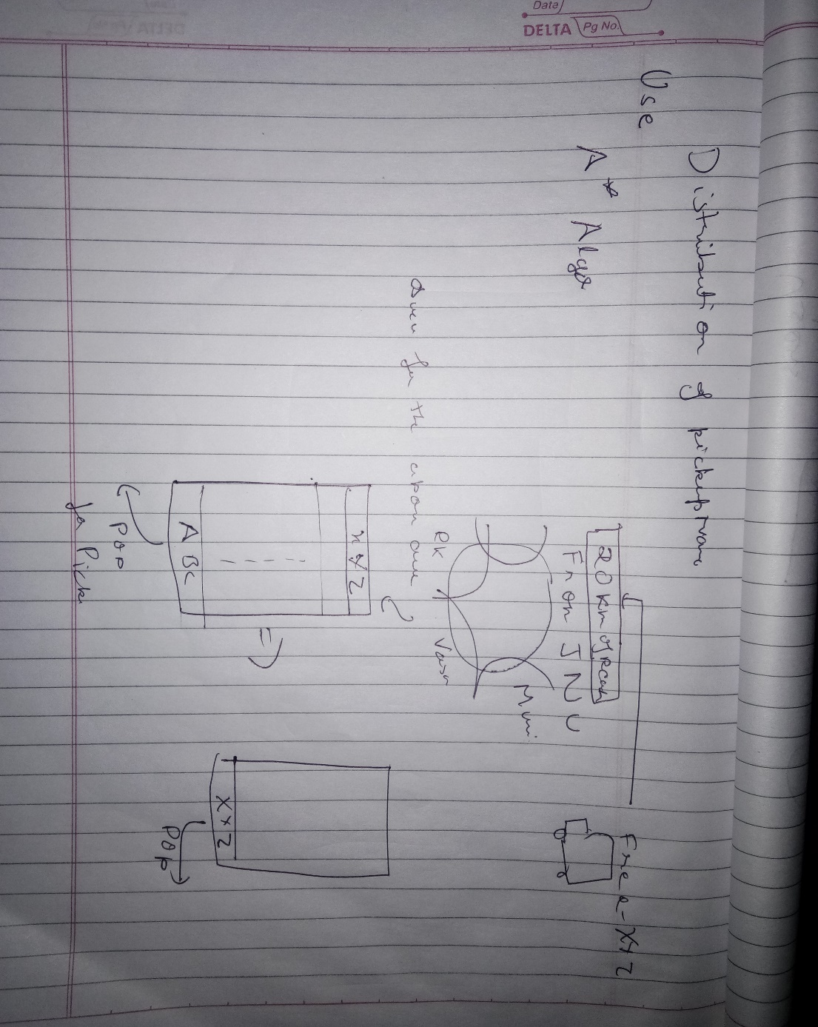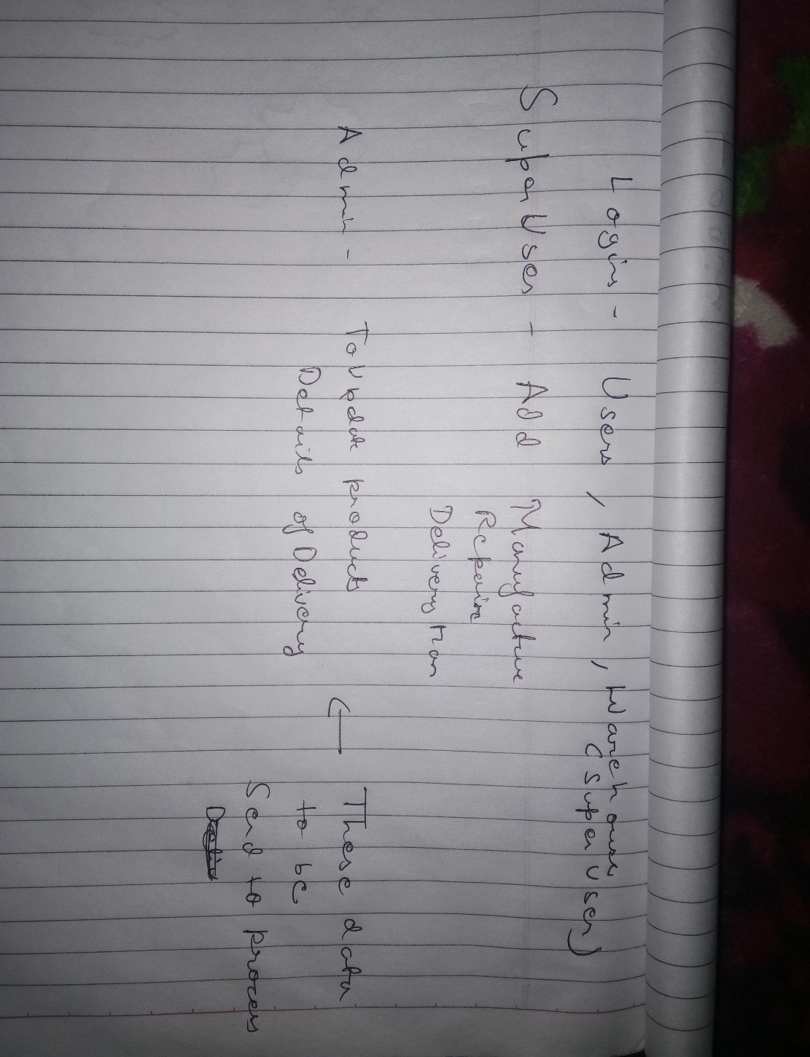

Projects to look at

<https://github.com/aj1497/e-Waste>

<https://github.com/GloriaRaphael/RecycleIt>

<https://github.com/YusufMS/eWasteProject>

<https://github.com/Harshad-Pardeshi/E-Waste-ManagementSystem>

<https://github.com/rahulagnii/e-Waste>

<https://github.com/annytikone/EWasteOnlineSystemUsingJava>

For user login(and other’s)

<https://github.com/cornflourblue/node-mongo-registration-login-api>

<https://github.com/knoldus/Node.js_UserLogin_Template>

Main objective

https://www.cashify.in/