**Learners have to come up with a Report to support the answers to the following questions and suggestions**

**Objective Questions:**

1. What is the distribution of account balances across different regions?  
     
   Answer:- The distribution of account balance across different regions

|  |  |  |  |  |  |  |
| --- | --- | --- | --- | --- | --- | --- |
| GeographyID | GeographyLocation | NumberOfCustomers | AvgBalance | MinBalance | MaxBalance | TotalBalance |
| 1 | France | 5014 | 62092.63652 | 0 | 238387.56 | 311332479.5 |
| 3 | Spain | 2509 | 119730.1161 | 27288.43 | 214346.96 | 300402861.4 |
| 2 | Germany | 2477 | 61818.14776 | 0 | 250898.09 | 153123552 |

1. Identify the top 5 customers with the highest Estimated Salary in the last quarter of the year. (SQL)  
     
   Answer:-   
     
     
   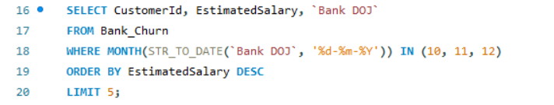

|  |  |  |
| --- | --- | --- |
| CustomerId | EstimatedSalary | Bank DOJ |
| 15634359 | 199970.74 | 29-11-2016 |
| 15804211 | 199841.32 | 25-12-2019 |
| 15687913 | 199805.63 | 12-11-2018 |
| 15763065 | 199753.97 | 01-10-2019 |
| 15599792 | 199638.56 | 16-11-2018 |

1. Calculate the average number of products used by customers who have a credit card. (SQL)  
     
   Answer:- Customers who own a credit card use an average of approximately **1.53** products  
     
     
     
   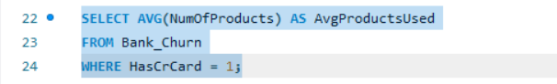  
     
   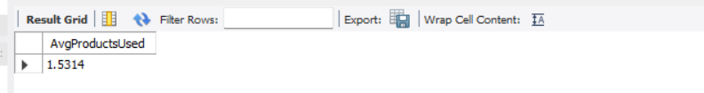
2. Determine the churn rate by gender for the most recent year in the dataset.  
     
     
     
     
   In the most recent year, 2019, the churn rate for male customers was 15.37%, while for female customers, it was 25.05%.

**Approach:** To determine this, we created a measure called "Exit Rate" using the following formula:  
= Divide (calculate (count('Bank_Churn'[CustomerId]), Bank_Churn[Exited] =1)*100 , count(Bank_Churn[CustomerId]))

This formula calculates the exit rate as a percentage. We then used a KPI card and applied slicers for the year (selecting the most recent year) and gender (filtering for male and female).

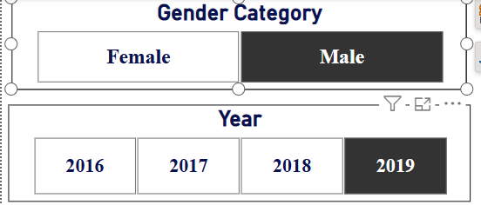  
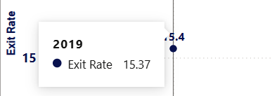  
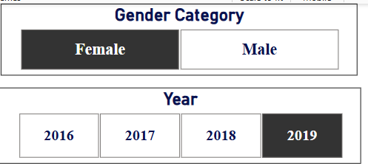  


1. Compare the average credit score of customers who have exited and those who remain. (SQL)  
   Answer:-   
     
     
     
     
     
     
     
     
     
     
   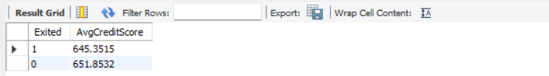  
     
     
     
   Exited = 0 → Average credit score of customers who remain.

Exited = 1 → Average credit score of customers who have left

1. Which gender has a higher average estimated salary, and how does it relate to the number of active accounts? (SQL)  
   Answer:- The average estimated salary for females is approximately **1,00,601**, while for males, it is around **99,664**. Despite the slightly higher average salary for females, males tend to have a greater number of active accounts.  
     
     
   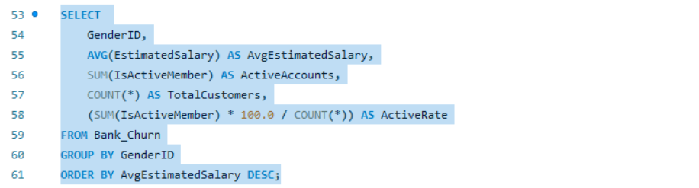  
     
     
   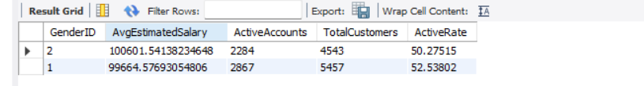
2. Find out which geographic region has the highest number of active customers with a tenure greater than 5 years. (SQL)  
   Answer:- The table below shows that **France** has a higher number of active customers with a tenure of more than **five years** compared to other regions such as **Spain and Germany**.  
     
   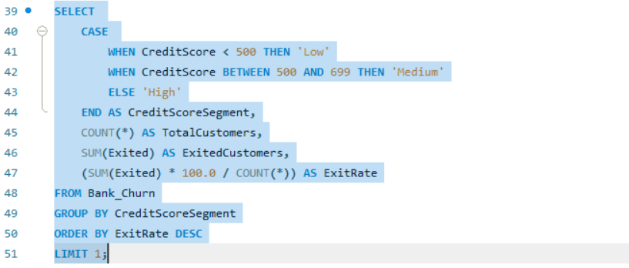  
     
   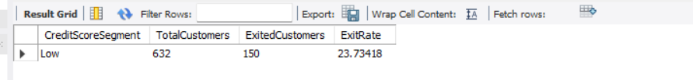
3. What is the impact of having a credit card on customer churn, based on the available data?  
     
   Answer:- The data indicates that the **churn rate is higher among customers who do not have credit cards** compared to those who do. This suggests that **non-credit card holders significantly contribute to the overall churn rate**.
4. For customers who have exited, what is the most common number of products they have used?  
   Answer:- The data shows that the **most commonly used product among customers who have exited is Product 1**, with an exit count of **1,409**.

|  |  |
| --- | --- |
| NumOfProducts | ExitedCount |
| 1 | 1409 |
| 2 | 348 |
| 3 | 220 |
| 4 | 60 |

1. Examine the trend of customers joining over time and identify any seasonal patterns (yearly or monthly). Prepare the data through SQL and then visualize it.  
     
   Answer:- The data reveals a **consistent increase in the number of new customers each year, indicating a positive growth trend**. Notably, there was a **significant spike from 2018 to 2019**, with **approximately 700 more customers joining in 2019 compared to the previous year**.  
     
     
     
     
   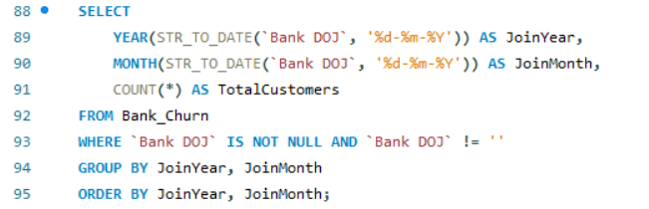

|  |  |
| --- | --- |
| **Row Labels** | **Sum of TotalCustomers** |
| 2016 | 1951 |
| 2017 | 2143 |
| 2018 | 2593 |
| 2019 | 3313 |
| **Grand Total** | **10000** |

1. Analyse the relationship between the number of products and the account balance for customers who have exited.  
     
   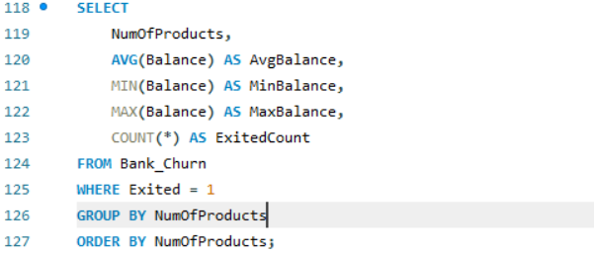  
   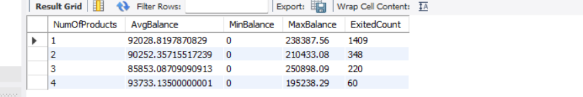  
     
   The overall trend shows that as the **number of products increases, account balance fluctuates slightly**, generally decreasing until a **spike at four products**. Notably, **customers with three products have the lowest account balance**, suggesting that those with more products may be **consolidating their funds or increasing their spending before exiting**.
2. Identify any potential outliers in terms of balance among customers who have remained with the bank.  
     
   Answer: - **Outlier Detection:** Certain data points fall significantly above or below the main cluster, indicating **customers with unusually high or low balances** relative to their estimated salary.

**Data Density:** The chart reveals a **dense concentration of points in the middle**, with some scattered at the top and bottom edges, suggesting the presence of **potential outliers**.

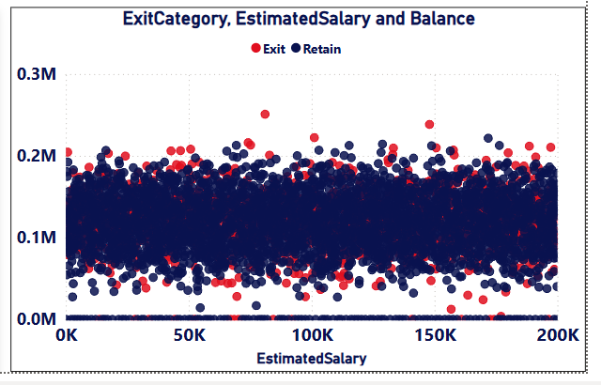  
  
Our analysis focuses on **potential outliers in account balance** among customers who have remained with the bank. We examined the **distribution of account balances and estimated salaries**, applying a filter for **active members who have not exited**. This revealed a few significant **outliers—customers with unusually low balances compared to the average**.

These findings suggest that **certain customers exhibit unique financial behaviors**, which should be further analyzed to understand their underlying reasons. Gaining these insights would enable the bank to **develop targeted strategies** to better serve diverse customer segments, ultimately **enhancing financial stability and improving customer satisfaction**.

1. How many different tables are given in the dataset, out of these tables which table only consists of categorical variables?  
   Answer:- We have seven different tables in our dataset:  
   ActiveCustomer  
   Bank_Churn  
   CreditCard  
   CustomerInfo  
   ExitCustomer  
   Gender  
   Geography  
   Tables with Categorical Variables:  
   CustomerInfo: Contains Surname as a categorical variable.  
   ExitCustomer: Includes Exit Category (Exit, Retain).  
   Gender: Contains Gender Category (Male, Female).  
   Geography: Includes Geography Location (France, Spain, Germany).  
   CreditCard: Contains Category (Credit-card holder, Non-Credit card holder).  
   ActiveCustomer: Includes Active Category (Active Member, Inactive Member).
2. Using SQL, write a query to find out the gender-wise average income of males and females in each geography id. Also, rank the gender according to the average value. (SQL)  
     
     
   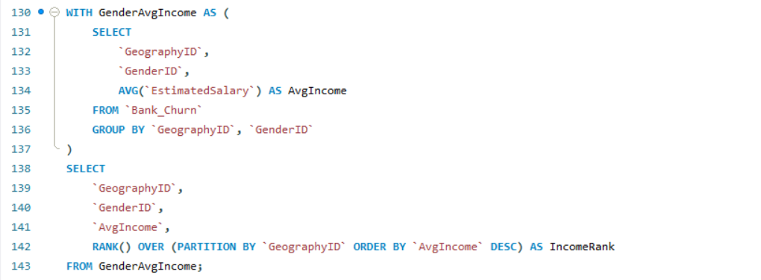  
     
     
     
   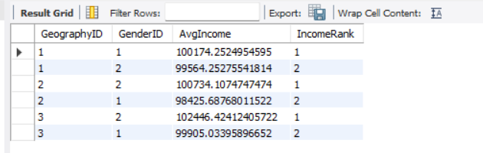
3. Using SQL, write a query to find out the average tenure of the people who have exited in each age bracket (18-30, 30-50, 50+).  
   Answer:-   
     
   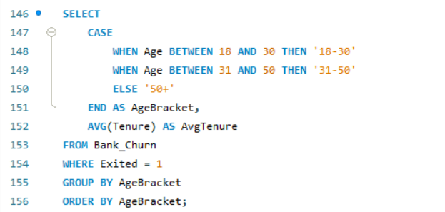  
     
     
   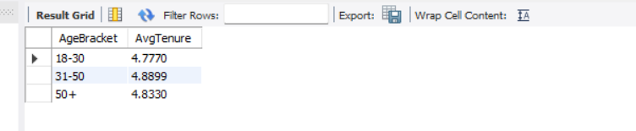
4. Is there any direct correlation between salary and the balance of the customers? And is it different for people who have exited or not?  
     
   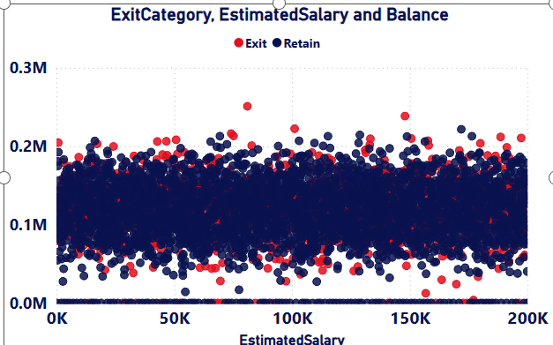
5. Is there any correlation between the salary and the Credit score of customers?  
      
   Answer: - There is no direct correlation between salary and credit score. Credit scores are influenced by multiple factors beyond income, so salary alone does not determine a customer's credit score.  
     
     
   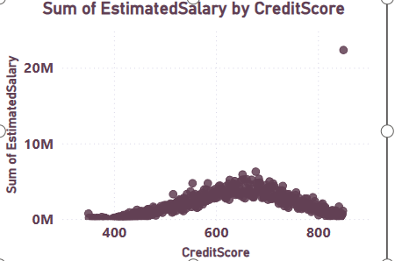
6. Rank each bucket of credit score as per the number of customers who have churned the bank.  
   Answer: -   
     
   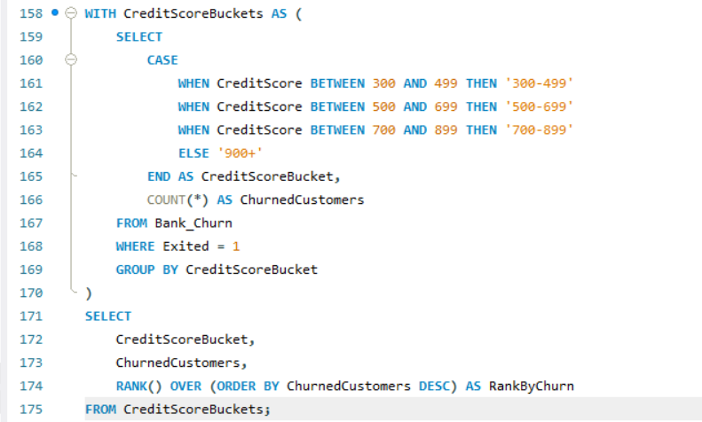  
     
   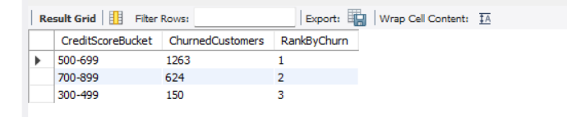
7. According to the age buckets find the number of customers who have a credit card. Also retrieve those buckets that have lesser than average number of credit cards per bucket.  
   Answer: -   
     
   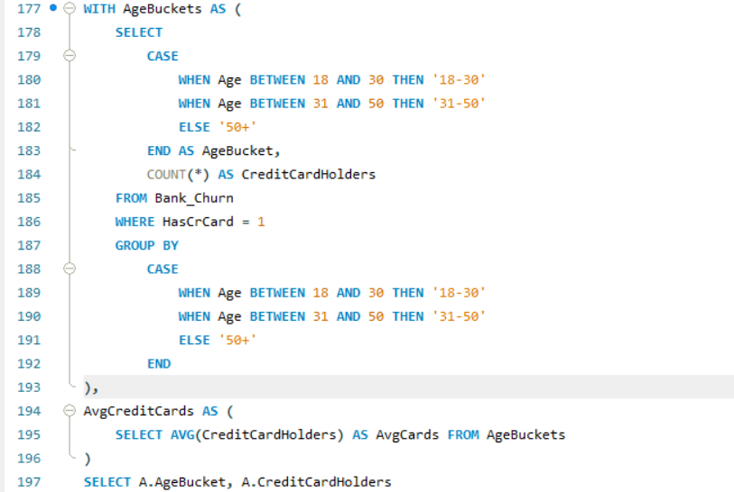  
     
     
   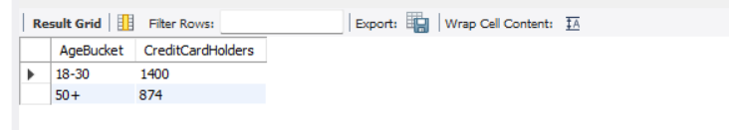
8. Rank the Locations as per the number of people who have churned the bank and average balance of the customers.  
   Answer:-   
     
   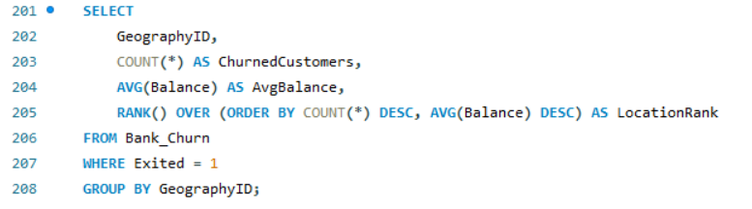  
   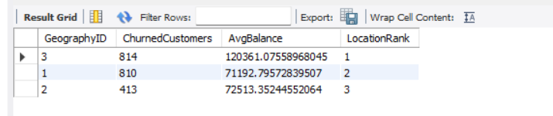
9. As we can see that the “CustomerInfo” table has the CustomerID and Surname, now if we have to join it with a table where the primary key is also a combination of CustomerID and Surname, come up with a column where the format is “CustomerID_Surname”.  
   Answer: -   
     
   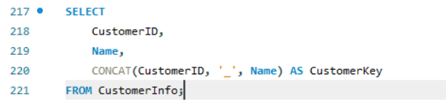  
     
   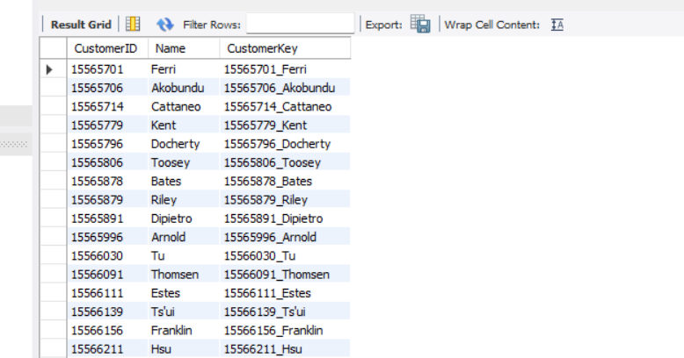
10. Without using “Join”, can we get the “ExitCategory” from ExitCustomers table to Bank_Churn table? If yes do this using SQL.  
      
    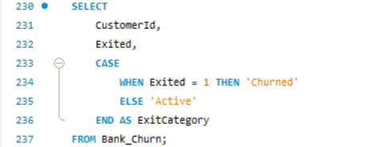  
    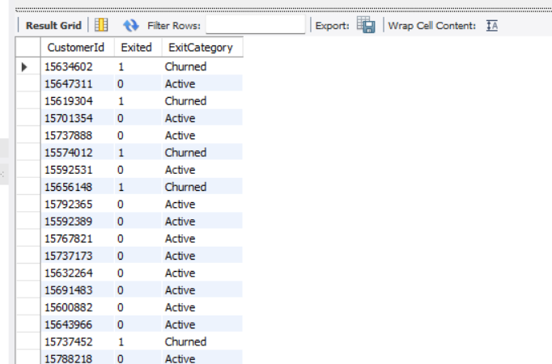
11. Were there any missing values in the data, using which tool did you replace them and what are the ways to handle them?  
    Answer:-  
    There are multiple ways to handle **missing values**, but the first step is to **identify them**. Once identified, we can decide how to handle them based on the nature of the data and specific requirements.

### **Handling Missing Values in SQL:**

1. **Identifying Missing Values:**
   * We can run a query to check for **NULL** values in the dataset.
2. **Replacing with a Default Value:**
   * Using the **COALESCE** function to replace NULL values with a default value.
3. **Replacing with Mean/Median Value:**
   * Calculating the mean or median of a column and replacing missing values accordingly.
4. **Removing Rows with Missing Values:**
   * If missing data is minimal and does not impact analysis, removing rows may be an option.

### **Handling Missing Values in Power BI:**

* In **Transform Data**, under the **View** tab, we can enable **Column Quality**, which displays the percentage of missing values in each column.
* Once identified, we can:
  + Replace missing values with the **mean** or **median**.
  + Remove entire rows with missing values.
  + Apply a **filter** to exclude NULL values automatically.

### **Missing Values in Our Dataset:**

In our dataset, the **ActiveCustomer** table contained **empty rows**, which were handled using the **filter option** to exclude null values.

1. Write the query to get the customer IDs, their last name, and whether they are active or not for the customers whose surname ends with “on”.  
   Answer:-   
   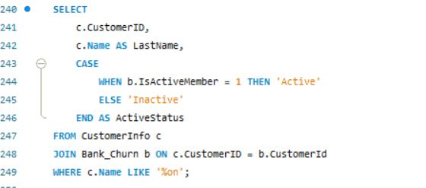  
   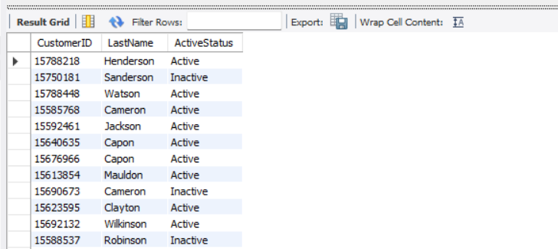
2. Can you observe any data disrupency in the Customer’s data? As a hint it’s present in the IsActiveMember and Exited columns. One more point to consider is that the data in the Exited Column is absolutely correct and accurate.  
   Answer:- We identified an inconsistency in the dataset where 'Exited' = 1 and 'Active' = 1, which is not logically possible. If a member has exited, they cannot be active, and if they are inactive, they cannot be retained.

This query ensures that if a customer has exited (Exited = 1), their active status is updated to inactive (Active = 0), maintaining data integrity.

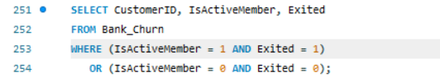  
  
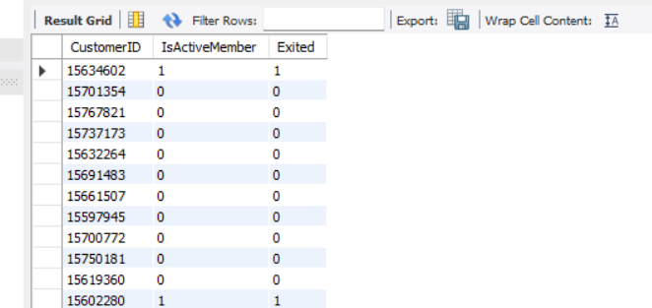

**Subjective Question:**

1. **Customer Behaviour Analysis: What patterns can be observed in the spending habits of long-term customers compared to new customers, and what might these patterns suggest about customer loyalty?**  
     
   Answer :- The bar and line chart illustrates customer spending habits based on tenure, providing key insights into financial behaviour and retention trends.

Key Insights:

Spending Patterns & Tenure:  
Customers with 5 years of tenure have the highest average salary (₹102K).  
They also show a higher customer count but a lower account balance, indicating higher spending habits.  
Financial Stability & Retention: A notable increase in customer count is seen at the 4th-year tenure, followed by a steady decline after 5 years.  
This suggests that many customers tend to exit or reduce engagement after this period.  
Banks should investigate the reasons behind declining customer count and implement strategies for retention.

Targeted Engagement:

Customers with 3–5 years of tenure appear to have a higher spending capacity.

This segment presents an opportunity for targeted marketing and loyalty programs to improve retention.

Conclusion:

The analysis underscores the importance of tenure in understanding customer behavior. While longer-tenured customers have higher earning potential, banks must also focus on retaining newer customers. By developing personalized engagement strategies for each tenure group, banks can optimize customer loyalty and retention for sustained growth.  
  
  
  
  
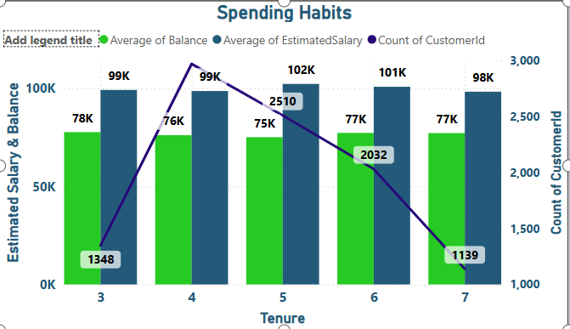

1. **Product Affinity Study: Which bank products or services are most commonly used together, and how might this influence cross-selling strategies?**  
     
   Answer:- The product usage analysis provides valuable insights into customer behaviour and opportunities for cross-selling additional banking services.

Key Insights:  
Commonly Used Products:

Over 50% of customers use only 1 or 2 products, showing a preference for simplicity or a lack of awareness about other offerings.  
  
Very few customers use 3 or 4 products, indicating a potential demand for comprehensive banking solutions but also challenges in adoption.

Cross-Selling Potential:

Customers with only 1 product can be targeted for promotions or educational campaigns to introduce credit cards, savings accounts, or investment options.

The drop in utilization of products 3 and 4 suggests that banks need better strategies to encourage customers to use more services.

Active Customer Engagement:

The column chart shows the distribution of active customers across different product tiers.

Active customers are more likely to engage with new product offerings, making them a priority for cross-selling efforts.

Optimizing Cross-Selling Strategies:

Using product affinity studies, banks can design personalized cross-selling campaigns based on customer preferences.  
Strategies may include targeted marketing, personalized recommendations, and bundled product offerings to increase product adoption.  
Conclusion:

Understanding product usage patterns and customer engagement levels is key to effective cross-selling. By identifying commonly used products and leveraging customer insights, banks can:

Increase revenue opportunities  
Enhance customer satisfaction  
Strengthen long-term relationships  
A well-executed cross-selling strategy will ensure that customers are aware of the full range of financial services, helping them make better financial decisions while improving overall bank profitability.  
  
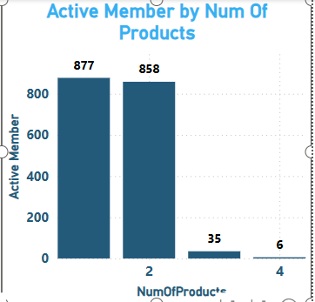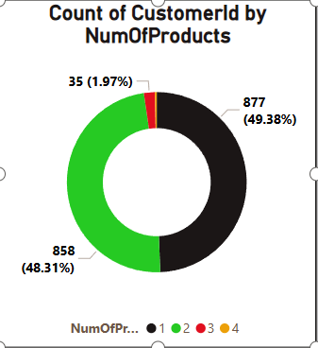

1. **Geographic Market Trends: How do economic indicators in different geographic regions correlate with the number of active accounts and customer churn rates?**  
     
     
     
   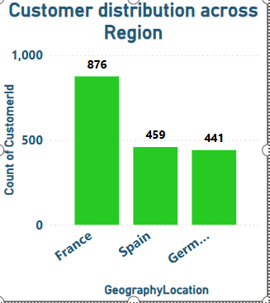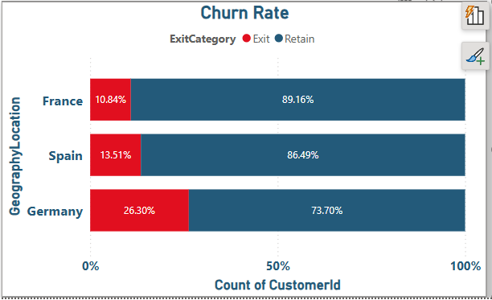  
     
     
   Regional Customer Analysis & Churn Insights

Key Findings:

Customer Distribution Across Regions:

France has the highest number of customers, followed by Germany and Spain.

The varying market sizes indicate growth opportunities for expanding business activities.

Churn Rates by Region:

Germany has the highest churn rate (32.44%), which suggests customer dissatisfaction or competition.

Spain (16.67%) and France (16.15%) have lower churn rates, indicating relatively higher customer retention.

Despite churn, over 80% of customers remain with the bank, especially in France and Spain.

Retention Strategies:

The factors contributing to retention in France and Spain can be analyzed and applied in Germany to reduce churn.

Strategies such as personalized banking services, loyalty programs, and improved customer engagement can enhance customer retention.

Economic Indicators Impacting Churn:

GDP growth, unemployment rates, standard of living, and household income may influence customer behavior and banking preferences.  
Understanding these macroeconomic factors can help refine retention strategies and target specific customer needs in each region.

Conclusion:  
By analyzing regional churn trends and economic influences, the bank can:

Improve customer satisfaction  
Develop region-specific retention strategies  
Identify opportunities for business expansion   
A targeted approach focusing on customer needs, service quality, and economic conditions will help reduce churn and strengthen customer loyalty across all regions.  
  
**4**. **Risk Management Assessment: Based on customer profiles, which demographic segments appear to pose the highest financial risk to the bank, and why?**  
  
Answer:- Customer Age & Balance Distribution Insights

Key Observations:

Age-Based Customer Distribution:

The highest concentration of customers falls within the 0-20 age bucket, with around 6K customers. Most of these customers are active members, but a notable portion is inactive, indicating a risk of disengagement. In the 20-40 age range, the inactive customer count is also high, reinforcing the need for engagement strategies.

Balance Distribution by Age:

Customers aged 0-20 hold the highest account balances, suggesting strong early financial engagement.

The balance gradually decreases in the 20-40 age group and drops significantly for older customers. Older age groups (60+) have both fewer customers and lower balances, indicating lower financial risk for the bank.  
Risk Concentration by Age:

Since younger customers (0-40) hold the majority of the bank’s total balance, managing risk in these groups is crucial. The high inactivity rate among younger customers poses a financial risk if they disengage or move their funds elsewhere. The older customer segment carries minimal financial risk, given their lower balances and smaller customer base.  
  
  
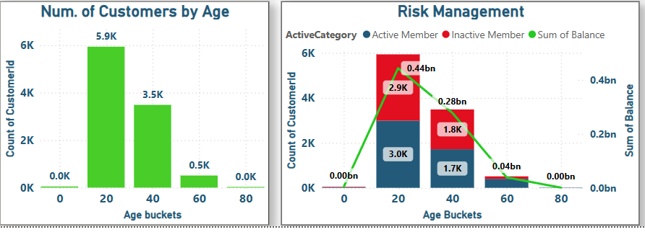

1. Customer Tenure Value Forecast: How would you use the available data to model and predict the lifetime (tenure) value in the bank of different customer segments?  
   Answer:-   
     
   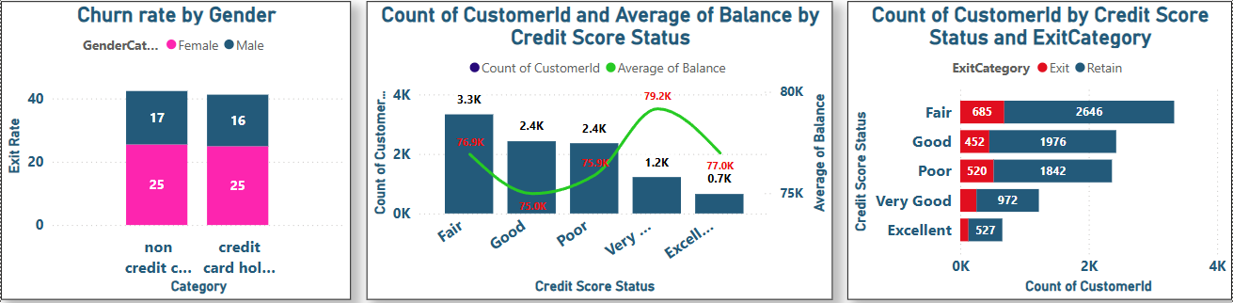  
   **Insights:**

* **Financial Stability and Tenure:** Customer count sees a significant rise in the fourth year of tenure, followed by a steady decline. Banks should analyze the reasons for this drop and implement strategies to enhance customer retention.
* **Targeted Engagement:** Customers with 3–5 years of tenure exhibit higher spending capacity, making them a key segment for retention efforts. Understanding why engagement declines after five years can help in crafting better retention strategies.
* **Customer Distribution by Credit Score:** The majority of customers fall under the "Fair" credit score category (3.3K), indicating that most bank customers have either Fair or Good credit scores.
* **Average Balance by Credit Score:** Customers with Very Good and Excellent credit scores maintain higher average balances. However, balance size does not necessarily decrease with lower credit scores, showing that customers with weaker scores can still hold substantial balances.
* **Risk Analysis:** Credit score alone is not a strong predictor of balance size. A more comprehensive approach considering multiple financial factors is necessary for accurate risk assessment.

**Strategy:**  
For customers in the Good and Fair credit categories, banks should strengthen relationships and promote additional product usage to improve engagement.

**Conclusion:**  
Since a large portion of customers have Fair or Good credit scores, banks can benefit from a targeted strategy that engages customers in lower credit categories with high balances. This approach can help in risk management and boost overall customer retention.

1. Marketing Campaign Effectiveness: How could you assess the impact of marketing campaigns on customer retention and acquisition within the dataset? What extra information would you need to solve this?  
     
   Answer:- **Customer Segmentation:** Customers were categorized into different credit score ranges—Excellent, Very Good, Good, Fair, and Poor—to enable a more focused analysis of their behavior and preferences.

**Campaign Effectiveness Over Time:** Exit rates varied between 2016 and 2019, with the highest recorded in 2017 at 22.4%, followed by 20.2% in 2018. A slight decline to 19.9% in 2019 indicates possible fluctuations in customer churn, potentially influenced by marketing initiatives over time.

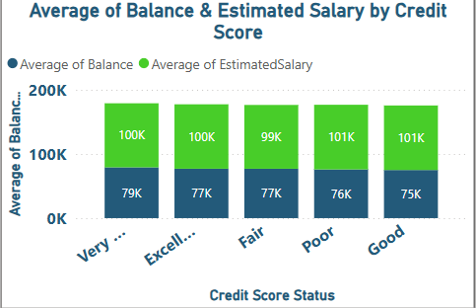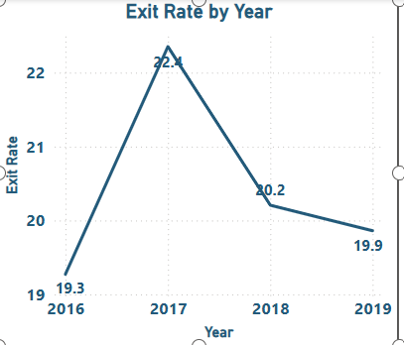  
  
  
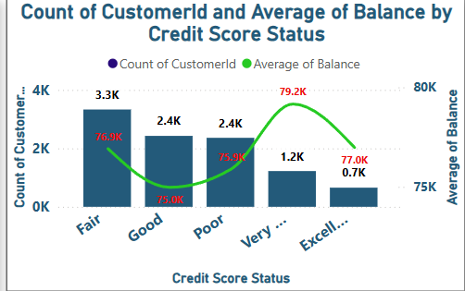  
  
Customer with higher credit score tend to have higher account balance and estimated salary. The customers with Very Good credit score have approximately 79 k balance and 100K estimated salary and the customers with excellent credit score have around 77k average balance and around 100k estimated salary.

**Conclusion:**  By leveraging the insights gained from the analysis of credit scores categories, financial profiles over the time period and the churn rate, the banks can take informative decision so that they can optimize their engagement and marketing strategies and can build long term customer loyalty and relationship.

1. Customer Exit Reasons Exploration: Can you identify common characteristics or trends among customers who have exited that could explain their reasons for leaving?  
     
     
   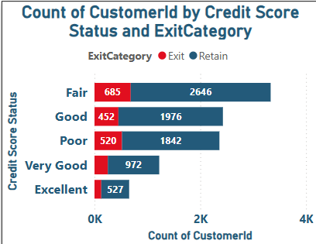  
     
   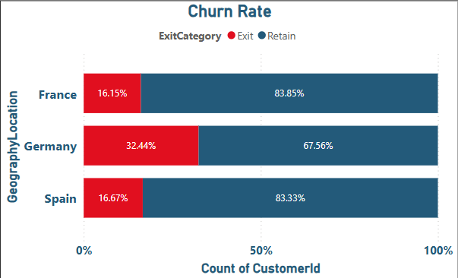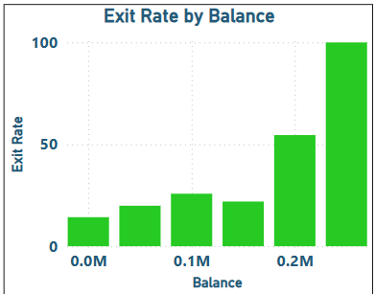  
     
   These are some charts which shows the churn on varying basis. Here we can see the middle aged group of customers has the highest churn rate and also those who have the highest average balance are exiting the bank which indicates that bank may not be sufficient in providing the good interest also they may not have that facilities so they may be switching to other bank where they think their funds will generate an extra income or better interest.

The data suggests that customers with lower credit scores and those in certain geographic regions, particularly Germany, are more likely to churn. Additionally, while the exit rate varied from year to year, it remained relatively stable overall.

1. Are 'Tenure', 'NumOfProducts', 'IsActiveMember', and 'EstimatedSalary' important for predicting if a customer will leave the bank?

Utilize SQL queries to segment customers based on demographics and account details.  
Answer: - **Significance of Tenure in Churn Prediction:**  
The chart indicates that tenure could be a key factor in forecasting customer churn. Newer customers tend to have a higher probability of exiting, as reflected in the distribution of churn across different tenure groups.  
  
  
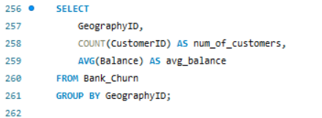

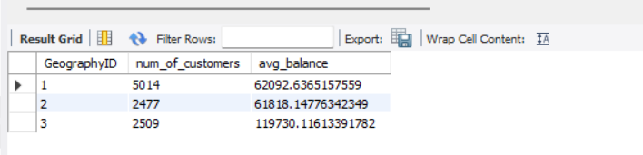  
  
  
  
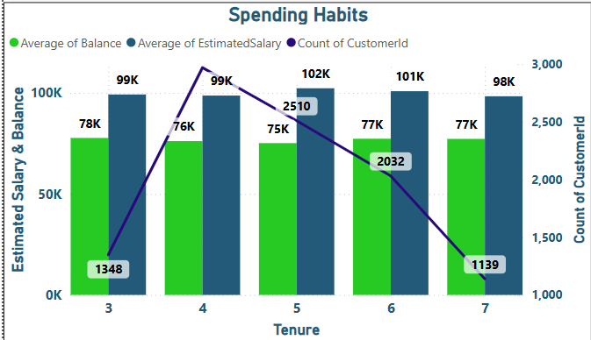  
**Relevance of NumOfProducts in Churn Prediction:**  
The chart does not indicate a strong correlation between the number of products and customer churn, as the exit rates fluctuate across different product categories.

* **Customer Needs:** Customers using multiple products may have their financial needs better addressed, leading to higher satisfaction and lower churn.
* **Account Management Complexity:** Handling multiple products can be overwhelming for some, potentially increasing the likelihood of churn.

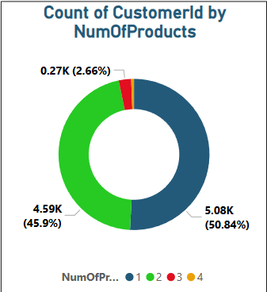  
**Significance of IsActiveMember in Churn Prediction:**  
The distribution of exited customers across active and inactive categories determines the predictive strength of this factor:

* **Strong Indicator:** If inactive members show a significantly higher churn rate, IsActiveMember is a key predictor.
* **Weaker Indicator:** If exit rates are similar for both active and inactive members, it may not be a strong standalone predictor.

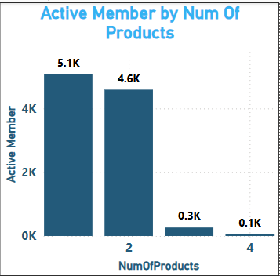  
  
**Significance of EstimatedSalary in Churn Prediction:**  
Customers with higher credit scores generally have higher account balances and estimated salaries. For example, those with a Very Good credit score typically hold around **79K balance** and **100K estimated salary**. However, these factors alone are not reliable predictors of churn. As observed earlier, balance alone does not determine churn rate, indicating the need to consider multiple factors for accurate prediction.

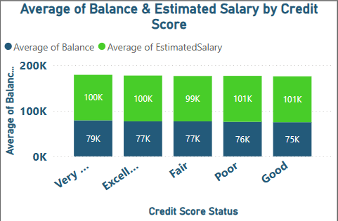

1. How can we create a conditional formatting setup to visually highlight customers at risk of churn and to evaluate the impact of credit card rewards on customer retention?  
   Answer:- Applying Conditional Formatting in Power BI for Churn Risk and Credit Card Impact

To highlight customers at risk of churn and assess the influence of credit card rewards on customer retention, follow these steps:

Create a Table Visualization in Power BI.  
Add the Following Fields:

CustomerId

Category (indicates whether the customer has a credit card)

ActiveCategory (filtered to show only “Active Member” records)

Sum of Balance  
Sum of EstimatedSalary  
Apply Conditional Formatting:

For the "Sum of Balance" column, apply magenta color formatting for customers with low account balances to highlight those at risk of churn.This approach helps in visually identifying high-risk customers and evaluating the impact of credit card rewards on customer retention.  
  
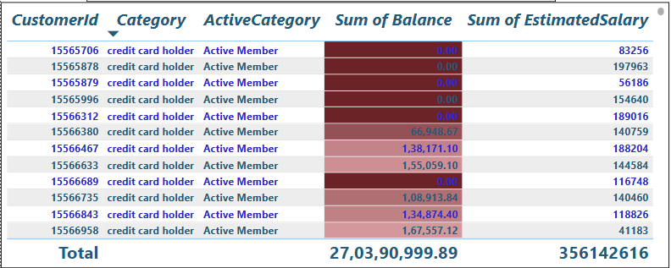

1. What is the current churn rate per year and overall as well in the bank? Can you suggest some insights to the bank about which kind of customers are more likely to churn and what different strategies can be used to decrease the churn rate?  
   Answer:-   
     
   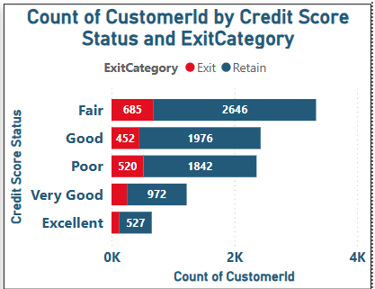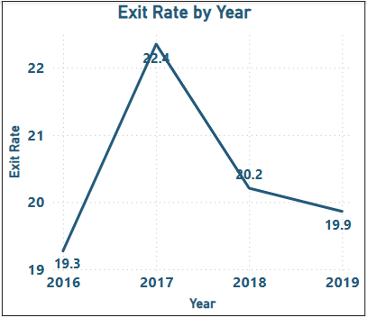  
   Insights

Credit Score Range Analysis:

Customers with lower credit scores, especially in the Bad and Poor categories, had a higher likelihood of exiting the bank.

This indicates that customers facing financial difficulties or past credit issues may be more prone to churn.

Temporal Analysis:

The exit rate fluctuated over the years, peaking in 2017 and reaching its lowest in 2019. Despite yearly variations, the average exit rate remained 20.45% over the four-year period.

Conclusion  
Customers with low credit scores and those in specific regions (notably Germany) exhibit a higher churn rate.Although yearly trends showed some fluctuations, the overall exit rate remained stable.  
  
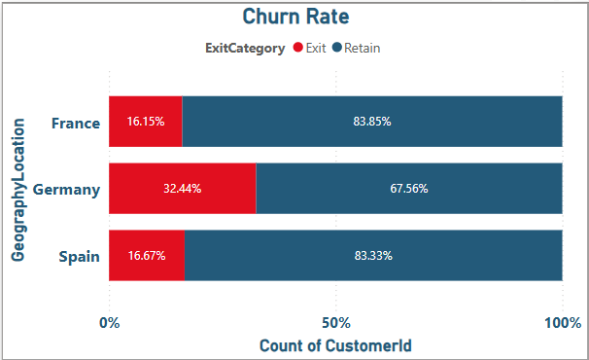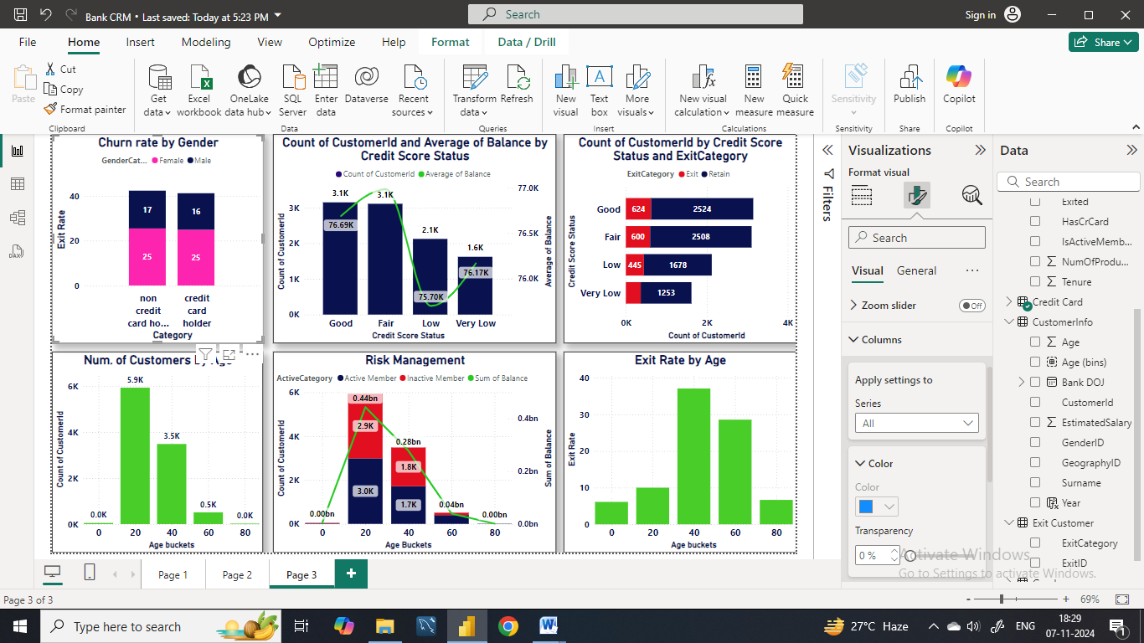  
Recommendations

Segmentation & Targeted Marketing

Use customer segmentation to identify high-risk groups, such as low-credit-score customers or those in high-churn regions.

Implement personalized marketing campaigns to address their specific needs and improve retention.

Regional Strategies

Address challenges in high-churn regions by improving customer service, expanding product offerings, and collaborating with local organizations to enhance customer experience.

Customer Engagement Programs

Launch personalized offers, loyalty rewards, and proactive communication strategies to boost engagement and reduce churn.

Continuous Monitoring

Regularly track churn rates and customer feedback to detect trends early and adjust strategies accordingly.

A data-driven approach ensures proactive retention efforts.

Credit Score Improvement

Provide financial literacy resources and credit-building tools to help customers improve their scores.

Empowering customers financially can reduce churn risk among lower-credit-score segments.

1. Create a dashboard incorporating all the KPIs and visualization-related metrics. Use a slicer in order to assist in selection in the dashboard.  
     
   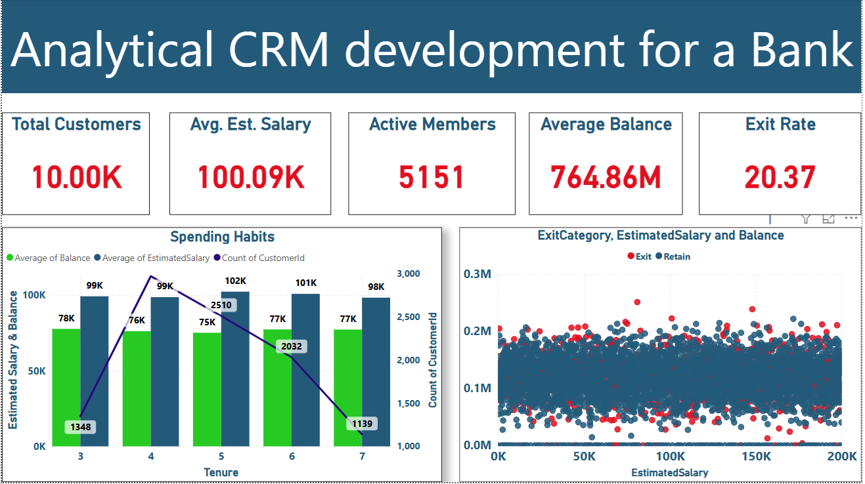  
     
   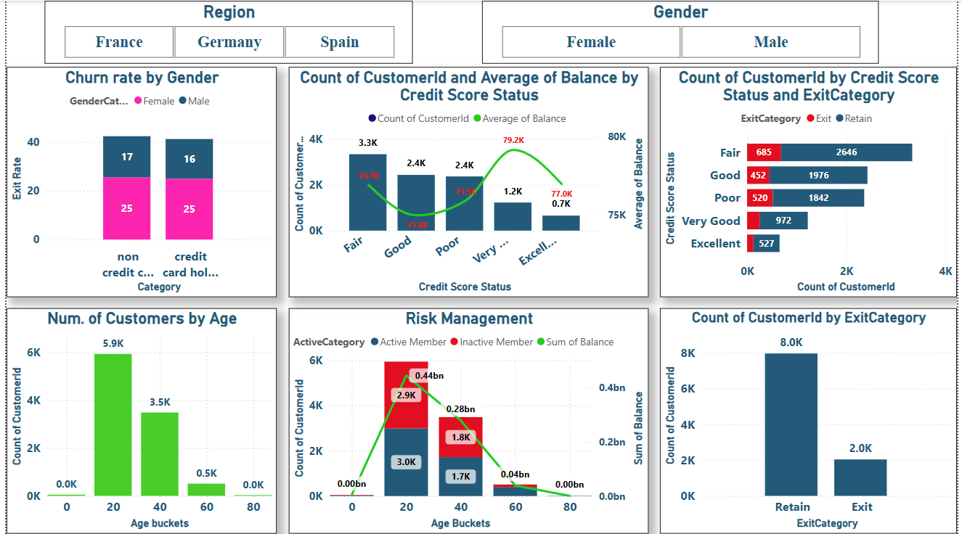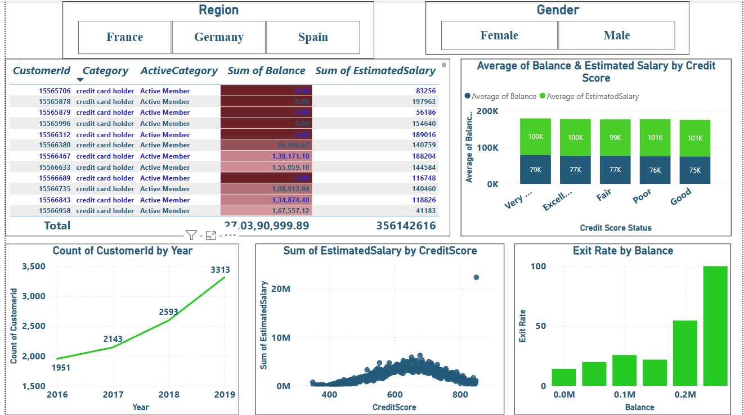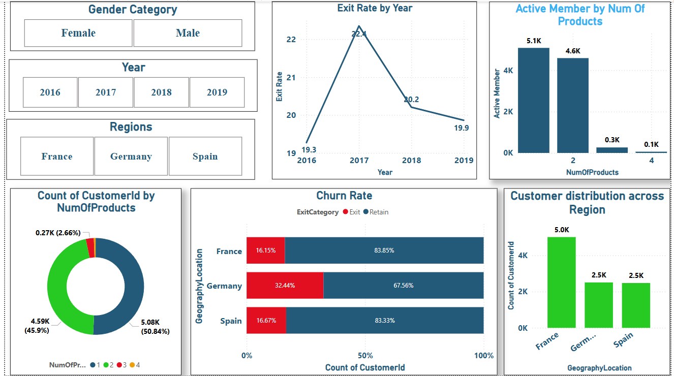
2. How would you approach this problem, if the objective and subjective   
   questions weren't given?  
   Answer:- Structured Approach to Problem Solving  
   1. Formulating Hypotheses  
   Begin with assumptions about the data or problem based on industry knowledge and initial observations.  
   Develop hypotheses to guide the analysis.  
   2. Key Questions to Explore  
   Customer Churn Analysis:  
   Does balance and estimated salary influence churn?  
   Do age or region impact bank churn rates?  
   Is there a correlation between credit scores and churn rate?  
   Marketing Campaign Analysis:  
   Which marketing channels are most effective?  
   Is there a correlation between ad expenditure and customer acquisition over the years?  
   What is the impact of marketing campaigns?  
   Does advertisement spending influence the churn rate?  
   Data Analysis & Visualization

Perform statistical analysis and visualizations to validate or refute hypotheses.  
Insights & Recommendations  
Extract actionable insights to improve customer retention, marketing strategies, and business performance.  
Use data-driven recommendations for better decision-making.  
  
**13.** In the “Bank_Churn” table how can you modify the name of the “HasCrCard” column to “Has_creditcard”?  
Answer: -  
SQL Query to change the column name:

Alter table bank_churn

Change Column HasCrCard Has_creditcard int;