SOC-Analysis Report

LogHawk –
Cloud-Hosted Application Security Monitoring
This report documents the analysis of a simulated brute-force attack detected through authentication log monitoring on a cloud-hosted application deployed on AWS EC2.



Prepared by: Vishali
Role: SOC Analyst / Cloud Security Analyst (Student Project)
Date: 21/12/ 2025
Overview
This report documents the analysis of authentication logs and suspicious activity observed on a cloud-hosted application. The investigation focuses on identifying and validating a simulated brute-force attack against the application’s login functionality.

The objective of this report is to demonstrate how log analysis, threshold-based detection, and SOC-style investigation are used to detect and assess security incidents in a cloud environment.

Environment Context
The application analysed in this report is hosted on an AWS EC2 instance running Ubuntu Linux. The server is assigned a public IP address, making the application accessible over the internet.
Because the application is internet-facing, it is exposed to common attacks such as brute-force login attempts. This setup closely resembles real-world cloud environments where public access increases the attack surface and requires continuous security monitoring.

Log Sources
The primary log source used for this investigation is the application authentication log file (auth.log). This log records all login attempts made to the application.
Each log entry includes:
- Username entered
- Source IP address
- Timestamp
- Login result (success or failure)
These logs are critical for SOC monitoring because they provide visibility into user behaviour and potential attack patterns.

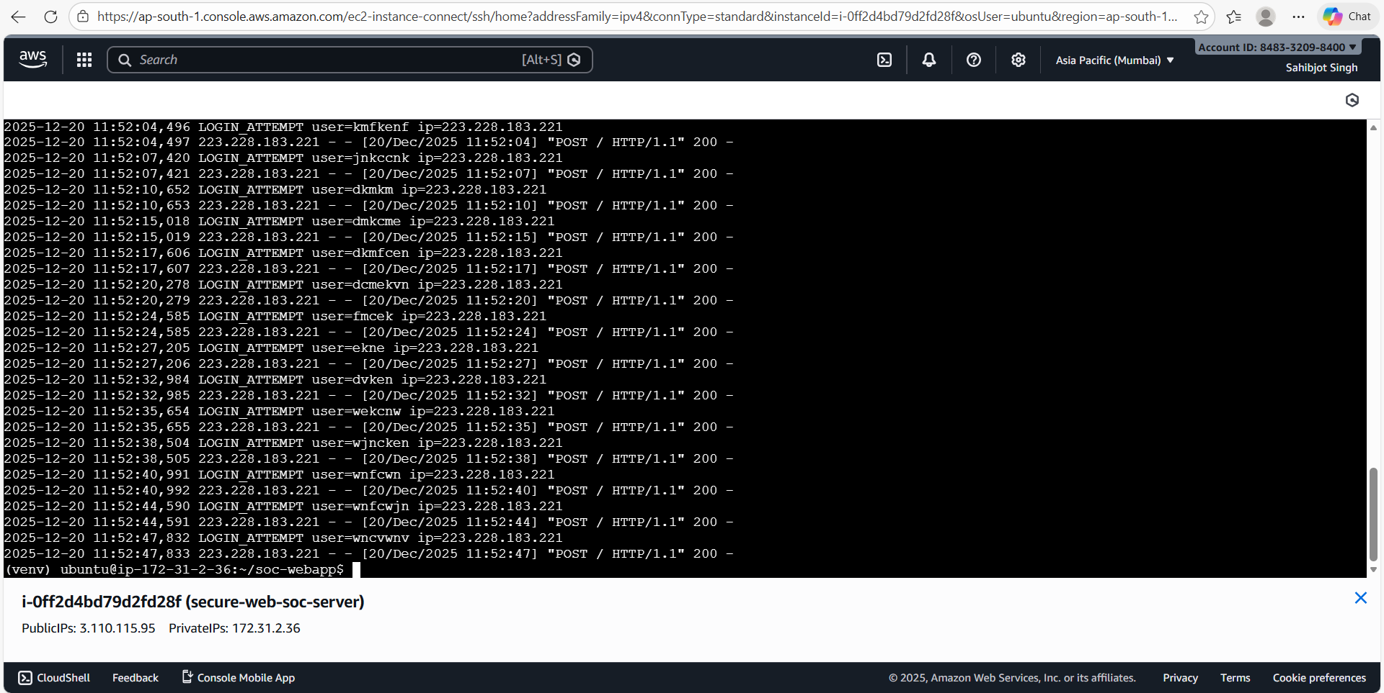
Application authentication logs (auth.log) showing multiple login attempts recorded on the cloud server.

Threat Description – Brute-Force Attack
A brute-force attack is a common authentication attack where an attacker repeatedly attempts different username or password combinations to gain unauthorized access.
In cloud-hosted applications, login endpoints are frequent targets because they are publicly accessible. Brute-force attacks are usually characterized by multiple rapid logins attempts from the same source within a short time period.
In this project, such behaviour was simulated to test detection and monitoring capabilities.

Detection Methodology
Detection of the brute-force activity was performed using a threshold-based approach.
A Bash script was used to analyse recent authentication log entries and count the number of login attempts. When the number of login attempts exceeded a predefined threshold, the activity was considered suspicious.
This detection approach is similar to how SIEM platforms apply correlation rules to identify abnormal patterns in authentication logs.
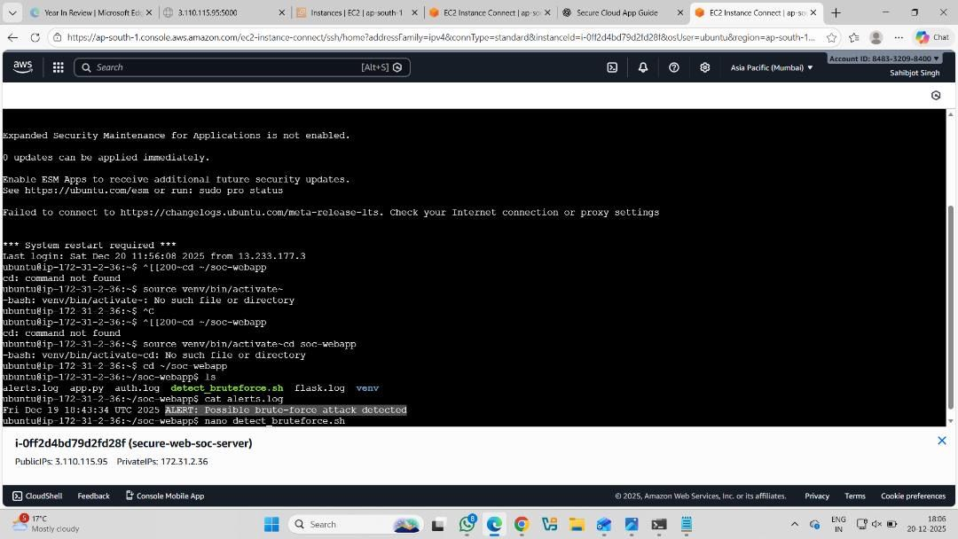
Bash-based detection script used to analyse authentication logs and trigger alerts.

Alert Details
When the defined threshold was exceeded, an alert was generated and written to an alert log file (alerts.log).
The alert indicates a possible brute-force attack and acts as a signal for the SOC analyst to begin further investigation. This alerting mechanism simulates SIEM-style alert generation in a simplified form.

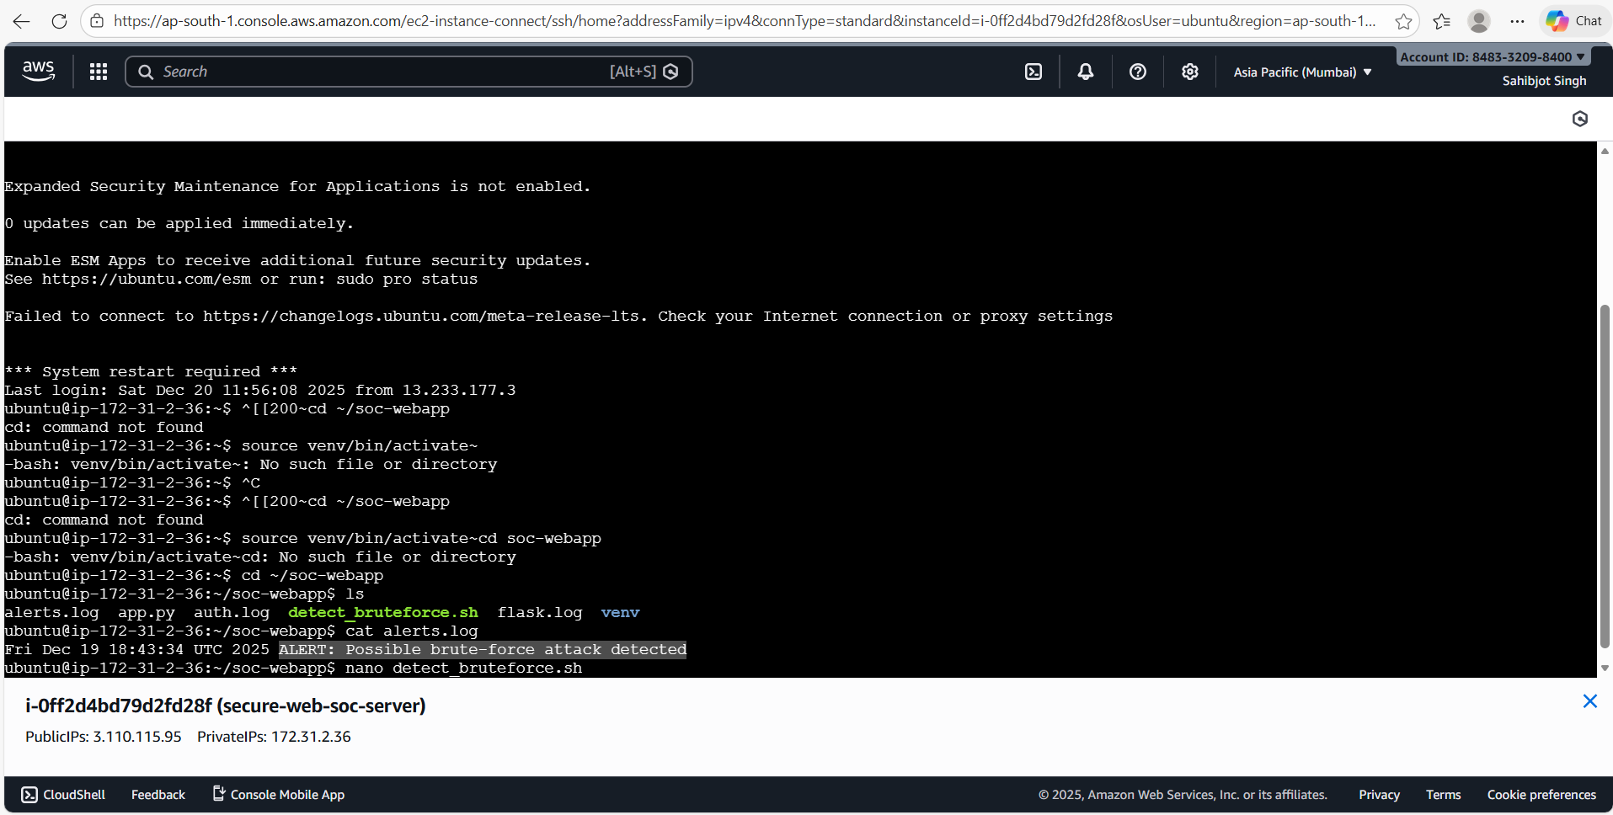
Alert generated after authentication activity exceeded the defined threshold, indicating a possible brute-force attack.

Incident Timeline
The following sequence of events was observed during the incident:
- Normal login activity was recorded in the authentication logs
- Multiple failed login attempts were observed within a short period
- The number of login attempts crossed the detection threshold
- An alert was generated indicating possible brute-force activity
- The SOC analyst reviewed the related log entries
This timeline helped confirm that the activity was abnormal and not part of normal user behaviour.

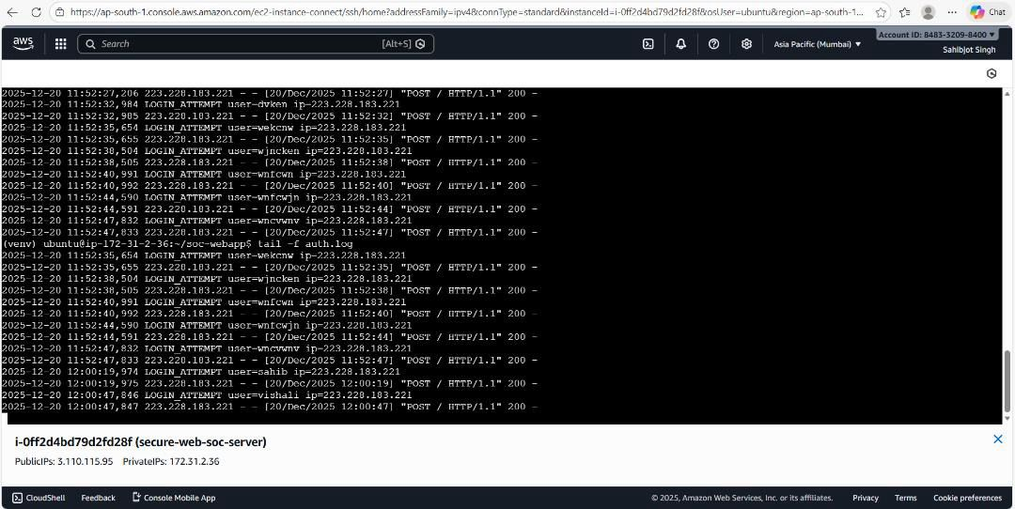
Real-time monitoring of authentication logs using log tailing on the EC2 instance.

Analyst Investigation
After the alert was generated, the SOC analyst manually reviewed the authentication logs to validate the incident.
The investigation involved:
- Identifying repeated login attempts from the same source
- Reviewing timestamps to confirm rapid activity
- Confirming multiple failed authentication attempts
Based on this analysis, the activity was classified as a brute-force login attempt.

Severity Assessment
The incident was assessed as Medium severity.
While the attack did not result in a successful login, brute-force attempts pose a significant risk if left undetected. Repeated attempts can eventually lead to credential compromise or service disruption.
Early detection reduced the potential impact of the attack.

Response & Recommendations
The following response actions are recommended:
- Block or rate-limit the attacking IP address
- Implement stronger authentication controls such as account lockout
- Monitor authentication logs continuously for repeat attempts
- Review and harden SSH access to reduce administrative risk
These measures help reduce the likelihood and impact of similar attacks in the future.

SOC Learnings
This analysis highlights the importance of log monitoring and threshold-based detection in cloud environments.
Key learnings include:
- Public cloud applications are frequent targets of brute-force attacks
- Authentication logs are a valuable source of security data
- Simple detection logic can effectively identify suspicious behaviour
- SOC investigation and validation are essential before taking response actions

