Exp.No: 10 Vishalini.R

231701062

**Creating a 3D Model in Blender**

**Aim:**

To create a simple 3D model (e.g., a house) using Blender and apply basic shading and textures to the model.

**Procedure:**

1. Open Blender → Select the default cube (already present in new project).
2. Scale or Move the cube if needed:

* Press S to scale, G to move, R to rotate.

1. Add Material:

* Go to Material Properties (sphere icon on right panel).
* Click New, choose a color in Base Color.

1. Apply Basic Shading:

* Right-click on cube → Shade Smooth (optional).

1. Add Light (if not present):

* Shift + A → Light → Point/Sun → position it so cube is well lit.

1. Render:

* Go to Render → Render Image.
* Save rendered image (Image → Save As).

**Output:**

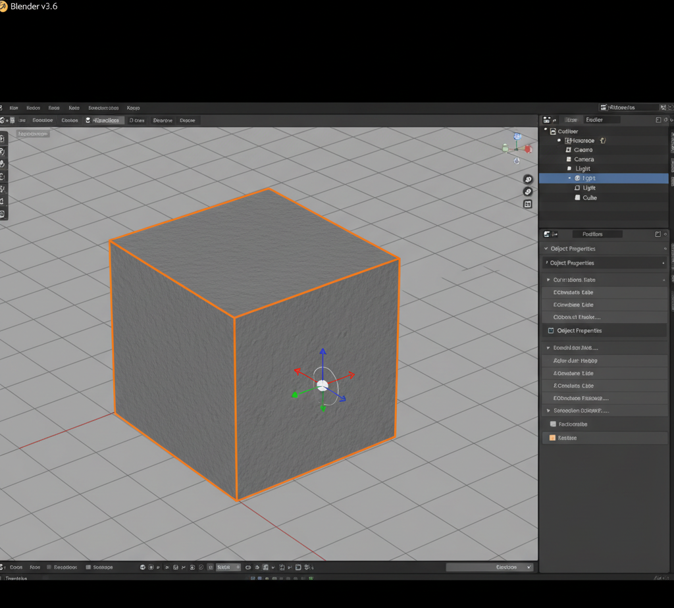

**Result:**

A simple 3D cube was created in Blender. Material color and basic shading were applied, and the cube was rendered successfully.