# EXPERIMENT - 3

Write a program that performs translation, scaling, and rotation on basic 2D shapes (e.g.. triangle, rectangle) using matrices.

***Translation***

import numpy as np

import matplotlib.pyplot as plt

def transform(points, matrix):

return np.dot(matrix, points)

triangle = np.array([[0, 1, 0.5, 0],

[0, 0, 1, 0],

[1, 1, 1, 1]])

T = np.array([[1, 0, 2],

[0, 1, 1],

[0, 0, 1]]

triangle_translated = transform(triangle, T.T)

plt.plot(triangle[0], triangle[1], 'b-', label='Original')

plt.plot(triangle_translated[0], triangle_translated[1], 'r-', label='Translated')

plt.legend()

plt.axis('equal')

plt.grid(True)

plt.show()

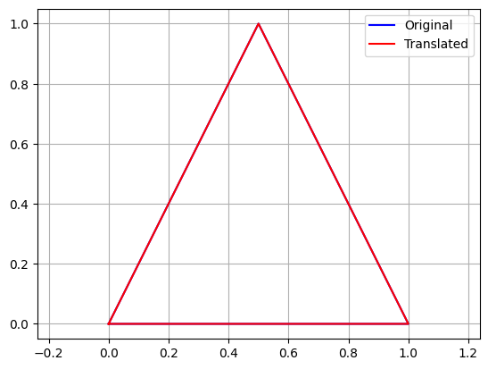

***Scaling:***

import numpy as np

import matplotlib.pyplot as plt

def transform(points, matrix):

return np.dot(matrix, points)

triangle = np.array([[0, 1, 0.5, 0],

[0, 0, 1, 0],

[1, 1, 1, 1]])

# Scaling matrix (sx=2, sy=1.5)

S = np.array([[2, 0, 0],

[0, 1.5, 0],

[0, 0, 1]])

triangle_scaled = transform(triangle, S.T)

plt.plot(triangle[0], triangle[1], 'b-', label='Original')

plt.plot(triangle_scaled[0], triangle_scaled[1], 'g-', label='Scaled')

plt.legend()

plt.axis('equal')

plt.grid(True)

plt.show()

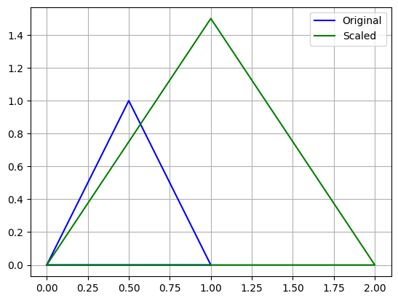

***Rotation:***

import numpy as np

import matplotlib.pyplot as plt

def transform(points, matrix):

return np.dot(matrix, points)

triangle = np.array([[0, 1, 0.5, 0],

[0, 0, 1, 0],

[1, 1, 1, 1]])

theta = np.radians(45)

R = np.array([[np.cos(theta), -np.sin(theta), 0],

[np.sin(theta), np.cos(theta), 0],

[0, 0, 1]])

triangle_rotated = transform(triangle, R.T)

plt.plot(triangle[0], triangle[1], 'b-', label='Original')

plt.plot(triangle_rotated[0], triangle_rotated[1], 'm-', label='Rotated 45°')

plt.legend()

plt.axis('equal')

plt.grid(True)

plt.show()

