**Project – Easily (NodeJS Project)**

A job portal that allows recruiters to post and manage job listings and provides a user-friendly platform for job seekers to find and apply for suitable roles.

I have implemented this project using MVC (Model View Controller) architecture with ExpressJS. I have separated the controllers, models, views and middlewares. I have used EJS templates to provide dynamic HTML pages. I have also used ES6 modules to maintain code modularity, organization and performance.

**Home-Page**



* If you click on “I’m a JobSeeker”, it takes you to the ‘Job Listings’ page.
* If you click on “I’m a Recruiter”, it takes you to the ‘Login/Register’ page.

**JobListings Page**

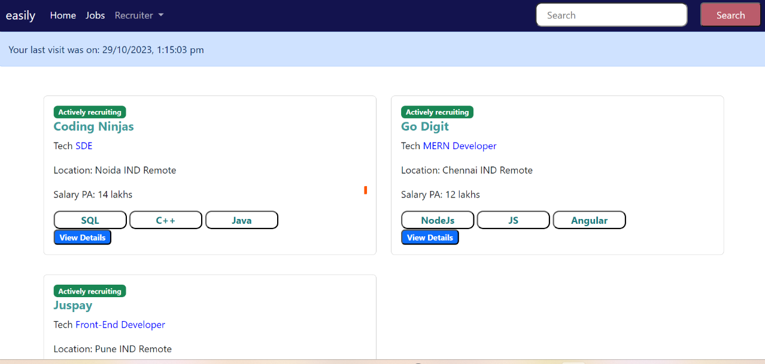

* In this page, I have used cookies to display the last visited date and time of the user.
* All jobs are listed in cards. Each with details like Company name, Location,Total positions etc.,
* As a jobseeker,
* You can go the job listings page
* You can view details of a job (edit and delete buttons will not be visible for a jobseeker)
* Apply to a job
* I have used authentication middleware to prevent jobseeker from
  + Posting a new job
  + Viewing the applicants of a job

**View Details** **Page**

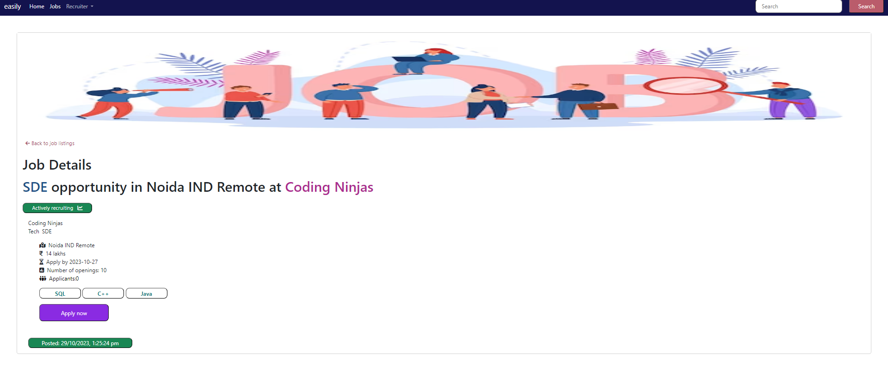

**Apply Now page**

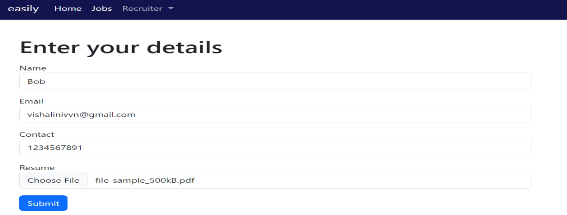

* I have added form validation middleware to validate the values entered in the form.

**Application success page**

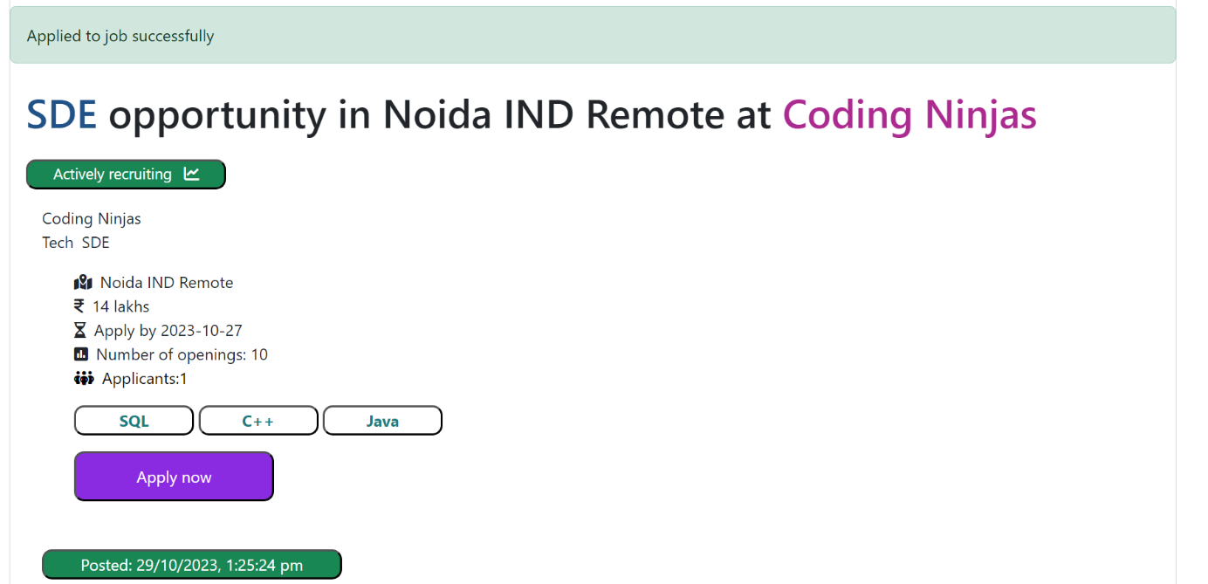

* Now, applicants count changed to 1 from 0.
* After the applicant has applied to job successfully, a confirmation email is sent to the given mail id using nodemailer. This is again done by a middleware.
* Also, I have used Multer in file upload middleware for uploading resume.

**Email Confirmation**

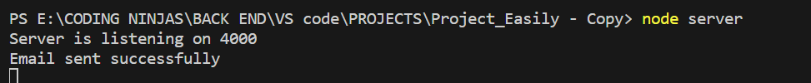

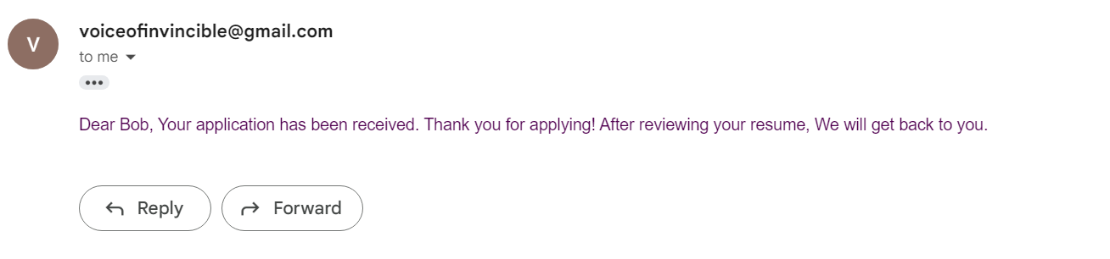

* If a jobseeker tries to access the post new job/applicants page  
  it displays 404 error page.



As a recruiter,

* You should register and login to access extra privileges to post/edit/delete a job.
* After logging in, it takes you to the Job listings page. The button changes from login to logout.
* I have also implemented sessions using ‘express-session’. After logging out, the session gets cleared.
* You can view the applicants of a job.
* You can also view the resume submitted by the applicant.
* You can also add/update/delete details of an applicant
* I have added prompts for updating/deleting details of job/applicants to avoid accidental modification.

**Login page**

* After logging in, the session is created and after logging out it is destroyed.

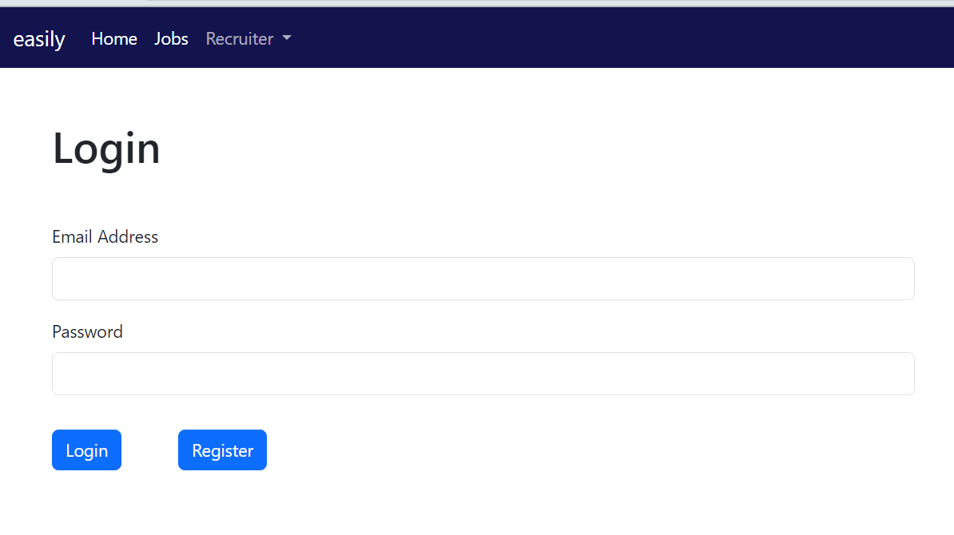

**Job Listing Page**

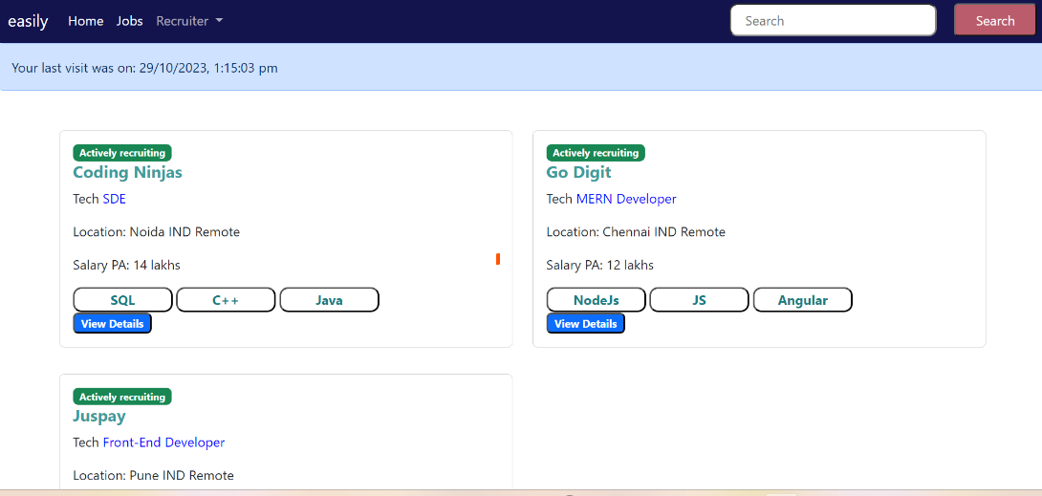

**Post a new job page**

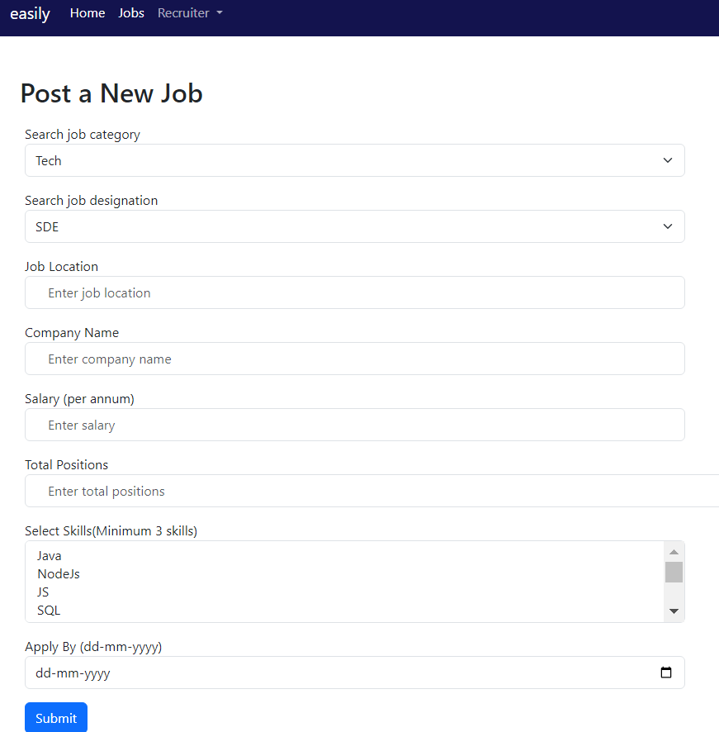

* I have used form validation middleware to validate the values.

**View-details page**

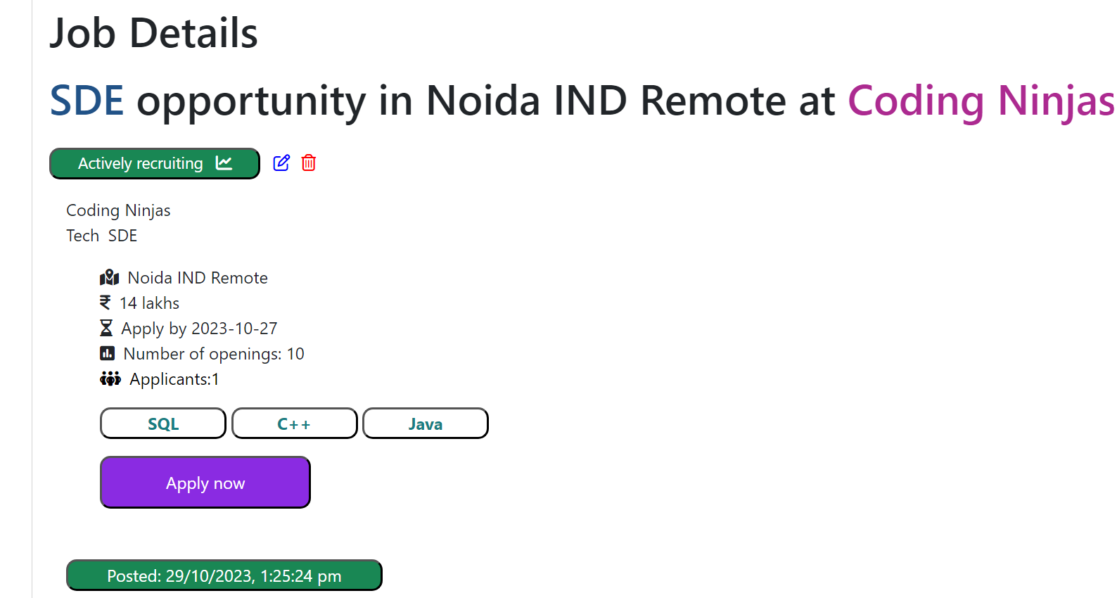

* Only after logging in you will see the edit and delete buttons in the view details page.

**Update job page**

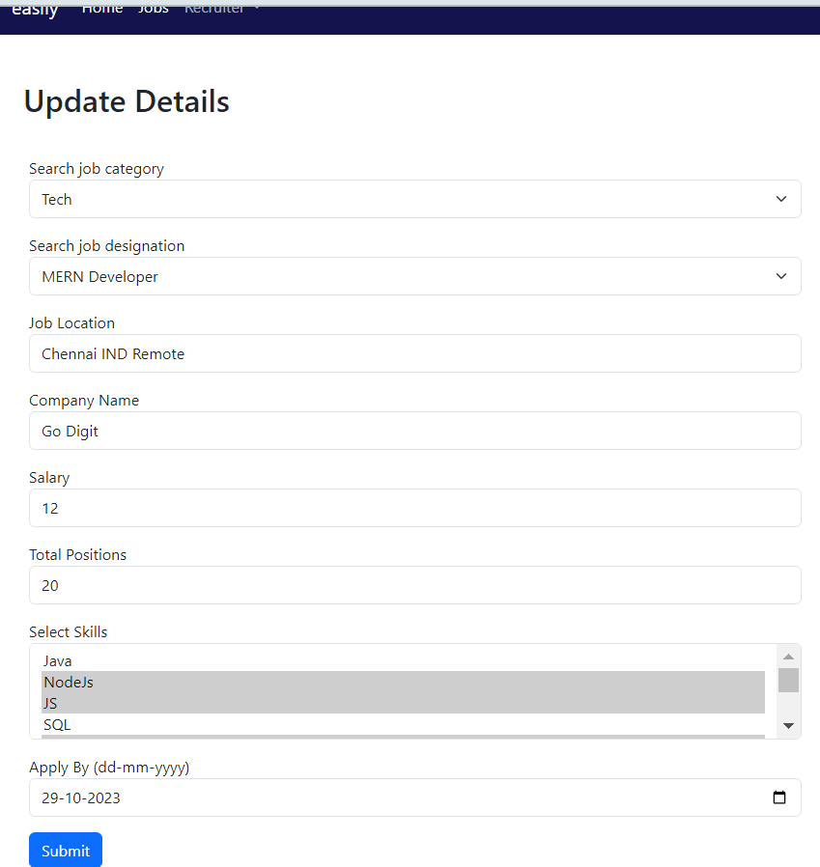

* If you click on submit, it will prompt a confirmation.

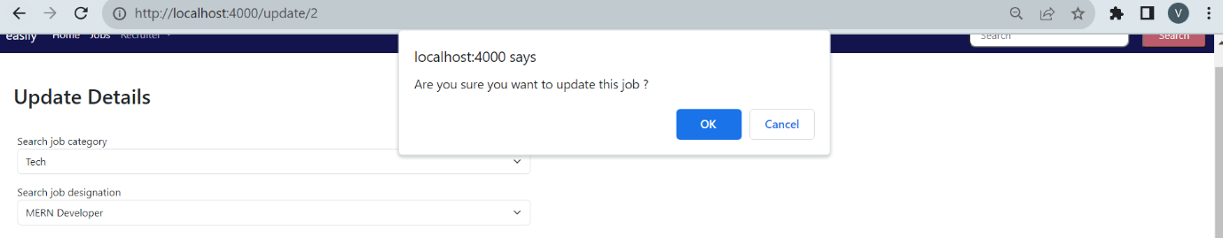

* Similarly, it prompts a confirmation for delete as well.

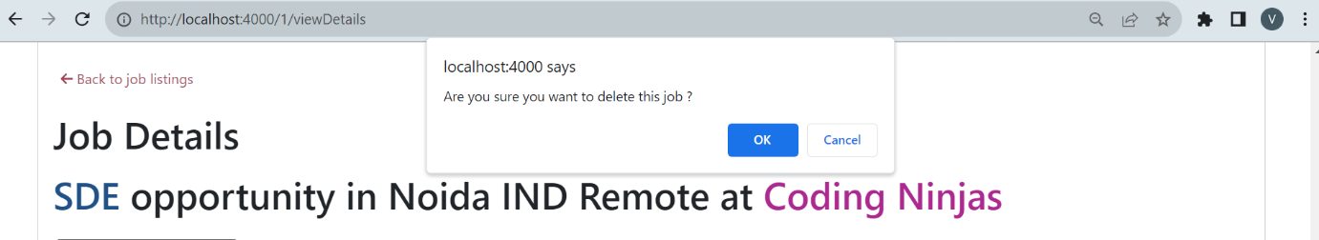

* After successful deletion, it takes you to the job listings page.

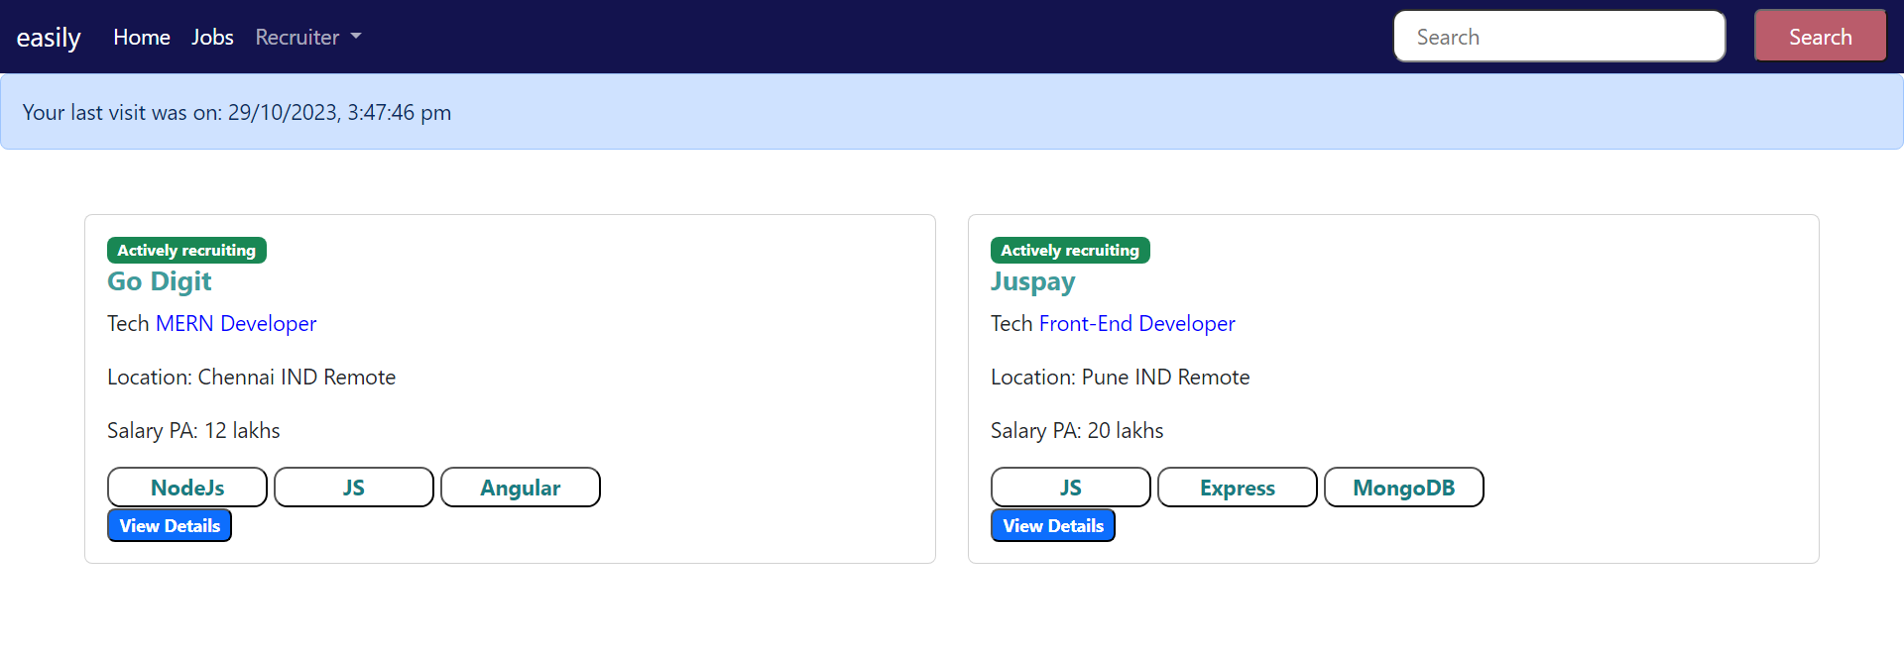

**Applicants page**

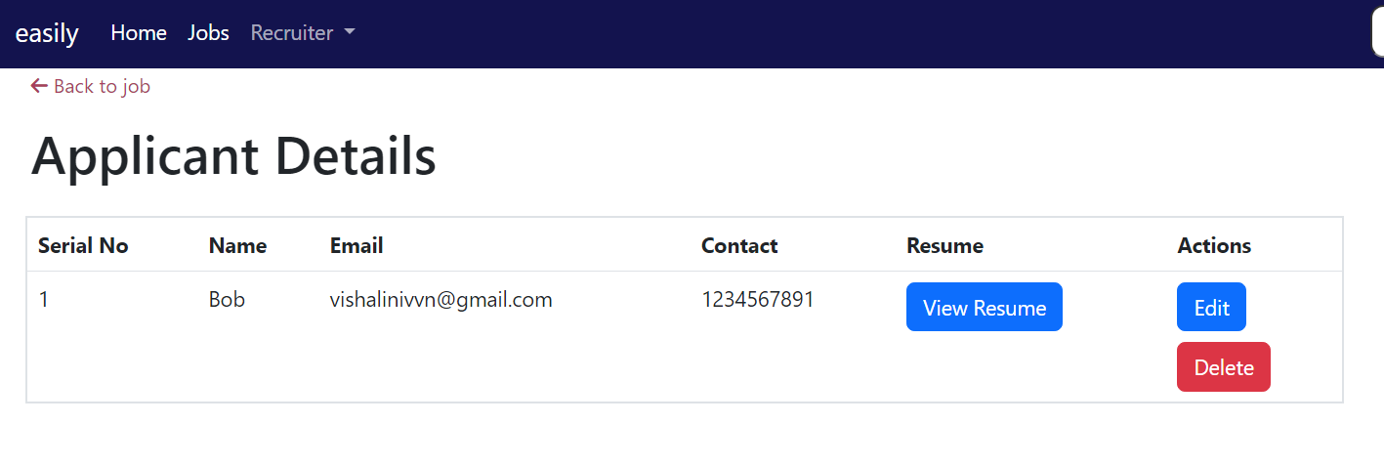

* You can view the resume submitted by the jobseeker when you click on view resume button
* You can also edit/delete details of an applicant.
* Similar prompts are used here as well.

**Update applicant page**

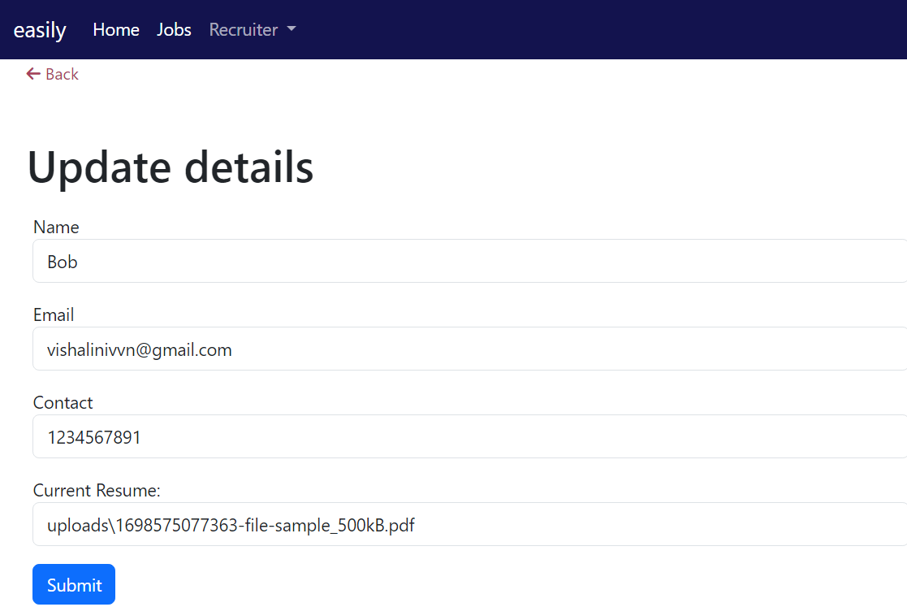

* If you click on submit, a prompt will be displayed to confirm your updation.
* Similarly, it will prompt for delete as well.

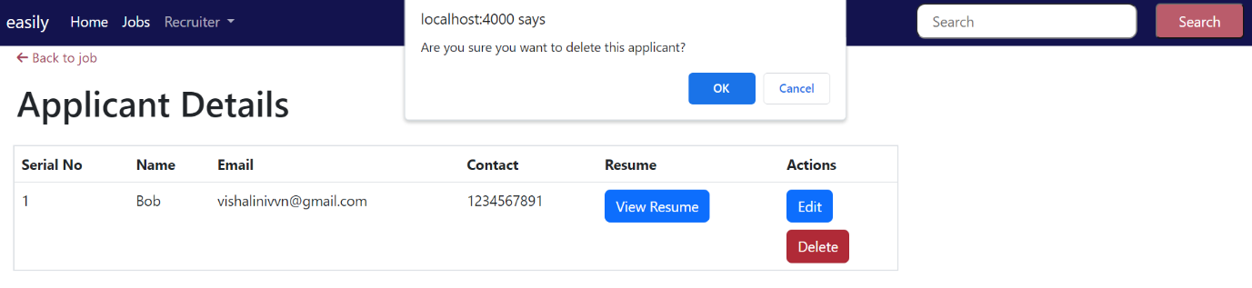

**Additional functionalities**

**Filter**

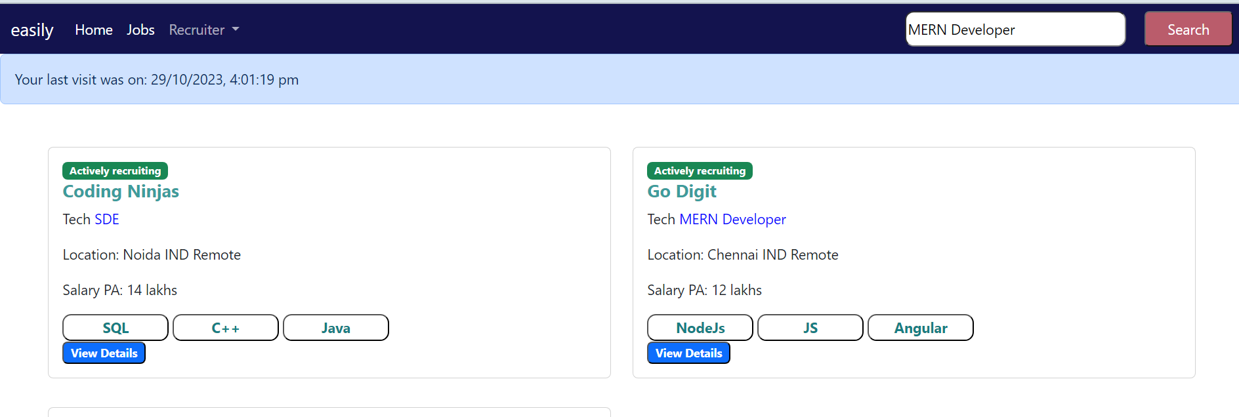

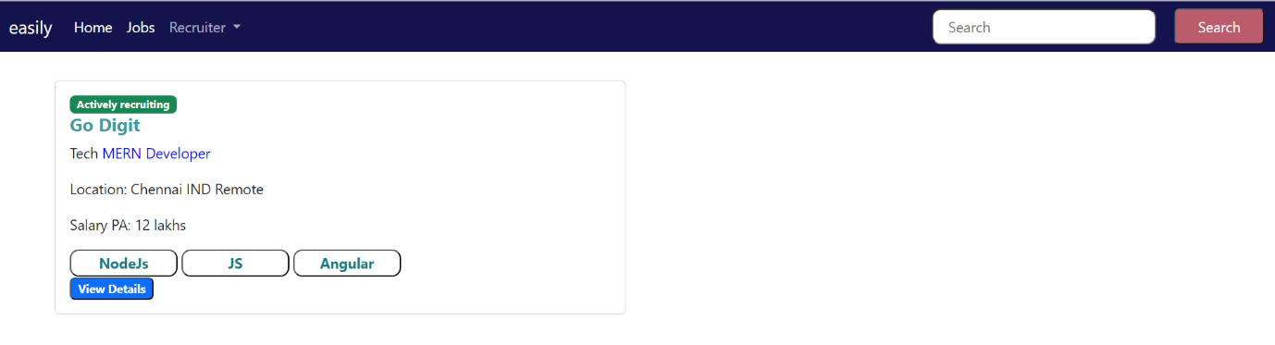

* I have implemented filter using job designation.
* **Middlewares** used for
* **File Upload**
* **Cookie and Sessions**
* **Sending Email**
* **Authentication**
* **Common Validation**
* I have implemented pagination where I have provided easy navigation across pages.
* I have implemented resource-based authorization using the authentication middleware so that only the recruiter who posted a job can update or delete it.