Name:V.Vishalini

Associate Id:765770

Mail id:765770@cognizant.com

GithubLink:https://github.com/VishaliniVenkatesh/StockExchangeMilestone_1

Schema Diagram

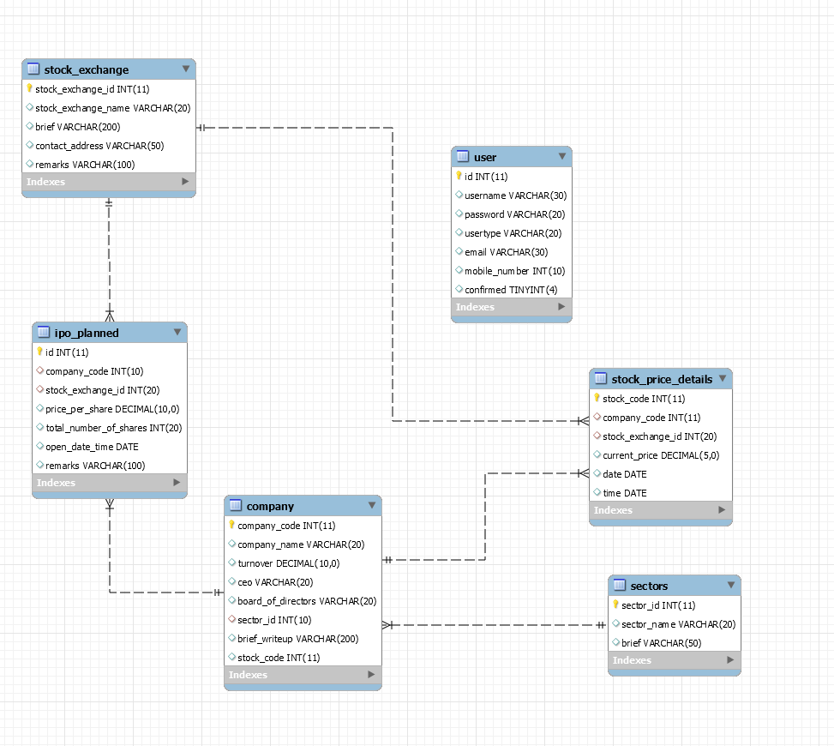

SignUp.html

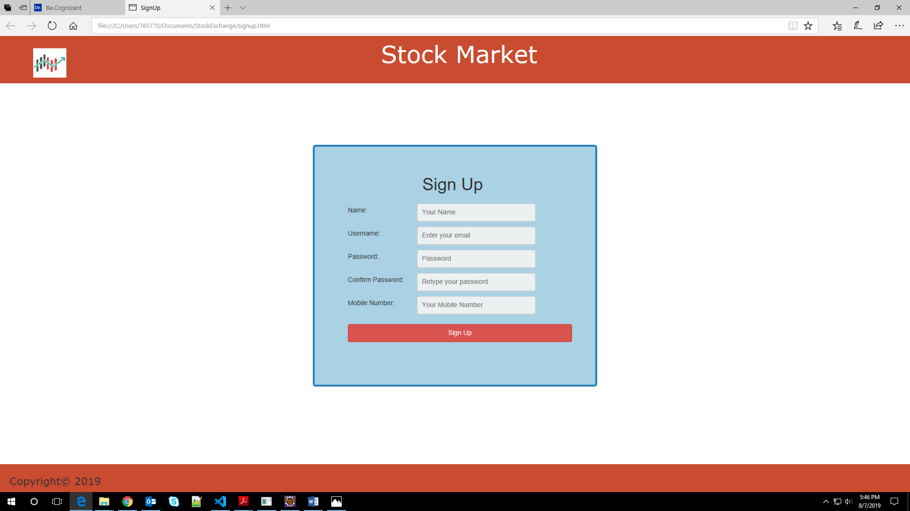

Login.html

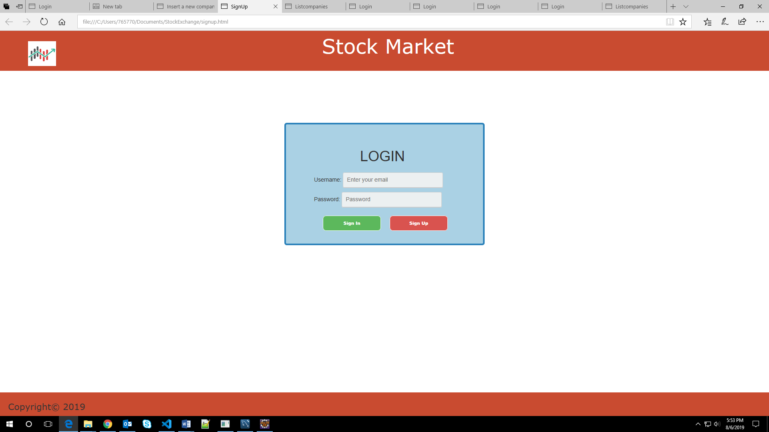

adminLandingPage.html

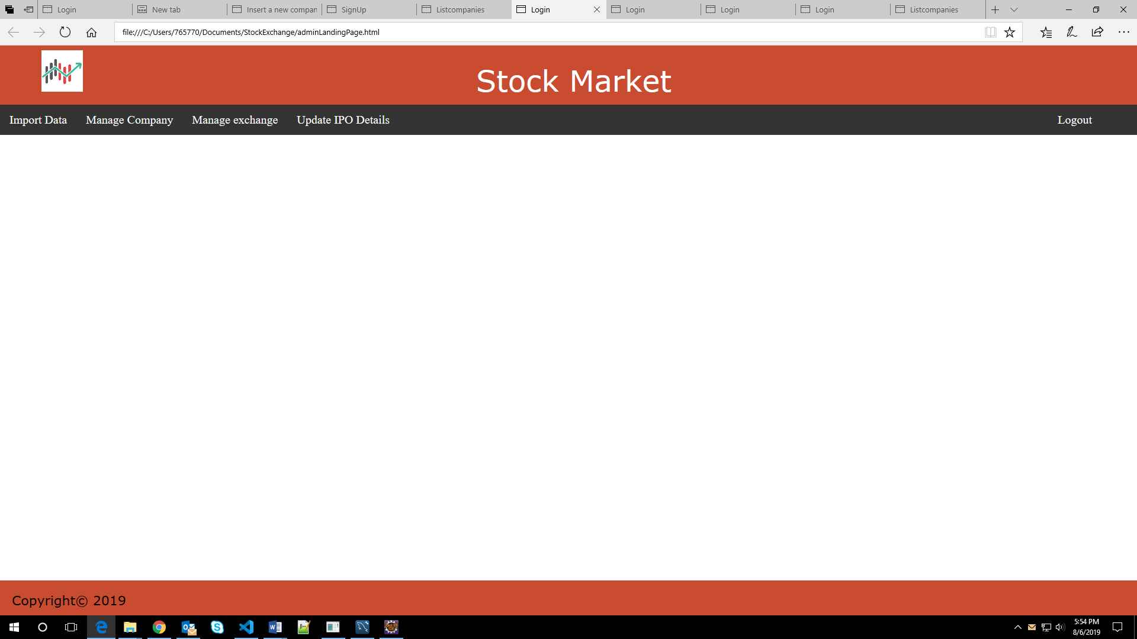

importStockPage.html

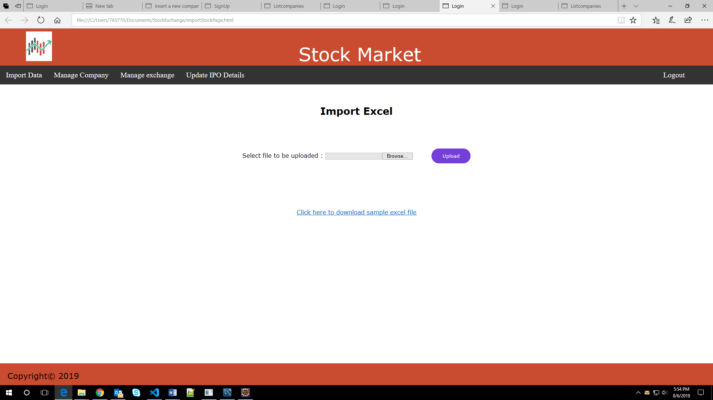

stockDetailsPage.html

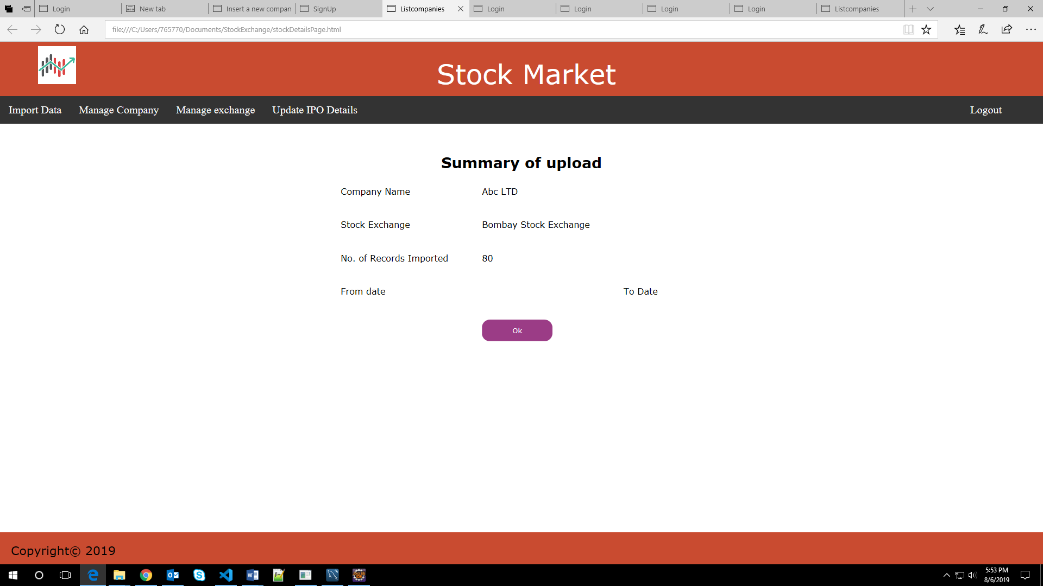

insertCompanyPage.html

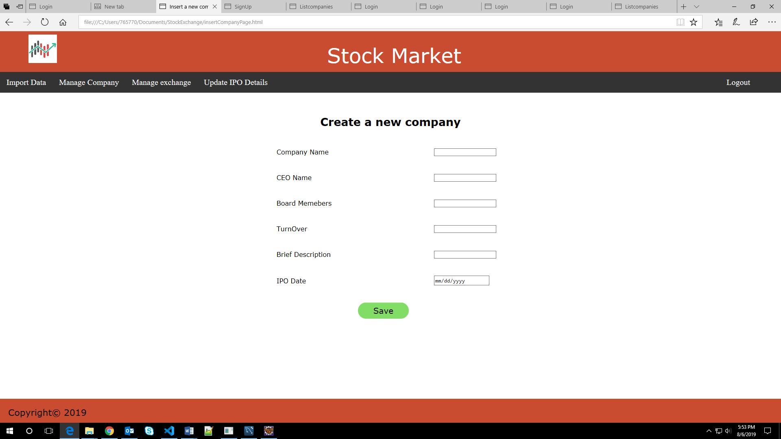

listCompanyPage.html

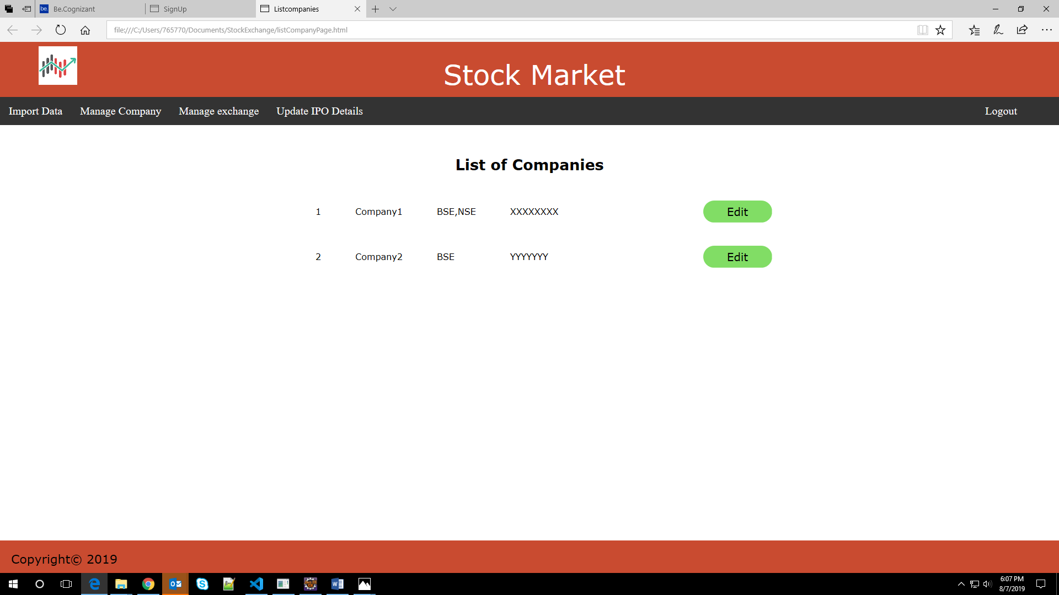

UserLandingPage.html

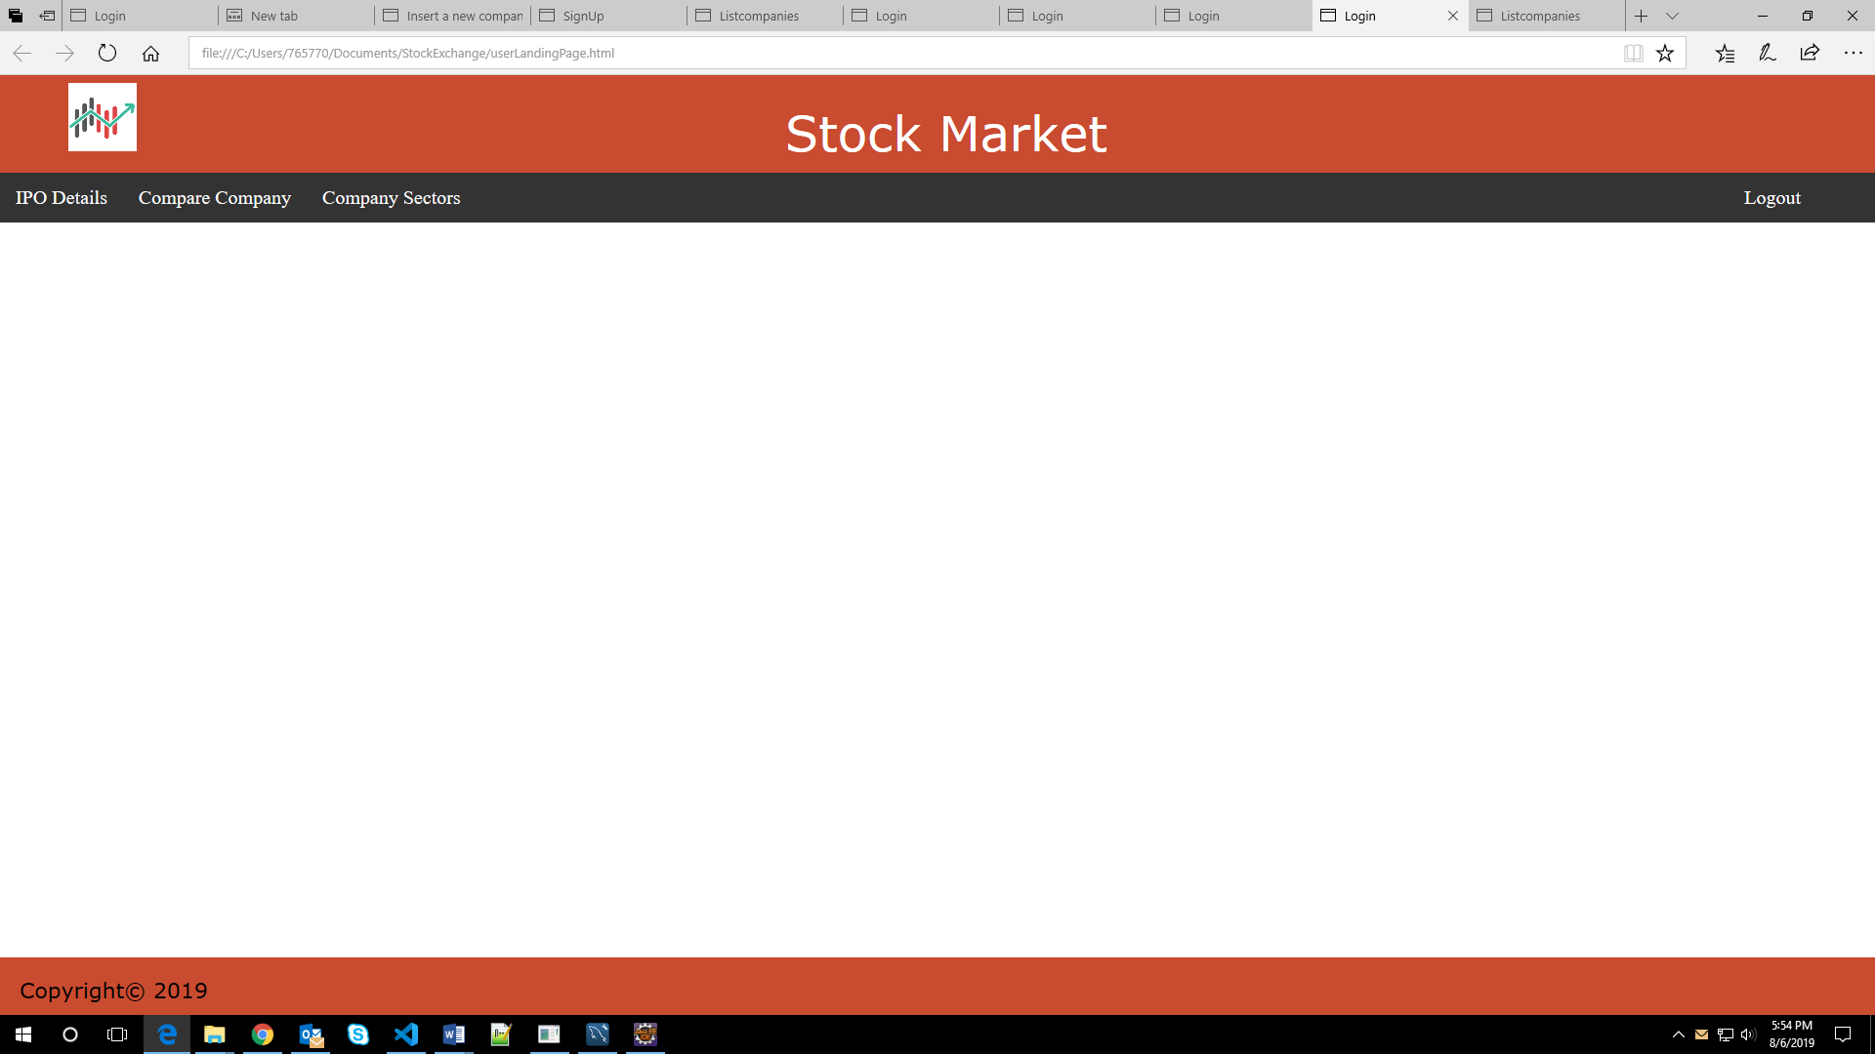

comparisonPage.html

