Lab Sheet: 1
Objective:
- To design ER diagrams and convert entities and relationships into relational tables using proper schema notation.
Instructions:
- Open your preferred Database Management System (DBMS) tool.
- Create a new database named DBMS_YourName.
- Draw ER diagrams for the given scenarios.
- Convert entities and relationships into relational schemas.
- Create tables using the derived schemas.

Relational Schema

PART A – COLLEGE DATABASE
STUDENT ( USN, SName, Address, Phone, Gender )
SEMSEC ( SSID, Sem, Sec )
CLASS ( USN, SSID )
SUBJECT ( Subcode, Title, Sem, Credits )
IAMARKS ( USN, Subcode, SSID, Test1, Test2, Test3, FinalIA )

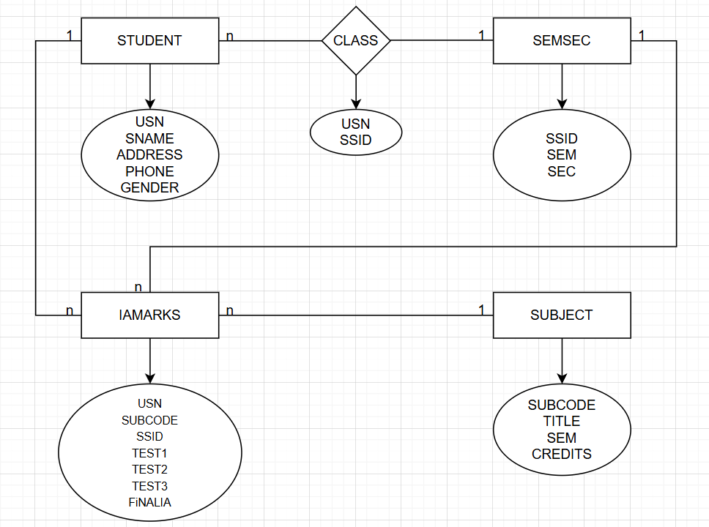
CREATE DATABASE DBMS_ALISA;
USE DBMS_ALISA;

CREATE TABLE STUDENT (
USN VARCHAR(20) PRIMARY KEY,
SName VARCHAR(50),
Address VARCHAR(100),
Phone VARCHAR(15),
Gender VARCHAR(10)
);

CREATE TABLE SEMSEC (
SSID VARCHAR(10) PRIMARY KEY,
Sem INT,
Sec VARCHAR(5)
);

CREATE TABLE SUBJECT (
Subcode VARCHAR(10) PRIMARY KEY,
Title VARCHAR(50),
Sem INT,
Credits INT
);

CREATE TABLE CLASS (
USN VARCHAR(20),
SSID VARCHAR(10),
PRIMARY KEY (USN, SSID),
FOREIGN KEY (USN) REFERENCES STUDENT(USN),
FOREIGN KEY (SSID) REFERENCES SEMSEC(SSID)
);

CREATE TABLE IAMARKS (
USN VARCHAR(20),
Subcode VARCHAR(10),
SSID VARCHAR(10),
Test1 INT,
Test2 INT,
Test3 INT,
FinalIA INT,
PRIMARY KEY (USN, Subcode, SSID),
FOREIGN KEY (USN) REFERENCES STUDENT(USN),
FOREIGN KEY (Subcode) REFERENCES SUBJECT(Subcode),
FOREIGN KEY (SSID) REFERENCES SEMSEC(SSID)
);
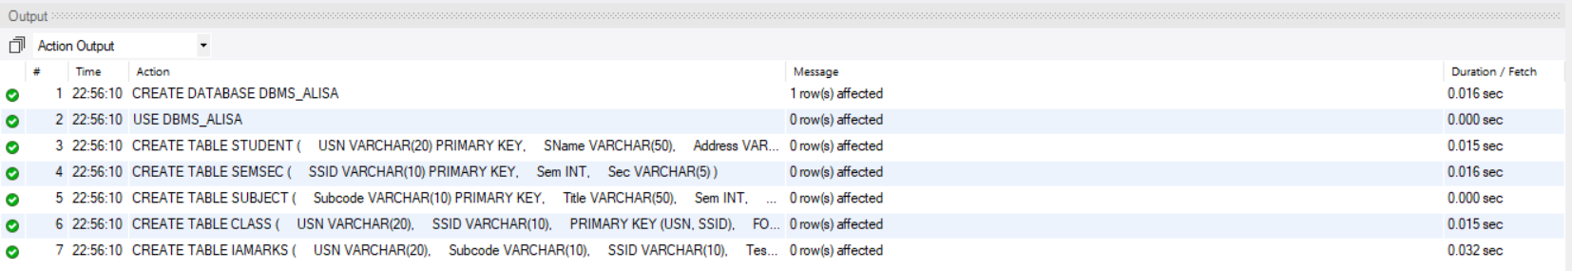

PART B – COMPANY DATABASE

EMPLOYEE ( SSN, Name, Address, Sex, Salary, Superssn, Dno )
DEPARTMENT ( Dno, Dname, Mgrssn, Mgrstartdate )
DLOCATION ( Dno, Dloc )
PROJECT ( PNo, PName, PLocation, DNo )
WORKS_ON ( SSN, PNo, Hours )

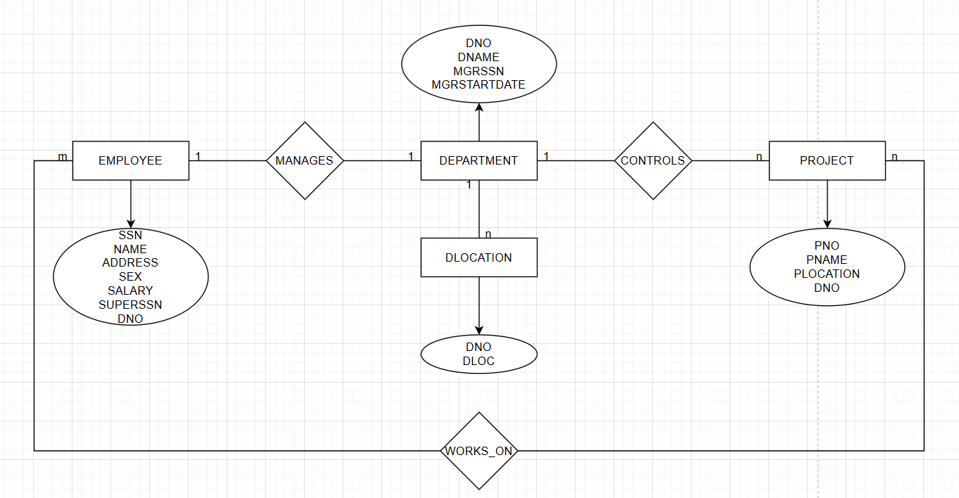
CREATE TABLE DEPARTMENT (
Dno INT PRIMARY KEY,
Dname VARCHAR(50),
Mgrssn VARCHAR(20),
Mgrstartdate DATE
);

CREATE TABLE EMPLOYEE (
SSN VARCHAR(20) PRIMARY KEY,
Name VARCHAR(50),
Address VARCHAR(100),
Sex VARCHAR(10),
Salary DECIMAL(10,2) NOT NULL,
Superssn VARCHAR(20),
Dno INT,
FOREIGN KEY (Superssn) REFERENCES EMPLOYEE(SSN),
FOREIGN KEY (Dno) REFERENCES DEPARTMENT(Dno)
);

CREATE TABLE PROJECT (
PNo INT PRIMARY KEY,
PName VARCHAR(50),
PLocation VARCHAR(50),
DNo INT,
FOREIGN KEY (DNo) REFERENCES DEPARTMENT(Dno)
);

CREATE TABLE WORKS_ON (
SSN VARCHAR(20),
PNo INT,
Hours DECIMAL(5,2),
PRIMARY KEY (SSN, PNo),
FOREIGN KEY (SSN) REFERENCES EMPLOYEE(SSN),
FOREIGN KEY (PNo) REFERENCES PROJECT(PNo)
);

CREATE TABLE DLOCATION (
Dno INT,
Dloc VARCHAR(50),
PRIMARY KEY (Dno, Dloc),
FOREIGN KEY (Dno) REFERENCES DEPARTMENT(Dno)
);
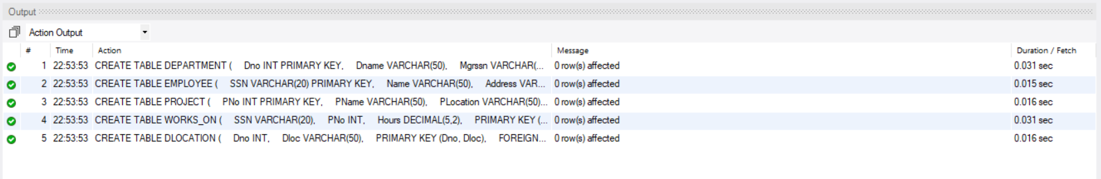

PART C – CUSTOMER SALE SCHEMA

  - Database Schema for a customer-sale scenario
  - Customer(Cust id : integer, cust_name: string)
  - Item(item_id: integer, item_name:string, price: integer) Sale(bill_no:integer,bill_data:date,cust_id: integer, item_id: integer, qty_sold: integer)

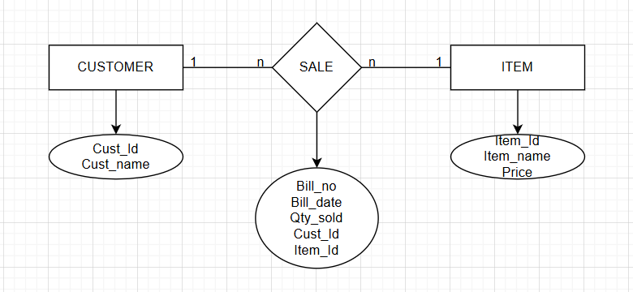
CREATE DATABASE DBMS_ALISA;
USE DBMS_ALISA;

CREATE TABLE CUSTOMER (
Cust_id INT PRIMARY KEY,
Cust_name VARCHAR(50)
);

CREATE TABLE ITEM (
Item_id INT PRIMARY KEY,
Item_name VARCHAR(50),
Price INT NOT NULL
);

CREATE TABLE SALE (
Bill_no INT PRIMARY KEY,
Bill_date DATE,
Cust_id INT,
Item_id INT,
Qty_sold INT,
FOREIGN KEY (Cust_id) REFERENCES CUSTOMER(Cust_id),
FOREIGN KEY (Item_id) REFERENCES ITEM(Item_id)
);
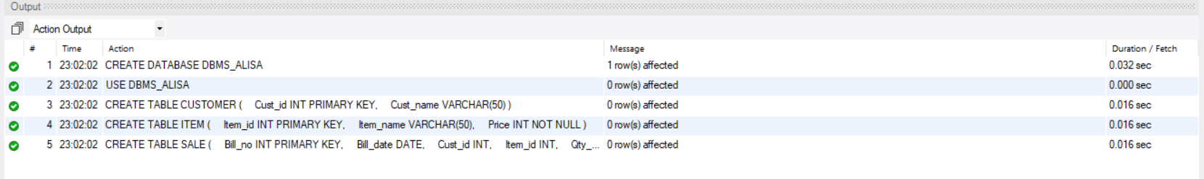

DDL Questions (Data Definition Language):

- Write SQL statements to create all the above relations with appropriate PRIMARY KEY and FOREIGN KEY constraints.
- Add a new column Email to the STUDENT relation.
- Apply NOT NULL constraints to Salary and Price attributes.
- Rename attribute SName to StudentName in STUDENT relation.
- Drop the DLOCATION relation.

DML Questions (Data Manipulation Language):

- Insert at least 10 tuples into CUSTOMER, ITEM, and SALE relations.
- List all bills of the current date with customer names and item names.
- Display total bill amount using quantity and price.
- List customers who purchased products priced above 200.
- Count the number of products purchased by each customer.
- List products purchased by customer having Cust_id = 5.
- Create a VIEW showing bill_no, bill_date, cust_id, item_id, price, qty,sold, amount.
- Create a VIEW showing daily sales date-wise for the last one week.

INSERT INTO CUSTOMER VALUES
(1,'Rahul'),
(2,'Anita'),
(3,'Vikram'),
(4,'Neha'),
(5,'Arjun'),
(6,'Priya'),
(7,'Rohit'),
(8,'Simran'),
(9,'Aman'),
(10,'Kiran');

INSERT INTO ITEM VALUES
(101,'Pen',20),
(102,'Notebook',80),
(103,'Bag',1200),
(104,'Shoes',2500),
(105,'Bottle',150),
(106,'Watch',2200),
(107,'Mouse',500),
(108,'Keyboard',800),
(109,'T-shirt',600),
(110,'Headphones',1800);

INSERT INTO SALE VALUES
(1,CURDATE(),1,103,1),
(2,CURDATE(),2,104,1),
(3,CURDATE(),3,101,5),
(4,CURDATE(),4,110,1),
(5,CURDATE(),5,106,1),
(6,CURDATE(),6,102,2),
(7,CURDATE(),7,109,2),
(8,CURDATE(),8,107,1),
(9,CURDATE(),9,108,1),
(10,CURDATE(),5,105,3);

SELECT S.Bill_no, C.Cust_name, I.Item_name
FROM SALE S
JOIN CUSTOMER C ON S.Cust_id = C.Cust_id
JOIN ITEM I ON S.Item_id = I.Item_id
WHERE S.Bill_date = CURDATE();

SELECT S.Bill_no,
I.Price,
S.Qty_sold,
(I.Price * S.Qty_sold) AS Total_Amount
FROM SALE S
JOIN ITEM I ON S.Item_id = I.Item_id;

SELECT DISTINCT C.Cust_name
FROM CUSTOMER C
JOIN SALE S ON C.Cust_id = S.Cust_id
JOIN ITEM I ON S.Item_id = I.Item_id
WHERE I.Price > 200;

SELECT C.Cust_name,
COUNT(S.Item_id) AS Total_Products
FROM CUSTOMER C
JOIN SALE S ON C.Cust_id = S.Cust_id
GROUP BY C.Cust_name;

SELECT I.Item_name
FROM SALE S
JOIN ITEM I ON S.Item_id = I.Item_id
WHERE S.Cust_id = 5;

CREATE VIEW Bill_Details AS
SELECT S.Bill_no,
S.Bill_date,
S.Cust_id,
S.Item_id,
I.Price,
S.Qty_sold,
(S.Qty_sold * I.Price) AS Amount
FROM SALE S
JOIN ITEM I ON S.Item_id = I.Item_id;

CREATE VIEW Weekly_Sales AS
SELECT Bill_date,
SUM(S.Qty_sold * I.Price) AS Total_Sales
FROM SALE S
JOIN ITEM I ON S.Item_id = I.Item_id
WHERE Bill_date >= CURDATE() - INTERVAL 7 DAY
GROUP BY Bill_date;

