**AWS Capstone project 2**

Deployed static Application from AWS resources like VPC, EC2, Load Balancer, S3, DynamoDB and RDS(MySQL) and Route 53.

1. Created VPC in North Virginia Region.

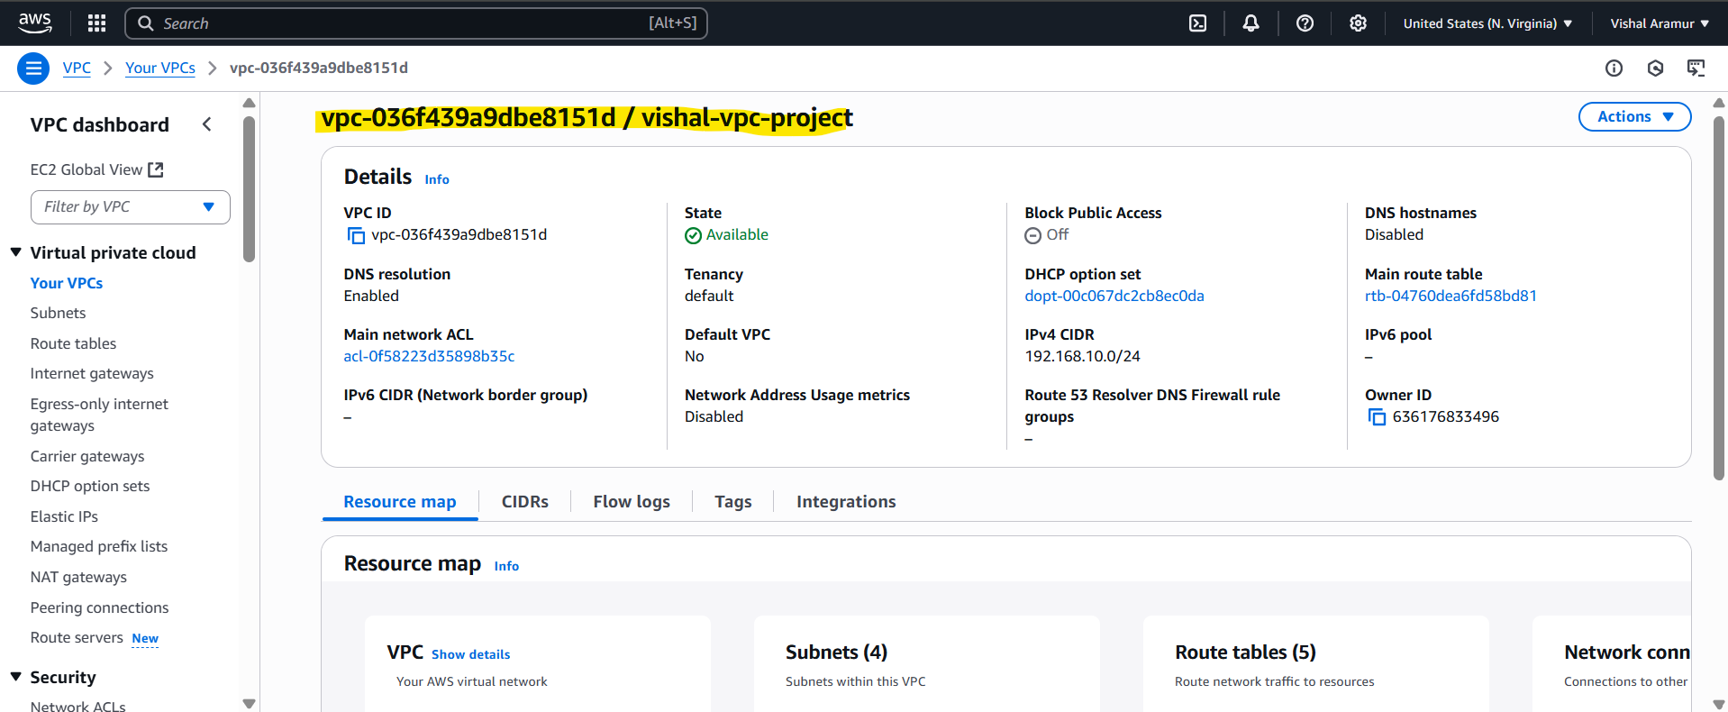

1. Created 4 subnets. 2 Private subnets and 2 Public Subnets.

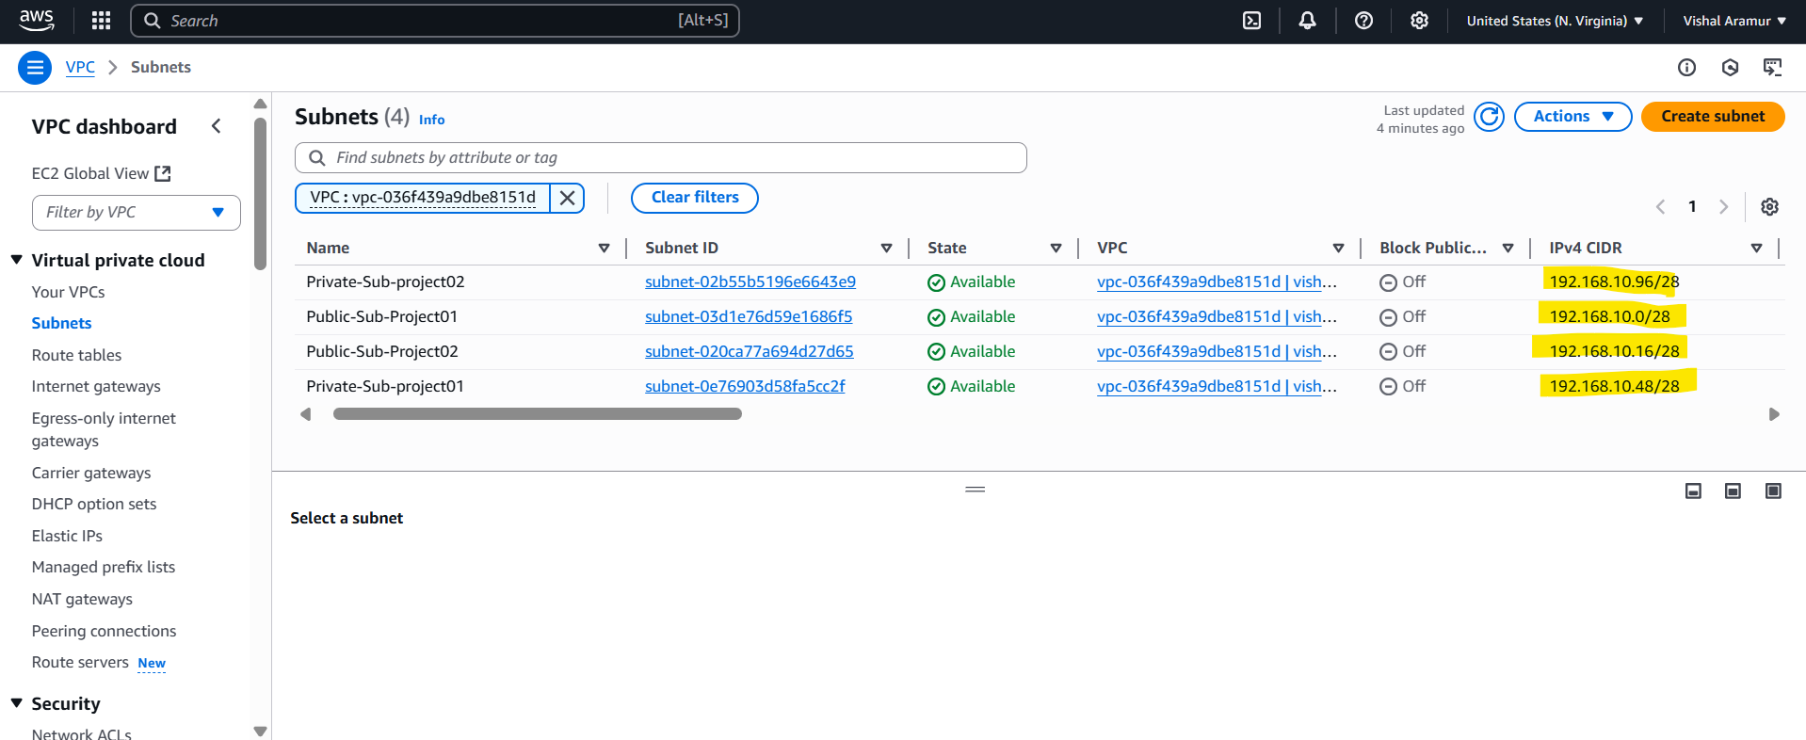

1. Created Internet Gateway.

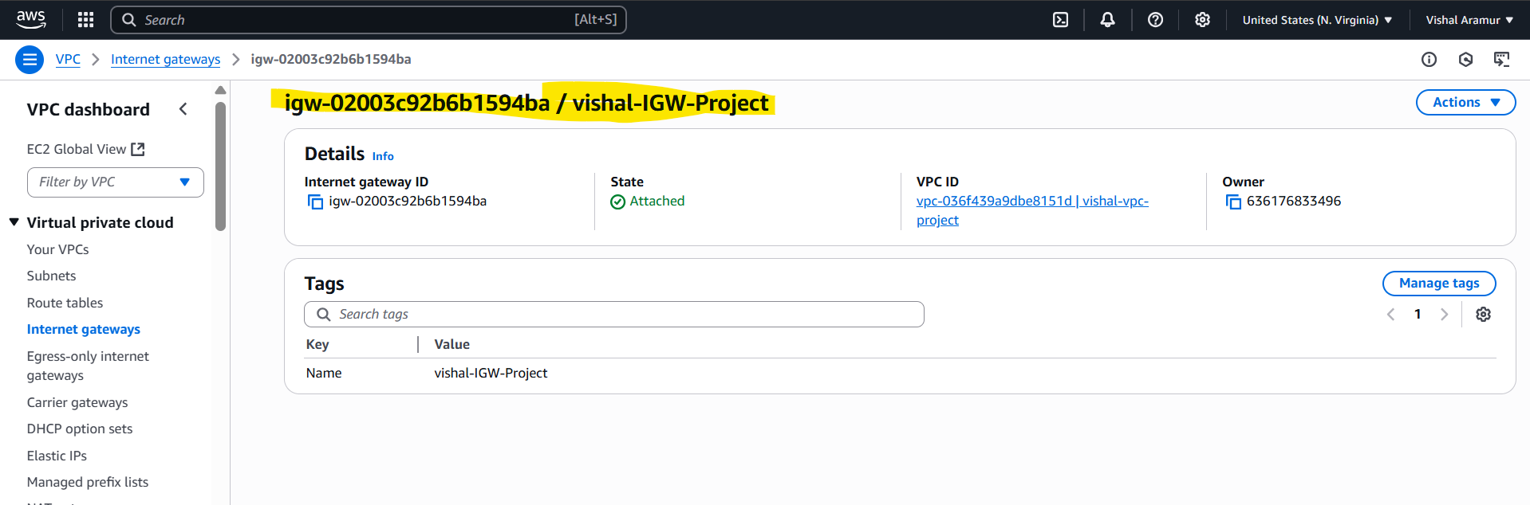

1. Created NAT gateway

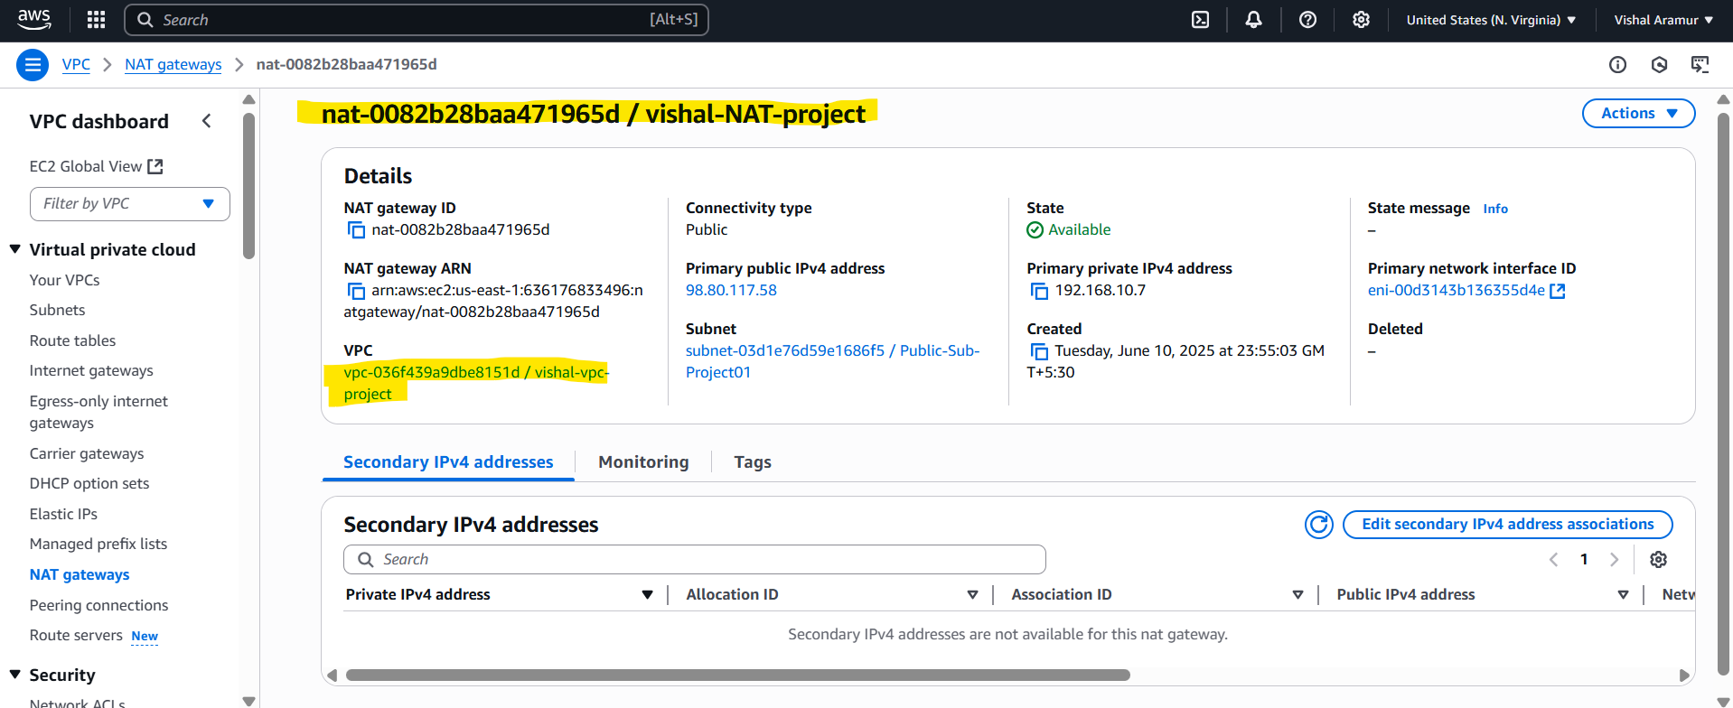

1. Created 4 Route Tables and associated with respective Subnets

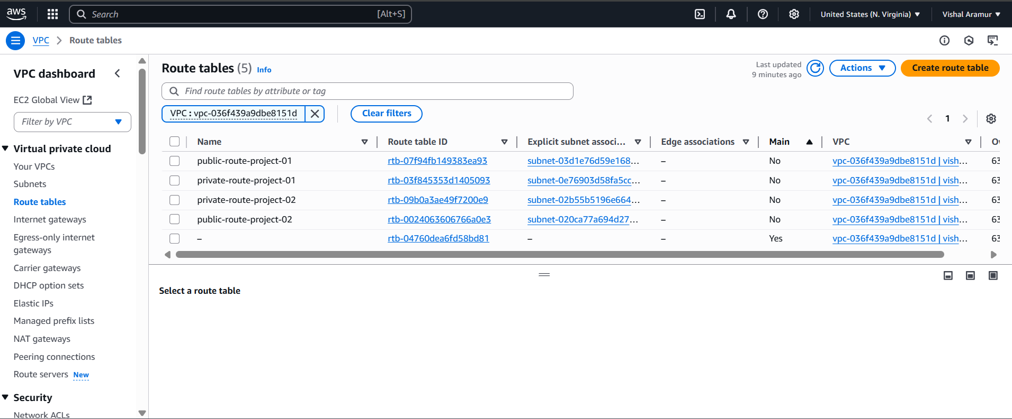

1. Created routes.

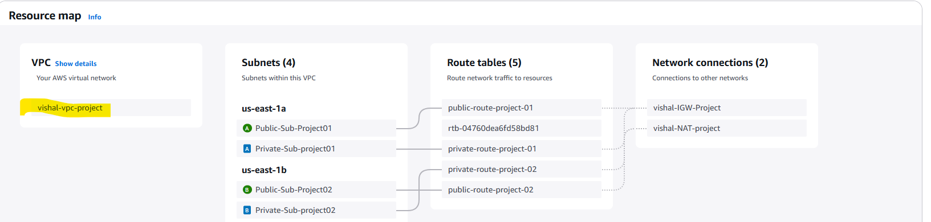

1. Created EC2 in Private subnet.

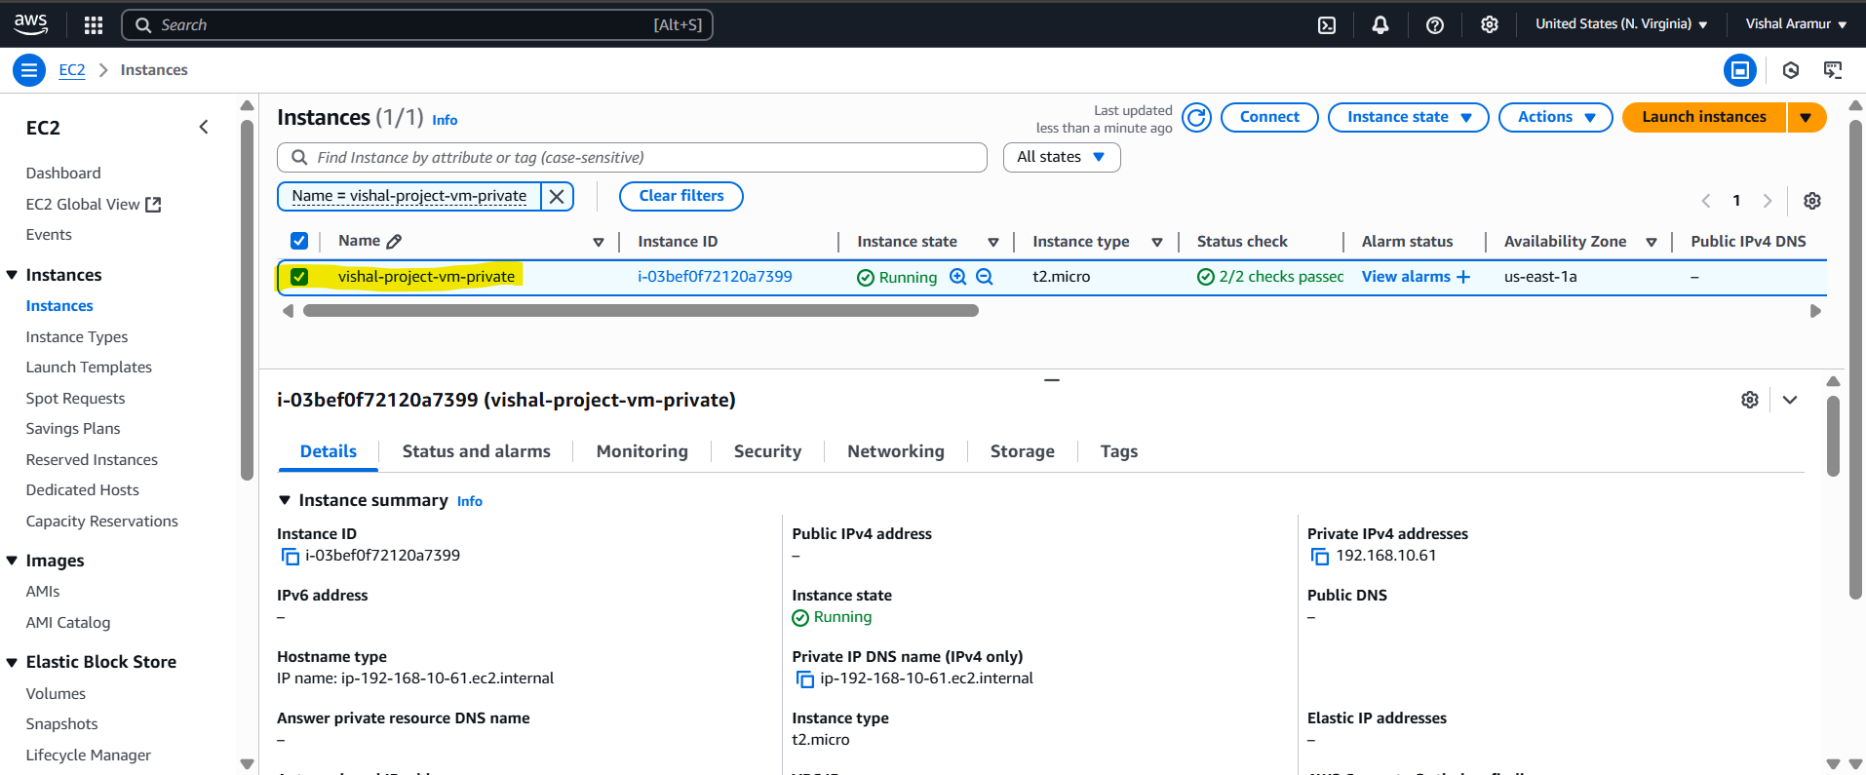

1. Created RDS(MySQL) Database

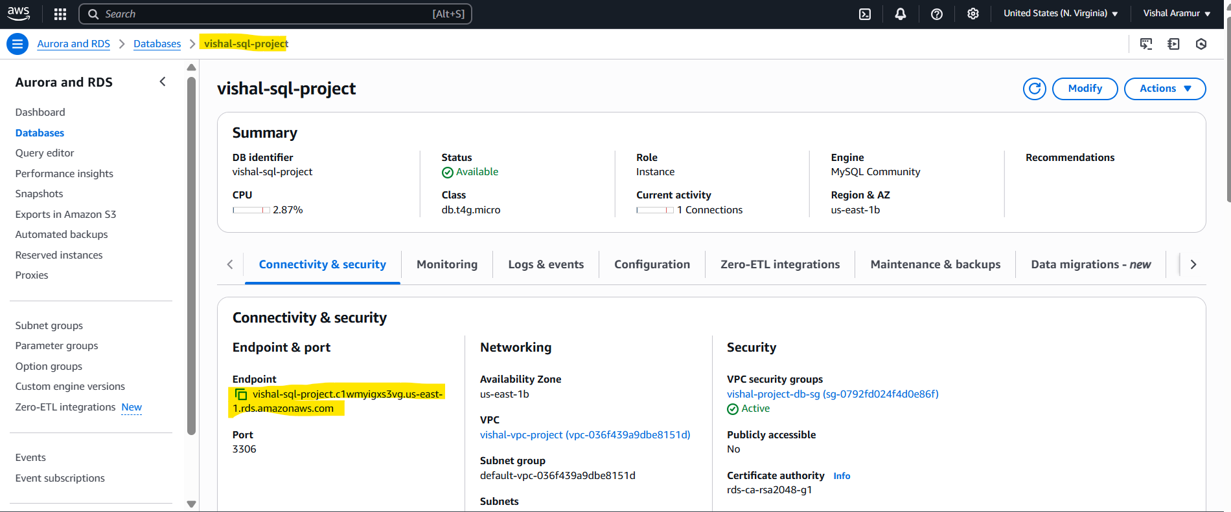

1. Created DynamoDB Table

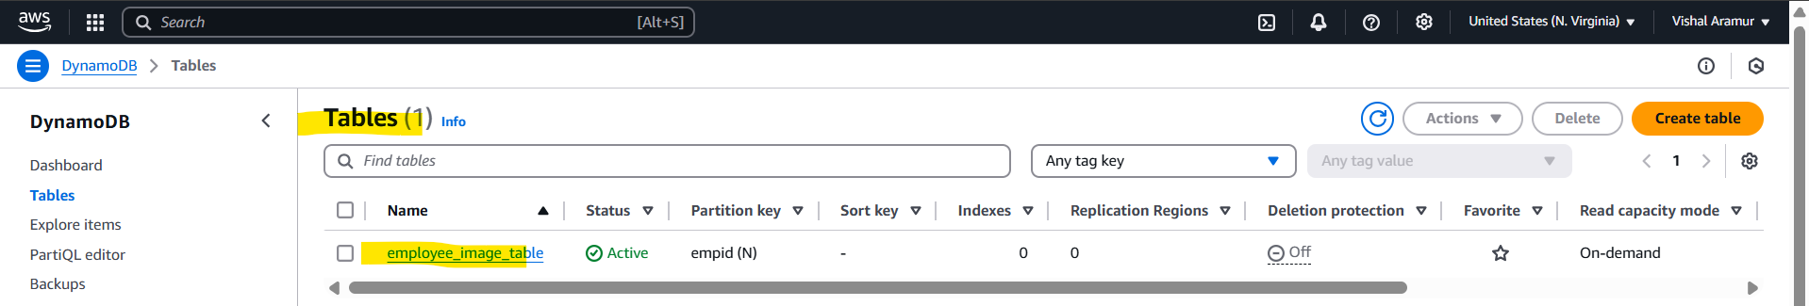

1. S3 bucket

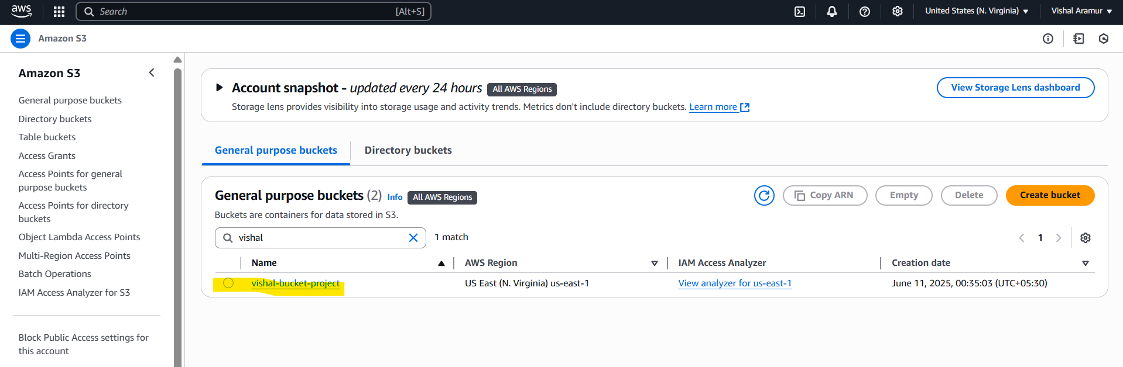

1. Load Balancer

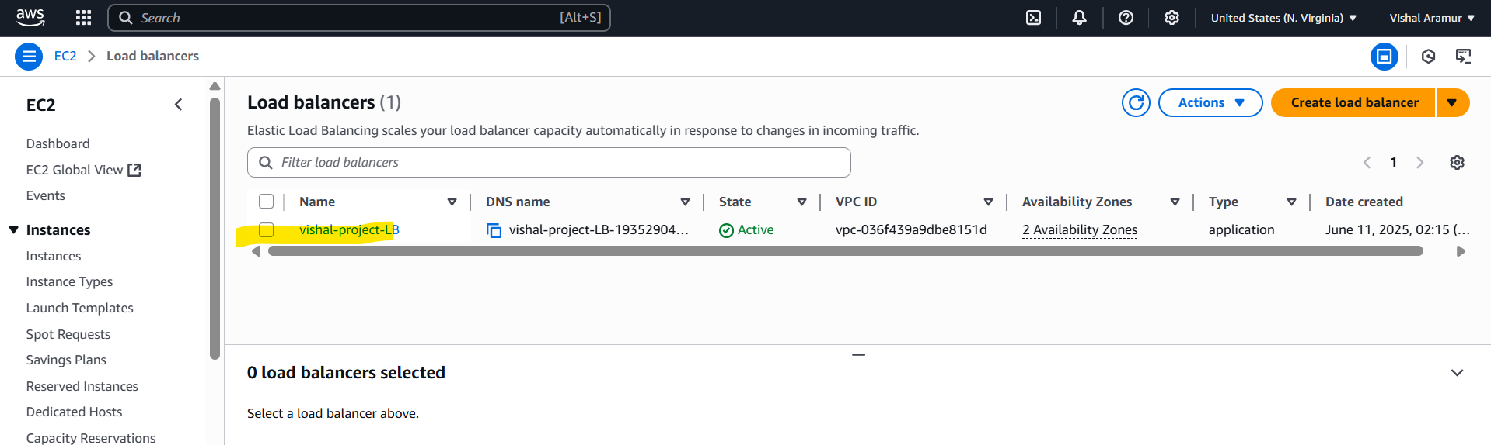

1. Created the IAM roles for the EC2 instance (Private) to access S3 bucket and DynamoDB.

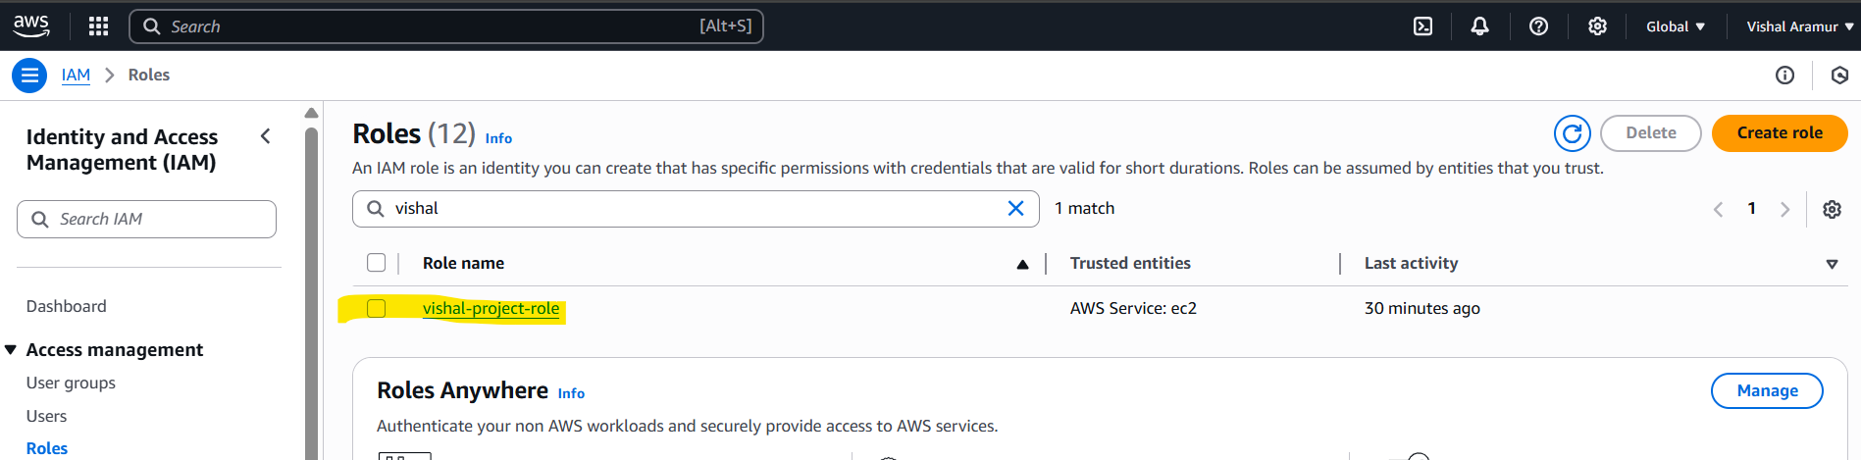

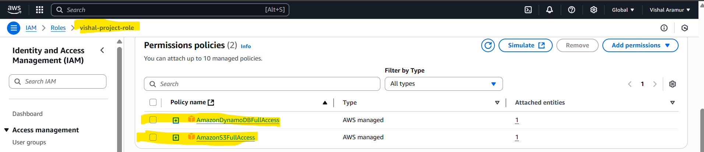

1. Attached the IAM role to the EC2 instance

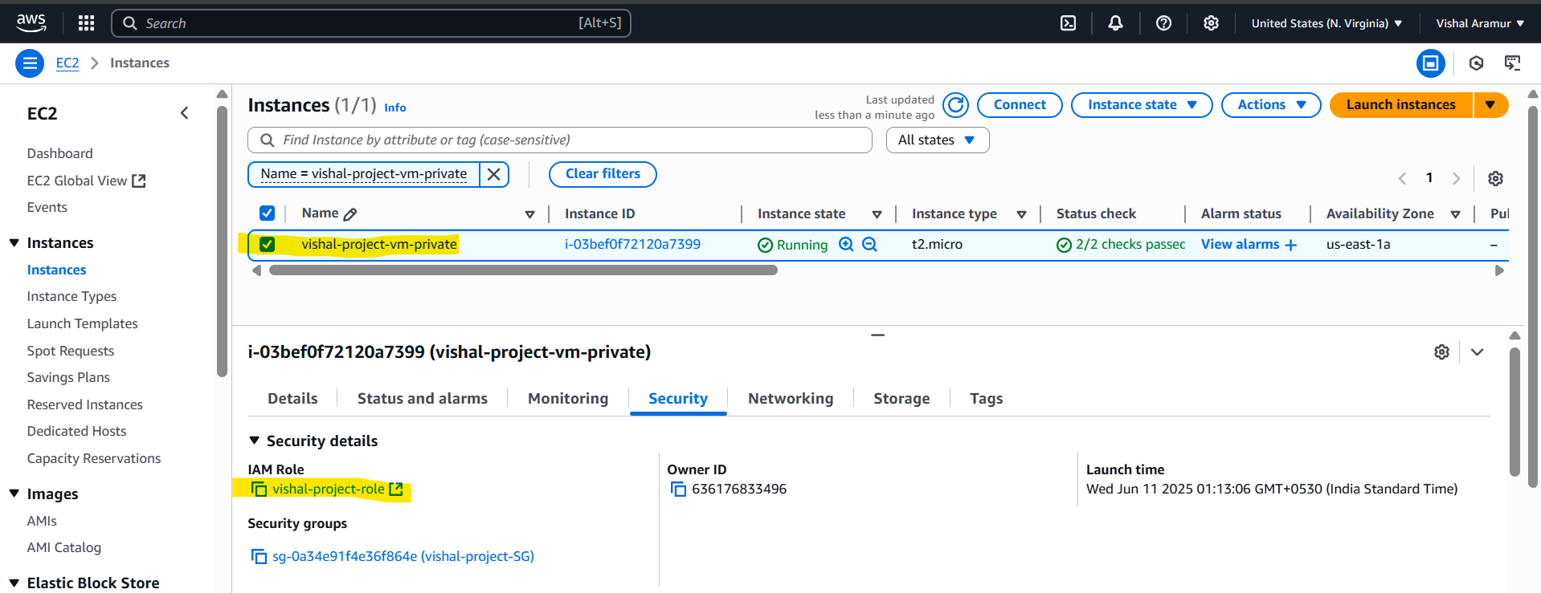

1. Launched another EC2 instance in public subnet to SSH the private EC2 Instance.

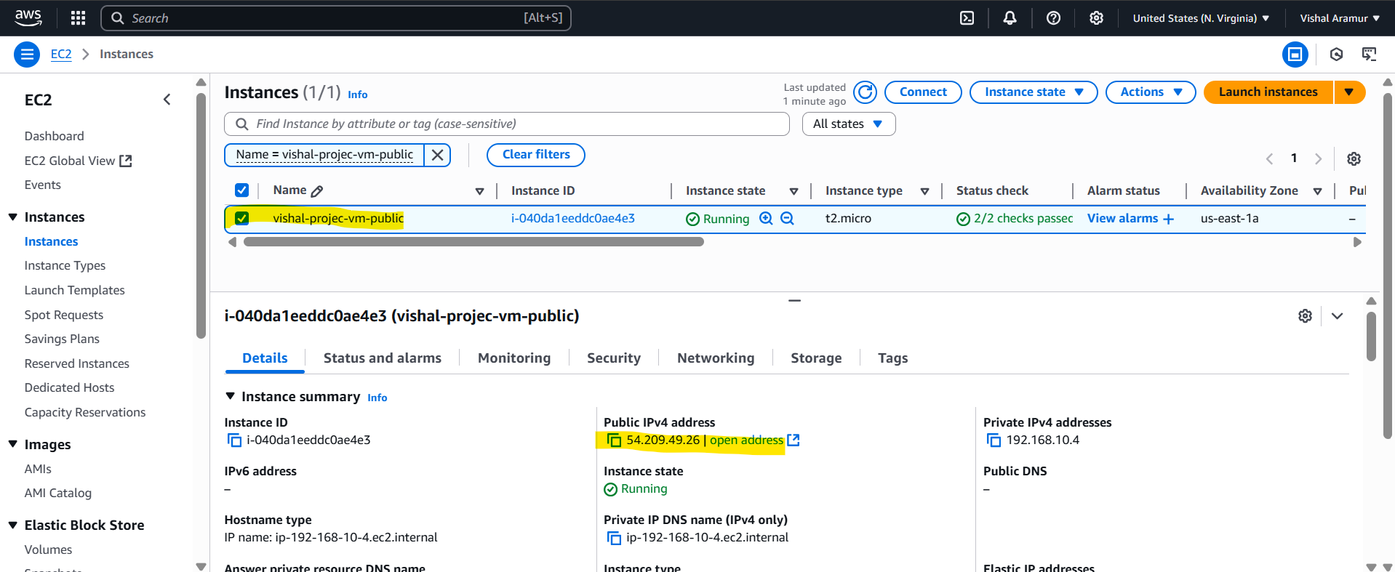

SSH to private instance.

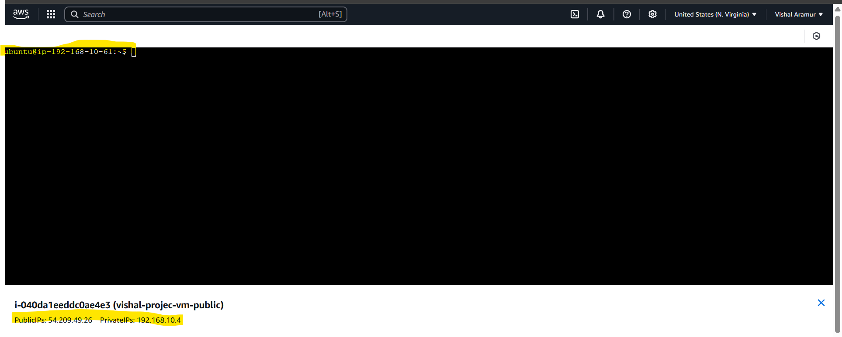

1. Installed the Python on the private instance and run the python script to make the instance as static application.

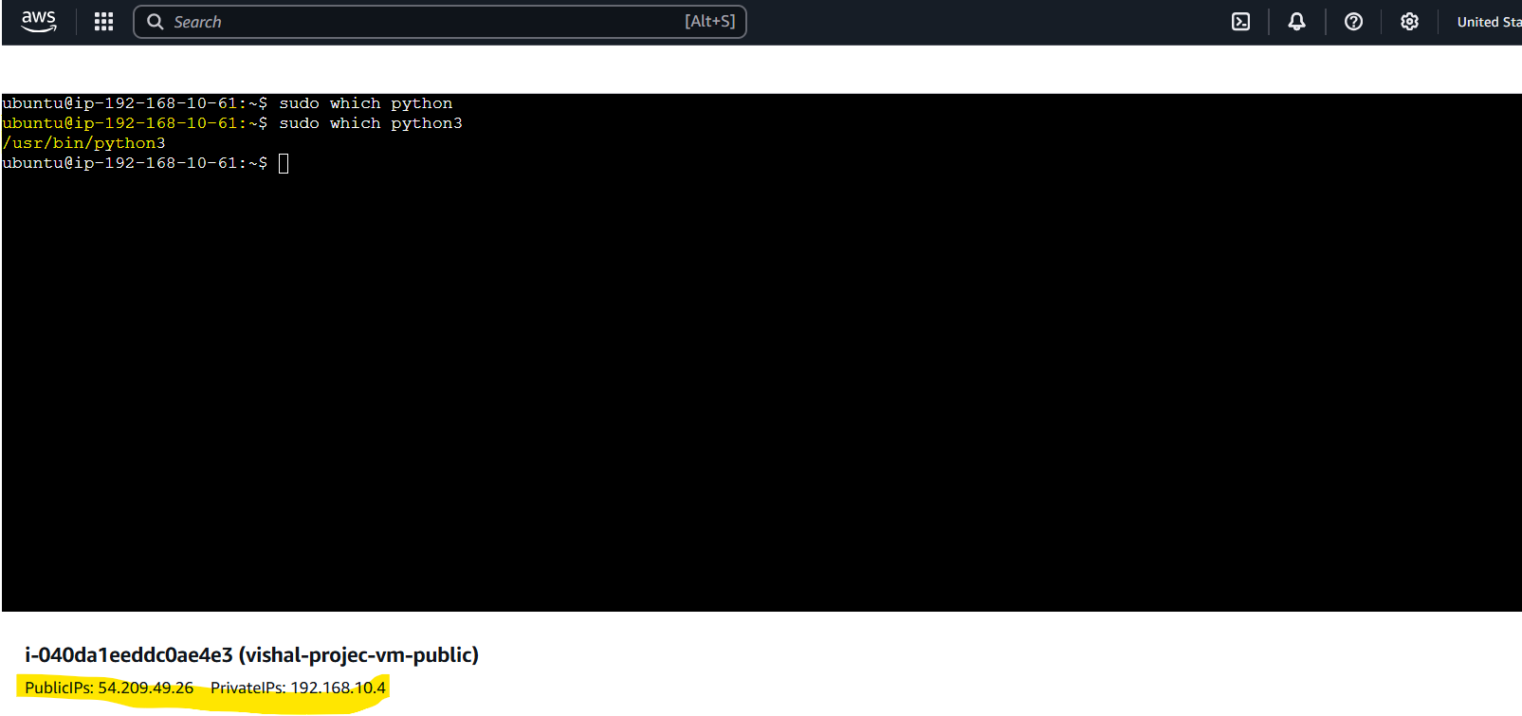

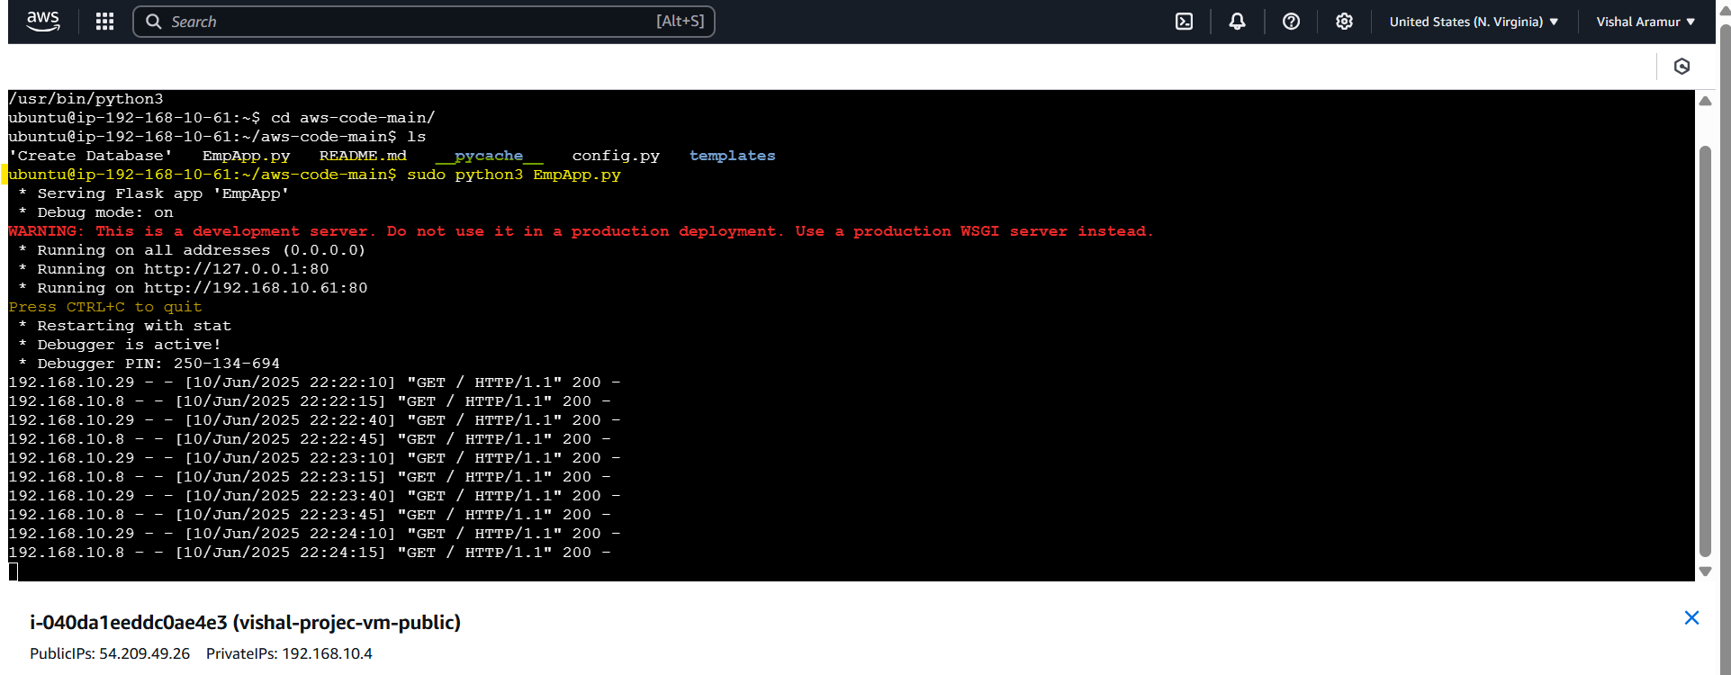

1. Able to access the application on browser through Load Balance URL

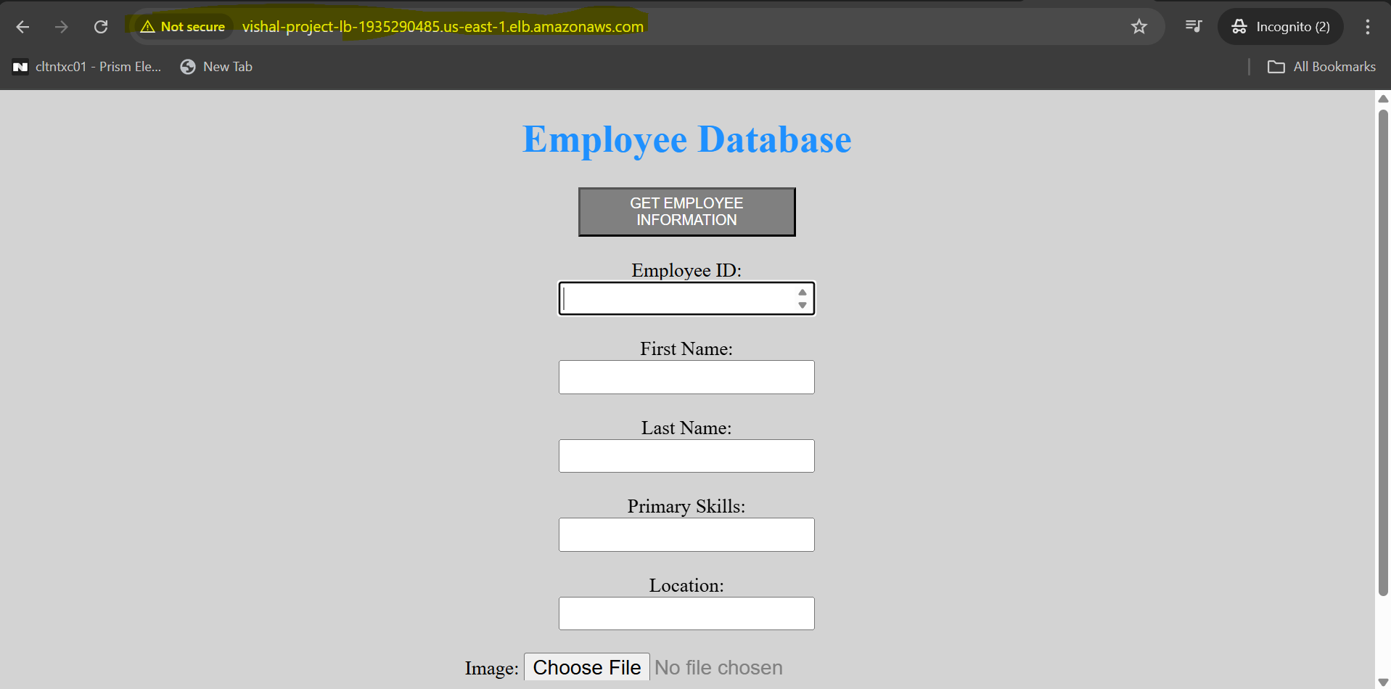

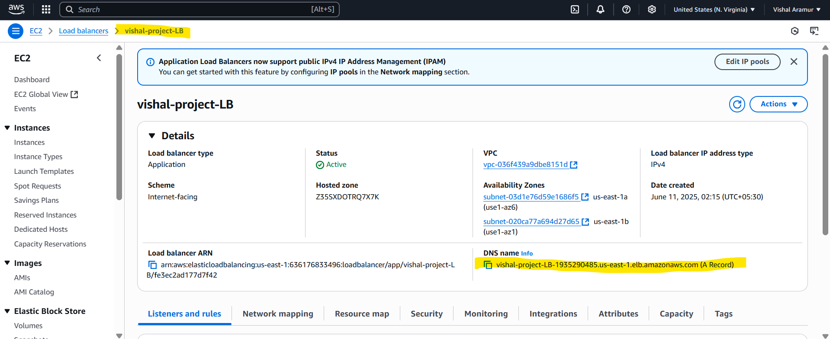

1. Added the private instance to the target group and attach to the load balancer.

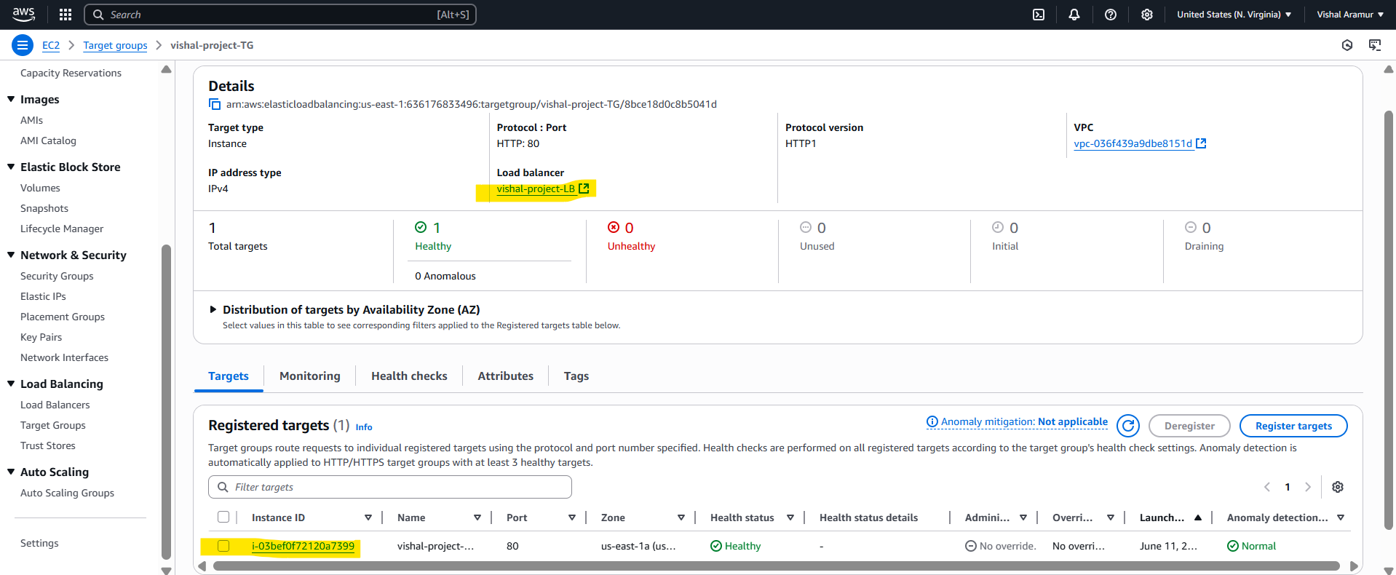

1. Created Hosted zone(vishresh.xyz) in Route 53, created DNS role (Alias) added the LB DNS.

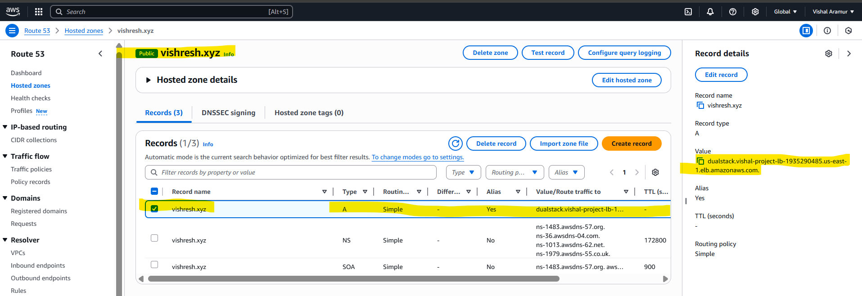

1. Able to access the Application with vishresh.xyz url. Filled the details and attach the image.

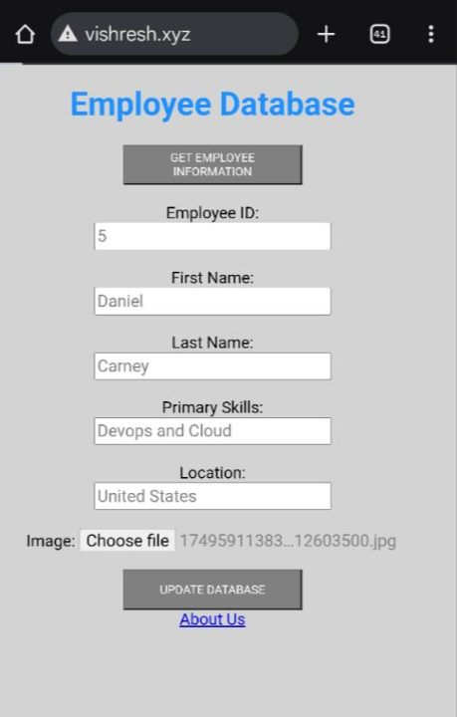

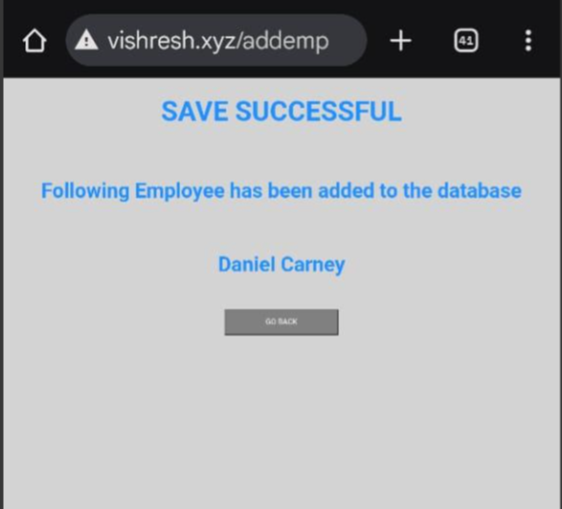

1. Filled data has been stored on the SQL database and images has been stored in S3.

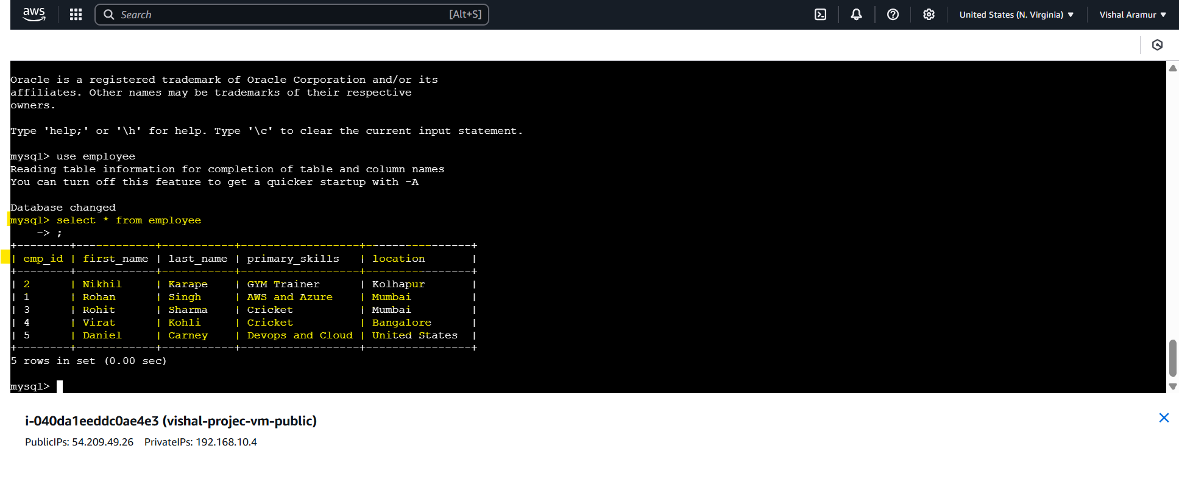

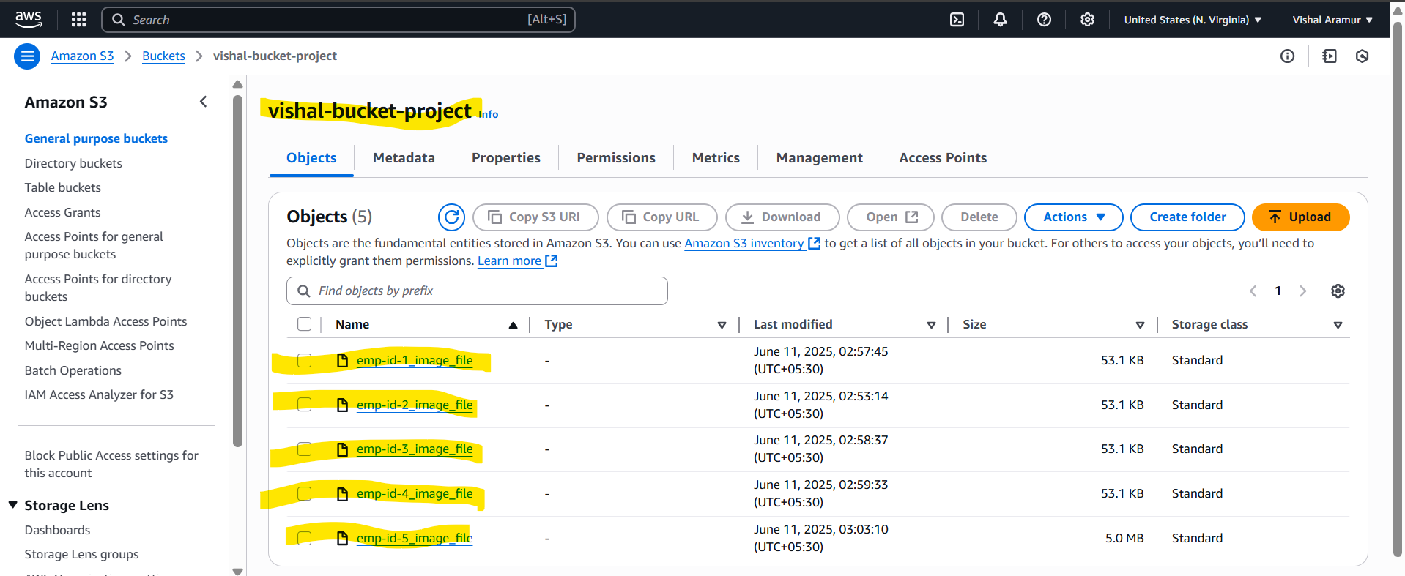

1. Metadata has been stored on DynamoDB

