Project Charter

Project Title: Lemniscate Online Tutorials
Project Start Date: 05/15/2020 Projected Finish Date: 06/04/2020
Budget Information: Self-Funded
Project Manager:
Name: Bhanu Prakash Thota
Phone:+1 6605415295
e-mail:s538363@nwmissouri.edu
Project Objectives:
Our primary objective is to help students by providing user-friendly website about all the process groups and knowledge areas.
Success Criteria:
Our ultimate goal is to develop the website without any errors and with user-friendly design before the deadline.
Approach:
AGILE APPROACH
Roles and Responsibilities
Name and Signature | Role | Organization | Contact Information
Bhanu Prakash Thota  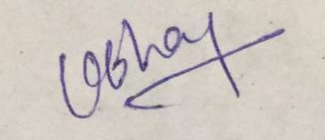 | Project Manager | NWMSU | +1 6605415295
Sri Sudheera Chitipolu  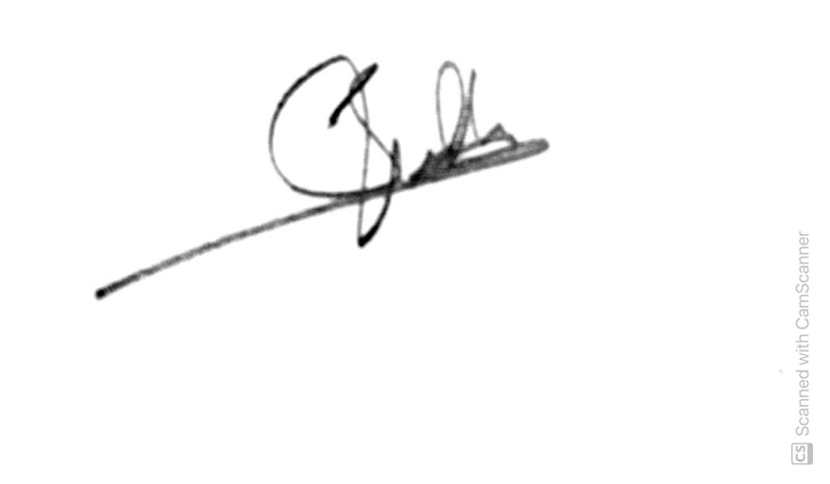 | Team Lead | NWMSU | +91 9502675474
Harika Kulkarni  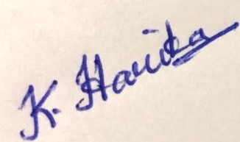 | Content Developer | NWMSU | +1 4808492551
Sai Krishna Emmadishetty  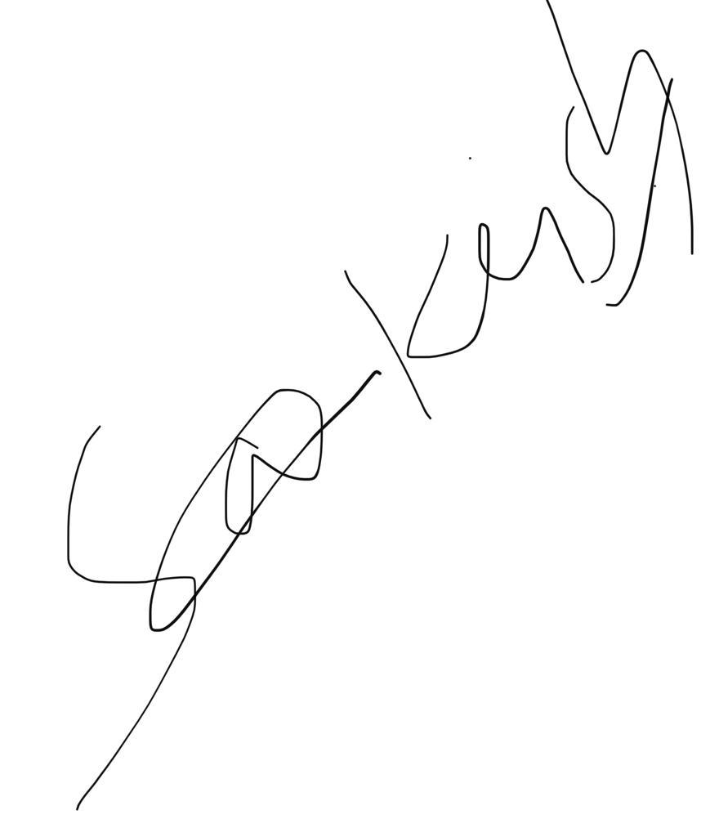 | Web application Developer | NWMSU | +91 9000159161
Vishal Reddy Vennavaram  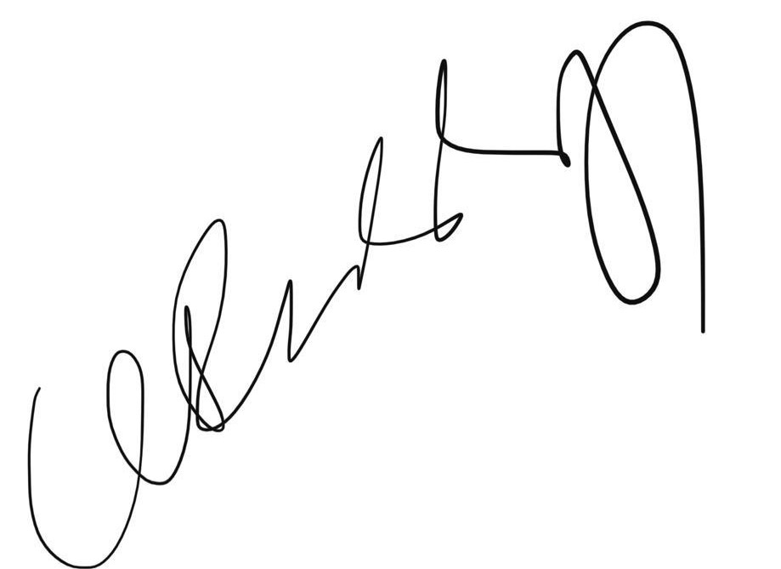 | User Interface Developer | NWMSU | +91 9515371876

