Results and Output

Url :: <Http://localhost:8080/>

**1 ) Front Page**

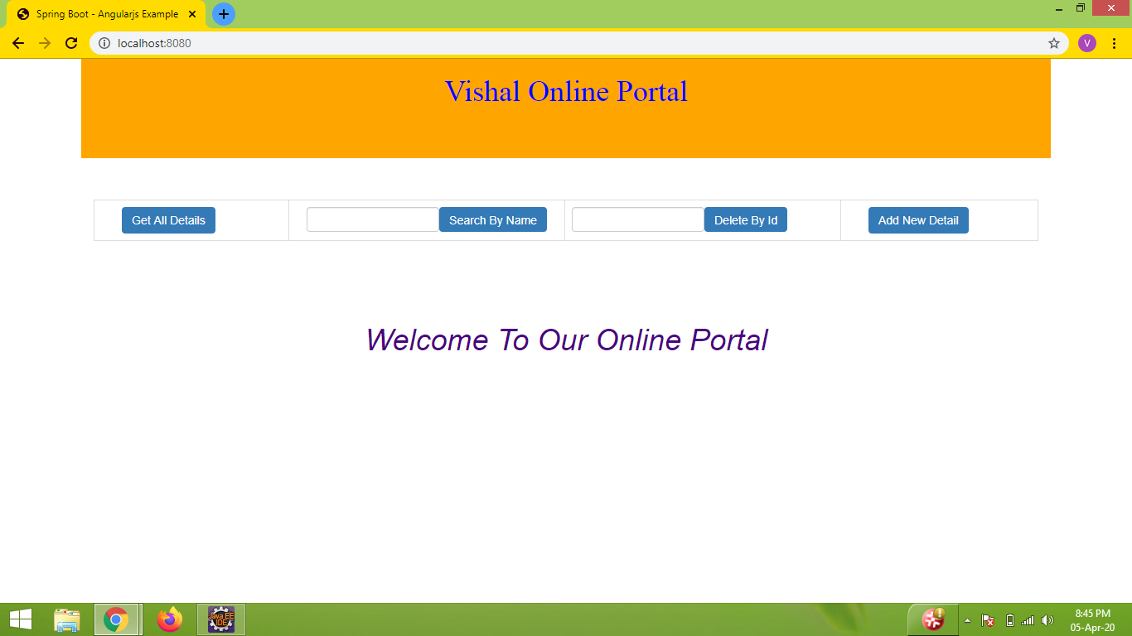

1. **Get All Details :**

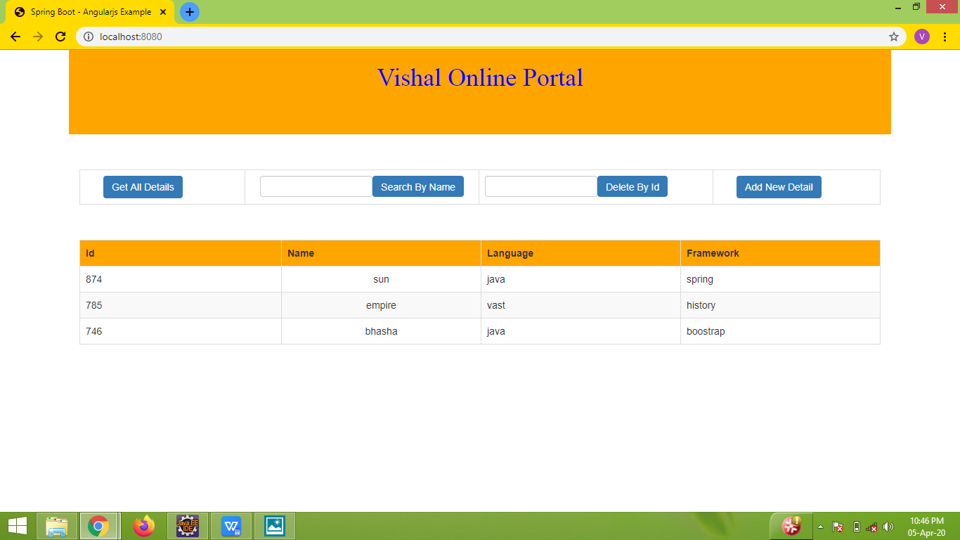

**3 ) Search By Name :**

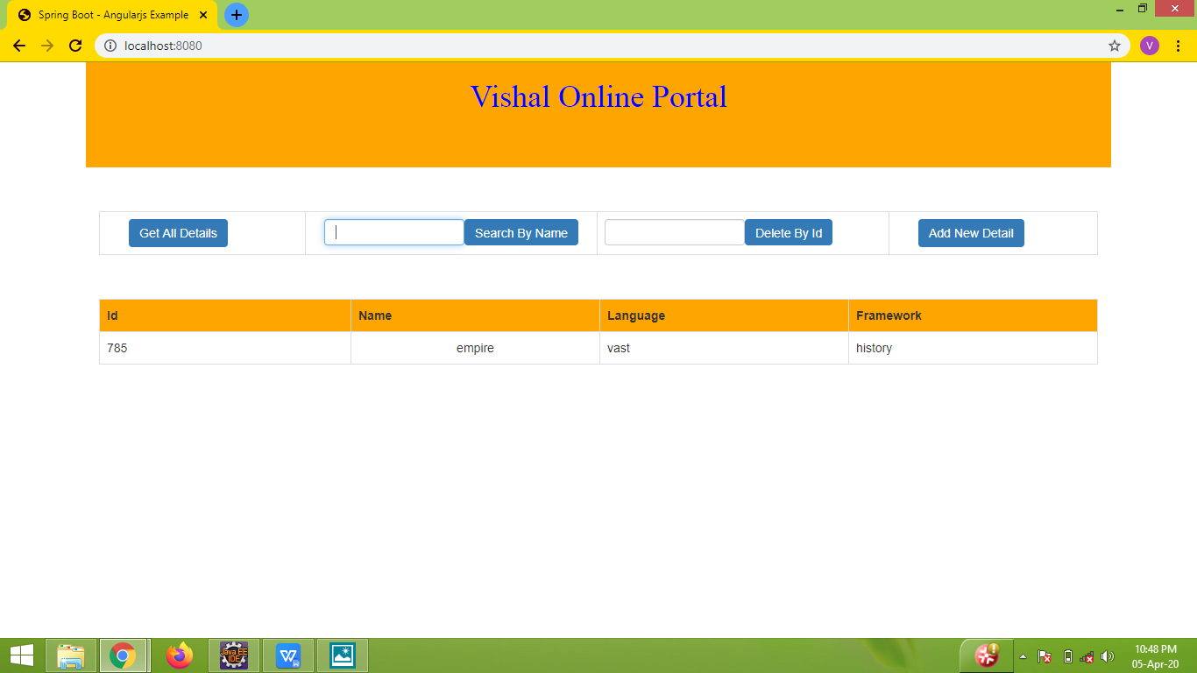

**4 ) Delete By Id :**

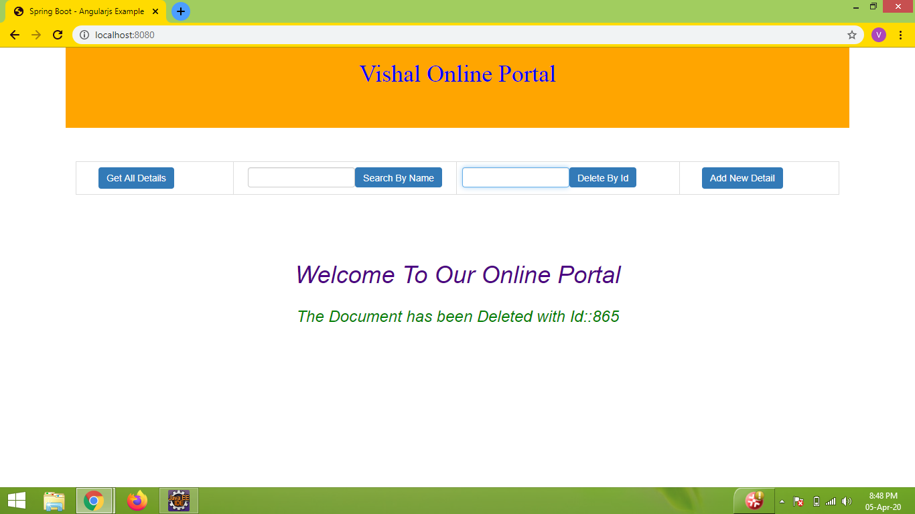

1. **Add New Details ::**

