**Screenshots of the deployed application (frontend, backend API responses, database):**

**Frontend Screenshots:**

**React UI:**

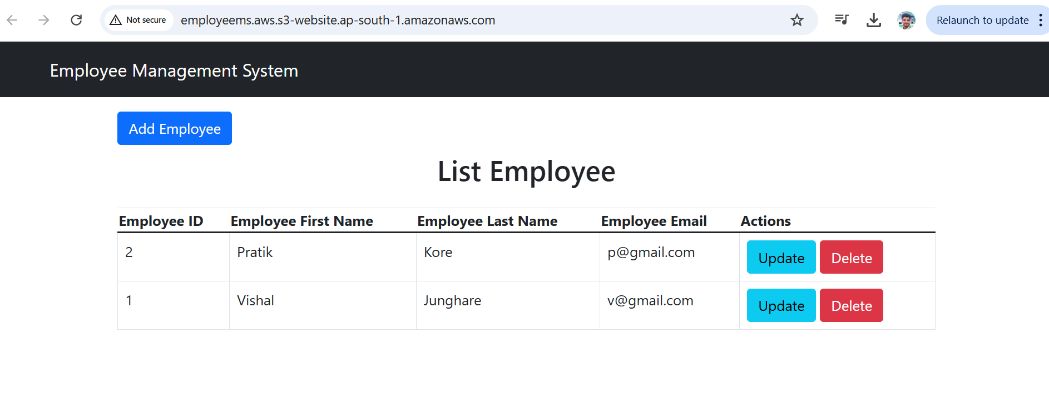

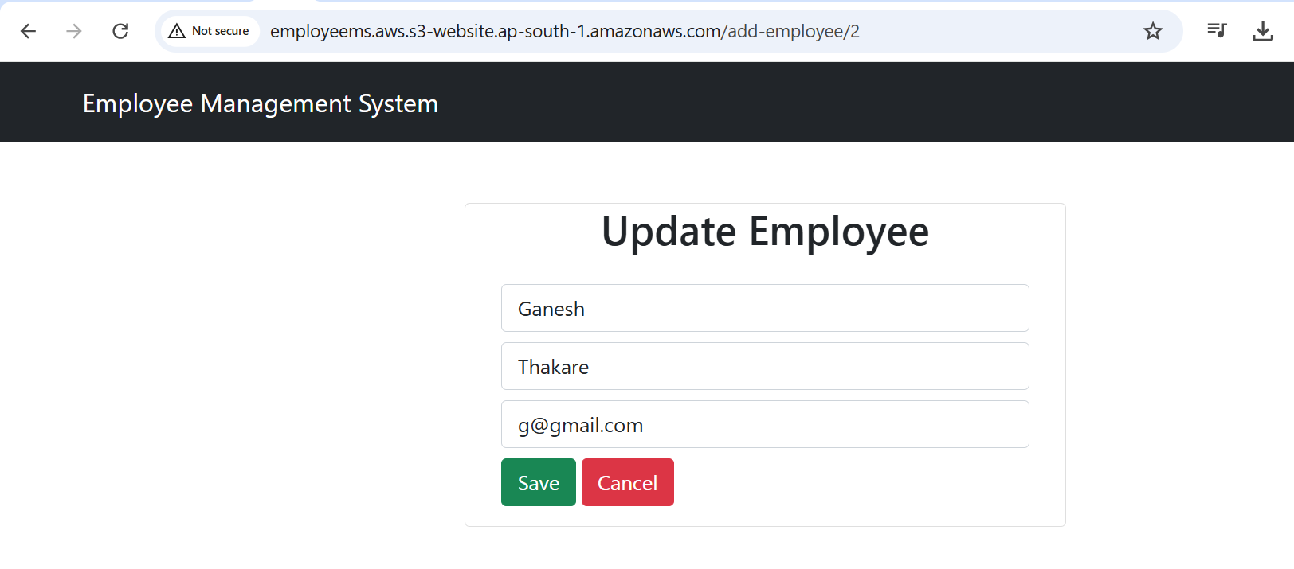

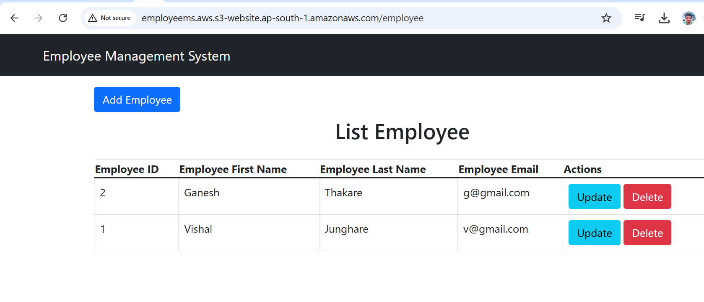

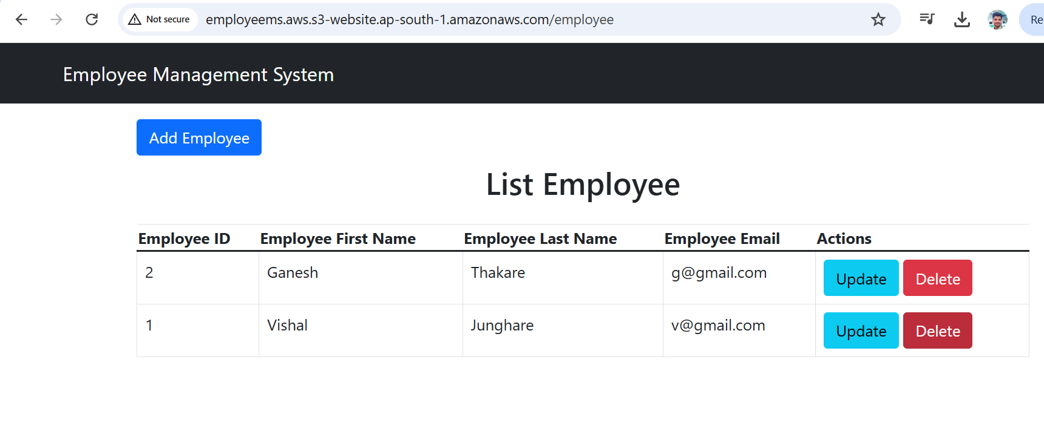

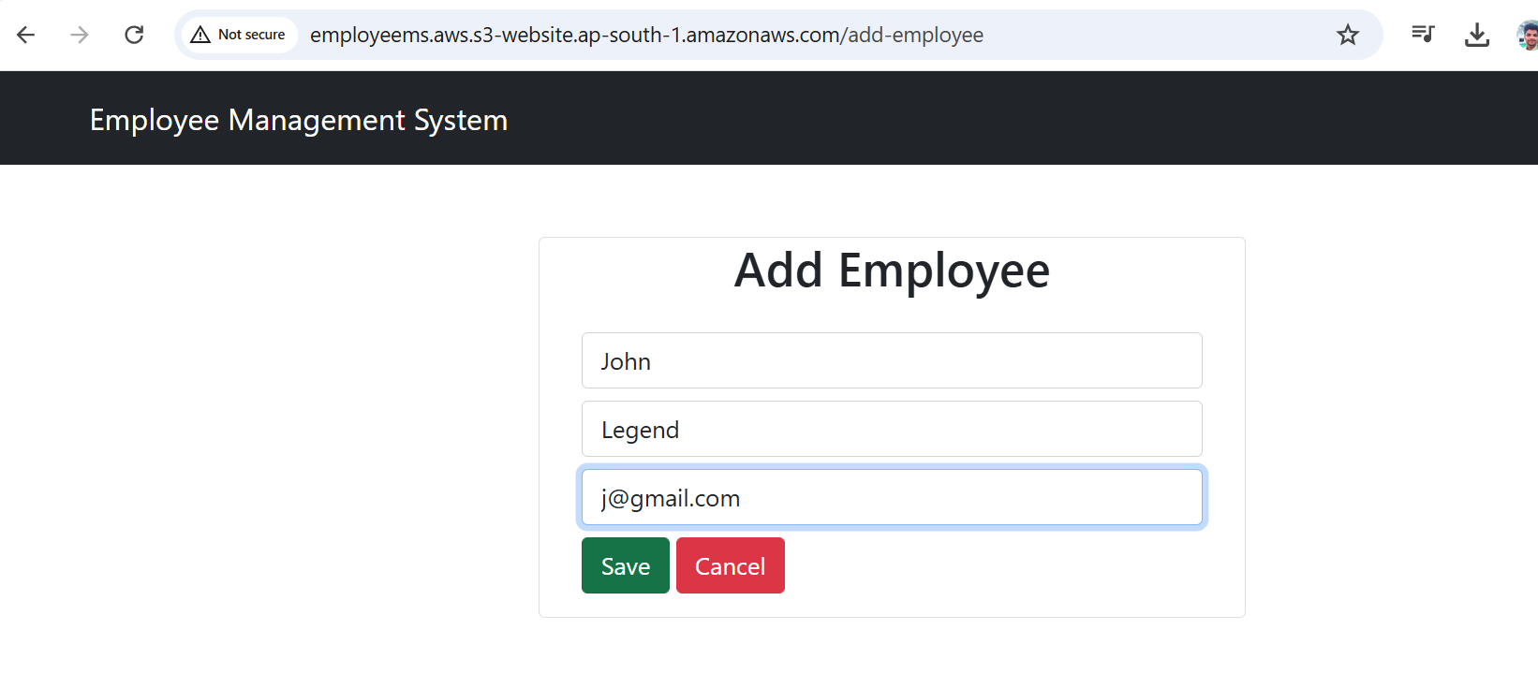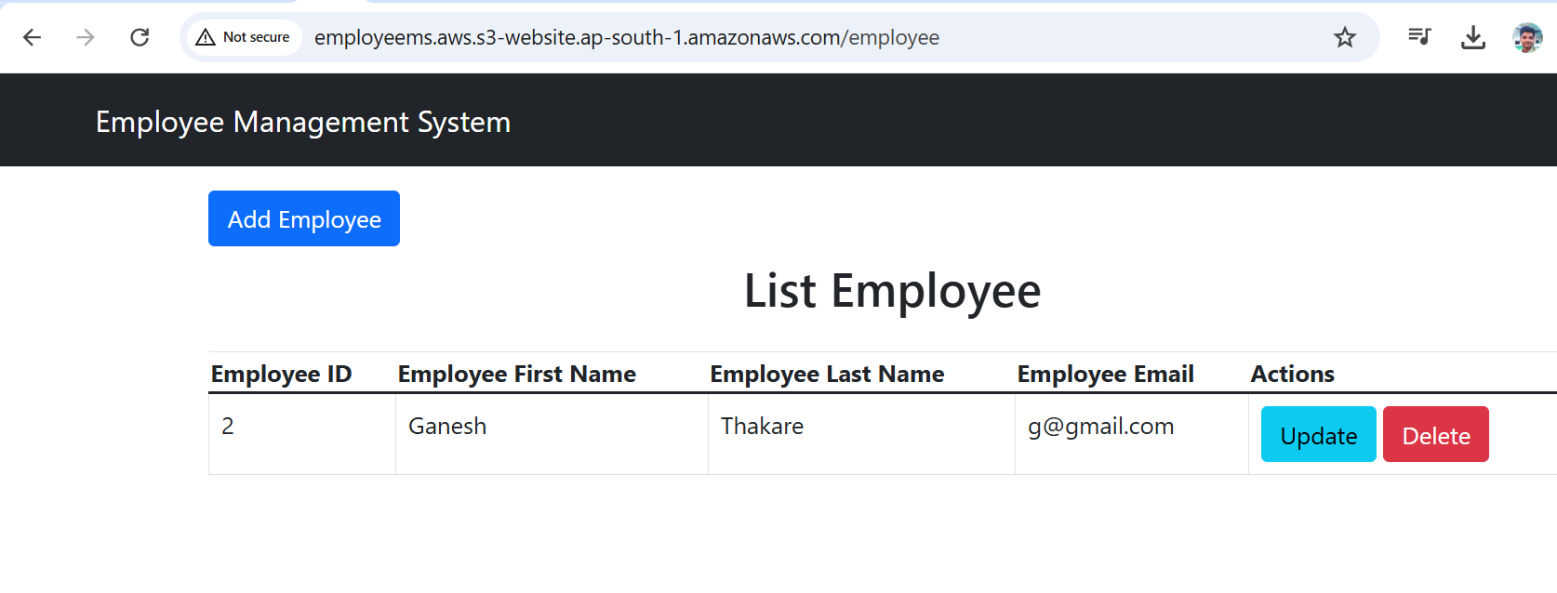

**S3 Bucket:**

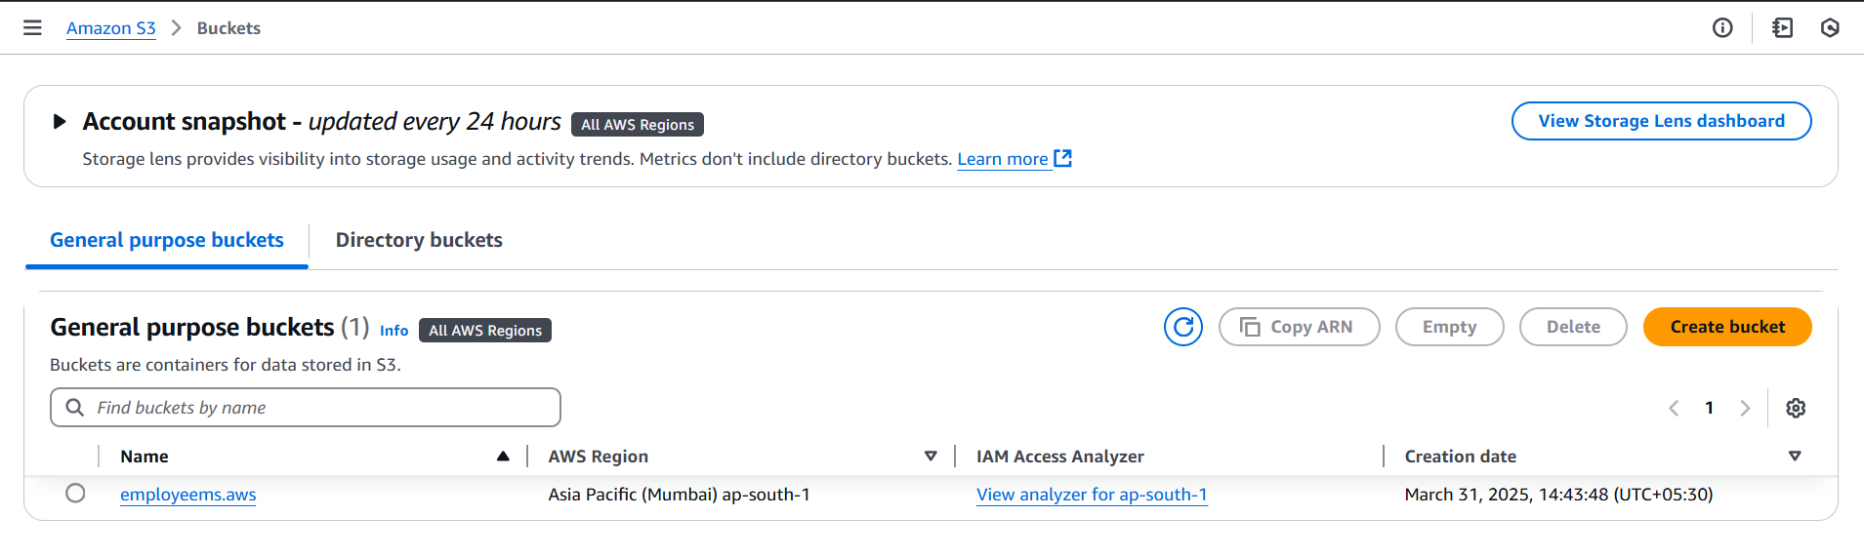

**Backend Screenshots:**

**EC2 Instance :**

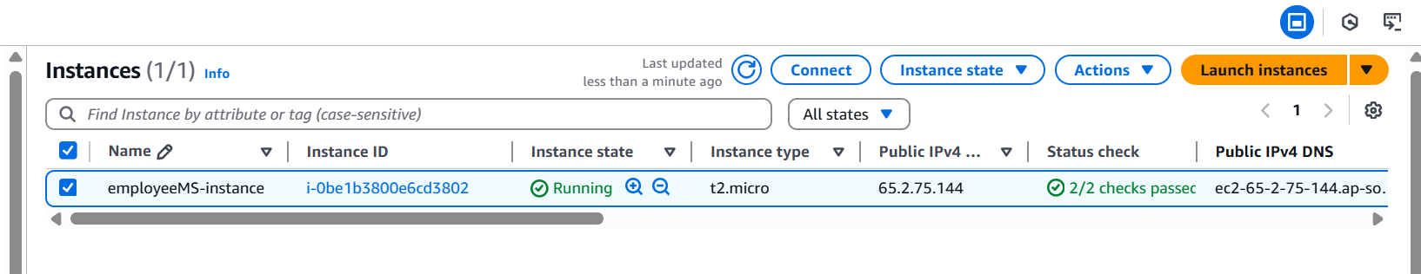

**Security-Group Configuration:**

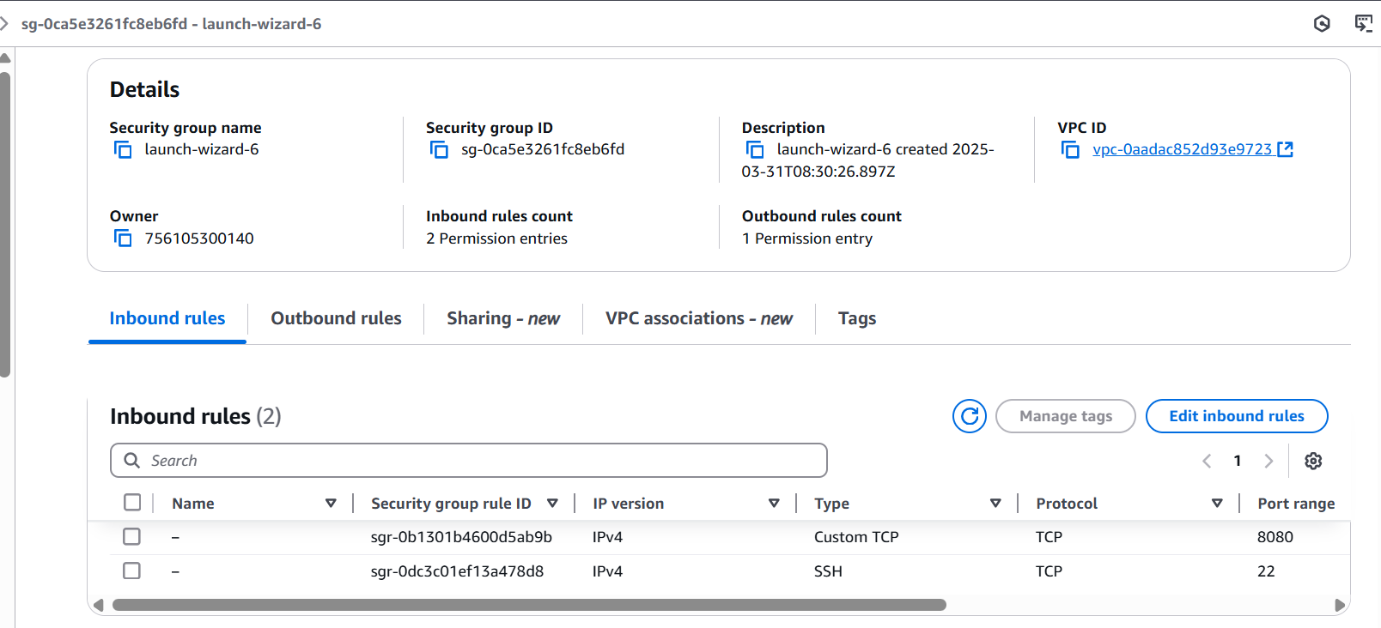

**Database Screenshots:**

**Connection through MySQL Workbench:**

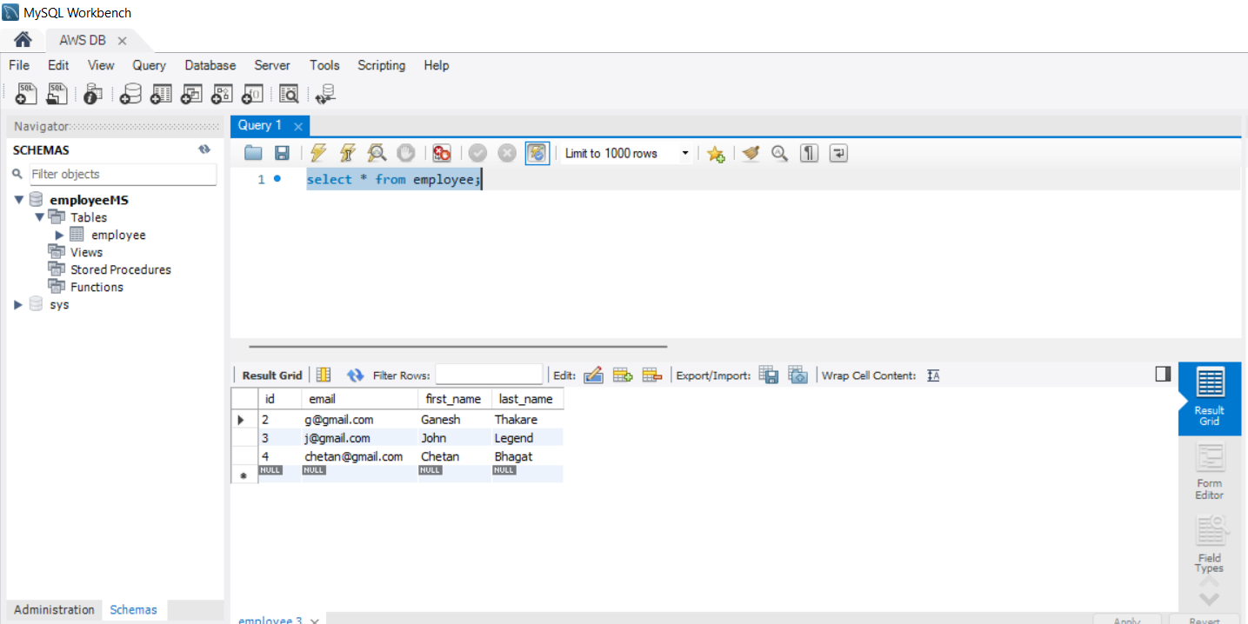

**AWS RDS Instance:**

