Week 3 Assignment: Data Visualization & EDA

Dataset Overview
This report analyzes the COVID-19 country-wise dataset using Exploratory Data Analysis (EDA). The dataset was cleaned, visualizations were created to identify trends, correlations, and outliers, and actionable insights were derived for stakeholders.

Data Cleaning Steps
- Removed unnecessary spaces from column names.
- Handled missing values using fillna(0).
- Validated numeric columns for analysis.

Top 10 Countries by Confirmed Cases
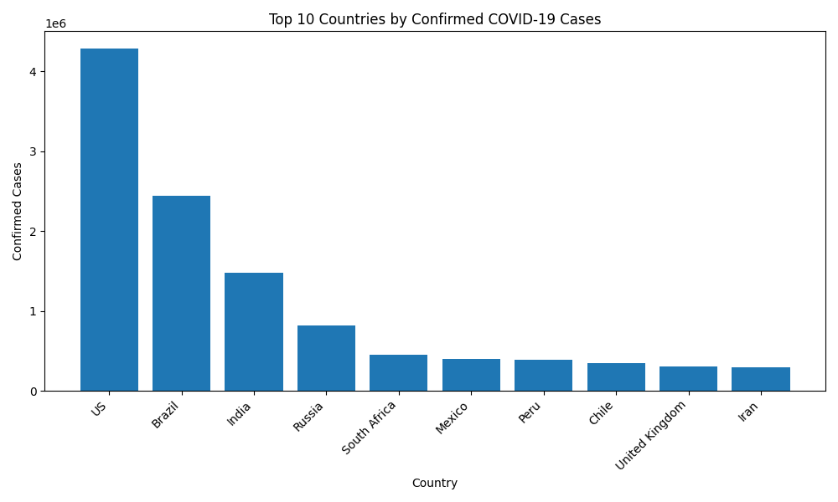
This bar chart helps stakeholders identify the countries with the highest infection counts and prioritize healthcare planning.

Correlation Heatmap
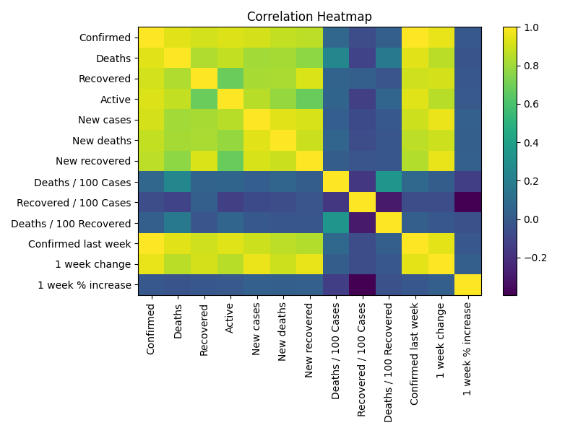
The heatmap helps stakeholders understand relationships between confirmed, recovered, deaths, and active cases.

Boxplot of Confirmed Cases
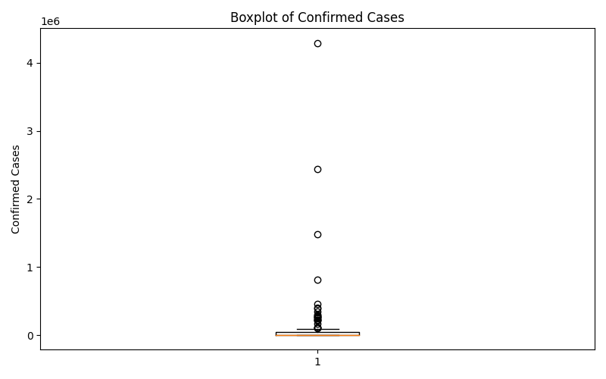
The boxplot identifies outliers and shows that a few countries had exceptionally high COVID-19 case counts.

Actionable Insights
- The United States, Brazil, and India reported the highest confirmed COVID-19 cases, showing where healthcare resources were under the greatest pressure.
- Confirmed, deaths, and recovered cases are highly correlated, indicating that countries with high infection rates also experienced higher recovery and mortality counts.
- The boxplot highlights strong outliers, meaning a small number of countries had extremely high confirmed cases compared to the global average.

Conclusion
The EDA process provided valuable insights into global COVID-19 trends. The visualizations helped highlight high-risk countries, relationships between key metrics, and unusual data patterns that can support strategic decision-making.

