1.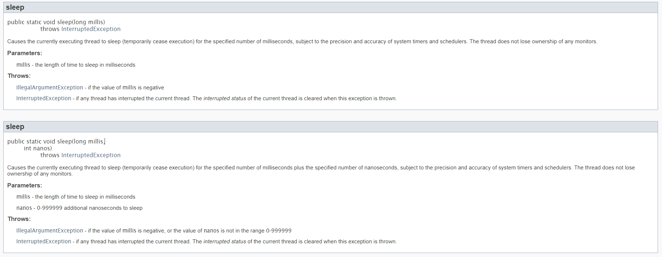

2.

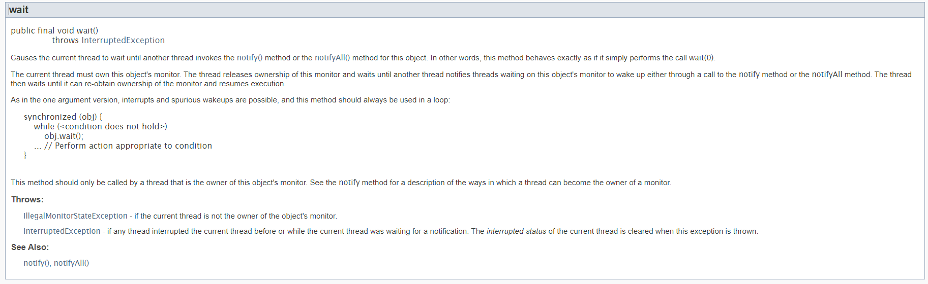

3.

Suppose we are calling t1.join() then the thread which has called t1.join() will wait until t1 thread’s run methods gets executed completely and t1 thread dies.

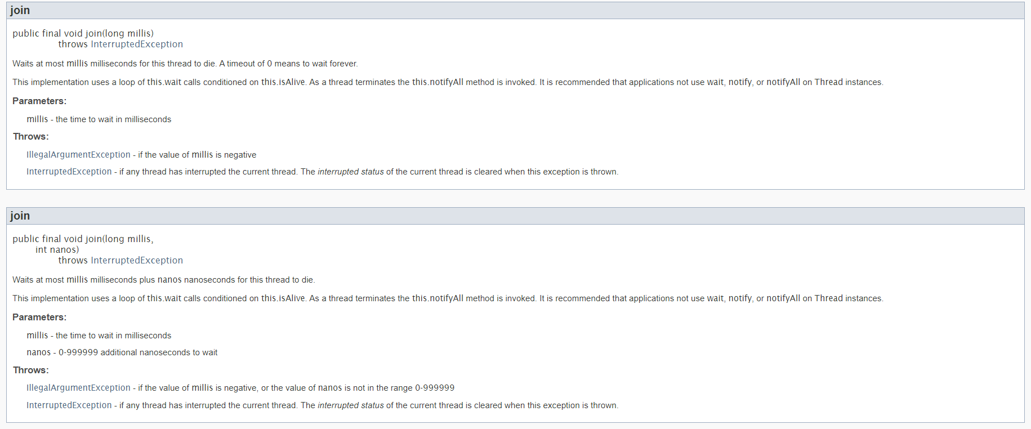

4. 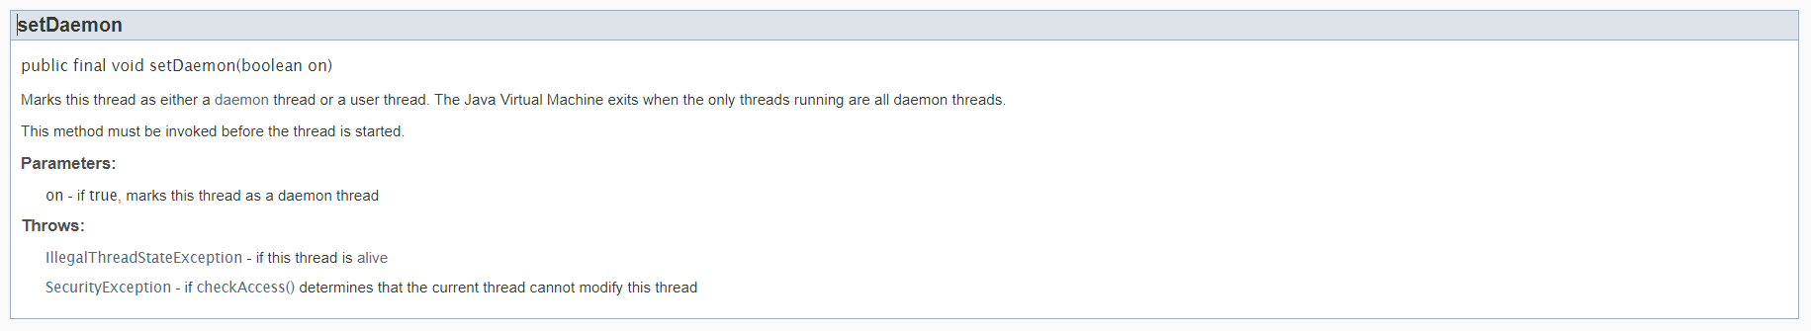

5.

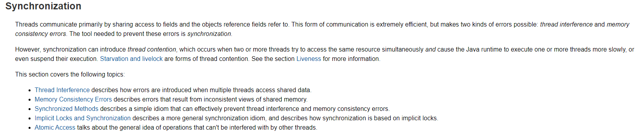

6.

**What are re-entrant locks?**

In the previous lectures we have been talking about locks (**intrinsic locks** or monitor locks).

* there is a single intrinsic lock associated with every object or class in Java
* a given  thread that needs exclusive and consistent access to an object's fields

has to acquire the object's intrinsic lock before accessing them,

* and then the thread releases the intrinsic lock when it's done with them
* with Locks: the acquired lock can be released any thread
* RLocks can be released by the thread that acquired it exclusively

Ok so a thread **cannot acquire a lock owned by another thread**. But a given thread **can acquire a lock that it already owns**. Allowing a thread to acquire the same lock more than once is called *re-entrant synchronization.*And this is exactly what is happening in Python when using RLocks- the same thread may acquire the lock more than once.

**For example**: let's consider recursive method calls. If a given thread calls a recursive and synchronized method several times then it is fine (note that in this case the same thread "enters" the synchronized block several times). There will be no deadlock because of re-entrant synchronization.

7.

**What is the difference between wait and sleep?**

Let's discuss the difference between sleep and wait. They may seem to be very similar but there are fundamental differences between them.

* you call wait on the **Object**while on the other hand you call sleepon the **Thread**itself
* wait can be interrupter (this is why we need the *InterruptedException*) while on the other hand sleep can not
* wait (and notify) must happen in a synchronized  block on the monitor object whereas sleep does not
* sleep operation does not release the locks it holds while on the other hand wait releases the lock on the object that wait() is called on

So as you can see there are some differences between wait and sleep operations!

**8. Calling notify method can awake a thread only and only if that other thread is in waiting state.**

**9.** **AtomicClasses** - Traditional multi-threading approaches use locks to protect shared resources. Synchronization objects like Semaphores provide mechanisms for the programmer to write code that doesn't modify a shared resource concurrently. The synchronization approaches block other threads when one of the thread is modifying a shared resource. Obviously blocked threads are not doing meaningful work waiting for the lock to be released.

Atomic operations on the contrast are based on non-blocking algorithms in which threads waiting for shared resources don't get postponed. Atomic operations are implemented using hardware primitives like compare and swap (CAS) which are atomic instructions used in multi-threading for synchronization.

Java supports atomic classes that support lock free, thread safe programming on single variables. These classes are defined in java.util.concurrent.atomic package. Some of the key classes include AtomicBoolean, AtomicInteger, AtomicLong, AtomicIntegerArray, AtomicLongArray and AtomicReference.

**10.** **Mutex and binary semaphore**

In the previous lectures we have been talking about binary semaphores and muteness. We have pointed out the fact that there are subtle differences between them. Let's consider the most critical difference again, the so-called **principle of ownership**.

*"Ownership is the simple concept that when a task locks (acquires) a mutex only it can unlock (release) it"*

* a mutex can be owned by at most one thread at any given time while on the other hand binary semaphore has no concept of ownership
* if a task tries to unlock a mutex it hasn’t locked (thus doesn’t own) then an error condition is encountered and, most importantly, the mutex is not unlocked. If the mutual exclusion object doesn’t have ownership then, irrelevant of what it is called, it is not a mutex.

I just wanted to point out the crucial difference between binary semaphores and muteness! Hope you find it useful!

**11.**