# Meeting Minutes: Group 8

# Day:1

1. Brief introduction of team members

* Skills Inventory

1. Designation of roles

* Project Manager: Vishanuel Prasad
* Database Admin: John Sade
* Developer/Tester: Nandita Nishika
* Developer /Tester: Renee Neemia

1. Collective read through the software requirement specification document
2. Decided on the development environment

* Decided to use Laravel Framework
* Why?
* Model View Controller Architecture
* Two members has hands-on

Present Members:

* John Sade
* Vishanuel Prasad
* Nandita Nishika
* Renee Neemia

# Day:2

1. Revision of the software requirements document
2. Identification of the tasks

Present Members:

* John Sade
* Vishanuel Prasad
* Nandita Nishika
* Renee Neemia

# Day:3

1. Identification of the Entities

* cos_order
* menu
* menu_food
* menu_food_item
* menu_manager
* migrations
* ordered_food_item
* password_resets
* patron
* restaurant
* special_food
* specials
* users

1. Identification of attributes of the entities

**Present Members:**

* John Sade
* Vishanuel Prasad
* Nandita Nishika

# Day:4

1. Related the tasks with entities

Feature one deals with

* cos_order
* menu
* menu_food
* menu_food_item
* ordered_food_item
* password_resets
* patron
* restaurant
* special_food
* specials
* users

Brainstormed the details of the features

**Present Members:**

* John Sade
* Vishanuel Prasad
* Nandita Nishika

# Day:5

1. Creation of the Entity Relation Diagram

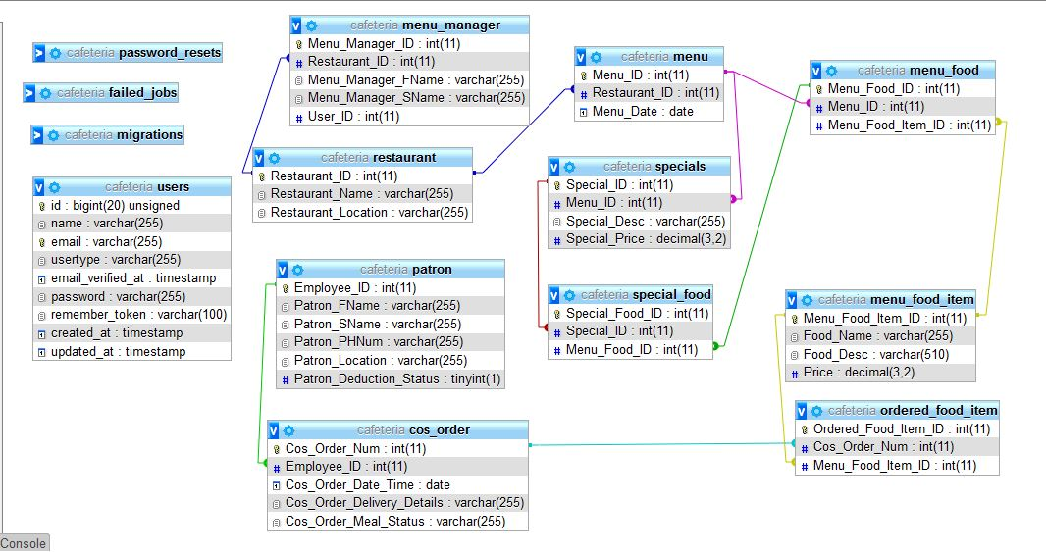

**Present Members:**

* John Sade
* Vishanuel Prasad
* Nandita Nishika

# Day:6

1. Meetup with the Client

Questions Asked?

1. Payroll system- how it works? How deduction of pay takes place?how do we interface the payroll system with our cafeteria ordering system
2. Number of resturants
3. Register meal payment option(payroll deduction vs cash)
4. Request for delivery
5. Cut off time

Present Members:

* John Sade
* Vishanuel Prasad
* Nandita Nishika
* Alvin Prasad
* Renee Neemia

# Day:7

1. Standup meetup within the project group

* Progress: Database created successfully

Present Members:

* John Sade
* Vishanuel Prasad
* Nandita Nishika

# Day:8

1. Preparation of the Presentation

**Present Members:**

* John Sade
* Vishanuel Prasad
* Nandita Nishika
* Alvin Prasad

# Tasks

## Back Log

* Divide backlog user stories among members to complete each task
* Feature 2: Create, View, Modify and Delete Menu
* Feature 1: Task 1(Restaurant/Menu Screen)

**Creating View for Available Restaurants/ Menus**

Display all available restaurants.  
- After a user clicks a restaurant, he/she should be able to see the  
corresponding menu for that particular restaurant for the specified date and display those food items for which at least one unit is available.  
-After the patron clicks on the order button, the system will check if the  
patron is registered for payroll deduction.  
-If the patron isn't registered, then the system will display if he would like to  
register for payroll deductions, and continue with the order, or to place an  
order for pickup, or cancel the order all together.  
-If current time is exceeds the order cutoff time, the patron will not be able to place an order

* Set Up IDE + Laravel Framework + UI Template
* Database Design + Implementation
* Convert functional requirements to user stories and divide user stories to smaller tasks
* Feature 1: Task 2(Place Order Screen)

**Place Order Screen**  
- When the patron chooses to place order, he should be greeted with a place  
order form, where he will be able to order multiple food items along with the  
ability to set their quantities against the quantity available.  
- Should be able to select meal date, if the meal date is the current date and the current time is after the order cutoff time, the system will inform patron that it's too late to place an order for today and the patron may change the meal date or cancel the order.  
- Should be able to choose between having his food delivered to him (if he has registered for payroll deduction) or picking the ordered food up from the cafeteria.  
- When patron chooses delivery option, he should be able to fill out the  
delivery instruction form which is extended to him (follow the Order.Deliver.* requirements in SRS).  
-Delivery form:  
1). display available delivery times for meal date and patron can choose one delivery time, change order, pickup or cancel order , delivery location(if delivery times are available), if no delivery time then patron can cancel order or select the pickup option.  
- Food item form should also be able to calculate the total cost of his order.  
- Food item form should check the cafeteria inventory system's food item  
quantities against the quantities the patron ordered.  
- Food item form should also have accept and cancel buttons.

* Feature 1: Task 4(Order Info Screen)

**Order Confirmation Request Screen**  
- Show food item ordered, individual price, total price for each food item  
(food item cost multiplied by QTY) and grand total.  
- Accept/Edit/Cancel buttons  
- After patron has clicked accept, the system will ask for the payment option.  
- If the patron is registered for payroll AND has selected the "pick up" option  
he will get the choice between payroll deduction OR pay in cash.  
- If the patron has selected the "Delivery" option, he will only be able to pay  
through payroll deduction.

* Feature 1: Task 5 (After patron has confirmed order)

**Order Info Screen**  
- Display all details of the current order

> Food Items

> Total Cost

> Payment Method

> Delivery Instruction

* Should be able to edit order
* Should be able to cancel order
* Should be able to confirm order
* Order.Pay.Confirm.Deduct
* Order.Pay.Confirm  
  :  
  :
  + Order.Done.Failure