
ONLINE CRIME REPORTING SYSTEM USING
PYTHON
A Project report

Submitted by:

PUJA RANA Mam,
SCHOOL OF COMPUTER SCIENCE, LOVELY PROFESSIONAL UNIVERSITY PHAGWARA, PUNJAB



Submitted By:
ABHINAV KUMAR SINGH
REG: 11901685, ROLL:24
SAURABH SINGH
REG:11901504, ROLL:08
VISHAVJEET SINGH,
12012866, ROLL:A77

ACKNOWLEDGEMENT

Respected sir/To whom so ever it may concern
We, hereby declare that the work done by us on “ONLINE CRIME REPORTING SYSTEM” as part of our CA-1, is a record of original work for the partial fulfillment of the requirements for the for the project allotted to us.

Names of the Students (Registration Numbers)

Abhinav Kumar Singh (11901685)
Saurabh Singh (11901504)
Vishavjeet Singh (12012866)

Dated:
31-10-2020

SUMMARY
______________________________________________

Crime is a part of illegal activities in human life. It is quite obvious that the rate of crimes is increasing day by day in all societies across the world, but we do believe that there is a lot which can be done by both the governments and the individuals to reduce the crimes in communities. The rise of population and complex society rises the range of anti-social conducts that must be restricted by the government through the military and different organizations particularly the Police Force. There are many current crime management systems which faces several difficulties, as there is no means to report crime instantly other than phone calls, messaging or face-to-face compliant filing. Hence, this Projects has proposed an online crime reporting system which allows the user to file complaints or missing reports and keep a track of it. There are 3 categories that a user can file; Complaint, Crime Report and Missing Report and can see all the status of what action has been taken by the admin. To file any of the above 3 complaints, the user should register in to the system and provide his right credentials to file them. The crime reporting system project also allows other users who doesn’t want to register but can check the crimes happening at his/her or any other area, has to just provide the pin code and in return the system displays the list of crimes if any filed. The offline i.e. the unregistered user can also take advantage of checking the missing person details, but he/she is refrained from getting complaints done by the users. The Front End of the crime reporting system is done using Android Studio and SQL serves as a backend to store books lists and inventory data. The system, has both the user as well the Admin Part, the role of admin is to just check all the 3 modules or categories and update their status likewise. This system helps the users in tracking any report filed to the law and take an advantage of reporting any complaint from anywhere bringing the whole system online.

Code:
from tkinter import *
import tkinter.messagebox as Messagebox
import mysql.connector as mysql

def insert():
name_label=e_name_label.get()
lastname_label=e_lastname_label.get()
phone_label=e_phone_label.get()

date_label=e_date_label.get()
time_label=e_time_label.get()
location_label=e_location_label.get()

if(name_label=="" or lastname_label=="" or phone_label=="" or location_label=="" or date_label=="" or time_label==""):
Messagebox.showinfo("All fields are Required")
else:
con = mysql.connect(host="localhost", port="3306",user="root", password="password246", database="mypro")
cursor = con.cursor()
cursor.execute("insert into report4 values('"+ name_label +"','"+lastname_label +"','"+ phone_label +"','"+location_label +"','"+date_label +"','"+time_label +"')")
cursor.execute("commit")
Messagebox.showinfo("Registered","Your Complaint has been Submmited")
con.close()

# def show():
# con = mysql.connect(host="localhost", port="3306",user="root", password="password246", database="project")
# cursor = con.cursor()
# cursor.execute("SELECT * FROM project")
# rows= cursor.fetchall()

# for row in rows:
# insertData = str(row[0])+ ' '+ row[1]
# list.insert(list.size()+1, insertData)

# con.close()

root = Tk()
root.geometry("790x630")
root.title("Crime Reporting ")
root.configure(bg='#E7412A')

name_label=Label(root,text="First Name",font=('bold', 11),foreground="#000000",background="#52E7E1")
name_label.grid(row=1,column=0,pady=10,padx=20,sticky="w")

lastname_label=Label(root,text="Last Name",font=('bold', 11),foreground="#000000",background="#52E7E1")
lastname_label.grid(row=2,column=0,pady=10,padx=20,sticky="w")

phone_label=Label(root,text="Phone Number",font=('bold', 13),foreground="#000000",background="#52E7E1")
phone_label.grid(row=3,column=0,pady=10,padx=20,sticky="w")

date_label=Label(root,text="Date of Crime",font=('bold', 13),foreground="#000000",background="#52E7E1")
date_label.grid(row=4,column=0,pady=10,padx=20,sticky="w")

time_label=Label(root,text="Time of Crime",font=('bold', 13),foreground="#000000",background="#52E7E1")
time_label.grid(row=5,column=0,pady=10,padx=20,sticky="w")

location_label=Label(root,text="Location",font=('bold', 14),foreground="#000000",background="#52E7E1")
location_label.grid(row=6,column=0,pady=10,padx=20,sticky="w")

# txt_location=Text(root,width=50,height=12,font=("italic",11),foreground="white",background="teal")
# txt_location.grid(row=6,column=1,pady=60,padx=20,sticky="w")

# Entry

e_name_label=Entry(root, width=30, font=('Arial', 14))
e_name_label.grid(row=1,column=1,pady=10,padx=20,sticky="w")

e_lastname_label=Entry(root, width=30, font=('Arial', 14))
e_lastname_label.grid(row=2,column=1,pady=10,padx=20,sticky="w")

e_phone_label=Entry(root, width=30, font=('Arial', 14))
e_phone_label.grid(row=3,column=1,pady=10,padx=20,sticky="w")

e_date_label=Entry(root, width=20, font=('Arial', 14))
e_date_label.grid(row=4,column=1,pady=10,padx=20,sticky="w")

e_time_label=Entry(root, width=20, font=('Arial', 14))
e_time_label.grid(row=5,column=1,pady=10,padx=20,sticky="w")

e_location_label=Entry(root,width=50, font=('Arial', 14))
e_location_label.grid(row=6,column=1,pady=10,padx=20,sticky="w")

# Button

insert = Button(root, width=30,text="Click Here For Submit", font=("italic", 15), bg="orange", command=insert)
insert.grid(row=7,column=1,pady=20,padx=50,sticky="w")

# list = Listbox(root)
# list.place(x=290,y=30 )
# show()

root.mainloop()

Output:

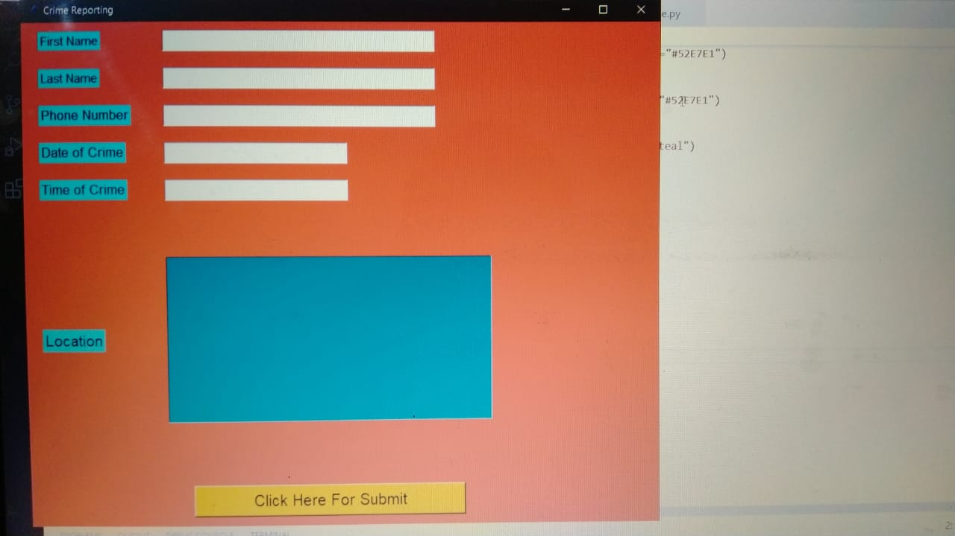
CODE EXPLANATION:
Firtsly, we import Tkinter, Tkinter is the standard GUI library for Python. Python when combined with Tkinter provides a fast and easy way to create GUI applications. Tkinter provides a powerful object-oriented interface to the Tk GUI toolkit.
Then we import tkinter.message box, The tkMessageBox module is used to display message boxes in your applications. This module provides a number of functions that you can use to display an appropriate message.
Then we import mysql.connector, The connect() constructor creates a connection to the MySQL server and returns a MySQLConnection object.
Then we are making a function insert in which we are taking input from the user like name(first name, last name), phone label and location label.

Then commit, This method sends a COMMIT statement to the MySQL server, committing the current transaction. Since by default Connector/Python does not autocommit, it is important to call this method after every transaction that modifies data for tables that use transactional storage engines.
Then we are giving geometry to the message box label, first name label, last name label, phone number label and location label. The geometry type is predefined and available in each database. You can create table columns of type geometry and operate on geometry data in the same manner as you would use other CLR types. Can be used in persisted and non-persisted computed columns. If we forget to submit any of details then it will show a message that “all field are required”. When we submit it the it will show a message that Inserted Succesfull and after that it will close.

Project Lifecycle:

____________________________________________________

Description
The waterfall Model is a linear sequential flow. In which progress is seen as flowing steadily downwards (like a waterfall) through the phases of software implementation. This means that any phase in the development process begins only if the previous phase is complete. The waterfall approach does not define the process to go back to the previous phase to handle changes in requirement. The waterfall approach is the earliest approach that was used for software development.
Work Distribution:
Abhinav Kumar Singh (11901685) | Saurabh Singh (11901504) | Vishavjeet Singh (12012866)
GUI and Documentation | Database Coding And Designing | Idea and help on GUI Design

- Hardware Requirement:

- i3 Processor Based Computer or higher
- Memory: 1 GB RAM
- Hard Drive: 50 GB
- Monitor
- Internet Connection

- Software Requirement:

- Windows 7 or higher
- Python
- MySQL database
- Advantages
- The User can check the missing reports or crime without giving his credentials to the system.
- The user is allowed to file any number of cases.
- Admin and the user have the same App limiting the cost and size.
- Limitation
- No status change reminder.
- No email or Message Confirmation in the case or action taken.
- Only 3 types of categories that can be filed.
- Application
- This system is project which was part of our academic task .

- GITHUB LINK:
https://github.com/Abhinav890/OnlineCrimeReporting
https://github.com/Saurabhsingh94/Crime-Reporting-App.git
https://github.com/VishavjeetS/Crime-Reportory-System.git
- Reference
- https://shsu-ir.tdl.org/shsu-ir/bitstream/handle/20.500.11875/1164/0781.pdf?sequence=1
- https://ieeexplore.ieee.org/document/6208293/
- https://ieeexplore.ieee.org/document/4679917/

