**EXPERIMENT 4**

| Roll No. C027 | Name: Vishesh Giyanani |
| --- | --- |
| Class: B | Batch: EB1 |
| Date of Experiment: | Date of Submission: |
| Grade : |  |

**AIM:** To understand linear programming.

**B.1 Documentation written by student:**

**Problem 1**

**Solution using graphical method**

**Solution using Algebraic method (final solution)**

**Solving using all slack method (iteration by iteration)**

Iteration 1

Iteration 2

Iteration 3

**Problem 3**

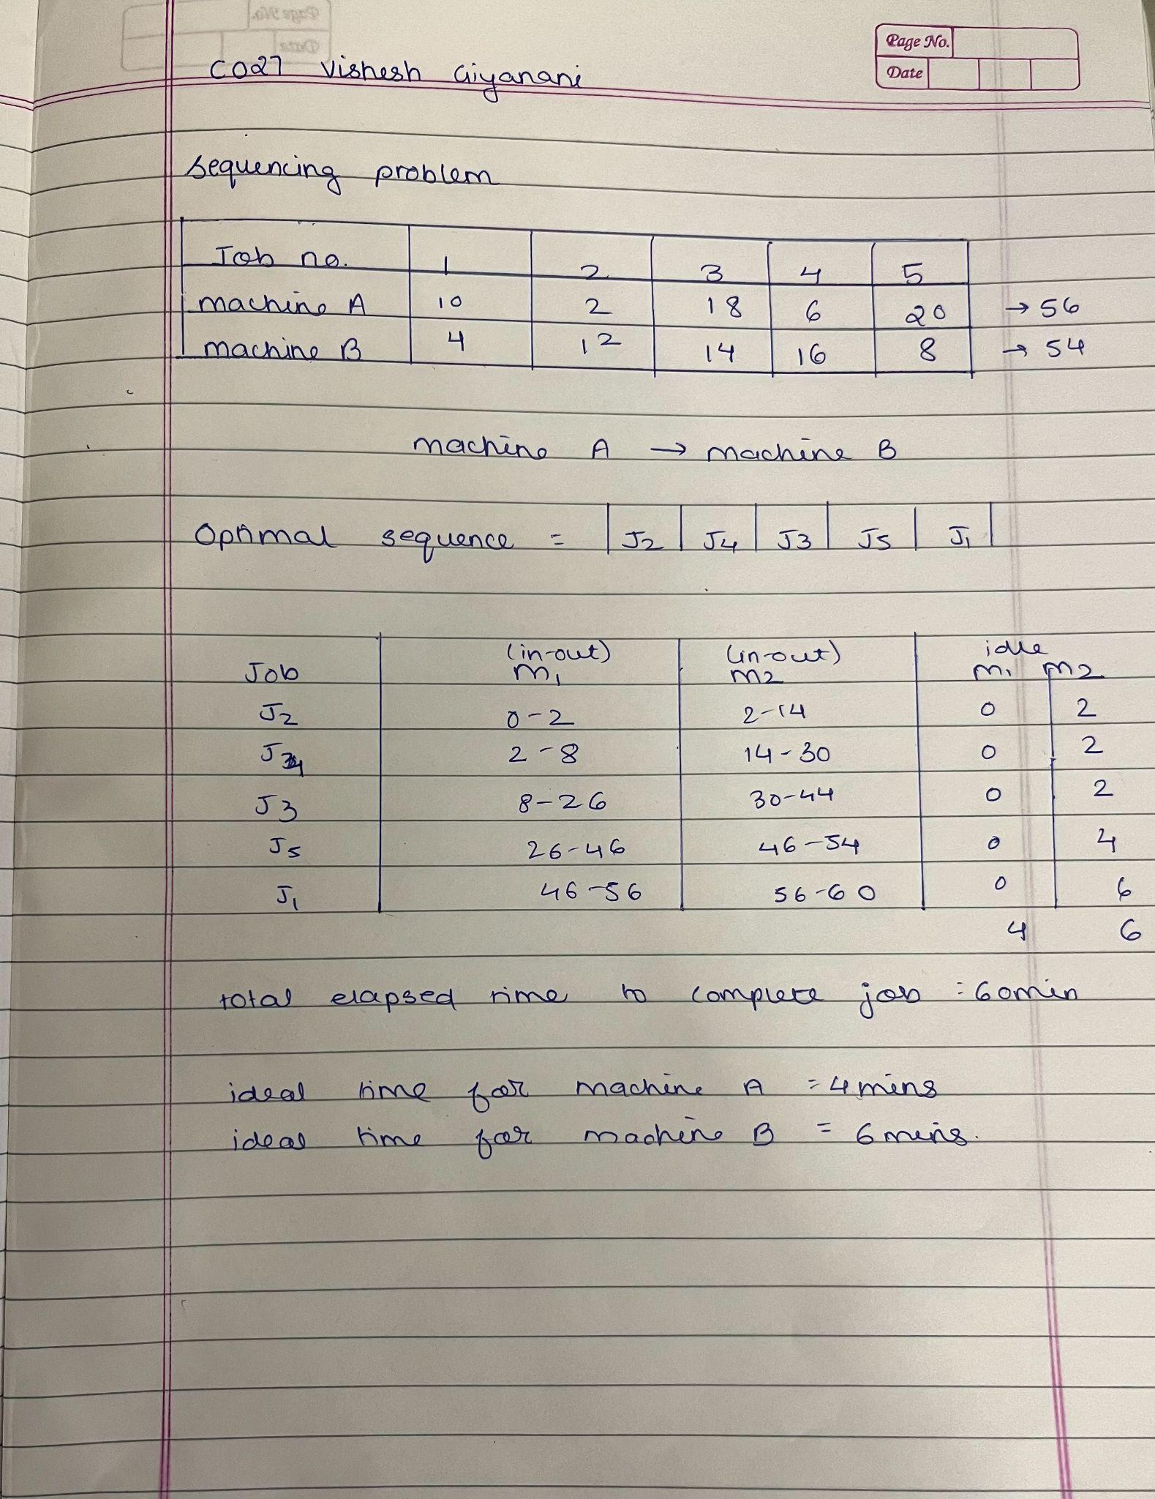

**B.2 Observations and learning:**

Exploring the Tora app has broadened my understanding of its capabilities in tackling various problem-solving tasks such as linear programming, CPM, PERT, and Non Zero Sums. Its user-friendly interface simplifies the process of defining problems and provides clear step-by-step guidance throughout. Through practical application, I successfully resolved a job sequencing problem and identified the optimal solution.

**B.3 Conclusion:**

In conclusion, I now understand how to use the Tora app for defining and solving problems like linear programming and job sequencing. It's a handy tool for tackling such tasks efficiently.