Exp-6 ​Ultrasonic Interface.
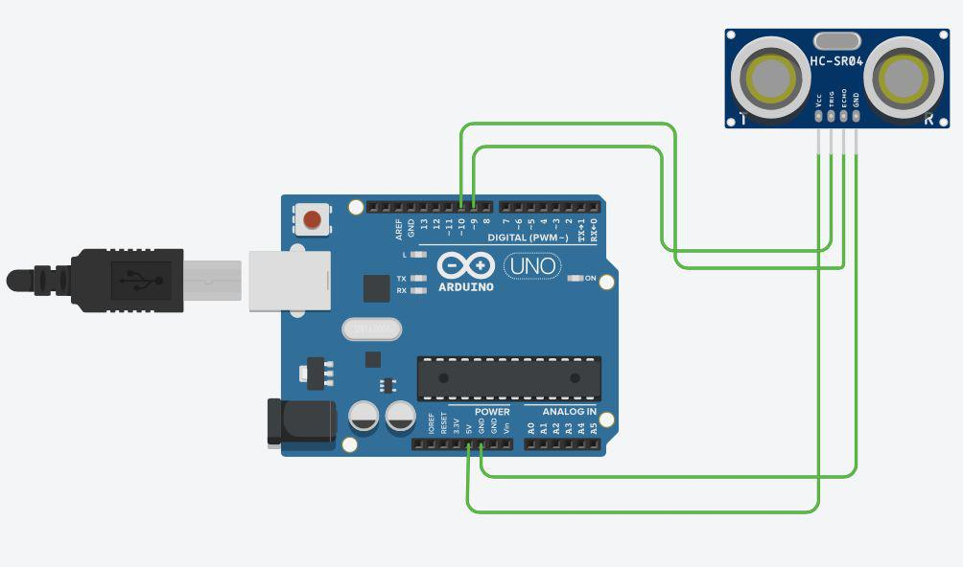

Concept Used :-

This experiment shows how does the obstacle detector works. The obstacle detector works on the principle of transmitting and receiving the Ultrasonic signal, and calculating the distance by measuring the time between transmitting and receiving the signal.
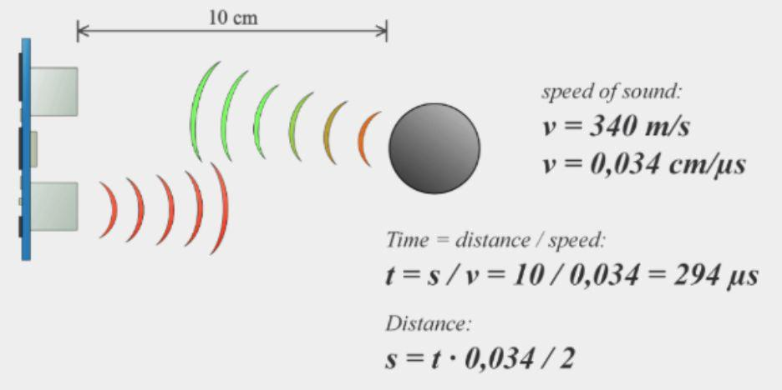

Learning and Observations :-

- Connection between the arduino and Ultrasonic signal transmitter IC

- Concept of calculation of distance on the basis of signal transmission and receiving.

- Coding to be done for Arduino.

- Basic understanding of Electrical Connections.

- What’s inside the Ultrasonic Signal Transmitter IC.

Problems & Troubleshooting:-

No problem occurred during the execution of the experiment.

Precautions:-

- Making correct connection

- Using multimeter to check whether the devices are damaged or not.

- Correct sets of instructions to be passed to successfully execute the experiment.

- Port selection for Arduino.

Learning Outcomes :-

- Setting up correct connection.

- Connecting Arduino and the Ultrasonic signal Transmitter.

- Concept of distance measuring using the Ultrasonic Signal.

- Working & Coding of Arduino.

Result :-

The whole Setup executed successfully and is ready to be used.

