Exp-7 ​ Programmable Digital Data Display system.
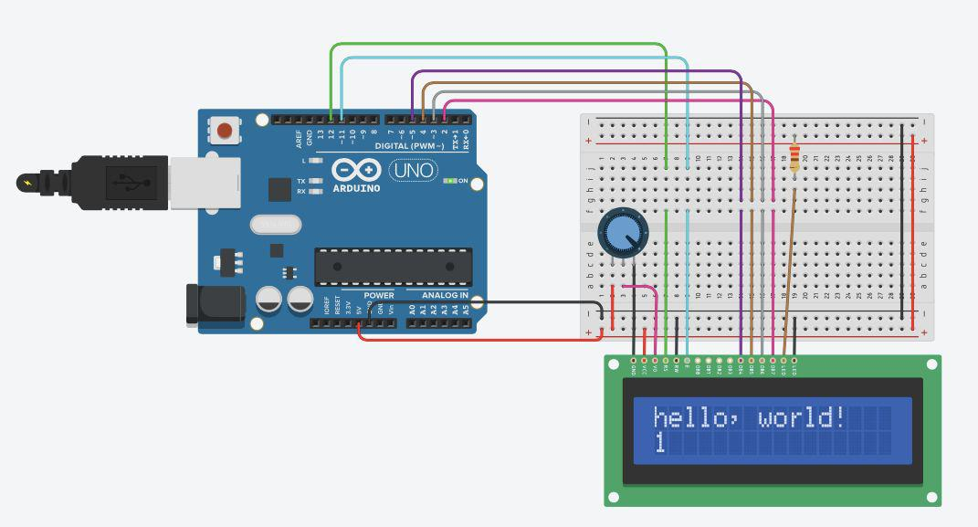

Concept Used:-

This Experiment shows how does the Liquid Crystal Display(LCD), works and how can it be programmed for the same.

Working with LCD is quite hard but with the help of Libraries defined for the same, it makes the task easy to execute.There are 16 pins on LCD which are used with a particular manner and for a particular purpose.

Learning & Observations:-

1. Connection between Aduino and Liquid Crystal Display.

- Coding to be done to execute the task.

- What pins are to be used to execute the task.

- Functioning of different pins on LCD and making the connection of the pins to arduino for the correct purpose.

- Basic understanding of Electrical Connections.

- Use of Potentiometric Wire.

- Coding and syntax used for execution.
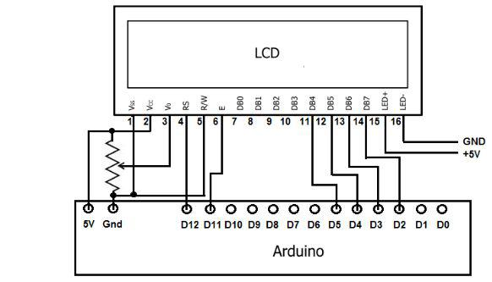

Problems & Troubleshooting:-

The problems faced were only making the connection between arduino and LCD as it was quite complex and so loosed connection could not be found easily.

Other than this, no problems occurred during the execution of the task.
Precautions:-

- Use of Safety Measures.

- Using a multimeter to test whether the appliances used are in right condition.

- Making correct Electric Circuit and connections.

- Selecting the correct port for Arduino.

- Making tight connections.

- Using correct pins of LCD.

Learning Outcomes:-

During the execution of this task, I learned the working of Arduino with Liquid Crystal Display altogether, also the coding that is needed to be done for the execution of tasks.

I learned how does the LCD is programmed and what libraries are needed to be included for the easy execution of the task.

Result:-

The whole Setup executed successfully and is ready to be used.

