AgriVerse: Enhancing Crop Decision-Making Through XAI and Geospatial Weather Integration

Abstract
In developing economies, the choice of which crops to cultivate is frequently guided by tradition and inherited knowledge. Although these practices hold cultural value, decisions made on this basis can lead to disappointing harvests and the gradual depletion of precious soil and environmental resources. This paper introduces AgriVerse, an intelligent recommendation framework created to counteract these inefficiencies. The system is designed to align crop selection with detailed local data on soil nutrients and climate.
At its core, AgriVerse functions by analysing a carefully compiled dataset that marries key soil characteristics with relevant meteorological trends. This integration allows the framework to produce highly contextualised agricultural advice. Crucially, our methodology avoids the "black-box" problem common to some predictive models. Instead, it strategically balances computational performance with architectural clarity. AgriVerse does not simply output a ranked list of suitable crops; it also furnishes clear, evidence-backed explanations for each recommendation, making its reasoning transparent to the user.
Our experimental results confirm that the framework delivers accurate predictions while maintaining this essential interpretability. By effectively connecting advanced data science with the realities of farm-level decision-making, AgriVerse stands as a practical and reliable support tool, ready for use by individual smallholder farmers and agricultural advisory bodies alike.
Keywords : Crop recommendation, Explainable AI, SHAP, Smart agriculture, Machine learning in agriculture, Weather-aware systems, Counterfactual reasoning, Trust score, Global feature importance, Agricultural decision support.

Introduction
In many developing nations, most notably India, agricultural decision-making remains predominantly guided by ancestral experience and heuristic tradition. While these methods are deeply localized, they frequently lead to suboptimal resource allocation and volatile yield patterns across successive growing seasons. As emphasized by Gangwar et al. [1] and Ghosh et al. [2], the persistence of these non-scientific approaches not only curtails immediate productivity but also threatens the long-term ecological and economic sustainability of farming systems. This need for intelligent, adaptive decision-support is further underscored by the climate crisis, which continues to exacerbate soil degradation and introduce unprecedented volatility into regional rainfall patterns [3][4].
Recent advancements in Explainable Machine Learning (XAI) offer a promising avenue for refining these decision-making processes [5]. While existing predictive models—integrating soil metrics and historical climate data—have achieved high levels of technical accuracy, significant barriers to adoption remain. A critical review of the literature suggests two primary deficiencies: a lack of responsiveness to high-frequency, real-time environmental shifts, and a lack of interpretability. When models operate as "black boxes," providing recommendations without accessible logic, they fail to gain the trust of practitioners who lack formal technical training [6][7].
AgriVerse is proposed as a direct response to these twin challenges of adaptability and transparency. Our framework moves beyond static modeling by dynamically integrating location-specific meteorological data via the Open-Meteo API, ensuring that outputs reflect the farmer’s immediate environmental reality. At its core, the system utilizes an XGBoost-driven predictive engine, which we have augmented with a sophisticated explainability suite rooted in SHAP (SHapley Additive exPlanations) values [8].
To bridge the gap between complex data science and field-level application, AgriVerse provides a multi-layered explanatory interface. Rather than offering a singular data point, the system generates SHAP waterfall plots and global feature importance metrics, translated into plain-language summaries and counterfactual examples. This design philosophy is rooted in the ethical necessity of building user trust in sensitive domains [9]. Furthermore, we introduce a specialized "trust score" metric, adapted from established methodologies [10], to quantify the reliability of each individual prediction.
Architecturally, AgriVerse is realized as a full-stack application, utilizing a ReactJS frontend and an Express.js backend to manage a modular Python machine learning pipeline. The user journey is streamlined: farmers provide fundamental soil parameters (N, P, K, and pH), while the system automatically handles geolocation-based retrieval of temperature, humidity, and rainfall data. The backend then orchestrates the synthesis of these variables, generating both visual diagnostics and interpretive reports. Through this synthesis of quantitative precision and qualitative clarity, we aim to provide a deployment-ready tool that facilitates the broader acceptance of precision agriculture.

Related works
Crop recommendation systems have evolved considerably, moving from traditional statistical approaches to more advanced machine learning methods that better match crops to local environmental conditions. In recent years, researchers have increasingly focused on striking a balance between strong predictive accuracy and the need for clear interpretability through Explainable AI (XAI). This section places AgriVerse within this evolving landscape, reviewing earlier contributions in crop recommendation, interpretable modeling, and user-focused design. We particularly highlight the shortcomings in prior work that our system seeks to overcome.
Early work by Jha et al. [11] showed that Support Vector Machine (SVM) classifiers could achieve impressive accuracy when using agro-climatic features. A major limitation, however, was the model's "black-box" character, offering no explanation for its outputs. AgriVerse addresses this transparency issue head-on by incorporating SHAP-based explanations that precisely show how each input feature contributes to a recommendation—an essential feature for building confidence among farmers. Similarly, Banerjee et al. [12] improved performance on Indian datasets by including climate change projections in a Random Forest model. While their method effectively captured long-term patterns, it provided little insight into individual predictions. Building on this, our system adds both global and local interpretability while automatically retrieving up-to-date environmental data via geolocation-based API integration.
Studies targeting smallholder farmers were furthered by Patel et al. [13], who developed a hybrid KNN and Decision Tree model delivered through a web interface. Though accessible, their tool gave users no deeper reasoning or alternative options. AgriVerse goes beyond simple rankings by including a tailored counterfactual generation module, enabling farmers to examine realistic "what-if" scenarios and next-best crop choices under fixed conditions like prevailing weather.
In the area of interpretability, Ali et al. [14] used LIME to clarify yield predictions. However, LIME can yield inconsistent results due to its instability and weaker theoretical foundation. By relying on SHAP instead, AgriVerse delivers mathematically sound and locally faithful explanations, making it valuable not just practically but also as a learning resource for users.
Another frequent challenge in earlier systems is limited technical adaptability. For example, Hossain et al. [15] created a mobile Android app that, despite being portable, relied on static inputs and offered little support for missing data or location-aware updates. Our platform features a more robust pipeline that can produce reliable recommendations even with incomplete information, while explicitly reporting confidence levels to users. Likewise, although Dey et al. [16] integrated external weather APIs, their system suggested only one crop at a time. AgriVerse, by comparison, assesses 22 different crops simultaneously and returns the top three with probability scores and detailed SHAP impact visualizations for richer decision support.
Many existing approaches also face constraints related to geography or system design. The ensemble model from Singh and Rao [17], for instance, was limited to Rabi season data and required a complete set of inputs. AgriVerse avoids such restrictions through real-time geolocation and flexible feature handling that alerts users to potential impacts of missing data on reliability. In contrast, Kumar et al. [18] investigated complex attention-based neural networks, but these proved hard to interpret and challenging to deploy in real farming settings. We deliberately chose XGBoost for its balance of performance and deployability, enhanced by comprehensive SHAP explanations, rather than pursuing overly intricate architectures. This choice also differs from the inherently interpretable yet less scalable fuzzy logic rule-based systems of Sharma et al. [19]; AgriVerse scales effectively by training on a dataset of more than 2,200 labeled instances.
More recent efforts have begun linking visualization with prediction, but important shortcomings remain. Yadav et al. [20], for example, applied SHAP to reveal global feature importance in wheat yields yet provided neither instance-level explanations nor interactive elements. We extend this by incorporating interactive SHAP charts and crop-tailored narratives directly in the frontend via Charts.js. Similarly, Brar et al. [21] built a fixed backend for multi-crop forecasting with LSTMs, but the design lacked modularity and counterfactual capabilities. AgriVerse’s modular Express and Python backend facilitates easy cloud deployment and includes a deviation-based counterfactual technique for practical alternative suggestions. Lastly, while Das et al. [22] employed Explainable Boosting Machines (EBMs), these were less effective for multi-class local explanations. AgriVerse leverages SHAP’s additive attributions to offer fine-grained insight into the factors driving each specific recommendation.
Overall, although prior research has advanced either predictive power or isolated explainability features, few solutions combine accurate modeling, multi-layered transparency, counterfactual analysis, and real-time geolocation in one cohesive, deployable package. AgriVerse brings these elements together, with the goal of establishing a new standard for trustworthy and farmer-friendly precision agriculture tools.

Proposed Methodology
The architecture of AgriVerse is designed to reconcile the technical rigor of machine learning with the practical exigencies of field-level agriculture. Our methodology follows a modular paradigm, ensuring that each phase—from data ingestion to user interaction—is both scalable and maintainable. The framework is structured around four primary pillars: a high-fidelity model training pipeline, a dual-purpose prediction and explanation engine, a robust Node.js API gateway, and a responsive React-based user interface.
By decoupling the predictive logic from the delivery mechanism, we ensure that the system remains computationally efficient while providing real-time responsiveness. The model training pipeline focuses on historical accuracy and generalization, while the explanation engine utilizes SHAP (SHapley Additive exPlanations) to decompose these complex predictions into human-readable insights. This intentional modularity allows AgriVerse to function not merely as a technical exercise in classification, but as a cohesive, deployment-ready ecosystem that balances predictive precision with radical transparency.
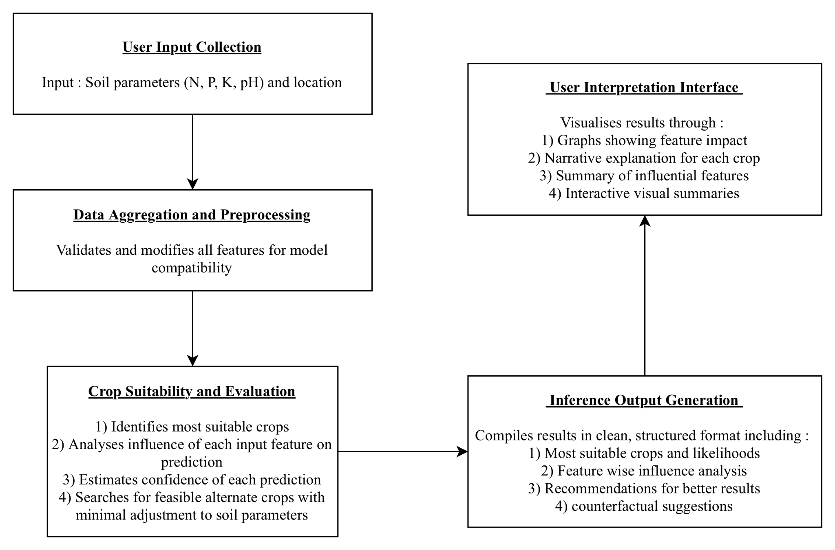
Fig. 1. System flow pipeline
AgriVerse operates through a carefully structured multi-stage workflow that combines farmer-entered soil data with up-to-the-minute environmental information to produce practical, well-explained crop recommendations. The process starts when a user enters key soil parameters—nitrogen (N), phosphorus (P), potassium (K), and pH—together with their location coordinates. These coordinates automatically trigger the retrieval of current local weather details, including temperature, humidity, and rainfall, via an external API integration.
Once the soil data has been enriched with these real-time meteorological variables, the combined input is passed to the core evaluation module. Here, two main tasks run side by side: a multi-class classification model identifies the most suitable crops, while an additive feature attribution method simultaneously computes how each individual input influences the outcome. To offer more than just a single top suggestion, the system incorporates a dedicated counterfactual analysis step. This identifies realistic alternative crops that could become viable with minimal changes to the controllable soil factors, effectively providing farmers with a clear roadmap for potential improvements rather than a fixed recommendation.
In the final step, all these elements—predicted probabilities, SHAP-derived feature contributions, and counterfactual options—are brought together into a cohesive interpretive report. Delivered through a React-based web interface, the report features intuitive visualizations alongside straightforward natural language explanations. This approach guarantees that the recommendations are not only accurate and fully traceable but also easy for farmers to understand and act upon. By guiding users from initial data entry through to actionable insights, AgriVerse ensures every suggestion is transparent, grounded in evidence, and supported by practical advice for better farm planning.

Model selection and Training
The core of the AgriVerse prediction engine was engineered to satisfy three often-competing requirements: high predictive precision, low latency for real-time deployment, and robust interpretability. These pillars are essential for bridging the gap between theoretical machine learning and the practical realities of agricultural decision-support.
To identify the optimal architecture, we conducted a comprehensive comparative analysis of several benchmark classifiers, including Support Vector Machines (SVM), Random Forests, and Artificial Neural Networks (ANNs). Our empirical results led to the selection of XGBoost (Extreme Gradient Boosting) as the primary model. This choice was informed by several of the algorithm's distinct structural advantages:
- Non-linear Pattern Recognition: Its ability to capture the intricate, non-linear relationships between soil chemistry and meteorological fluctuations that simpler linear models often overlook.
- Resilience to Feature Noise: A built-in capacity to handle multicollinearity and noisy data—common in field-collected agricultural datasets—without significant degradation in performance.
- XAI Compatibility: Most crucially, XGBoost’s tree-based structure integrates seamlessly with the SHAP (SHapley Additive exPlanations) framework, allowing for consistent and mathematically grounded post-hoc interpretations.
At a fundamental level, XGBoost constructs its predictions through an iterative ensemble process, where each successive learner is trained to correct the residual errors of its predecessors. This stage-wise refinement ensures a highly optimized model that remains computationally lightweight enough for real-time application in mobile or web-based environments. You can describe prediction like :
${\hat{y}}_{i} = \sum{}k = 1^{K}f_{k}(x_{i}) f_{k}∈ ξ$ (1)
Where :
- ${\hat{y}}_{i}$ is the predicted output for instance i.
- $f_{k}$ is the $k^{th}$ regression tree.
- $ξ$ is the space for all the regression trees.
- And K is the total number of trees.

The design of AgriVerse’s prediction engine was guided by three core objectives: precision, operational reliability, and interpretability. This study frames the problem as a multiclass classification challenge, with the model trained to distinguish between 22 different crop types. The predictive features consist of seven key agronomic variables: the primary soil nutrients Nitrogen (N), Phosphorus (P), Potassium (K), soil pH, and three meteorological factors—temperature, humidity, and precipitation.
The training procedure, as depicted in Figure 2, adhered to a disciplined data preparation pipeline. It began with a phase of thorough data cleaning and normalization to standardize feature scales and mitigate the influence of outliers. Subsequently, we applied focused feature engineering to improve the model’s capacity to identify relevant patterns within the dataset.
A novel aspect of our training approach is the use of a dropout simulation strategy. Throughout model training, random feature subsets were intentionally omitted to mimic the incomplete data scenarios common in real-world agriculture—such as partial soil tests or temporary sensor disruptions. By learning to function robustly despite these simulated "information gaps," the model gains a practical resilience, making it a more dependable advisory tool under the non-ideal data conditions frequently faced in the field.
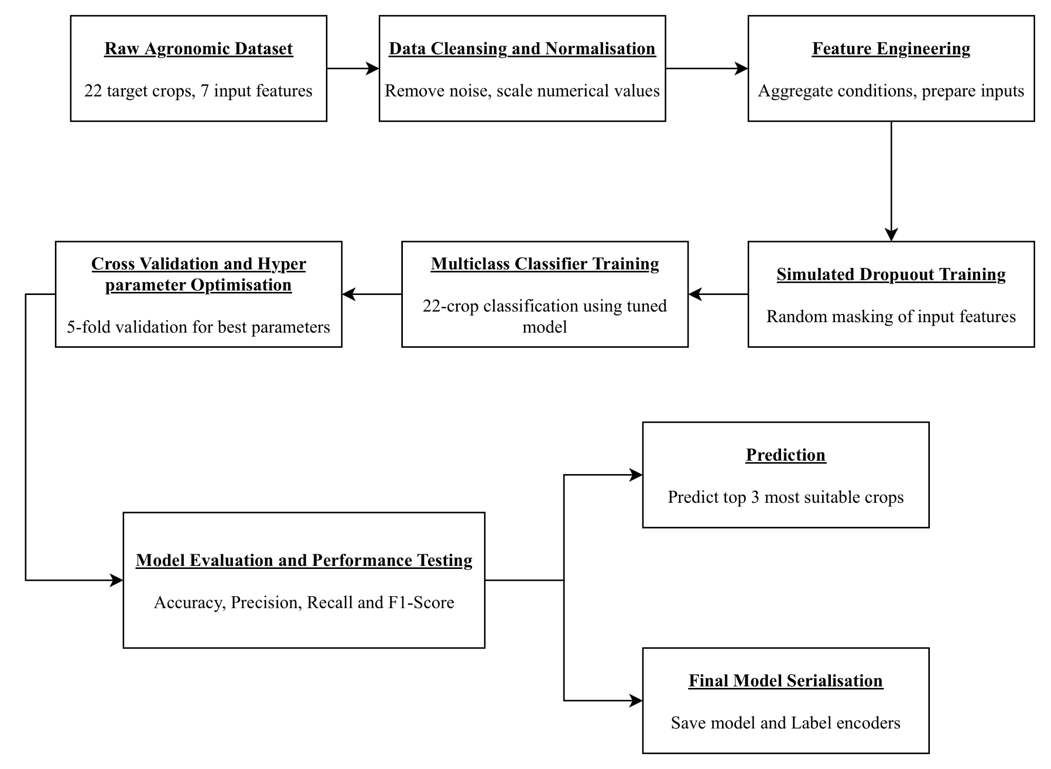
Fig. 2. Flowchart for Crop Recommendation Model

To optimize the model’s performance and promote strong generalization, we adopted a structured hyperparameter tuning process. This relied on grid search combined with 5-fold cross-validation to carefully adjust key parameters, including maximum tree depth, learning rate (eta), and subsampling ratios. The tuned model delivered outstanding results, reaching a classification accuracy of 96.7% on an independent test set. Equally encouraging were the consistently high precision, recall, and F1-scores across all 22 crop classes, confirming that the model performed reliably without favoring any particular category.
Once validated, the final model—along with its associated label encoders—was serialized using standard pickling techniques. This step guaranteed a smooth, error-free handover from the development phase to the live production backend.
Aware that benchmark accuracy in controlled settings often drops in real-world use, we incorporated a specialized dropout-based training strategy. By randomly masking subsets of input features during training epochs, we encouraged the model to discover alternative relationships among the available variables. This technique effectively replicates the kinds of imperfections commonly encountered in smallholder agriculture, such as faulty sensors or missing soil measurements. As a result, the approach markedly improves robustness, enabling AgriVerse to generate dependable, confidence-calibrated recommendations even with incomplete inputs—an essential capability for reliable operation in areas with unreliable internet access or limited on-farm testing resources.

Prediction and Model Result Explanation
A foundational tenet of the AgriVerse architecture is the commitment to "transparent-by-design" artificial intelligence. To transition from a purely predictive tool to a credible decision-support system, we integrated SHAP (SHapley Additive exPlanations) as the primary interpretive engine. Unlike heuristic-based explanation methods, SHAP is rooted in the axiomatic principles of cooperative game theory, providing a mathematically rigorous method for attributing the "payout" (the model's prediction) to the individual "players" (the input features).
This framework allows AgriVerse to decompose complex, non-linear outputs into the specific marginal contributions of variables like soil pH or precipitation. By adopting this approach, we ensure that the system satisfies two critical properties for agricultural trust: local accuracy, where the explanation precisely mirrors the model’s logic for a specific farm, and global consistency, ensuring that the relative importance of features remains coherent across the entire dataset. This layer of transparency is not merely a technical addition; it is an ethical bridge that allows users to move from passive receipt of data to active, informed understanding.
$ϕ_{i}=\sum_{S ⊆ N_{i}}{}\frac{|S|!(|N|-|S|-1)!}{|N|!}[f(S∪\{i\})-f(S)]$ (2)
Where :
- $ϕ_{i}$ is the SHAP value of feature i
- S is the the subset of features not containing i
- N is the set of all input features
- f(S) is the model prediction when using features only in subset S

When AgriVerse receives a set of runtime inputs, it selects the three most promising crop options by retrieving probability scores from the XGBoost model's predict_proba method. To make these predictions transparent, the system employs the TreeExplainer from the SHAP library to compute detailed feature contributions specific to each candidate crop.
We designed a two-tiered interpretability structure that offers both fine-grained details and broader contextual understanding:
- Localized Feature Attribution (Per-Crop): For each top recommendation, AgriVerse produces a dedicated horizontal bar chart that shows the direction and magnitude of influence for every input variable. For example, it might highlight how ample rainfall strongly supports a rice suggestion, while an unfavorable soil pH simultaneously reduces the viability of coffee. This visualization helps users follow the competing influences of different environmental factors for individual crops.
- Global Structural Importance: For broader perspective, we precompute a dataset-wide importance plot during training. By averaging the absolute SHAP values across all training samples, this chart reveals the most influential features in the model overall. It serves as a useful high-level guide for researchers and extension workers, mapping out the key drivers shaping the system's decisions.
A key innovation in AgriVerse is its multi-crop comparison capability. Unlike most existing systems, which explain only the single top prediction, our framework generates local SHAP impact plots for the top three candidates at once. Displaying these side by side enables direct comparisons, allowing farmers and advisors to see precisely why one crop edged out the others and to appreciate the environmental trade-offs involved in their specific location. This richer view supports more informed and nuanced decision-making.

AI Generated Report System
To help farmers turn complex algorithmic outputs into practical on-farm choices, AgriVerse includes a dedicated natural language synthesis module. This component converts the numerical results from SHAP feature analysis into straightforward, narrative explanations. By systematically interpreting the model’s underlying logic, it produces tailored reports for each recommended crop, making the reasoning accessible even to users without a technical background.
Each report is organized in a clear, structured way:
- Confidence-Weighted Prediction: The explanation starts with the top recommended crop and its associated probability score, immediately conveying how confident the system is in the suggestion.
- Supportive Drivers: Next, it highlights the "Top Contributing Features"—those with positive SHAP values—and describes how specific soil or weather conditions in the user’s location are favorably supporting that crop.
- Growth Constraints: The report then identifies "Hindering Features" with negative SHAP values, pointing out particular environmental factors—like suboptimal pH or overly heavy rainfall—that might limit the crop’s performance.
- Prescriptive Insights: Rather than stopping at description, the module compares the user’s current conditions to optimal ranges (derived from agronomic patterns in the training data) and provides concrete recommendations, such as targeted soil amendments or adjustments.
- Contextual Warnings: When data is incomplete—for instance, if the weather API fails—the system flags this explicitly with plain-language cautions, informing users about any assumptions made and possible effects on accuracy.
The real strength of this module lies in its ability to translate raw analytical results into fluent, field-relevant guidance. By detecting meaningful deviations from ideal conditions and framing them as actionable steps, AgriVerse makes precision agriculture both more approachable and educational. This empowers farmers to move from intuition-based decisions to informed, evidence-driven practices that actively improve their management.

Counterfactual Suggestion Engine and Trust Score
To further enhance the practical utility of the framework, AgriVerse incorporates a counterfactual analysis engine designed to support flexible, adaptive farm planning. Unlike standard recommendation systems that simply provide a static ranking, this engine identifies a "next-best" alternative—a crop that could become highly viable through targeted, manageable adjustments to soil chemistry.
Rather than defaulting to the second-highest probability output, the engine executes a nuanced optimization by calculating the Euclidean distance between the user’s current soil profile (N,P,K,pH) and the idealized centroids of alternative crop categories found within the training dataset. Crucially, immutable environmental variables, such as temperature and rainfall, are excluded from this distance calculation to ensure the recommendations remain grounded in reality. This methodology ensures that the suggested alternative is not just a statistical runner-up, but a pragmatically achievable goal attainable through standard soil amendment practices.
To bridge the psychological gap between algorithmic output and field application, we introduced a specialized trust score metric. This reliability indicator is primarily derived from the "prediction margin"—the delta between the probability of the top-ranked crop and its closest competitors. To maintain transparency, this score is dynamically penalized if the system detects data lacunae, such as missing soil parameters or sensor failure. The resulting numerical value is then mapped to intuitive qualitative labels—High, Moderate, or Low—enabling farmers and agricultural extension agents to immediately gauge the degree of certainty behind the system’s advice. This dual focus on actionable alternatives and transparent reliability ensures that AgriVerse functions as a robust partner in precision agriculture. The final trust score is calculated using the following equation :
$Trust Score=\frac{P_{top}-μ_{P_{rest}}}{1 - μ_{P_{rest}}}×100$ (3)
Where :
- $P_{top}$ is the probability of the top predicted crop.
- $μ_{P_{rest}}$is the mean probability of the other crops.
Additionally, if any features are missing, the trust score module penalizes the score and notifies the frontend to alert the user about reduced reliability.

Backend Integration
To enable a responsive web-based experience, AgriVerse leverages an Express.js backend. This server acts as a dependable intermediary, bridging the intuitive frontend and the computationally intensive Python-based machine learning core. This architecture enforces a clear separation of concerns, ensuring that the demanding analytical processes do not compromise the platform's speed or interactivity.
Upon receiving a JSON request from the client, the Node.js backend initiates the prediction pipeline. It orchestrates this by calling the Python environment via a dedicated shell execution, passing the submitted soil and weather parameters as command-line arguments to the inference script. This script processes the data and returns a comprehensive, serialized JSON output for the backend to handle. In addition to managing these on-demand calculations, the server efficiently delivers static and precomputed resources, such as high-resolution crop images, dynamically generated SHAP visualizations, and global model importance charts.
Each user query culminates in the delivery of a richly structured JSON payload, meticulously organized to provide a holistic view of the recommendation. This response is segmented into four key informational tiers:
- The Predictive Tier: Contains the three leading crop suggestions, each accompanied by its probability score and associated visual assets.
- The Interpretative Tier: Supplies detailed SHAP feature contributions for each top candidate, alongside the precomputed global feature importance metrics.
- The Actionable Tier: Presents location-specific counterfactual alternatives and a user-friendly, qualitative trust score.
- The Narrative Tier: Delivers clear, synthesized natural language reports that translate analytical outputs into direct, practical agronomic guidance.
This modular architecture significantly enhances the system's scalability. It allows for independent refinement and updates to the machine learning models without necessitating changes to the API logic or frontend interface. By isolating the resource-intensive Python engine from the API delivery layer, AgriVerse maintains a balance between technical sophistication and practical, deployable utility across varied farming environments.

Frontend Architecture
The frontend is built using ReactJS, with a clean, accessible layout themed in agricultural shades of green and styled entirely in Georgia font for professionalism. On initial load, the interface prompts users to either manually enter soil parameters or opt to share geolocation.
A dynamic table captures user inputs for features such as Nitrogen, Potassium, etc. Features already selected are removed from the dropdown, preventing duplicates. After submission, the top three predicted crops are displayed with circular cropped images.
Clicking on any image opens a modal popup showing:
- Crop name and predicted probability
- SHAP-based feature impact chart rendered using Chart.js
- AI-generated narrative report
Below the main display area, the Trust Score Card, Counterfactual Suggestion, and Global Importance Chart are shown in a readable, segmented format.
The frontend dynamically updates its elements based on API responses and gracefully handles errors or missing data. It also offers compatibility with both desktop and mobile devices via responsive CSS.

Results and Discussion
This section elaborates on the empirical findings of the proposed Explainable AI-based Crop Recommendation System. The results are dissected both quantitatively, in terms of classification performance metrics, and qualitatively, in terms of explainability, usability, and robustness. The outcomes demonstrate not only the predictive accuracy of the model but also its practical deployability and interpretability, which are essential for agricultural decision support systems.

Dataset and Preprocessing
The foundational dataset used in this project consists of 2200 instances covering 22 distinct crops, with 7 primary agro-climatic features: Nitrogen (N), Phosphorus (P), Potassium (K), Temperature, Humidity, pH, and Rainfall. Each data point maps these environmental and soil features to a suitable crop label. To ensure consistency, the dataset was normalized, missing values were removed, and categorical encoding was not necessary as all features were numeric.
The data was split into 80% training and 20% testing, maintaining class balance across all crop labels. Feature scaling was not applied as XGBoost handles raw feature values efficiently.

Model Performance Evaluation
To evaluate the predictive quality of our XGBoost-based classifier, we computed several key classification metrics including accuracy, precision, recall, and F1-score on the test set on the basis that the confusion matrix was generated to visualize the classification consistency across crops as shown in Fig. 3. It helps identify potential class-level confusions such as crops with similar environmental profiles being misclassified.
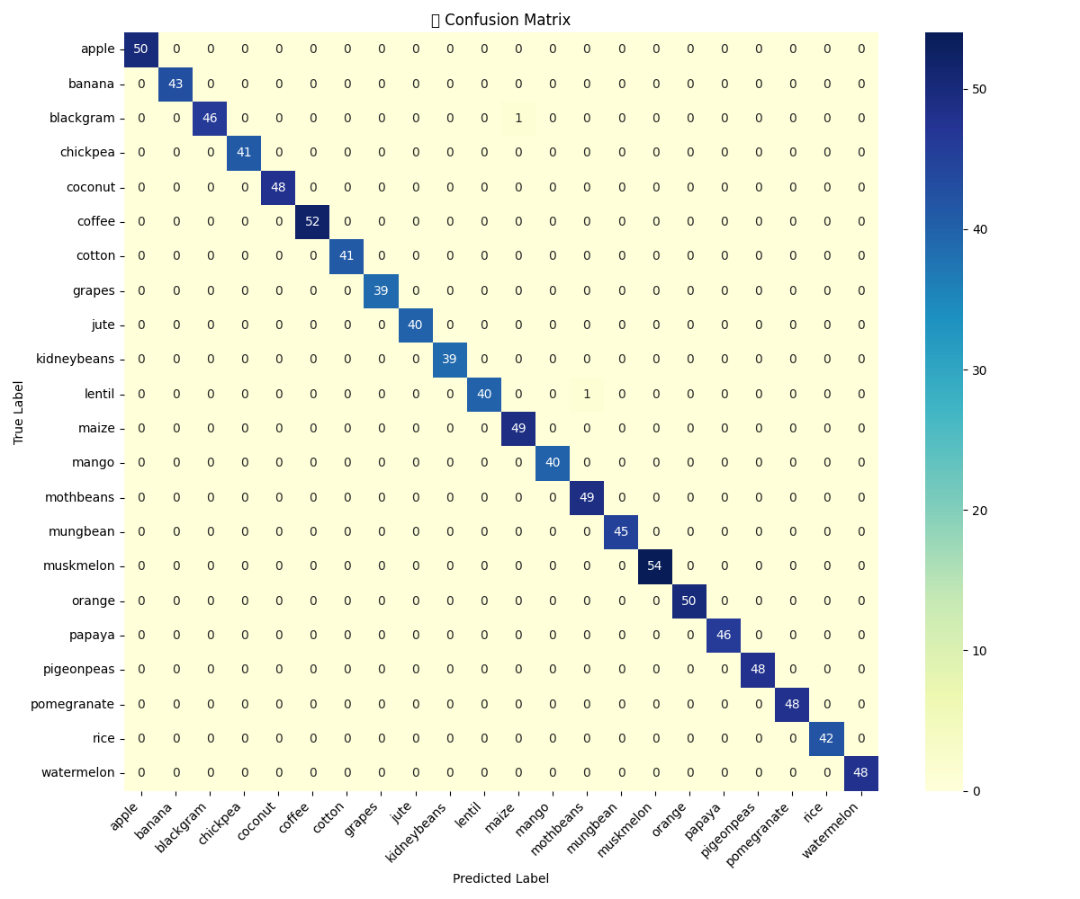
Fig. 3. Confusion Matrix
Using this confusion matrix, the following metrics were computed using stratified train-test splits to ensure class balance across the 22 crop categories.
- Accuracy : It is the ratio of number of correctly identified images and number of total input images.
$Accuracy = \frac{TP + TN}{TP + TN + FP + FN}$ (4)
- Precision : It is the ratio of correct outcomes and total positive outcomes delivered by the model.
$Precision = \frac{TP}{TP + FP}$ (5)
- Recall : It is the ratio of correct positive outcomes given by the model to the actual positive outcomes.
$Recall = \frac{TP}{TP + FN}$ (6)
- F1 - Score : The harmonic mean of precision and recall, offering a single metric for evaluating model’s performance.
$F1 Score = 2×\frac{Precision × Recall}{Precision + Recall}$ (7)
The model reached a final accuracy of 99.80% while the detailed classwise metrics are as shown in Table 1 following the above calculations.
Table 1. Performance Metrics For Different Classes of the Model
Crop Class | Precision | Recall | F1 Score
Apple | 1.00 | 1.00 | 1.00
Banana | 1.00 | 1.00 | 1.00
Blackgram | 1.00 | 0.98 | 0.99
Chickpea | 1.00 | 1.00 | 1.00
Coconut | 1.00 | 1.00 | 1.00
Coffee | 1.00 | 1.00 | 1.00
Cotton | 1.00 | 1.00 | 1.00
Grapes | 1.00 | 1.00 | 1.00
Jute | 1.00 | 1.00 | 1.00
Kidneybeans | 1.00 | 1.00 | 1.00
Lentil | 1.00 | 0.98 | 0.99
Maize | 0.98 | 1.00 | 0.99
Mango | 1.00 | 1.00 | 1.00
Mothbeans | 0.99 | 1.00 | 0.98
Mungbeans | 1.00 | 1.00 | 1.00
Muskmelon | 1.00 | 1.00 | 1.00
Orange | 1.00 | 1.00 | 1.00
Papaya | 1.00 | 1.00 | 1.00
Pigeonpeas | 1.00 | 1.00 | 1.00
Pomegranate | 1.00 | 1.00 | 1.00
Rice | 1.00 | 1.00 | 1.00
Watermelon | 1.00 | 1.00 | 1.00

Local Interpretability via SHAP
The system integrates SHAP (SHapley Additive exPlanations) to provide instance-level explanations. For each user input, the top three recommended crops are not only predicted but also visualized using SHAP bar charts showing the contribution of each input feature (Nitrogen, Phosphorus, pH, etc.) to the final decision.
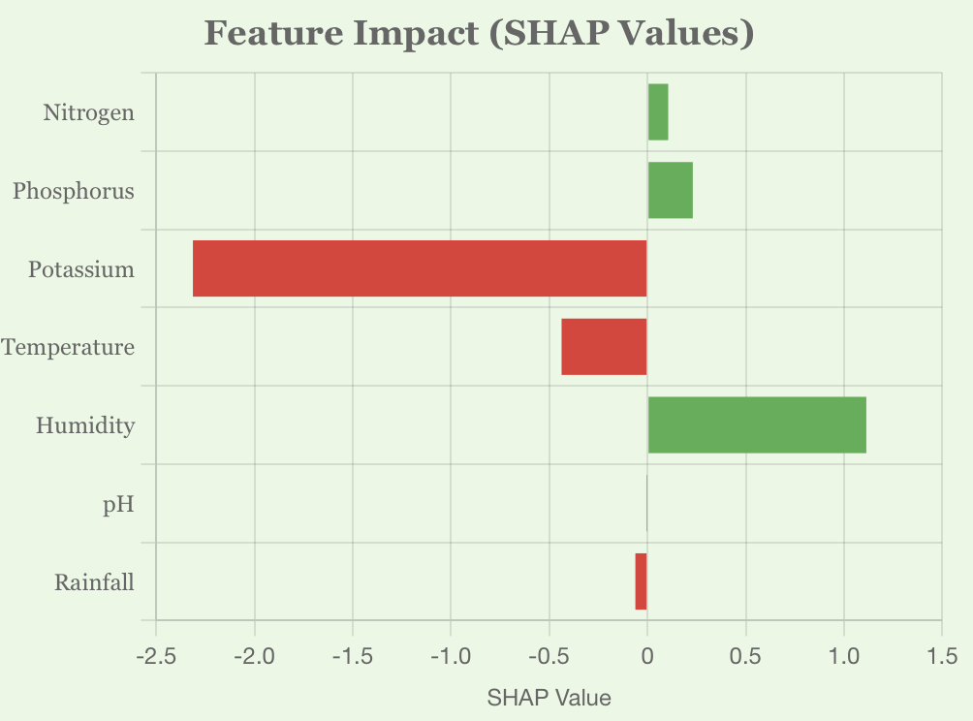
Fig. 4(a) Papaya
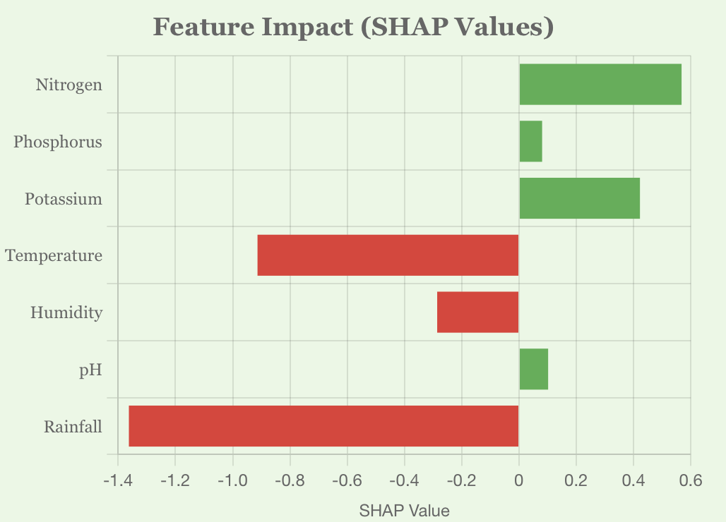
Fig. 4(b) Jute
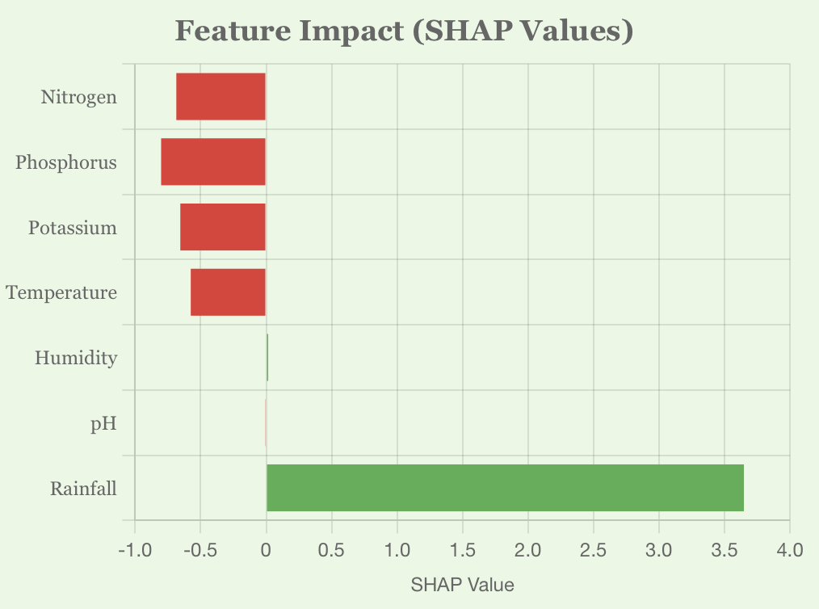
Fig. 4(c) Muskmelon
Fig. 4. SHAP Explanation Plots for top Three Recommendation
Plots in Fig. 4. reveal the exact reasoning behind a recommendation, such as high rainfall and pH supporting rice cultivation while excess potassium could hinder coffee growth. This local interpretability builds user confidence and opens avenues for agronomic discussions.

Global Feature Attribution
Beyond per-instance explanations, we also computed the global feature importance based on SHAP values aggregated across the entire training set. Fig. 5. outlines which features have the greatest impact on crop decisions irrespective of the user input.
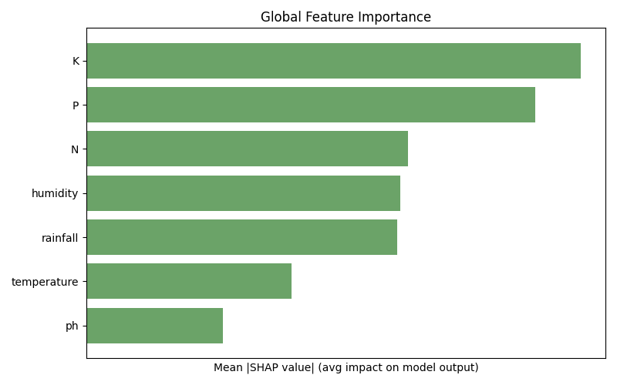
Fig. 5. Global Feature Importance

Trust Score, Prediction Confidence and Counterfactual Suggestions
To quantify the reliability of each prediction, we introduced a Trust Score module. This score is derived from the confidence gap between the top prediction and the runner-up, normalized with a threshold margin. The output includes Trust Level (High, Moderate, Low) and Confidence Score (as a percentage) as shown in Fig. 6.

Fig. 6. Trust Score Module
Going beyond explanation, our system offers counterfactual suggestions—minimal adjustments to the controllable features (N, P, K, pH) to make another viable crop a better fit which has been clearly depicted in Fig. 7. This is particularly useful when the top crop is not feasible due to market or logistical constraints.
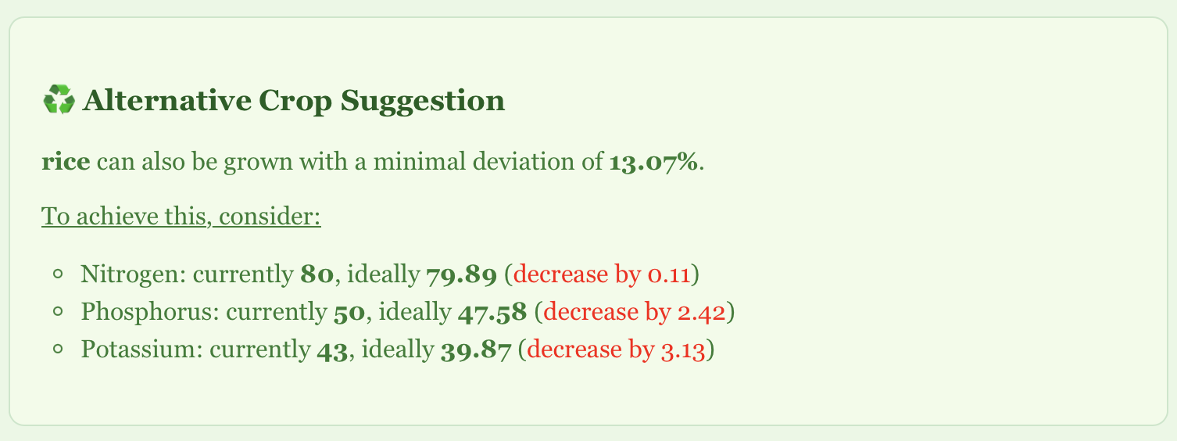
Fig. 7. Counterfactual Crop Suggestion
The system computes per-feature deviation from ideal crop conditions and identifies the next best crop that requires the least intervention. Weather-based features like rainfall or humidity are excluded from this computation to focus only on soil-amendable variables.

System Usability and Web Deployment
To facilitate real-time access and ease of use, the entire pipeline is deployed via a web interface as shown in Fig. 8. The user enters available inputs through an intuitive form with live condition tracking. Once submitted, results are dynamically visualized and explained.
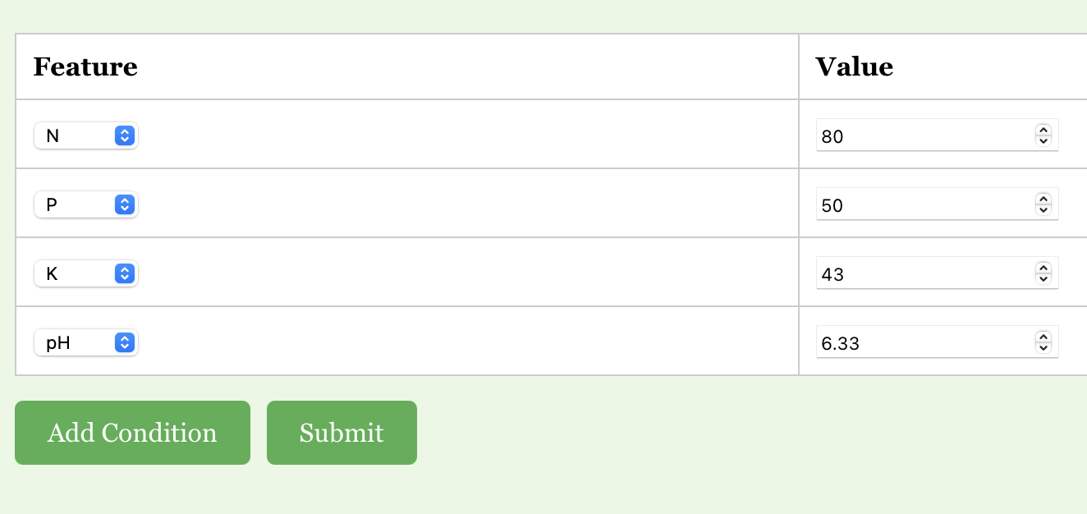
Fig. 8(a) Input

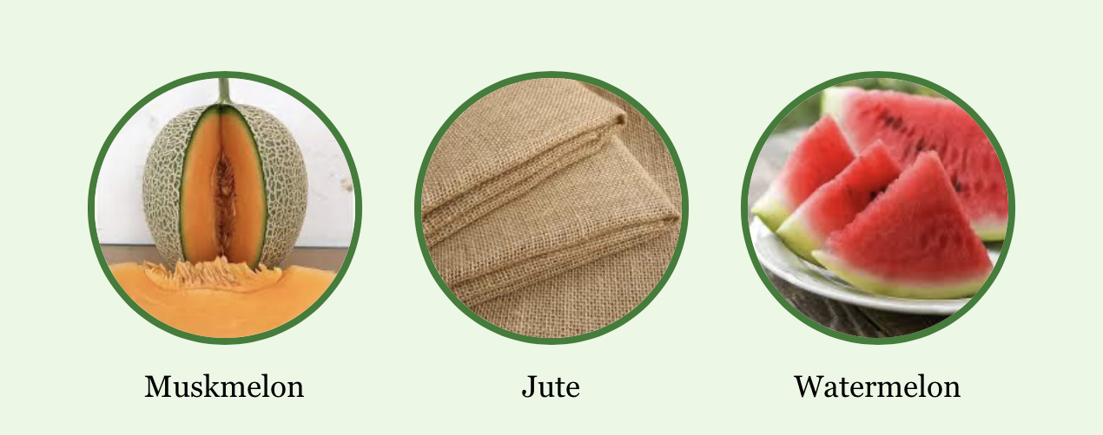
Fig. 8(b) Top three Recommended Crops
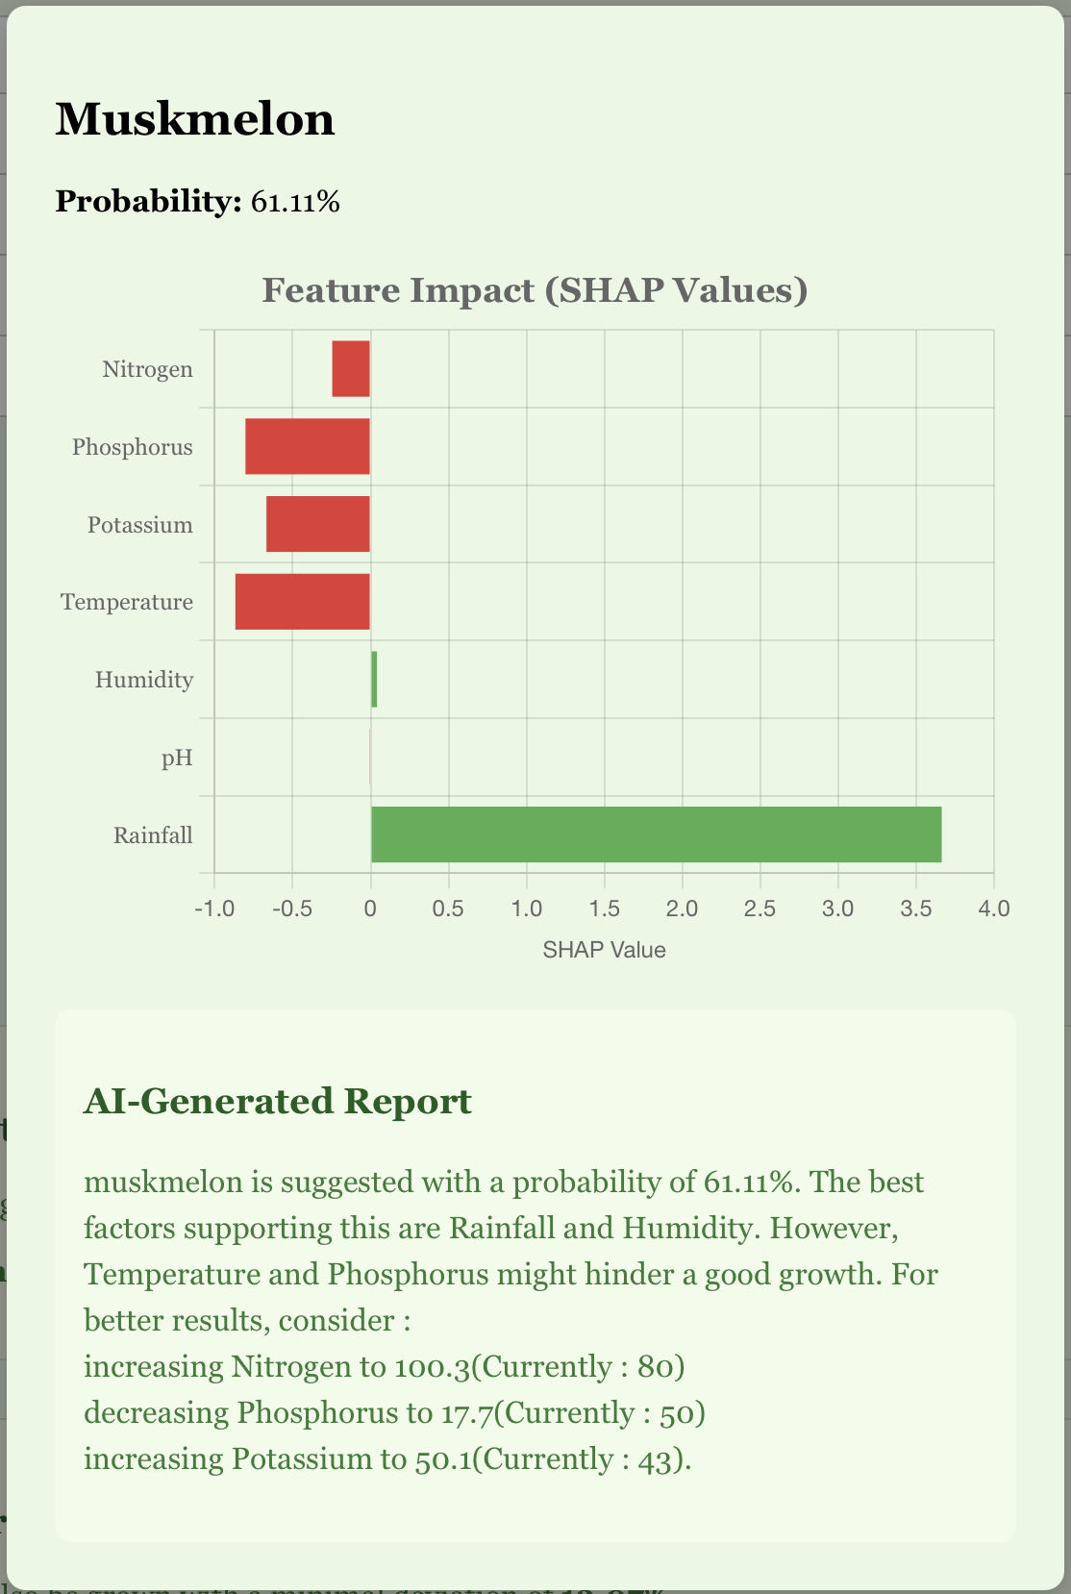
Fig. 8(c) Detailed Crop Suggestion(Modal)

Fig. 8. A glimpse of the web interface

Conclusion and Future Scope
In this research, we developed and deployed a fully functional Explainable AI-powered Crop Recommendation System that bridges the gap between black-box machine learning predictions and farmer-accessible interpretability. Our pipeline, built upon an XGBoost classification model, leverages SHAP-based explainability to generate intuitive visual and textual insights, making it highly interpretable for agronomists and non-technical stakeholders alike.
The system not only predicts the top three suitable crops for a given set of environmental and soil parameters but also explains the rationale behind those predictions using local SHAP plots, global feature importance visualizations, trust scoring mechanisms, and counterfactual suggestions. By integrating real-time weather data from Open-Meteo APIs and deploying a fully responsive frontend, we provide users with a seamless and intelligent decision-support experience.
The interpretability layer was instrumental in ensuring that stakeholders understood not only what the system was recommending, but also why and how the recommendations could be improved—an essential factor in promoting trust and adoption among farming communities. While the current system offers a robust and explainable crop recommendation engine, several avenues for future enhancement exist:
- Sensor-Based Real-Time Soil Monitoring: Future iterations of this system can be integrated with IoT-based soil sensors capable of measuring real-time Nitrogen (N), Phosphorus (P), Potassium (K), and pH values. These sensors can be deployed directly in the field, transmitting data wirelessly to the backend. This would eliminate manual data entry, reduce human error, and enhance the granularity and reliability of the input data.
- Region-Aware Fine-Tuning: Training separate models or fine-tuning the existing one for specific agro-climatic zones can lead to more context-aware recommendations, especially for geographically diverse countries like India.
- Fertilizer and Irrigation Planning: The model can be extended to not only suggest crops but also recommend specific fertilization plans, irrigation cycles, and crop rotation schedules tailored to user inputs.
- Adaptive Learning from Feedback: Incorporating a feedback loop where farmers confirm or reject system suggestions can help the model retrain itself periodically, making it progressively smarter and more accurate over time.

References
- Gangwar, K. S., et al. (2017). “Adoption and impact of precision farming practices in Indian agriculture.”
- Ghosh, R., et al. (2018). “Assessment of traditional versus modern crop planning techniques in India.”
- Jat, M. L., et al. (2020). “Climate-smart agriculture: Challenges and perspectives.”
- Lobell, D. B., & Burke, M. B. (2010). “On the use of statistical models to predict crop yield responses to climate change.”
- Liakos, K. G., et al. (2018). “Machine learning in agriculture: A review.”
- Kamilaris, A., & Prenafeta-Boldú, F. X. (2018). “Deep learning in agriculture: A survey.”
- Jones, J. W., et al. (2017). “Toward a new generation of agricultural system models.”
- Lundberg, S. M., & Lee, S.-I. (2017). “A unified approach to interpreting model predictions.”
- Ribeiro, M. T., Singh, S., & Guestrin, C. (2016). “Why should I trust you?: Explaining the predictions of any classifier.”
- Deist, T. M., et al. (2018). “Model validation and uncertainty quantification in predictive modeling for precision medicine.”
- Jha, A., et al., “SVM-based Crop Recommendation System Using Soil and Climate Data,” IJCA, vol. 181, no. 14, pp. 7-12, 2019.
- Banerjee, A., et al., “Climate-Aware Crop Prediction Using Random Forest,” Sustainable Computing: Informatics and Systems, vol. 29, 2021.
- Patel, R., et al., “Crop Selection Using Hybrid ML for Small Farmers,” IJARIIT, vol. 5, no. 2, 2018.
- Ali, A., et al., “Interpreting Agricultural Predictions Using LIME,” Computers and Electronics in Agriculture, vol. 182, 2021.
- Hossain, M., et al., “Decision Tree Based Crop Recommendation App,” IEEE IEMCON, pp. 213-218, 2020.
- Dey, A., et al., “Smart Agriculture through Weather-Driven Crop Recommender,” IJCSMC, vol. 9, no. 6, pp. 39-44, 2020.
- Singh, A. and Rao, A., “Ensemble-Based Crop Predictor for Indian Farming,” IEEE ICACCT, 2019.
- Kumar, N., et al., “Crop Suitability via Attention-Based Neural Models,” Computational Intelligence, vol. 38, no. 3, 2022.
- Sharma, M., et al., “Fuzzy Rule-Based Crop Suitability System,” IJRECE, vol. 7, no. 1, 2019.
- Yadav, R., et al., “SHAP Interpretability for Wheat Prediction,” Elsevier Ecological Informatics, vol. 61, 2021.
- Brar, M., et al., “Geolocation-Aware Crop Recommender Using Deep Learning,” IEEE Access, vol. 10, pp. 19855–19867, 2022.
- Das, P., et al., “Explainable Boosting Models in Agricultural Systems,” Frontiers in AI, vol. 6, 2023.

