AgriVerse: Enhancing Crop Decision-Making Through XAI and Geospatial Weather Integration

Abstract
In a rapidly developing market, classic wisdom and family wisdom frequently decide which kind of plant to prefer. Although it is similar to the idea of continuing communal beliefs, reserved resolutions based on the current situation may lead to the development of a blue crop and a gradual decline of a prestigious region and environmentally friendly capital. AgriVerse, a intelligent recommendation platform designed to combat these shortcomings, is mentioned in the previous post. In order to facilitate the selection of the plant, detailed regional information on soil nutrition and climate will be developed.
In addition to their core functions, AgriVerse functions by studying carefully collected data that combine key features with related meteorological forms. This integration enables the structure to produce highly contextual agricultural advice. Our method avoids the usual difficulties in the use of several forecasting models. Alternatively, it strategically balances the performance of the computer with architectural clarity. AgriVerse is not just a list of graded suitable crops; it also provides a clear, evidence-based explanation for each recommendation, making it clear to the consumer why it is wrong.
Our experimental findings confirm that the outline provides target prediction in support of the current necessary interpretability. AgriVerse is a sensible and reliable support tool ready to be used by individual smallholder farmers as well as by agricultural advisory bodies, thanks to its efficient link with the world of agricultural decision making.
Keywords : Crop recommendation, Explainable AI, SHAP, Smart agriculture, Machine learning in agriculture, Weather-aware systems, Counterfactual reasoning, Trust score, Global feature importance, Agricultural decision support.

Introduction
In several developing countries, most especially India, agricultural decision-making still mostly relies on heuristic custom and ancestral wisdom. Although these techniques are quite regional, they often result in poor resource distribution and erratic yield patterns over consecutive growing seasons. As underlined by Gangwar et al. [1] and Ghosh et al. [2], the tenacity of these non-scientific methods not only slows down present production but also jeopardizes the long-term ecological and economic sustainability of agriculture systems. Climate disasters, which have worsened land degradation and have created extreme volatility in regional rainfall [3] [4] have also highlighted the current demand for intelligent, adaptable decision support.
The present assertion of the art XAI (explainable machine acquiring knowledge ) development [5] is a promising method to improve such decision-making systems. Although a relevant prognosis model including the planet's prosody and archaic climate statistics achieves high technical accuracy, there are still major impediments to adoption. A few key weaknesses arise from a careful study of the search, a requirement for interpretability, and a desire for chemical chemical reactions to produce high frequency, real-time environmental transformation. Practitioners free from official technical surroundings, see the model serving as a 'black box '' contribution suggestion free from all apparent explanation and lose confidence [6][7].
AgriVerse tackles the issue of openness and adaptability. Our structure goes further than passive casting in order to build a certain end product that correctly reflects the farmer's current habitat. Although it has been improved with a sophisticated explanation suite anchored on the SHAP recommendations [8], the structure is largely based on the XGBoost-driven estimation engine.
AgriVerse offers a multi-layered explanatory interface to help to close the gap between field-level implementation and complicated data science. Instead of providing a single data point, the system creates SHAP waterfall plots and global feature significance measures converted into simple-language summaries and counterfactual examples. The ethical need of establishing user confidence in sensitive areas gives rise to this design philosophy [9]. Moreover, we present a specialized "trust score" metric based on established techniques [10] to measure the dependability of every single prediction.
In terms of architecture, AgriVerse can be considered as a complete application using ReactJS front end and Express.js back end for organizing a modular Python machine training grapevine. Farmer supply essential earth parameters (N, P, K, and pH) as the framework unconsciously retrieves temperature, humidity, and rainfall statistics based on location. The synthesis of these variables is then organized in the backend, and a simultaneous eye examination and interpretation report is drawn up. We aim to provide a deployment-ready device that enables wide confidence in precision farming by synthesising quantitative precision and qualitative clarity.

Related works
The Crop Recommendation Systems have progressed well, moving from the usual statistical approach to more advanced machine training strategies which are better suited to Community Sustainable Environments. In recent years, researchers have been increasingly focused on strike a balance between robust anticipation accuracy and the need for clear interpretation using explainable artificial intelligence (XAI). This part shall confine AgriVerse to the limits of the current farming environment, examine the previous contributions to crop recommendations, explainable mold, and user-oriented design. We draw attention to the lack of prior responsibility that our framework is looking for to prevail.
Jha et al's Ahead of Time Task. [11] demonstrate that support vector machine (SVM) classifier using agroclimatic features can achieve high accuracy. However, the model's 'black box '' fictional character did not provide any explanation of its final product. AgriVerse tackles this transparency issue head-on by integrating SHAP-based explanations that precisely show how each information characteristic contributes to a recommendation, a significant factor for construction boldness among farmers. Similarly, Banerjee et al. [12] improved performance on Indian data by including climate change projections in Random forest models. While their means effectively capture the long-term shape, they provide little insight into individual forecasts. The present structure, our framework integrates worldwide and municipal interpretation as naturally available up-to-date ecological statistics via geolocation-based API integration.
Patel et al promoted investigations focusing on smallholder farmers. [13], which improved the hybrid KNN and determination sapling model communicated via a web interface. Though it is available, its apparatus does not provide the user with any deep rationale or option. AgriVerse goes beyond simple rankings by including a special counterfactual coevals faculty, allowing farmers to investigate realistic 'what if '' scenarios and the next-best crop alternatives under stable circumstances such as predicted weather.
In the area of interpretation, Ali et al. [14] used LIME to clarify yield prediction. Nevertheless, LIME may produce contradictory findings due to its fragility and weak conceptual foundations. AgriVerse, by trusting the SHAP alternatively, provides a mathematically sound and locally precise explanation, which is treasured not only practically but also as a user's study material.
Technical flexibility is restricted due to other frequent challenges in previous systems. For instance, Hossain et al. [15] created a movable Android app that, although it is portable, relies on an inactive input signal and provides little assistance in the case of missing statistics otherwise location-aware update. Our platform also has a strong grapevine that can produce reliable recommendations even in spite of partial information, while explicitly reporting conviction levels to users. Similarly, although Dey et al. [16] combined external meteorological APIs, their framework proposes a single crop near a given duration. AgriVerse, by correlation, measures 22 unique crops simultaneously and returns the top three with probability tons and a detailed visual image of the SHAP consequence in the case of a large choice.
A number of existing approaches also address constraints related to geography or structure design. The Singh and Rao ensemble model, for instance, was limited to Rabi season statistics and required a complete input signal. AgriVerse avoids this limitation by real-time geolocation and flexible attribute management that alerts users to the power of missing data over dependability. In contrast, Kumar et al. [18] investigate complex attention-based nervous networks, which are difficult to interpret and difficult to use in a real agricultural setting. We deliberately choose XGBoost for its robustness to performance and deployment, enhanced by a comprehensive SHAP explanation, rather than pursue an excessively complex architecture. In addition, this choice differs from the inherently explainable yet less scalable fuzzed logic rule-based frameworks of Sharma et al. [19] ; AgriVerse scaled successfully by train on a dataset of more than 2200 labeled cases.
Further recent efforts have begun to associate visual image with prediction, despite the continuing fundamental flaw. Yadav et al. [20] used SHAP to discover the global characteristic significance of wheat production but did not provide instance-level explanation nor synergies. We extend the current one by integrating synergistic SHAP charts and cropped narrative directly into the frontend using Charts.js. Similarly, Brar et al. [21] construct a fixed backend for multi-crop estimation using LSTMs, but the architecture lacks modularity and counterfactual capabilities. AgriVerse's modular Express and Python backends make it easier to use the cloud and include a deviation-based counterfactual technique for pragmatic alternative suggestions. Lastly, while Das et al. [22] use explainable Boosting tools (EBMs), which were less capable of multi-class local explanation. AgriVerse uses SHAP's linear attribute to propose powder penetration into the components driving each specific recommendation.

Proposed Methodology
The design of AgriVerse takes into account both the logistic challenges of pasture cultivation as well as the technical obstacles of machine learning. Our method is based on a modular paradigm, which ensures that all settings from detail consumption to consumer contact are scalable and renewable. The design of the fast React-based consumer interface, the powerful Node.js API gateway, the dual purpose prediction and explanation engine, and the high-fidelity model training network are based on four important pillars.
The separation of the forecast logic from the cargo procedure ensures real-time accuracy and enables the organization to continue to be computationally productive. The explanatory engine uses the SHAP (Shapley Additive Explanation ) to decompose the complex prognosis into a human-readable position, but the model train grapevine stresses olden accuracy and generalization. The present intentional modularity allows AgriVerse to function as a cohesive, usable biome whose prognostic accuracy is balanced by high visibility and technical classification operations.
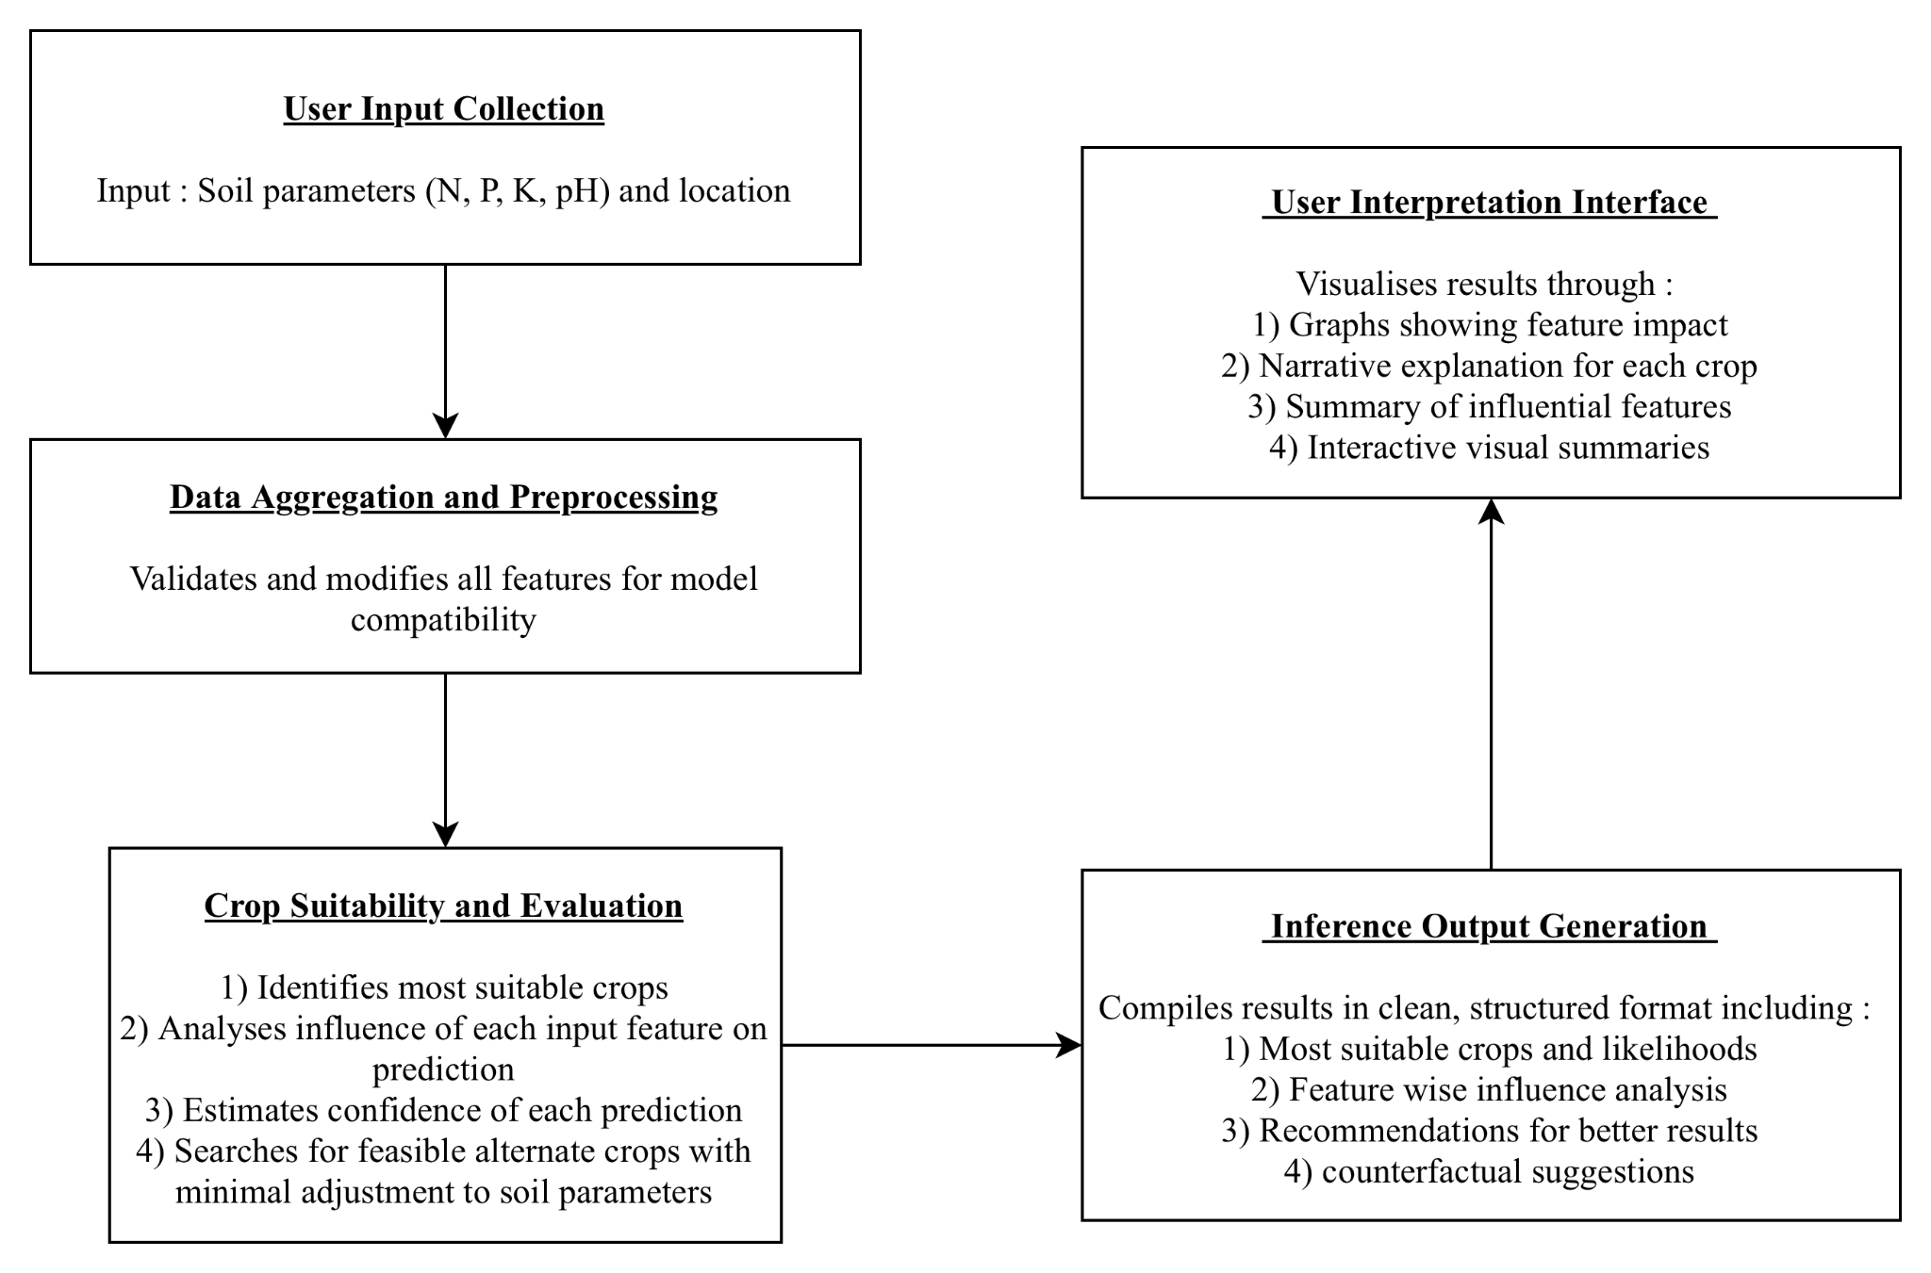
Fig. 1. System flow pipeline
AgriVerse operates in a deliberately structured multi-stage function stream that integrates farmer information with up-to-the-minute ecological facts to produce a feasible and well-explained crop recommendation. At that point, the organization initiates the client to enter the crucial topography parameters, nitrogen (N), phosphorus (P), potassium (K), and pH, together with the coordinates of their location. Similar coordination naturally accelerates the retrieval of up-to-date Community meteorological data, including temperature, humidity, and precipitation, via external API integration.
Once land statistics have been combined with real-time meteorological variables, the combined information will be passed to the main appraisal faculty. Here, two key undertakings run side by side a multi-class categorization model to select the mainly correct crop while simultaneously calculating how the corresponding human input influences the result. The organization will conduct a dedicated counterfactual investigation to provide additional, rather than merely a personal superior suggestion. In comparison with a fixed recommendation, which provides a farmer with a realistic choice crop which can develop into feasible with minimal changes to the controllable earth variables, it provides a farmer with a clear roadmap to potential improvements rather than a fixed recommendation.
In the closing measure, all these elements are communicated together in a coherent interpretation report. The report is presented in a simple web interface based on React and has an intuitive visual image accompanied by an easy explanation in a simple organic dialect. This technique ensures that the advice is exclusively targeted and wholly traceable, in addition to being simple for the farmer to grasp and act on. AgriVerse ensures that every suggestion is clear, anchored by a sign, and confirmed by practical advice on better farm organization.

Model selection and Training
AgriVerse's main objective was to meet three common mutually contradictory requirements: better prognosis accuracy, reduced rotational rotational latency in real-time usage, and robust interpretation. The present pillar, which links the imagined world of machines acquiring knowledge to the real world of support for agricultural choices, is of particular importance.
We conduct extensive comparative investigations atop multiple benchmark classifiers, including support vector machines (SVM), random forest, and simulated neural alliance (ANNs), to select the optimal architecture. We chose XGBoost (Extremist Gradient Boosting) as the main model based on our experimental results. Numerous unexpected systemic advantages of the algorithm were essential in the relevant decision.
- Nonlinear Pattern Validation's ability to detect sophisticated, nonlinear bonds in the context of meteorological variations and the world's chemistry that simpler linear models commonly overlook.
- A strong versus feature Noise flexibility to Attribute Noise Often seen in field-collected agricultural data, a built-in capacity to process multicollinearity and noisy information enables an individual to prevent a meaningful performance decline.
- The compatibility of XAI, particularly the tree-based architecture of XGBoost Igniters with the SHAP (Shapley Additive Explanation) method, enables a changeless and mathematically robust post-hoc analysis.

XGBoost uses an iterative ensemble method where each subsequent learner is trained to correct the residual error of its predecessor alongside a crucial level. The current state of the art guarantees a highly optimized model which is still light enough to operate in real time in a portable, otherwise web-based environment. You can describe prediction like:
${\hat{y}}_{i} = \sum{}k = 1^{K}f_{k}(x_{i}) f_{k}∈ ξ$ (1)
Where :
- ${\hat{y}}_{i}$ is the predicted output for instance i.
- $f_{k}$ is the $k^{th}$ regression tree.
- $ξ$ is the space for all the regression trees.
- And K is the total number of trees.
Precision, operational reliability, and interpretation were three primary objectives in developing AgriVerse's forecast engine. The issue is framed as a multiclass classification problem wherein the model train must distinguish among twenty-two different crop types. Seven crucial agronomic components define the prognosis: nitrogen (N), phosphorus (P), potassium (K), soil pH, and three meteorological variables, temperature, humidity, and rainfall.
Disciplinary information: The training program employs preparation grapevine, as shown in Fig. 2. Following this is a stage of rigorous data cleansing and standardization intended to homogenize the attribute scale and lower the prevalence of outliers. Finally, we used focused attribute technology to increase the model's ability to recognize related forms inside the dataset.
The use of Dropout Replica Tactics as a new aspect to our training method. Everywhere in model training, random characteristic subsets were intentionally excluded to mimic the insufficient information scenario common in real world agriculture, such as fragmented dirt trial or other impermanent detector break. By studying the functioning robustly in spite of such imitations, the model added a sensible force, thus becoming a further reliable advisory tool underpinned by the frequently encountered non-ideal statistical circumstances encountered on the meadow.
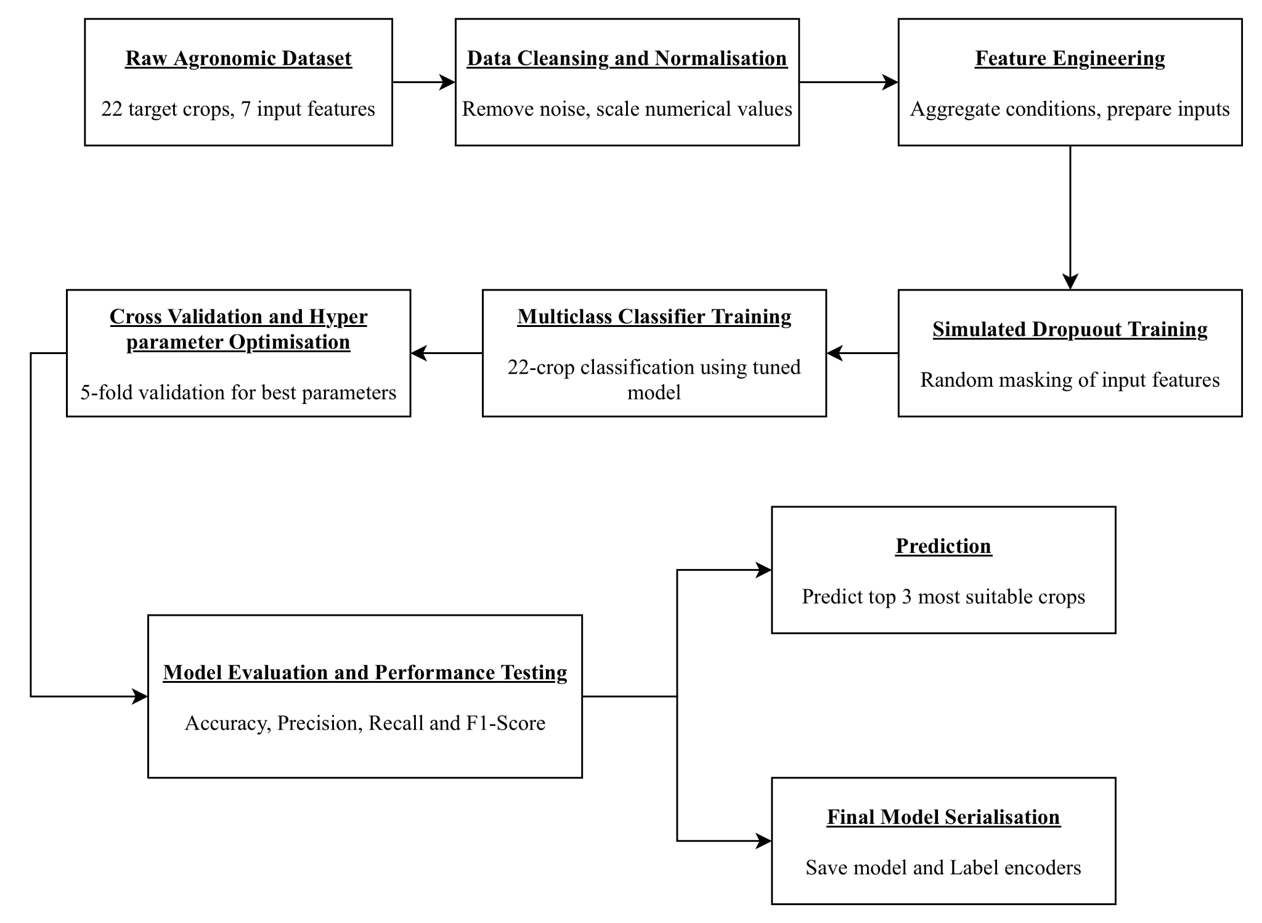
Fig. 2. Flowchart for Crop Recommendation Model
We used a structured hyperparameter tuning method to maximize the performance of the model and facilitate strong generalization. The current trust in grid search combined with 5-fold cross-validation to thoroughly adjust the major parameters including maximum timber depth, knowledge acquisition ( Basque Homeland and Freedom ), and sampling ratio. The adapted model has given outstanding results, achieving a classification accuracy of 96.7 % in independent trials. The systemically increased precision, recall, and F1 scores across all 22 crop classes confirmed that the model performed accurately without preferentially selecting any particular class.
Once validated, the final model is serialized using standard pickle approaches. This step ensures a smooth and error-free transition from the development phase to the live production backend.
Conscious of the fact that benchmark accuracy in a controlled context frequently drops in applied applications, we introduce a special dropout-based training tactic. By randomly dissembling a subset of feedback features during train epochs, we enable the model to detect alternative bonds surrounded by incomprehensible aspects. The current approach correctly retroflexes the type of mistake sometimes found in smallholder agriculture, referring to a broken sensor or otherwise erroneous land measurement. Consequently, the method greatly increases resilience and lets AgriVerse provide accurate, confidence-calibrated recommendations even with imperfect data—a crucial skill for reliable operation in rural locations as well as poor internet access or modest on-farm testing capital.

Prediction and Model Result Explanation
The basic idea of AgriVerse architecture is the devotion to 'transparent by design '' intelligent automation. In order to move from a strictly predictive tool to a real decision support system, we include the SHAP (Shapley Additive Explanation) as the main interpretative engine. Unlike the heuristic explanation method, SHAP is grounded in the axiomatic ideas of concerted recreation theory and provides a mathematically precise way of dividing the'payout'(the model's prognosis ) between different'players'(input features).
The current arrangement enables AgriVerse to break down more complex, nonlinear results into precise fractions of components corresponding to rainfall or soil pH. The adoption of this method ensures that the architecture satisfy two important elements for agricultural confidence: muncipal accuracy, where the defense precisely firewood the model's rationale for a given farm, and planet consistency, which ensures that the relative relevance of the feature remains stable throughout the entire dataset. Compared to merely technical progress, this obvious layer represents a moral bridge, allowing users to move from the passive consumption of facts to active, knowledgeable knowledge.
$ϕ_{i}=\sum_{S ⊆ N_{i}}{}\frac{|S|!(|N|-|S|-1)!}{|N|!}[f(S∪\{i\})-f(S)]$ (2)
Where :
- $ϕ_{i}$ is the SHAP value of feature i
- S is the the subset of features not containing i
- N is the set of all input features
- f(S) is the model prediction when using features only in subset S
Although AgriVerse gets the start of the runtime input gesture, it selects the three most likely crop options based on the probability distribution of the XGBoost model. The model calculates the exact property input signal for every political campaign crop using the SHAP library's TreeExplainer, thus revealing the aforementioned prediction.
We have developed a two-tier interpretability structure that provides equally precise data and a wide contextual understanding.
- AgriVerse has a unique horizontal baroque display of the course and extent of the effect of the individual aid component in relation to the Community-based feature per crop for the correct superior recommendation. For instance, he might have a system in which rice is strongly extending adequate rainfall while simultaneously limiting its viability due to an unsuitable soil pH. The present ocular image directs the viewers through the conflict which bestows different natural riches on each plant.
- International architectural relevance During training, we precomputed a global value plot on the dataset. The mean, the absolute SHAP evaluation through the entire training sample reveals the main crucial property of the model as a whole. It will be a useful high-level asset for experts and an extension force since it brings out the results of the necessary operator model of the organization.
The individual's ability to analyze multicrops will be a major AgriVerse development. Unlike the present model, which describes only human superiority, our model generates a SHAP control graph once for the top three campaigners. Following disclosure of such side sanctions, farmer and advisor in order to analyze the findings and thoroughly distinguish the reasons precise crops lie beyond the innumerable individuals and the sustainable trade in their specific surroundings. The current broad speculation favors a more remote and sophisticated solution.

AI Generated Report System
AgriVerse includes a dedicated organic language synthesizer to support farmer rotation in realistic on-farm options. The present component converts the numeric results of the SHAP characteristic analysis into a simple, narrative explanation. By systematically interpreting the core logic of the model, it produces a personalized report on the individual recommended crop, making the reasoning accessible to the user without any technical background.

Each report is organized in a clear, structured way:
- Confidence-Weighted Prediction: The Confidence-Weighted Predictive explanation starts, together with the higher recommended variety and its associated probability mark, and immediately shows the confidence of the organization in the suggestion.
- Supportive Drivers: The supporting driver shall then be emphasized as the oinnacle supporting feature, which together with the favourable SHAP values, as well as the description of the ways in which detailed soil conditions in the second location contribute positively to the cultivation of the cultivated area.
- Growth Constraints: The report then defines the 'impeding features' together with the harmful SHAP principles and indicates external natural factors such as inadequate pH or otherwise excessively heavy rainfall which may restrict the second performance of the plant.
- Prescriptive Insights: Prescriptive perceptions rather than stopping next to account, the faculty compares the consumer's current situation in order to obtain the optimum scope (derived from the agronomic form of the training data ) and gives real recommendations, such as the modification of the soil or the adjustment of the surface.
- Contextual Warnings: While facts are incomplete, for instance, assuming the meteorological API fails, the system explicitly warns the user about approximately every conjecture made and possible outcomes in terms of accuracy.
The current architecture’s true power resides in its ability to convert natural analytic results into relevant, practical guidance. By recognizing notable variations from the ideal conditions and modeling them as realistic steps, AgriVerse makes farming obvious and educational. The present helps farmers to adopt aware, evidence-based methods optimizing energy instead of relying on intuition-driven solutions. Under their control now.

Counterfactual Suggestion Engine and Trust Score
AgriVerse has also included a counterfactual inspection engine meant to help flexible, adaptive farm management to maximize its possible benefit. This engine picks a "next-best" alternative—a plant that may be quite realistic with a targeted, manageable alteration in soil chemistry—rather than classic suggestion systems that provide only an inactive ranking.
Rather than resorting to the second-highest likelihood end product, the engine calculates the Euclidian distance between the customer's contemporary Earth profile (N, P, K, pH) and the idealized centroid of the alternate crop types set in the training dataset to execute a subtle optimization. Especially excluded from this distance calculation are irreversible sustainable elements like temperature and rain so as to ensure that the idea is consistent globally. The approach ensures that the proposed substitute is also a pragmatically possible goal reachable utilizing conventional ground correction techniques in addition to a statistical runner-up.
To close the mental divide between various final goods and prairie application, a devoted trust mark measure has been created. Mainly used to determine the'reliable index,' the'predictability margin' is the difference between the chance of the highest rated crop and its nearest competitors. To support transparency, the current mark has to be dynamically sanctioned should the framework sense facts of lacuna, such as the Miss Earth criterion or sensor failure. Farmers and extension officers may immediately assess the degree of confidence in the second advice offered by the structure by mapping the result numerical value to easy qualitative labels—High, Moderate, or Low. This dual emphasis on actual potential and clear dependability guarantees AgriVerse's function as a trusted partner in the area of precision agriculture. The final trust score is calculated using the following equation :

$Trust Score=\frac{P_{top}-μ_{P_{rest}}}{1 - μ_{P_{rest}}}×100$ (3)
Where :
- $P_{top}$ is the probability of the top predicted crop.
- $μ_{P_{rest}}$is the mean probability of the other crops.
Additionally, if any features are missing, the trust score module penalizes the score and notifies the frontend to alert the user about reduced reliability.

Backend Integration
Using the Express.js backend, AgriVerse offers confidential data over the Internet. Linking the intuitive front end to the computationally demanding Python-based knowledge-acquisition machine, the present server is a dependable mediator. This design distinguishes clearly the problems to guarantee that demand analysis methods do not compromise platform speed or interaction.
Upon receipt of a JSON request from the client, the Node.js backend initiates a prediction grapevine. It arranges for the name of the Python environment via the given shell execution to pass the provided dirt and weather parameter as a command-line argument to the inference script. The script follows the statistics and returns a complete, serialized JSON output for the backend to manage. The waiter effectively delivers inactive and precomputed materials identical to high-resolution crop images, dynamically generated SHAP visual image, and international model relevance chart, in addition to supervising such on-demand calculations.
The relevant buyer's question culminated in the delivery of a highly structured JSON missile, precisely formed to give an integrated impression of the recommendation. The current response shall be divided into four important information grades :
- The Predictive Tier: The predictive grade takes into account the three main crops, the individual attachment to them by its probability mark, and the associated ocular properties.
- The Interpretative Tier: In addition to the precomputed Worldwide Attribution Significance Prosody, the interpretative grade provides details on the SHAP aspects for every major campaigner.
- The Actionable Tier: Presents location-specific counterfactual alternatives and a user-friendly, qualitative trust score.
- The Narrative Tier: The narrative grade provides a clear, synthesized Natural Language Report that translates analytic output into clear, sensible agricultural guidance.
This modular architecture significantly enhances the system's scalability. This enables independent polishing and updating of the machine learning model, which does not require any changes to the API logic or front end interface. AgriVerse maintains a balance between technical perfection and sensible, deployable functionality in a wide range of agricultural environments by separating the resource-intensive Python engine from the API distribution layer.

Frontend Architecture
ReactJS and a new, achievable design theme in agricultural sunglasses with complete Georgian font for professionalism will be used in the front end. The interface prompts the user on first starting to either manually enter the dirt parameter or to select to share geolocation.
For attributes like Nitrogen, Potassium, etc., a dynamic table catches user inputs. Features already chosen are taken from the dropdown to avoid duplicates. The top three forecasted crops are shown with circular cropped photos following submission.
Clicking on any picture brings up a modal popup with:
- Crop name and expected probability
- SHAP-based feature impact chart created using Chart.js
- AI-created narrative review
Readable, segmented form of the Trust Score Card, Counterfactual Recommendation, and Global Significance Chart are shown below the primary display area.
Based on API replies, the frontend dynamically changes its components and smoothly manages faults or missing information. Through responsive CSS, it further allows compatibility across both mobile and computer devices.

Results and Discussion
The findings of the envisioned AI-based Crop Recommendation Organisation are analysed simultaneously quantitatively and qualitatively in terms of explanation, usability, and robustness. The results show not only the predictive accuracy of the model but also its pragmatic application and interpretation, which are essential for the support of agricultural research.

Dataset and Preprocessing
The elemental data used in the current study, covering 22 distinct cultivars, together with 7 primary agroclimatic features: nitrogen (N), phosphorus (P), potassium (K), temperature, humidity, pH, and rainfall. The relevant information guide designates the aforementioned natural and earth features for the right crop label. To ensure consistency, the dataset was normalized, the missing standards were eliminated, and the categorical encoding was not important since the entire feature was a numeral.
The data divided into 80 % training and 20 % testing so as to maintain a balance between the classes for the entire crop label. Trait escalating was not used in academic writing applied as XGBoost for smooth handling of natural aspect beliefs.

Model Performance Evaluation
To evaluate the predictive quality of our XGBoost-based classifier, we computed several key classification metrics including accuracy, precision, recall, and F1-score on the test set on the basis that the confusion matrix was generated to visualize the classification consistency across crops as shown in Fig. 3. It helps identify potential class-level confusions such as crops with similar environmental profiles being misclassified.
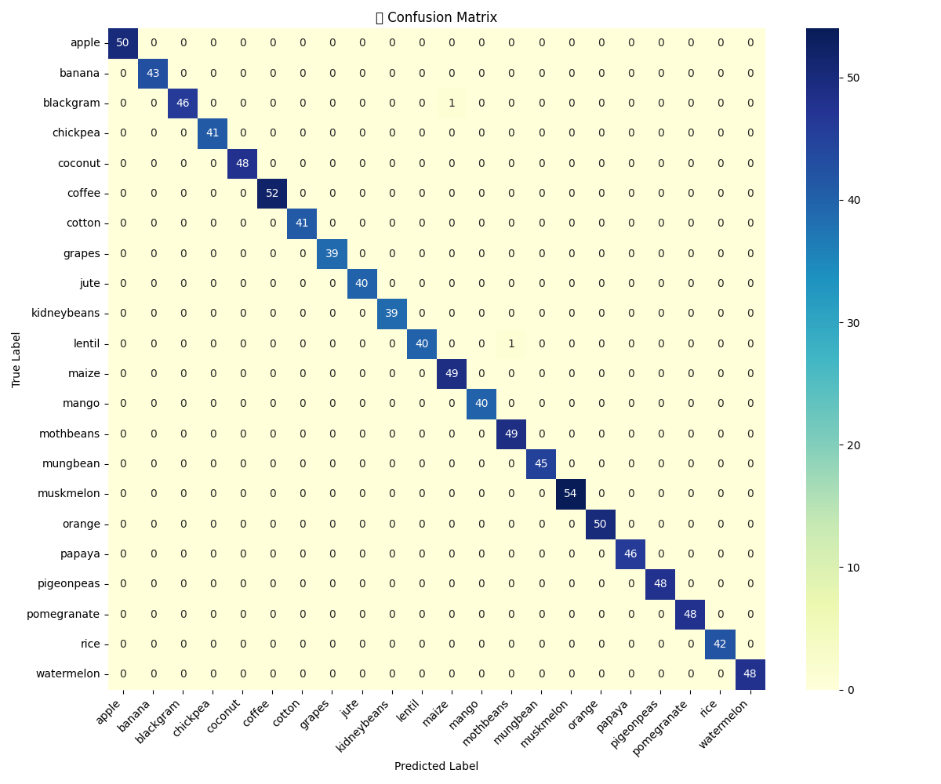
Fig. 3. Confusion Matrix
Using this confusion matrix, the following metrics were computed using stratified train-test splits to ensure class balance across the 22 crop categories.
- Accuracy : It is the ratio of number of correctly identified images and number of total input images.
$Accuracy = \frac{TP + TN}{TP + TN + FP + FN}$ (4)
- Precision : It is the ratio of correct outcomes and total positive outcomes delivered by the model.
$Precision = \frac{TP}{TP + FP}$ (5)
- Recall : It is the ratio of correct positive outcomes given by the model to the actual positive outcomes.
$Recall = \frac{TP}{TP + FN}$ (6)
- F1 - Score : The harmonic mean of precision and recall, offering a single metric for evaluating model’s performance.
$F1 Score = 2×\frac{Precision × Recall}{Precision + Recall}$ (7)
The model reached a final accuracy of 99.80% while the detailed classwise metrics are as shown in Table 1 following the above calculations.
Table 1. Performance Metrics For Different Classes of the Model
Crop Class | Precision | Recall | F1 Score
Apple | 1.00 | 1.00 | 1.00
Banana | 1.00 | 1.00 | 1.00
Blackgram | 1.00 | 0.98 | 0.99
Chickpea | 1.00 | 1.00 | 1.00
Coconut | 1.00 | 1.00 | 1.00
Coffee | 1.00 | 1.00 | 1.00
Cotton | 1.00 | 1.00 | 1.00
Grapes | 1.00 | 1.00 | 1.00
Jute | 1.00 | 1.00 | 1.00
Kidneybeans | 1.00 | 1.00 | 1.00
Lentil | 1.00 | 0.98 | 0.99
Maize | 0.98 | 1.00 | 0.99
Mango | 1.00 | 1.00 | 1.00
Mothbeans | 0.99 | 1.00 | 0.98
Mungbeans | 1.00 | 1.00 | 1.00
Muskmelon | 1.00 | 1.00 | 1.00
Orange | 1.00 | 1.00 | 1.00
Papaya | 1.00 | 1.00 | 1.00
Pigeonpeas | 1.00 | 1.00 | 1.00
Pomegranate | 1.00 | 1.00 | 1.00
Rice | 1.00 | 1.00 | 1.00
Watermelon | 1.00 | 1.00 | 1.00

Local Interpretability via SHAP
The system integrates SHAP (SHapley Additive exPlanations) to provide instance-level explanations. For each user input, the top three recommended crops are not only predicted but also visualized using SHAP bar charts showing the contribution of each input feature (Nitrogen, Phosphorus, pH, etc.) to the final decision.
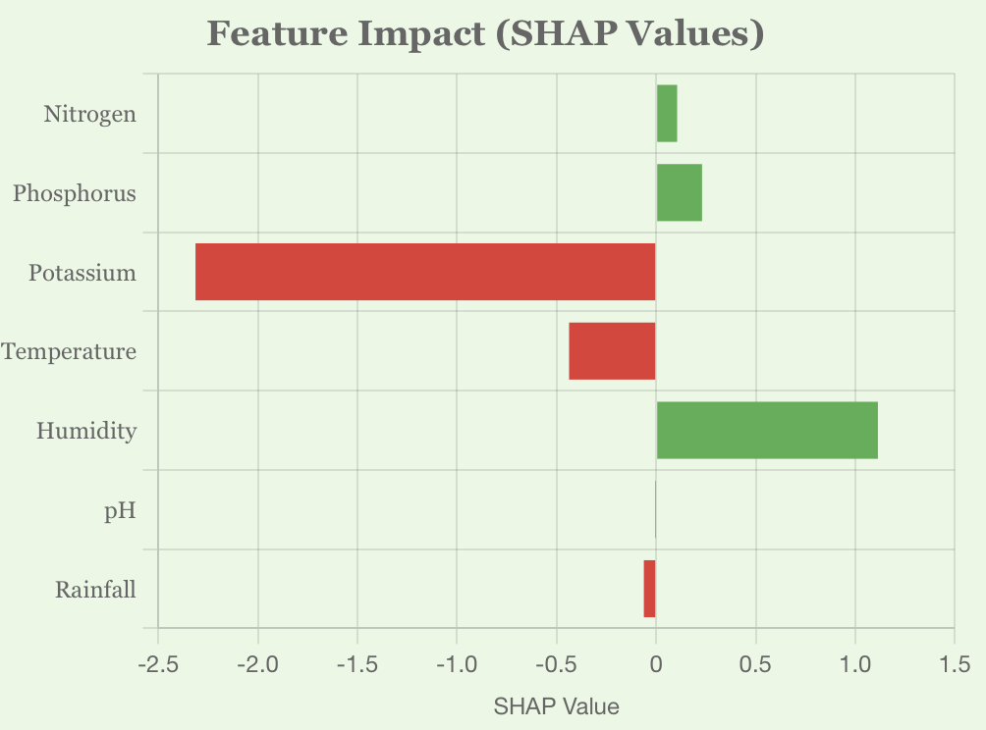
Fig. 4(a) Papaya
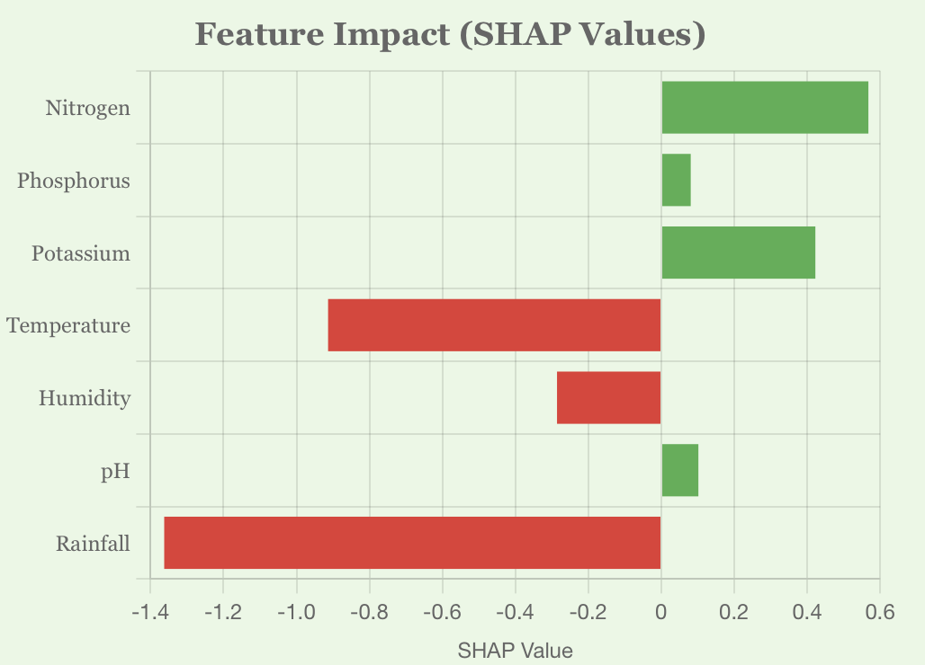
Fig. 4(b) Jute
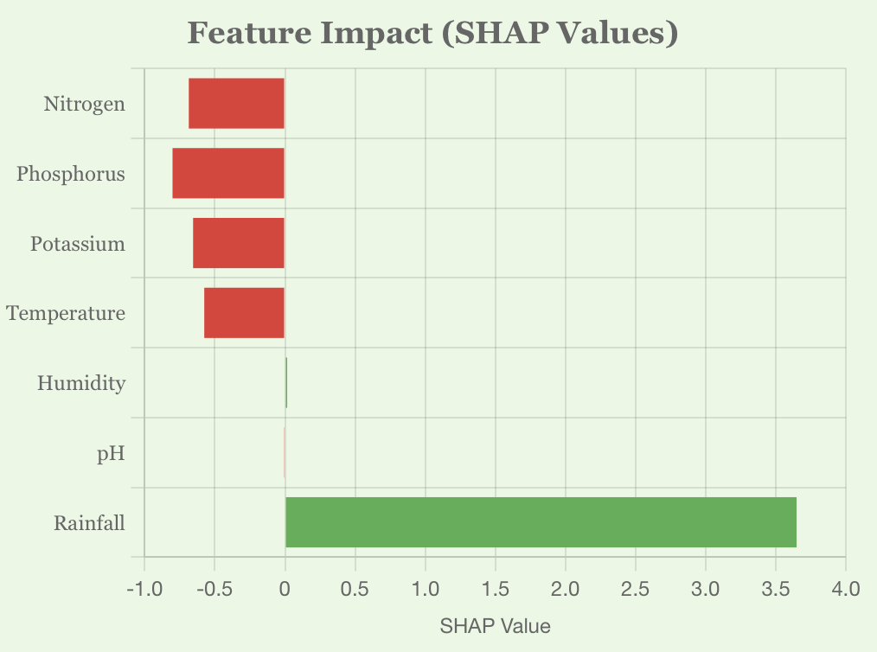
Fig. 4(c) Muskmelon
Fig. 4. SHAP Explanation Plots for top Three Recommendation
Plots in Fig. 4. reveal the exact reasoning behind a recommendation, such as high rainfall and pH supporting rice cultivation while excess potassium could hinder coffee growth. This local interpretability builds user confidence and opens avenues for agronomic discussions.

Global Feature Attribution
Beyond per-instance explanations, we also computed the global feature importance based on SHAP values aggregated across the entire training set. Fig. 5. outlines which features have the greatest impact on crop decisions irrespective of the user input.
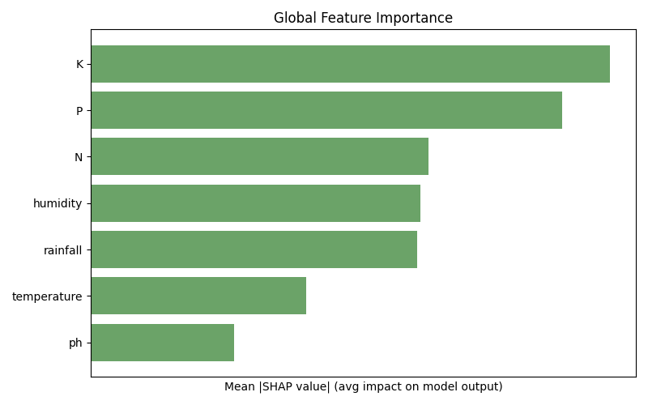
Fig. 5. Global Feature Importance

Trust Score, Prediction Confidence and Counterfactual Suggestions
We introduced the Trust Score Module to quantify the reliability of any forecast. That value can be determined from the confidence gaps between the main prediction and the second one, normalized with a threshold margin. As shown in Fig, the final product includes the trust level (high, moderate, reduced), as well as the assurance score (percentage). 6.

Fig. 6. Trust Score Module
Going beyond explanation, our system offers counterfactual suggestions—minimal adjustments to the controllable features (N, P, K, pH) to make another viable crop a better fit which has been clearly depicted in Fig. 7. This is particularly useful when the top crop is not feasible due to market or logistical constraints.
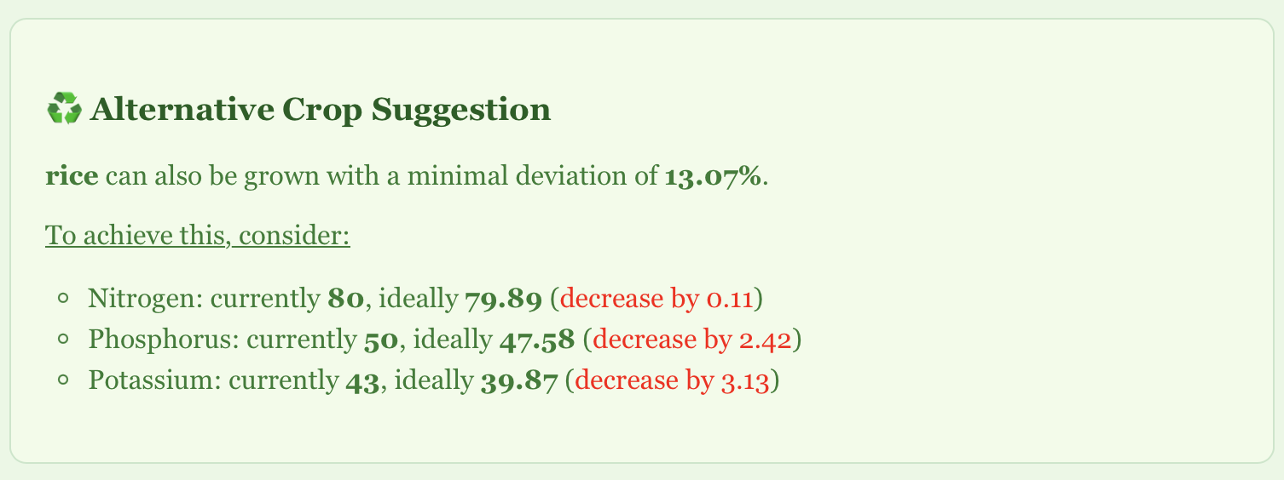
Fig. 7. Counterfactual Crop Suggestion
The system computes per-feature deviation from ideal crop conditions and identifies the next best crop that requires the least intervention. Weather-based features like rainfall or humidity are excluded from this computation to focus only on soil-amendable variables.

System Usability and Web Deployment
To facilitate real-time access and ease of use, the entire pipeline is deployed via a web interface as shown in Fig. 8. The user enters available inputs through an intuitive form with live condition tracking. Once submitted, results are dynamically visualized and explained.
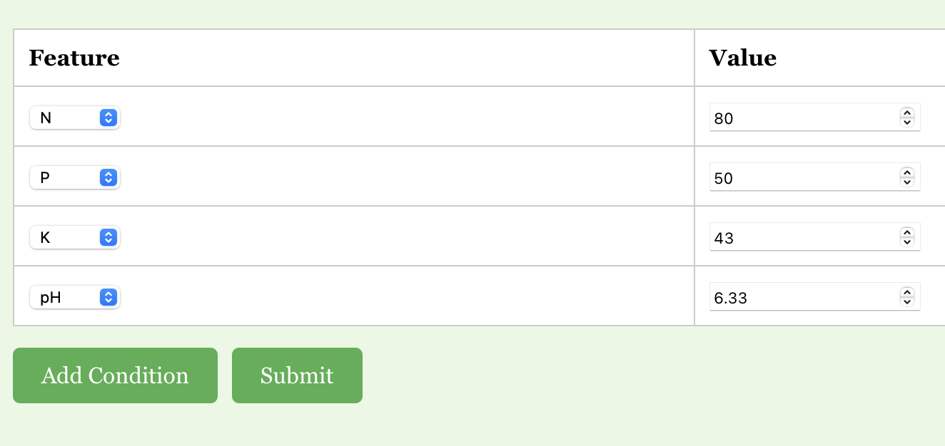
Fig. 8(a) Input

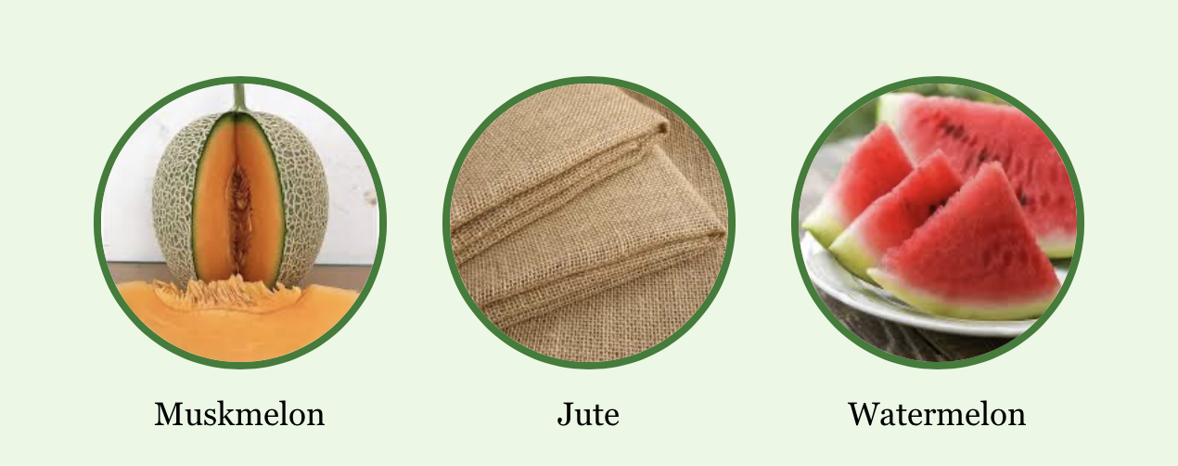
Fig. 8(b) Top three Recommended Crops
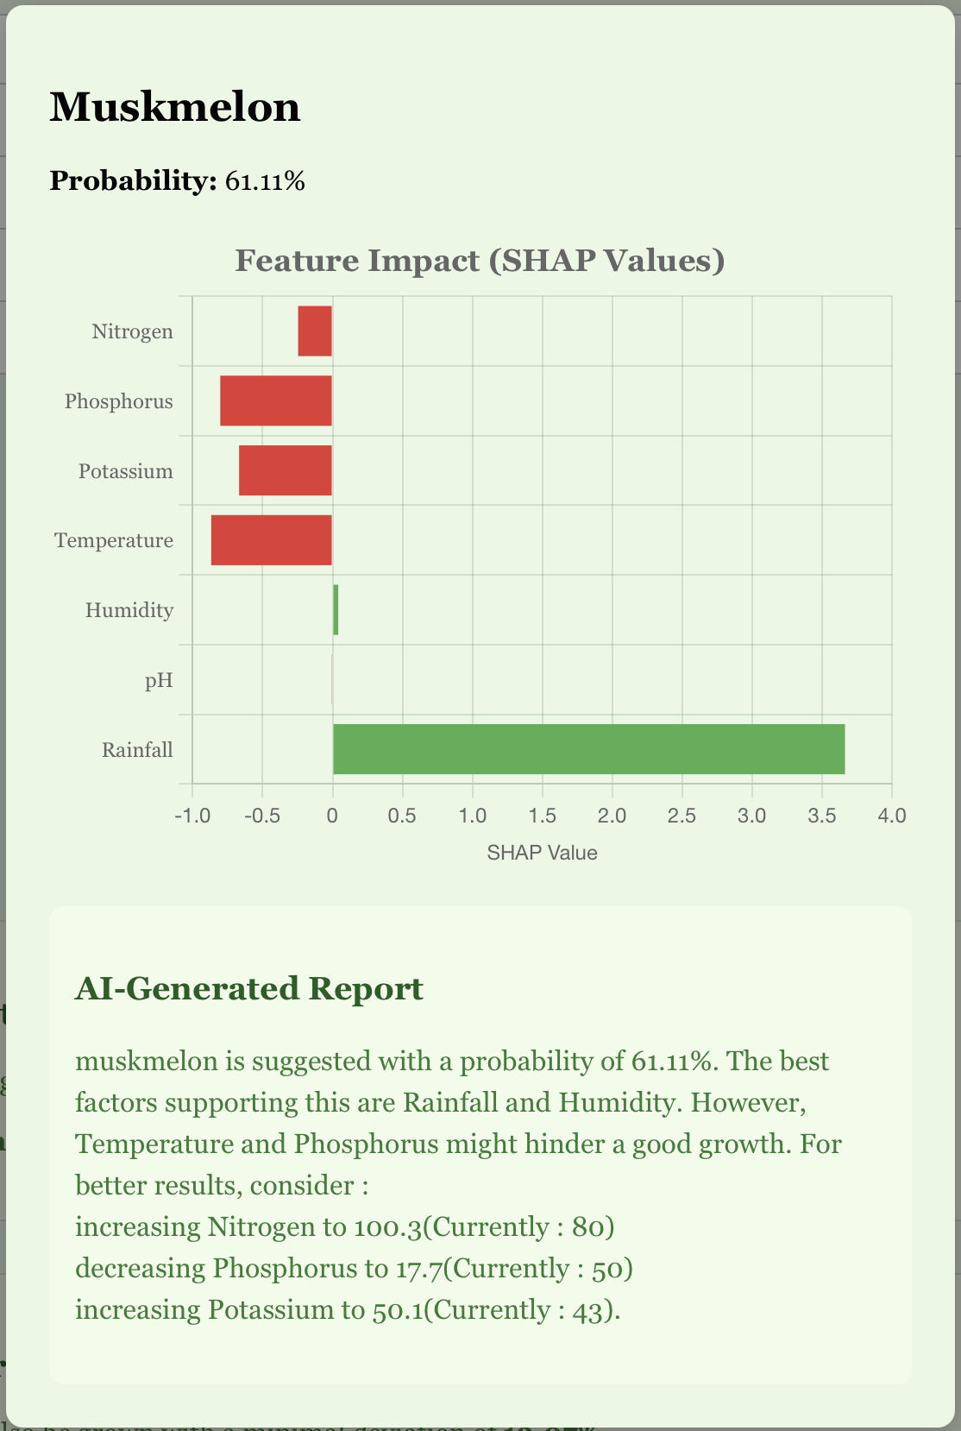
Fig. 8(c) Detailed Crop Suggestion(Modal)

Fig. 8. A glimpse of the web interface

Conclusion and Future Scope
We have developed and deployed a fully functional explainable machine learning-enabled Crop Recommendation System, which bridges the gap between black box machines acquiring knowledge and farmer-friendly interpretation. Our grapevine, built on an XGBoost categorization model, uses SHAP-based explainability to produce intuitive ocular and textual views, which are highly explainable to both agronomists and non-technical stakeholders.
The architecture never only predicts the prime three appropriate crops for a bestowed lay of green and land parameter but also explains the rationale following these predictions using community-based SHAP plot, global attribute relevance visual image, confidence score mechanism, and counterfactual suggestion. We provide users with seamless and intelligent decision support by integrating real-time meteorological data from Open-Meteo APIs and deploying a highly responsive front end.
In order to ensure that stakeholders understand that nay is not used solely in academic writing for which the organization is recommended, although in addition to the reason and the ways in which the recommendation can be improved, an important factor for supporting confidence and adoption among farmers. While the current system provides a robust and understandable crop recommendation engine, there are several opportunities for further development.
- The sensor-based real-time ground monitoring of the upcoming version of the current framework can be combined with an IoT-based dirt detector capable of measuring real-time nitrogen, phosphorus, potassium, and pH beliefs. These detectors may remain deployed directly on the surface, transmitting information wirelessly to the back end. This will eliminate the manual entry of facts, reduce human error, and increase the coherence and reliability of the report. Statistics.
- Region-Aware Fine-Tuning: Training the detach model or polishing the existing individual in particular agroclimatic areas can lead to more contextually aware recommendations, particularly in geographically diverse territories such as Hindustan.
- The fertilizer and irrigation strategies of the model may remain wide, so as not to exclusively suggest a particular cultivar but to propose explicit propagation plans, irrigation phases, and a rotation plan tailored to the customer's input signal.
- Individualized guidance from the evaluation integrates a reaction cringle where the farmer confirms or rejects the structure suggestion can help the model retrain itself periodically, making it more intelligent and more precise than before.

References
- Gangwar, K. S., et al. (2017). “Adoption and impact of precision farming practices in Indian agriculture.”
- Ghosh, R., et al. (2018). “Assessment of traditional versus modern crop planning techniques in India.”
- Jat, M. L., et al. (2020). “Climate-smart agriculture: Challenges and perspectives.”
- Lobell, D. B., & Burke, M. B. (2010). “On the use of statistical models to predict crop yield responses to climate change.”
- Liakos, K. G., et al. (2018). “Machine learning in agriculture: A review.”
- Kamilaris, A., & Prenafeta-Boldú, F. X. (2018). “Deep learning in agriculture: A survey.”
- Jones, J. W., et al. (2017). “Toward a new generation of agricultural system models.”
- Lundberg, S. M., & Lee, S.-I. (2017). “A unified approach to interpreting model predictions.”
- Ribeiro, M. T., Singh, S., & Guestrin, C. (2016). “Why should I trust you?: Explaining the predictions of any classifier.”
- Deist, T. M., et al. (2018). “Model validation and uncertainty quantification in predictive modeling for precision medicine.”
- Jha, A., et al., “SVM-based Crop Recommendation System Using Soil and Climate Data,” IJCA, vol. 181, no. 14, pp. 7-12, 2019.
- Banerjee, A., et al., “Climate-Aware Crop Prediction Using Random Forest,” Sustainable Computing: Informatics and Systems, vol. 29, 2021.
- Patel, R., et al., “Crop Selection Using Hybrid ML for Small Farmers,” IJARIIT, vol. 5, no. 2, 2018.
- Ali, A., et al., “Interpreting Agricultural Predictions Using LIME,” Computers and Electronics in Agriculture, vol. 182, 2021.
- Hossain, M., et al., “Decision Tree Based Crop Recommendation App,” IEEE IEMCON, pp. 213-218, 2020.
- Dey, A., et al., “Smart Agriculture through Weather-Driven Crop Recommender,” IJCSMC, vol. 9, no. 6, pp. 39-44, 2020.
- Singh, A. and Rao, A., “Ensemble-Based Crop Predictor for Indian Farming,” IEEE ICACCT, 2019.
- Kumar, N., et al., “Crop Suitability via Attention-Based Neural Models,” Computational Intelligence, vol. 38, no. 3, 2022.
- Sharma, M., et al., “Fuzzy Rule-Based Crop Suitability System,” IJRECE, vol. 7, no. 1, 2019.
- Yadav, R., et al., “SHAP Interpretability for Wheat Prediction,” Elsevier Ecological Informatics, vol. 61, 2021.
- Brar, M., et al., “Geolocation-Aware Crop Recommender Using Deep Learning,” IEEE Access, vol. 10, pp. 19855–19867, 2022.
- Das, P., et al., “Explainable Boosting Models in Agricultural Systems,” Frontiers in AI, vol. 6, 2023.

