

Student Name: Vishesh Aggarwal UID: 24BCY70145
Branch: AIT-CSE (Core) Section: 24AIT_KRG-G2(A)
Semester: 5 Date: 07-09-2026
Subject Name: ADBMS Subject Code: 24CSP-333

EXPERIMENT: Advanced SQL Queries

AIM: To study and implement transaction management in PostgreSQL using BEGIN, COMMIT, ROLLBACK, SAVEPOINT, and ROLLBACK TO SAVEPOINT, along with
exception handling, to maintain data consistency and integrity during successful and failed database operations.

Question 1: Design a robust PostgreSQL transaction system for the Students table in which multiple student records are inserted. If any individual insertion fails due to invalid or duplicate data, roll back only that insertion using savepoints while preserving previous successful insertions. Display appropriate success or failure messages.
Solution: CREATE TABLE Students ( Id SERIAL PRIMARY KEY,
Name VARCHAR(50) UNIQUE, Age INT,
Class INT

);

BEGIN;
-- Student 1
INSERT INTO Students(Name, Age, Class)

VALUES ('Anisha', 16, 8);
RAISE NOTICE 'Anisha inserted successfully'; SAVEPOINT sp1;

-- Student 2
INSERT INTO Students(Name, Age, Class) VALUES ('Neha', 17, 8);
RAISE NOTICE 'Neha inserted successfully'; SAVEPOINT sp2;

-- Student 3
-- Assume this may violate UNIQUE constraint INSERT INTO Students(Name, Age, Class) VALUES ('Anisha', 18, 9);

DO $$ BEGIN
BEGIN
INSERT INTO Students(Name, Age, Class) VALUES ('Anisha', 16, 8);
RAISE NOTICE 'Anisha inserted successfully'; EXCEPTION WHEN OTHERS THEN
RAISE NOTICE 'Anisha insertion failed'; END;

BEGIN
INSERT INTO Students(Name, Age, Class) VALUES ('Neha', 17, 8);
RAISE NOTICE 'Neha inserted successfully'; EXCEPTION WHEN OTHERS THEN
RAISE NOTICE 'Neha insertion failed'; END;

BEGIN
INSERT INTO Students(Name, Age, Class) VALUES ('Anisha', 18, 9);
RAISE NOTICE 'Anisha duplicate insertion successful'; EXCEPTION WHEN OTHERS THEN
RAISE NOTICE 'Anisha duplicate insertion failed and was rolled back'; END;

BEGIN
INSERT INTO Students(Name, Age, Class) VALUES ('Mayank', 19, 9);
RAISE NOTICE 'Mayank inserted successfully'; EXCEPTION WHEN OTHERS THEN
RAISE NOTICE 'Mayank insertion failed'; END;

END;

$$;

SELECT * FROM Students;

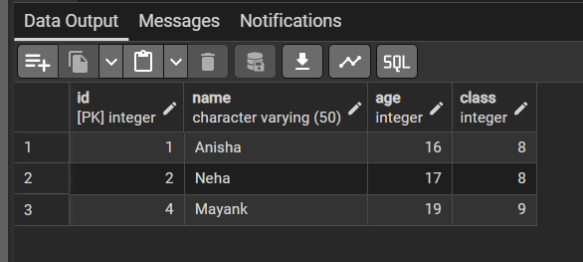
OUTPUT:

LEARNING OUTCOMES:
- Understand the concept of SQL transactions and the role of transaction control commands such as BEGIN, COMMIT, and ROLLBACK.
- Apply the ACID properties to ensure data consistency, reliability, and integrity during database transactions.
- Implement SAVEPOINT, ROLLBACK TO SAVEPOINT, and RELEASE SAVEPOINT for controlled partial rollback within transactions.
- Handle transaction failures and constraint violations using appropriate rollback and exception-handling techniques.
- Design and execute robust PostgreSQL transactions that preserve successful operations while safely recovering from failed operations.

