

Student Name: Vishesh Aggarwal UID: 24BCY70145
Branch: AIT-CSE (Core) Section: 24AIT_KRG-G2(A)
Semester: 5 Date: 14-09-2026
Subject Name: ADBMS Subject Code: 24CSP-333

EXPERIMENT: Advanced SQL Queries

AIM: To study and implement SQL Window Functions such as ROW_NUMBER(), RANK(), DENSE_RANK(), LAG(), and LEAD() to perform analytical operations, salary comparisons, and department-wise ranking on employee data.

Question 1: A company stores the monthly salary history of its employees in an EmployeeSalaryHistory table. Write an SQL query to find employees whose salary has increased in every recorded month compared to the immediately previous month.
For each salary record, compare the current month's salary with the employee's previous month's salary using the LAG() window function. Display only those employees for whom all later salary records are greater than their respective previous salary.
Output should display:
- Employee ID
- Employee Name
Solution: CREATE TABLE EmployeeSalaryHistory ( record_id INT PRIMARY KEY,
employee_id INT NOT NULL, employee_name VARCHAR(50) NOT NULL, salary_month DATE NOT NULL,

salary INT NOT NULL
);
INSERT INTO EmployeeSalaryHistory
(record_id, employee_id, employee_name, salary_month, salary) VALUES
(1, 101, 'Alok', '2026-01-01', 50000),
(2, 101, 'Alok', '2026-02-01', 52000),
(3, 101, 'Alok', '2026-03-01', 55000),
(4, 102, 'Priya', '2026-01-01', 60000),
(5, 102, 'Priya', '2026-02-01', 58000),
(6, 102, 'Priya', '2026-03-01', 62000),
(7, 103, 'Raj', '2026-01-01', 45000),
(8, 103, 'Raj', '2026-02-01', 47000),
(9, 103, 'Raj', '2026-03-01', 49000),
(10, 104, 'Sneha', '2026-01-01', 70000),
(11, 104, 'Sneha', '2026-02-01', 70000),
(12, 104, 'Sneha', '2026-03-01', 72000);

select * from EmployeeSalaryHistory;

select employee_id,employee_name from(
select *,LAG(salary) over(partition by employee_id ORDER BY salary_month

)prev_salary
from EmployeeSalaryHistory

)E
group by employee_id,employee_name having count(*) filter(
WHERE salary <= prev_salary
)=0;

OUTPUT:
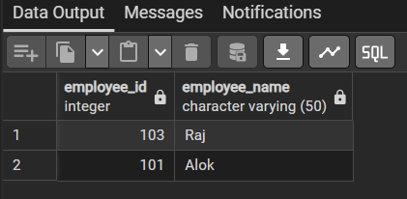
Question 2: A company maintains employee details in an Employee table and department information in a Department table.
Write an SQL query to find employees whose salaries belong to the top three distinct salary levels within their respective departments.
If multiple employees have the same salary, they should receive the same salary rank and all of them should be included in the result.
Output should display:
- Department Name
- Employee Name
- Salary
Solution: CREATE TABLE Department (

id INT PRIMARY KEY,
name VARCHAR(50) NOT NULL
);
INSERT INTO Department (id, name) VALUES

(1, 'IT'),
(2, 'Sales'),

(3, 'HR');

CREATE TABLE Employee ( id INT PRIMARY KEY,
name VARCHAR(50) NOT NULL,
salary INT NOT NULL, departmentId INT,
FOREIGN KEY (departmentId) REFERENCES Department(id)
);

INSERT INTO Employee
(id, name, salary, departmentId) VALUES
(1, 'Max', 90000, 1),
(2, 'Jim', 85000, 1),
(3, 'John', 85000, 1),

(4, 'Alex', 75000, 1),
(5, 'Sam', 70000, 1),
(6, 'Henry', 80000, 2),
(7, 'Susan', 75000, 2),
(8, 'David', 70000, 2),
(9, 'Robert', 65000, 2),
(10, 'Tina', 60000, 3),
(11, 'Rita', 55000, 3),
(12, 'Manoj', 50000, 3);

SELECT D.name AS Department, E.name AS Employee, E.salary

FROM ( SELECT *,
DENSE_RANK() OVER (
PARTITION BY departmentId ORDER BY salary DESC
) AS rnk FROM Employee

) E
JOIN Department D
ON E.departmentId = D.id WHERE rnk <= 3;

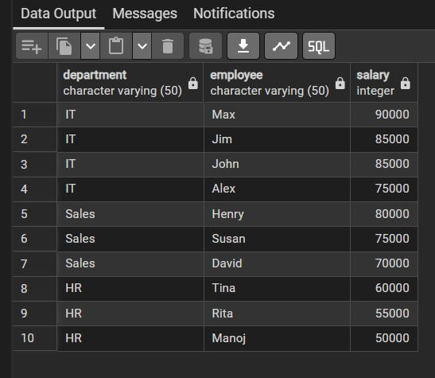
OUTPUT:

LEARNING OUTCOMES:
- Understand the concept and purpose of SQL Window Functions for performing analytical operations.
- Apply window functions such as ROW_NUMBER(), RANK(), and DENSE_RANK() to rank records within groups.
- Use LAG() and LEAD() to compare current records with previous or subsequent records.
- Analyze employee salary data using PARTITION BY and ORDER BY for department- wise comparisons.
- Develop efficient SQL queries to solve real-world analytical problems involving salary trends, rankings, and sequential data.

