

Student Name: Vishesh Aggarwal UID: 24BCY70145
Branch: AIT-CSE (Core) Section: 24AIT_KRG-G2(A)
Semester: 5 Date: 21-09-2026
Subject Name: ADBMS Subject Code: 24CSP-333

EXPERIMENT: Advanced SQL Queries

AIM: To study and implement PostgreSQL triggers and trigger functions for automatically maintaining an audit log of employee INSERT and DELETE operations along with the current date and time.

Question 1: Design and implement a PostgreSQL trigger on the student table that automatically displays the details of the row whenever a record is inserted or deleted. The output should display the Student ID, Name, Age, and Class using the appropriate NEW and OLD references.
Solution: CREATE TABLE student ( id SERIAL PRIMARY KEY, name VARCHAR(100),
age INT,
class VARCHAR(20)
);

-- STEP 2: Create Trigger Function
CREATE OR REPLACE FUNCTION fn_student_audit() RETURNS TRIGGER
LANGUAGE plpgsql

AS
$$ BEGIN
IF TG_OP = 'INSERT' THEN RAISE NOTICE
'Inserted Row -> ID: %, Name: %, Age: %, Class: %', NEW.id,
NEW.name, NEW.age, NEW.class; RETURN NEW;
ELSIF TG_OP = 'DELETE' THEN RAISE NOTICE
'Deleted Row -> ID: %, Name: %, Age: %, Class: %', OLD.id,
OLD.name, OLD.age, OLD.class; RETURN OLD;
END IF;
RETURN NULL;
END;
$$;

-- STEP 3: Create Trigger
CREATE TRIGGER trg_student_audit AFTER INSERT OR DELETE
ON student
FOR EACH ROW
EXECUTE FUNCTION fn_student_audit();

INSERT INTO student (name, age, class) VALUES ('Aman', 19, '11th');
INSERT INTO student (name, age, class) VALUES ('Rohit', 20, '12th');
SELECT * FROM student;

DELETE FROM student WHERE name = 'Aman';

SELECT * FROM student; OUTPUT:
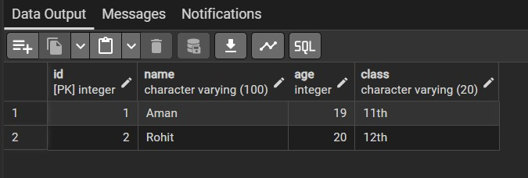

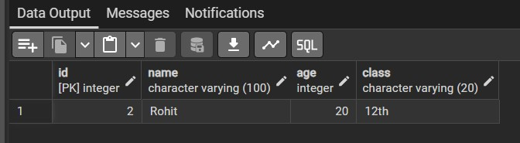

Question 2: A company maintains employee information in tbl_employee and an audit log in tbl_employee_audit. Design and implement a PostgreSQL trigger such that:
- Whenever a new employee is inserted, an audit record is created with the message: "Employee name <emp_name> has been added at <current_time>"
- Whenever an employee is deleted, an audit record is created with the message: "Employee name <emp_name> has been deleted at <current_time>
- The solution must use a PostgreSQL trigger function and trigger.
- Test the trigger using INSERT and DELETE operations and display the audit records. Solution: CREATE TABLE tbl_employee (
emp_id SERIAL PRIMARY KEY, emp_name VARCHAR(100) NOT NULL,
emp_salary NUMERIC
);
CREATE TABLE tbl_employee_audit ( sno SERIAL PRIMARY KEY,
message TEXT
);

CREATE OR REPLACE FUNCTION audit_employee_changes() RETURNS TRIGGER

LANGUAGE plpgsql AS
$$ BEGIN
IF TG_OP = 'INSERT' THEN
INSERT INTO tbl_employee_audit(message) VALUES (
'Employee name ' || NEW.emp_name || ' has been added at ' || NOW()
);
RETURN NEW;
ELSIF TG_OP = 'DELETE' THEN
INSERT INTO tbl_employee_audit(message) VALUES (
'Employee name ' || OLD.emp_name || ' has been deleted at ' || NOW()
);
RETURN OLD; END IF; RETURN NULL;
END;
$$;

CREATE TRIGGER trg_employee_audit

AFTER INSERT OR DELETE
ON tbl_employee FOR EACH ROW
EXECUTE FUNCTION audit_employee_changes();

INSERT INTO tbl_employee (emp_name, emp_salary) VALUES ('Aman', 50000);
INSERT INTO tbl_employee (emp_name, emp_salary) VALUES ('Rohit', 55000);

SELECT * FROM tbl_employee;

DELETE FROM tbl_employee WHERE emp_name = 'Aman';

SELECT * FROM tbl_employee;

SELECT * FROM tbl_employee_audit; OUTPUT:
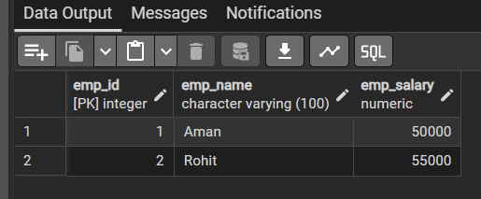

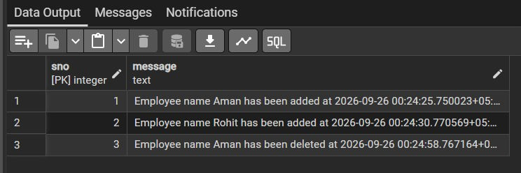
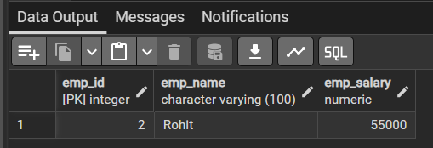

LEARNING OUTCOMES:
- Understand the concept and purpose of PostgreSQL triggers and trigger functions.
- Create PL/pgSQL trigger functions to automatically perform actions after database operations.
- Use NEW, OLD, and TG_OP to handle INSERT and DELETE operations.
- Implement an automated audit mechanism to record employee changes with timestamps.
- Test and verify trigger execution by performing insert/delete operations and retrieving audit records.

