


Student Name: Vishesh Aggarwal UID: 24BCY70145
Branch: AIT-CSE (Core) Section: 24AIT_KRG-G2(A)
Semester: 5 Date: 10-08-2026
Subject Name: ADBMS Subject Code: 24CSP-333

EXPERIMENT: Advanced SQL Queries

AIM: To study and implement advanced SQL queries using conditional logic, aggregate functions, joins, self-joins, and date operations to solve real-world database problems.

Question 1:

(i) (A) A website maintains records of users who have registered on the platform and the status of confirmation requests sent to them. A confirmation request can either be successfully completed or may expire without completion.
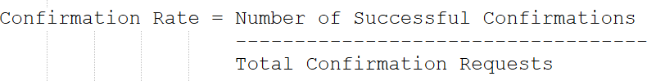
For each registered user, calculate the confirmation rate, which is defined as:

If a user has never received any confirmation request, their confirmation rate should be considered 0.
Display the user ID along with the confirmation rate rounded to 2 decimal places. The result can be returned in any order.

Table:
CREATE TABLE Signups (

user_id INT PRIMARY KEY, time_stamp TIMESTAMP
);

INSERT INTO Signups VALUES
(3,'2020-03-21 10:16:13'),
(7,'2020-01-04 13:57:59'),
(2,'2020-07-29 23:09:44'),
(6,'2020-12-09 10:39:37');

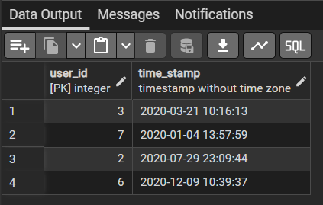
SELECT * FROM Signups;

CREATE TABLE Confirmations (
user_id INT,
time_stamp TIMESTAMP, action VARCHAR(20),
PRIMARY KEY(user_id, time_stamp),
FOREIGN KEY(user_id) REFERENCES Signups(user_id)
);

INSERT INTO Confirmations VALUES
(3,'2021-01-06 03:30:46','timeout'),

(3,'2021-07-14 14:00:00','timeout'),
(7,'2021-06-12 11:57:29','confirmed'),
(7,'2021-06-13 12:58:28','confirmed'),
(7,'2021-06-14 13:59:27','confirmed'),
(2,'2021-01-22 00:00:00','confirmed'),
(2,'2021-02-28 23:59:59','timeout');
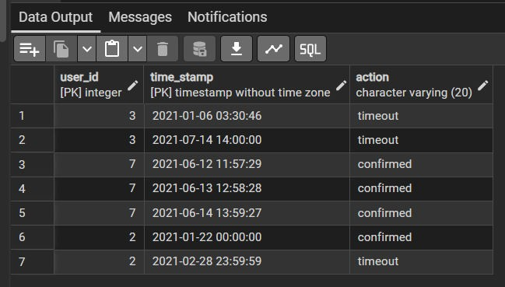
SELECT * FROM Confirmations;

Answer: SELECT s.user_id, ROUND(
AVG(
CASE
WHEN c.action = 'confirmed' THEN 1.0 ELSE 0.0
END
), 2
) AS confirmation_rate FROM Signups s
LEFT JOIN Confirmations c ON s.user_id = c.user_id

GROUP BY s.user_id; Output:
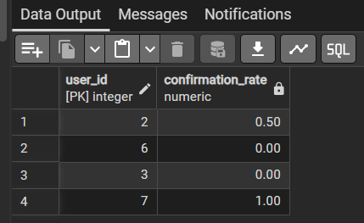

Question 2: A ride-booking company maintains information about trip requests and the users involved in those trips. Some users may be restricted from using the platform, while others are active participants. Each trip can either be completed successfully or cancelled by one of the participants.
For each day between 2013-10-01 and 2013-10-03, determine the proportion of canceled trips among all valid trips. A trip should be considered valid only when both the customer and the driver associated with that trip are active users. The final result should display the date and the calculated cancellation rate rounded to two decimal places.
We need to calculate: Cancellation Rate
=
Cancelled Trips

Total Valid Trips
But only consider trips where: Client is NOT banned AND
Driver is NOT banned

And Date between 2013-10-01
And
2013-10-03
Table: CREATE TABLE Users (
users_id INT PRIMARY KEY, banned VARCHAR(3),
role VARCHAR(20)
);

INSERT INTO Users VALUES
(1,'No','client'),
(2,'Yes','client'),
(3,'No','client'),
(4,'No','client'),
(10,'No','driver'),
(11,'No','driver'),
(12,'No','driver'),
(13,'No','driver'); select * from Users;

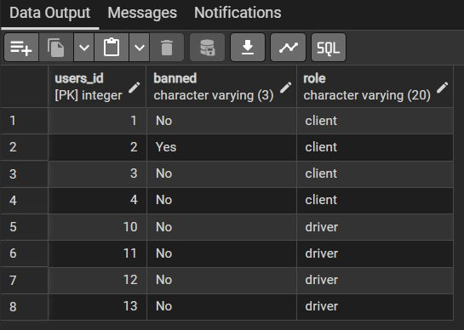

CREATE TABLE Trips (
id INT PRIMARY KEY,
client_id INT, driver_id INT, city_id INT,
status VARCHAR(30), request_at DATE
);

INSERT INTO Trips VALUES
(1,1,10,1,'completed','2013-10-01'),
(2,2,11,1,'caelled_by_driver','2013-10-01'),
(3,3,12,6,'completed','2013-10-01'),
(4,4,13,6,'cancelled_by_client','2013-10-01'),
(5,1,10,1,'completed','2013-10-02'),
(6,2,11,6,'completed','2013-10-02'),
(7,3,12,6,'completed','2013-10-02'),
(8,2,12,12,'completed','2013-10-03'),

(9,3,10,12,'completed','2013-10-03'),
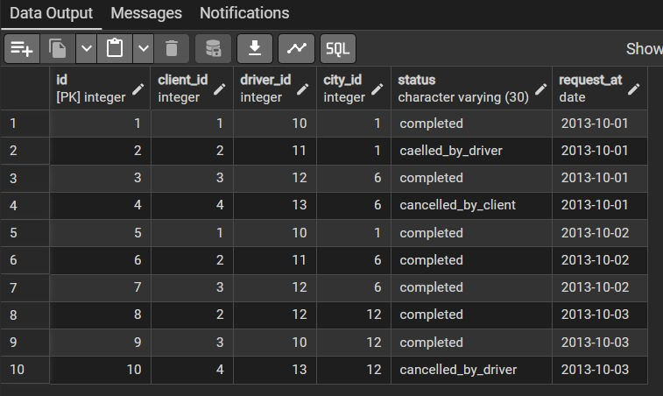
(10,4,13,12,'cancelled_by_driver','2013-10-03'); select * from Trips;

Answer: SELECT t.request_at AS Day, ROUND(
AVG(
CASE
WHEN t.status IN ('cancelled_by_driver', 'cancelled_by_client') THEN 1.0
ELSE 0.0 END
), 2
) AS Cancellation_Rate FROM Trips t
JOIN Users c

ON t.client_id = c.users_id AND c.banned = 'No'
AND t.request_at between '2013-10-01' and '2013-10-03' JOIN Users d
ON t.driver_id = d.users_id AND d.banned = 'No'
AND t.request_at between '2013-10-01' and '2013-10-03' GROUP BY t.request_at
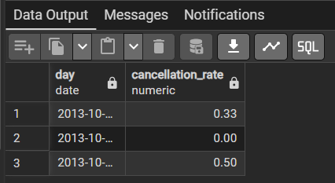
ORDER BY t.request_at; Output:

LEARNING OUTCOMES:

- Learned to calculate confirmation rates using aggregate functions such as AVG() and conditional logic with the CASE statement.
- Gained practical understanding of using LEFT JOIN to include all registered users, even those who have not received any confirmation requests.
- Learned to use self-joins on the Users table to separately identify and validate active clients and drivers in trip records.
- Developed the ability to calculate cancellation rates using conditional aggregation, AVG(), and ROUND() for accurate two-decimal results.
- Enhanced understanding of combining JOIN, WHERE/date conditions, GROUP BY, ORDER BY, CASE, and aggregate functions to solve real-world database problems involving user confirmations and ride cancellations.

