


Student Name: Vishesh Aggarwal UID: 24BCY70145
Branch: AIT-CSE (Core) Section: 24AIT_KRG-G2 (A)
Semester: 5 Date: 10-08-2026
Subject Name: ADBMS Subject Code: 24CSP-333

EXPERIMENT: Advanced SQL Queries

AIM: To study and implement advanced SQL queries using conditional logic, aggregate functions, joins, self-joins, and date operations to solve real-world database problems.

Question 1: A fruit distribution company records the number of apples and oranges sold each day. For every date, exactly one record exists for apples and one record exists for oranges.
Generate a daily sales comparison report showing the difference between the number of apples sold and the number of oranges sold on the same day. The difference should be calculated as:

Difference = Apples Sold - Oranges Sold
Display the sale date and the calculated difference. The result should be sorted by sale date in ascending order.
Table:

CREATE TABLE Sales (
sale_date DATE, fruit VARCHAR(20),
sold_num INT,

PRIMARY KEY (sale_date, fruit)
);

INSERT INTO Sales VALUES

('2020-05-01','apples',10),
('2020-05-01','oranges',8),

('2020-05-02','apples',15),
('2020-05-02','oranges',15),

('2020-05-03','apples',20),
('2020-05-03','oranges',0),

('2020-05-04','apples',15),
('2020-05-04','oranges',16);

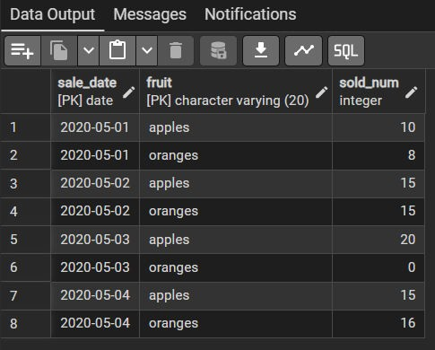
select * from Sales;

Answer: select s1.sale_date,
s1.sold_num - s2.sold_num AS diff FROM Sales s1
JOIN Sales s2
ON s1.sale_date = s2.sale_date WHERE s1.fruit = 'apples'

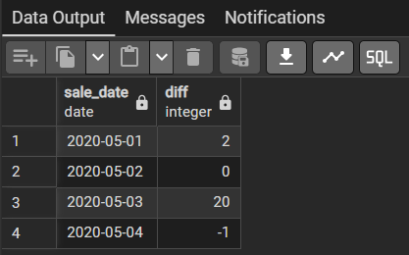
AND s2.fruit = 'oranges'; Output:

Question 2: A company stores hierarchical employee reporting information in a table. Each record represents a node in a hierarchy where:
- id represents the current node.
- p_id represents the parent node.
Classify every node into one of the following categories:
- Root: A node that does not have any parent.
- Leaf: A node that has a parent but does not have any children.
- Inner: A node that has both a parent and at least one child.
Display the node ID along with its category. Return the result sorted by node ID.
Table: CREATE TABLE Tree (
id INT PRIMARY KEY,
p_id INT
);

INSERT INTO Tree VALUES (1,NULL),
(2,1),
(3,1),
(4,2),
(5,2);

select * from Tree;
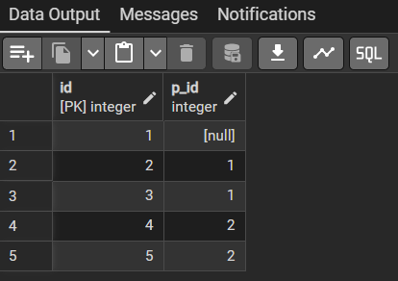

Answer: select id, case when p_id IS NULL THEN 'Root'
when id in (select p_id from tree where p_id is not null) then 'Inner'
else 'Leaf' end
from tree order by id; Output:

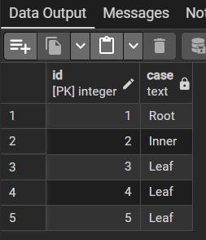

LEARNING OUTCOMES:

- Learned to use self-joins to compare records from the same table and calculate the difference between apples and oranges sold on the same date.
- Gained practical understanding of using JOIN conditions and WHERE clauses to match related records based on common attributes such as sale dates and fruit types.
- Learned to use the CASE statement to classify hierarchical data into Root, Inner, and Leaf nodes based on parent-child relationships.
- Developed an understanding of subqueries to identify nodes that act as parents and determine whether a node has child nodes.
- Enhanced the ability to combine JOINs, CASE expressions, subqueries, conditional logic, and ORDER BY to solve real-world database problems involving sales analysis and hierarchical data.

