

Student Name: Vishesh Aggarwal UID: 24BCY70145
Branch: AIT-CSE (Core) Section: 24AIT_KRG-G2 (A)
Semester: 5 Date: 24-08-2026
Subject Name: ADBMS Subject Code: 24CSP-333

EXPERIMENT: Advanced SQL Queries

AIM: To study and implement PostgreSQL Views and Materialized Views for simplifying data access and analysis by combining data from multiple tables, performing SQL operations such as joins and aggregations, controlling access to data, and analyzing query execution performance.

Question 1: A company maintains customer information, product information, and sales order information in three separate tables: customer_master, product_catalog, and sales_orders.
The company wants to provide an order report to an external client. The report must contain the Order ID, Order Date, Customer Name, Product Name, and Final Amount.
For every order, first calculate the Gross Amount using:
Gross Amount = Unit Price × Quantity Then calculate the Discount Amount using:
Discount Amount = Gross Amount × Discount Percentage / 100 Finally, calculate the Final Amount using:
Final Amount = Gross Amount − Discount Amount
Create a complex view using the three tables to generate this report. The view should expose only the required five columns and should not expose the customer's phone/email, product brand/unit price, or the order's quantity/discount percentage.
The company also wants to provide access to an external client. Create a PostgreSQL user named client_user and give this user only SELECT permission on the view. The client must

not have direct access to the three original tables and must not be allowed to modify the view data.
Solution: CREATE TABLE customer_master (
customer_id VARCHAR(5) PRIMARY KEY, full_name VARCHAR(50) NOT NULL,
city VARCHAR(30)
);

CREATE TABLE product_catalog (
product_id VARCHAR(5) PRIMARY KEY, product_name VARCHAR(50) NOT NULL, unit_price NUMERIC(10,2) NOT NULL
);

CREATE TABLE sales_orders (
order_id SERIAL PRIMARY KEY, product_id VARCHAR(5)
REFERENCES product_catalog(product_id), quantity INT NOT NULL,
customer_id VARCHAR(5)
REFERENCES customer_master(customer_id),

discount_percent NUMERIC(5,2), order_date DATE NOT NULL
);

INSERT INTO customer_master (customer_id, full_name, city) VALUES
('C1', 'Amit Sharma', 'Delhi'),
('C2', 'Priya Verma', 'Mumbai'),
('C3', 'Ravi Kumar', 'Bangalore'),
('C4', 'Neha Singh', 'Kolkata'),
('C5', 'Arjun Mehta', 'Hyderabad');

INSERT INTO product_catalog (product_id, product_name, unit_price) VALUES
('P1', 'Smartphone X100', 25000), ('P2', 'Laptop Pro 15', 65000),
('P3', 'Wireless Earbuds', 5000), ('P4', 'Smartwatch Fit', 30000),
('P5', 'Gaming Console', 45000);

INSERT INTO sales_orders
(product_id, quantity, customer_id, discount_percent, order_date)

VALUES
('P1', 2, 'C1', 5, '2025-09-01'),
('P2', 1, 'C2', 10, '2025-09-02'),
('P3', 3, 'C3', 0, '2025-09-03'),
('P4', 1, 'C4', 8, '2025-09-04'),
('P5', 1, 'C5', 12, '2025-09-05'),
('P1', 1, 'C2', 5, '2025-09-06'),
('P3', 2, 'C1', 0, '2025-09-07');

---EXPLAIN ANALYZE---
CREATE VIEW vw_sales_order_details AS SELECT
so.order_id, so.order_date, cm.full_name, pc.product_name,

-- Gross Amount
pc.unit_price * so.quantity AS gross_amount,

-- Discount Amount (pc.unit_price * so.quantity)
- so.discount_percent / 100 AS discount_amount,

-- Final Amount (pc.unit_price * so.quantity)
- ((pc.unit_price * so.quantity)
- so.discount_percent / 100) AS final_amount

FROM sales_orders so

JOIN customer_master cm
ON so.customer_id = cm.customer_id

JOIN product_catalog pc
ON so.product_id = pc.product_id;

SELECT *
FROM vw_sales_order_details;

CREATE USER client_user PASSWORD '12345';

REVOKE ALL ON customer_master FROM client_user; REVOKE ALL ON product_catalog FROM client_user; REVOKE ALL ON sales_orders FROM client_user;

GRANT SELECT

ON vw_sales_order_details TO client_user;

SELECT *
FROM vw_sales_order_details;

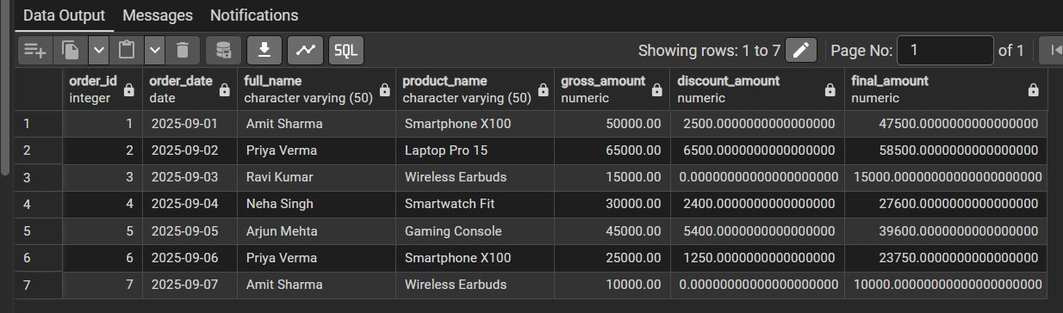
OUTPUT:

Question 2: An e-commerce company wants to regularly analyze the performance of its product categories. The company stores product, category, customer, and order information in separate tables. To generate the category performance report, the database needs to perform multiple JOINs, GROUP BY, aggregate functions, DISTINCT counting, calculated values, and CASE statements.
Since the same report is generated frequently, executing the complete analytical query every time can increase database workload.
Create a PostgreSQL Materialized View named mv_category_sales to store the result of this analytical query.
The report must contain the following attributes:
- Category ID
- Category Name

- Total Products Sold
- Total Orders
- Unique Customers
- Total Revenue
- Average Revenue per Order
- Category Performance

Solution: CREATE TABLE category_master ( category_id VARCHAR(5) PRIMARY KEY, category_name VARCHAR(50) NOT NULL
);
CREATE TABLE product_master ( product_id VARCHAR(5) PRIMARY KEY,
product_name VARCHAR(50) NOT NULL, category_id VARCHAR(5)
REFERENCES category_master(category_id)
);
CREATE TABLE customer_master ( customer_id VARCHAR(5) PRIMARY KEY, customer_name VARCHAR(50) NOT NULL
);
CREATE TABLE order_details (
order_id VARCHAR(5) PRIMARY KEY,
customer_id VARCHAR(5)

REFERENCES customer_master(customer_id), product_id VARCHAR(5)
REFERENCES product_master(product_id), quantity INT NOT NULL,
unit_price NUMERIC(10,2) NOT NULL
);

INSERT INTO category_master (category_id, category_name) VALUES
('C1', 'Electronics'),
('C2', 'Clothing'),
('C3', 'Books');

INSERT INTO product_master (product_id, product_name, category_id) VALUES
('P101', 'Laptop', 'C1'),
('P102', 'Headphones', 'C1'),
('P201', 'Jacket', 'C2'),
('P202', 'Shoes', 'C2'),
('P301', 'SQL Book', 'C3');

INSERT INTO customer_master

(customer_id, customer_name) VALUES
('U1', 'Aman'),
('U2', 'Priya'),
('U3', 'Rahul'),
('U4', 'Simran');

INSERT INTO order_details
(order_id, customer_id, product_id, quantity, unit_price) VALUES
('O101', 'U1', 'P101', 1, 5000),
('O102', 'U2', 'P102', 2, 1000),
('O103', 'U1', 'P201', 1, 3000),
('O104', 'U3', 'P202', 2, 2000),
('O105', 'U4', 'P301', 3, 500),
('O106', 'U2', 'P101', 1, 5000),
('O107', 'U3', 'P201', 1, 3000),
('O108', 'U4', 'P102', 1, 1000);

---ORIGINAL ANALYTICAL QUERY--- SELECT
c.category_id, c.category_name,
SUM(od.quantity) AS total_products_sold,

COUNT(DISTINCT od.order_id) AS total_orders, COUNT(DISTINCT od.customer_id) AS unique_customers, SUM(od.quantity * od.unit_price) AS total_revenue, ROUND(
SUM(od.quantity * od.unit_price)::NUMERIC
/ COUNT(DISTINCT od.order_id), 2
) AS avg_revenue_per_order, CASE
WHEN SUM(od.quantity * od.unit_price) >= 10000 THEN 'Excellent'
WHEN SUM(od.quantity * od.unit_price) >= 6000 THEN 'Good'
WHEN SUM(od.quantity * od.unit_price) >= 3000 THEN 'Average'
ELSE 'Low'
END AS category_performance FROM category_master c
JOIN product_master p
ON c.category_id = p.category_id JOIN order_details od
ON p.product_id = od.product_id GROUP BY
c.category_id,

c.category_name ORDER BY
c.category_id;

---EXPLAIN ANALYZE ORIGINAL QUERY--- EXPLAIN ANALYZE
SELECT
c.category_id, c.category_name,
SUM(od.quantity) AS total_products_sold, COUNT(DISTINCT od.order_id) AS total_orders, COUNT(DISTINCT od.customer_id) AS unique_customers, SUM(od.quantity * od.unit_price) AS total_revenue, ROUND(
SUM(od.quantity * od.unit_price)::NUMERIC
/ COUNT(DISTINCT od.order_id), 2
) AS avg_revenue_per_order, CASE
WHEN SUM(od.quantity * od.unit_price) >= 10000 THEN 'Excellent'
WHEN SUM(od.quantity * od.unit_price) >= 6000 THEN 'Good'
WHEN SUM(od.quantity * od.unit_price) >= 3000

THEN 'Average' ELSE 'Low'
END AS category_performance FROM category_master c
JOIN product_master p
ON c.category_id = p.category_id JOIN order_details od
ON p.product_id = od.product_id GROUP BY
c.category_id, c.category_name
ORDER BY
c.category_id;

CREATE MATERIALIZED VIEW mv_category_sales_01 AS SELECT
c.category_id, c.category_name,
SUM(od.quantity) AS total_products_sold, COUNT(DISTINCT od.order_id) AS total_orders, COUNT(DISTINCT od.customer_id) AS unique_customers, SUM(od.quantity * od.unit_price) AS total_revenue, ROUND(
SUM(od.quantity * od.unit_price)::NUMERIC

/ COUNT(DISTINCT od.order_id), 2
) AS avg_revenue_per_order, CASE
WHEN SUM(od.quantity * od.unit_price) >= 10000 THEN 'Excellent'
WHEN SUM(od.quantity * od.unit_price) >= 6000 THEN 'Good'
WHEN SUM(od.quantity * od.unit_price) >= 3000 THEN 'Average'
ELSE 'Low'
END AS category_performance FROM category_master c
JOIN product_master p
ON c.category_id = p.category_id JOIN order_details od
ON p.product_id = od.product_id GROUP BY
c.category_id, c.category_name;

---DISPLAY MATERIALIZED VIEW--- SELECT *
FROM mv_category_sales_01

ORDER BY category_id;

---EXPLAIN ANALYZE MATERIALIZED VIEW--- EXPLAIN ANALYZE
SELECT *
FROM mv_category_sales_01 ORDER BY category_id;

INSERT INTO order_details
(order_id, customer_id, product_id, quantity, unit_price) VALUES
('O109', 'U1', 'P101', 2, 5000);

---DISPLAY BEFORE REFRESH--- SELECT *
FROM mv_category_sales_01 ORDER BY category_id;

---REFRESH MATERIALIZED VIEW---
REFRESH MATERIALIZED VIEW mv_category_sales_01;

---DISPLAY AFTER REFRESH--- SELECT *
FROM mv_category_sales_01

ORDER BY category_id;

---EXPLAIN ANALYZE AFTER REFRESH--- EXPLAIN ANALYZE
SELECT *
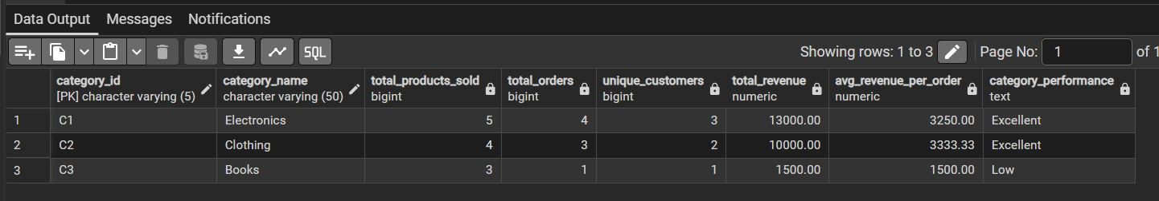
FROM mv_category_sales_01 ORDER BY category_id; OUTPUT:

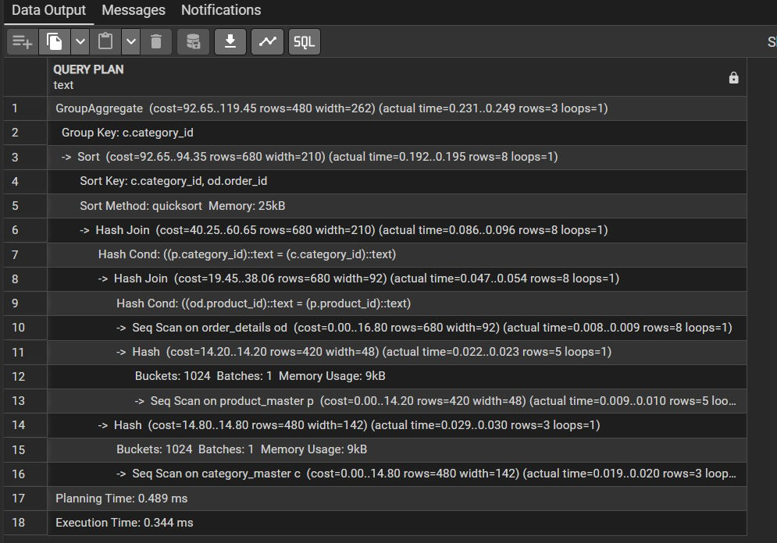

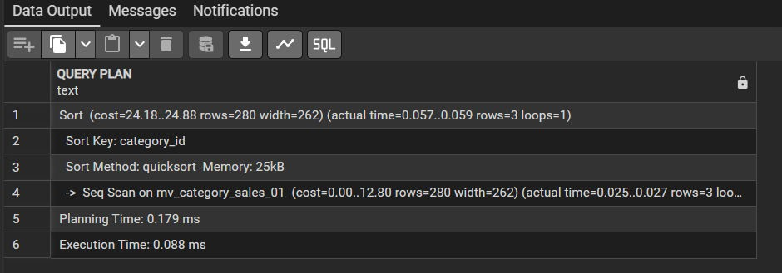

LEARNING OUTCOMES:
- Understood PostgreSQL Views and Materialized Views and explain their purpose and differences.
- Created and managed Views using SQL queries involving multiple tables, joins, calculations, and filtering.
- Created Materialized Views to store precomputed results of complex queries involving aggregation and analysis.
- Performed data analysis using SQL functions such as SUM(), COUNT(), ROUND(), GROUP BY, and conditional CASE statements.
- Analyzed query performance using EXPLAIN ANALYZE and understand how Materialized Views can improve data retrieval for analytical queries.

