

Student Name: Vishesh Aggarwal UID: 24BCY70145
Branch: AIT-CSE (Core) Section: 24AIT_KRG-G2
Semester: 5 Date: 31-08-2026
Subject Name: ADBMS Subject Code: 24CSP-333

EXPERIMENT: Advanced SQL Queries

AIM: To understand and implement PostgreSQL stored procedures, conditional stock management, sales processing, foreign key constraints, CASCADE operations, and table management using PL/pgSQL, while maintaining data consistency and integrity between related tables.

Question 1: An organization maintains employee details in a table named employee_info. The table contains the employee ID, name, gender, salary, and city.
Create a PostgreSQL stored procedure that accepts an employee's gender as an IN parameter and calculates the total number of employees belonging to that gender.
The calculated count should be returned through an OUT parameter and should also be displayed as a message using RAISE NOTICE.
Solution: CREATE TABLE employee_info ( id SERIAL PRIMARY KEY,
name VARCHAR(50) NOT NULL, gender VARCHAR(10) NOT NULL, salary NUMERIC(10,2) NOT NULL, city VARCHAR(50) NOT NULL
);
INSERT INTO employee_info (name, gender, salary, city)
VALUES
('Alok', 'Male', 50000.00, 'Delhi'),
('Priya', 'Male', 60000.00, 'Mumbai'),
('Rajesh', 'Female', 45000.00, 'Bangalore'),
('Sneha', 'Male', 55000.00, 'Chennai'),
('Anil', 'Male', 52000.00, 'Hyderabad'),
('Sunita', 'Female', 48000.00, 'Kolkata'),
('Vijay', 'Male', 47000.00, 'Pune'),
('Ritu', 'Male', 62000.00, 'Ahmedabad'),
('Amit', 'Female', 51000.00, 'Jaipur');

CREATE OR REPLACE PROCEDURE count_employees_by_gender( IN p_gender VARCHAR,
OUT employee_count INTEGER
)
LANGUAGE plpgsql AS $$
BEGIN
-- Count employees belonging to the given gender SELECT COUNT(*)
INTO employee_count FROM employee_info WHERE gender = p_gender;
-- Display the result as a message
RAISE NOTICE 'Total number of % employees: %', p_gender, employee_count;
END;
$$;

CALL count_employees_by_gender('Male', NULL); CALL count_employees_by_gender('Female', NULL);

OUTPUT:

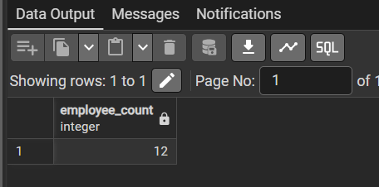
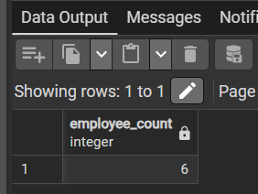
Question 2: An e-commerce company maintains product stock information in a products table and completed order information in a sales table. Create a PostgreSQL stored procedure named pr_buy_products that accepts the product name and required quantity as input parameters.
The procedure should check whether the requested product exists and whether sufficient stock is available. If sufficient stock is available, the procedure should:
- Retrieve the product code and price.
- Calculate the total sale amount using: Sale Price = Product Price × Quantity Ordered
- Insert a new order record into the sales table.

- Reduce the quantity_remaining in the products table.
- Increase the quantity_sold by the purchased quantity.
- Display a success notification.
If sufficient stock is not available, the procedure should not modify any data and should display an appropriate insufficient quantity notification.
Create the required tables, insert sample data, create the stored procedure pr_buy_products, and execute it to verify the result.
Solution: CREATE TABLE products ( product_code VARCHAR(10) PRIMARY KEY, product_name VARCHAR(100) NOT NULL, price NUMERIC(10,2) NOT NULL,
quantity_remaining INT NOT NULL, quantity_sold INT DEFAULT 0
);

CREATE TABLE sales (
order_id SERIAL PRIMARY KEY, order_date DATE NOT NULL, product_code VARCHAR(10) NOT NULL, quantity_ordered INT NOT NULL, sale_price NUMERIC(10,2) NOT NULL,
FOREIGN KEY (product_code) REFERENCES products(product_code)
);

INSERT INTO products (product_code, product_name, price, quantity_remaining, quantity_sold)
VALUES
('P001', 'iPHONE 13 PRO MAX', 109999.00, 10, 0),
('P002', 'Samsung Galaxy S23 Ultra', 99999.00, 8, 0),
('P003', 'iPAD AIR', 55999.00, 5, 0),
('P004', 'MacBook Pro 14"', 189999.00, 3, 0),
('P005', 'Sony WH-1000XM5 Headphones', 29999.00, 15, 0);

INSERT INTO sales (order_date, product_code, quantity_ordered, sale_price) VALUES
('2025-09-15', 'P001', 1, 109999.00),
('2025-09-16', 'P002', 2, 199998.00),
('2025-09-17', 'P003', 1, 55999.00),
('2025-09-18', 'P005', 2, 59998.00),
('2025-09-19', 'P001', 1, 109999.00);

SELECT * FROM PRODUCTS; SELECT * FROM SALES;

CREATE OR REPLACE PROCEDURE pr_buy_products( IN p_product_name VARCHAR,
IN p_quantity INT
)

LANGUAGE plpgsql AS $$
DECLARE
v_product_code VARCHAR(10); v_price NUMERIC(10,2); v_count INT;
v_total NUMERIC(10,2); BEGIN

-- Check whether product exists and sufficient stock is available SELECT COUNT(*)
INTO v_count FROM products
WHERE product_name = p_product_name AND quantity_remaining >= p_quantity;

-- If sufficient stock is available IF v_count > 0 THEN

-- Retrieve product code and price SELECT product_code, price INTO v_product_code, v_price FROM products
WHERE product_name = p_product_name;

-- Calculate total sale amount v_total := v_price * p_quantity;

-- Insert new order into sales table INSERT INTO sales (
order_date, product_code, quantity_ordered, sale_price
) VALUES (
CURRENT_DATE,
v_product_code, p_quantity, v_total
);

-- Reduce remaining stock and increase quantity sold UPDATE products
SET quantity_remaining = quantity_remaining - p_quantity, quantity_sold = quantity_sold + p_quantity
WHERE product_code = v_product_code;

-- Success message RAISE NOTICE
'PRODUCT SOLD..! Order placed successfully for % unit(s) of %.', p_quantity, p_product_name;

ELSE

-- No data modification RAISE NOTICE
'INSUFFICIENT QUANTITY..! Order cannot be processed for % unit(s) of %.', p_quantity, p_product_name;

END IF;

END;
$$;

CALL pr_buy_products('MacBook Pro 14"', 1);

CALL pr_buy_products('MacBook Pro 14"', 10);

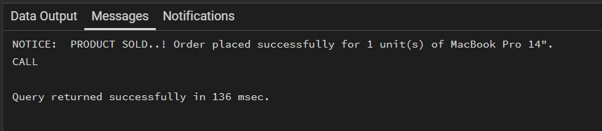
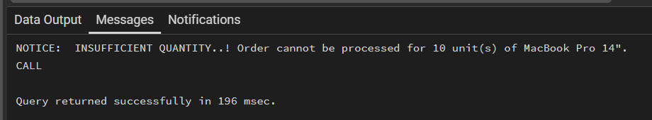
OUTPUT:

LEARNING OUTCOMES:
- Understand the concept and syntax of stored procedures in PostgreSQL using PL/pgSQL.
- Implement input parameters, conditional statements, variables, and RAISE NOTICE messages in stored procedures.
- Apply SQL operations such as SELECT, INSERT, and UPDATE to process product purchases and manage stock efficiently.
- Understand and implement foreign key constraints and ON DELETE CASCADE / ON UPDATE CASCADE for maintaining referential integrity.
- Execute and verify database operations such as creating, modifying, and deleting tables while ensuring data consistency between related tables.

