

Student Name: Vishesh Aggarwal UID: 24BCY70145
Branch: AIT-CSE (Core) Section: 24AIT_KRG-G2 (A)
Semester: 5 Date: 23/09/2026
Subject Name: Computer Networks Subject Code: 24CSH-337

AIM: To capture and analyse network packets using Wireshark Packet Analyzer and understand the structure and communication of different network protocols such as ICMP, ARP, DNS, and TCP.To implement a client-server communication system using Python UDP sockets over the IPv4 loopback interface, and to demonstrate connectionless message transmission, server responses, and termination of communication using a predefined message.

OBJECTIVES:
- To understand the basic functionality of Wireshark as a network packet analyzer.
- To capture and analyse ICMP packets generated using the ping command.
- To capture and analyse ARP request and reply packets.
- To capture and analyse DNS query and response packets.
- To capture and analyse TCP connection packets and identify the TCP three-way handshake.

SOFTWARE REQUIREMENTS:

Software:
  - Wireshark
  - Windows Operating System
  - Command Prompt (CMD)
  - Active Ethernet/Wi-Fi/mobile hotspot connection
  - Npcap for packet capture on Windows

THEORY: (i) What is Wireshark?

Wireshark is a network packet analyzer used to capture and inspect network traffic. It can capture packets from an active network interface and display protocol-level information.
Wireshark uses the network interface and packet-capture tools such as Npcap on Windows to obtain raw packets from the operating system.

What is Promiscuous Mode?
Normally, a network interface processes packets intended for the device. Wireshark can enable Promiscuous Mode to capture packets available on the network segment, subject to the capabilities and configuration of the network interface.

What is Monitor Mode?
For wireless interfaces, Monitor Mode can capture wireless frames in the air, including frames not specifically addressed to the device, depending on hardware and driver support.

Packet Capture Flow:
Network Traffic→Network Interface→Npcap→Operating System→ Wireshark→Packet Analysis
PROTOCOLS ANALYSED:
  - HTTP / HTTPS
  - ARP
  - DHCP
  - DNS
  - ICMP
  - SSH / FTP
  - TCP
The experiment specifically demonstrates ICMP, ARP, DNS, and TCP packet capture.

STEPS/IMPLEMENTATION:
EXPERIMENT 1: ICMP PACKET CAPTURE

Procedure:
- Connect the laptop to the Internet using Ethernet, Wi-Fi, or mobile hotspot.
- Open Wireshark.
- Select the active network interface.
- Double-click the interface to start packet capture.
- Open Command Prompt.
- Execute: ping 8.8.8.8
- Wait for the ping command to finish.
- Stop packet capture.
- Apply the filter: icmp && ip.addr == 8.8.8.8
- Identify the Echo Request and corresponding Echo Reply packets.

Packet Size Analysis:

Component | Size
Ethernet Header | 14 bytes
IPv4 Header | 20 bytes
ICMP Header | 8 bytes
Ping Data | 32 bytes
Total | 74 bytes

EXPERIMENT 2: ARP PACKET CAPTURE

Procedure:

- Connect the laptop to Ethernet/Wi-Fi/mobile hotspot.
- Open Command Prompt.
- Execute: ipconfig
- Note the Default Gateway IP.
- Open Command Prompt as Administrator.
- Clear the dynamic ARP cache: arp -d *
- Open Wireshark.
- Select the active network interface.
- Start packet capture.
- Execute: ping <Default-Gateway-IP> Eg: ping 192.168.0.1
- Stop packet capture. 12.Apply the filter: arp
13.Identify the ARP Request and corresponding ARP Reply. 14.Analyse:
  - Source
  - Destination
  - Length
  - Info
  - Sender IP/MAC
  - Target IP/MAC

EXPERIMENT 3: DNS PACKET CAPTURE

Procedure:

- Connect the laptop to the Internet.
- Open Wireshark.
- Select the active Ethernet or Wi-Fi interface.
- Start packet capture.
- Open Command Prompt.
- Execute: nslookup example.com
- Wait for the DNS result.
- Return to Wireshark.
- Stop packet capture.
- Apply the filter: dns.qry.name == "example.com" 11.Identify the DNS query and response.
- Analyse:
  - Source
  - Destination
  - Protocol
  - Length
  - Info
- Inspect the DNS and UDP fields.

EXPERIMENT 4: TCP PACKET CAPTURE

Procedure:
- Connect the laptop to the Internet.
- Open Wireshark.
- Select the active interface.

- Start packet capture.
- Open Command Prompt.
- Execute: curl http://example.com
- Wait for the command to complete.
- Return to Wireshark.
- Stop packet capture.
- Apply the filter: tcp.port == 80 11.Identify the TCP connection.
- Observe the TCP three-way handshake:
[SYN]
↓
[SYN, ACK]
↓ [ACK]
- Examine:
  - Source
  - Destination
  - Source Port
  - Destination Port
  - Sequence Number
  - Acknowledgment Number
  - TCP Flags
- Optionally use Follow → TCP Stream to inspect the HTTP communication.

IMPORTANT WIRESHARK FILTERS

Protocol | Wireshark Filter
ICMP | icmp
ICMP with specific IP | icmp && ip.addr == 8.8.8.8
ARP | arp
DNS | dns
Specific DNS query | dns.qry.name == "example.com"
TCP Port 80 | tcp.port == 80

DEMONSTRATION/OUTPUT:
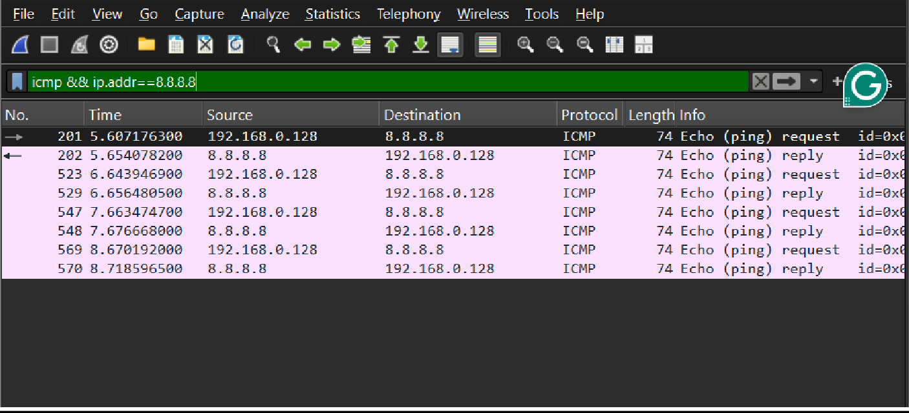
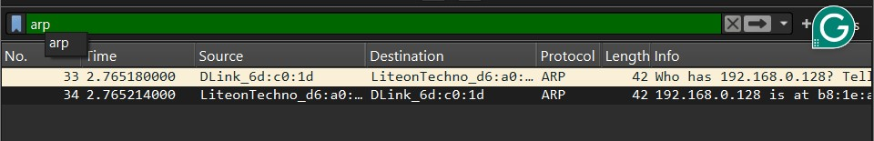

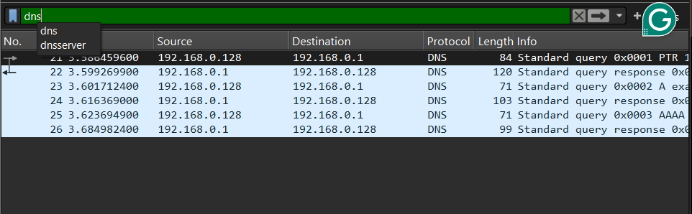
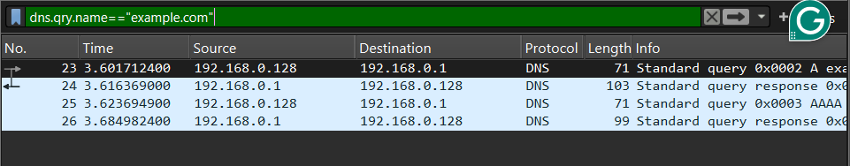
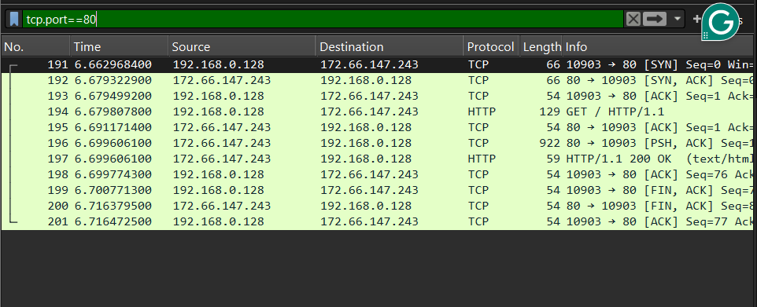

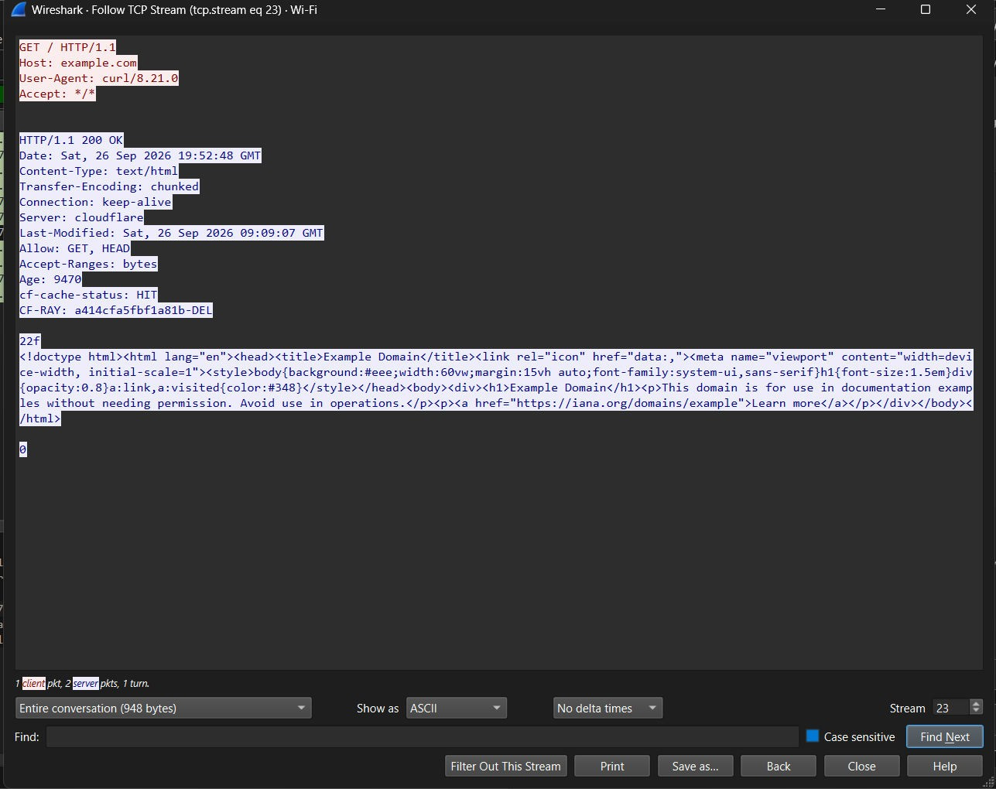
RESULT: The network packets were successfully captured and analysed using Wireshark. ICMP Echo Request/Reply, ARP Request/Reply, DNS query/response, and TCP connection packets were identified and examined using appropriate Wireshark filters. The experiment provided practical understanding of packet structure, protocol fields, addressing, and network communication.

LEARNING OUTCOMES:
After completing this experiment:
  - I understood the basic working of Wireshark and network packet capture.
  - I learned to capture and analyse ICMP, ARP, DNS, and TCP packets.
  - I learned to apply appropriate Wireshark display filters for protocol analysis.
  - I understood important packet fields such as source, destination, ports, addresses, flags, and protocol information.
  - I developed practical skills in analysing real network traffic and understanding protocol- level communication.

