

Student Name: Vishesh Aggarwal UID: 24BCY70145
Branch: AIT-CSE (Core) Section: 24AIT_KRG-G2(A)
Semester: 5 Date: 02/09/2026
Subject Name: Computer Networks Subject Code: 24CSH-337

AIM: To implement a Cisco router as a DHCP server that can automatically assign IP addresses to multiple VLANs using Router-on-a-Stick Inter-VLAN Routing in Cisco Packet Tracer.

OBJECTIVES:
- To understand the concept of VLANs.
- To create and configure multiple VLANs on a Cisco switch.
- To assign switch ports to appropriate VLANs.
- To understand the difference between Access Port and Trunk Port.
- To configure a trunk link between a switch and a router.
- To understand Inter-VLAN Routing.
- To understand the concept of Router-on-a-Stick.
- To configure router subinterfaces for multiple VLANs.
- To configure a Cisco router as a DHCP server.
- To create separate DHCP pools for different VLANs.
- To automatically assign IP addresses to PCs using DHCP.
- To verify VLAN, trunk, DHCP, and routing configurations.

SOFTWARE REQUIREMENTS:

Software:
  - Cisco Packet Tracer
  - Windows Operating System

Hardware (Virtual):
- PC-PT*4

- Cisco 2960 Switch
- Copper Straight-Through Cable
- Cisco 2911 Router

THEORY: (i) What is VLAN?
VLAN stands for Virtual Local Area Network.
A VLAN is a logical network created within a physical switch. Instead of placing every device connected to a switch into the same logical network, devices can be divided into different VLANs.

Why Do We Need VLANs?
Without VLANs, devices connected to the same Layer 2 network generally belong to the same broadcast domain.
VLANs are used for:

Problem | VLAN Solution | Benefit
Large broadcast domain | Divide network into VLANs | Reduces broadcast traffic
Difficult network segmentation | Create separate VLANs | Better organization
Security concerns | Logically separate users | Improves segmentation
Different departments | Assign different VLANs | Easier management
Large LAN | Create multiple logical networks | Better scalability

What is Inter-VLAN Routing?

Different VLANs represent separate Layer 2 networks. For example:
  - VLAN 10 → Students
  - VLAN 20 → Faculty
A Layer 2 switch cannot normally route traffic between these VLANs.
To allow communication between different VLANs, a Layer 3 device is required, such as:
  - Router
  - Layer 3 switch
The process of allowing communication between different VLANs is called Inter-VLAN Routing.
For example:
VLAN 10 → Router → VLAN 20
The router acts as the Layer 3 device responsible for routing traffic between the VLANs.

What is Router-on-a-Stick?
Router-on-a-Stick is a method of performing Inter-VLAN Routing using one physical router interface divided into multiple logical subinterfaces.
Router R1 G0/0
| Trunk
| Switch
/ \
VLAN 10 VLAN 20

The physical interface:
G0/0
can be divided into:
G0/0.10 G0/0.20
where:
- G0/0.10 handles VLAN 10
- G0/0.20 handles VLAN 20
Thus, one physical router interface can handle traffic from multiple VLANs.

What is a Subinterface?
A subinterface is a logical interface created from a physical router interface. Instead of requiring separate physical router interfaces for every VLAN: G0/0 → VLAN 10
G0/1 → VLAN 20
we can use:
G0/0.10 → VLAN 10 G0/0.20 → VLAN 20

VLAN Tagging:
When multiple VLANs travel over a trunk link, the receiving device needs to determine which VLAN an Ethernet frame belongs to.
This is achieved using VLAN tagging. The commonly used standard is:

IEEE 802.1Q
The VLAN ID contained in the tag identifies the VLAN to which the frame belongs. Command: encapsulation dot1Q 10
  - It associates the router subinterface with VLAN 10.

What is a Default Gateway?
A default gateway is the device that a host sends packets to when the destination is outside its local network.
For example:
PC1
IP Address: 192.168.10.10
Subnet Mask: 255.255.255.0
Default Gateway: 192.168.10.1
If PC1 wants to communicate with:
192.168.20.10
PC1 identifies that the destination belongs to another network and sends the packet to its default gateway:
192.168.10.1
The router then routes the packet toward VLAN 20.

What is DHCP?
DHCP stands for Dynamic Host Configuration Protocol.
DHCP automatically provides network configuration information to client devices. A DHCP server can provide:

  - IP address
  - Subnet mask
  - Default gateway
  - DNS server
  - Lease information
Without DHCP, an administrator would have to manually configure the network settings of every computer.

Why do we need DHCP?
Consider a network containing 500 computers. Manually configuring:
  - IP address
  - Subnet mask
  - Default gateway
  - DNS
for every computer would be time-consuming and error-prone. With DHCP:
PC
↓
DHCP Request
↓
DHCP Server
↓
IP Configuration Automatically Assigned

Therefore, DHCP simplifies network administration.

Can a Router Act as a DHCP Server?
Yes.
A Cisco router can be configured to act as a DHCP Server.
In this experiment, a separate dedicated DHCP server is not required. The router performs two major functions:
- Inter-VLAN Routing
- DHCP Address Allocation

- DHCP and Multiple VLANs:
We want:
VLAN 10 PCs
↓
DHCP Pool
↓ 192.168.10.x
and:
VLAN 20 PCs
↓
DHCP Pool
↓ 192.168.20.x
Therefore, the router will have separate DHCP pools for each VLAN.

DHCP Pool:
A DHCP pool defines the network from which the router allocates IP addresses. For VLAN 10:
Pool Name: VLAN10_POOL Network: 192.168.10.0/24 Gateway: 192.168.10.1
For VLAN 20:
Pool Name: VLAN20_POOL Network: 192.168.20.0/24 Gateway: 192.168.20.1 Therefore:
VLAN 10 → VLAN10_POOL VLAN 20 → VLAN20_POOL

DHCP DORA Process:
DHCP generally works using four major steps called DORA. D — Discover
The client broadcasts a DHCP Discover message asking whether a DHCP server is available. O — Offer
The DHCP server offers an available IP address to the client. R — Request
The client requests the offered IP address. A — Acknowledgment
The DHCP server confirms the IP address allocation.

DHCP Excluded Address:
Certain IP addresses should not be assigned dynamically because they may already be used by network devices.
For example, the VLAN 10 router gateway is: 192.168.10.1
Therefore, this address should be excluded from the DHCP pool. Conceptually:
192.168.10.1 → Router Gateway 192.168.10.2 → PC
      - → PC
      - → PC
...
The Cisco command used is:
ip dhcp excluded-address 192.168.10.1

STEPS/IMPLEMENTATION:
Part I – Creating the Network Topology:
- Open Cisco Packet Tracer.
- The following devices are required:
Router:
Network Devices → Routers → 2911 Switch:
Network Devices → Switches → 2960

PCs:
Select:

End Devices → PC
Place four PCs and rename them: PC1
PC2 PC3 PC4

Part II – Connecting the Devices: Use Copper Straight-Through cables.
Device | Connected To | Port
PC1 | S1 | Fa0/1
PC2 | S1 | Fa0/2
PC3 | S1 | Fa0/3
PC4 | S1 | Fa0/4
R1 | S1 | G0/0 ↔ Fa0/24

Part III- Configure VLAN 10 on Switch1:
- Open Switch1 → CLI.
- Enter the following commands: enable
configure terminal Create VLAN 10:

vlan 10

name STUDENTS exit
Create VLAN 20:

vlan 20

name FACULTY exit
The switch now contains: VLAN 10 → STUDENTS VLAN 20 → FACULTY
Part IV – Assign PC Ports to VLANs: Assign PC1 and PC2 to VLAN 10- Configure Fa0/1:
interface fa0/1 switchport mode access switchport access vlan 10

exit

Configure Fa0/2:

interface fa0/2 switchport mode access switchport access vlan 10 exit
Therefore:

PC1 → VLAN 10 PC2 → VLAN 10
Assign PC3 and PC4 to VLAN 20- Configure Fa0/3:
interface fa0/3 switchport mode access switchport access vlan 20 exit
Configure Fa0/4:

interface fa0/4 switchport mode access switchport access vlan 20 exit
Therefore:

PC3 → VLAN 20 PC4 → VLAN 20
Part V – Configure the Trunk Port: S1 Fa0/24 | TRUNK | R1 G0/0
Configure Fa0/24 as a trunk: interface fa0/24
switchport mode trunk exit
Part VI – Verify VLAN Assignment show vlan brief
The output should show:

VLAN 10 → Fa0/1, Fa0/2 VLAN 20 → Fa0/3, Fa0/4
Part VII – Verify the trunk Enter:
show interfaces trunk The output should show:
Fa0/24

as a trunk port.

Part VIII – Configure Router R1 Open:
R1 → CLI

Enter:

enable

configure terminal

First configure the physical interface: interface gigabitEthernet 0/0

no shutdown exit
Part IX – Configure VLAN 10 Subinterface Create the VLAN 10 subinterface:
interface gigabitEthernet 0/0.10 encapsulation dot1Q 10
ip address 192.168.10.1 255.255.255.0

exit

This creates the default gateway for VLAN 10: VLAN 10
Gateway: 192.168.10.1

Part X - Configure VLAN 20 Subinterface Create the VLAN 20 subinterface: interface gigabitEthernet 0/0.20 encapsulation dot1Q 20
ip address 192.168.20.1 255.255.255.0

exit

This creates the default gateway for VLAN 20:

VLAN 20

Gateway: 192.168.20.1

The router can now perform Inter-VLAN Routing between VLAN 10 and VLAN 20. Part XI - Configure DHCP for VLAN 10
First exclude the gateway address:

ip dhcp excluded-address 192.168.10.1 Create the DHCP pool:
ip dhcp pool VLAN10_POOL network 192.168.10.0 255.255.255.0
default-router 192.168.10.1 exit
The router can now allocate IP addresses from: 192.168.10.0/24
to devices in VLAN 10.

Part XII - Configure DHCP for VLAN 20 Exclude the gateway address:
ip dhcp excluded-address 192.168.20.1 Create the DHCP pool:
ip dhcp pool VLAN20_POOL network 192.168.20.0 255.255.255.0
default-router 192.168.20.1 exit
The router can now allocate IP addresses from: 192.168.20.0/24
to devices in VLAN 20.

Part XIII - Configure PCs for DHCP

Device | VLAN | Expected IP Range | Default Gateway
PC1 | VLAN 10 | 192.168.10.x | 192.168.10.1
PC2 | VLAN 10 | 192.168.10.x | 192.168.10.1
PC3 | VLAN 20 | 192.168.20.x | 192.168.20.1

PC4 | VLAN 20 | 192.168.20.x | 192.168.20.1

Part XIV – Verify Router Interfaces On R1, use:
show ip interface brief The output should show: GigabitEthernet0/0 GigabitEthernet0/0.10 GigabitEthernet0/0.20
The subinterfaces should have their respective IP addresses: G0/0.10 → 192.168.10.1
G0/0.20 → 192.168.20.1

Part XV – Verify DHCP Configuration Use:
show ip dhcp pool

This displays the configured DHCP pools.

You can also use:

show ip dhcp binding

This displays the IP addresses that have been dynamically assigned to clients. Part XVI – Test Connectivity

Test 1 – Same VLAN

From PC1, open:

Desktop → Command Prompt

Use:

ping <PC2-DHCP-IP>

Expected result:

Successful

Both PC1 and PC2 belong to VLAN 10.

Test 2 – Same VLAN 20

From PC3, use:

ping <PC4-DHCP-IP>

Expected result:

Successful

Both PC3 and PC4 belong to VLAN 20.

Test 3 – Inter-VLAN Connectivity

From a VLAN 10 PC, ping a VLAN 20 PC:

ping <PC3-DHCP-IP>

Expected result:

Successful

PROCEDURE:
- Network Topology
  - Open Cisco Packet Tracer.
  - Place one Cisco 2911 router.
  - Place one Cisco 2960 switch.
  - Place four PCs.
  - Connect the PCs to the switch.
  - Connect the switch to the router using a GigabitEthernet interface.
- VLAN Configuration
  - Create VLAN 10.

  - Create VLAN 20.
  - Assign PC1 and PC2 to VLAN 10.
  - Assign PC3 and PC4 to VLAN 20.
- Trunk Configuration
  - Configure the switch port connected to the router as a trunk.
  - Use IEEE 802.1Q VLAN tagging through router subinterfaces.
- Router-on-a-Stick Configuration
  - Enable the router's physical interface.
  - Create G0/0.10.
  - Associate it with VLAN 10.
  - Assign 192.168.10.1/24.
  - Create G0/0.20.
  - Associate it with VLAN 20.
  - Assign 192.168.20.1/24.
- DHCP Configuration:
  - Create a DHCP pool for VLAN 10.
  - Create a DHCP pool for VLAN 20.
  - Configure the appropriate networks and default gateways.
  - Exclude gateway addresses from DHCP allocation.
- PC Configuration:
  - Select DHCP in the IP Configuration window of each PC.
  - Verify that IP addresses are automatically assigned.
- Verification:
- show vlan brief
- show interfaces trunk
- show ip interface brief
- show ip dhcp pool

- show ip dhcp binding
- Connectivity Testing:
Use the ping command to test:
  - Same-VLAN communication
  - Inter-VLAN communication
  - Router gateway connectivity

INPUT/OUTPUT DETAILS:
- Devices Used
  - PC-PT × 4
  - Cisco 2960 Switch*1
  - Cisco 2911 Router*1
  - Copper Straight-Through Cable
- VLANs Used
  - VLAN 10 → Student
  - VLAN 20 → Faculty
- IP Networks Used
  - 192.168.10.0/24 → VLAN 10
  - 192.168.20.0/24 → VLAN 20
- Default Gateways
  - VLAN 10 → 192.168.10.1
  - VLAN 20 → 192.168.20.1
(d) Important Cisco IOS Commands
- VLAN Configuration: vlan 10

name STUDENTS vlan 20
name FACULTY
- Access Ports:
interface fa0/1 switchport mode access switchport access vlan 10 interface fa0/2 switchport mode access switchport access vlan 10 interface fa0/3 switchport mode access switchport access vlan 20 interface fa0/4 switchport mode access switchport access vlan 20
- Trunk:
interface fa0/24 switchport mode trunk
- Router Subinterfaces: interface gigabitEthernet 0/0.10 encapsulation dot1Q 10
ip address 192.168.10.1 255.255.255.0
interface gigabitEthernet 0/0.20

encapsulation dot1Q 20
ip address 192.168.20.1 255.255.255.0
- DHCP:
ip dhcp excluded-address 192.168.10.1 ip dhcp pool VLAN10_POOL
network 192.168.10.0 255.255.255.0
default-router 192.168.10.1
ip dhcp excluded-address 192.168.20.1 ip dhcp pool VLAN20_POOL
network 192.168.20.0 255.255.255.0
default-router 192.168.20.1

DEMONSTRATION/OUTPUT:
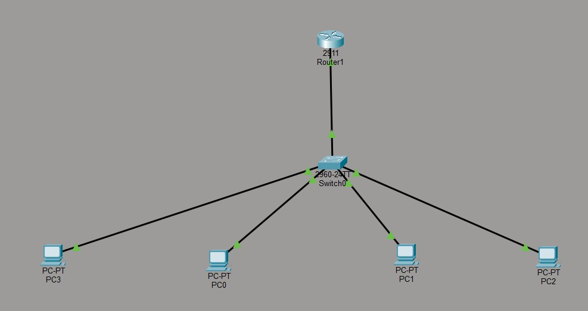

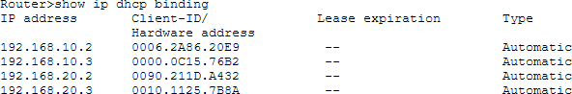
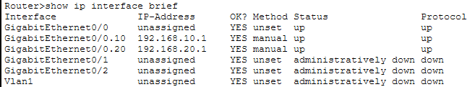
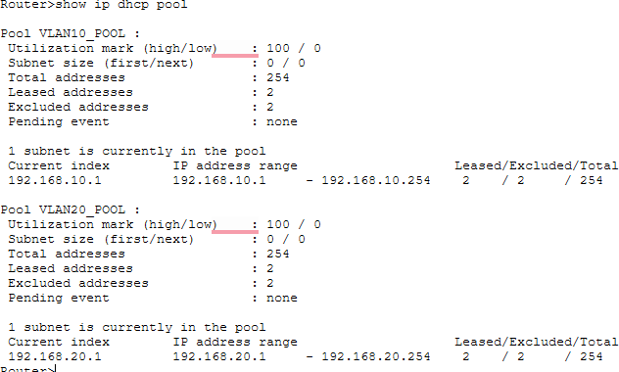

RESULT: The experiment was successfully completed in Cisco Packet Tracer. VLAN 10 and VLAN 20 were created and configured on the Cisco 2960 switch. Access ports were assigned to their respective VLANs, and the link between the switch and router was configured as a trunk.
Router-on-a-Stick Inter-VLAN Routing was implemented using router subinterfaces with IEEE 802.1Q encapsulation. The Cisco 2911 router was successfully configured as a DHCP server with separate DHCP pools for the two VLANs. PCs automatically obtained IP addresses, subnet masks, and default gateways through DHCP. Connectivity within the same VLAN and between different VLANs was successfully verified using the ping command.

LEARNING OUTCOMES:
After completing this experiment:

- I understood the concept of VLANs and their role in logically segmenting a network.
- I learned to configure VLANs, access ports, and trunk ports on a Cisco switch.
- I understood and implemented Inter-VLAN Routing using the Router-on-a-Stick method.
- I learned to configure a Cisco router as a DHCP server with separate DHCP pools for multiple VLANs.
- I developed practical skills in verifying VLAN, trunk, routing, DHCP configurations, and network connectivity using Cisco IOS commands and Cisco Packet Tracer.

