

Student Name: Vishesh Aggarwal UID: 24BCY70145
Branch: AIT-CSE (Core) Section: 24AIT_KRG-G2(A)
Semester: 5 Date: 16/09/2026
Subject Name: Computer Networks Subject Code: 24CSH-337

AIM: To implement a client-server communication system using Python UDP sockets over the IPv4 loopback interface, and to demonstrate connectionless message transmission, server responses, and termination of communication using a predefined message.

OBJECTIVES:
- To understand the basic concept of socket programming.
- To understand the client-server communication model.
- To understand the concept of connectionless communication using UDP.
- To understand the difference between TCP and UDP communication.
- To create an IPv4 UDP socket using Python's socket module.
- To configure a UDP server socket using bind().
- To send data from the client using sendto().
- To receive data at the server using recvfrom().
- To send a response from the server using sendto().
- To receive the server response at the client using recvfrom().
- To understand encoding and decoding of messages during socket communication.
- To use the localhost address 127.0.0.1 and UDP port 5000 for local communication.
- To implement a simple request-response communication system.
- To terminate communication using the predefined message "Over".
- To understand that UDP does not require connection establishment using connect(), listen(), or accept().

SOFTWARE REQUIREMENTS:

Software:

  - Python 3.x
  - Visual Studio Code
  - Windows Operating System
  - Python socket module (built-in; no external package required)

Hardware (Virtual):
  - One computer/laptop
  - Network interface with TCP/IP support
  - Local loopback interface

THEORY: (i) What is Socket Programming?
Socket programming is a method of enabling two programs to communicate over a network. A socket acts as an endpoint of communication. In a client-server model, the server creates a socket and waits for data, while the client creates a socket and sends data to the server.
In this experiment, UDP sockets are used for communication.

What is a Socket?
A socket is a software endpoint used by applications to send and receive data over a network. A socket is associated with:
  - IP address
  - Port number
  - Transport protocol
In this experiment, Python creates an IPv4 UDP socket using: socket.AF_INET
and: socket.SOCK_DGRAM Socket Parameters:

Parameter | Meaning
AF_INET | Uses IPv4 addressing.
SOCK_DGRAM | Creates a UDP datagram socket.
127.0.0.1 | IPv4 loopback/localhost address used for communication on the same computer.
5000 | UDP port on which the server receives messages.

What is UDP?
UDP (User Datagram Protocol) is a connectionless transport-layer protocol.
Unlike TCP, UDP does not establish a connection before sending data. It sends independent datagrams from one endpoint to another.
UDP provides:
  - Connectionless communication
  - Low communication overhead
  - Faster transmission
  - Datagram-based communication However, UDP does not inherently guarantee:
  - Delivery
  - Ordering
  - Retransmission
  - Duplicate protection

Client-Server Model:

The server starts first and binds its UDP socket to an IP address and port. The client then sends a datagram to the server's IP address and port. There is no connection establishment between the client and server.

Component | Main Responsibility
Server | Creates socket, binds IP/port, receives messages and sends replies.
Client | Creates socket, sends messages and receives replies.

Important UDP Socket Functions:

Function | Purpose
socket() | Creates a new socket.
bind() | Associates the server socket with an IP address and port.
sendto() | Sends data to a specified IP address and port.
recvfrom() | Receives data and the sender's address.
encode() | Converts a string into bytes.
decode() | Converts bytes into a string.
close() | Closes the socket.

- IPv4 Loopback Address:
The address 127.0.0.1 is the IPv4 loopback address. It refers to the same computer on which the program is running. Therefore, this experiment does not require two physical computers. Both the UDP server and UDP client can run on the same computer.

Port Number:
A port identifies a particular application endpoint on a host. In this experiment, TCP port 5000 is used by the server. The client connects to 127.0.0.1:5000.

Encoding and Decoding:
Socket communication works with bytes. Before sending a string: message.encode() converts the string into bytes.
For example:
message = "Hello Server" message.encode()
The receiver converts the received bytes back into a string using: data.decode()

UDP Communication and Data Flow:
The communication sequence used in this experiment is:
- Server creates an IPv4 UDP socket.
- Server binds the socket to 127.0.0.1 and port 5000.
- Server waits for a datagram using recvfrom().
- Client creates an IPv4 UDP socket.
- Client enters a message.
- Client sends the message using sendto().
- Server receives the message and client address using recvfrom().
- Server displays the message.
- Server enters a reply.
- Server sends the reply using sendto().
- Client receives the reply using recvfrom().
- Communication continues until the client sends "Over".
- Both programs close their sockets.

STEPS/IMPLEMENTATION:
Part I – Prepare the Project:
- Open Visual Studio Code.
- Open the UDP_Socket_Experiment project folder.
- Ensure that server.py and client.py are present in the project folder.
- Python 3.x should be installed and available in the VS Code terminal. Part II – Server Program:
- Open server.py.
- Import the socket module.
- Create an IPv4 UDP socket.
- Bind the socket to 127.0.0.1 and port 5000.
- Display the server status.
- Wait for incoming datagrams using recvfrom(1024).
- Decode the received bytes.
- Display the client message.
- Check whether the received message is "Over".
- If it is not "Over", enter a reply.
- Send the reply using sendto().
- Repeat the process.
- Close the server socket after receiving "Over".
--- server.py--- import socket
# Creating a UDP Socket
server_socket = socket.socket(socket.AF_INET, socket.SOCK_DGRAM)

# Bind the socket to localhost and port 5000 server_socket.bind(("127.0.0.1", 5000)) print("UDP Server started")
print("Waiting for messages...") while True:
message, client_address = server_socket.recvfrom(1024) message = message.decode()
print("Client:", message) if message == "Over":
break
reply = input("Enter reply: ") server_socket.sendto(reply.encode(), client_address)
server_socket.close() print("Server closed")

Part III- Client Program:
- Open client.py.
- Import the socket module.
- Create an IPv4 UDP socket.
- Define the server address as 127.0.0.1:5000.
- Enter a message from the user.
- Encode the message into bytes.
- Send the message using sendto().
- If the message is "Over", terminate the loop.

- Otherwise, receive the server response using recvfrom().
- Decode and display the server response.
- Repeat the process.
- Close the client socket.
---client.py--- import socket
client_socket = socket.socket(socket.AF_INET, socket.SOCK_DGRAM) server_address = ("127.0.0.1", 5000)
print("UDP Client started") while True:
message = input("Enter message: ") client_socket.sendto(message.encode(), server_address) if message == "Over":
break
reply, server_address_received = client_socket.recvfrom(1024) print("Server:", reply.decode())
client_socket.close() print("Client closed")

PROCEDURE:
- Network Setup:
  - Open Visual Studio Code.
  - Open the UDP_Socket_Experiment project.
  - Verify that server.py and client.py are available.
  - Open the integrated terminal.

- Server Configuration:
  - Create an IPv4 UDP socket.
  - Bind the socket to 127.0.0.1:5000.
  - Wait for incoming datagrams using recvfrom(). 3.Client Configuration:
  - Create an IPv4 UDP socket.
  - Set the server address to 127.0.0.1:5000.
  - Send the message using sendto().
- Data Communication:
  - Enter a message on the client.
  - Send the message to the server.
  - Server receives the message.
  - Server displays the message.
  - Server enters a reply.
  - Server sends the reply to the client.
  - Client receives and displays the reply.

- Connection Termination:
- Enter "Over" on the client.
- The client sends "Over" to the server.
- The server receives "Over".
- The server exits its loop.
- Both sockets are closed.

INPUT/OUTPUT DETAILS:
- Communication Parameters:

Parameter | Value
Communication Model | Client-Server
Transport Protocol | UDP

Address Family | IPv4
Server IP | 127.0.0.1
Server Port | 5000
Client | client.py
Server | server.py
Buffer Size | 1024 bytes
Communication Type | Connectionless
Socket Type | SOCK_DGRM
Termination Message | Over

- Sample Message Exchange:

Step | Client | Server
1 | Starts UDP client | Starts UDP server
2 | Sends Hello Server | Receives: Hello Server
3 | Waits for response | Sends: Hello Client
4 | Displays: Server: Hello Client | Waits for next datagram
5 | Sends: How are you? | Receives: How are you?
6 | Waits for response | Sends: I am fine
7 | Displays Server: I am fine | Waits for next datagram
8 | Sends: Over | Receives Over and terminates

COMMANDS: - Create UDP Socket socket.socket(socket.AF_INET, socket.SOCK_DGRAM)

- Bind server server_socket.bind(("127.0.0.1", 5000))
- Receive UDP datagram
message, client_address = server_socket.recvfrom(1024)
- Send UDP datagram server_socket.sendto(reply.encode(), client_address)
- Client sends message client_socket.sendto(message.encode(), server_address)
- Client receives response
reply, server_address_received = client_socket.recvfrom(1024)
- Close socket client_socket.close()

TCP V/S UDP:

Feature | TCP | UDP
Connection | Connection-oriented | Connectionless
Socket Type | SOCK_STREAM | SOCK_DGRAM
listen() | Required for server | Not required
accept() | Required | Not required
connect() | Used by client | Not required here
Sending | send() | sendto()
Receiving | recv() | recvfrom()
Reliability | Reliable | No delivery guarantee

Ordering | Ordered | No ordering guarantee
Overhead | Higher | Lower
Data Unit | Byte stream | Datagram

DEMONSTRATION/OUTPUT:
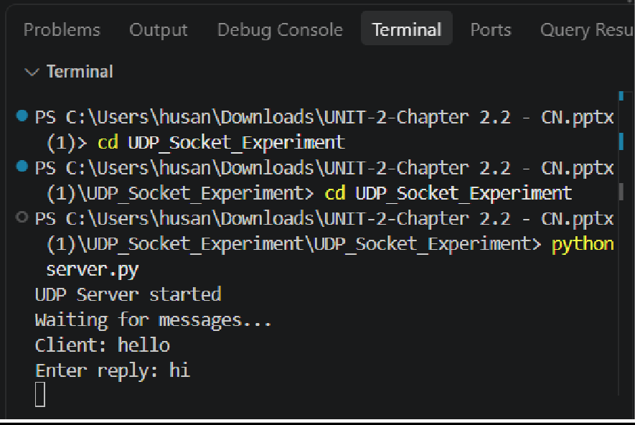
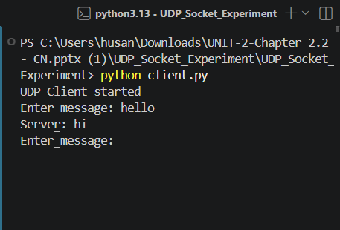

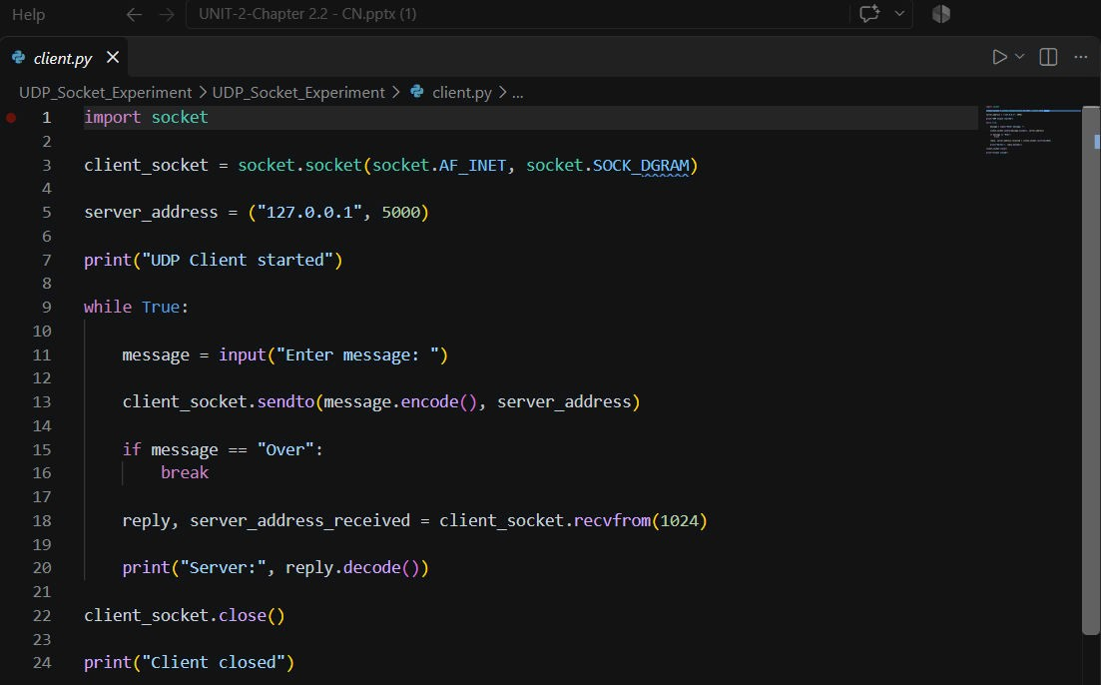
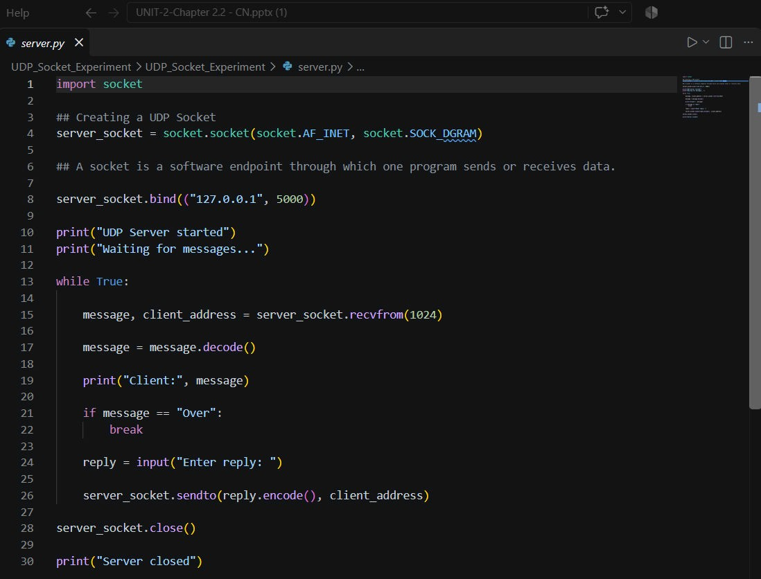

RESULT: The experiment was successfully implemented using Python UDP socket programming. An IPv4 UDP server was created and bound to 127.0.0.1:5000, while the client sent datagrams to the server using sendto().
The server received client messages using recvfrom() and sent responses back to the client using sendto(). String encoding and decoding were used for byte-based socket communication.
The experiment demonstrated connectionless communication using UDP, without using listen(), accept(), or a TCP-style connection establishment process. The communication was terminated using the "Over" message, followed by proper socket closure.

LEARNING OUTCOMES:
After completing this experiment:
- I understood the client-server model and the role of UDP sockets in network communication.
- I learned to create and configure IPv4 UDP sockets using Python's socket module.
- I learned the use of bind(), sendto(), recvfrom(), and close() for UDP communication.
- I understood the difference between connection-oriented TCP and connectionless UDP communication.
- I developed practical skills in implementing and testing UDP client-server communication using localhost and a UDP port.

