Student Name: Vishesh Aggarwal UID: 24BCY70145
Branch: AIT-CSE (Cybersecurity) Section/Group: 24AIT_KRG-G2
Semester: 4
Subject Name: Database Management System Subject Code: 24CSH-298

Experiment 4 – Data Analysis Using SQL and PL/SQL
Experiment
Experiment 4: Creating tables, inserting data, performing conditional queries, and using PL/SQL blocks to analyze schema violations and student grades. This experiment demonstrates table creation, updates, conditional logic, and ordering in Oracle SQL and PL/SQL.
Aim
The aim of this experiment is to practice working with Oracle SQL tables, using conditional logic to determine status and grades, and displaying results using SELECT queries and PL/SQL blocks.
Objective
- To create and populate tables in Oracle SQL.
- To use CASE statements for conditional evaluation of violation counts and student grades.
- To add and update columns based on conditions.
- To use PL/SQL anonymous blocks for status messages.
- To sort query results based on defined criteria.
Software Requirements
- Database: Oracle XE or Oracle Live SQL
Practical / Experiment Steps
- Create a table schema_violations with columns id, schema_name, and violation_count.
- Insert data for various departments into the schema_violations table.
- Select violation status for each department using a CASE statement.
- Add a new column approval_status to schema_violations.
- Update approval_status based on violation count using a CASE statement.
- Display the updated schema_violations table.
- Execute a PL/SQL block to print a system status message based on a variable v_count.
- Create a students table with columns name and marks.
- Insert student data into the students table.
- Display student grades using a CASE statement based on marks.
- Order schema_violations by severity using a CASE statement in ORDER BY.
Procedure of the Experiment
- Open Oracle XE or Live SQL and connect to the database.
- Create the schema_violations and students tables.
- Insert sample data into both tables.
- Execute SELECT queries with CASE statements to analyze violation and grade data.
- Alter and update tables using conditional logic.
- Write and execute a PL/SQL anonymous block for dynamic status messages.
- Sort and retrieve data based on defined severity.
- Observe outputs at each step and take screenshots for documentation.
Input / Output Details
Input
- schema_violations table: id, schema_name, violation_count
- students table: name, marks
- PL/SQL block variable: v_count
- Conditional logic in SELECT and UPDATE statements

Step-wise Output
Step 1 – Create schema_violations table
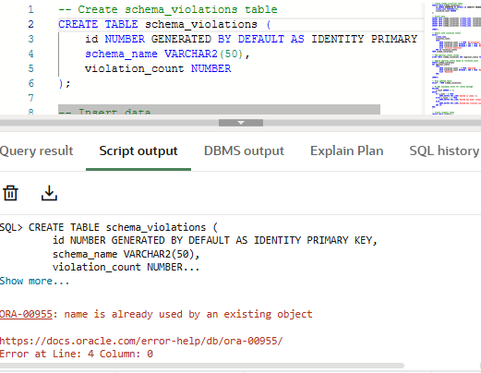
Step 2 – Insert data into schema_violations
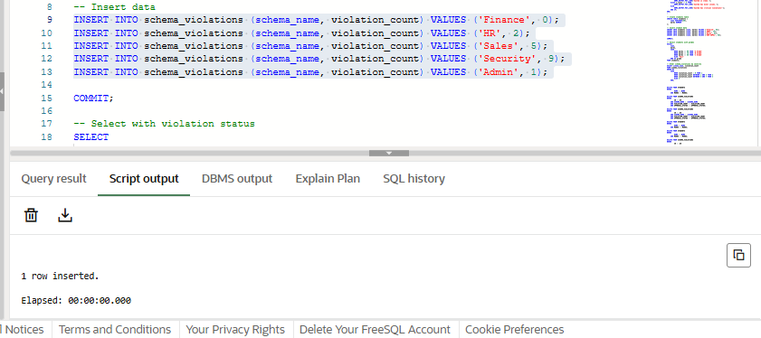
Step 3 – Violation status of each department
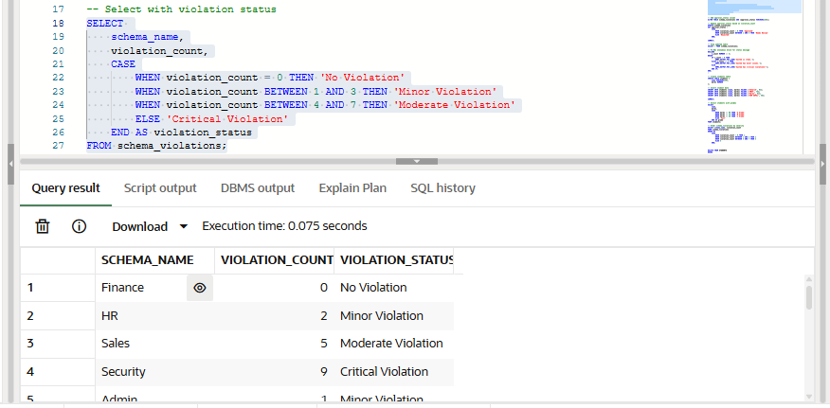
schema_name | violation_count | violation_status
Finance | 0 | No Violation
HR | 2 | Minor Violation
Sales | 5 | Moderate Violation
Security | 9 | Critical Violation
Admin | 1 | Minor Violation
Step 4 – Add approval_status column
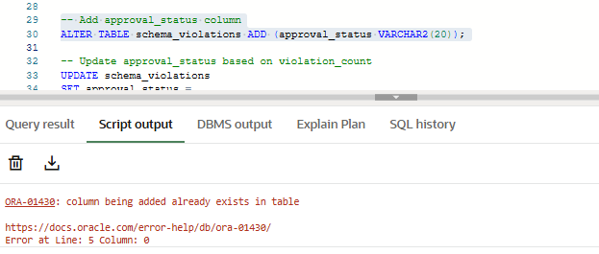Step 5 – Update approval_status based on violation_count
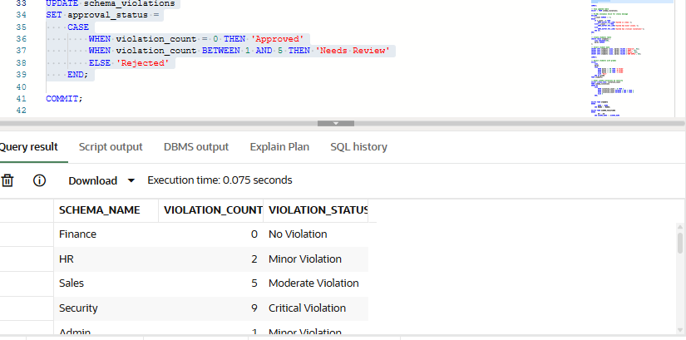
Step 6 – View updated schema_violations table
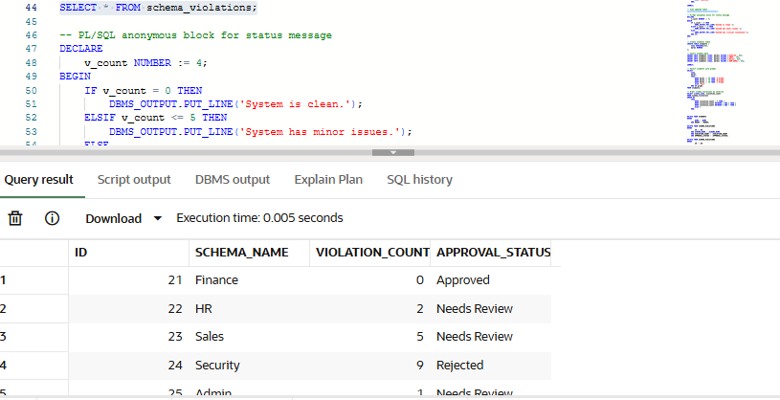
id | schema_name | violation_count | violation_status | approval_status
1 | Finance | 0 | No Violation | Approved
2 | HR | 2 | Minor Violation | Needs Review
3 | Sales | 5 | Moderate Violation | Needs Review
4 | Security | 9 | Critical Violation | Rejected
5 | Admin | 1 | Minor Violation | Needs Review
Step 7 – PL/SQL anonymous block for status message
Screenshot: s7.png
Output:
System has minor issues.
Step 8 – Create students table
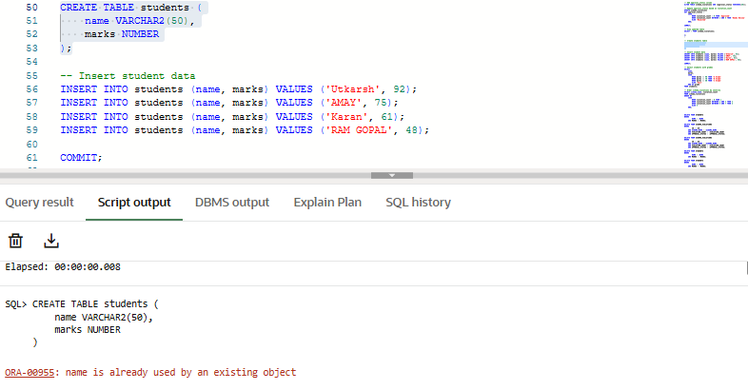
Step 9 – Insert student data
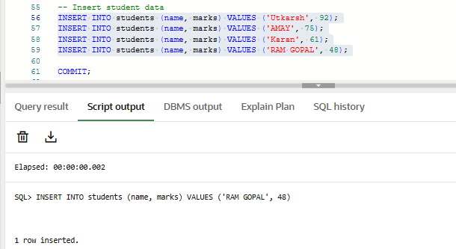Step 10 – Student grades using CASE statement
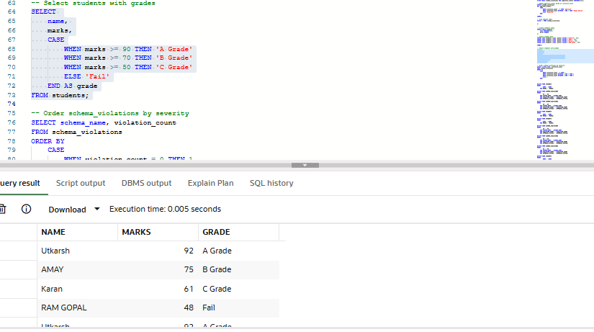
name | marks | grade
Vishesh | 92 | A Grade
Shreya | 75 | B Grade
Navneet | 61 | C Grade
RAM | 48 | Fail
Step 11 – Schema violations ordered by severity
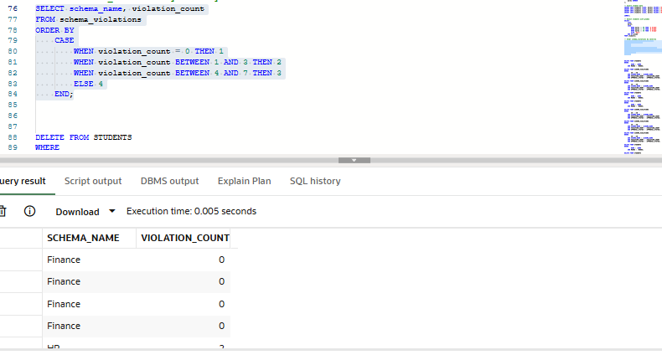
schema_name | violation_count
Finance | 0
HR | 2
Admin | 1
Sales | 5
Security | 9

Learning Outcome
After completing this experiment, the student will be able to:
- Create and populate tables in Oracle SQL.
- Use CASE statements to evaluate conditions in queries.
- Update table data based on conditional logic.
- Write PL/SQL blocks for dynamic status messages.
- Sort query results using CASE statements in ORDER BY.
- Analyze data and assign grades or approval statuses automatically.
- Interpret step-wise outputs for better understanding of database operations.

