

MULTI-STEP SIGNIFICANT WAVE HEIGHT FORECASTING IN THE BAY OF BENGAL USING HYBRID MACHINE LEARNING AND DEEP LEARNING FRAMEWORKS
Vishesh Bhagwandas Agarwal

MULTI-STEP SIGNIFICANT WAVE HEIGHT FORECASTING IN THE BAY OF BENGAL USING HYBRID MACHINE LEARNING AND DEEP LEARNING FRAMEWORKS
Report submitted to
Indian Institute of Technology Kharagpur
for the award of the degree
of
Dual Degree (Bachelor of Technology and Master of Technology)
in Ocean Engineering and Naval Architecture
by
Vishesh Bhagwandas Agarwal (22NA30045)
under the guidance of
Professor Swapnadip De Chowdhury
DEPARTMENT OF OCEAN ENGINEERING
AND NAVAL ARCHITECTURE
INDIAN INSTITUTE OF TECHNOLOGY KHARAGPUR
November 2026
© 2026 Vishesh Bhagwandas Agarwal. All rights reserved.
DECLARATION
I certify that
(a) The work contained in this report is original and has been done by me under the guidance of my supervisor.
(b) The work has not been submitted to any other Institute for any degree or diploma.
(c) I have followed the guidelines provided by the Institute in preparing the report.
(d) I have conformed to the norms and guidelines given in the Ethical Code of Conduct of the Institute.
(e) Whenever I have used materials (data, theoretical analysis, figures, and text) from other sources, I have given due credit to them by citing them in the text of the report and giving their details in the references. The ERA5 reanalysis data used in this work were produced by ECMWF and are distributed by the Copernicus Climate Change Service under the Creative Commons Attribution 4.0 licence, which permits reuse with attribution.
Signature of the Student
Vishesh Bhagwandas Agarwal (22NA30045)
Date: 10/11/2026 Place: Kharagpur
CERTIFICATE
This is to certify that the project report entitled “Multi-Step Significant Wave Height Forecasting in the Bay of Bengal Using Hybrid Machine Learning and Deep Learning Frameworks” submitted by Vishesh Bhagwandas Agarwal (22NA30045) to Indian Institute of Technology Kharagpur, India, is a record of bona fide project work carried out under my supervision and guidance, and is worthy of consideration for the award of the degree of Dual Degree (Bachelor of Technology and Master of Technology) in Ocean Engineering and Naval Architecture of the Institute.
______________________
Professor Swapnadip De Chowdhury
Department of Ocean Engineering and Naval Architecture
Indian Institute of Technology Kharagpur
Date: 10/11/2026
ACKNOWLEDGEMENTS
I am deeply grateful to my supervisor, Professor Swapnadip De Chowdhury, Department of Ocean Engineering and Naval Architecture, IIT Kharagpur, for the guidance, encouragement and critical questions that shaped this work.
I thank the faculty and staff of the Department of Ocean Engineering and Naval Architecture for the courses and facilities that made this project possible, and the members of the evaluation panel for their time and feedback.
This work would not have been possible without open data. I thank the European Centre for Medium-Range Weather Forecasts and the Copernicus Climate Change Service for the ERA5 reanalysis, INCOIS for the OMNI buoy programme, and the developers of the open-source Python libraries used throughout: pandas, NumPy, xarray, SciPy, statsmodels, scikit-learn, LightGBM, CatBoost, XGBoost, Optuna, TensorFlow/Keras and Matplotlib.
Finally, I thank my family and friends for their constant support.
Vishesh Bhagwandas Agarwal
IIT Kharagpur, November 2026
ABSTRACT
Accurate forecasts of significant wave height (H_{s}) 6 to 72 hours ahead are essential for marine safety in the Bay of Bengal, where tropical cyclones raise H_{s} from 1–2 m to more than 10 m within a day. This report develops a data-driven alternative to numerical wave models and compares classical, tree-based and deep-learning forecasters under a strictly leakage-free protocol. Ten years (2015–2024) of hourly ECMWF ERA5 data at the positions of the INCOIS OMNI buoys BD08, BD10 and BD11 were aligned with a KD-tree on the sphere and enriched with physically based predictors: wind stress, pressure tendency and anomaly, the air–sea temperature difference and cyclically encoded directions. Direct multi-step LightGBM and CatBoost models, tuned by Bayesian optimisation on a pooled multi-horizon RMSE, and an encoder–decoder bidirectional LSTM with attention were trained on 2015–2020 and tested on 2023–2024, a period containing cyclones Mocha, Michaung, Remal and Dana; every model was scored on the same forecast origins. With ERA5 H_{s} as the target, the best learned model reduced the test RMSE of persistence by 18% at 24 h (CatBoost, 0.247 m) and by 23% at 72 h (LightGBM, 0.419 m), and the ARIMA baseline by 15% and 23% respectively. A peak-weighted asymmetric loss lowered the share of under-predicted extreme sea states (above the training 95th percentile) at 24 h from 72% to 55%, at a cost of 14% in overall RMSE. All forecasters lose skill at long lead times during cyclones, which points to forecast forcing as the next step. The pipeline is ready to take the buoy observations as the target once they are available.
Keywords: significant wave height; multi-step forecasting; Bay of Bengal; tropical cyclones; ERA5; gradient boosting; LightGBM; CatBoost; sequence-to-sequence LSTM; attention; peak-weighted loss
CONTENTS
Declaration 0
Certificate by the Supervisor 0
Acknowledgements 0
Abstract 0
Contents 0
List of Figures 0
List of Tables 0
List of Symbols and Abbreviations 0
Chapter 1: Introduction 0
1.1 Background 0
1.2 Problem statement 0
1.3 Objectives 0
1.4 Scope and contributions 0
1.5 Organisation of the report 0
Chapter 2: Literature Review 0
2.1 Numerical wave models and reanalyses 0
2.2 Data-driven wave forecasting 0
2.3 Multi-step strategies and verification 0
2.4 Research gap 0
Chapter 3: Study Area and Data 0
3.1 The Bay of Bengal and the buoy sites 0
3.2 ERA5 reanalysis 0
3.3 INCOIS OMNI buoy data 0
Chapter 4: Methodology 0
4.1 Phase 1: ingestion, quality control and alignment 0
4.1.1 Quality control and regularisation 0
4.1.2 Gap filling 0
4.1.3 Spatial alignment 0
4.2 Phase 2: feature engineering 0
4.3 Forecasting strategy and sample generation 0
4.3.1 Chronological blocks without leakage 0
4.4 Phase 3a: reference forecasts 0
4.5 Phase 3b: direct multi-step gradient boosting 0
4.6 Phase 4: Seq2Seq LSTM with attention 0
4.6.1 Peak-weighted loss 0
4.7 Phase 5: verification 0
Chapter 5: Results and Discussion 0
5.1 Overall accuracy by lead time 0
5.2 Statistical significance 0
5.3 Forecasts over a continuous month 0
5.4 Performance during tropical cyclones 0
5.5 Effect of the peak-weighted loss 0
5.6 What the tree models learned 0
5.7 Trees versus the Seq2Seq LSTM 0
5.8 LSTM sensitivity 0
5.9 Limitations 0
Chapter 6: Conclusions and Future Work 0
6.1 Conclusions 0
6.2 Future work 0
References 0
Appendix A: Hyperparameter Search Spaces and Selected Values 0
Appendix B: Software and Reproducibility 0
LIST OF FIGURES
Figure 3.1 ERA5 significant wave height at the three sites, 2015–2024 9
Figure 3.2 Monthly distribution of Hs at the three sites (median and 5–95 % range) 9
Figure 4.1 Methodology: the five phases of the forecasting framework 11
Figure 4.2 Architecture of the Seq2Seq Bi-LSTM forecaster with attention 17
Figure 5.1 Test RMSE against lead time at the three sites 20
Figure 5.2 Skill relative to persistence, SS = 1 − RMSE/RMSEpers 21
Figure 5.3 Test RMSE of ARIMA, the tree models and the LSTMs at 24 h and 72 h 23
Figure 5.4 Forecast against observed Hs at 24 h at BD08 23
Figure 5.5 Forecasts at BD08 over a 30-day test window 25
Figure 5.6 Forecasts during cyclone Mocha at BD08, at 24 h and 72 h 26
Figure 5.7 Forecasts during cyclone Michaung at BD11, at 24 h and 72 h 27
Figure 5.8 Mean error and under-prediction rate on extreme sea states 28
Figure 5.9 CatBoost feature importance at 6 h and 72 h 29
Figure 5.10 Training and early-stopping loss of the two LSTM variants at BD08 30
LIST OF TABLES
Table 3.1 Buoy sites and the ERA5 nodes matched to them 6
Table 3.2 ERA5 variables, units and native grid 7
Table 3.3 Statistics of ERA5 at the buoy sites, 2015–2024 7
Table 3.4 Largest wave events at each site 8
Table 4.1 Engineered features 13
Table 4.2 Chronological blocks 14
Table 5.1 Test RMSE (m) at BD08, 2023–2024 19
Table 5.2 Test RMSE (m) at BD10, 2023–2024 20
Table 5.3 Test RMSE (m) at BD11, 2023–2024 20
Table 5.4 Skill score relative to persistence, mean over the three sites 21
Table 5.5 Coefficient of determination R², mean over the three sites 22
Table 5.6 Scatter index SI = RMSE / mean observation, mean over the three sites 22
Table 5.7 Diebold–Mariano p-values against the best model at each site and lead time 24
Table 5.8 RMSE and mean error inside the cyclone windows of 2023–2024 26
Table 5.9 Scores on extreme sea states (observed Hs ≥ q95), all sites 28
Table 5.10 LSTM (MSE) sensitivity to training settings at BD08 30
Table A.1 Optuna search spaces (ranges sampled on a log scale are marked “log”) 36
Table A.2 Selected hyperparameters and boosting rounds per horizon 36
LIST OF SYMBOLS AND ABBREVIATIONS
Symbol | Description | Unit
H_{s} | Significant wave height | m
T_{m} | Mean wave period | s
θ_{w} | Mean wave direction (coming from) | °
u₁₀, v₁₀ | Eastward and northward wind components at 10 m | m/s
U₁₀ | Wind speed at 10 m | m/s
θ_{U} | Wind direction (coming from) | °
p | Mean sea-level pressure | hPa
T_{2m} | Air temperature at 2 m | °C
SST | Sea surface temperature | °C
ρ_{a} | Air density | kg/m³
C_{d} | Drag coefficient at 10 m | –
τ | Surface wind stress | N/m²
L₀ | Deep-water wavelength, gT²/2π | m
g | Gravitational acceleration (9.81) | m/s²
R_{d} | Specific gas constant of dry air (287.05) | J/(kg·K)
h | Forecast lead time (horizon) | h
L | Look-back window length | h
t | Forecast origin | –
q | Extreme-sea-state threshold (95th percentile) | m
β, γ | Extra weights of the peak-weighted loss | –
τ_{s} | Width of the sigmoid in the peak-weighted loss | m
SS | Skill score relative to persistence | –
ABBREVIATIONS
Abbreviation | Meaning
ARIMA | Autoregressive integrated moving average
BoB | Bay of Bengal
Bi-LSTM | Bidirectional long short-term memory network
CC | Correlation coefficient
CDS | Copernicus Climate Data Store
DM | Diebold–Mariano test
DMS | Direct multi-step (forecasting strategy)
ECMWF | European Centre for Medium-Range Weather Forecasts
ERA5 | Fifth-generation ECMWF atmospheric reanalysis
GBDT | Gradient-boosted decision trees
IMD | India Meteorological Department
INCOIS | Indian National Centre for Ocean Information Services
LSTM | Long short-term memory network
MAE | Mean absolute error
MSE | Mean squared error
MSLP | Mean sea-level pressure
NWP | Numerical weather prediction
OMNI | Ocean Moored buoy Network for the northern Indian Ocean
RMSE | Root-mean-square error
Seq2Seq | Sequence-to-sequence (encoder–decoder)
SI | Scatter index
SST | Sea surface temperature
TPE | Tree-structured Parzen estimator
WAM | Wave Model (third-generation spectral model)

CHAPTER 1
Introduction

1.1 Background
The Bay of Bengal is a semi-enclosed basin of the north-eastern Indian Ocean bounded by India, Bangladesh, Myanmar and Sri Lanka. Its sea state is governed by the reversing monsoon: south-westerly winds from June to September generate a persistent wind sea and long-period swell, while weaker north-easterlies prevail from November to February. Superimposed on this seasonal cycle are tropical cyclones, which form mainly in the pre-monsoon (April–May) and post-monsoon (October–December) seasons and raise the significant wave height from about 1–2 m to more than 8–10 m within one or two days [1]. The coasts that surround the bay are among the most densely populated in the world, and its ports, fishing fleets, offshore oil and gas installations and coastal communities all depend on timely warnings of hazardous seas.
The significant wave height H_{s}, defined as four times the square root of the zeroth moment of the wave spectrum and close to the mean height of the highest third of the waves [2], is the single most widely used descriptor of the sea state. Operational forecasts of H_{s} are produced by third-generation spectral wave models such as WAM [3] and WAVEWATCH III [4], which integrate the wave action balance equation forced by numerical weather prediction (NWP) winds. These models are physically complete but computationally expensive: a basin-scale ensemble run needs a supercomputer, a high-quality wind forcing and a long chain of pre- and post-processing. For an operator who needs a forecast at a fixed location, for example a mooring, a port approach or an offshore platform, a data-driven model that maps recent observations and forcing to future H_{s} can be orders of magnitude cheaper to run and can be retrained as new data arrive.

1.2 Problem statement
Forecasting H_{s} at a point 6 to 72 hours ahead is a multi-step time-series problem. The simplest approach trains a one-step model and feeds its own predictions back as inputs to reach longer lead times (the recursive strategy). Errors then accumulate with every step, and the model is never trained on the inputs it receives at long lead times [5]. A sounder approach is the direct multi-step (DMS) strategy, in which a separate mapping is learned for every lead time, or a sequence-to-sequence network that emits all lead times jointly without feedback. A second difficulty is that the most important forecasts are the rarest: tropical cyclones make up a small fraction of any record, and a model that minimises the mean squared error over all samples tends to under-predict exactly the peaks that matter for safety. A third is information leakage: sliding windows over an autocorrelated series make it easy to let future values reach the training set, which inflates every reported skill score. This thesis addresses all three.

1.3 Objectives
1. To build a reproducible, leakage-free pipeline that ingests ECMWF ERA5 reanalysis and INCOIS OMNI buoy data, aligns them in space and time and engineers physically meaningful predictors (wind stress, pressure tendency, air–sea temperature difference, cyclically encoded directions).
2. To forecast H_{s} at lead times of 6, 12, 24, 48 and 72 h with direct multi-step gradient-boosted trees (LightGBM, CatBoost) tuned by Bayesian optimisation on a multi-horizon objective.
3. To design an encoder–decoder (sequence-to-sequence) bidirectional LSTM with attention for the same task, and a peak-weighted loss that penalises under-prediction during extreme sea states.
4. To compare all models against persistence, climatology and ARIMA on an unseen test period (2023–2024) that contains several tropical cyclones, using common samples, standard wave-verification metrics and formal significance tests.

1.4 Scope and contributions
The study covers ten years (2015–2024) of hourly data at the positions of three OMNI moored buoys, BD08, BD10 and BD11, which sample the northern, central and south-western bay. Because the INCOIS buoy records had not been received when the experiments were run, all models in this report are trained and verified against ERA5 significant wave height at the buoy positions. The pipeline is written so that the buoy record can replace the ERA5 target without code changes, and Section 5.9 discusses what this choice implies. The main contributions are:
- A leakage-free windowing and splitting scheme in which every sample's inputs and all of its targets lie inside one chronological block, verified by automated tests.
- A fair, common-sample comparison of classical, tree-based and deep-learning forecasters at five lead times and three locations, including skill during the named cyclones of the test period.
- A peak-weighted asymmetric loss for the Seq2Seq LSTM, evaluated against an otherwise identical network trained with the mean squared error.
- An open, modular Python implementation with 44 automated tests, from which every table and figure in this report is regenerated.

1.5 Organisation of the report
Chapter 2 reviews numerical and data-driven wave forecasting. Chapter 3 describes the study area, the ERA5 and buoy data, and the preprocessing. Chapter 4 presents the feature engineering, the forecasting strategy, the models and the verification framework. Chapter 5 reports and discusses the results, and Chapter 6 draws the conclusions and outlines future work.

CHAPTER 2
Literature Review

2.1 Numerical wave models and reanalyses
Third-generation spectral models solve the action balance equation for the directional wave spectrum, with source terms for wind input, non-linear four-wave interactions and whitecapping dissipation [2]. WAM introduced this approach for global forecasting [3], and WAVEWATCH III extended it with improved physics and numerics [4]. Their skill is limited mainly by the quality of the forcing winds, particularly inside tropical cyclones where the wind field is poorly resolved.
Reanalyses combine such a model with data assimilation over decades. ERA5, the fifth-generation ECMWF reanalysis, couples the IFS atmospheric model with WAM, assimilates satellite altimeter wave heights, and provides hourly fields from 1940 to the present: atmospheric variables on a 0.25° grid and wave variables on a 0.5° grid [6]. Its homogeneous, gap-free record makes it the standard training source for data-driven models where in-situ data are short or interrupted.

2.2 Data-driven wave forecasting
Neural networks were applied to wave forecasting from the late 1990s. Deo and Naidu forecast wave heights from preceding observations with a feed-forward network [7], and Deo et al. showed that networks driven by wind inputs can match empirical and numerical approaches at short lead times [8]. Londhe and Panchang extended point forecasts to 24 h with buoy data off the United States coast [9], and Mandal and Prabaharan used recurrent networks to capture the temporal dependence of the wave record [10]. Long short-term memory (LSTM) networks [11], whose gated memory cells mitigate the vanishing-gradient problem of simple recurrent networks, have since become the default deep-learning model for H_{s} series; Fan et al. reported clear gains of LSTM over conventional networks for multi-hour forecasts [12].
Sequence-to-sequence (Seq2Seq) encoder–decoder networks [13] map an input sequence to an output sequence of different length and are a natural fit for multi-horizon forecasting. Bidirectional encoders read the history in both directions [14], and attention mechanisms let each output step weigh the relevant part of the input [15]. In parallel, gradient-boosted decision trees [16], in their modern implementations XGBoost [17], LightGBM [18] and CatBoost [19], have become the strongest general-purpose learners for tabular data. They need little preprocessing, handle heterogeneous predictors and are fast to train, and they can be applied to time series through lagged features.

2.3 Multi-step strategies and verification
Ben Taieb et al. compared recursive, direct and multiple-output strategies and found that direct and multiple-output approaches avoid the error accumulation of recursion at long horizons [5]. For verification, the wave-modelling community reports RMSE, bias, correlation and the scatter index; Mentaschi et al. showed that RMSE-based indices can favour models that under-predict variability, and recommended reporting bias-removed measures alongside them [20]. Differences between forecasters evaluated on the same sample should be tested for significance, for which the Diebold–Mariano test [21] with the small-sample correction of Harvey et al. [22] is the standard tool.

2.4 Research gap
Three gaps motivate this work. First, most data-driven studies forecast one lead time or use recursion, and few compare direct multi-step trees with Seq2Seq networks on identical samples. Second, published skill scores rarely document how look-ahead bias was excluded, although overlapping windows make leakage easy. Third, models are usually trained with a symmetric loss and scored on all samples, so their behaviour in cyclones, the cases of greatest consequence in the Bay of Bengal, is seldom examined separately. This thesis addresses each of these.

CHAPTER 3
Study Area and Data

3.1 The Bay of Bengal and the buoy sites
The study area is the Bay of Bengal between 4° and 23° N and 79° and 100° E. Three sites of the INCOIS Ocean Moored buoy Network for the northern Indian Ocean (OMNI) [23] were selected to sample different wave regimes: BD08 in the northern bay, on the track of most cyclones that recurve towards Odisha, West Bengal, Bangladesh and Myanmar; BD10 in the central bay; and BD11 in the south-western bay off the Andhra Pradesh and Tamil Nadu coasts, which is exposed to post-monsoon cyclones that move west. Table 3.1 lists their nominal positions and the ERA5 grid nodes matched to them (Section 4.1.3).
Table 3.1: Buoy sites and the ERA5 nodes matched to them (distance from the buoy in brackets)
Buoy | Region | Nominal position | Atmospheric node (0.25°) | Wave node (0.5°)
BD08 | northern bay | 18.15 N, 89.67 E | 18.25 N, 89.75 E (14 km) | 18.00 N, 89.50 E (25 km)
BD10 | central bay | 16.32 N, 87.98 E | 16.25 N, 88.00 E (8 km) | 16.50 N, 88.00 E (20 km)
BD11 | south-western bay | 13.58 N, 84.11 E | 13.50 N, 84.00 E (15 km) | 13.50 N, 84.00 E (15 km)

3.2 ERA5 reanalysis
ERA5 [6] supplies hourly fields of the variables in Table 3.2 for 1 January 2015 to 31 December 2024, i.e. 87,672 hours at every site. The data were retrieved from the Copernicus Climate Data Store (CDS) through its time-series service [24], which serves the same reanalysis values as the gridded product for a box of at most 2° × 2° over any period. One request per buoy (a 1.5° × 1.5° box) replaced the 60 two-month requests that the size limit of the gridded product would have required; the values were checked to agree with the gridded download for January 2015 to within 0.0002 in every variable. Every series is complete: there are no missing hours in the ten years at any site.
Table 3.2: ERA5 variables used, their units (as delivered → as used) and native grid
Symbol | Variable | Units | Grid
u₁₀, v₁₀ | 10 m wind components | m/s | 0.25°
T_{2m} | 2 m air temperature | K → °C | 0.25°
MSLP | Mean sea-level pressure | Pa → hPa | 0.25°
SST | Sea surface temperature | K → °C | 0.25°
H_{s} | Significant height of combined wind waves and swell | m | 0.5°
θ_{w} | Mean wave direction (coming from) | ° | 0.5°
T_{m} | Mean wave period | s | 0.5°

Summary statistics are given in Table 3.3. Mean H_{s} is about 1.5 m at all three sites, but the tails differ: H_{s} exceeded 10 m at BD10 during cyclone Amphan (2020) and at BD08 during Yaas (2021), while the maximum at BD11 is about 7 m. The seasonal cycle (Figure 3.2) peaks in July at the two northern sites, with median H_{s} above 2 m during the south-west monsoon, whereas BD11 has a flatter cycle with relatively higher seas during the north-east monsoon (November–January). The largest events at each site (Table 3.4) all coincide with named tropical cyclones in the IMD records [1], which confirms that the reanalysis resolves cyclone-driven seas at these positions, if with some smoothing of the peak.
Table 3.3: Statistics of ERA5 at the buoy sites, 2015–2024
Buoy | Mean H_{s} (m) | Std (m) | q95 (m) | q99 (m) | Max (m) | Mean T_{m} (s) | Mean U₁₀ (m/s) | Min MSLP (hPa)
BD08 | 1.54 | 0.74 | 2.98 | 3.94 | 10.47 | 8.9 | 5.5 | 979
BD10 | 1.59 | 0.73 | 3.00 | 3.92 | 10.68 | 8.8 | 5.9 | 981
BD11 | 1.49 | 0.57 | 2.54 | 3.12 | 7.18 | 7.9 | 6.1 | 988

Table 3.4: Largest wave events at each site (distinct events at least five days apart)
Buoy | Time of peak (UTC) | Peak H_{s} (m) | Min MSLP within ±2 days (hPa)
BD08 | 25 May 2021 07:00 | 10.5 | 979
BD08 | 20 May 2020 03:00 | 8.6 | 991
BD08 | 13 May 2023 21:00 | 6.2 | 986
BD08 | 07 Aug 2019 00:00 | 5.7 | 992
BD10 | 19 May 2020 06:00 | 10.7 | 981
BD10 | 24 May 2021 19:00 | 8.1 | 988
BD10 | 07 Aug 2019 00:00 | 5.6 | 996
BD10 | 20 Jun 2015 06:00 | 5.3 | 994
BD11 | 09 May 2022 19:00 | 7.2 | 988
BD11 | 01 May 2019 08:00 | 7.1 | 992
BD11 | 11 Dec 2016 03:00 | 6.0 | 992
BD11 | 18 May 2020 07:00 | 5.0 | 993

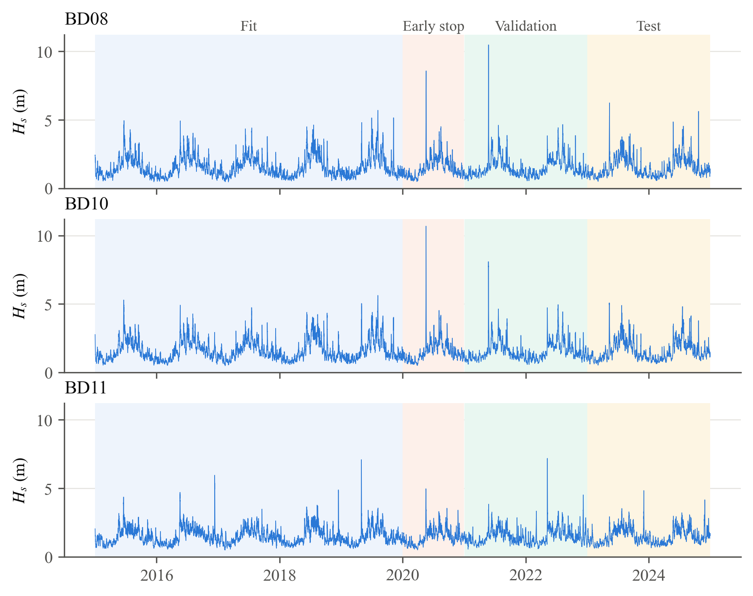
Figure 3.1: ERA5 significant wave height at the three sites, 2015–2024, with the fit, early-stopping, validation and test blocks shaded
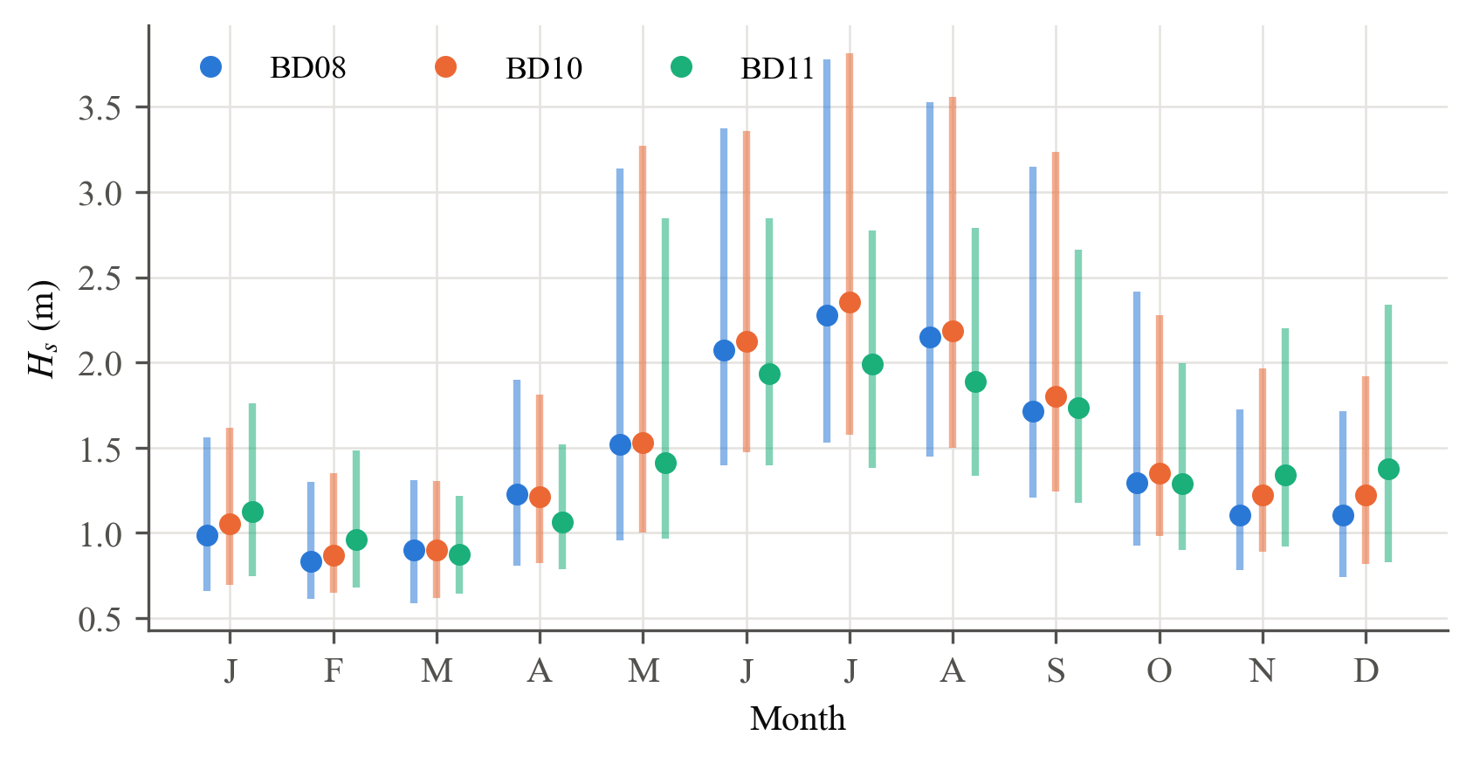
Figure 3.2: Monthly distribution of H_{s} at the three sites (median and 5–95 % range)

3.3 INCOIS OMNI buoy data
The OMNI buoys measure H_{s}, wave period and direction, wind, pressure, air temperature and SST, typically every hour or three hours. The pipeline includes a reader for INCOIS CSV/TXT exports that maps the varying column headers to canonical names, removes sentinel codes and converts timestamps to UTC, together with range checks, an isolated-spike test and short-gap filling (Section 4.1). The buoy records had not been received when the experiments in this report were run, so ERA5 H_{s} at the buoy positions serves as the forecast target throughout; the buoy data can be substituted without changes to the code.

CHAPTER 4
Methodology
The methodology is organised in five phases (Figure 4.1): data ingestion and preprocessing, feature engineering and sample generation, baseline and tree-based models, the Seq2Seq LSTM, and evaluation. Every phase is a module of the Python package written for this work, and an automated test suite checks each guardrail described below.
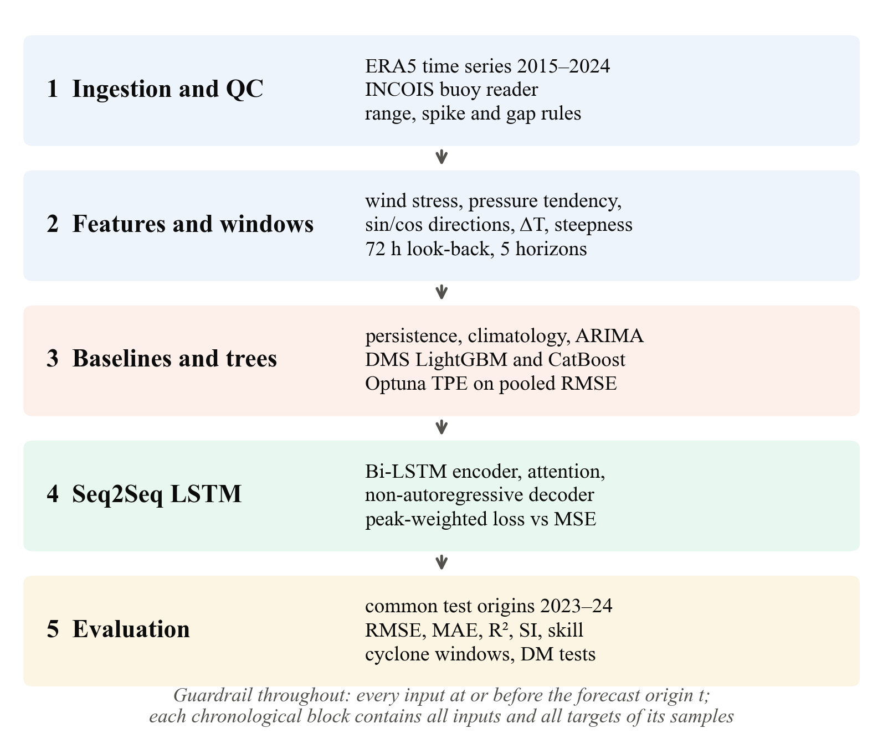
Figure 4.1: Methodology: the five phases of the forecasting framework

4.1 Phase 1: ingestion, quality control and alignment

4.1.1 Quality control and regularisation
Values outside physically admissible ranges (for example 0 ≤ H_{s} ≤ 20 m and 870 ≤ p ≤ 1060 hPa) are rejected. Only negative sentinel codes (−999, −99.9, …) are removed as codes, because 999 hPa is a valid pressure inside a cyclone. Sensor records are averaged onto an hourly grid in right-closed bins, (t − 1 h, t] ↦ t, so that a value labelled t never contains later information; directions are averaged as unit vectors. An isolated spike is a sample that departs from both neighbours by more than 1.5 m in the same sense while the neighbours agree within 0.5 m; sustained storm peaks pass this test, unlike a standard-deviation filter, which would clip them.

4.1.2 Gap filling
Gaps of at most three hours are filled by forward fill, which is causal. Linear, PCHIP and cubic interpolation are available but use the first value after the gap, which would leak up to three hours of future information into the inputs. Filled values are flagged, and a filled value is never used as a training or verification target. Longer gaps are left missing and remove every sample that touches them.

4.1.3 Spatial alignment
Grid nodes and buoy positions are mapped to Cartesian coordinates on the unit sphere and indexed with a KD-tree. The chord distance c = 2 sin(d/2R) increases monotonically with the great-circle distance:
(4.1)
Hence the KD-tree nearest neighbour is exactly the haversine nearest neighbour. Only valid nodes enter the tree: nodes where any field is undefined (land in the wave grid) are excluded, so a coastal buoy is never matched to a land point. The atmospheric (0.25°) and wave (0.5°) grids are matched separately (Table 3.1).

4.2 Phase 2: feature engineering
The predictors, summarised in Table 4.1, encode the physics of wave generation.
The surface wind stress and the air density are:
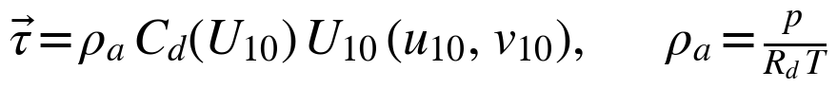 (4.2)
Here τ is the momentum flux from the wind to the sea surface. The drag coefficient follows Large and Pond [25]:
(4.3)
Above 25 m/s the coefficient is held at its 25 m/s value, because field measurements in tropical cyclones show C_{d} levelling off at high wind speeds [26]; an alternative scheme after Wu [27] is also implemented. Waves are duration-limited, so the stress is also averaged over the preceding 6, 12 and 24 h. A falling pressure is the earliest sign of an approaching depression, and the air–sea temperature difference measures the stability of the surface layer. Directions are encoded by their sine and cosine to remove the 359° → 0° discontinuity, and raw degree values are excluded from the model inputs. Every feature at time t uses data at times ≤ t only (backward differences, trailing windows); a test confirms that changing future values leaves all earlier features unchanged.
Table 4.1: Engineered features
Feature | Definition | Physical rationale
Wind speed U₁₀ | √(u₁₀² + v₁₀²) | Forcing of wind-sea growth
Wind direction θ_{U} | atan2(−u, −v) mod 360° | Same convention as θ_{w}
Air density ρ_{a} | p / (R_{d} T) | Scales the momentum flux
Wind stress τ | ρ_{a} C_{d} |U| (u, v) | Momentum input to waves
Stress history | mean τ, max U₁₀ over 6–24 h | Duration-limited growth
Pressure tendency | p(t) − p(t − h), h = 3–24 h | Approaching depression
Pressure anomaly | p − 30-day trailing mean | Synoptic signal
Air–sea ΔT | T_{2m} − SST | Surface-layer stability
Direction encodings | sin θ, cos θ (θ_{w}, θ_{U}) | No 359° → 0° jump
Wind–wave alignment | cos(θ_{U} − θ_{w}) | Wind sea vs. crossing swell
Wave steepness | H_{s} / L₀, L₀ = gT_{m}²/2π | Wind sea vs. swell
H_{s} tendency | H_{s}(t) − H_{s}(t − h), h = 3–12 h | Growth or decay phase
Seasonal phase | sin, cos of 2π·doy/365.25 | Monsoon cycle

4.3 Forecasting strategy and sample generation
For a forecast origin t, look-back L = 72 h and horizons h ∈ {6, 12, 24, 48, 72} h, a sample is:
(4.4)
Each horizon is a target of its own (direct multi-step), so no forecast is ever fed back as an input. The tree models receive a flat layout of lags H_{s}(t − k), k ∈ {0, 1, 2, 3, 6, 9, 12, 18, 24, 36, 48, 72} h, of H_{s}, ERA5 wind stress, wind speed and pressure, plus all other features at t (78 inputs). The LSTM receives the sequence itself. A sample is kept only if every input over [t − L, t] and every target is available, and both layouts keep exactly the same origins.

4.3.1 Chronological blocks without leakage
Table 4.2: Chronological blocks
Block | Period | Use | Cyclones
Fit | 2015–2019 | Training | Fani (2019) and others
Early stopping | 2020 | Number of boosting rounds / epochs | Amphan
Validation | 2021–2022 | Hyperparameter selection | Yaas, Asani, Sitrang
Test | 2023–2024 | Reported results only | Mocha, Michaung, Remal, Dana, Fengal

The record is divided into four blocks (Table 4.2). A sample belongs to block [T_{s}, T_{e}] only if:
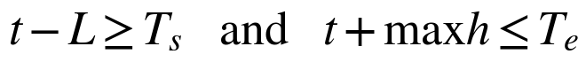 (4.5)
The second condition removes the usual multi-step leak, in which the last training samples have targets inside the validation period; the first keeps the blocks fully independent. Early stopping uses the 2020 block and hyperparameter selection the 2021–2022 block, so the validation score is optimised only once, and the test block is used for reporting only. Every block contains named cyclones.

4.4 Phase 3a: reference forecasts
Persistence forecasts Ĥ_{s}(t + h) = H_{s}(t), which is hard to beat at short lead times. Climatology forecasts the training-period mean for the calendar day of t + h, smoothed over ±15 days. ARIMA(p, d, q) [28] models the differenced series as:
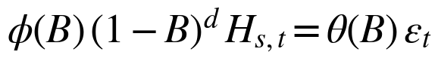 (4.6)
Here B is the backshift operator. The order (2, 1, 1) was chosen by AIC, and the parameters were estimated on the last two years of the training period with statsmodels [29]. At test time the state-space form [30] is filtered through the record with fixed parameters, and the h-step forecast from every origin is obtained from the filtered state, a_{t+h|t} = T a_{t+h−1|t}, using information up to t only. This reproduces the statsmodels forecast at each origin to machine precision but needs a single filter pass for all 17,400 test origins. The baseline is univariate because forcing at t + h is not known at forecast time.

4.5 Phase 3b: direct multi-step gradient boosting
For each horizon, an independent ensemble of regression trees is trained [16]:
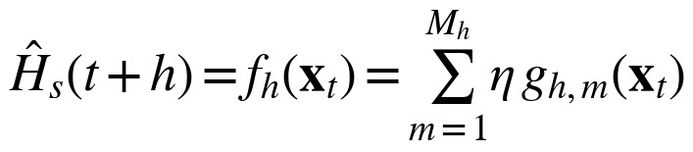 (4.7)
LightGBM [18] grows trees leaf-wise on histogram-binned features; CatBoost [19] uses symmetric (oblivious) trees with ordered boosting, which reduces the prediction shift of classical gradient boosting. The number of rounds M_{h} is set by early stopping on the 2020 block for each horizon separately. Hyperparameters were searched with the tree-structured Parzen estimator [31] of Optuna [32], with a median pruner, minimising the pooled multi-horizon RMSE on the validation block:
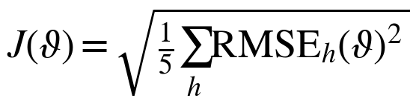 (4.8)
One parameter set is shared by all horizons. Every third training origin was used during the search (adjacent hourly origins are nearly collinear), and the final models were refitted on all origins. Within the computing budget of this project (a laptop CPU), each search was limited to 15 minutes or 40 trials. LightGBM completed 40 trials at every site (about a third pruned after the first horizons), CatBoost, whose deep symmetric trees are slower to fit, only 8–27; the search spaces are listed in Appendix A.

4.6 Phase 4: Seq2Seq LSTM with attention
An LSTM cell [11] updates a memory c_{t} through input, forget and output gates:
(4.9)
Here f_{t}, i_{t} and o_{t} are sigmoid gates of [h_{t−1}, x_{t}]. The forecaster (Figure 4.2) has three parts. A bidirectional LSTM encoder [14] with 64 units per direction reads the history of H_{s}, u₁₀, v₁₀, MSLP and T_{m} over 72 h at a 3-hourly step (25 steps); its final states initialise the decoder. An LSTM decoder runs over five steps, one per horizon, whose inputs are only quantities known at forecast time: the normalised lead time h/72 and the seasonal phase at t + h. Additive attention [15] forms, for each decoder state s_{j}, a context vector over the encoder outputs e_{k}:
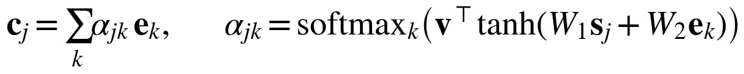 (4.10)
A dense head then predicts the change from the value at the origin, Ĥ_{s}(t + h_{j}) = H_{s}(t) + Δ_{j}, so the untrained network starts from persistence. The decoder is non-autoregressive: it never receives its own predictions, so there is no error feedback between horizons and no exposure bias. Inputs are standardised with statistics of the fit block only. Training used Adam [33] (learning rate 10⁻³, gradient clipping at 1, batch 256), early stopping on the 2020 block with patience 6, and learning-rate halving on plateaus [34].
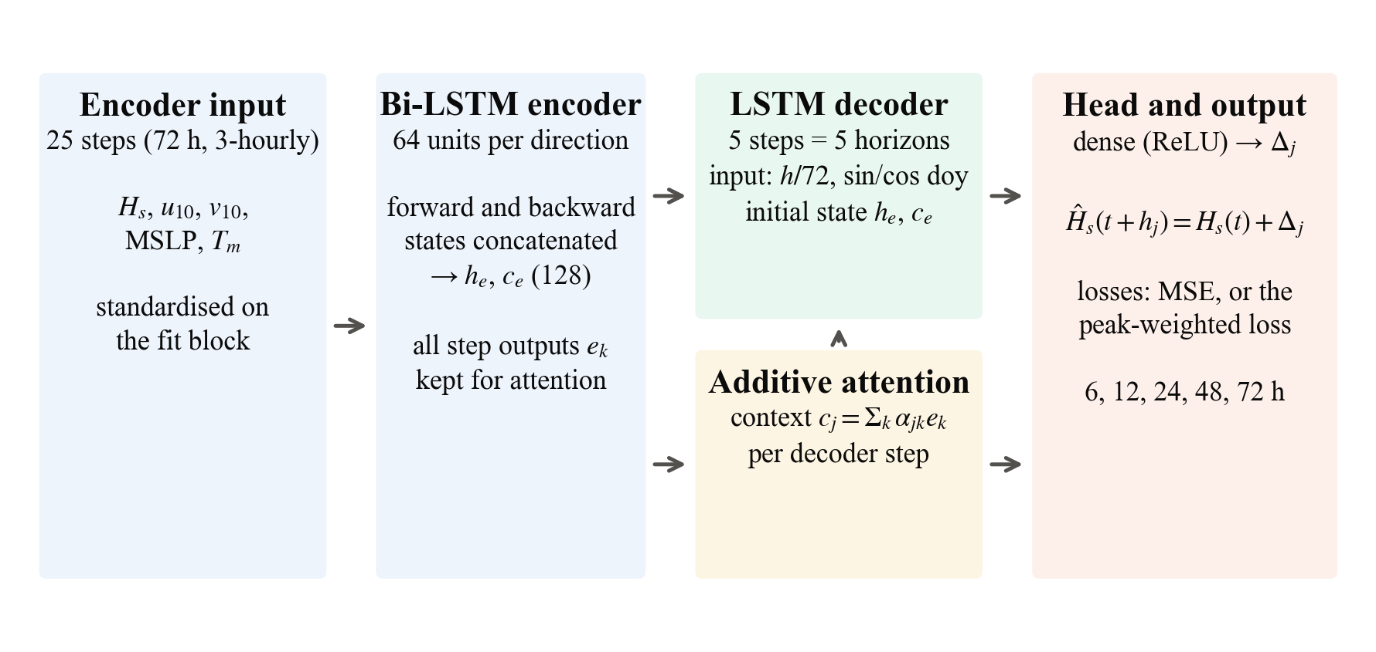
Figure 4.2: Architecture of the Seq2Seq Bi-LSTM forecaster with attention

4.6.1 Peak-weighted loss
Let e = y − ŷ (e > 0 is an under-prediction) and s(y) = σ((y − q)/τ_{s}) a soft indicator of an extreme sea state, with q the 95th percentile of the training targets and τ_{s} = 0.25 m. The loss is:
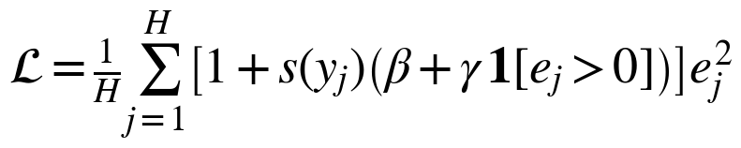 (4.11)
In ordinary seas (s ≈ 0) it reduces to the MSE; in extreme seas (s ≈ 1) every error weighs 1 + β = 2 times as much and an under-prediction 1 + β + γ = 6 times as much. The loss accepts some positive bias at the peaks in return for fewer missed extremes. An otherwise identical network trained with the MSE isolates the effect.

4.7 Phase 5: verification
All models are scored on the same test origins. For observations o_{i} and forecasts p_{i} at one horizon:
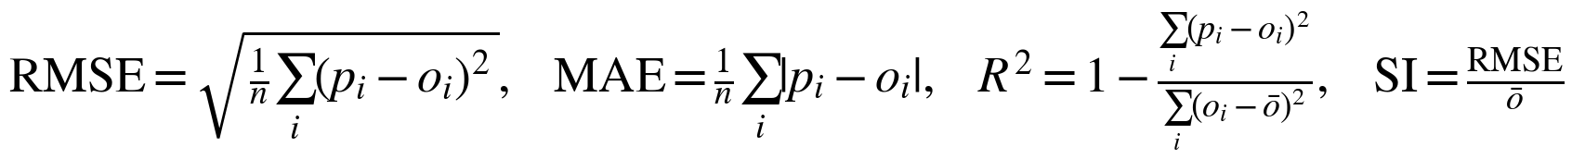 (4.12)
The bias and the correlation coefficient are reported alongside these [20], together with the skill relative to persistence:
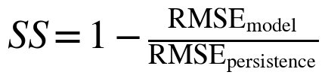 (4.13)
Scores are also computed on the extreme subset (o ≥ q) and within the windows of the named cyclones of 2023–2024. Differences in squared error between models are tested with the Diebold–Mariano statistic [21] with the small-sample correction of Harvey et al. [22]; because forecasts issued every hour overlap, the long-run variance uses a Newey–West estimator with h lags.

CHAPTER 5
Results and Discussion
All results in this chapter are for the test period 2023–2024, which no model saw during training, early stopping or hyperparameter selection. The target is ERA5 H_{s} at the buoy positions (Section 3.3), and every model is scored on exactly the same forecast origins at each site.

5.1 Overall accuracy by lead time
Tables 5.1–5.3 give the RMSE of every model at every lead time, and Figure 5.1 shows the same results graphically. Averaged over the three sites, the most accurate model is LightGBM at 6 h (0.106 m), CatBoost at 24 h (0.247 m) and LightGBM at 72 h (0.419 m). Errors grow with lead time for every model, from about 0.11 m at 6 h to 0.42 m at 72 h for the best model, against 0.13 m and 0.54 m for persistence.
Table 5.1: Test RMSE (m) at BD08, 2023–2024 (17,400 common forecast origins; best learned or baseline model per lead time in bold)
Model | 6 h | 12 h | 24 h | 48 h | 72 h
Persistence | 0.133 | 0.218 | 0.345 | 0.527 | 0.621
Climatology | 0.508 | 0.508 | 0.508 | 0.508 | 0.507
ARIMA | 0.120 | 0.206 | 0.331 | 0.520 | 0.623
LightGBM | 0.115 | 0.178 | 0.270 | 0.386 | 0.446
CatBoost | 0.116 | 0.180 | 0.266 | 0.392 | 0.448
LSTM (MSE) | 0.125 | 0.194 | 0.285 | 0.403 | 0.473
LSTM (peak loss) | 0.150 | 0.218 | 0.309 | 0.444 | 0.544

Table 5.2: Test RMSE (m) at BD10, 2023–2024 (17,400 common forecast origins; best learned or baseline model per lead time in bold)
Model | 6 h | 12 h | 24 h | 48 h | 72 h
Persistence | 0.125 | 0.202 | 0.309 | 0.471 | 0.561
Climatology | 0.480 | 0.480 | 0.480 | 0.479 | 0.479
ARIMA | 0.115 | 0.194 | 0.299 | 0.466 | 0.564
LightGBM | 0.103 | 0.170 | 0.249 | 0.364 | 0.434
CatBoost | 0.106 | 0.170 | 0.251 | 0.359 | 0.426
LSTM (MSE) | 0.121 | 0.187 | 0.267 | 0.375 | 0.430
LSTM (peak loss) | 0.151 | 0.216 | 0.303 | 0.432 | 0.524

Table 5.3: Test RMSE (m) at BD11, 2023–2024 (17,400 common forecast origins; best learned or baseline model per lead time in bold)
Model | 6 h | 12 h | 24 h | 48 h | 72 h
Persistence | 0.122 | 0.186 | 0.251 | 0.373 | 0.451
Climatology | 0.400 | 0.400 | 0.400 | 0.399 | 0.398
ARIMA | 0.114 | 0.186 | 0.247 | 0.372 | 0.451
LightGBM | 0.101 | 0.160 | 0.230 | 0.326 | 0.377
CatBoost | 0.101 | 0.158 | 0.225 | 0.351 | 0.386
LSTM (MSE) | 0.115 | 0.175 | 0.230 | 0.322 | 0.375
LSTM (peak loss) | 0.170 | 0.226 | 0.285 | 0.381 | 0.438

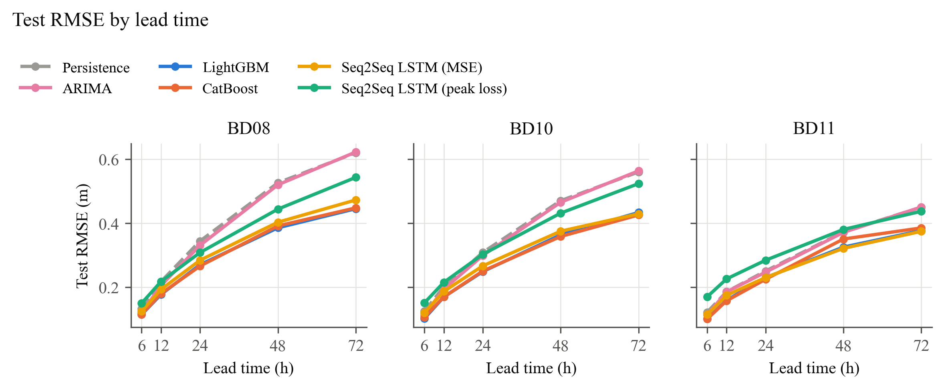
Figure 5.1: Test RMSE against lead time at the three sites
Persistence is a strong reference at short lead times because hourly H_{s} is highly autocorrelated. ARIMA improves on it at 6–24 h (mean RMSE 0.116 against 0.126 m at 6 h) but converges to persistence by 48–72 h (0.546 against 0.544 m at 72 h), as expected of a univariate linear model whose forecasts revert towards the recent level. Climatology does not depend on the lead time (0.462 m) and is the weakest model up to 24 h. At 48 h it roughly matches persistence (better at BD08, worse at BD10 and BD11), and at 72 h it beats both persistence and ARIMA at every site: three days ahead, the seasonal mean is a better guess than the current state. A useful forecaster at long lead times must therefore beat climatology, not only persistence. The learned models do both: at 24 h the best of them reduces the persistence RMSE by 18%, and at 72 h by 23%, which is 9% below climatology (Figure 5.2, Table 5.4).
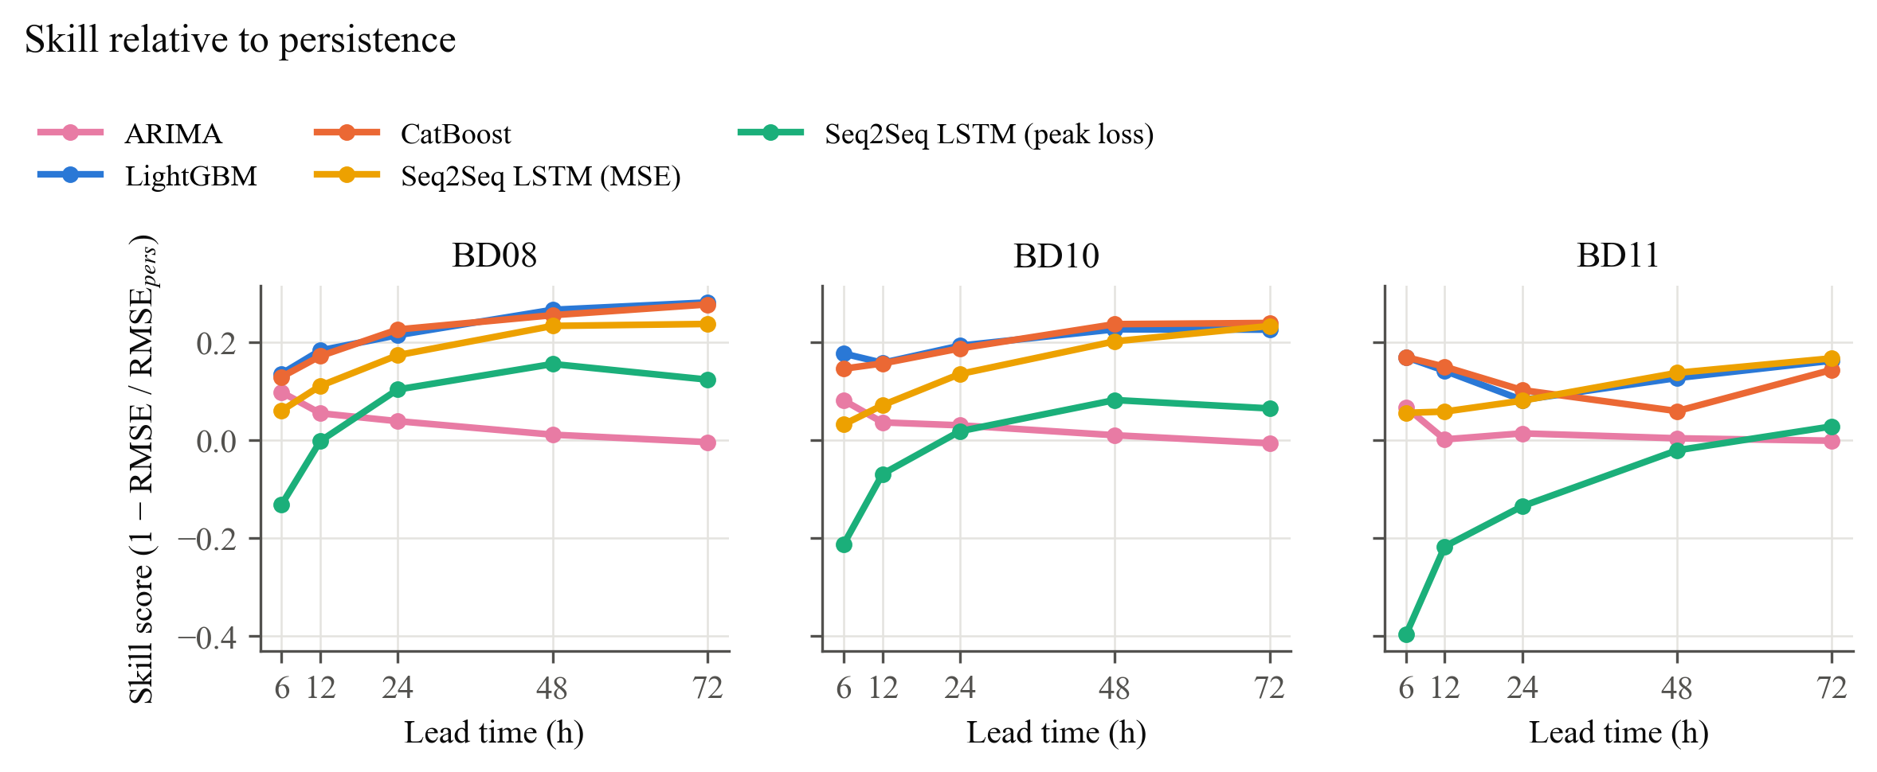
Figure 5.2: Skill relative to persistence, SS = 1 − RMSE/RMSE_{pers}
Table 5.4: Skill score relative to persistence, mean over the three sites
Model | 6 h | 12 h | 24 h | 48 h | 72 h
Climatology | −2.65 | −1.29 | −0.54 | −0.02 | +0.15
ARIMA | +0.08 | +0.03 | +0.03 | +0.01 | −0.00
LightGBM | +0.16 | +0.16 | +0.16 | +0.21 | +0.22
CatBoost | +0.15 | +0.16 | +0.17 | +0.18 | +0.22
LSTM (MSE) | +0.05 | +0.08 | +0.13 | +0.19 | +0.21
LSTM (peak loss) | −0.25 | −0.10 | −0.00 | +0.07 | +0.07

The R² of the best model decreases from 0.97 at 6 h to 0.86 at 24 h and 0.60 at 72 h, and its scatter index rises from 0.07 to 0.27 (Table 5.5, Table 5.6). A scatter index below about 0.2 is usually regarded as good agreement in wave-model verification [20], which the learned models reach up to about 24 h.
Table 5.5: Coefficient of determination R², mean over the three sites
Model | 6 h | 12 h | 24 h | 48 h | 72 h
Persistence | 0.963 | 0.906 | 0.796 | 0.531 | 0.334
Climatology | 0.516 | 0.516 | 0.516 | 0.517 | 0.518
ARIMA | 0.969 | 0.912 | 0.807 | 0.540 | 0.330
LightGBM | 0.974 | 0.934 | 0.857 | 0.706 | 0.599
CatBoost | 0.973 | 0.934 | 0.860 | 0.687 | 0.595
LSTM (MSE) | 0.967 | 0.921 | 0.846 | 0.695 | 0.588
LSTM (peak loss) | 0.940 | 0.885 | 0.793 | 0.598 | 0.429

Table 5.6: Scatter index SI = RMSE / mean observation, mean over the three sites
Model | 6 h | 12 h | 24 h | 48 h | 72 h
Persistence | 0.082 | 0.131 | 0.196 | 0.297 | 0.354
Climatology | 0.301 | 0.301 | 0.301 | 0.300 | 0.300
ARIMA | 0.075 | 0.127 | 0.190 | 0.294 | 0.355
LightGBM | 0.069 | 0.110 | 0.163 | 0.233 | 0.273
CatBoost | 0.070 | 0.110 | 0.161 | 0.239 | 0.273
LSTM (MSE) | 0.078 | 0.121 | 0.169 | 0.239 | 0.277
LSTM (peak loss) | 0.102 | 0.143 | 0.194 | 0.273 | 0.326

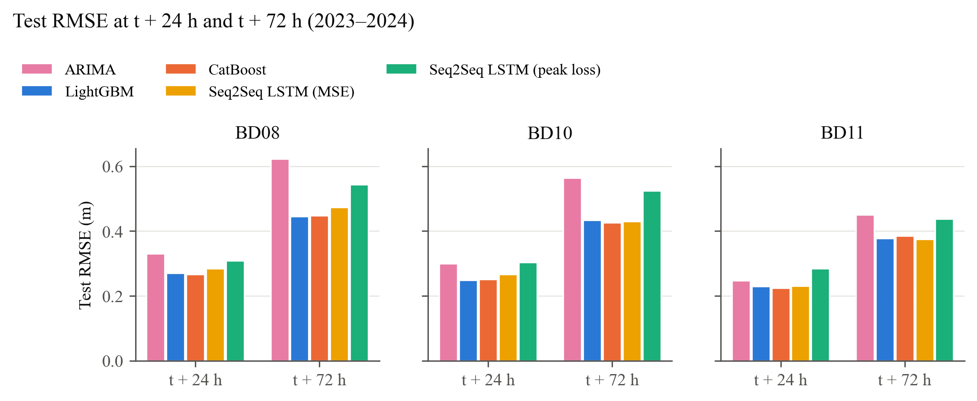
Figure 5.3: Test RMSE of ARIMA, LightGBM, CatBoost and the two LSTM variants at 24 h and 72 h
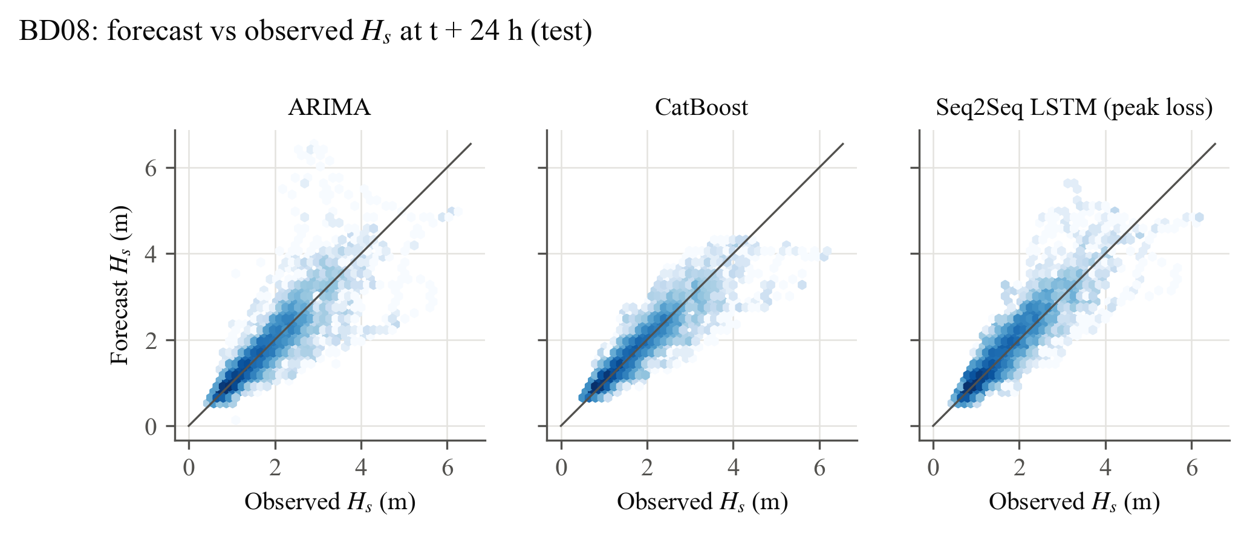
Figure 5.4: Forecast against observed H_{s} at 24 h at BD08 (hexagonal bins, log density)

5.2 Statistical significance
Table 5.7 gives, for each site at 24 h and 72 h, the model with the lowest RMSE and the Diebold–Mariano p-values of the other learned models against it. Two results are robust. First, testing directly against ARIMA (the strongest classical baseline up to 48 h), both tree models and the MSE-trained LSTM are significantly better at 24 h and 72 h at BD08 and BD10 (p < 0.01). At BD11, where the sea is calmer and ARIMA relatively stronger, CatBoost is significantly better at both lead times (p < 0.03), and LightGBM and the LSTM at 72 h only (p < 0.01); at 24 h their gains there are not significant (p = 0.06 and 0.11). The improvement over the baselines is therefore not a sampling artefact, but at the calmest site it is clear only at long lead times. Second, the differences between LightGBM and CatBoost are mostly not significant (85% of their pairwise tests have p ≥ 0.05), and at 72 h the MSE-trained LSTM is statistically indistinguishable from the best tree model at all three sites: the ranking among the strong models is within the sampling uncertainty. Over all comparisons among learned models, 62% are significant at the 5% level. The Newey–West correction matters here: forecasts issued every hour overlap, which reduces the effective sample size far below the 17,400 origins per site.
Table 5.7: Diebold–Mariano p-values against the best model at each site and lead time (small p: the model is significantly worse than the best)
Site | Lead | Best model | ARIMA | LightGBM | CatBoost | LSTM (MSE) | LSTM (peak loss)
BD08 | 24 h | CatBoost | < 0.001 | 0.273 | best | 0.053 | < 0.001
BD08 | 72 h | LightGBM | < 0.001 | best | 0.680 | 0.127 | < 0.001
BD10 | 24 h | LightGBM | < 0.001 | best | 0.474 | 0.010 | < 0.001
BD10 | 72 h | CatBoost | < 0.001 | 0.079 | best | 0.828 | < 0.001
BD11 | 24 h | CatBoost | 0.015 | 0.005 | best | 0.315 | < 0.001
BD11 | 72 h | LSTM (MSE) | 0.006 | 0.815 | 0.353 | best | < 0.001

5.3 Forecasts over a continuous month
Figure 5.5 compares the forecasts with ERA5 over the 30-day window of the test period with the most variable sea state at BD08. At 24 h all three learned models follow the growth and decay of individual events closely, with small phase errors at the onset of rapid growth. At 72 h the forecasts are smoother than the observations: they keep the level of the monsoon sea but damp, and often delay, short events, which is the usual behaviour of point forecasters trained with squared-error losses when the forcing that will drive an event is not yet visible at the origin.
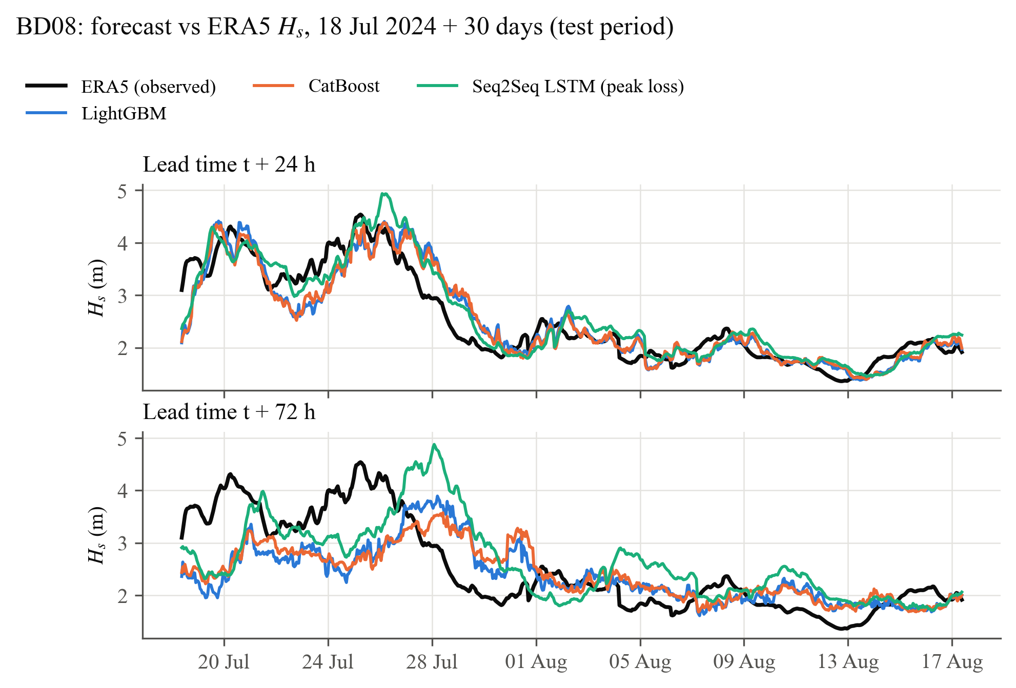
Figure 5.5: Forecast and observed H_{s} at BD08 over a 30-day test window, at 24 h and 72 h

5.4 Performance during tropical cyclones
Figure 5.6 zooms on cyclone Mocha at BD08 (peak H_{s} 6.2 m on 13 May 2023). At 24 h the learned models start the rise on time, because the growing wind stress and falling pressure are already visible at the origin, but the trees and the MSE-trained LSTM level off near 4 m, about two metres below the peak. The peak-loss LSTM comes closest to the peak. ARIMA, in contrast, reproduces the shape of the event about a day late, as a persistence-like forecaster must. At 72 h no model reproduces the peak: three days before it the cyclone is still far from the buoy and leaves little trace in the local wind, pressure and wave history. Table 5.8 quantifies this over all named cyclones of the test period.
Inside the cyclone windows the RMSE of the best model at 24 h is 0.51 m against 0.25 m over all test samples, and at 72 h 0.85 m against 0.42 m, i.e. about twice the all-sample error at both lead times. The trees reduce the storm-window RMSE of persistence and ARIMA by a quarter to a third at 24–72 h, but their mean errors inside the windows are negative: storms are under-predicted on average, increasingly so with lead time. The peak-loss LSTM is the exception, with a mean error within ±0.07 m at every lead time inside the cyclone windows.
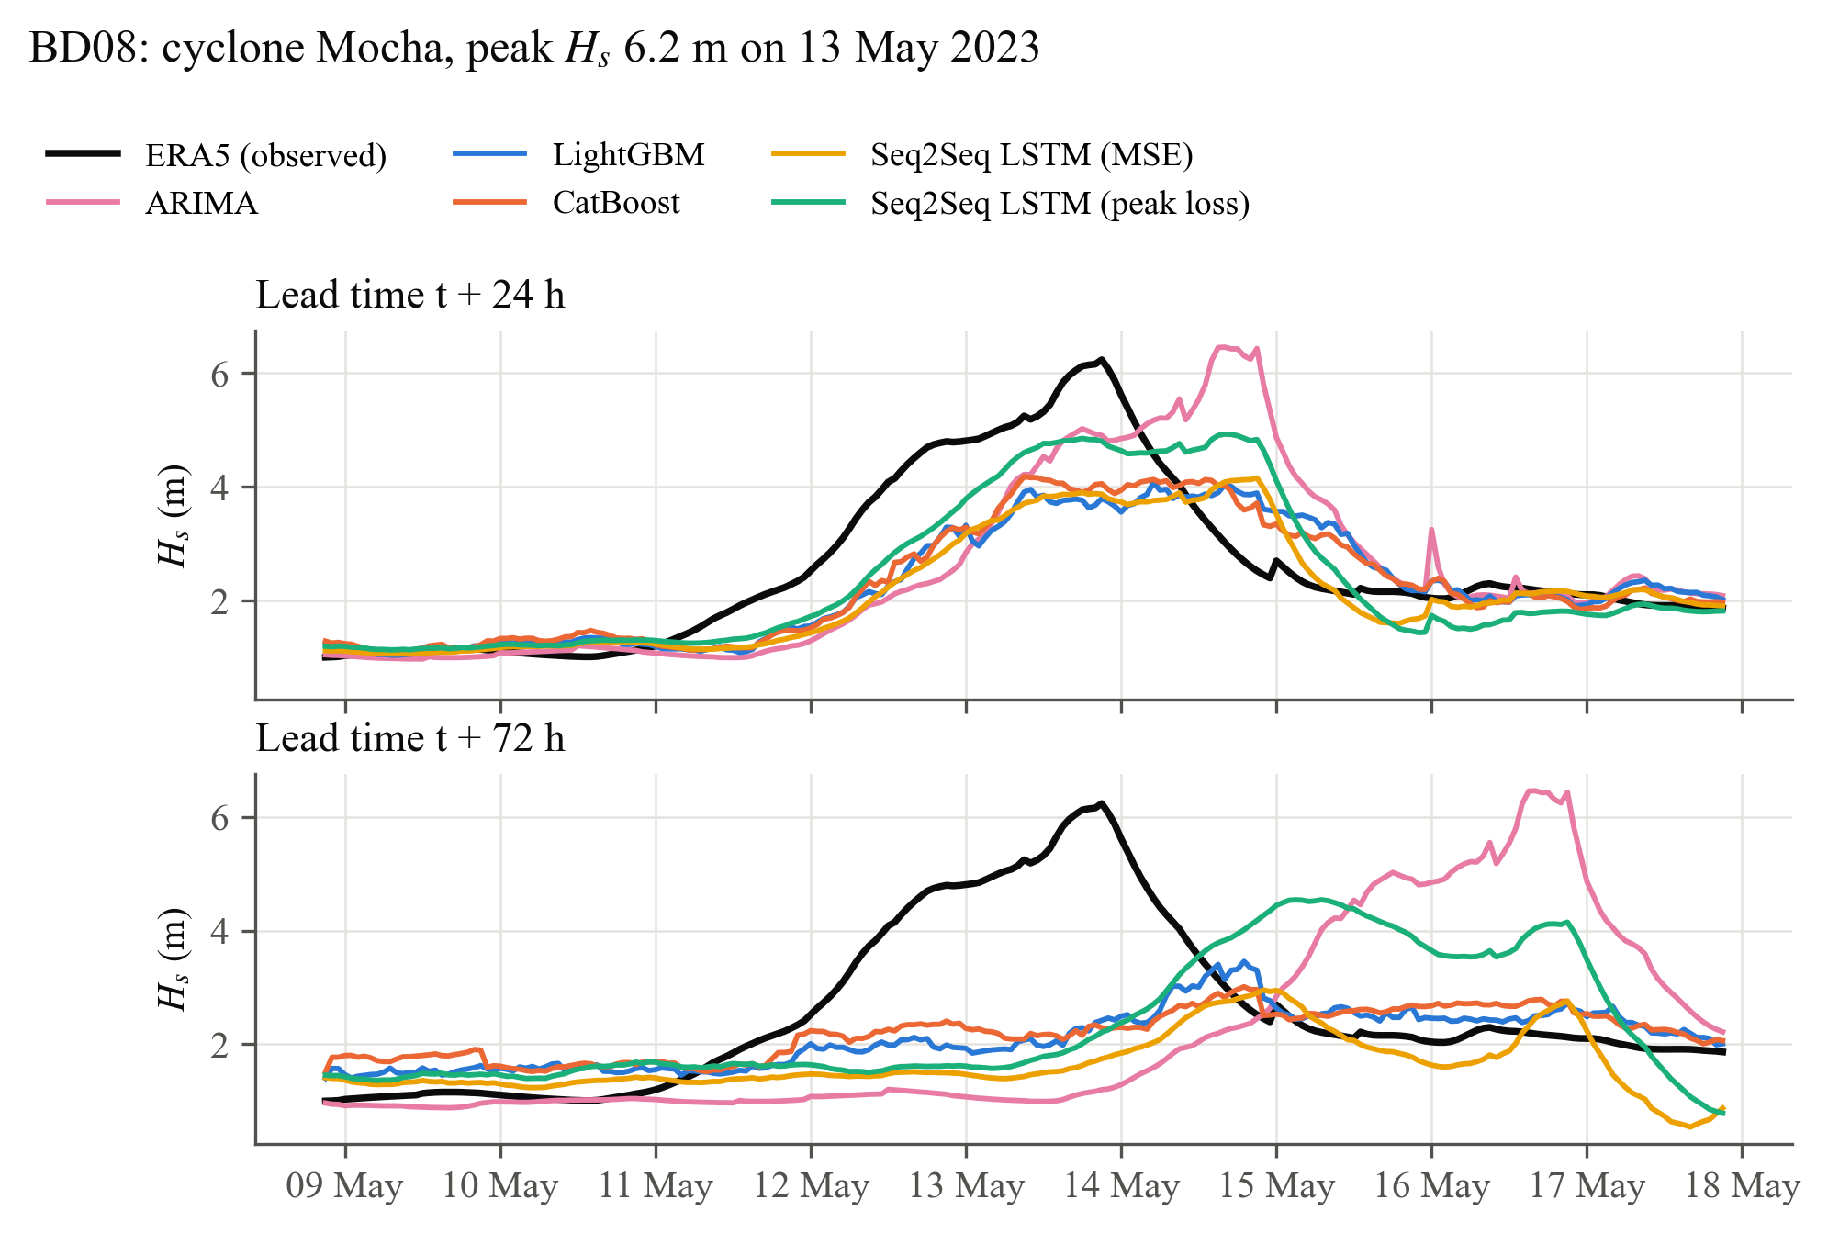
Figure 5.6: Forecasts during cyclone Mocha at BD08, at 24 h and 72 h
Table 5.8: RMSE (m) and mean error (m, in brackets) inside the windows of the named cyclones of 2023–2024, mean over the three sites
Model | 24 h | 48 h | 72 h
Persistence | 0.730 (−0.07) | 1.084 (−0.21) | 1.175 (−0.42)
ARIMA | 0.687 (−0.06) | 1.070 (−0.18) | 1.189 (−0.39)
LightGBM | 0.532 (−0.08) | 0.752 (−0.23) | 0.852 (−0.31)
CatBoost | 0.506 (−0.07) | 0.745 (−0.21) | 0.855 (−0.29)
LSTM (MSE) | 0.580 (−0.14) | 0.825 (−0.26) | 0.943 (−0.35)
LSTM (peak loss) | 0.574 (+0.02) | 0.837 (−0.03) | 0.988 (−0.07)

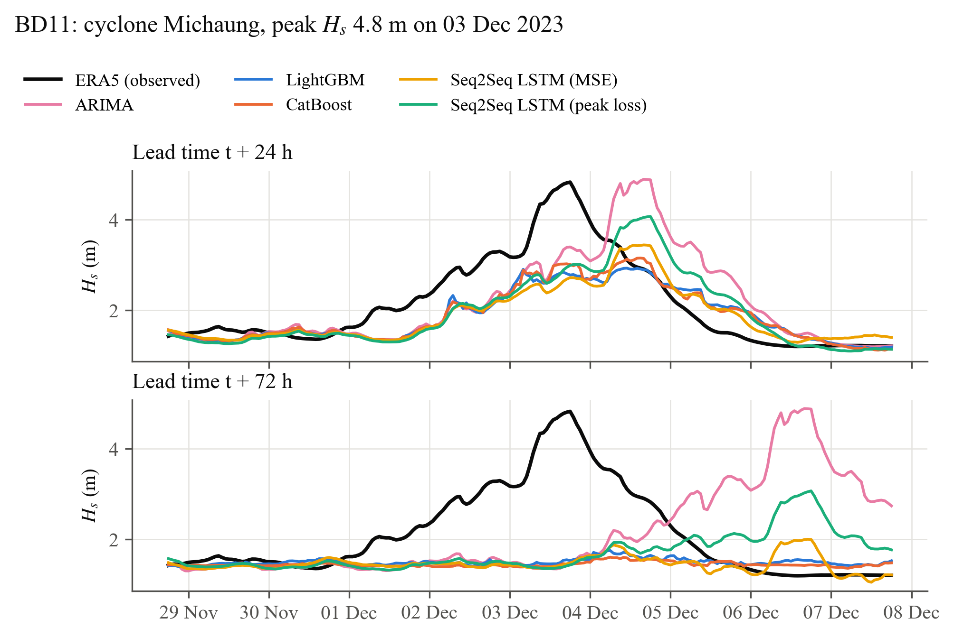
Figure 5.7: Forecasts during cyclone Michaung at BD11, at 24 h and 72 h

5.5 Effect of the peak-weighted loss
Figure 5.8 and Table 5.9 isolate the effect of the peak-weighted loss on the extreme subset (observed H_{s} at or above the training 95th percentile, 2.57–3.09 m depending on the site). Trained with the MSE, the LSTM under-predicted 72% of these cases at 24 h and 89% at 72 h, with a mean error of −0.36 m and −0.92 m. The peak-weighted loss reduced the under-prediction rate to 55% and 76% and moved the mean error at the peaks to −0.13 m and −0.56 m. The RMSE on the extreme subset changed from 0.77 to 0.66 m at 24 h and from 1.29 to 1.15 m at 72 h. The price is paid in ordinary conditions: over all samples the RMSE of the peak-loss network is +14% at 24 h and +18% at 72 h relative to the MSE network, because the loss tolerates over-prediction near the threshold. This is the intended trade-off for a warning system, in which a missed peak is far costlier than a false alarm, but it means the two losses answer different questions and should be chosen by the application rather than by RMSE alone.
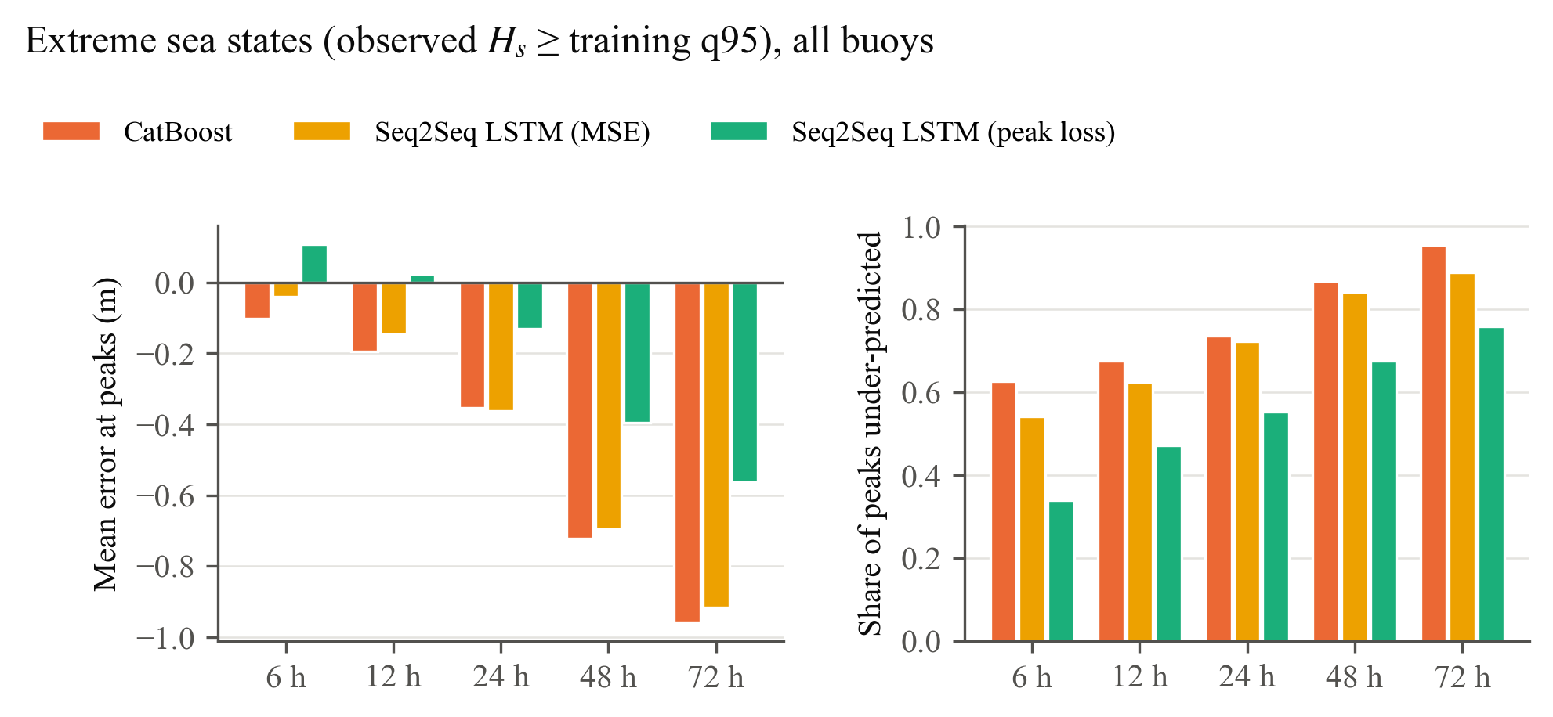
Figure 5.8: Mean error and under-prediction rate on extreme sea states (observed H_{s} ≥ training q95), all sites
Table 5.9: Extreme subset (obs ≥ q95), all sites: RMSE (m) / mean error (m) / share under-predicted
Model | 24 h | 72 h
Persistence | 0.86 / −0.33 / 67% | 1.45 / −1.00 / 86%
ARIMA | 0.84 / −0.27 / 64% | 1.45 / −0.98 / 86%
LightGBM | 0.70 / −0.37 / 75% | 1.20 / −0.94 / 95%
CatBoost | 0.68 / −0.35 / 73% | 1.21 / −0.96 / 95%
LSTM (MSE) | 0.77 / −0.36 / 72% | 1.29 / −0.92 / 89%
LSTM (peak loss) | 0.66 / −0.13 / 55% | 1.15 / −0.56 / 76%

5.6 What the tree models learned
Figure 5.9 shows the CatBoost feature importance at 6 h and 72 h. At 6 h the forecast is dominated by the most recent values of H_{s} (the current value and the three preceding hours carry 76% of the importance) and its short-term tendency, i.e. by persistence corrected for the current growth or decay. At 72 h the weight moves to the slow, large-scale state: the seasonal phase, SST, the mean sea-level pressure and its 24 h tendency, with the current H_{s} still contributing. SST in the bay follows the monsoon cycle closely, and the pressure level separates the monsoon trough from fair-weather conditions, so the 72 h model behaves like a climatology conditioned on the present large-scale state rather than like an extrapolation of the local sea. This is consistent with Section 5.1, where climatology overtakes persistence at 48–72 h, and with the cyclone results: a storm that is not yet visible in these slow variables at the origin cannot be forecast three days ahead from local inputs. The 24 h pressure tendency is the main short-lived signal that survives at 72 h, which supports the inclusion of pressure features.
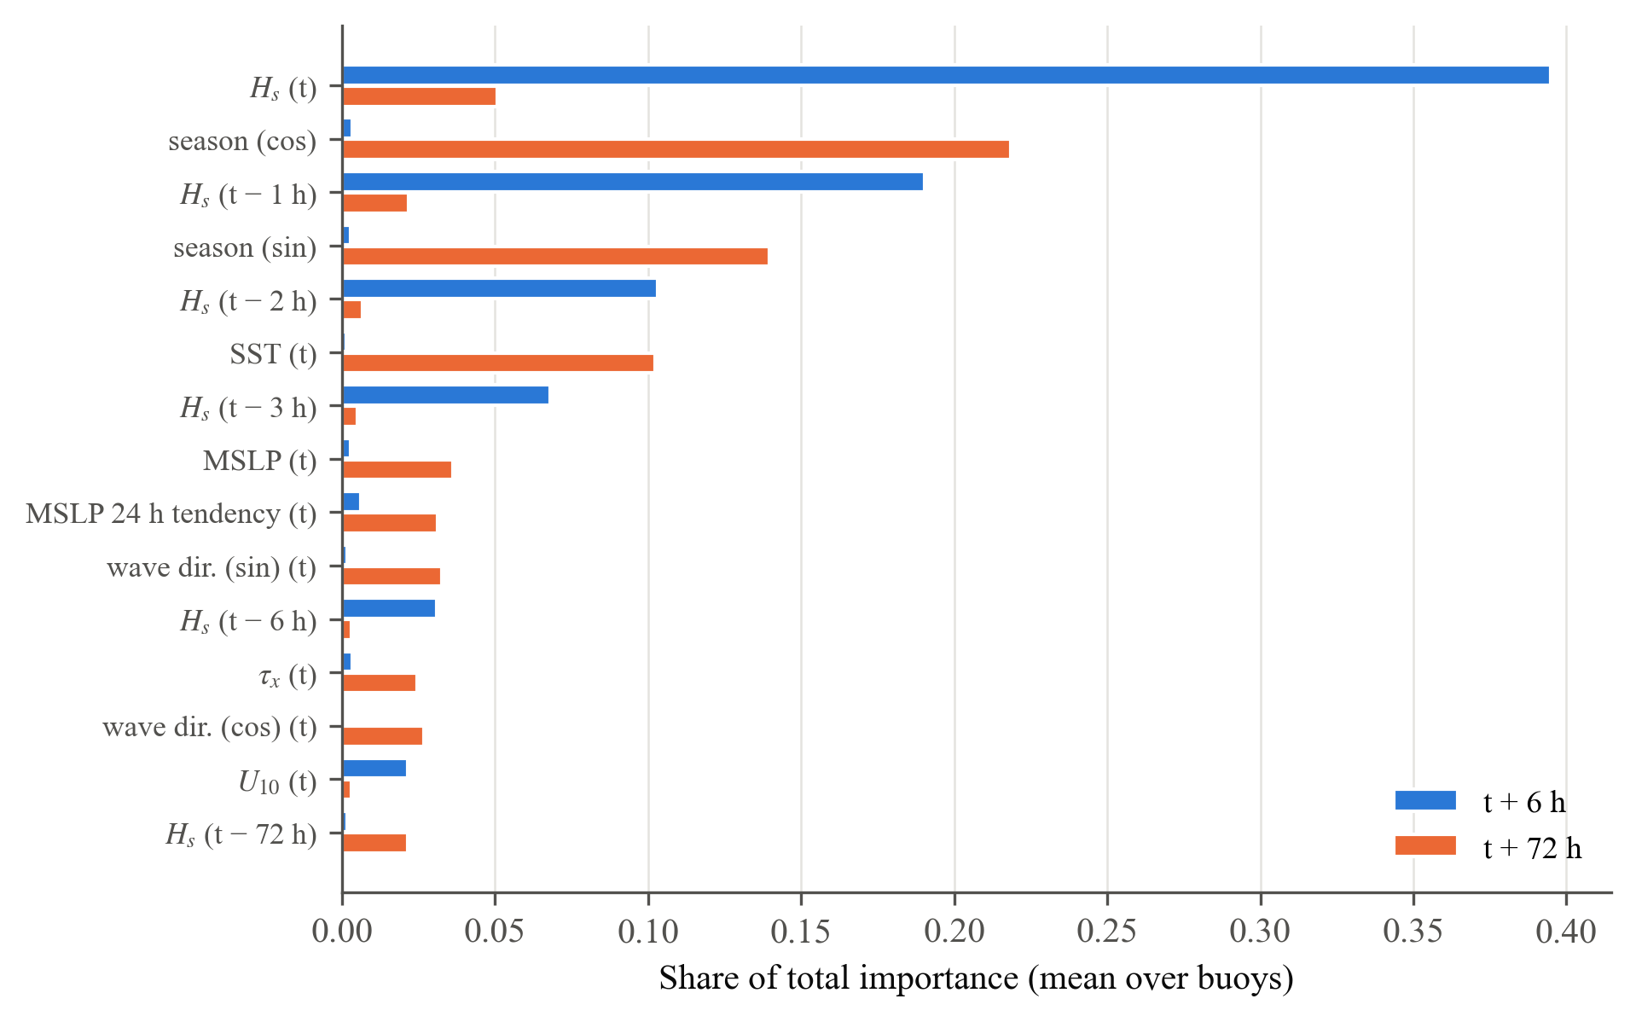
Figure 5.9: CatBoost feature importance at 6 h and 72 h (top 15 features, mean over the sites)

5.7 Trees versus the Seq2Seq LSTM
The gradient-boosted trees and the LSTM reach broadly similar accuracy, with the ranking depending on the lead time and the site. Three factors favour the trees in this setting. First, the trees see 78 engineered predictors, including wind stress, pressure tendency and direction encodings, whereas the LSTM was given the five core variables of the thesis objective; the feature engineering therefore does part of the work that the network has to learn. Second, the training set (about 43,000 hourly origins, strongly autocorrelated) is modest for a recurrent network: the early-stopping loss was lowest after only 2 epochs at every site, after which the network began to over-fit (Figure 5.10), so the recurrent layers were only lightly trained. Third, the LSTM was trained with fixed hyperparameters, whereas the trees were tuned (Section 5.8 reports a first sensitivity check). Even so, the MSE-trained LSTM is the most accurate model at 48 h and 72 h at BD11, and statistically equivalent to the best tree model at 72 h at every site. The LSTM, on the other hand, produces all five horizons from one jointly trained network, which keeps the forecast trajectory consistent across lead times, and it is the only architecture in which the peak-weighted loss could be applied directly.
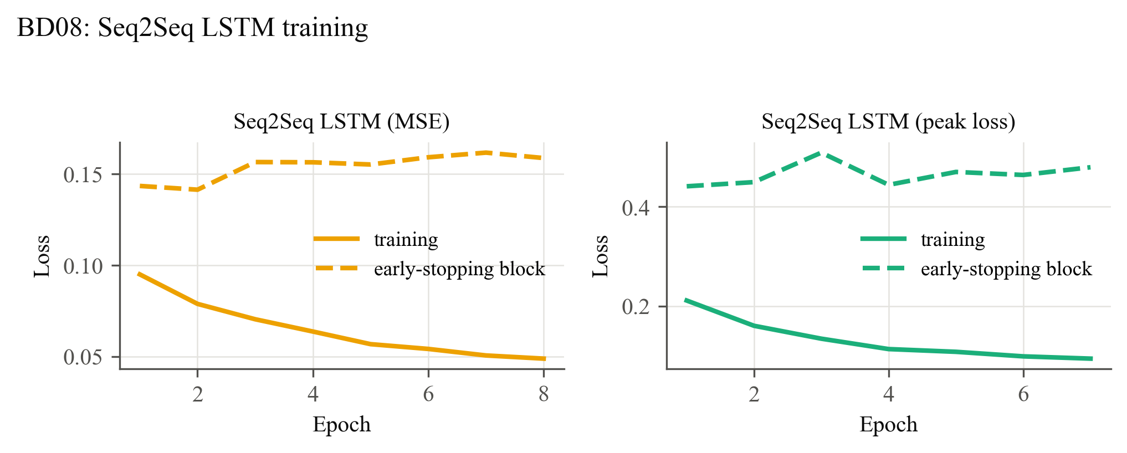
Figure 5.10: Training and early-stopping loss of the two LSTM variants at BD08

5.8 LSTM sensitivity
Table 5.10: LSTM (MSE) sensitivity at BD08: best early-stopping epoch and test RMSE (m)
Configuration | Best epoch | 6 h | 12 h | 24 h | 48 h | 72 h
Baseline (core inputs, lr 10⁻³, dropout 0.1) | 2 | 0.125 | 0.194 | 0.285 | 0.403 | 0.473
Core inputs, lr 3×10⁻⁴, dropout 0.2 | 4 | 0.123 | 0.189 | 0.279 | 0.409 | 0.475
Extended inputs (17), lr 3×10⁻⁴, dropout 0.2 | 3 | 0.120 | 0.182 | 0.273 | 0.394 | 0.458

Because the LSTM stopped improving after very few epochs, the MSE variant was retrained at BD08 with a lower learning rate and stronger dropout, with the core inputs and with an extended input set of 17 variables (core plus wind stress, pressure tendencies and anomaly, SST, air–sea ΔT, wave direction and seasonal phase). Table 5.10 shows the result. With the core inputs, the slower training moves the best epoch later but leaves the test RMSE practically unchanged (−2% to +1%), so the LSTM results of this chapter are not an artefact of the training settings. The extended inputs improve the RMSE at every lead time (−6% to −2%), to 0.273 m at 24 h and 0.458 m at 72 h against 0.270 and 0.446 m for LightGBM: the engineered physical features help the network too, and narrow but do not close the gap to the tree models. A full hyperparameter search of the network, with the extended inputs, remains future work.

5.9 Limitations
- Target. The models are verified against ERA5 H_{s}, not against buoy measurements. ERA5 smooths cyclone peaks and is itself a model product, so the absolute errors against observations will be larger; the relative ranking of the forecasters and the effect of the loss are expected to carry over, but this must be confirmed with the OMNI data.
- Forcing. Only information up to the forecast origin is used. In operational practice NWP wind forecasts for t + h would be available and would raise the skill at 48–72 h, particularly in cyclones.
- Point models. Each site uses a 1.5° box around the buoy. Swell generated elsewhere in the bay is seen only through its local signature (period, direction), not at its source.
- Computing budget. Hyperparameter searches were limited to 15 minutes per study on a laptop CPU, and the LSTM was not tuned. Larger searches would probably narrow some of the differences between models.

CHAPTER 6
Conclusions and Future Work

6.1 Conclusions
1. A leakage-free pipeline was built from ERA5 time series at three OMNI buoy positions: quality control, KD-tree alignment on the sphere, physically based features (wind stress with a saturating drag coefficient, pressure tendency and anomaly, air–sea temperature difference, sine/cosine directions) and a containment rule that keeps every sample's inputs and targets inside one chronological block. Automated tests verify each guardrail.
2. The tree models and the MSE-trained LSTM beat every baseline at every lead time on the unseen 2023–2024 test period. Averaged over the sites, the best of them reduced the persistence RMSE by 18% at 24 h and 23% at 72 h, and the ARIMA RMSE by 15% and 23%.
3. Direct multi-step gradient boosting and the Seq2Seq Bi-LSTM reached broadly similar accuracy; the most accurate model was LightGBM at 6 h, CatBoost at 24 h and LightGBM at 72 h. Feature importance shows a physically consistent shift: persistence and short-term tendency at 6 h; seasonal phase, SST, pressure and the 24 h pressure tendency at 72 h, where the model acts as a state-conditioned climatology.
4. The peak-weighted loss reduced the share of under-predicted extreme sea states at 24 h from 72% to 55% at the cost of 14% higher overall RMSE, a trade-off suited to warning applications.
5. Inside cyclone windows the errors roughly double and storms are under-predicted on average; three days ahead, the information available at the origin is not sufficient to forecast a cyclone peak at a point.

6.2 Future work
- Buoy targets. Train on ERA5 and fine-tune on the OMNI observations, or use the buoy record directly as the target, to verify the models against measurements and to correct the smoothing of ERA5 cyclone peaks.
- Forecast forcing. Add NWP wind and pressure forecasts for t + h as decoder inputs of the Seq2Seq network; the architecture already separates known-future inputs from the history.
- Spatial context. Replace the point inputs by fields around the site (ConvLSTM or graph networks), so that approaching cyclones and remote swell are seen at their source.
- Probabilistic output. Quantile or distributional losses would give calibrated uncertainty bands, which are more useful for go/no-go decisions in marine operations than a single value.
- Larger searches and ensembles. Longer hyperparameter searches, LSTM tuning and an ensemble of the tree and LSTM forecasts are inexpensive next steps on a GPU.

REFERENCES
[1] India Meteorological Department, Reports on Cyclonic Disturbances over the North Indian Ocean, RSMC – Tropical Cyclones, New Delhi, India, annual reports 2015–2024.
[2] L. H. Holthuijsen, Waves in Oceanic and Coastal Waters. Cambridge, U.K.: Cambridge University Press, 2007.
[3] The WAMDI Group, “The WAM model—A third generation ocean wave prediction model,” Journal of Physical Oceanography, vol. 18, no. 12, pp. 1775–1810, 1988.
[4] The WAVEWATCH III Development Group, “User manual and system documentation of WAVEWATCH III version 6.07,” NOAA/NWS/NCEP/MMAB, College Park, MD, USA, Tech. Note 333, 2019.
[5] S. Ben Taieb, G. Bontempi, A. F. Atiya, and A. Sorjamaa, “A review and comparison of strategies for multi-step ahead time series forecasting based on the NN5 forecasting competition,” Expert Systems with Applications, vol. 39, no. 8, pp. 7067–7083, 2012.
[6] H. Hersbach et al., “The ERA5 global reanalysis,” Quarterly Journal of the Royal Meteorological Society, vol. 146, no. 730, pp. 1999–2049, 2020, doi: 10.1002/qj.3803.
[7] M. C. Deo and C. S. Naidu, “Real time wave forecasting using neural networks,” Ocean Engineering, vol. 26, no. 3, pp. 191–203, 1998.
[8] M. C. Deo, A. Jha, A. S. Chaphekar, and K. Ravikant, “Neural networks for wave forecasting,” Ocean Engineering, vol. 28, no. 7, pp. 889–898, 2001.
[9] S. N. Londhe and V. Panchang, “One-day wave forecasts based on artificial neural networks,” Journal of Atmospheric and Oceanic Technology, vol. 23, no. 11, pp. 1593–1603, 2006.
[10] S. Mandal and N. Prabaharan, “Ocean wave forecasting using recurrent neural networks,” Ocean Engineering, vol. 33, no. 10, pp. 1401–1410, 2006.
[11] S. Hochreiter and J. Schmidhuber, “Long short-term memory,” Neural Computation, vol. 9, no. 8, pp. 1735–1780, 1997.
[12] S. Fan, N. Xiao, and S. Dong, “A novel model to predict significant wave height based on long short-term memory network,” Ocean Engineering, vol. 205, Art. no. 107298, 2020.
[13] I. Sutskever, O. Vinyals, and Q. V. Le, “Sequence to sequence learning with neural networks,” in Advances in Neural Information Processing Systems 27, 2014, pp. 3104–3112.
[14] M. Schuster and K. K. Paliwal, “Bidirectional recurrent neural networks,” IEEE Transactions on Signal Processing, vol. 45, no. 11, pp. 2673–2681, 1997.
[15] D. Bahdanau, K. Cho, and Y. Bengio, “Neural machine translation by jointly learning to align and translate,” in Proc. 3rd International Conference on Learning Representations (ICLR), San Diego, CA, USA, 2015.
[16] J. H. Friedman, “Greedy function approximation: A gradient boosting machine,” Annals of Statistics, vol. 29, no. 5, pp. 1189–1232, 2001.
[17] T. Chen and C. Guestrin, “XGBoost: A scalable tree boosting system,” in Proc. 22nd ACM SIGKDD International Conference on Knowledge Discovery and Data Mining, 2016, pp. 785–794.
[18] G. Ke et al., “LightGBM: A highly efficient gradient boosting decision tree,” in Advances in Neural Information Processing Systems 30, 2017, pp. 3146–3154.
[19] L. Prokhorenkova, G. Gusev, A. Vorobev, A. V. Dorogush, and A. Gulin, “CatBoost: Unbiased boosting with categorical features,” in Advances in Neural Information Processing Systems 31, 2018, pp. 6638–6648.
[20] L. Mentaschi, G. Besio, F. Cassola, and A. Mazzino, “Problems in RMSE-based wave model validations,” Ocean Modelling, vol. 72, pp. 53–58, 2013.
[21] F. X. Diebold and R. S. Mariano, “Comparing predictive accuracy,” Journal of Business & Economic Statistics, vol. 13, no. 3, pp. 253–263, 1995.
[22] D. Harvey, S. Leybourne, and P. Newbold, “Testing the equality of prediction mean squared errors,” International Journal of Forecasting, vol. 13, no. 2, pp. 281–291, 1997.
[23] Indian National Centre for Ocean Information Services, “Moored buoy observations, Ocean Moored buoy Network for the northern Indian Ocean (OMNI),” Hyderabad, India. [Online]. Available: https://incois.gov.in
[24] Copernicus Climate Change Service, “ERA5 hourly time-series data on single levels from 1940 to present,” Climate Data Store, dataset, 2024. [Online]. Available: https://cds.climate.copernicus.eu/datasets/reanalysis-era5-single-levels-timeseries
[25] W. G. Large and S. Pond, “Open ocean momentum flux measurements in moderate to strong winds,” Journal of Physical Oceanography, vol. 11, no. 3, pp. 324–336, 1981.
[26] M. D. Powell, P. J. Vickery, and T. A. Reinhold, “Reduced drag coefficient for high wind speeds in tropical cyclones,” Nature, vol. 422, pp. 279–283, 2003.
[27] J. Wu, “Wind-stress coefficients over sea surface from breeze to hurricane,” Journal of Geophysical Research, vol. 87, no. C12, pp. 9704–9706, 1982.
[28] G. E. P. Box, G. M. Jenkins, G. C. Reinsel, and G. M. Ljung, Time Series Analysis: Forecasting and Control, 5th ed. Hoboken, NJ, USA: Wiley, 2015.
[29] S. Seabold and J. Perktold, “Statsmodels: Econometric and statistical modeling with Python,” in Proc. 9th Python in Science Conference, 2010, pp. 92–96.
[30] J. Durbin and S. J. Koopman, Time Series Analysis by State Space Methods, 2nd ed. Oxford, U.K.: Oxford University Press, 2012.
[31] J. Bergstra, R. Bardenet, Y. Bengio, and B. Kégl, “Algorithms for hyper-parameter optimization,” in Advances in Neural Information Processing Systems 24, 2011, pp. 2546–2554.
[32] T. Akiba, S. Sano, T. Yanase, T. Ohta, and M. Koyama, “Optuna: A next-generation hyperparameter optimization framework,” in Proc. 25th ACM SIGKDD International Conference on Knowledge Discovery and Data Mining, 2019, pp. 2623–2631.
[33] D. P. Kingma and J. Ba, “Adam: A method for stochastic optimization,” in Proc. 3rd International Conference on Learning Representations (ICLR), San Diego, CA, USA, 2015.
[34] M. Abadi et al., “TensorFlow: A system for large-scale machine learning,” in Proc. 12th USENIX Symposium on Operating Systems Design and Implementation, 2016, pp. 265–283.

APPENDIX A
Hyperparameter Search Spaces and Selected Values
Table A.1: Optuna search spaces (ranges sampled on a log scale are marked “log”)
Hyperparameter | LightGBM | CatBoost
Learning rate | 0.01–0.2 (log) | 0.01–0.2 (log)
Tree size | leaves 15–255 (log) | depth 4–10
Minimum samples per leaf | 10–300 (log) | 1–200 (log)
Row / column subsampling | rows 0.5–1, columns 0.4–1 | rows 0.5–1 (Bernoulli)
Regularisation | L1 and L2: 10⁻⁸–10 (log) | L2: 1–30 (log); random strength 0.1–10 (log)

Table A.2: Selected hyperparameters and boosting rounds per horizon (6, 12, 24, 48, 72 h)
Buoy | Model | Selected parameters | Boosting rounds
BD08 | LightGBM | learning rate 0.059; leaves 17; min. leaf samples 77; row subsample 0.585 | 234, 151, 158, 163, 448
BD08 | CatBoost | learning rate 0.0249; depth 4; min. leaf samples 10; row subsample 0.561 | 689, 751, 985, 768, 482
BD10 | LightGBM | learning rate 0.0164; leaves 22; min. leaf samples 34; row subsample 0.591 | 557, 568, 454, 301, 216
BD10 | CatBoost | learning rate 0.0268; depth 4; min. leaf samples 11; row subsample 0.681 | 800, 1097, 913, 545, 592
BD11 | LightGBM | learning rate 0.0107; leaves 15; min. leaf samples 14; row subsample 0.618 | 2107, 1750, 303, 633, 614
BD11 | CatBoost | learning rate 0.0365; depth 6; min. leaf samples 4; row subsample 0.646 | 1077, 501, 124, 199, 68

APPENDIX B
Software and Reproducibility
All code is in the Python package bobswh (modules config, era5, buoy, alignment, preprocess, features, windowing, baselines, sarimax, trees, tuning, seq2seq, evaluation, plots) with command-line scripts for each phase. The experiments of this report are reproduced with:
- Data: scripts/download_era5_timeseries.py retrieves the ERA5 time series for the three sites (three CDS requests).
- Phases 1 and 2: scripts/build_features.py --era5-only builds the quality-controlled feature tables.
- Phases 3 and 4: scripts/run_era5_only.sh, run with PHASE=3 and PHASE=4, trains the tuned trees and the two LSTM variants.
- Phase 5: scripts/run_phase5.py produces all tables and figures of Chapter 5.
The automated test suite (pytest) checks, among others, that features are causal, that windows and splits contain no look-ahead, that the fast ARIMA forecasts equal the statsmodels reference, and that the peak-weighted loss has the stated weights. Software: Python 3.12, pandas 2.2, xarray 2023.6, SciPy 1.13, statsmodels 0.14, LightGBM 4.7, CatBoost 1.2, Optuna 5.0, TensorFlow 2.17 with Keras 3.

