

INFO 608 – 900
Human Computer Interaction
Final Group Project
Evaluation of Orbitz.com
Steven Greulich, Douglas Durrenberger, Vishesh Singh Thakur

Table of Contents
Table of Contents 2
Executive Summary 3
Human-Computer Interaction (HCI): 4
Project Scenario 4
Evaluation of Orbitz.com 4
Description and prioritization of test results 6
Limitations of the study 11
Conclusion 12
References cited 12
Appendix: Individual heuristic evaluations 12
Appendix: Individual academic honesty statements 16

Table of Figures
Figure 1: 'Your Trip' Fill-in Entries - 5 -
Figure 2: Results of hotel selection page (Irregularly listed) - 5 -
Figure 3: Filtering according time - 6 -
Figure 4: If booked nearest date - 7 -
Figure 5: If booked far-off date - 8 -
Figure 6: : No facility of changing cars - 9 -
Figure 7: Detailed flight information - 10 -
Figure 8: Error in number input field - 10 -
Figure 9: Facilities of hotel room - 11 -

Executive Summary
With the ever increasing number of travel websites that are appearing online, having a site that sets itself from the rest will allow it to remain in business. Having a website that follows all of the ten usability design principles will help increase the popularity the website. By not following any of these ten design principles, or poorly implementing them, users might be turned off from the site and give their business to alternative travel websites. We performed ‘Task Analysis’ to interact with the interface of Orbitz.com to understand if the desired tasks such as booking airline tickets or hotel reservation or renting a car could be done with utmost fluidity. The way we performed these actions involved splitting the interaction into minute and trivial steps and testing if they satisfied the purpose.

There are two typical methods for performing task analysis. The first method deals with determining how technology is used by users in their day to day activities and the second method conveys how they value its interface. One cannot deny that analyzing these tasks is a little subjective, bearing in mind human behavior and the relationship of each with technology. Task analysis is for that reason a useful notion, but it can entail a lot of effort to put into practice.

Introduction
The common use of the internet has changed the entire way of travelling. There was a time when tourists or travellers would seek help from travel agents to book a tour. The use of a travel agent was sometimes perceived as a waste of time and money, but the level of effort that a travel agent endured to book a vacation tour was, in fact, not valued enough. There were high probabilities of fraud and other deceptions of which the travel agent needed to be wary.
Fortunately, with the advent of online booking, now people can easily research any desired destination, book tickets online, and start their journey. Everything can happen very smoothly without the need of a middle man. There are many travel websites which assist the user in the selection of flight, hotel, and vehicle rentals, with myriad options.
Additionally, travel websites have began making applications for smartphones, which make booking a trip even more convenient. The travel websites have customized travel packages with specific themes: romantic destinations, weekend getaways, foreign trips, and commercial travel packages, for example.
The user now has the ability to install a travel application on their smart phones, browse through it and book flights, hotels, or any other vacation packages as per his/her wants and budget considerations. The best thing about travel websites is that they are cost-effective. Discounts and special offers help entice users to book with these sites.
Planning a vacation can be an exciting activity, but examined more closely, things begin to get complicated. Although in today’s world these tasks can be done at your fingertips due to the availability of numerous travel web sites, booking flight tickets, making hotel reservations and renting a car can be a challenge due to the design of these travel websites and applications.

Human-Computer Interaction (HCI):
HCI is a diverse discipline which involves numerous cognitive inclinations and biases to interpret the way the human brain interacts with computers/machines by utilizing predictive models. The Design of Everyday things by Don Norman has taught us the user-centered approach, which states that there are three important design criteria. First, making sure that owners/users are happy by satisfying the elementary necessities; the second concern is not to assume that clients will have the same views, opinions, or agendas about the design that the developers will have. The last design criterion involves the understanding of the user’s motivations. These principles facilitate providing a better experience to clients (in our case, the travelers) in getting what the user wants done and incorporating it in the scheme will result in a farther reach. Consequently, the way the interface is conceived can significantly influence how well it is received by its consumers in performing their tasks and lead to additional usage in the future.

Project Scenario
Imagine you are booking a trip for a group of four people to go on a multi-day vacation. All four people want to leave from the same location (Philadelphia) and arrive in another location (San Diego) at the same time. They also want to travel back together. The travelers would like to sit together although if they have to sit apart, then at least two of the four should sit together and the other two can sit together in another part of the aircraft. They want to rent one car at their destination that will hold them and their luggage. In the destination city, they want two hotel rooms at the same hotel. They want very inexpensive flights but are concerned about changing planes on the way out and getting stuck at an intermediate airport. Also they don’t want to waste too much of their vacation time flying. It is not exactly clear how much extra each person would be willing to pay for a direct flight from Philadelphia to San Diego versus having to change planes (which entails possibly getting stuck in an intermediate airport if the second leg is cancelled) and spending more time traveling between the origin and destination.

Evaluation of Orbitz.com
Overall, we found the design of the website simple, dynamic and straightforward as it allowed us a hassle-free approach to book flight tickets, perform hotel reservations and car rental by entering the pertinent details and hitting the search button. However, there were a few cases in which we felt that the design of the website needs improvement.

- On the main Orbitz.com page, we selected the following
  - Flight + Hotel + Car
  - From City: Philadelphia
  - To Cite: San Diego
  - Leave Date: March 1, 2016
  - Return Date: March 8, 2016
  - Booked 2 rooms, 2 adults in each room

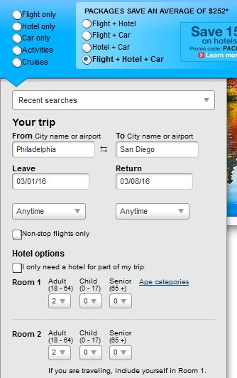
Figure 1: 'Your Trip' Fill-in Entries

- Sorted the hotel results based on ‘Lowest prices’ but it caused undesired outcomes. 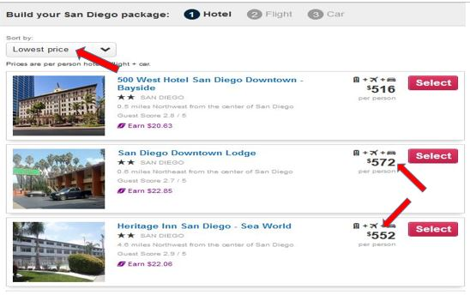

Figure 2: Results of hotel selection page (Irregularly listed)
- In order to maximize our vacation time, we selected arrival between Monday, 9:30AM to 12:00PM. We would depart Friday between 8:00PM and 10:45PM.
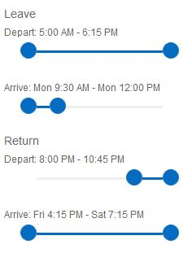
Figure 3: Filtering according time

- Determine shortest flight with 1 or more stops, by using the shortest flight filter (unable to provide a secondary filter to sort by price as well)
- Select flight
- Select type of room for room 1
- Select type of room for room 2
- Unable to determine how to choose seats for each flight.
- Choose Vehicle of choice
- Select method of payment to purchase vacation
- Complete transaction

Description and prioritization of test results
Considering our present scenario, the judgments and/or the decisions taken are as follows:
- We would prioritize cost and time versus the chance of being caught at an intermediate airport for a couple reasons. One is that sitting together is a convenience, but not overly problematic in terms of our stated goals. We would prioritize cost and time since these are things which are not easily compromised.
- We do like that in the beginning of the search, you can choose how many rooms you would like and how many people would be in each room. This ability allows users to calculate the number of rooms to be booked based on the number of travelers.
- Considering our scenario, we would suggest that all four of us sit together, so that we have significant details such as first name, last name, age, date of birth to verify while booking the flight tickets. This would allow us to come to a quick understanding about the timing constraints as well as the budget so that, if one of us is making payment then we can equally share among ourselves.
- Moreover, if we decide to do it individually, we will end up choosing different flights or might not get to sit next to each other.
- If we choose the earliest date for travel, we incur a greater cost, approximately $900+/person for flight only. However if we book a further-off date, the cost will drop down by $300. The trade-off is shown below. Therefore if we want to spend less for our trip, then we need to choose a further-off date.
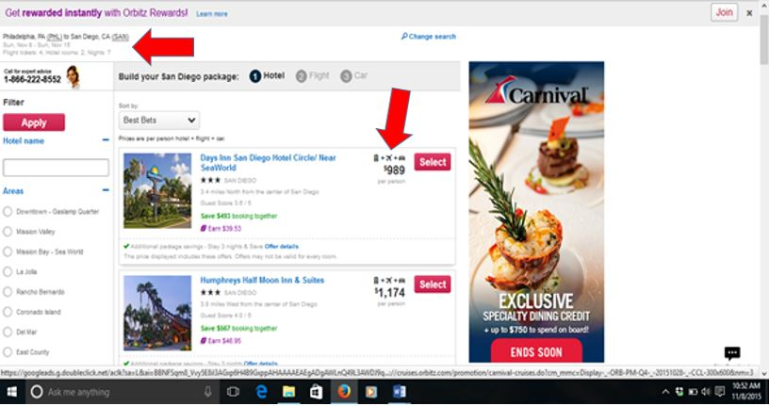
Figure 4: If booked nearest date

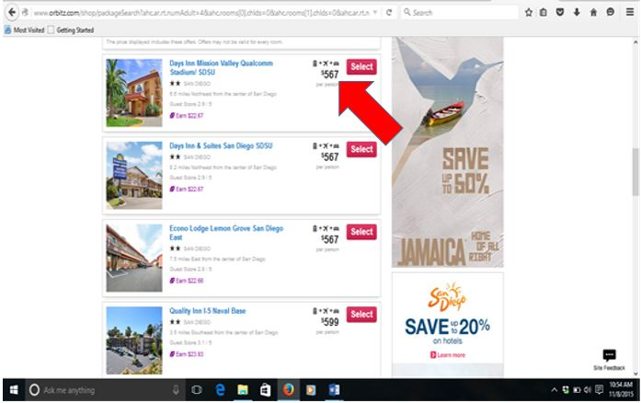
Figure 5: If booked far-off date

- While it does search for flights that all of our passengers can get on together, it does not necessarily mean that they will all sit together. We would suggest if we are looking for direct flight without getting stuck at an intermediate airport, we will have to spend more and as far as sitting next to each other is concerned, considering it to be an economy class flight, there will be 2 rows with 3 seats in each. Hence only 2 of us can sit next to each other. This information is bound to be missed be new travelers and would be a hassle as some would think of reverting all the way back and change the flight and have to go through the process again. It would be good if they would just let us select the seat when we are selecting the flight in the beginning of the process.
- Choosing a car was not the most enjoyable experience. We are glad that we viewed the details of the car before paying. Since we selected that there will be four people traveling, we would assume that the site would choose a car by default that would fit at least four people. On multiple occasions that we used this tool, the default car selected was for two people. This would have been a headache if left unnoticed. We would have run the risk of getting there and not having a second car available for us to use, leaving us stranded at the airport or the unanticipated expense of a taxi.

Recommendations for Design
After meeting with the evaluators of the Orbitz.com website, there were a number of recommendations that were presented. There were occasions that there were multiple instances of the same recommendations. Those duplicates have been removed for redundancy purposes.

- Follow a more logical sequence in the entire process. It was quite confusing throughout the process, as we booked the hotel, the flight, and then went back to the hotel to choose the room. At the end of the entire process, we would then choose our seats.
- The color scheme for banners and buttons was popping out at the user. We were having issues determining the difference between an essential link and an advertisement.
- One of the difficulties experienced was trying to decide what the most cost effective option truly means in terms of hotel+flight+car. Additionally, there is not a way to know if all the travelers will indeed have tickets available to them at the price offered on the search page.
- Also, in the search page, it is not clear what “Best Bets” refers to, or what criteria Orbitz.com used to determine what a “Best Bet” is.
- Would prefer to have a 360 ⁰ tour of lobby, restaurant and meeting facilities.
- Some important features impressed me such as: use of Google Maps, previous reviews, ratings and a table which differentiates between deluxe rooms and premium suites with respect to their pricing, discounts they offer for early booking and the maximum allowed guests in a room.
- Interface options should take into consideration travellers with disabilities, such as seizures), those with perceptual boundary problems who might not be able to have a window seat, or are sensitive to colour, video, or flashing lights
- We wish if there was an option for users to be alerted about the change in prices on the chosen dates by subscribing to a type of “Price Watch” which expedia.com offers.
- Older individuals might prefer if hotel booking could be done over the phone or paid directly at the hotel. Younger or more tech-savvy users might prefer if payments could be done through Google Wallet and/or Android/Apple/Samsung pay.
- On some occasions, the system did not allow us to change the car status and presented the following dialog:
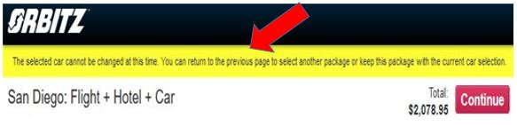
Figure 6: No option to changing cars

- It forced us to change the package plan to let us access the “car change” status. We would prefer to change the shuttle information to select a car that could accommodate all four of us including our luggage, but that option was not available as most of the cars were appropriate for only two passengers.
- The search mechanism rendered the details within seconds pointing to the exact address along with economy booking rate according to the room type, excluding tax.
However there were a few features that caused some error and confusion. These are as follows:

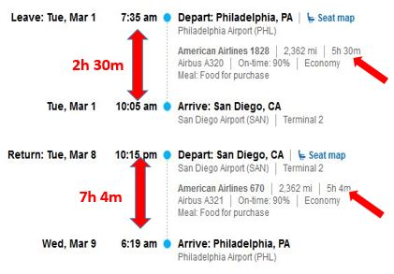
Figure 7: Detailed flight information

The picture shown above confuses travelers about the flight duration of the aircraft as the flight time shown above for departure from Philadelphia is 2 hours and 30 mins but the number of hours shown is 5h 30 mins, whereas the flight from San Diego is clearly more than 5h 4m as listed above.
- The screenshot shown below demonstrates that travelers can input any random fake phone number. A fix to this issue would be to perform phone number validation by sending a text message which would help separate actual from merely potential travelers.
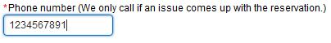
Figure 8: Error in number input field

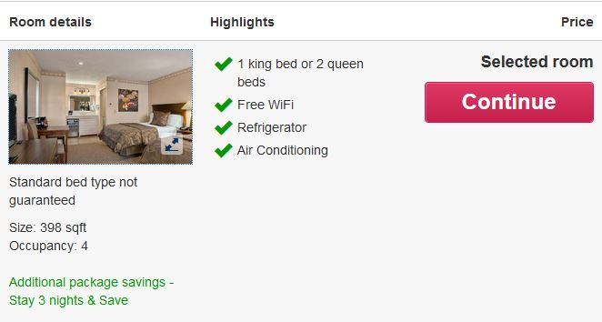
Figure 9: Facilities of hotel room

- We would prefer to view more pictures of the hotel room but clicking on the picture yielded only one image. A fairly easy fix to this would be to link to the hotel’s site itself.

Limitations of the study
Even though the three evaluators on this study discovered and documented numerous accounts of failed usability principles, there were some limitations that constrained the study.
- It is typically determined by many that three to five evaluators should be used. There is barely an additional benefit by bringing in more than 5 evaluators to judge the site. In this evaluation, we used a total of three evaluators. While there were many design limitations that were discovered, the amount of issues could have increased by having an additional one to two people evaluating the website (Rogers, 507)
- The scenario called for looking for a hotel, flight and car for four people. While the study did look at having alternative flight considerations, the hotel and car were straightforward. The preference for hotel was not specified and the only car requirement was that it would fit all four people with their luggage. If additional criteria was considered (such as each travelers wanting his own room, specific room preferences, or a specific type of car), then many additional design limitations would have been found to be non-compliant.
- The scenario involved four people consistently from the hotel, to the flight, to the car booking. There are instances when there might be varying numbers of people for each part of the vacation. For example, there might be only two people flying, but five people staying in the hotel, for example if travelers were coming from different points of origin. These types of scenarios were not considered in this study.

Conclusion
In an ever increasing online presence of travel sites, one must take into consideration the various types of actions a user could partake in while booking a trip. While it is increasingly difficult to imagine all of the ways that a user could use the site, designers should focus on the most frequent ones. Sites should also be in compliant of the ten heuristic design principles. While these principles are merely guidelines to design a website, failure to uphold any of these principles could result in loss of user traffic.

References cited
- Cockton, G., Lavery, D., & Woolrych, A. (2003). Inspection-based evaluations. In the Human-Computer Interaction Handbook: Fundamentals, Evolving Technologies and Emerging Applications, J. A. Jacko and A. Sears, Eds. Lawrence Erlbaum Associates, Mahwah, NJ, pp. 1118-113
- Home | Usability.gov. (n.d.). Retrieved November 20, 2015, from http://www.usability.gov/
- Rogers, Y., & Sharp, H. (2011). Interaction design: Beyond human-computer interaction (3rd ed.). Chichester, West Sussex, U.K.: Wiley.
- Ten Usability Heuristics (n.d.). Nielson Norman Group. Retrieved November 20, 2015, from http://www.nngroup.com/articles/ten-usability-heuristics/

Appendix: Individual heuristic evaluations

Item | Heuristic violated | Where in interface | Problem description | Severity
1 | User control and freedom | Flight search result page | When selecting a departing flight, the page got stuck at the loading screen with no way out other than moving away from the screen  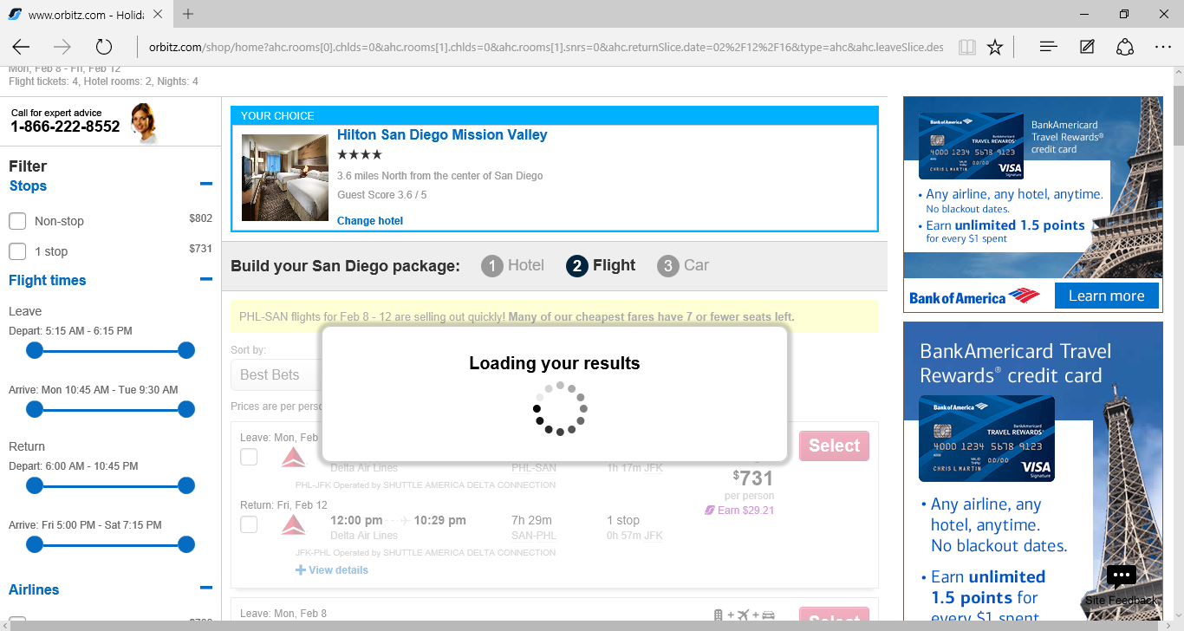 | 4
2 | Visibility of system status | Flight selection screen | It is not immediately indicated how many flight tickets are available for the flight selected, regardless of how many travelers are chosen at the original search screen. | 4
3 | User control and freedom | Flight+hotel+car selection screen | There is not an option, when searching for a package, to indicate number of travelers if it is not the same as the number of hotel rooms needed. For example, if 4 flight tickets are needed, but only one person needs a hotel, the search does not allow for that flexibility. This seems like a relatively easy thing to fix—just make Number of Flight Passengers a different search option than Hotel Reservations. | 4
4 | User control and freedom | Flight+hotel_cr results screen | Important information, such as that a flight requires a train connection or that the return flight requires a different airport than the origin flight, is omitted until the user has already chosen a hotel option | 4
5 | Match between system and the real world | Review page | When presented with the default car of choice, we were presented with a 2 person car. This did not allow us to put all 4 of us + our luggage into 1 vehicle  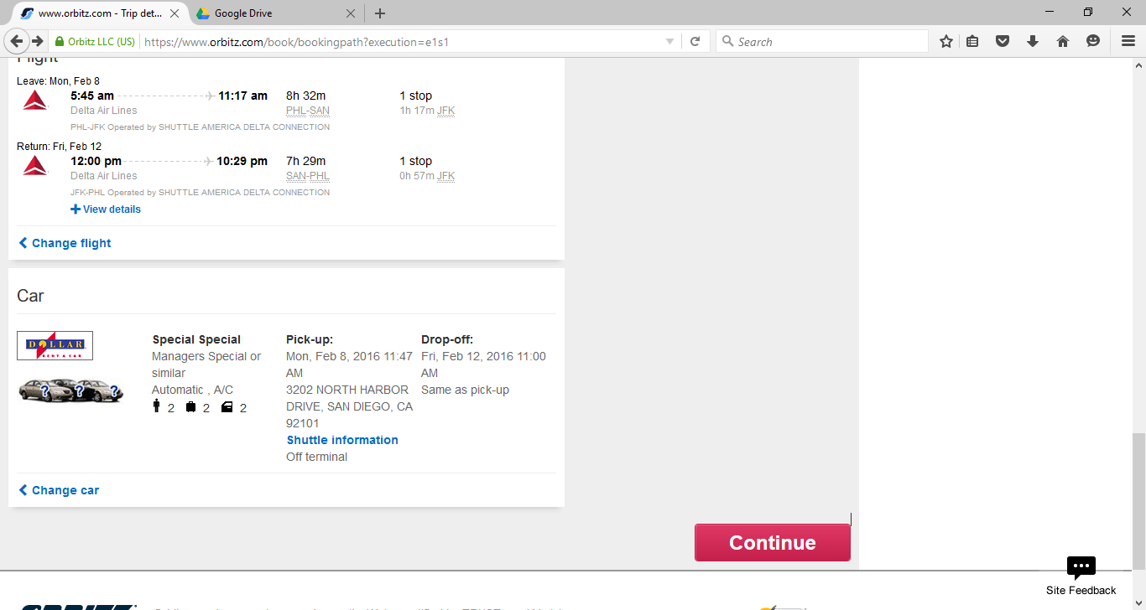 | 3
6 | Match between system and the real world | Flight search result page, review page | It was difficult to find the seating chart. After viewing the seats, it was not clear whether we could book the seats at the time of purchase. This should be functionality as to ensure that you could book with multiple people in mind. We wanted to book a flight that would ensure we could select our seats to either have all 4 of us together, or to have 2 pairs of seats | 3
7 | Match between system and the real world | Review page | We were made to select the type of room we wanted after selecting the flight. We think this should be presented in the hotel selection step. | 3
8 | Aesthetics and minimalistic design | Car Change Screen | Unable to judge about the difference between blue and green color fonts based on 4 different categories. If there were some kind of legend stating the difference between the two, that would solve the problem. | 3
9 | Error Prevention | Checkout Traveler Information page | Phone number field is not verified and users can fill in any random phone number. | 3
10 | Match between system and the real world | Initial search results page | One of the sort options is to order results by “Best Bets”. It is unclear what metrics Orbitz.com is using to arrive at what a Best Bet is or is not. | 3
11 | User control and freedom | Flight+hotel+car results screen | Total price for all four passengers not given until “View details” is selected beneath the basic flight path information. | 3
12 | Match between system and the real world, User control and freedom | At Car selection screen | When choosing a car, it does not let you filter car results for the amount of people you have. It will let us choose a vehicle that accommodates fewer than four people even though we are traveling with four people. | 2
13 | Visibility of System status, User control and freedom, Error prevention | On Selection of Hotel / Flight screens | During loading of new data when we select a filter, there is no loading screen. We kept clicking on the filter, hoping that it would eventually work | 2
14 | Visibility of System status, Aesthetics and minimalistic design | Flight search result page | Choosing the leaving and departing was confusing. The system should let you first select the departing flight, and then the return flight. The way the site is laid out is that they show everything at once which overloads the screen. | 2
15 | Flexibility and efficiency of use | Flight search result page | Difficult to compare the prices between non-stop and direct flights | 2
16 | Consistency and Standardization, Aesthetics and minimalistic design | Throughout the website | Sometimes information is not clear as the website entails different font styles and font colors and there is no proper differentiation if something is clicked in what way it will affect the results. | 2
17 | Visibility of system status | Flight selection screen | When you look at duration of flight, it is not clear how much time you will your travel time take as there is no correlation between the timings column and # of hours | 2
18 | Flexibility and efficiency | Car Change Screen | System is not able to provide car based on the details input such as four persons will need four suitcase bags, but a car which can accommodate these many people with their luggage is not available. Nonetheless we can opt for a car with more people to accommodate the required luggage | 2
19 | Consistency and standards, Aesthetics and minimalistic design | All pages | Some links and text were different font styles. Noticed there is a majority of Arial text, but there was some Calibri text as well | 1

Appendix: Individual academic honesty statements
