**VEC.gg - Valorant Esports Coverage**

**(Esports News & Analytics Website)**

INT6012CEM (User Experience Design)

Final Report

Name: Vishnu Murthy

Coventry Student ID: 12673416

Lecturer Name: Mr Shahriman Mohd Said

Github Link:

https://github.com/Vishfrendy/6012CEM_JAN2025_Assignment

BACHELOR OF SCIENCE WITH HONOURS IN COMPUTING, 3+0 IN COLLABORATION WITH COVENTRY UNIVERSITY

School of Engineering and Technology,

INTI International College Penang

26th August 2024

|  |  |  |
| --- | --- | --- |
| **Individual Assignment (20%)** | | |
| **Module’s Information:** | | |
| **Module** | | INT6012CEM User Experience Design |
| **Session** | | August 2024 |
| **Programme** | | BCTCU |
| **Lecturer** | | **Shahriman Mohd Said** |
| **Email** | | **shahriman.said@newinti.edu.my** |
| **Coursework Type** | | Individual Report |
| **Percentage** | | 100% |
| **Hand-out Date** | | 26 August 2024 |
| **Due Date** | | 4 Nov 2024, by 11.59pm |
| **Student’s Declaration:** | | |
| ***I declare that:***   1. ***I understand what is meant by plagiarism*** 2. ***This assignment is all my own work and I have acknowledged any use of the published or unpublished works of other people.*** 3. ***I hold a copy of this assignment which I can produce if the original is lost or damaged***  |  |  |  | | --- | --- | --- | | **Name** | **Semester** | **Signature** | | **Vishnu Murthy** | **11** | **VishnuMurthy** | | | |
| **Learning Outcomes Assessed:** | | |
|  | 1. Understand, design and implement effective user experiences, informed by research into the state of the art for given problem spaces  2. Develop and action rigourous user test designs, based on systematic knowledge of a range methods and the ability to argue for their selection  3. Follow a User Centred Design process, featuring conceptual prototypes  4. Implement a fully-coded, product level GUI  5. Demonstrate through sustained argument how user study data and analysis have been used to evaluate the effectiveness of the GUI in terms of the user experience  6. Show systematic understanding of the role of UX design within full-stack development  7. Understand and critically apply ethical and professional standards | |

|  |  |  |  |
| --- | --- | --- | --- |
| **Assessment Criteria** | | **Total Marks** | **Marks** |
|  | Report quality | **20** |  |
|  | Prototype work | **20** |  |
|  | User evaluation | **20** |  |
|  | Implementation | **60** |  |
|  | | **Penalty** |  |
| **Final Mark (100%)** | | |  |

**Acknowledgement**

I would be happy to convey my honest gratitude to my lecturer, Mr. Shahriman Mohd Said, for his helping hand in accomplishing this assignment. In this whole process, his frequent guidance throughout each stage was influential, as he consistently provided clear instructions on ways to deal with each part of the work. It certainly helped me rectify possible mistakes, plus aided me in improving the overall quality of the assignment.

I am equally grateful to my friends whose useful advice and fresh perspectives have been instrumental to the success of this assignment. It facilitated the fine-tuning of my work and helped me gain more information regarding this subject. Their openness to share their knowledge was emulated as a source of motivation for this assignment.

**Table of Contents**

Cover Page………………………………..…………………………...………………….…..i

Acknowledgement……………………………..…………………………...……………..iii

Table of Contents……………………………………..…………………………...……...iv

List of Figures………………………………………………………………………………..vi

List of Tables…………………………………………………………………….………...viii

List of Abbreviations……………………………………………………………….……...ix

Abstract……………………………………………………………………………...……..x

CHAPTER 1: INTRODUCTION……………………………………………………………1

* 1. Overview………………………………………………………………….…………1
  2. Introduction………………………………………………………………….………2
  3. Problem Statement………………………………………………………………3
  4. PACT Analysis………………………………………………………….…………4
  5. Objective………………………………………………………………….…………6
  6. Detailed Research Question………………………………………….…………7
  7. Scope of Research…………………………………………………….…………8

CHAPTER 2: LITERATURE REVIEW……………………………………………………9

2.1 Introduction…………………………………………………………….…………9

2.2 Understand & Review Current Market Trends/Technologies……………….10

2.3 Challenges…..………………………………………………………….…………12

2.4 Opportunities…………………………………………………………….………13

2.5 Critical Analysis….……………………………………………………….………14

2.6 Terminologies…………………………………………………………….………15

2.7 Proposed Solution……………………………………………………….………17

CHAPTER 3: RESEARCH METHODOLOGY …………………………………………18

3.1 Appropriate Methodology……………………………………………….………18

3.2 Explanation of Methodology Phases………………….……………….………19

3.3 Justification……………………………………………………………….………25

3.4 Use of Development Tools…………………………………………….………26

3.4.1 Programming Languages……………………………………….………26

3.4.2 Development IDE………………………………………………….………27

3.4.3 Version Control…………………………………………………….………27

3.4.4 User Feedback Tools……………………………………………….………27

3.4.5 JavaScript Library………………………………………………….………28

3.4.6 JavaScript Runtime……………………………………………….………28

CHAPTER 4: INITIAL DESIGN …………………………………………………………29

CHAPTER 5: FIGMA PROTOYPE TESTING.…. ……………………………………34

5.1 Figma Prototype………………….……………………………………….………34

5.2 Testing………………………………………….………….……………….………36

5.3 Results…………………………………………………………………….………37

5.4 Summary of Feedback and Result…………………………………….………42

CHAPTER 6: DIGITAL PROTOTYPE TESTING ……………………………………43

6.1 Digital Prototype………………….……………………………………….………43

6.2 Testing………………………………………….………….……………….………17

6.3 Results…………………………………………………………………….………23

6.4 Summary of Feedback and Result…………………………………….………24

CHAPTER 7: CONCLUSION & FUTURE IMPROVEMENTS………………………32

7.1 Conclusion……………………………………………………………….………32

7.2 Future Improvements………………………………………………….…………33

REFLECTION………………………………………………………………………………34

REFERENCES………………………….…………………………………………………35

APPENDICES………………………………………………………………………………36

Appendix A - Survey Results/User Feedback…………………………………….36

Appendix B - Supplementary Charts & Graphs………………………………….46

Appendix C - Similarity Report…………………………………….……………….50

**List of Figures**

Figure 1 - Waterfall Model………………………………………..………….……...………?

Figure 2 - Requirement Gathering Phase………………………………….………….....?

Figure 3 - System Design Phase…………………………………………..………....…..?

Figure 4 - Implementation Phase…………………………………….…..……….…..…..?

Figure 5 - Testing Phase……………………………………………...……..…….…..…..?

Figure 6 - Deployment Phase……………………………………………….…….…..…..?

Figure 7 - Maintenance Phase……………………..………………….…..……….…..…?

Figure 8 - HTML…………………………………………………..………….……...………?

Figure 9 - CSS……………………………..………………………………….………….....?

Figure 10 - JavaScript………………………………………………………..………....…..?

Figure 11 - Visual Studio Code………….…………………………………..………...…..?

Figure 12 - GitHub……………………………….….…………………...…..…….…..…..?

Figure 13 - Google Forms…………………………………………………….…….…..…..?

Figure 14 - React………………………………………..………………….…..…….…..…?

Figure 15 - Node.js ……………………………………………………….…..…….…..…?  
Figure 16 - Homepage Prototype………………………………………………………..…?  
Figure 17 - Player Comparison Prototype…………….……..……………….…….…..…?  
Figure 18 - Match Analysis Prototype………………………………………….………..?

Figure 19 - Events Prototype…………………………………………………….………..?

Figure 20 - Patch Notes Prototype…………………….………………………….………..?

Figure 21 - Google Form Survey 1……………………………………………….………..?

Figure 22 - Google Form Survey 2……………………………………………….………..?

Figure 23 - Google Form Survey 3……………………………………………….………..?

Figure 24 - Google Form Survey 4……………………………………………….………..?

Figure 25 - Google Form Survey 5……………………………………………….………..?

Figure 26 - Google Form Survey 6……………………………………………….………..?

Figure 27 - Google Form Survey 7………………………..…………………….………..?  
Figure 28 - Google Form Survey 8………..……………………….…………..…………..?

Figure 29 - Google Form Survey 9…………………………………………….….…….…?

Figure 30 - Google Form Survey 10…………………………………….…………….……?

Figure 31 - Google Form Survey 11…………………………………….………….……...?

Figure 32 - Google Form Survey 12………………………………..…………….……...?

Figure 33 - Revenue by Market………………………………..………………….……...?

Figure 34 - Number of Global Esports Viewers………………………………..….……...?

Figure 35 - Number of Occasional and Regular Viewers………………………………..?

Figure 36 - Global Esports Viewers Percentage………………………………..……...?

Figure 37 - Growth of Esports Market over the Year…………….…………………..…..?

Figure 38 - Similarity Report………………………………..……………………….……...?

**List of Tables**

Table 1 - Terminologies………..……………………………………….……….…………14

Table 2 - Figma Prototypes Testing Results……………………………...……………..14

Table 3 - Digital Prototypes Testing Results…………………………….……………..14

**List of Abbreviations**

PACT People, Activities, Contexts, Technologies

UX User Experience

UI User Interface

QA Quality Assurance

5G 5th Generation

VCT Valorant Champions Tour

EMEA Europe, Middle East and Africa

ACS Average Combat Score

KAST Kill/Assist/Survived/Traded

ADR Average Death per Round

HS% Headshot Percentage

FK First Kills

FD First Deaths

**Abstract**

This assignment aspires to create an intuitive esports analytics website named VEC.gg, designed to streamline the process of acquiring information about Valorant esports. The common ways of tracking esports events and statistics often frustrate users due to cluttered interfaces, limited filters, and outdated data. VEC.gg deals with these issues by offering a sleek and user-friendly website. Key features include advanced filters for team and player statistics, real-time match updates, tournament schedules, and global team rankings. Standardised by the PACT analysis, the design process shall satisfy itself that the website accommodates various individuals' needs, providing a comprehensive solution for esports enthusiasts to keep track of the up-to-date pieces of information in the Valorant esports industry.

Keywords: Valorant esports, user experience design, esports analytics website, real-time updates, tournament schedules, team rankings, PACT analysis.

**CHAPTER 1: INTRODUCTION**

**1.1 Overview**

The esports industry has transformed dramatically in recent years in company with the appeal of competitive gaming. This additionally leads to the significant rise of esports analytics websites. Unfortunately, the majority of them remain poorly to bring up a seamless experience. Thus, this assignment will primarily focus on designing an intuitive esports analytics website named VEC.gg, that promotes an effortless process of retrieving up-to-date pieces of information in the Valorant esports industry. Through the guidance of PACT analysis, the website will be adapted to the requirements necessary for various users comprising esports fans, players, teams, and analysts. The website’s design puts the spotlight on ease of use, offering advanced filtering options, real-time updates, and tool integration such as tournament schedules and team rankings. Following the strong UI/UX laws and principles, the assignment strives to revolutionize the esports analytics experience.

**1.2 Introduction**

Esports, short for Electronic Sports, are played competitively by professional gamers in a wide spectrum of multiplayer video games. This industry has encountered unparalleled development over the past decade and is forecasted to continue rising. The number of users worldwide is expected to reach 896 million users by 2029. In 2025 alone, the revenue in the esports market worldwide is projected to reach USD 4.8 billion (Statista, 2025). Factors contributing to the growth of esports include live-streaming websites, huge prize pools, sponsorships and a global audience estimated to be in the hundreds of millions range.

Relative to this, a great deal of esports analytics websites have also emerged. Unfortunately, many of them remain poorly to provide a seamless user experience. Esports fans, players, teams, coaches, and analysts often encounter difficulties such as complex interfaces, limited filtering options, and delayed updates on tournament results and team rankings. As the demand is constantly on the increase, it is becoming necessary for a website that simplifies the process of accessing and analyzing esports data.

Thus, this project aims to tackle the problem by developing VEC.gg, an esports analytics website focused on the popular game, Valorant. The website will offer real-time updates, advanced filtering, and in-depth data visualizations. It will cater to various users by providing essential features like tournament schedules, team rankings, player statistics, and match history while maintaining simplicity. VEC.gg will also incorporate community-driven elements such as player rankings, match predictions, and user-generated insights. By integrating social features like forums or comment sections, users will be able to engage with each other, share strategies, and discuss match outcomes, fostering a more interactive experience.

The design process commences with the PACT analysis, focusing on the people, activities, context, and technology involved in esports analytics. VEC.gg will prioritize ease of use, advanced filtering options, and integration with real-time data, creating an intuitive website that empowers esports enthusiasts to access valuable insights with ease. This report provides an overview of the research, design principles, technological infrastructure, and testing involved in developing this improved website for the esports community.

**1.3 Problem Statement**

With the esports industry experiencing remarkable growth in the recent decade, there is no denying that countless websites associated with esports analytics and news have unfolded in recent times responding to the demands for real-time data and insight across the industry. Somehow, most cases fall short of addressing UI/UX challenges that hinder their effectiveness and user satisfaction, diminishing the value of esports analytics as a key resource for the community.

The first and foremost problem is the navigation complexity whereby users frequently encounter an overwhelming amount of tabs and links. This results in difficulty for both new and accustomed users to search for essential features or information promptly.

Next, these existing websites are inclined to be inconsistent with their visual design elements, conveying the impression of being visually cluttered regardless minimalist design approach.

Furthermore, performance-related issues exist impacting user engagement and experience in these existing websites. For instance, slow loading time triggers users who are seeking for quick information. In a similar fashion, these websites fail to follow the accessibility standards, likely neglecting users with disabilities. Moreover, poor placement of buttons, icons, or texts leads to confusion. This eventually leads to users taking the wrong actions.

Taking into account these problems, VEC.gg seeks to create a dedicated esports website specifically tailored for Valorant, and simultaneously, overcome these shortcomings present in existing esports analytics websites. This will be achieved by offering a user-centric design prioritizing simplicity, intuitive navigation, consistent visual design, and accessibility. Some key features include tournament schedules, team rankings, player statistics, match histories, discussion forums, and user-generated insights. This approach will ensure that VEC.gg serves analytics, and news and acts as a community hub for the Valorant community.

**1.4 PACT Analysis**

The PACT Analysis is a framework used to determine the requirements of interactive systems by analyzing four key components which are People, Activities, Context, and Technologies. It helps designers understand the diverse characteristics of users, the activities they perform, the context in which these activities take place, and the technologies involved. Through consideration of these factors, VEC.gg ensures an intuitive website design that enhances accessibility, usability, and engagement for the Valorant esports community.

The ‘People’ who will benefit from this Valorant esports analytical website consist of a wide range of users such as esports fans, professional players, coaches, analysts, and team managers. Each user has specific needs. For instance, fans seek detailed match insights, schedules, and news updates. Professional players and coaches require advanced analytics to strategize and analyze game performance, while analysts look for in-depth statistical data on team compositions, player performances, and tournament trends. VEC.gg is designed to cater to these diverse user requirements by providing a seamless experience for all parties involved.

The ‘Activities’ revolve around users accessing match results, analyzing team and player statistics, exploring tournament schedules, and engaging in discussions on forums. Users can filter match data by teams, players, and maps to gain insights into performance trends. The website also supports activities like following live events, predicting match outcomes, and reading news updates about the Valorant esports scene. Community-driven features such as user-generated predictions and insights further enhance engagement.

In terms of ‘Context’, VEC.gg will be accessed across devices such as laptops or smartphones. Users may interact with the website during tournaments, on breaks, or at any convenient time to stay updated with the latest events. Given this context, a responsive and accessible design is critical to providing a seamless experience regardless of the device or environment. The website is optimized to handle fluctuating traffic volumes during major events and offers uninterrupted access to data across devices.

Finally, the ‘Technology’ behind VEC.gg ensures compatibility across devices. The website integrates essential tools such as real-time data feeds for match updates, interactive data visualizations for performance analysis, and communication features like forums for community discussions. These technological integrations ensure a robust and engaging experience for all users, making VEC.gg a streamlined and efficient Valorant analytics website.

**1.5 Objective**

1. To design an intuitive Valorant esports analytics website with a clean layout and navigation, assuring users can comfortably access necessary information without being overwhelmed.
2. To prioritize a seamless user experience via use of advanced filtering, responsive design, as well as well-structured content layouts for a better user engagement and satisfaction.
3. To design a visually consistent website that aligns with the UI/UX laws, promoting an inclusive and accessible experience for diverse users, including those who require accessibility needs.

**1.6 Detailed Research Question**

1. How can a Valorant esports analytics website deliver a seamless user experience by addressing navigation complexity, content organization, and real-time data accessibility?
2. What are the primary UI/UX pain points faced by users on existing esports analytics websites, and how can a new website resolve issues related to cluttered interfaces, inconsistent design, and accessibility limitations?
3. How can interactive design elements, personalized data visualizations, and community-driven features be effectively integrated to foster user engagement and provide a superior user experience?

**1.7 Scope of Research**

The scope of this research centers on designing an intuitive and visually appealing user interface that enhances the experience of esports enthusiasts, professional players, analysts, and team managers in the Valorant community. By providing easy access to match statistics, tournament schedules, player rankings, and in-depth analytics, VEC.gg will provide users with valuable insights to always stay informed and engaged with the continuously evolving esports scene. Emphasis will be placed on creating advanced filtering and sorting functionalities that allow users to quickly access specific data points based on criteria such as team, player, map, and event history. This will improve usability and streamline information discovery.

Additionally, the study will explore community engagement through interactive features like prediction tools, discussion forums, and user-generated content sections. Social features such as comment sections will be designed to foster collaboration, discussions, and knowledge sharing among users, making VEC.gg a hub for the Valorant esports community. To ensure accessibility and inclusivity, the research will incorporate UI/UX best practices, focusing on responsive design and compatibility with multiple devices and operating systems. The study will also evaluate and integrate user feedback to continuously refine the platform, ensuring it meets the diverse needs of its audience and maintains a competitive edge in the esports analytics landscape.

**CHAPTER 2: LITERATURE REVIEW**

**2.1 Introduction**

In this chapter, a thorough review of already existing literature will be conducted to establish a solid foundation for the design and development of this study. Aiming to understand the topic through exploration of relevant previous research, theoretical frameworks, and key concepts related to user interface (UI) and user experience (UX) design for esports websites. It involves identifying significant studies, analyzing best practices in web design, and synthesizing information relevant to the research objectives.

Through careful evaluation and organizing past research, the aim is to identify gaps in the esports analytics websites, including issues such as navigation complexity, poor content organization, and limited filtering options. Additionally, the literature review will highlight current trends in UI/UX design and user engagement strategies within the esports industry, providing valuable insights to guide the design process for the VEC.gg website.

The review will include an examination of both foundational and recent contributions to esports analytics and digital design, focusing on areas that are most pertinent to the research questions. This will not only contextualize the study but also underscore its relevance and potential contributions to enhancing the online experience for esports enthusiasts, players, and analysts.

**2.2 Understand & Review Current Market Trends/Technologies**

Mutually, video games and esports industries have experienced growth, particularly during the COVID-19 pandemic era. The gaming audience is currently more than 3.27 billion players worldwide which is nearly half of the global population. The gaming and esports industry is adapting to diverse emerging trends influenced by economic, technological, and societal shifts.

Among the key trends is the continued growth in Augmented Reality (AR) & Virtual Reality (VR). Although they emerged many years ago, the recent advancements have certainly made a significant impact thus, there is a significant expectation for them to become more conventional among esports competitors. Although it might not become the core of esports, it certainly has the potential to become a staple in casual gaming if proper enhancements are made especially for personalized avatars and in-game communication (Morgan, 2021).

Moving on to Cloud Gaming & Streaming Services. With the creation of popular services like Google Stadia and NVIDIA GeForce Now, gamers are able to stream high-quality games without requiring expensive hardware. Apart from that, subscription services such as XBOX Game Pass and PlayStation Now are becoming popular by offering access to a wide library of games through subscription. This trend is possible all because of internet speed improvement plus the necessity of flexibility and accessibility across devices for gamers (Morgan, 2021).

Subsequently, Esports as a Mainstream Industry. Gradually esports is becoming a mainstream industry attributable to larger prize pools, established leagues, and sponsorships from well-known brands such as Razer, Redbull, and Secretlab. Not to mention that esports programs are being offered in a bunch of universities and high schools. In recent years, streaming platforms like Twitch and YouTube have become crucial for esports broadcasting, and lately, even media companies are beginning to broadcast major events on traditional TV networks too (Morgan, 2021).

Furthermore, the unprecedented rise of 5G Technology within the gaming industry can be considered as a contributing factor. Although it is yet to be mainstream due to the lack of proper connectivity worldwide, the majority of current users or players can access it comfortably without any issues. In the future, when everyone has access to 5G networks, we will be able to enjoy faster internet browsing, increased download speeds, and top-quality streaming without latency which would be vital for boosting mobile game development and cooperative gameplay experiences (Morgan, 2021).

Ultimately, the constant demographic shifts. There are approximately 3.27 billion gamers worldwide and it is expected that there will be roughly 640.8 million global esports audience by 2025, consisting of 318.1 million dedicated fans and 322.7 million occasional viewers. These numbers just prove the extent of progress made starting from a niche activity to evolving into a mainstream sport. It is calculated that the global esports market is valued at $2.89 billion (Kumar, 2025).

**2.3 Challenges**

Designing and developing the VEC.gg website does emerge several challenges, essentially caused by the unique requirements of diverse user groups comprising esports fans, players, teams, coaches, and analysts, that increase the difficulty of coming up with a common solution.

Firstly, designing a website that balances simplicity with advanced features and catering to both casual users and esports fanatics presents a major challenge.

Casual users require straightforward experience while on the contrary, esports fanatics need in-depth analytics, advanced filtering options, and real-time data. Thus, it is important to ensure the website’s interface doesn’t overwhelm casual users by attentively designing the UI/UX and a well-structured navigation system.

Next, designing a website that ensures accurate up-to-date data updates, including match results, player statistics, and patch notes. Delaying these data might provoke user frustration and cause a loss of trust in this website. In order to ensure a reliable yet competitive website, official data needs to be integrated into the feeds promptly while maintaining the website’s layout and performance.

Moving on, designing a website that has optimized performance and loading speed. Performance optimization is crucial especially when there are vast amounts of data displayed such as match statistics, player comparisons, and tournament schedules.

Users tend to get frustrated when faced with slow-loading pages and that could leave them with a negative impression towards the website. Thus, a couple of methods that can be implemented are minimizing heavy scripts and optimizing image assets to ensure a smooth user experience.

Lastly, designing a website that integrates with multiple external sources such as Twitch, Youtube, X, and Reddit, for updates that many esports fanatics rely on. Integrating external data sources, live streams, and social media feeds while maintaining UI consistency does present a challenge in terms of both design and backend development.

**2.4 Opportunities**

With esports gaining in popularity and with the ever-increasing demand for more advanced analytics in the gaming industry, there are a significant amount of opportunities that VEC.gg can capitalize on. For example, VEC.gg can become an essential tool for casual users as well as esports fanatics by focusing on the specific needs of its diverse audience. Especially with the esports community continuing to expand, there is a huge demand for websites that offer deep insights and comprehensive statistics. Thus, VEC.gg can grab this opportunity to provide one that goes beyond just showing basic score updates. This would certainly grab the attention of a wider audience, with gamers looking for performance analytics to coaches and analysts seeking in-depth team performance metrics.

Apart from that, VEC.gg can grab the opportunity by leveraging partnerships with esports organizations, sponsors, and streaming platforms that would boost the website’s visibility and credibility in the gaming industry. Collaborating with them could lead to exclusive content such as behind-the-scenes footage, player interviews, or even live match footage. These would both improve the website’s content offering as well as provide unique opportunities for monetization through advertisements or sponsorships. VEC.gg can establish itself as a preferred source for its diverse users, creating a sustainable revenue model on top of fostering long-term brand loyalty.

**2.5 Critical Analysis**

A critical analysis of VEC.gg website development must address several challenges faced by the esports analytical websites available currently, particularly in terms of usability, design, and content accuracy. The majority of the existing websites suffer from cluttered UI/UX that ends up overwhelming users making it harder to access necessary information right away. The lack of information on player statistics, match statistics, and upcoming events also contributes to these problems. Thus, VEC.gg aims to simplify the user interface while providing intuitive navigation and real-time data feeds to ensure users stay updated with the latest information, resulting in a more engaging and intuitive experience.

The integration of community-driven elements within VEC.gg will certainly enhance user engagement. In comparison with existing websites that lack proper interactive features, VEC.gg will incorporate discussion forums and user-generated content, allowing interaction among the Valorant community while providing them valuable match insights for players, coaches, analysts, and fans. By integrating these features, VEC.gg can effectively stand out from existing websites by providing a more compelling yet interactive experience for its wide audience.

**2.6 Terminologies**

Terminology refers to specific terms used within a field or subject, encompassing unique and precise words that carry particular meanings.

|  |  |
| --- | --- |
| **Term** | **Definition** |
| Match Analytics | The detailed statistical breakdown of a match, including round wins, damage dealt, and player performance. |
| User Interface (UI) | The visual elements of the website, including menus, buttons, and layouts, that facilitate user interaction. |
| User Experience (UX) | The overall experience a user has while navigating and interacting with the website. |
| Navigation Menu | The structured set of links that help users move between different sections of the website. |
| Pagination | A method of dividing content (e.g., match history, event listings) into multiple pages for better readability. |
| VCT (Valorant Champions Tour) | The official global esports circuit for Valorant, organized by Riot Games. |
| EMEA (Europe, Middle East & Africa) | One of the major competitive regions in Valorant esports. |
| ACS (Average Combat Score) | A performance metric in Valorant that evaluates a player's effectiveness based on kills, assists, damage, and multi-kills per round. |
| KAST (Kill, Assist, Survive, Trade) | A percentage-based metric showing how often a player positively contributes in a round. |
| ADR (Average Damage per Round) | The average amount of damage a player deals per round, indicating their overall impact. |
| HS% (Headshot Percentage) | The percentage of a player's total kills that were headshots, measuring their aiming precision. |

|  |  |
| --- | --- |
| FK (First Kill) | The number of times a player gets the first elimination in a round, critical for gaining early advantages. |
| FD (First Death) | The number of times a player dies first in a round, which can negatively impact a team’s chances of winning. |
| Prototype | An interactive mock-up that simulates user interactions before development. |
| Cognitive Load | The mental effort required to use a website; a good UX minimizes unnecessary complexity. |
| Tooltips | Small pop-up text boxes that provide additional information when users hover over elements (e.g., explaining ACS or ADR). |
| Comparison View | A side-by-side stat comparison between two players, teams, or matches for a detailed performance analysis. |

Table 1 - Terminologies

**2.7 Proposed Solution**

To address the ever-growing demand for detailed esports analytics, the proposed solution is to develop VEC.gg, a comprehensive platform that focuses on simplicity yet with deep insights into team and player performance in an intuitive interface. This ensures that even those who are not tech-savvy can quickly access key information they require without stressing out by the volume of data and stay informed effortlessly with fresh information in the Valorant esports industry. The website will also integrate features such as match statistics, player comparison tools, and historical performance analysis in a clean and visually appealing layout.

Concerning UI/UX design, VEC.gg will assure consistency and accessibility, ensuring that users have a smooth experience. The website will incorporate visual elements like icons to represent data in a straightforward way. Features such as customizable player comparison options will be presented through interactive interfaces that allow users to filter and sort information based on their preferences. By focusing on clear design principles and a simple user interface, VEC.gg will provide a better overall user experience likewise will also increase the platform’s appeal to a wider range of esports enthusiasts, from casual fans to serious analysts.

**CHAPTER 3: RESEARCH METHODOLOGY**

**3.1 Appropriate Methodology**

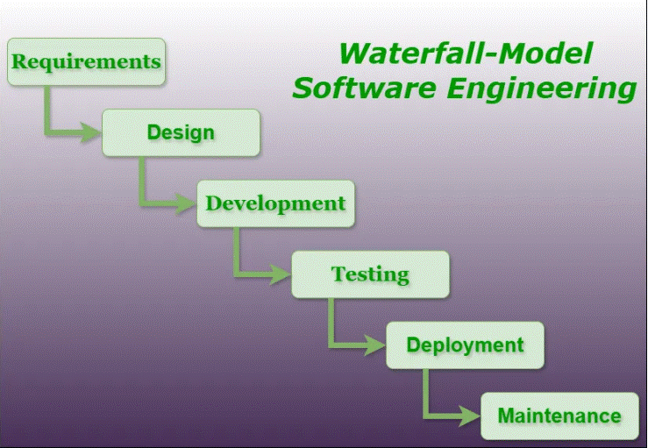

Figure 1 - Waterfall Model

The Waterfall Model is a traditional software development methodology that follows a structured linear approach ideal for the development of this Valorant esports analytical website. This model consists of several distinct phases such as requirements gathering, system design, development, testing, deployment, and maintenance, whereby each phase must be completed before proceeding to the next.

Just like a waterfall, the process flows in one direction making it well-suited for this assignment where requirements are well-defined and changes are least expected.

One of the main advantages of using the Waterfall Model is for clear documentation and well-defined requirements, ensuring the process follows a logical progression that aids in precise planning, in-depth goal tracking, and compliance with deadlines, enabling a smooth assignment flow. The model structure comes in handy during the ‘Testing’ phase, as complete quality assurance will be carried out on a completely developed product prior to releasing the finalized version of the website.

**3.2 Explanation of Methodology Phases**



Figure 2 - Requirement Gathering Phase

The ‘Requirement Gathering’ phase comprises collecting and documenting all prerequisites for the Valorant esports analytical website. This includes understanding the preferences, challenges, and expectations of potential users using the website. The desired features, including search filters, player comparisons, and match analysis will influence the website's core structure. Requirements from the diverse audience in the gaming community will be taken into consideration, ensuring everyone will be able to use the website equally and achieve their tasks straightforwardly without hindering other parties.



Figure 3 - System Design Phase

The ‘System Design’ phase is where the assignment’s initial layout and design are established. For the VEC.gg website, the focus will be on creating an intuitive yet visually appealing interface design that enhances the Valorant esports analytics experience, ensuring users can access information regarding match and player statistics, events information, and patch updates. Apart from that, implement filtering options that would enable fans, players, coaches, and analysts to efficiently find the data they want.



Figure 4 - Development Phase

The ‘Development’ phase is where the coding of the website will take place. VEC.gg will be built using programming languages such as HTML, CSS, and JavaScript, a framework like React, and a backend like Node.js. The development process will ensure that the core features such as tournament schedules, event information, player compassion, and match statistics are implemented first. Apart from that, prioritization will be made for cleaner coding, simple yet functional design, and ensure scalability to encourage future enhancements.



Figure 5 - Testing Phase

The ‘Testing’ phase is pivotal in ensuring the quality and performance of the website.

It involves rigorous quality assurance (QA) processes to identify and fix any bugs present. This includes functional testing that ensures all features work as intended, usability testing to refine the UI/UX of the website, and performance testing to optimize the loading speeds. Furthermore, user feedback will be collected through user testing that will be done to further refine the website.



Figure 6 - Deployment Phase

The ‘Deployment’ phase is where the finalized website is launched. VEC.gg website will be hosted on a secure server to ensure high availability and fast performance. A soft launch will be conducted with selected users to test and review the website to gather any final feedback, make adjustments accordingly, and verify its readiness before fully releasing it to public access.



Figure 7 - Maintenance Phase

The ‘Maintenance’ phase is where regular updates, improving security, performance optimizations, bug monitoring, adding new features, and response to user-reported issues will be performed to keep the website continuously running without any issues. Furthermore, server maintenance and backups will be done on a regular basis to ensure the website is always under control and up-to-date.

**3.3 Justification**

The Waterfall model suits this assignment in designing and developing a Valorant esports analytical website assignment as it provides a structured linear approach, ensuring that each phase is completed before proceeding to the next one. Considering that UI/UX design requires thorough planning and research before implementation, the Waterfall model ensures that all goals and requirements are well understood before starting the ‘Development’ phase.

Furthermore, the Waterfall model is great due to its well-defined stages, making it easier to track progress and maintain accountability. Especially for this UI/UX assignment, prototypes, and user testing results are crucial for maintaining consistency throughout development. With each phase documented, we can always refer back to the initial design decisions whenever needed, avoiding any misinterpretation.

Moving on, the Waterfall model is appropriate for UI/UX projects as user research and prototyping is conducted prior to the coding process. The Waterfall model ensures that usability testing, heuristic evaluations, and data gathering are properly conducted before moving to the next phase. This will scale down the chances of serious design revamps later in development, saving us all some time and resources.

Lastly, this user experience design assignment will benefit from the predictability and ease of management in the Waterfall model considering there are clear milestones and deadlines. Stakeholders can easily review progress at every stage due to the Waterfall model structure, ensuring that the finalized VEC.gg website is well-designed, intuitive, and meets the expectations set during the initial design phase.

**3.4 Use of Development Tools**Development tools are necessary for successfully creating a Valorant esports analytical website assignment. Programming languages, integrated development environments, version control systems, and user feedback tools as a whole lean on each other in simplifying the designing and development processes.

**3.4.1 Programming Languages**



Figure 8 - HTML

HTML or Hypertext Markup Language, is the backbone of web development as it is pivotal in creating the main layout of a webpage. It defines elements such as headings, paragraphs, lists, links, and images.



Figure 9 - CSS

CSS or Cascading Style Sheets, is responsible for ensuring visually appealing and consistent website design. It defines the styles for HTML elements such as fonts, colors, position, padding, and margin.



Figure 10 - JavaScript

CSS or Cascading Style Sheets, is responsible for ensuring visually appealing and consistent website design. It defines the styles for HTML elements such as fonts, colors, position, padding, and margin.

**3.4.2 Development IDE (Integrated Development Environment)**



Figure 11 - Visual Studio Code

Visual Studio Code is a commonly used text editor by developers for various programming tasks. It features multiple tab support, powerful search and replace functionality, smart auto-completion, fast performance and uses system resources efficiently.

**3.4.3 Version Control (VCS)**



Figure 12 - GitHub

GitHub is a widely used web-based platform for developers to manage and collaborate on code. It offers users features like version control with Git, to track changes, pull requests for code review, manage assignments, making it essential for both individual and team-based development.

**3.4.4 User Feedback Tools**



Figure 13 - Google Forms

Google Forms is a simple yet powerful tool used for creating custom feedback surveys and forms to collect responses from users on their experience with the website’s usability and features in real time. The data collected are easy to be analyzed as well.

**3.4.5 JavaScript Library**



Figure 14 - React

React is a JavaScript library for building user interfaces, targetting mainly web applications. It uses a virtual DOM for efficient updates.

**3.4.6 JavaScript Runtime**



Figure 15 - Node.js

Node.js is a JavaScript runtime environment which allows devolopers to build applications that run outside of a browser. It is very commonly used for backend development as it is open-sourced and cross-platform.

**CHAPTER 4: INITIAL DESIGN**

The UI/UX design of VEC.gg website derives from the 10 Usability Heuristics set by Jakob Nielsen, which is listed down below and followed by the VEC.gg prototype model and examples:

1. Visibility of System Status:

The design must provide appropriate feedback promptly so that users are made aware of what’s going on. Through familiarity of the system status, users can grasp the outcome of their actions and move forward to the succeeding task. Predictable interactions promote trust in both the product and the brand. (Nielsen, 1994)

1. Match Between System and Real World:

Sometimes there might be situations whereby terms, concepts, icons, and images that are familiar to us may be foreign to other users. The design should be tailored to specific users and apply familiar words, phrases, and concepts, that convey information naturally and logically. By doing so, users can quickly grasp and remember how the interface works, making it intuitive. (Nielsen, 1994)

1. User Control and Freedom:

The design should include an easy “emergency exit” where users would be able to undo their mistakes without going through a lengthy process. These would prevent users from getting stuck which would eventually leave them in frustration. (Nielsen, 1994)

1. Consistency and Standards:

The design should be consistent to reduce users’ cognitive load from learning something new. Jakob’s law states that user’s expectations are influenced by other products/websites they use. Thus, users should not be guessing if different words, situations, or actions mean the same. (Nielsen, 1994)

1. Error Prevention:

The design should provide good error messages or even better, prevent problems from happening in the first place. This can be achieved by eliminating error-prone conditions or offering confirmation for users before proceeding to the next step. (Nielsen, 1994)

1. Recognition Rather Than Recall:

The design should reduce users’ memory load by keeping key information easily accessible and making elements, actions, and options visible. It is important to remember that users shouldn’t be recalling information from one part of the UI to another. (Nielsen, 1994)

1. Flexibility and Efficiency of Use:

The design should provide experts with secret shortcuts to speed up the process while maintaining a simpler design for novice users. Need to make sure we provide options that would allow users to choose methods that work best for them. (Nielsen, 1994)

1. Aesthetic and Minimalist Design:

The design should focus on essential information, thus, removing any irrelevant or rarely needed details that would otherwise clutter the interface. It should support the user’s main goals without distracting them unnecessarily. (Nielsen, 1994)

1. Help users recognize, diagnose, and recover from errors:

The design should provide simple error messages that indicate the problem clearly as well as suggest necessary solutions. These messages must be visually noticeable so that users can recognize them with ease. (Nielsen, 1994)

1. Help and Documentation:

The design should provide help and documentation. They should be straightforward, concise, task-focused, and provide clear steps for users to follow. (Nielsen, 1994)

I started off the design process by creating prototypes or the so-called initial design of the VEC.gg website using the Figma app. It is necessary to do these prototypes as it can help figure out the needs and looks of what the potential website will be like.

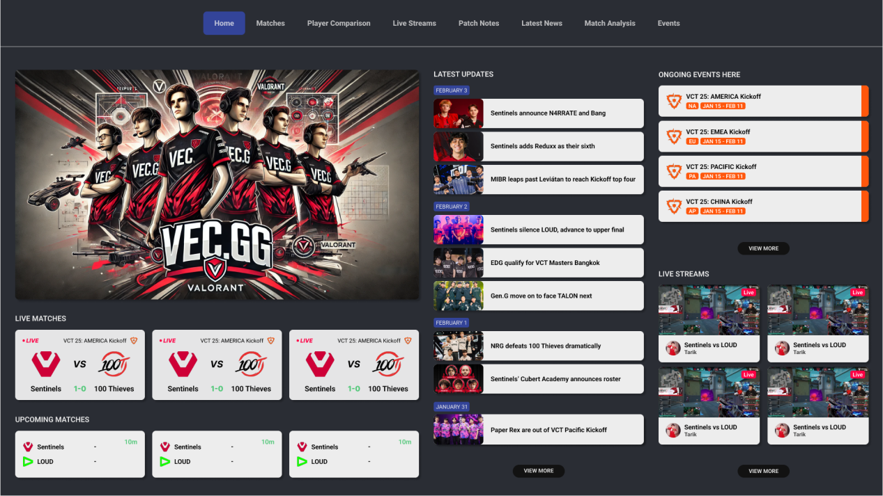

Figure 16 - Homepage Prototype

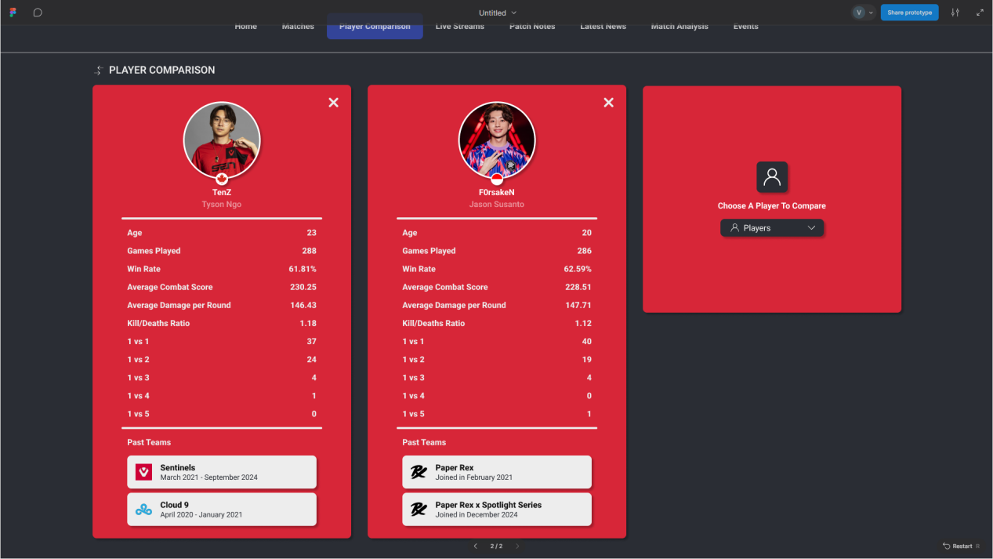

Figure 17 - Player Comparison Page Prototype

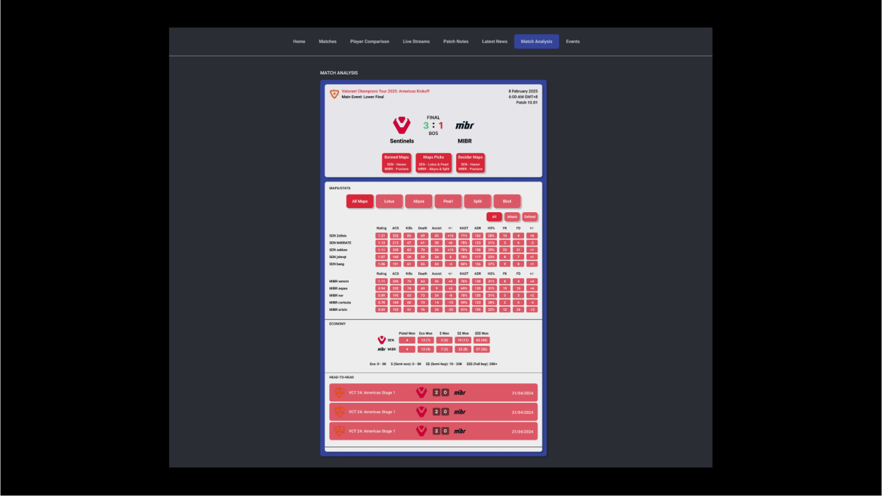

Figure 18 - Match Analysis Page Prototype

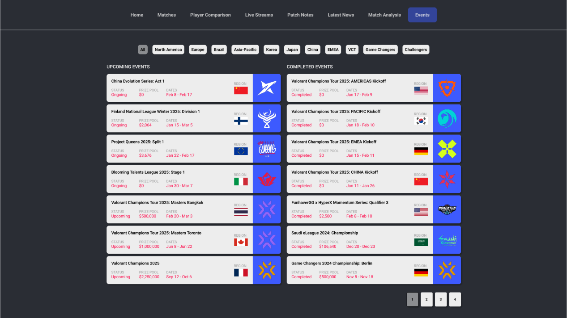

Figure 19 - Events Page Prototype

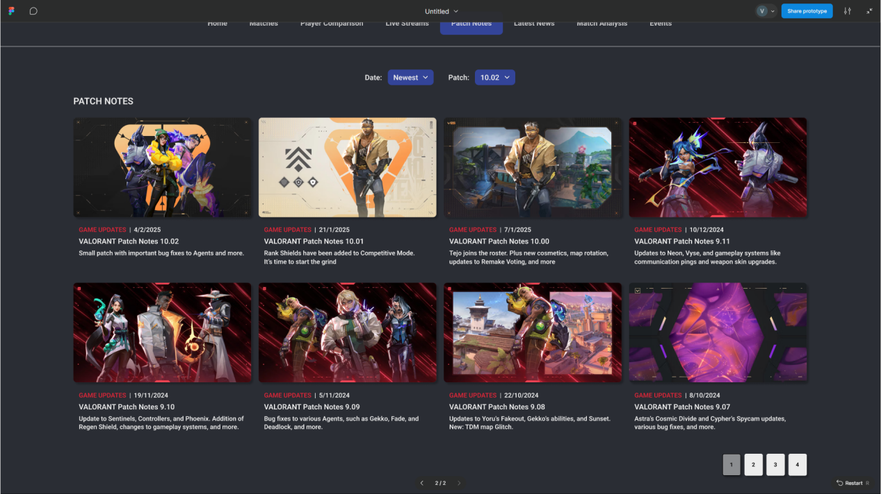

Figure 20 - Patch Notes Page Prototype

**CHAPTER 5: FIGMA PROTOTYPE TESTING**

**5.1 Figma Prototype**

For the first user testing, a Figma prototype is done instead of a paper prototype. User tested the app through this design.

|  |  |
| --- | --- |
| **Prototype** | **Function** |
| Picture1 | The Homepage Prototype is the first page users will see when they browse the VEC.gg website. In this webpage, there is a navigation bar at the top where users can click a single option that they desire and it will automatically redirect them to the specific webpage. Now for the content, there are live matches, upcoming events, the latest updates, upcoming events, and live streams. |
| Picture2 | The Player Comparison Page Prototype is where users will use it to make comparisons between two or three Valorant Pro players. In this webpage, there is a navigation bar at the top where users can click a single option that they desire and it will automatically redirect them to the specific webpage. Now for the contents, there are 3 containers available to display max of three Valorant pro players’ statistics. By default, it displays text stating “Choose A Player To Compare” and below it is the dropdown menu and search bar combined for users to choose a player that they want to compare. When the player is selected, it will display information such as age, games played, win rate, average combat score, average damage per round, kills/deaths ratio, 1 vs 1, 1 vs 2, 1 vs 3, 1 vs 4, and 1 vs 5, and all of the past teams that they have played with as well as the duration. |

|  |  |
| --- | --- |
| Picture4 | The Match Analysis Page Prototype is the main webpage that users will see first when they browse the VEC.gg website. In this webpage, |
| Picture5 | The Events Page Prototype is the main webpage that users will see first when they browse the VEC.gg website. |
| Picture3 | The Patch Notes Prototype is the main webpage that users will see first when they browse the VEC.gg website. In this webpage, |

Table 2 - Figma Prototype

**5.2 Testing**

There are 5 questions prepared for the users to answer during the testing, which are:

1. Identify the best player on the Player Comparison page?
2. Can you identify what ACS stands for on the Match Analysis page.
3. Do you think there is too much information on Match Analysis page?
4. Who has the highest first kills in the Sentinels vs MIBR match?
5. Find information for the Valorant Champions 2025 on the Events page.

Link for the First User Testing:

* https://youtu.be/_c9QgGOGyIc?si=NnzhAT6vA6GB5E4V

**5.3 Result**

This are the results and feedback received from the 5 selected users during the first User Testing done.

|  |  |
| --- | --- |
| **User** | **Feedback** |
| Syafiqah Othman | Q1. Identify the best player. |
| Q2. Identify what ACS stands for. |
| Q3. Do you think there is too much information on Match Analysis page? |
| Q4. Who has the highest first kills in the Sentinels vs MIBR match? |
| Q5. Find information for the Valorant Champions 2025. |

|  |  |
| --- | --- |
| Sofia Alkubra | Q1. Identify the best player.   * On the Player comparison page, I can see there is two players, Tenz and Forsaken. And going through their statistics, they both seem to be equally good but in my opinion I think Tenz is slightly better so yes, I would say Tenz is the best player. It would be easier to figure out who is the best by maybe adding each player with their ranks and maybe add a color to highlight player that has higher statistics compared to the other player. |
| Q2. Identify what ACS stands for.   * Browsing through the Match Analysis page, I can see ACS. Since I do play Valorant, I know that ACS does mean Average Combat Score. It would be better if there is like a information corner that states the meaning of ACS or even for any other abbreviations. Since not everyone may be familiar with these word. |
| Q3. Do you think there is too much information on Match Analysis page?   * I think the amount of information presented is good but maybe can add abit more information that can trully be helpful for analysts, coaches and players for better analyzation. And maybe add different colors to differentiate each stats. Right now the red color is too saturated and makes it harder to differentiate each stats. |
| Q4. Who has the highest first kills in the Sentinels vs MIBR match?   * Based on First Kills or the term FK, SEN Zekken seems to have the highest amount with 22 first kills. Similar to question 2, it will be easier if there is like a information corner that states what does FK mean so that people who don't know where to find first kills can refer to. |
| Q5. Find information for the Valorant Champions 2025.   * Going to the events page, I see valorant champions 2025 at the most bottom under upcoming events. The information states that the tournament status is upcoming, the prize pool is $2,250,000 , the dates are from sep 12 to oct 6 and is in the france region. The information given seems reasonable but maybe instead of just stating the region and expecting users to guess the tournament location, maybe can provide the actual location of the tournament or atleast the city where it will be held. |

|  |  |
| --- | --- |
| Bryan | Q1. Identify the best player.   * I am currently in the Player comparison page, there are two players who are Tenz and Forsaken. And seeing their statistics, they seem to have similar statistics. Personally, I would say that Tenz is the best player. I do think there are some informations lacking. Maybe a player ranking would help making faster decision. |
| Q2. Identify what ACS stands for.   * Browsing through and on the match analysis page, I spot ACS, and as far as i know, it stands for Average Combat Score. But i do think a number of people would find it difficult to figure that out. So maybe add like a section to display the meaning of ACS. It would definitely be helpful. |
| Q3. Do you think there is too much information on Match Analysis page?   * Personally, I would say it does lack some information plus the red color used for the statistics is kinda making it difficult to read. So I would advise to either use lighter red color or use multiple colors for each statistics. It would certainly make it easier to compare statistics. |
| Q4. Who has the highest first kills in the Sentinels vs MIBR match?   * Browsing through the match analysis page again, and under FK, Sen Zekken seems to have the highest first kills with 22 first kills. As a gamer, it was pretty easy to figure out but I can see some people may find it difficult to spot this. The only way I think it would help is to add section to display the meaning of FK or just display the full word "First kills". |
| Q5. Find information for the Valorant Champions 2025.   * Browsing through the events page, I spot the valorant champions 2025 at the bottom under the upcoming event category. Based on the information displayed, I know that the tournament is upcoming, starting from sep 12 till oct 6, the prize pool of @2,250,000, and the region is france. Pretty sufficient information i would say but it would be nice to maybe know what teams are invited and where exactly in france this tournament will be held at. |

|  |  |
| --- | --- |
| Ammar | Q1. Identify the best player.   * I am currently in the Player comparison page, there are two players who are Tenz and Forsaken. And seeing their statistics, they seem to have similar statistics. Personally, I would say that Tenz is the best player. I do think there are some informations lacking. Maybe a player ranking would help making faster decision. |
| Q2. Identify what ACS stands for.   * Browsing through and on the match analysis page, I spot ACS, and as far as i know, it stands for Average Combat Score. But i do think a number of people would find it difficult to figure that out. So maybe add like a section to display the meaning of ACS. It would definitely be helpful. |
| Q3. Do you think there is too much information on Match Analysis page?   * Personally, I would say it does lack some information plus the red color used for the statistics is kinda making it difficult to read. So I would advise to either use lighter red color or use multiple colors for each statistics. It would certainly make it easier to compare statistics. |
| Q4. Who has the highest first kills in the Sentinels vs MIBR match?   * Browsing through the match analysis page again, and under FK, Sen Zekken seems to have the highest first kills with 22 first kills. As a gamer, it was pretty easy to figure out but I can see some people may find it difficult to spot this. The only way I think it would help is to add section to display the meaning of FK or just display the full word "First kills". |
| Q5. Find information for the Valorant Champions 2025.   * Browsing through the events page, I spot the valorant champions 2025 at the bottom under the upcoming event category. Based on the information displayed, I know that the tournament is upcoming, starting from sep 12 till oct 6, the prize pool of @2,250,000, and the region is france. Pretty sufficient information i would say but it would be nice to maybe know what teams are invited and where exactly in france this tournament will be held at. |

|  |  |
| --- | --- |
| Praveenash Chelvam | Q1. Identify the best player.   * So this can be seen in the player comparison page, and there are two players who are Tenz and Forsaken. And based on their statistics, they seem to be on par. But I think I would go with Tenz. It's hard to compare as there are very little statistics displayed. Adding a couple more information could ease up the decision making on who is the best player. |
| Q2. Identify what ACS stands for.   * So this can be seen in the player comparison page, and there are two players who are Tenz and Forsaken. And based on their statistics, they seem to be on par. But I think I would go with Tenz. It's hard to compare as there are very little statistics displayed. Adding a couple more information could ease up the decision making on who is the best player. |
| Q3. Do you think there is too much information on Match Analysis page?   * Looking through the page, it seems to have a good amount of information. The only down side is that the same color is being used all over which makes it hard to differentiate each statistics. So, apply multiple colors that would allow users to easily spot specific statistics and to be compared with. |
| Q4. Who has the highest first kills in the Sentinels vs MIBR match?   * Alright, now looking at the match statistics, if we look at FK which is first kills, and check each player, it's easy to conclude that SEN Zekken has the most first kills with 22. A suggestion for improvement, add hint that explains what FK means. |
| Q5. Find information for the Valorant Champions 2025.   * So in the events page. If you look through, you will find the Valorant Champions 2025 tournament at the bottom. It is under the upcoming event category. Reading it you can get some information about the tournament. That includes the fact that the tournament status is listed as upcoming, the prize pool is $2,250,000.00 and its in the france region. For improvements, I think it would be better if the actual location or city to be displayed because right now i am clueless of where the tournament will be held and pretty certain other users would feel the same as well. |

Table 2 - Figma Prototype Testing Results

**5.4 Summary of Feedback and Results**

Completing this testing, It’s good to receive some valuable feedback from the selected users as there are a couple of issues present that certainly need to be fixed. Users would prefer to have highlighted statistics for the better player when making comparisons, as well as display each player’s rank. This would significantly ease the decision-making when deciding which player is better.

For match analysis, users find themselves finding it slightly difficult to identify particular statistics since the entire statistics are pretty much covered with the same saturated red color. Although they are knowledgeable about the terms/abbreviations, it is suggested to maybe include a section where they are explained. For events, the majority of them are pretty satisfied with the amount of information displayed, but they still suggested potentially adding the specific city or venue and the invited teams for each event.

Some of the users’ feedback given for improving the website include:

1. Add player ranking for each player.
2. Highlight the better statistics between 2 players.
3. Explain terms/abbreviations in match analysis.
4. Use multiple colors to differentiate or categorize statistics.
5. More data for match analysis.
6. Display the specific city or venue of a particular event.
7. Display the invited teams for a particular event.

**CHAPTER 6: DIGITAL PROTOTYPE TESTING**

**6.1 Digital Prototype**

**6.2 Testing**

There are 5 questions prepared for the users to answer during the testing, which are:

1. Identify the best player on the Player Comparison page?
2. Can you identify what ACS stands for on the Match Analysis page.
3. Do you think there is too much information on Match Analysis page?
4. Who has the highest first kills in the Sentinels vs MIBR match?
5. Find information for the Valorant Champions 2025 on the Events page.

Link for the Second User Testing:

**6.3 Result**

This are the results and feedback received from the 5 selected users during the second User Testing done.

|  |  |
| --- | --- |
| **User** | **Feedback** |
| Sofia Alkubra | Q1. Identify the best player.   * TenZ is definitely the best player as he has more better statistics in comparison and he is also already being ranked as number one player. * By making text green color for statistics of a player that is better when compared, clearly makes it easier when making comparison, as the person with more green text color would pretty much be the better player. |
| Q2. Identify what ACS stands for.   * Since I do play Valorant, I know that ACS stands for Average Combat Score. * But I don’t think anyone would struggle figuring that out as there are a couple of explanation for words like ACS and others being displayed below the statistics area. |
| Q3. Do you think there is too much information on Match Analysis page?   * I would say that the information being presented is good. I can easily differentiate each statistics since each of them are displayed with different color now. Plus, I can also know what agents each player have picked for the matches. |
| Q4. Who has the highest first kills in the Sentinels vs MIBR match?   * Well, looking through the match statistics and under FK which is ‘First Kills’, SEN Zekken seems to have the highest amount with 22 first kills. There is nothing much to say as you can spot it pretty straightforward. |
| Q5. Find information for the Valorant Champions 2025.   * The information given states that the status is upcoming, the prize pool is $2,250,000, dates are from September 12 until October 6, 2025, and will be held at France, specifically at the city of Paris. Personally, the information displayed seems sufficient and I think adding more information would just make it too cluttered. |

|  |  |
| --- | --- |
| Syafiqah Othman | Q1. Identify the best player.   * Looking at their stats, it’s clear that TenZ is the better player. His statistics are stronger overall, and he’s also ranked as the number one player. That just reinforces the fact that he’s the best. * The way the website highlights better stats in green makes it really easy to compare. If a player has more green text, it’s obvious that they’re performing better. |
| Q2. Identify what ACS stands for.   * Since I play Valorant, I already know that ACS stands for Average Combat Score. But even if I didn’t, it wouldn’t be hard to figure out because there are explanations for terms like ACS right below the stats section. This is super helpful because users can quickly check what these abbreviations mean without having to look elsewhere. |
| Q3. Do you think there is too much information on Match Analysis page?   * I’d say the information is presented well. It’s easy to distinguish each statistic since they’re displayed in different colors. Another thing is that I can also see which agents each player picked for the matches, which is a nice touch. I would like to suggest maybe add a icon or something similar to let users know who was the best performing player in a particular match. |
| Q4. Who has the highest first kills in the Sentinels vs MIBR match?   * Looking at the match stats under ‘FK’ (which stands for First Kills), I can see that SEN Zekken has the highest number, with 22 first kills. It’s pretty direct to spot. And again, just like with ACS, there’s already an area explaining terms like FK, so I don’t think anyone would struggle with this. |
| Q5. Find information for the Valorant Champions 2025.   * The information provided says the event is upcoming, the prize pool is $2,250,000, and it’s scheduled from September 12 to October 6, 2025, in Paris, France. Honestly, the details given are more than enough. |

|  |  |
| --- | --- |
| Bryan | Q1. Identify the best player.   * Looking at their stats, TenZ is clearly ahead. He has better overall statistics, and he’s ranked as the number one player, which further proves his dominance. I personally like the highlighting of the better stats in green making comparisons really simple since whoever has more green stats is obviously the better player. |
| Q2. Identify what ACS stands for.   * As a gamer who has played numerous FPS games, I know it means Average Combat Score. But even if I didn’t, the site provides proper explanations for terms like ACS right under the stats section. |
| Q3. Do you think there is too much information on Match Analysis page?   * Not at all. The stats are color-coded, making them easy to distinguish. Also, I can see which agents each player picked, which adds extra useful context. The layout feels well-organized and easy to read. Maybe for future updates, you can add a community comment section at the bottom for users to comment their prediction or thoughts about the teams involved in that particular match. |
| Q4. Who has the highest first kills in the Sentinels vs MIBR match?   * Looking at the match stats under FK (First Kills), I see that SEN Zekken leads with 22 first kills. It’s easy to find, and since the site already explains what FK means, there’s no reason for any confusion to arise. |
| Q5. Find information for the Valorant Champions 2025.   * The details show that it’s an upcoming tournament with a $2,250,000 prize pool, taking place from September 12 to October 6, 2025, in the France region, and it is in the Paris city to be exact. Honestly, considering that the events are mostly upcoming, I’m pretty certain any extra information are still unavailable. For instance, we won’t know which teams will be involved as there are still multiple events that needs to be completed prior to conclude which teams are qualified to participate in this event. |

|  |  |
| --- | --- |
| Ammar | Q1. Identify the best player.   * After a short moment of looking at their stats, it’s obvious that TenZ is the best player. His stats are stronger overall, and he’s already ranked number one, which confirms it. Plus, as a person who watches Valorant Tournament pretty frequently, there is no denying about it. I like the way better stats are in green color makes it super easy to compare. |
| Q2. Identify what ACS stands for.   * Personally, as a gamer, I do know that ACS means Average Combat Score. But anyways, I will navigate myself to ‘Match Analysis.’ and briefly reading all the information available and yes, I spot the ACS. It is pretty straightforward to spot on, but even if someone wasn’t familiar with it, they wouldn’t struggle since the site includes a section explaining terms like ACS right below the statistics area. This certainly reduces the workload for some of the potential users. |
| Q3. Do you think there is too much information on Match Analysis page?   * Personally, I think the way the information is presented is great. The different colors help separate the statistics, making them easy to understand. Plus, I can see which agents each player picked, which is useful information. It is way nicer to see this webpage now in comparison to before where the colors were mostly in red and super saturated which does hurt the eye. |
| Q4. Who has the highest first kills in the Sentinels vs MIBR match?   * Looking under the FK (First Kills) section, I see that SEN Zekken has the most, with 22 first kills. It’s really easy to spot, and since the site already explains FK, I don’t think anyone would struggle with it. |
| Q5. Find information for the Valorant Champions 2025.   * The information given tell me it’s an upcoming tournament with a $2,250,000 prize pool, scheduled from September 12 to October 6, 2025, in Paris, which the capital city of France. The information given is sufficient. |

|  |  |
| --- | --- |
| Irina | Q1. Identify the best player.   * Looking at both their stats, it’s clear that TenZ is the superior player. He has better overall numbers and is ranked number one, which backs it up. |
| Q2. Identify what ACS stands for.   * Before I navigate to the ‘Match Analysis’ page, I would just like to say, as a fellow gamer, ACS stands for Average Combat Score. Now, in the ‘Match Analysis’ page, I can easily spot the term ACS in the Maps/Stats section. And I think that no matter who it is, we sure can easily figure it out as there is even a small section under this that lists all these gaming terms with their full explanation. So people shouldn’t be scratching their heads trying to figure these out. |
| Q3. Do you think there is too much information on Match Analysis page?   * Honestly, I think the information is well-organized. The stats are color-coded, making them easy to read, and I can also see the agents each player picked, which adds a bit context. Would say that in comparison to the previous version, it is not that eye-straining as before it was pretty much the same saturated red color almost everywhere. |
| Q4. Who has the highest first kills in the Sentinels vs MIBR match?   * Looking back into the statistics that is being displayed and checking the FK (First Kills) section, I see the highest is with 22 first kills and that belongs to SEN Zekken. It’s quite straightforward to find since that term is already explained on the page and will be pretty easy for anyone to refer. |
| Q5. Find information for the Valorant Champions 2025.   * The event informations includes the $2,250,000 prize pool, the dates from September 12 to October 6, 2025, and the location Paris, France. The information is clear and well-presented. Maybe for future updates, the filter can be more functional by adding filter by dates, prize pools, regions, and status upcoming or completed. |

Table 3 - Digital Prototype Testing Results

**6.4 Summary of Feedback and Results**

Completing this testing, It’s good to see that users are feeling much more comfortable using the website. Users no longer feel eye-strained by the saturated red colors on the ‘Match Analysis’ page as well as able to identify information much quicker with the multiple color-coded statistics. With the implementation of a section for term/abbreviations reference, users can now easily refer to words that they don’t know without wasting much time.

For the ‘Player Comparison’ page, a few slight changes were made to the color usage, making it less saturated which again lessens the eye strain at the same time shows the statistics much clearer. Apart from that, highlighting the better stats of players and adding their ranks makes the comparison process way clearer and faster. Moving on to the ‘Events’ page, by adding the city location, users can easily find the exact event location instead of guessing which part of the France region it will be held in.

Some of the users’ recommendations given for future implementation:

1. A page for player transfers.
2. A feed for Valorant-related social media posts.
3. An icon for the best-performing player in each match.
4. A community comment section under matches for discussions and predictions.
5. Adding filter options for events based on date, prize pool, region, and status.

**CHAPTER 7: CONCLUSION & FUTURE IMPROVEMENTS**

**7.1 Conclusion**

Each phase of this assignment was executed thoroughly ensuring the VEC.gg website stays aligned with the market trends and satisfies user expectations. The requirements-gathering process highlighted essential features such as search filters, functionality to compare players' statistics, and necessary match statistics, all of which were implemented effectively. A structured development flow was created through the Waterfall methodology, ensuring a clear understanding of each phase and accomplishment before progressing to the next phase. Testing and deployment phases played a vital role as they ensured in production a high-quality and accessible website experience. With consistent updates, this Valorant esports analytical website will be reliable and stable for long-term operation.

**7.2 Future Improvements**

Although the Valorant esports analytical website has successfully hit the initial goals, there is still room for further enhancements that can be done in the future to better improve the website in terms of user experience and functionality, as well as adapting to current market trends.

Firstly, implement dark mode and light mode toggle. It has become a necessity these days as a huge percentage of people prefer dark mode rather than the default light mode. This would grant users the ability to switch between themes based on their preference for better readability and comfort.

Secondly, implement user community polls and analysis. This would allow users to vote on upcoming matches as well as look into the community’s opinion on certain relevant topics. Users can exchange thoughts on players' or teams' recent performance and then predict who will win the upcoming match.

Next up, implement user esports trivia and challenges. It involves users engaging with interactive quizzes and Valorant-related challenges for entertainment. At the same time, it would allow users to test their already known knowledge as well as gain knowledge unaware of.

Moving on, implement user social media integration. This can be done by displaying live X and Reddit posts related to Valorant esports such as posts, images, videos, art, or even updates related to Valorant esports or just Valorant in general. This would ease users as they would have one main place to stay updated with all the latest updates.

Lastly, implement user live event ticket sales. As well all know, tournaments are successful mainly because of audiences, and it has become common for people to purchase tickets to attend tournaments they are interested in. But, instead of purchasing on a separate website. Users can straightaway purchase tickets here for upcoming Valorant esports events. Unfortunately, this would require an agreement from the official Riot Games company.

**REFLECTION**

The designing and developing process for this Valorant esports analytical website has certainly been a challenging journey yet fulfilling. Involving technical hurdles, creative problem-solving, and personal growth. The main aim of this assignment was to design and develop an intuitive website for users consisting of esports fans, players, teams, and analysts to get information regarding upcoming and completed matches or events, player statistics, and patch notes with ease while integrating good UI/UX practices.

In terms of challenges, one of the biggest ones was creating multiple versions of designs to figure out the best version that would satisfy both the design and functionality aspects of the website. Apart from that, time management played a crucial role in the shorter amount of time given to accomplish this assignment. Especially during both user tests, getting feedback from my friends does occupy quite an amount of time as not all of them are available due to work or exams. It wasn’t an easy task managing datasets to offer proper pieces of information and ensure quick search functionality.

On a personal level, this assignment highlighted the importance of time management and continuous effort to accomplish it at a satisfactory level within the given time. Effective planning played an important role in the assignment’s success, with realistic goals and time completion expectations. Each setback experienced served as a learning opportunity, enhancing my problem-solving skills and confidence for future endeavors. Besides, it has also deepened my knowledge of UI/UX in general.

**REFERENCES**

‌

1. Statista. (2025). Esports - Worldwide | Statista Market Forecast. [online] Available at: https://www.statista.com/outlook/amo/esports/worldwide [Accessed 27 Jan. 2025].
2. VLR.gg. (2025). Valorant esports coverage | VLR.gg. [online] Available at: https://www.vlr.gg/ [Accessed 27 Jan. 2025].

‌

1. Rashmini Nayanathara (2021). PACT Analysis - Bootcamp - Medium. [online] Medium. Available at: https://medium.com/design-bootcamp/pact-analysis-3ac5fbe8817 [Accessed 28 Jan. 2025].
2. Scoutli.co. (2025). Scoutli — VALORANT Esports Analytics. [online] Available at: https://www.scoutli.co/comparison [Accessed 10 Feb. 2025].

‌

1. Playvalorant.com. (2025). Patch Notes. [online] Available at: https://playvalorant.com/en-us/news/tags/patch-notes/ [Accessed 10 Feb. 2025].

‌

1. Morgan, T. (2021). Esports And Gaming Industry Trends | GlowTouch. [online] GlowTouch LLC. Available at: https://www.glowtouch.com/esports-and-gaming-industry-trends-to-watch-for/ [Accessed 12 Feb. 2025].
2. Kumar, N. (2025). eSports Viewership Statistics 2025 – Audience Growth Data. [online] DemandSage. Available at: https://www.demandsage.com/esports-statistics/#:~:text=The%20global%20esports%20audience%20is%20expected%20to%20exceed%20640.8%20million,people%20joining%20the%20esports%20community. [Accessed 12 Feb. 2025].

**APPENDICES**

**Appendix A - Survey Results/User Feedback**

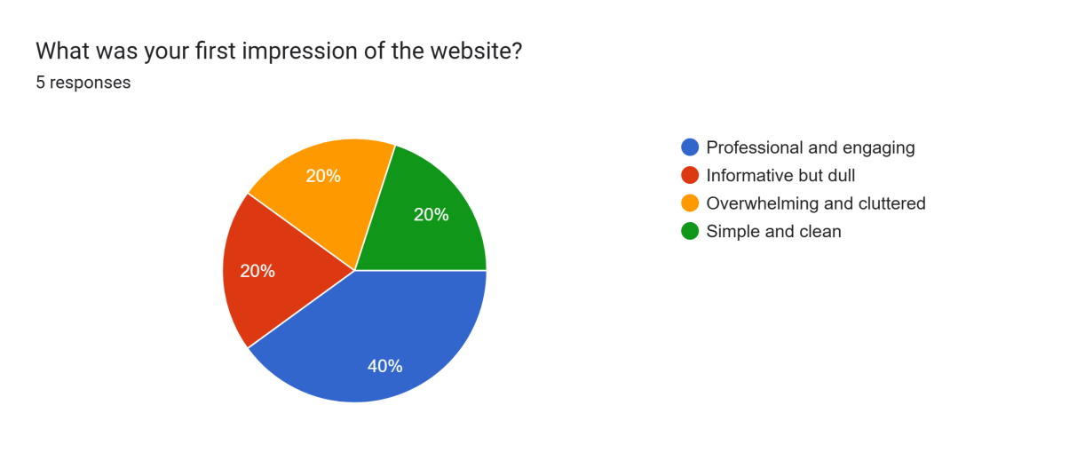

Figure 21 - Google Form Survey Question 1

Based on feedback from five users, the first impressions of VEC.gg were mixed, highlighting both strengths and areas for improvement. While 40% of users found the website professional and engaging, indicating that the design and content successfully capture the essence of Valorant esports analytics, 20% felt it was informative but dull, suggesting a need for more visually dynamic elements or interactive features. Another 20% found the interface overwhelming and cluttered, pointing to possible issues with content organization, navigation, or excessive information density. Lastly, 20% appreciated the simplicity and cleanliness of the design, indicating that certain aspects of the UI were well-structured and easy to navigate. This feedback suggests a balance needs to be struck between maintaining professionalism and engagement while refining the layout to ensure clarity, visual appeal, and ease of use.

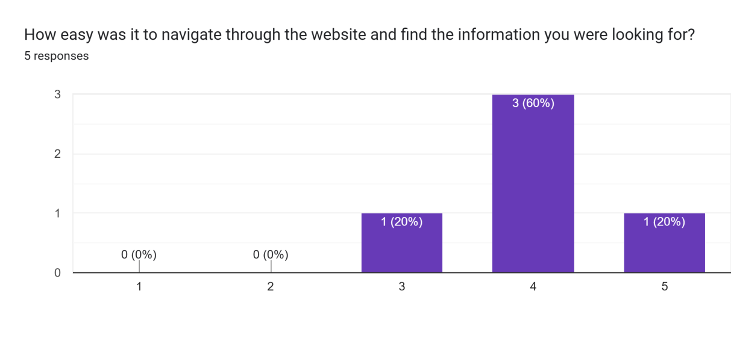

Figure 22 - Google Form Survey Question 2

The navigation experience on VEC.gg received generally positive feedback, with 60% of users rating it a 4, indicating that most found it relatively easy to find the information they were looking for. Additionally, 20% rated it a 5, suggesting that at least one user had a seamless experience. However, another 20% rated it a 3, implying that while navigation was manageable, there may have been some areas where clarity or ease of access could be improved. Notably, no users found it very difficult (1 or 2), which is a positive sign that the website’s structure is functional. To enhance the user experience further, refining menu organization, improving search functionality, or simplifying certain sections could help ensure a consistently smooth navigation experience for all users.

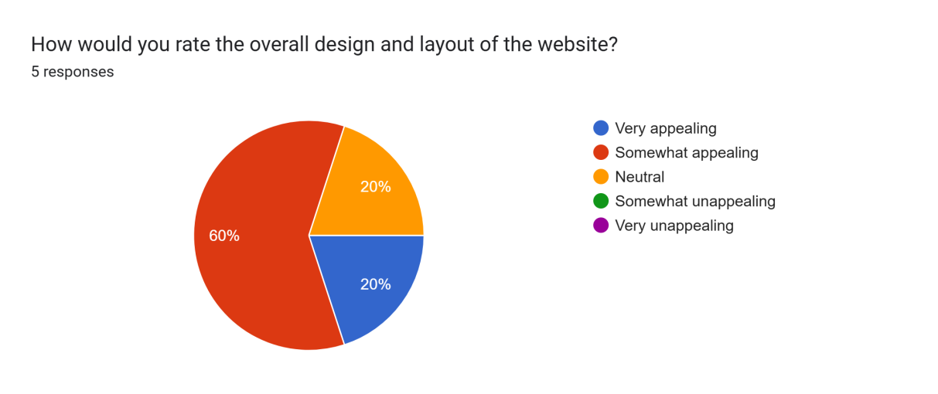

Figure 23 - Google Form Survey Question 3

The overall design and layout of VEC.gg received mostly positive feedback, with 60% of users finding it somewhat appealing and 20% rating it as very appealing. This suggests that the website has a solid design foundation that resonates with most users. However, 20% remained neutral, indicating that while the design was not necessarily bad, it may not have stood out or left a strong impression. Notably, no users found the design unappealing, which is a positive indicator of its effectiveness. To enhance the design further, refining visual elements, improving consistency, and incorporating more engaging UI components could help move more users from a neutral stance to a more positive perception.

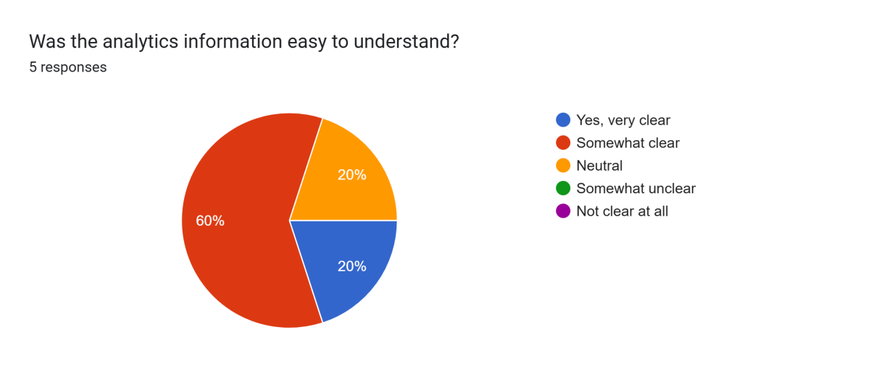

Figure 24 - Google Form Survey Question 4

The clarity of analytics information on VEC.gg was generally well-received, with 20% of users finding it very clear and 60% rating it as somewhat clear. This suggests that the majority of users were able to understand the analytics but may have encountered minor difficulties in interpreting certain data points or visualizations. Additionally, 20% of users remained neutral, indicating that while the information was not necessarily confusing, it may not have been as intuitive or engaging as expected. Notably, no users found the analytics unclear, which is a positive sign. To improve clarity further, simplifying complex data visualizations, adding tooltips or explanations, and ensuring a user-friendly layout could help make the analytics even more accessible and insightful for all users.

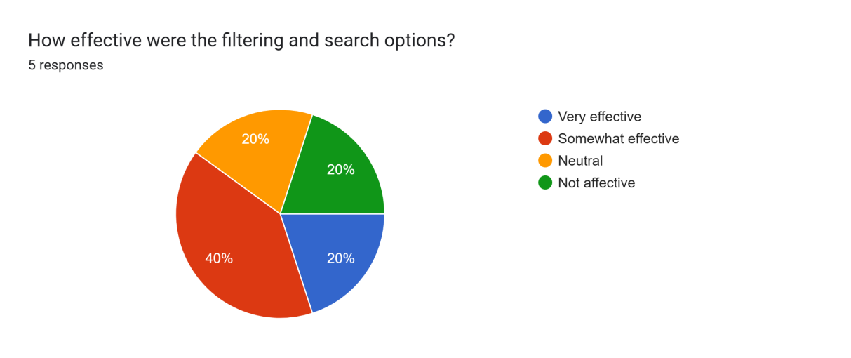

Figure 25 - Google Form Survey Question 5

The filtering and search options on VEC.gg received mixed feedback, with 20% of users finding them very effective and 40% rating them as somewhat effective. This indicates that while the features are functional for most users, there is room for improvement in terms of efficiency and usability. Additionally, 20% remained neutral, suggesting that the filtering and search options may not have stood out or provided a significant advantage in navigating the website. However, 20% of users found them ineffective, highlighting potential issues such as unclear filtering criteria, slow performance, or lack of relevant results. Enhancing these features by refining search algorithms, improving filter categories, and ensuring a seamless user experience could help increase their overall effectiveness and usability.

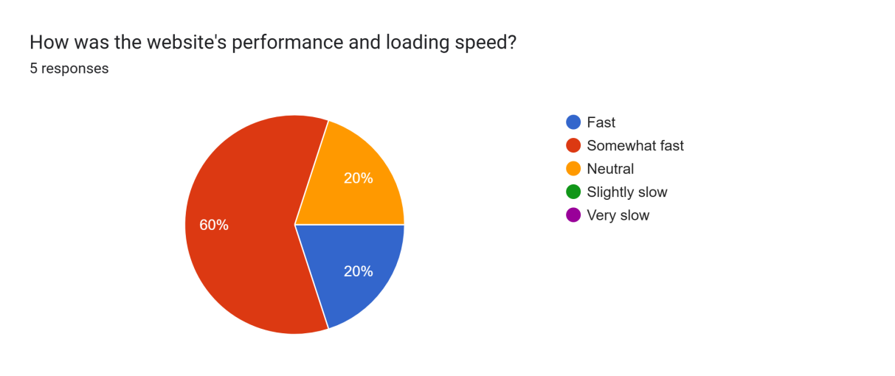

Figure 26 - Google Form Survey Question 6

The performance and loading speed of VEC.gg were generally positive, with 20% of users finding it fast and 60% rating it as somewhat fast. This indicates that the website performs well for most users, with only minor delays or areas for optimization. However, 20% of users remained neutral, suggesting that while the speed was not a major issue, it may not have felt particularly smooth or impressive either. Notably, no users found the website slow, which is a strong indicator of good overall performance. To further enhance loading speed, optimizing images, improving caching strategies, and minimizing unnecessary scripts could help ensure a consistently fast experience for all users.

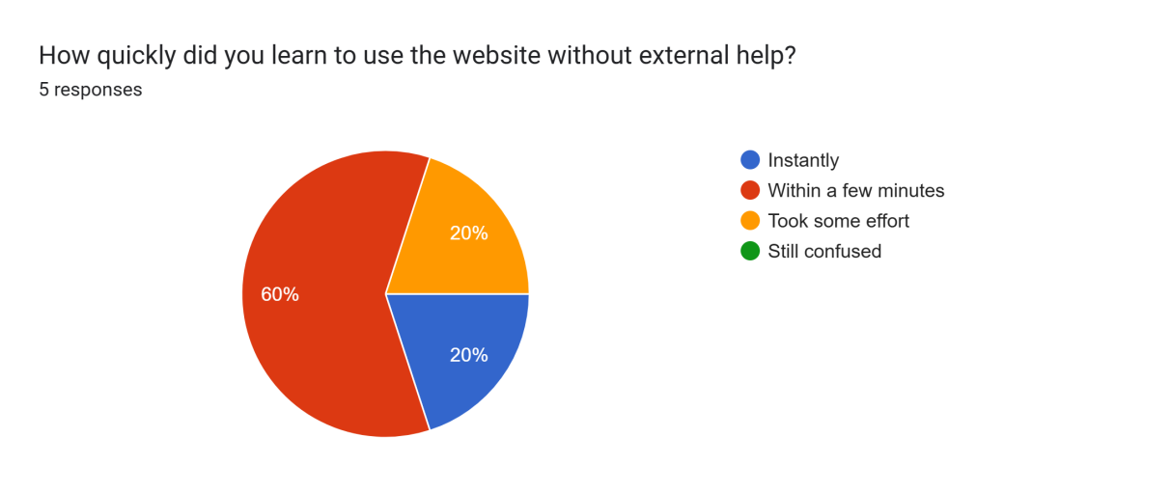

Figure 27 - Google Form Survey Question 7

The learnability of VEC.gg was largely positive, with 20% of users able to navigate it instantly and 60% learning to use it within a few minutes. This suggests that the website has an intuitive design that allows most users to adapt quickly without external help. However, 20% of users mentioned that it took some effort to understand, indicating that certain elements or features might not be immediately clear or intuitive. Notably, no users reported being completely confused, which is a strong indicator of a generally user-friendly interface. To further improve ease of use, refining onboarding elements, providing subtle tooltips, and ensuring a logical content hierarchy could help make the website even more accessible for all users.

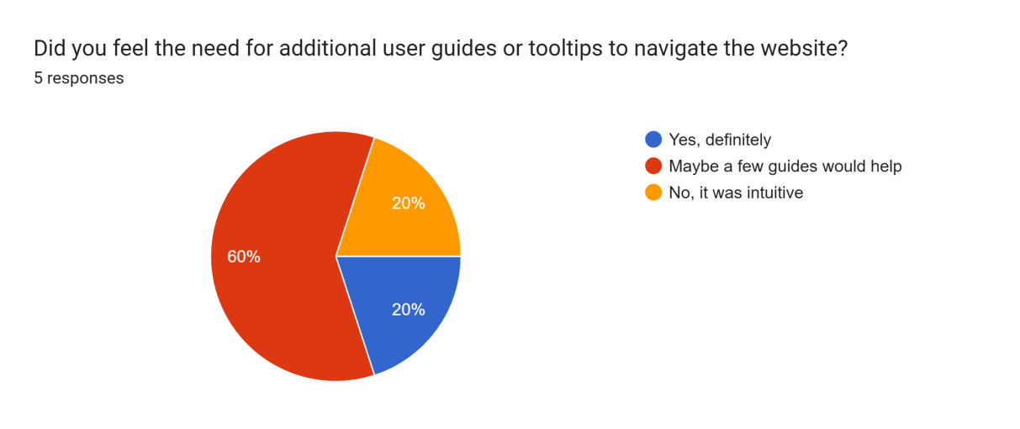

Figure 28 - Google Form Survey Question 8

The feedback regarding the need for additional user guides or tooltips was mixed. While 20% of users felt that additional guides or tooltips were needed, 60% suggested that having a few guides would be helpful, indicating that some users encountered minor uncertainties or needed extra assistance in specific areas. On the other hand, 20% of users felt the website was intuitive enough, implying that the current design and navigation were clear and did not require additional help. To address the varying needs, incorporating optional tooltips, brief guides, or an FAQ section could enhance the experience, ensuring that both novice and experienced users feel confident using the site.

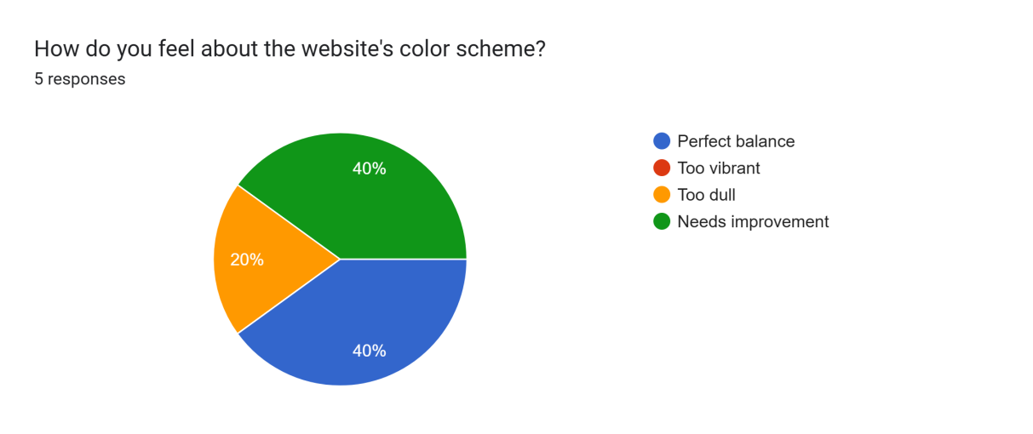

Figure 29 - Google Form Survey Question 9

The feedback on the website’s color scheme was somewhat divided. 40% of users felt there was a perfect balance, suggesting that the color choices effectively complemented the design and content. However, 40% found the colors too vibrant, indicating that certain tones or contrasts might be overwhelming or distracting for some users. Additionally, 20% felt the color scheme was too dull, possibly implying that the site lacked enough visual energy or contrast to capture attention. This mixed response suggests that the color palette could benefit from refinement. A more balanced approach that tones down overly vibrant colors while adding more depth or accents could help appeal to a broader range of users.

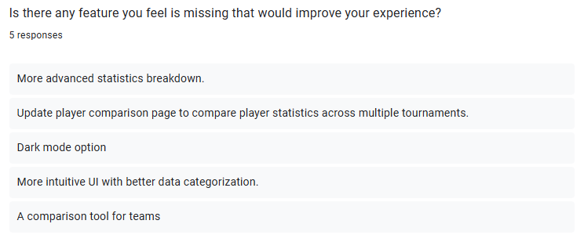

Figure 30 - Google Form Survey Question 10

Based on user feedback, several features were identified that could enhance the experience on VEC.gg. A more advanced statistics breakdown was suggested, which would allow users to delve deeper into the data for more insightful analysis. Additionally, an update to the player comparison page, enabling users to compare player statistics across multiple tournaments, would provide a more comprehensive view. A dark mode option was also requested, catering to those who prefer a less bright interface for prolonged use. Improving the UI to be more intuitive, with better data categorization, would make navigation and data interpretation even easier. Lastly, the addition of a comparison tool for teams could enhance the site's functionality by allowing users to analyze and contrast team performances more effectively. These improvements would help create a more user-friendly and data-rich experience for esports enthusiasts.

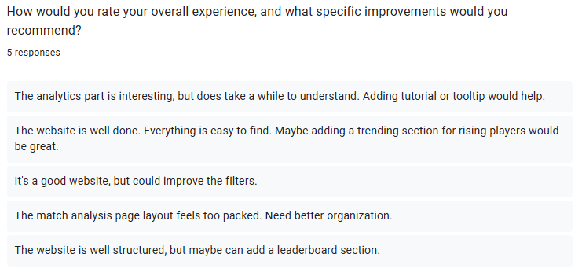

Figure 31 - Google Form Survey Question 11

Overall, users seem to have had a positive experience with VEC.gg, though several specific improvements were suggested. One user found the analytics interesting but noted that it takes time to fully understand, recommending the addition of tutorials or tooltips for better guidance. Another user praised the ease of navigation but suggested adding a trending section for rising players to enhance the content. The filters were highlighted as an area for improvement by one user, indicating that they could be refined for a better experience. Another user felt that the match analysis page layout was too packed and would benefit from better organization to make it more digestible. Finally, a user recommended adding a leaderboard section to further enhance the website's functionality. These improvements would help streamline the experience, making it even more intuitive and informative for users.

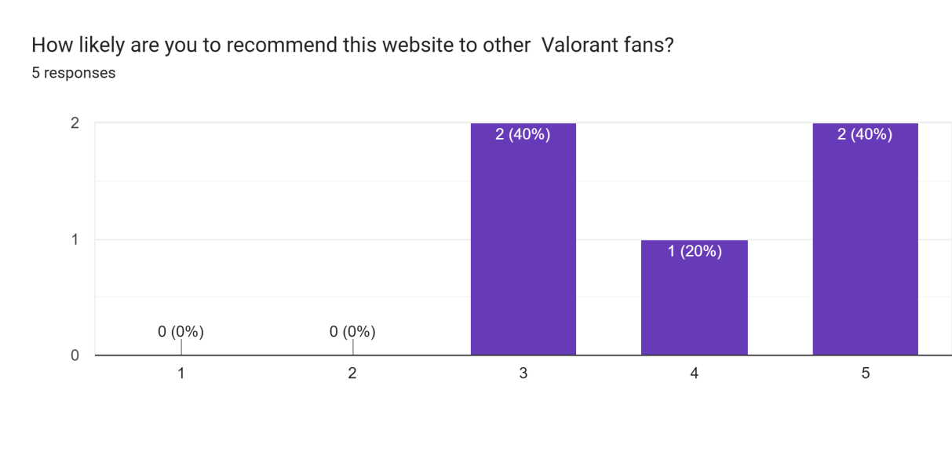

Figure 32 - Google Form Survey Question 12

The likelihood of recommending VEC.gg to other Valorant fans was generally high, with 40% of users rating it a 5 (very likely) and another 40% rating it a 3 (somewhat likely). This suggests that the website resonates well with most users, but there is still room for improvement to ensure it fully meets everyone's expectations. 20% of users rated it a 4, indicating that they found it quite good but not perfect. No users rated it a 1 or 2, which is a positive sign of the website's overall appeal. To further increase the likelihood of recommendations, addressing areas like UI organization, analytics clarity, and additional features could help make the site more universally appealing.

**Appendix B - Supplementary Charts & Graphs**

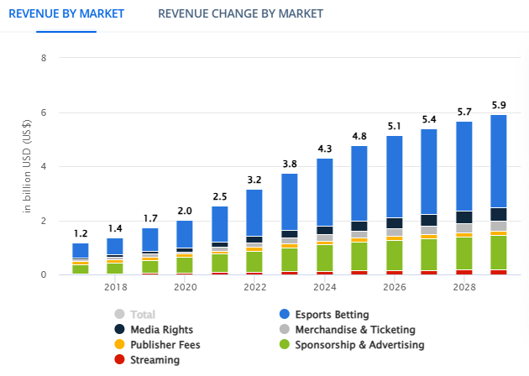

Figure 33 - Revenue by Market

The graph shows the dramatic rise of revenue by market in the esports industry. This revenue comprises diverse sources such as media rights, publisher fees, streaming, merchandise & ticketing, and sponsorship & advertising, and the major contributor in this industry, esports betting. The esports market continues to thrive annually, showing no signs of slowing down. In 2017, the revenue was already at 1.2 billion USD, and it’s expected to skyrocket to a remarkable 5.9 billion USD by 2029.

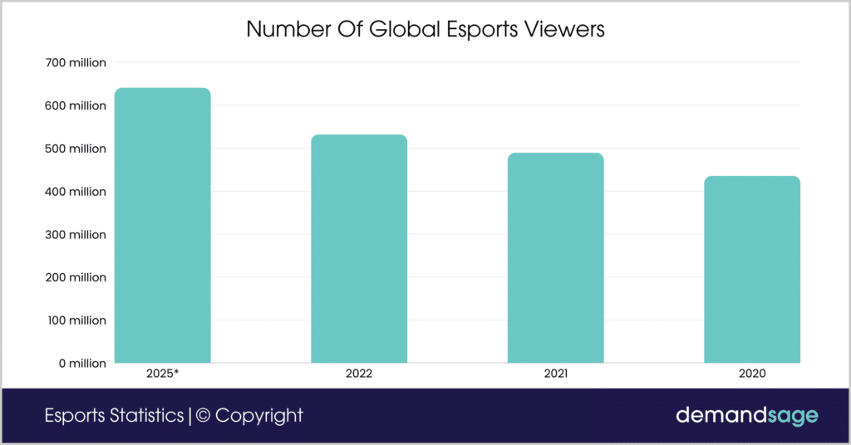

Figure 34 - Number of Global Esports Viewers

The number of global esports viewers is expected to exceed past 640.8 million in 2025. With the worldwide spread of gaming plus better streaming options have impacted more people joining the esports community. Back in 2020, there were about 435.7 million viewers, and by 2022, the number had jumped to 532.1 million viewers. As esports becoming even more mainstream, there is no denying that the audience number will keep on growing. (Kumar, 2025)

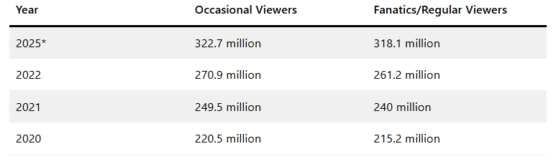

Figure 35 - Number of Occasional and Regular Viewers

As more established gamers join the esports scene, their fan bases are expanding mutually to support their favourite influencers. Esports has certainly become a mainstream sport, as in 2022, there were 261 million fanatics viewers and 270.9 million occasional viewers. With viewership growing at a steady pace, it is estimated that by 2025, there will be roughly 318.1 million fanatics viewers and 322.5 million occasional viewers. (Kumar, 2025)

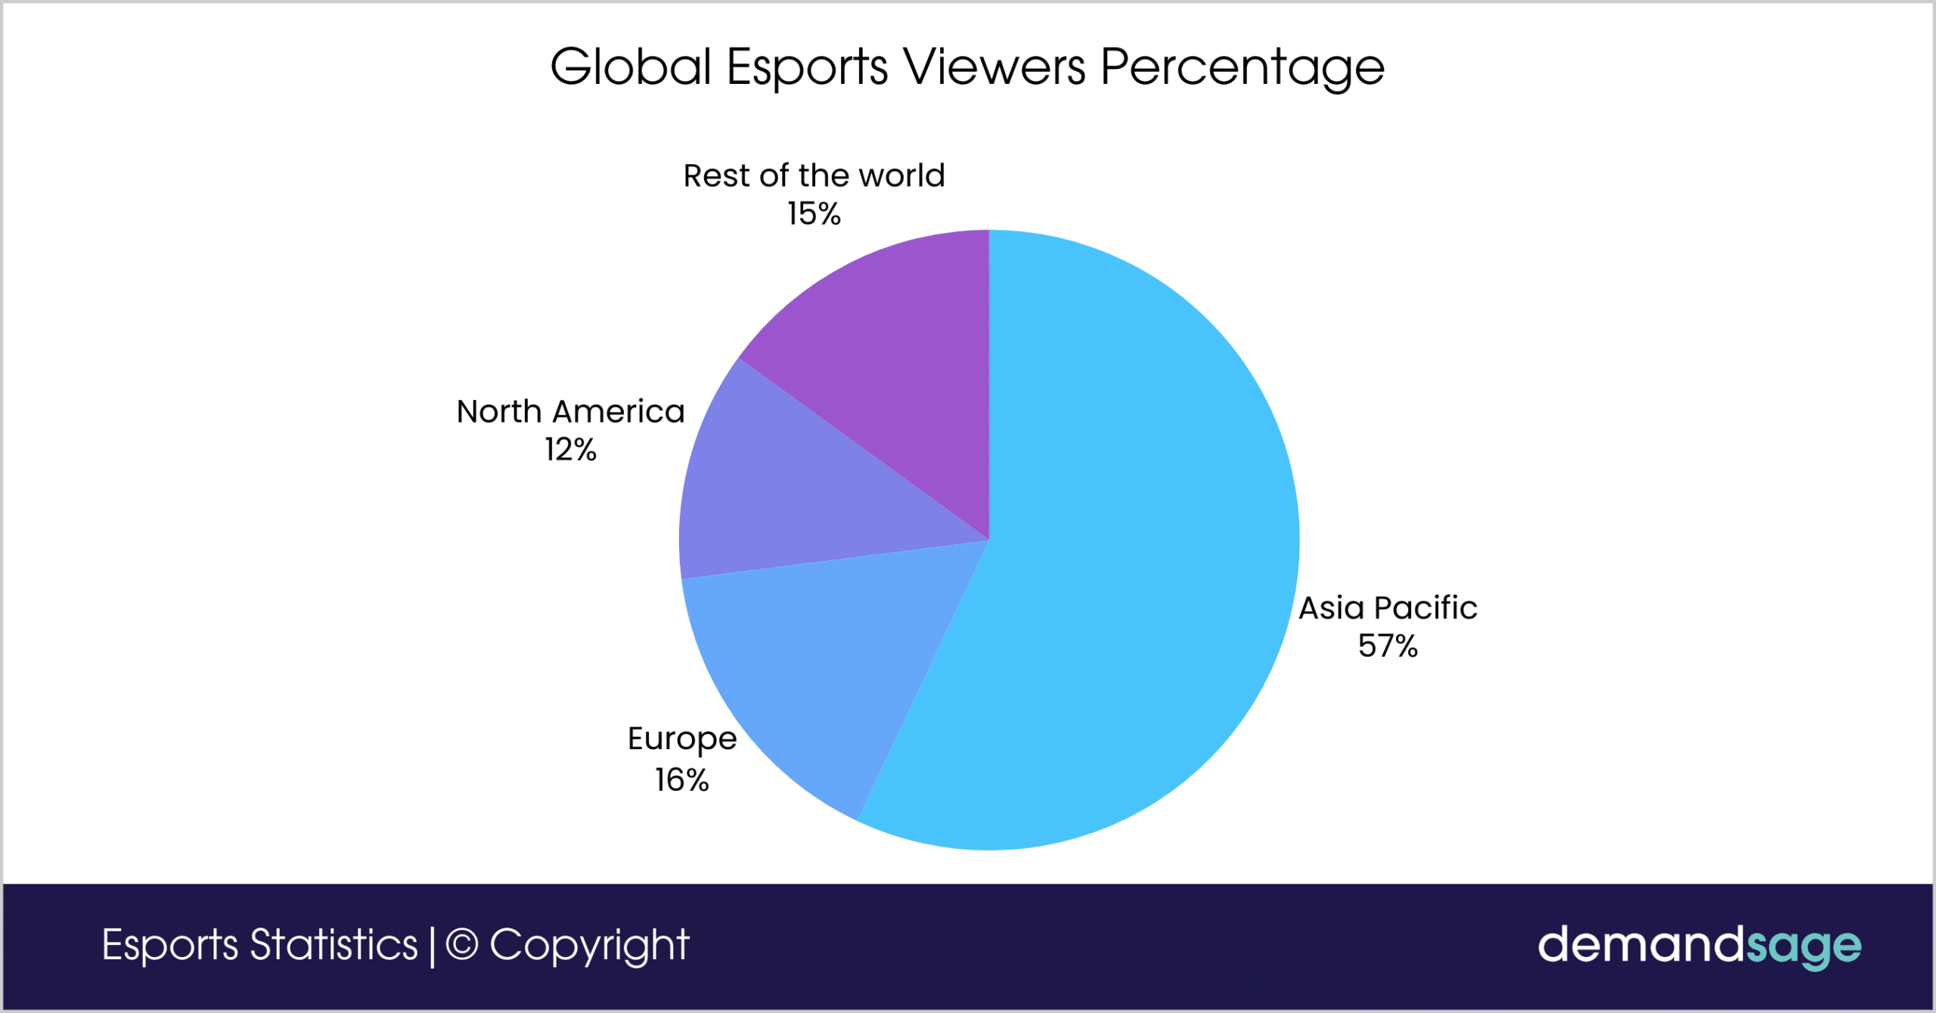

Figure 36 - Global Esports Viewers Percentage

There are roughly 1.5 billion gamers from Asia, and you can’t deny that the majority of esports fans come from that region. To be exact, that equals to about 57% which accounts for the biggest share of global esports viewers, contributed by major gaming countries like Indonesia, China, Japan, and Korean. Next up would be Europe with 16% of the global share, then North America with 12%, and finally 15% consisting of viewers from the rest of the world. (Kumar, 2025)

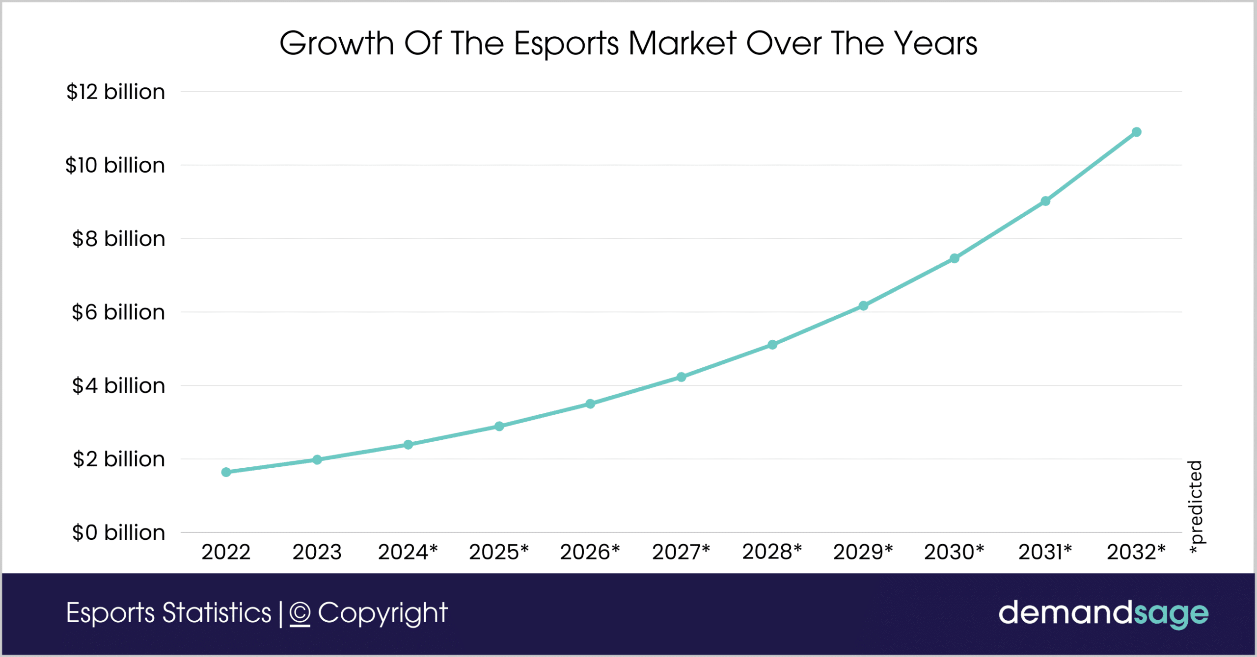

Figure 37 - Growth of the Esports Market over the Years.

The global esports market was $1.98 billion in 2023 and hasn’t slowed down ever since. With an annual growth rate of 20.9%, it is expected to reach $2.89 billion by the end of this year. It is predicted that by the year 2032, the industry could be valued at a whopping $10.9 billion, highlighting how incredible its potential growth is. (Kumar, 2025)

**Appendix C - Similarity Report**

Figure 38 - Similarity Report