**E-commerce Return Rate Reduction Analysis Report**

# 1. Objective

The objective of this project is to analyze customer return behavior in an e-commerce platform. Specifically, it focuses on identifying the reasons behind product returns and how return rates vary by product category, supplier, geography, and marketing channel.

# 2. Tools Used

* Python
* Power BI
* SQL

# 3. Step-by-Step Procedure

Step 1: Data Collection and Preparation

* Import return and order datasets.
* Remove duplicates, handle missing values, and ensure correct data types.

Step 2: Exploratory Data Analysis (EDA)

* Analyze return rates by category, supplier, and geography.
* Identify trends and outliers in return behavior.

Step 3: Feature Engineering

* Generate features such as return rate per category, average return time, and customersegments.

Step 4: Predictive Modeling

* Use logistic regression to model the probability of product returns.
* Evaluate the model using metrics such as accuracy, precision, recall, and AUC.

Step 5: Visualization and Reporting

* Use Power BI to create an interactive return risk score dashboard.
* Implement drill-through filters for deep insights by category, geography, and supplier.

# 4. Deliverables

* Interactive Power BI dashboard with drill-through filters
* Python codebase for return probability prediction
* CSV file listing high-risk products based on model predictions

**5. Code & Output**

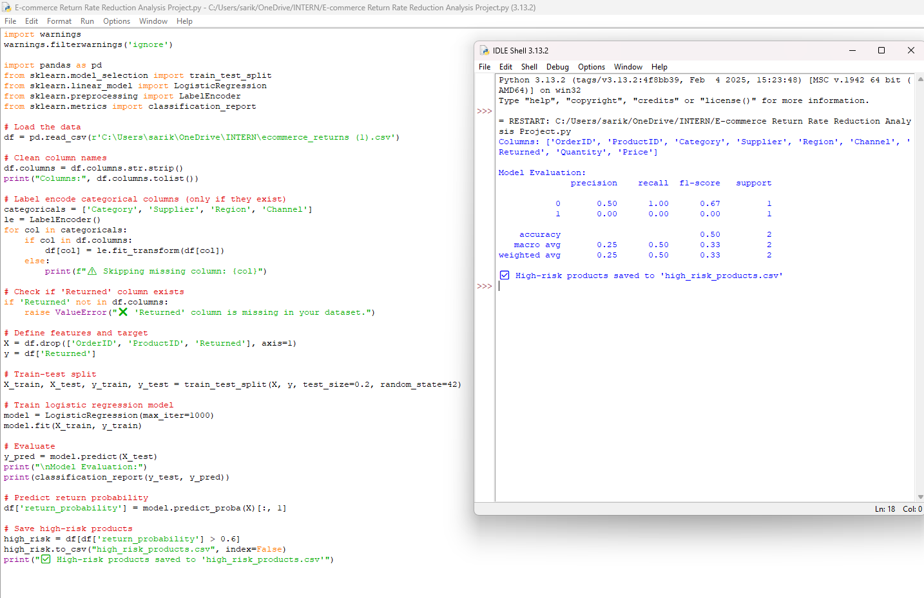

# 6. Power BI Dashboard Screenshot