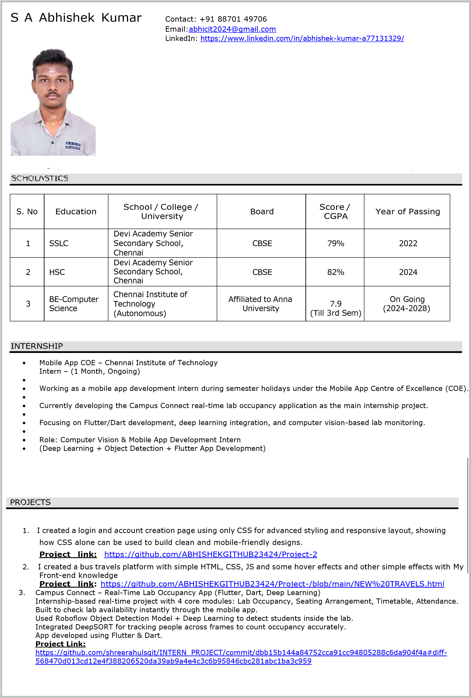

S. N o | Platform | Link / ID | Number of  Problems  Solved / Posted | Joined by
1 | Code Chef | https://www.codechef.com/users/trip_praise_67 | 75 | Aug’24
2 | Skill Rack | http://www.skillrack.com/profile/489145/e0468e1254346a74751415a1ab 9544442d47f1df | 72 | Aug’24
3 | Leetcode | yescode4534as | 158 | Aug’24
4 | GitHub | https://github.com/ABHISHEKGITHUB23424 | 4 | Aug’24

- Completed Python essentials 1 and 2 in Cisco (Waiting for certificate)
- Completed C essentials 1 in Cisco (Waiting for certificate)
- Completed Ethical hacking course in AICTE platform
- Completed basics of MongoDB course MongoDB platform
- Introduction to Java Programming – Sololearn
- Google Cloud Arcade Game + Completed 19 Google Cloud Skill Badges (Awaiting certificate

Frontend Skills:

- HTML, CSS – 1 year of learning and practicing (Intermediate)
- JAVASCRIPT - 4 months of learning and practicing (Basics)
- Programming skills: Python, C, C++ (In learning stage – Intermediate) SQL (Database management), Node.js
(Beginner)
- React.js (Beginner - 2 Months)
- Flutter & Dart – Intermediate

Backend Skills:
1. Dart(for mobile Application development)

- . Tree Plantation at Parks, School, Roadside
- . Singing
- . Shuttle Playing
- Volunteer for club activities, learning new things
- Trying to solve real world problems

