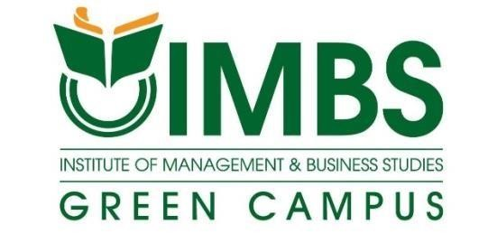

Education Field

Student Name : B. G. Janani Chamodya Nethmini Gunawansha
Student Number : C189262
Diploma : Diploma In English (78 batch online)
Submission Date : 22nd June 2025
Word Count : 2390

Table of Contents

Acknowledgment 3
List of Abbreviations 4
Introduction 5
The Importance and Evolution of Education Field 6
Why Education Matters 6
How Education Has Changed Over Time 7
The Role of ICT in Education 8
Education During the COVID-19 Pandemic 9
Global Goals and Organizations Supporting Education 10
Major Challenges in Education 11
Education and Jobs 12
Looking Ahead: The Future of Education 13
Conclusion 14
Recommendations 15
References 16

Acknowledgment

I would like to express my gratitude to all those who supported me in completing this report on the Education Field. I sincerely thank my friends, family members, and teachers who encouraged and guided me throughout this project. No matter what they were doing, their support gave me great strength to complete this work successfully. I would also like to thank all the educational websites, articles, and online sources that helped me gather important information. Many thanks also go to the internet service providers who made it possible for me to access learning materials and resources.

List of Abbreviations

- ICT - Information and Communication Technology
- UNESCO - United Nations Educational, Scientific and Cultural Organization
- MOOCs - Massive Open Online Courses
- UNICEF - United Nations International Children's Emergency Fund
- GPE - Global Partnership for Education
- SDG - Sustainable Development Goal
- VET - Vocational Education and Training
- IT - Information Technology
- AI - Artificial Intelligence
- AR - Augmented Reality

Introduction

Education is one of the most valuable foundations in any society. It helps individuals grow intellectually, emotionally, and socially while preparing them to face real-world challenges. From learning basic skills like reading and writing to developing advanced knowledge in science, technology, and the arts, education plays a powerful role in shaping a person’s future. It also supports the development of communities by creating responsible and informed citizens.
Over time, education systems have evolved significantly. Traditional classroom settings that once relied only on textbooks and chalkboards have now been transformed by modern teaching methods. Many schools and institutions use interactive tools, digital content, and group-based learning strategies to make education more engaging. This shift reflects the growing need to keep pace with global trends and technological advancements.
The rise of Information and Communication Technology (ICT) has brought a major change in the field of education. Online learning platforms, mobile apps, and virtual classrooms are now commonly used, especially after the COVID-19 pandemic. These methods have made learning more flexible and accessible to students worldwide. However, this progress also comes with challenges such as unequal access to technology and a lack of digital training for teachers and students.
This report focuses on the field of education, highlighting its importance in the modern world. It explores how education has changed over time, the impact of technology, the problems faced by today’s education systems, and the steps that can be taken to improve them. Through this report, readers will gain a better understanding of why education matters and how it can shape a better future for everyone.

The Importance and Evolution of Education Field

Why Education Matters
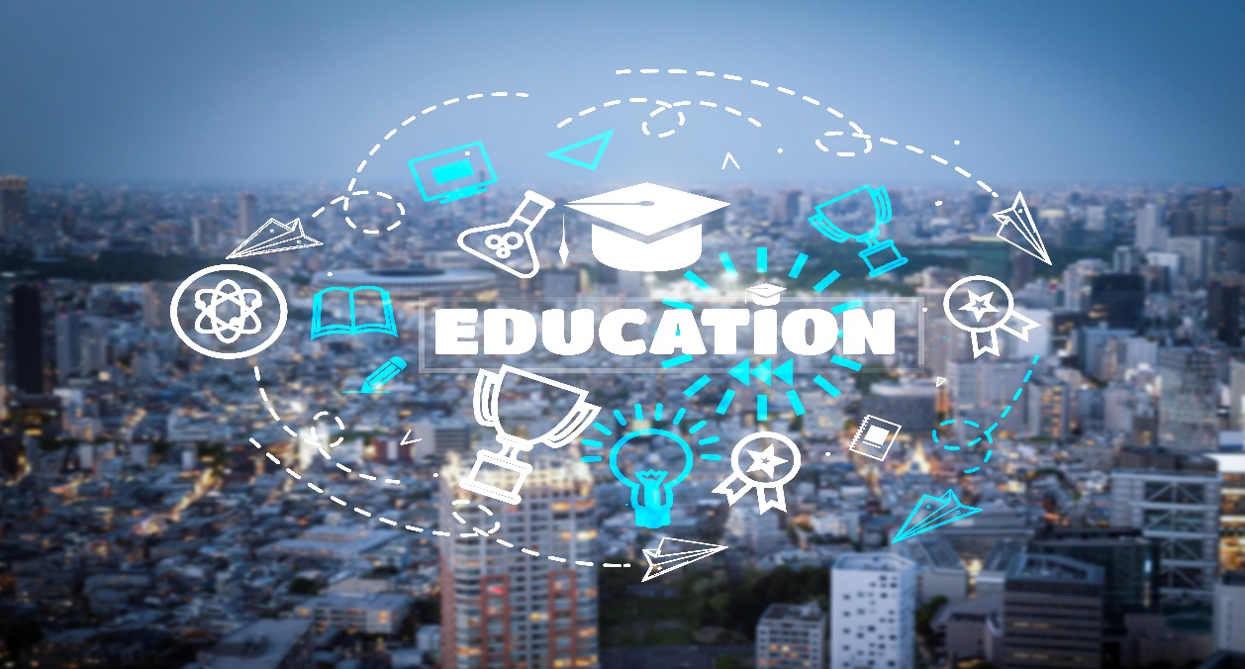

Education is one of the most important tools for improving people’s lives. It is not just about going to school or getting good grades. Education helps us learn important life skills such as thinking carefully, solving problems, making good choices, and speaking or writing clearly.
In both rich and poor countries, education plays a key role in development. It can reduce poverty, improve health, increase jobs, and bring fairness to society. According to the United Nations Educational, Scientific and Cultural Organization(UNESCO), education is a basic human right and is needed for long-term, sustainable growth that means growth that helps today’s people without harming the future.
For individuals, education builds self-confidence and helps them understand the world around them. In society, it promotes peace, respect for others, and equal opportunities. Educated people are more likely to vote, follow rules, and help in the development of their country. Also, education gives power to women and girls, helping them live better lives, make decisions, and take leadership roles

How Education Has Changed Over Time
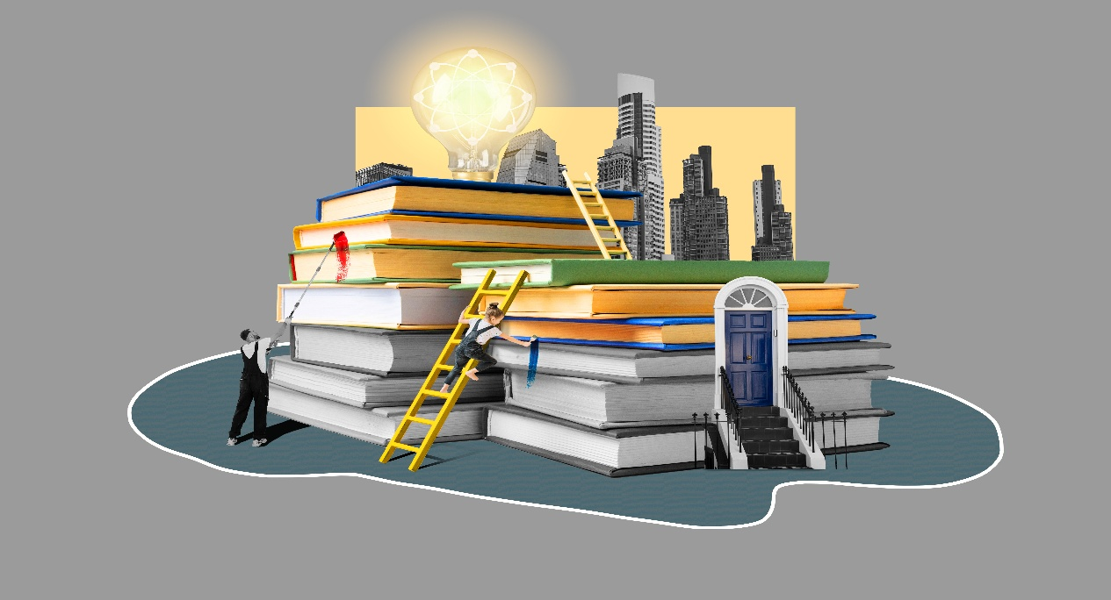

Education has gone through many changes over the years. In the past, only wealthy families or religious groups had access to formal education. Most people learned basic skills from their parents, relatives, or community through informal learning.
Big changes started during the Enlightenment period in Europe. During this time, schools became more common and more people, including the poor, had the chance to get an education. In the 20th and 21st centuries, many governments made primary education free and compulsory, meaning all children had the right and duty to attend school.
School subjects and methods were updated to match what society needed. Education began to focus more on students’ individual needs and not just on memorizing facts. In recent years, technology has become an important part of learning. Today’s classrooms are more interactive, and students are encouraged to ask questions, solve problems, and work in teams.

The Role of ICT in Education


ICT stands for Information and Communication Technology. It includes tools such as computers, the internet, tablets, smartphones, and digital learning platforms. ICT has changed both how teachers teach and how students learn.
Platforms like Google Classroom, Moodle and Zoom allow students to learn at their own pace and from anywhere in the world. Teachers can share lessons, give homework, and check student progress online.
Massive Open Online Courses (MOOCs) provide free online courses from top universities. These allow people from remote areas to access the same quality education as someone living in a big city. For example, a student in a village can take an online class from a university in another country.
Still, not all schools have the resources to use ICT. In many developing countries, schools lack internet, electricity, or devices. Some teachers don’t know how to use digital tools properly. This is called the digital divide the gap between those who have access to technology and those who don’t. To reduce this gap, governments must invest in ICT infrastructure and training.

Education During the COVID-19 Pandemic

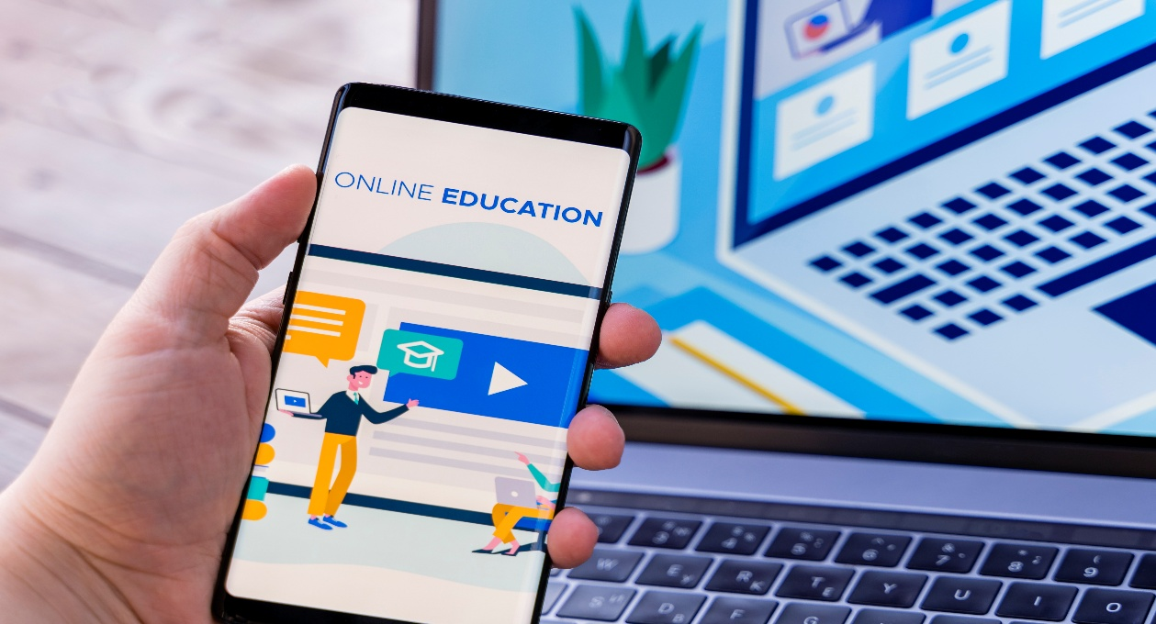

The COVID-19 pandemic had a major impact on education worldwide. When schools closed to prevent the spread of the virus, over 1.6 billion students across more than 190 countries were affected. Learning had to shift from classrooms to online platforms almost overnight.
Students started using Zoom, Google Meet, YouTube and even radio and television to attend classes. Some students could continue learning smoothly, but many others faced big problems. Many families did not have computers, smartphones, or internet at home. Some parents couldn’t help with online lessons because they were busy or didn’t understand the schoolwork.
Teachers also had to change quickly. Most were not trained in online teaching and many had trouble keeping students interested through a screen. Besides academic issues, students faced emotional and mental health challenges because they missed their friends, routine, and support from teachers.
Governments and charities tried to help by giving out devices, free internet and teacher training. The pandemic taught us that education systems must be ready for emergencies and able to keep working in difficult times.

Global Goals and Organizations Supporting Education
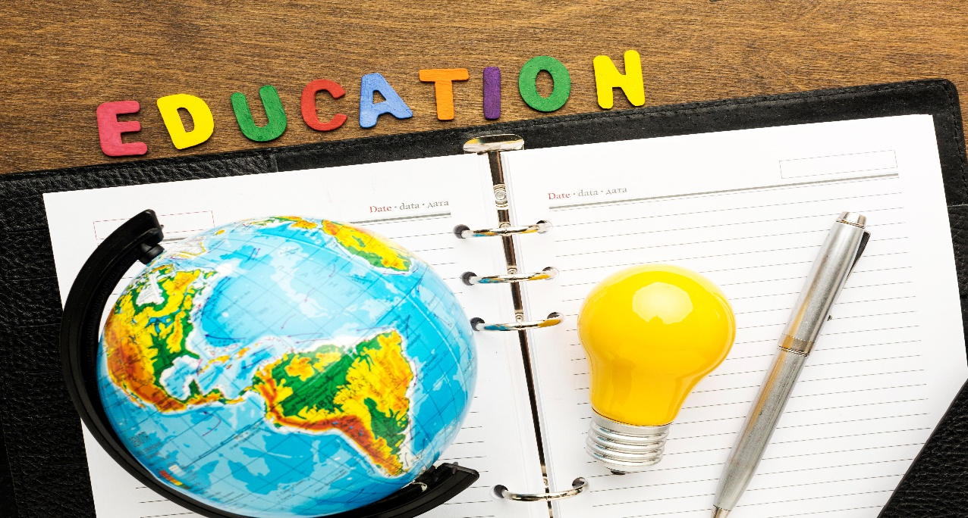

Many international organizations are working to improve education around the world. One of the main ones is UNESCO, which helps guide countries in creating good education policies. UNESCO’s Education 2030 Framework for Action supports Sustainable Development Goal 4 (SDG 4): “Ensure inclusive and quality education for all and promote lifelong learning.”
Other major organizations include:
- UNICEF, which protects children’s rights and focuses on education for every child.
- The World Bank, which gives money and advice to improve school systems in poorer countries.
- GPE (Global Partnership for Education), which supports countries with weak education systems.
These groups often help countries that are affected by war, disasters, or poverty. They help build schools, train teachers, and provide learning materials. National governments, such as the Ministry of Education in Sri Lanka, also work to improve education by creating better policies and using technology in schools.

Major Challenges in Education
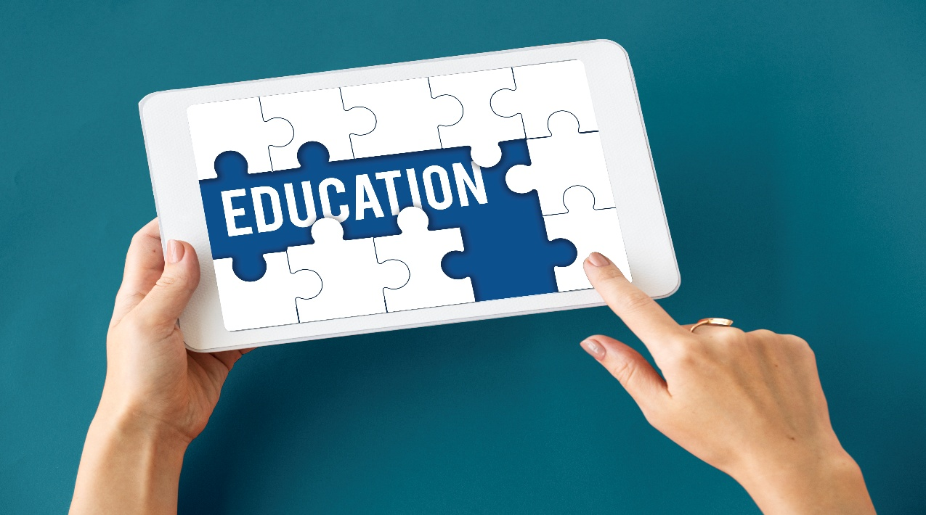

Although much progress has been made, there are still many problems in the education sector. One of the biggest is unequal access. In many places, children : especially girls, children with disabilities, and those from poor families still don’t go to school. Some must work to earn money, take care of siblings, or travel long distances to reach school.
Even when children attend school, the quality of education is not always good. Some schools are too crowded or don’t have enough books, desks, or trained teachers. This makes it hard for students to learn properly, and many drop out early.
Corruption is also a problem in some areas. Money meant for schools may be stolen or misused. In conflict zones, schools may be destroyed or used for other purposes.
Another challenge is that many education systems are not updated for the modern job market. Students often graduate without the skills they need to find good jobs or start their own businesses.

Education and Jobs


Education is closely linked to employment. People who are better educated usually get better jobs, earn more money, and are more secure in their careers. However, today’s employers don’t only look at degrees. They also want employees who have soft skills like communication, teamwork, creativity, and the ability to adapt.
Vocational Education and Training (VET) helps students learn practical skills for specific jobs, like in tourism, IT (Information Technology), healthcare, or construction. VET programs are especially useful in helping young people get jobs quickly after finishing school.
Governments and private companies should work together to make sure education matches what the job market needs. Schools should also teach entrepreneurship (how to start a business) and financial literacy (how to manage money). These skills can help young people create their own jobs and reduce unemployment.

Looking Ahead: The Future of Education
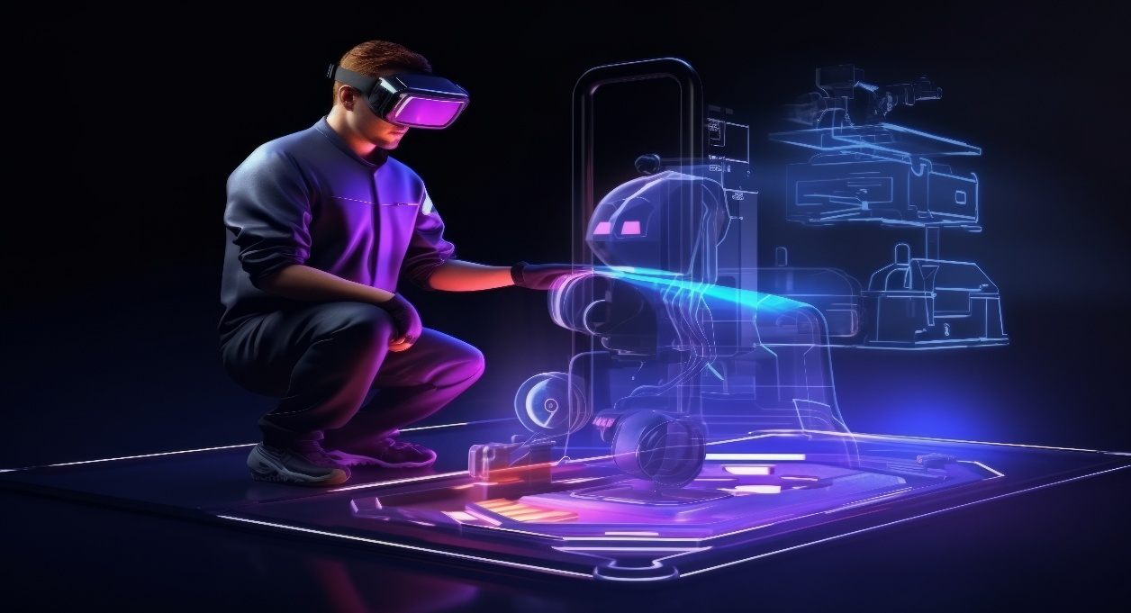

The future of education will likely combine both traditional classroom learning and modern digital tools. Technologies such as Artificial Intelligence (AI), Augmented Reality (AR) and virtual classrooms are already starting to be used in schools. These tools can make lessons more interactive and help students learn in ways that suit them best. In the future, education will need to focus more on:
- Global citizenship, which means teaching students to understand and respect different cultures and to solve problems together.
- Environmental education, so that students grow up caring about the planet and how to protect it.
- Digital responsibility, to help students use the internet and social media in safe, respectful ways.
Lifelong learning will also become more important. As technology and the job market change fast, people will need to keep learning new things throughout their lives. Schools must prepare students not only for tests but for life in a world that is always changing. Inclusive education will be another major goal. This means making sure that every student no matter their gender, ability or background gets a fair chance to learn. With strong policies, proper funding and support from families and communities; we can build education systems that help everyone succeed.

Conclusion

Education is very important for both individuals and society. It helps people gain knowledge, develop skills, and live better lives. Education also supports peace, equality, and economic growth in every country.
Over the years, education has changed a lot. With the help of technology, learning has become easier and more flexible. But there are still many challenges such as lack of access, poor school facilities and the need for better teacher training.
The COVID-19 pandemic showed us that education systems need to be stronger and ready for emergencies. It also reminded us that every child deserves the chance to learn, no matter where they live or what problems they face.
In the future, we must continue to improve education so that it is fair, modern and useful for everyone. With support from governments, teachers, and communities; we can build a better education system for the next generation.

Recommendations

After looking at the current situation in the education field, these recommendations can help improve the field of education.

- Increase Access to Education
Governments and organizations should ensure that all children, especially those in rural or low-income areas, have access to quality education. This includes building more schools, reducing school fees and providing free learning materials.

- Use More Technology in Schools
Investment in Information and Communication Technology (ICT) is essential. Schools must be equipped with internet access, digital devices and power supply. Special training programs should be introduced to help teachers and students use digital tools effectively.
- Improve Teacher Training
Teachers are key to a successful education system. Continuous professional development should be provided so that teachers can learn new teaching methods, classroom management skills and digital literacy.

- Add More Practical Learning
Vocational Education and Training (VET) programs should be expanded to help students gain practical skills for employment in fields like IT, healthcare, construction and tourism. Partnerships between schools and industries can help align training with job market needs.

- Prepare for Emergencies
Education systems must have backup plans in case of crises like pandemics or natural disasters. This includes blended learning models, home-based learning kits and teacher training in remote instruction.

- Encourage Lifelong Learning
Learning should not stop after school. Communities and workplaces should promote lifelong learning through workshops, online courses and adult education programs.

- Spend More on Education
Governments should spend more money on schools, teachers, and learning materials to make education better. This support can ensure students have a safe place to learn and the tools they need to succeed.

References

- UNESCO. (2022). Education: From disruption to recovery.
https://www.unesco.org

- UNICEF. (2021). The State of the World's Children 2021: On My Mind – Promoting, protecting and caring for children’s mental health.
https://www.unicef.org

- World Bank. (2020). Remote Learning During COVID-19: Lessons from Today, Principles for Tomorrow.
https://www.worldbank.org

- Global Partnership for Education. (2023). What We Do.
https://www.globalpartnership.org

- United Nations. (2015). Transforming our world: The 2030 Agenda for Sustainable Development.
https://sdgs.un.org/goals

- OECD. (2021). The Future of Education and Skills: Education 2030. https://www.oecd.org

- "Education." Wikipedia, Wikimedia Foundation, 20 May 2024, https://en.wikipedia.org/wiki/Education

