Contents

Lesson 1. Intro 2

Lesson 2. Installing 2

Lesson 3. Plugins and MOJO 2

Lesson 4. JVM arguments, Program arguments, Environment variables 2

Lesson 5. Archetype plugin 3

Lesson 6. POM Project Object Model 3

Lesson 7. Effective POM 3

Lesson 8. Dependency management 3

Lesson 9. Dependency scope, Dependency plugin 4

Lesson 10. Transitive dependencies, exclusions, optional dependencies 4

Lesson 11. Project lifecycles. Clean lifecycle 4

Lesson 12. Validate and compile phases 5

Lesson 13. Test phase. Surefire plugin 6

Lesson 14. Package phase 6

## Lesson 1. Intro

Before build tools projects were built by batch/shell scripts. It had drawbacks:

* Platform dependence (unix/windows required different scripts)
* Scripts from on project didn’t fit to another
* No uniform project structure (more onboarding time when you come on new project)

2000 – released Apache Ant which were more convenient than scripts.

2002 – released Apache Maven which was better because supplied uniformed project structure.

2007 – released Gradle which can use Groovy/Kotlin instead of xml.

-----------------------------------------------------------------------------------------------------------------------------------------------------------

## Lesson 2. Installing

About installing of environment variables (JAVA_HOME, JDK) for unix/windows and about apache maven in the video. About installing of Maven Wrapper in the last video of the course.

-----------------------------------------------------------------------------------------------------------------------------------------------------------

## Lesson 3. Plugins and MOJO

Maven is just a set of plugins. Each plugin is a separate java project. Plugins contain commands (goals).

Goals are MOJO (Maven plain Old Java Object) – ordinary java classes with method execute(). So we can create own goals and plugins.

mvn plugin:goal (e.g. mvn compiler:compile)

Each plugin has goal “help”.

-----------------------------------------------------------------------------------------------------------------------------------------------------------

## Lesson 4. JVM arguments, Program arguments, Environment variables

IDEA->Run->Edit Configuration

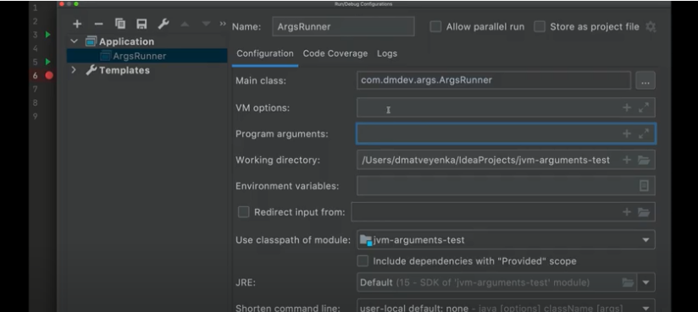

Program arguments = arguments of main()

VM options = JVM arguments:

* User args Dkey=value
* Reserved args XkeyValue Xms512m – heap size during program start

XX… for tuning JIT compiler or garbage collector

To look at arguments passed to our program:

IDEA->DEBUG->evaluate expression->System.getProperties();

To look at environment variables:

IDEA->DEBUG->evaluate expression->System.getEnv(name:);

-----------------------------------------------------------------------------------------------------------------------------------------------------------

## Lesson 5. Archetype plugin

Generates project of required structure

-----------------------------------------------------------------------------------------------------------------------------------------------------------

## Lesson 6. POM Project Object Model

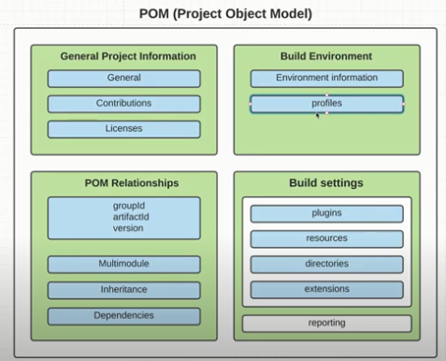

-----------------------------------------------------------------------------------------------------------------------------------------------------------

## Lesson 7. Effective POM

All POM files inherit super POM (like object in java) and parent POM files. To see result POM (effective) there is a goal:

mvn help:effective-pom

-----------------------------------------------------------------------------------------------------------------------------------------------------------

## Lesson 8. Dependency management

Classpath – directory where all our dependencies (.jar) are stored. They are not in our project but in maven local repository in our PC (~/.m2/repository). If we add a new dependency in our project maven first look for it in local repo and then in remote repo.

${maven}/conf/settings.xml – here we can change path to local repo (better not to do it)

-----------------------------------------------------------------------------------------------------------------------------------------------------------

## Lesson 9. Dependency scope, Dependency plugin

|  |  |  |
| --- | --- | --- |
| TYPE | DESCRIPTION | EXAMPLE |
| Compile (Default) | Dependency is needed to compile our project |  |
| Provided | By another dependency. | Jackarta.servlet-api is provided by Tomcat |
| Runtime | Dependency is needed in runtime. | Database driver |
| System | Jar is on our pc. | DO NOT USE AT ALL! |
| Test | Dependency is needed during test phase | Junit |

mvn dependency:analyze - shows unused or required dependencies

mvn dependency:tree -Dverbose - tree of dependencies

-----------------------------------------------------------------------------------------------------------------------------------------------------------

## Lesson 10. Transitive dependencies, exclusions, optional dependencies

Each dependency in our local maven repo has its own POM file. From it transitive dependencies are pulled by chain.

For instance spring dependencies pull a lot of transitive dependencies. Problems occur when those dependencies don’t fit by versions.

mvn dependency:tree –Dverbose

Sometimes in output of the goal above we can see that some dependencies are marked as “omitted for conflict with X.X.X RELEASE”.

In such situation those dependencies win which are located higher in POM file. So effective POM depends on order of dependencies. In opposite to Maven in Gradle dependencies with higher version win.

Another way to solve dependency conflict is tag <exclusions></exclusions>.

Also we can make dependencies optional and anybody who connect our project as a dependency has to choose one of them and add to his POM. But better not to do it.

-----------------------------------------------------------------------------------------------------------------------------------------------------------

## Lesson 11. Project lifecycles. Clean lifecycle

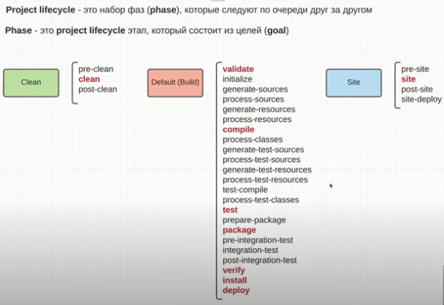

Maven has 3 lifecycles. Each lifecycle consists of phases. Phase consists of goals.

Short description of phases:

* Clean – deleting folder target
* Validate – validate POMs
* Compile – generation .class files
* Test – unit testing
* Package – creating artefact (JAR/WAR)
* Verify – integration testing
* Install – copying of our artefact to local maven repo
* Deploy – pushing of our artefact to remote maven repo
* Site – generation of reports (documentation, test reports and so on)

Set of goals on each phase depends on artefact type we choose, plugins and dependencies and so on.

When we work in IDEA we use not the Maven which is in our PATH variable, but maven chosen in:

Shift-shift/Maven home directory

-----------------------------------------------------------------------------------------------------------------------------------------------------------

## Lesson 12. Validate and compile phases

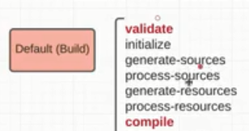

All phases go consequently:

* Validate – validation of POMs
* Initialize – by default does nothing (we can override by connecting a plugin)
* Generate-sources – generator of .java (like QueryDSL) work on the phase
* Process sources – we can set vals of vars
* Generate-resources –
* Process resources – put all recourses from main to target folder
* Compile – generation .class files from .java

Which phases were passes we can see in output of terminal:

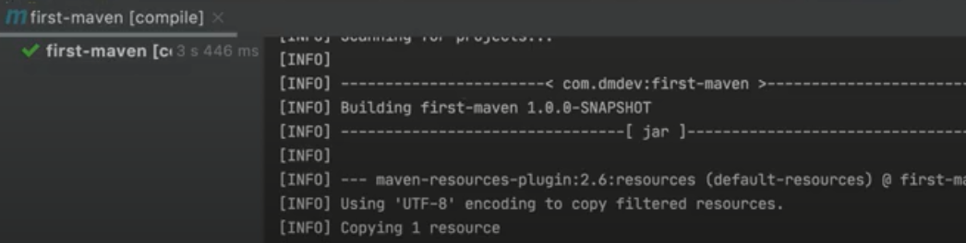

In section build we can override version and behavior of our plugins:

|  |  |
| --- | --- |
|  | <plugins> |
|  | <plugin> |
|  | <groupId>org.apache.maven.plugins</groupId> |
|  | <artifactId>maven-compiler-plugin</artifactId> |
|  | <version>3.8.1</version> |
|  | <configuration> |
|  | <source>15</source> |
|  | <target>15</target> |
|  | </configuration> |
|  | </plugin> |
|  | </plugins> |
|  | </build> |

-----------------------------------------------------------------------------------------------------------------------------------------------------------

## Lesson 13. Test phase. Surefire plugin

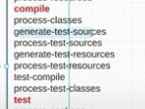

* Process-classes – to change something in bytecode
* Others – clear from names

Surefire plugin runs test and generates statistics. By default it runs tests with following names only:

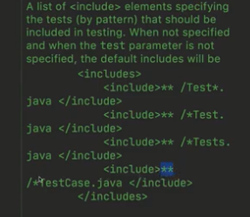

But this behavior can be overridden.

-----------------------------------------------------------------------------------------------------------------------------------------------------------

## Lesson 14. Package phase

By default projects are packaged to JAR, but there are other types (not only WAR):

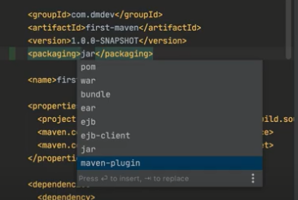

We probably face only JAR, WAR, POM, Maven-plugin. Others are very rare.

NOTE: by default JAR is not executable, because it doesn’t contain required dependencies. It contains only our code. So it needs lib folder where required dependencies are stored. There is also executable JAR.