Game Design Document

Fill up the Following document

1. Write the title of your project.

Flappy Bird Game Retro 8bit

1. What is the goal of the game?

Get the highest score and avoid hitting the pipes

1. Write a brief story of your game?

There is a bird trying to its nest help the bird to find the nest and avoid hitting the industrial pipes.

1. Which are the playing characters of this game?

* Playing characters are the ones which respond to the user based on the input from the user
* Cars, monkeys, dinos, wizards etc., are the playing characters in the game.

|  |  |  |
| --- | --- | --- |
| Number | Character Name | What can this character do? |
| 1 | Flappy Bird | The bird fly and players must control its movement to avoid hitting the pipes. |
| 2 |  |  |
| 3 |  |  |
| 4 |  |  |
| 5 |  |  |
| 6 |  |  |
| 7 |  |  |
| 8 |  |  |

1. Which are the Non Playing Characters of this game?

* Non Playing characters are the ones which don't have an action or a behavior when the user interacts with the game.
* Hurdles, stones, bananas, coins, etc. are non-playing characters in the game.

|  |  |  |
| --- | --- | --- |
| Number | Character Name | What can this character do? |
| 1 | Industrial Pipes | It the bird touches the pipe the bird dies and the player loses the game. |
| 2 |  |  |
| 3 |  |  |
| 4 |  |  |
| 5 |  |  |
| 6 |  |  |
| 7 |  |  |
| 8 |  |  |

Draw your imagination of this game. What does this game look like?

* Draw the game either on your computer or on paper,
* Add images of scenes of the game to show each of the playing and non-playing characters at least once.

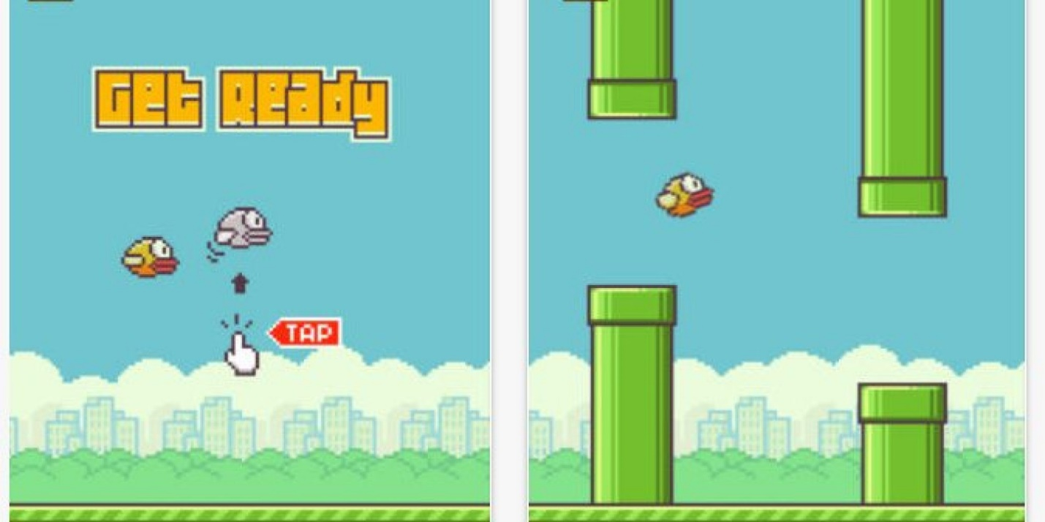

How do you plan to make your game engaging?

I am going to make the game engaging by adding sounds and increasing the speed of the moving pipe after the player reaches a certain distance.