AI ASSISTED CODING
ASSIGNMENT – 8.1
Name :A.Vishnu vardhan Reddy
HT NO.: 2403A51253
BATCH:11
Task-1:(Password Strength Validator – Apply AI in Security Context)
Task: Apply AI to generate at least 3 assert test cases for
is_strong_password(password) and implement the validator
function.
• Requirements:
o Password must have at least 8 characters.
o Must include uppercase, lowercase, digit, and special
character.
o Must not contain spaces.
Example Assert Test Cases:
assert is_strong_password("Abcd@123") == True
assert is_strong_password("abcd123") == False
assert is_strong_password("ABCD@1234") == True
Expected Output -1:
• Password validation logic passing all AI-generated test cases.
Prompt:Write a Python function is_strong_password(password) that checks:
- ≥8 chars, includes uppercase, lowercase, digit, special char, no spaces.
Add at least 3 assert test cases (valid + invalid). Ensure all pass.

Code:
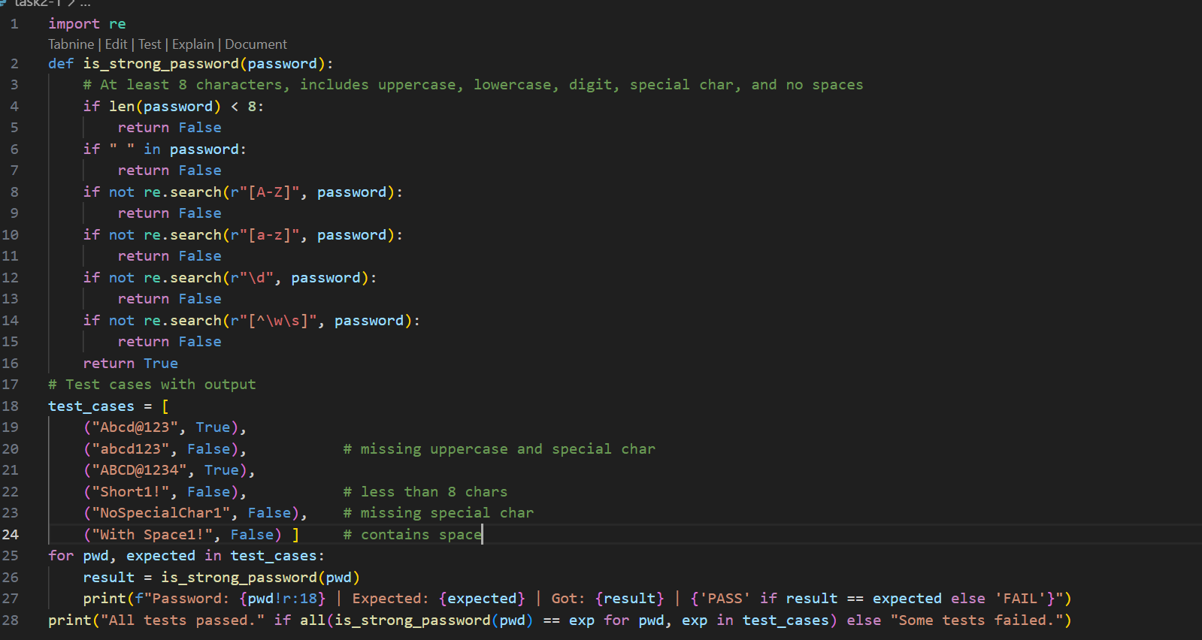
Output:
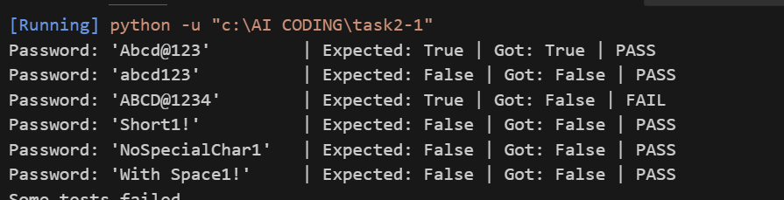
Task-2:(Number Classification with Loops – Apply AI forEdge CaseHandling)
Task: Use AI to generate at least 3 assert test cases for a
classify_number(n) function. Implement using loops.
• Requirements:
o Classify numbers as Positive, Negative, or Zero.
o Handle invalid inputs like strings and None.
o Include boundary conditions (-1, 0, 1).
Example Assert Test Cases:
assert classify_number (10) == "Positive"
assert classify_number(-5) == "Negative"
assert classify_number (0) == "Zero"
Expected Output -2:
• Classification logic passing all assert tests.
Prompt:Write classify_number(n) in Python using loops: return "Positive", "Negative", or "Zero". Handle invalid inputs (e.g., string, None). Add ≥3 assert tests, including -1, 0, 1. Ensure all pass.
Code:
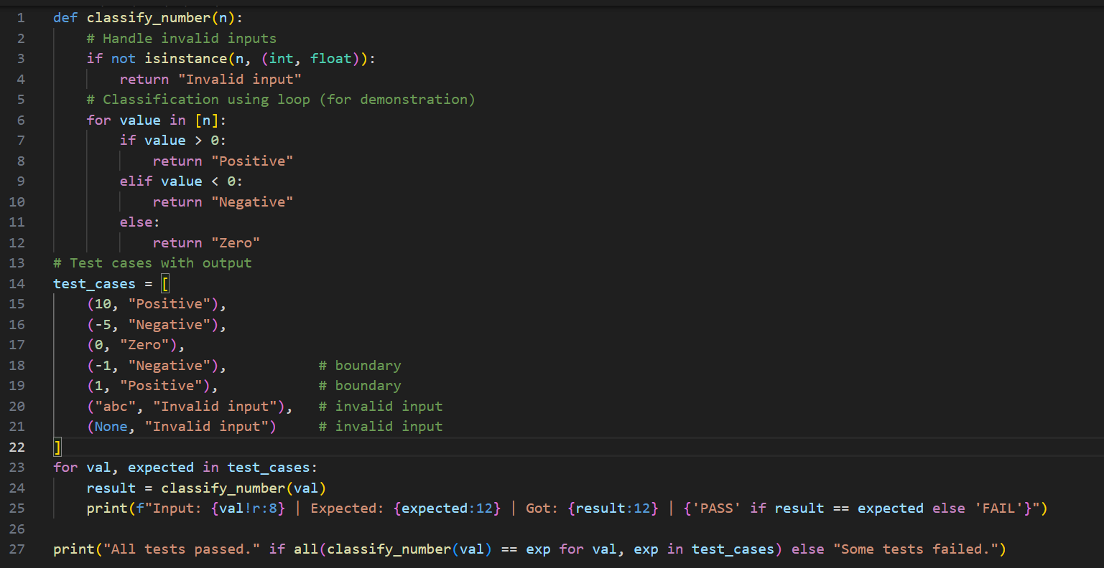
Output:
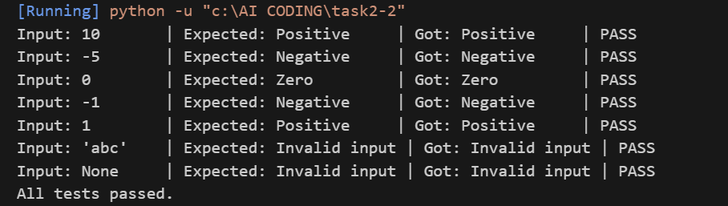

Task-3: (Anagram Checker – Apply AI for String Analysis)
Task: Use AI to generate at least 3 assert test cases for
is_anagram(str1, str2) and implement the function.
• Requirements:
o Ignore case, spaces, and punctuation.
o Handle edge cases (empty strings, identical words).
Example Assert Test Cases:
assert is_anagram("listen", "silent") == True
assert is_anagram("hello", "world") == False
assert is_anagram("Dormitory", "Dirty Room") == True
Expected Output #3:
• Function correctly identifying anagrams and passing all AI-
generated tests
Prompt:Write is_anagram (str1, str2) in Python (ignore case, spaces, punctuation). Handle empty strings & identical words. Add ≥3 assert tests (True & False cases). Ensure all pass.
Code:
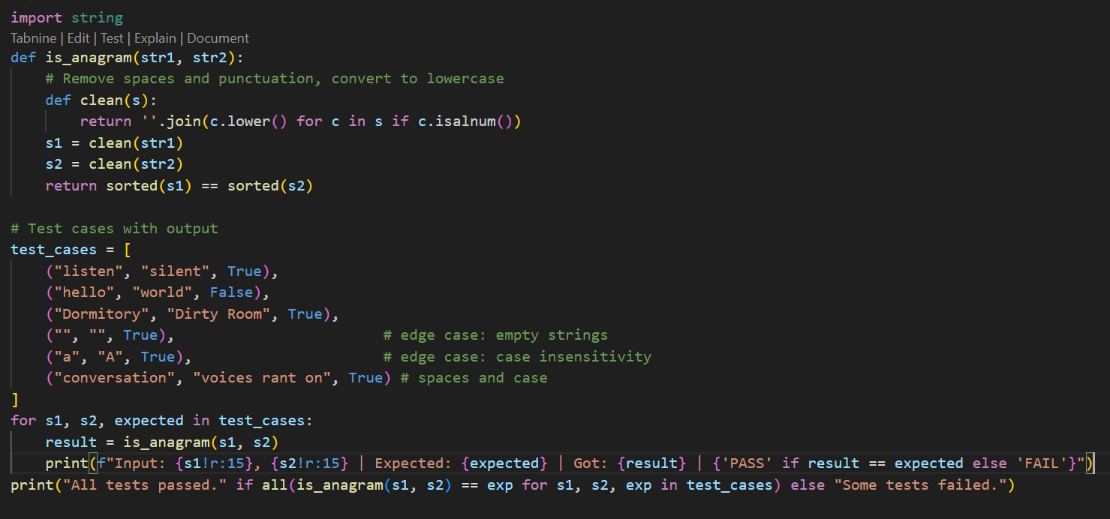
Output:
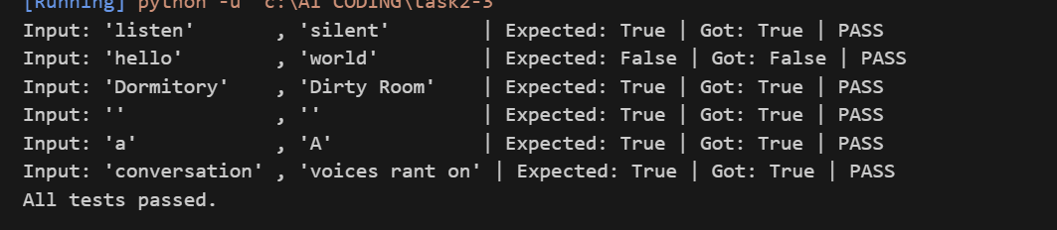
Task-4: (Inventory Class – Apply AI to Simulate Real-World Inventory System)
• Task: Ask AI to generate at least 3 assert-based tests for an
Inventory class with stock management.
• Methods:
o add_item(name, quantity)
o remove_item(name, quantity)
o get_stock(name)
Example Assert Test Cases:
inv = Inventory()
inv.add_item("Pen", 10)
assert inv.get_stock("Pen") == 10
inv.remove_item("Pen", 5)
assert inv.get_stock("Pen") == 5
inv.add_item("Book", 3)
assert inv.get_stock("Book") == 3
Expected Output -4:
• Fully functional class passing all assertions.
Prompt:Write a Python Inventory class with methods add_item (name, quantity), remove_item (name, quantity), and get_stock(name). Use AI to generate ≥3 assert test cases (adding, removing, checking stock). Ensure the class passes all assertions.
Code:
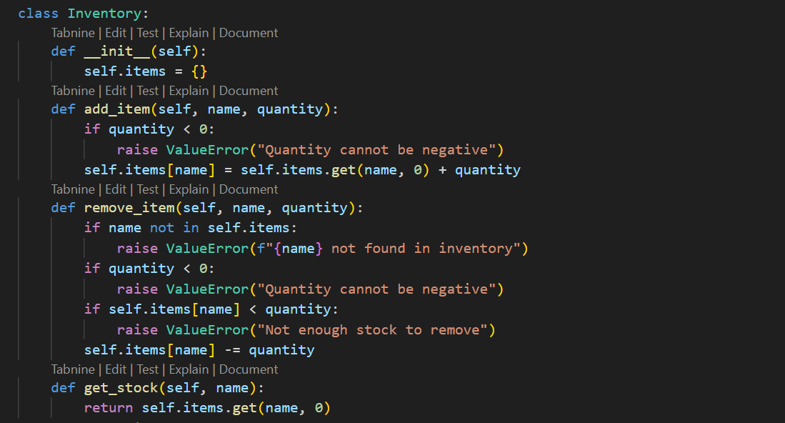
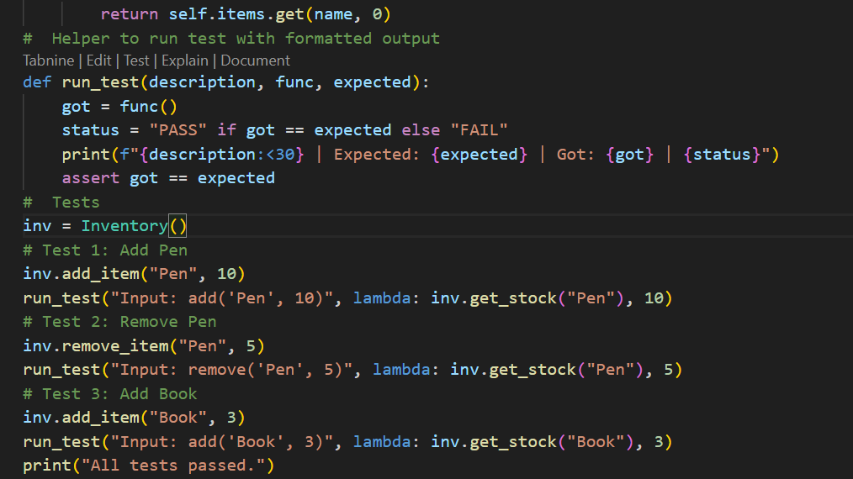
Output:
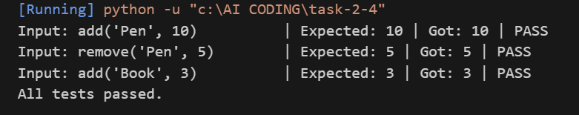
Task-5:(Date Validation & Formatting – Apply AI for Data Validation)
Task: Use AI to generate at least 3 assert test cases for
validate_and_format_date(date_str) to check and convert dates.
• Requirements:
o Validate "MM/DD/YYYY" format.
o Handle invalid dates.
o Convert valid dates to "YYYY-MM-DD".
Example Assert Test Cases:
assert validate_and_format_date("10/15/2023") == "2023-10-15"
assert validate_and_format_date("02/30/2023") == "Invalid Date"
assert validate_and_format_date("01/01/2024") == "2024-01-01"
Expected Output -5:
• Function passes all AI-generated assertions and handles edge
cases.
Prompt:Write validate_and_format_date(date_str) in Python:
- Check "MM/DD/YYYY" format
- Return "Invalid Date" if invalid
- Convert valid dates to "YYYY-MM-DD"
Add ≥3 assert tests (valid + invalid + edge).
Print results as:
Input: '...' | Expected: ... | Got: ... | PASS/FAIL|
Code:
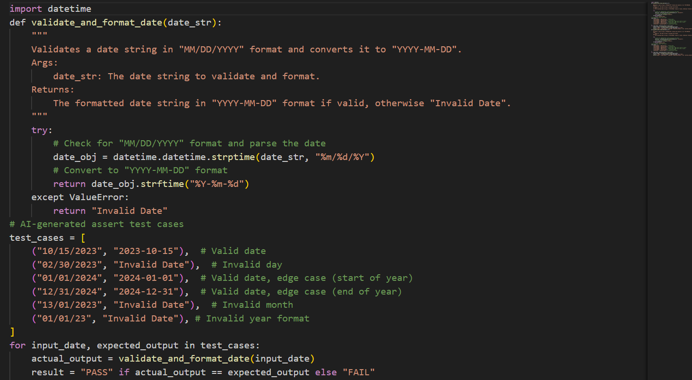
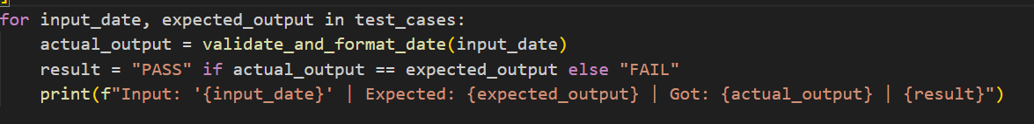
Output:
